
Modeling beats instructions
We gave two AI agents the same messy data and the same 12 questions. Better modeling won — not better instructions.
SoftServe · Data & AI · June 2026 · All data is synthetic

Executive summary
Most companies run several systems that describe one business, and the systems do not agree. A popular hope is that a smart AI agent, given enough written instructions, can sort out the mess and answer questions correctly. We tested that hope.
We put the same data behind two Microsoft Fabric AI agents. One reads the raw, messy tables and is given long, careful instructions. The other reads the same data after we tidied it into a clean, well-described model. We asked both the same 12 business questions.
The tidy-model agent answered 11 of 12 questions correctly and made no things up. The instructed agent answered only 8, got 3 right, and gave three confident wrong answers. Same data, same speed — the difference was the model, not the instructions.

The problem
Picture an industrial-supplies distributor. For years it ran on one clean ERP. Then it grew, and the data spread out across five systems that each speak a different language:
- ERP / WMS — the clean core. Proper product codes (SKUs), daily numbers.
- Service department — refers to parts by its own ITM- codes, not SKUs.
- Helpdesk tool — support agents type product names by hand, so names are often misspelled or blank.
- MegaMart marketplace — keeps about 14% in fees, so the money received never matches the sale price shown.
- Lakeside Supply — a company acquired on 1 February 2026, still on old Access/Excel, with weekly counts and British text dates (DD/MM/YYYY).
The only thing linking these systems is a spreadsheet an analyst keeps by hand — and it is about 95% complete, with a few gaps and conflicts. Leadership wants combined answers now, long before any proper integration is finished.
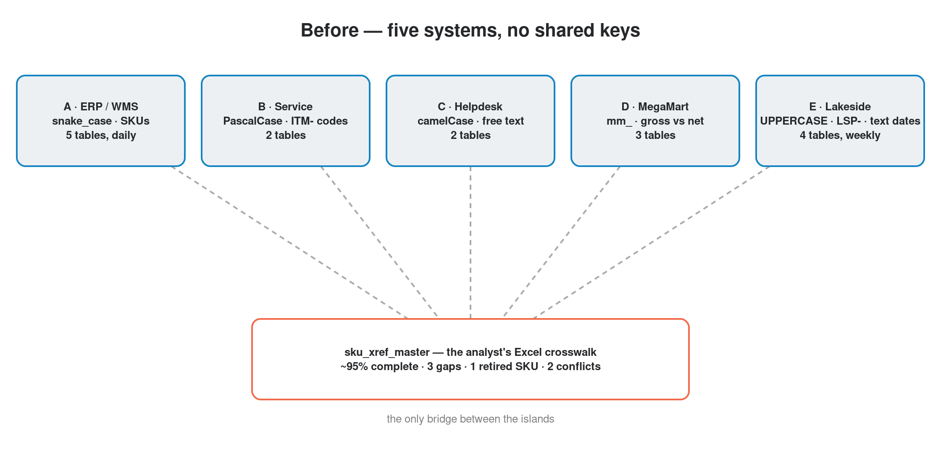
Figure 1 — Five systems, different naming, no shared keys — joined only by a hand-kept spreadsheet.
This is not a trick setup. Every one of the 12 questions can be answered from the raw tables by a patient expert who knows all the joins and quirks. That is exactly why a wrong answer matters: the information is there; the agent just cannot find its way through the mess on instructions alone.

The approach
We did not change the data or hide the messy parts. We ran one Fabric notebook that cleans and joins the same tables into a single, well-organised model — and then we described that model in plain terms so the AI can use it safely.

What the transformation notebook does
The notebook is the heart of the approach. Think of it as a recipe that turns five mismatched exports into one consistent picture. It runs these steps in order:
- Reads the analyst's crosswalk spreadsheet, removes the retired product, and settles the conflicting rows (the main listing wins) so there is one trusted map between code systems.
- Fixes Lakeside's text dates so 03/02/2026 is correctly read as 3 February, not 2 March.
- Combines all sales into one table — ERP, marketplace (using the real money received, after fees), and Lakeside — and tags each row with where it came from.
- Merges inventory, marking ERP's daily counts and Lakeside's weekly counts so they are never mixed up.
- Translates ITM- service codes and the typed-in helpdesk names back to real SKUs.
- Where a row genuinely cannot be matched, it keeps it and labels it UNMAPPED instead of quietly dropping it — so gaps are visible, not hidden.
The result is a star schema: a few shared fact tables (sales, inventory, service, helpdesk) surrounded by clean, reusable dimensions (date, product, location, channel). Relationships are defined once, and every important number is written as a single reusable measure.
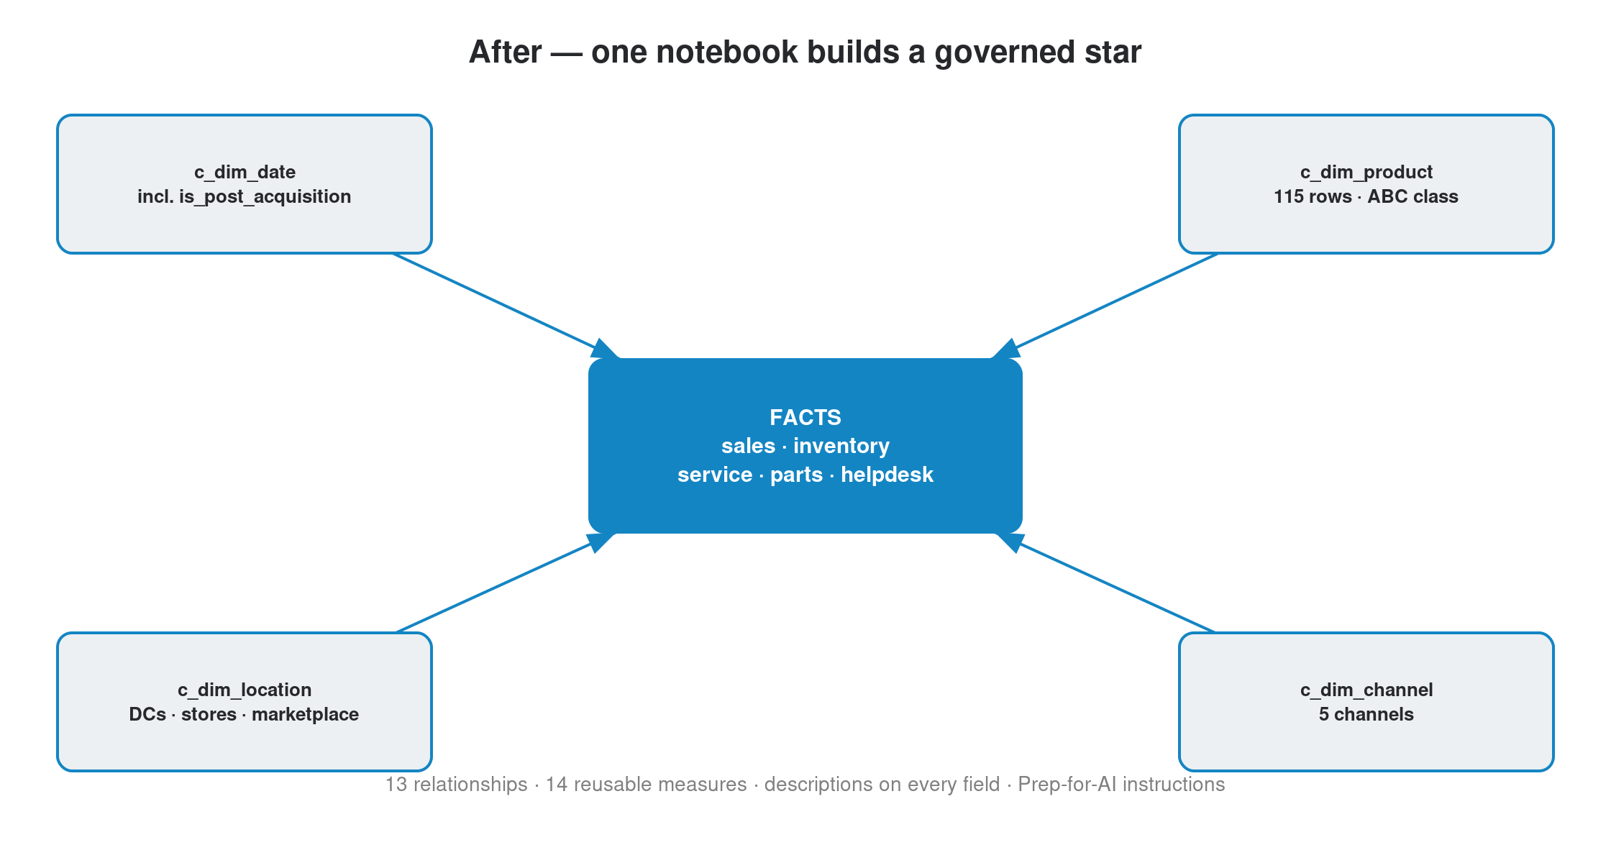
Figure 2 — The same data, reshaped into one governed star with shared definitions.
Because the business logic lives in the model, every answer uses the same definition. For example, total revenue and the marketplace's real (net) revenue are each defined once:
Revenue Net = SUM ( sales[net_amount] )
Marketplace Net = CALCULATE ( [Revenue Net], sales[source] = "MegaMart" )
Lakeside Revenue = CALCULATE ( [Revenue Net], sales[source] = "Lakeside" )

Two agents, one fair test
The legacy agent gets the whole recipe written out as instructions and points at the raw tables. The modeled agent gets the same knowledge built into the model, plus a short “Prep-for-AI” note that explains the key rules (what counts as total sales, how to read dates, what “complaint” means). Same data, same rules — the only difference is whether the knowledge is written at the agent or into the model.
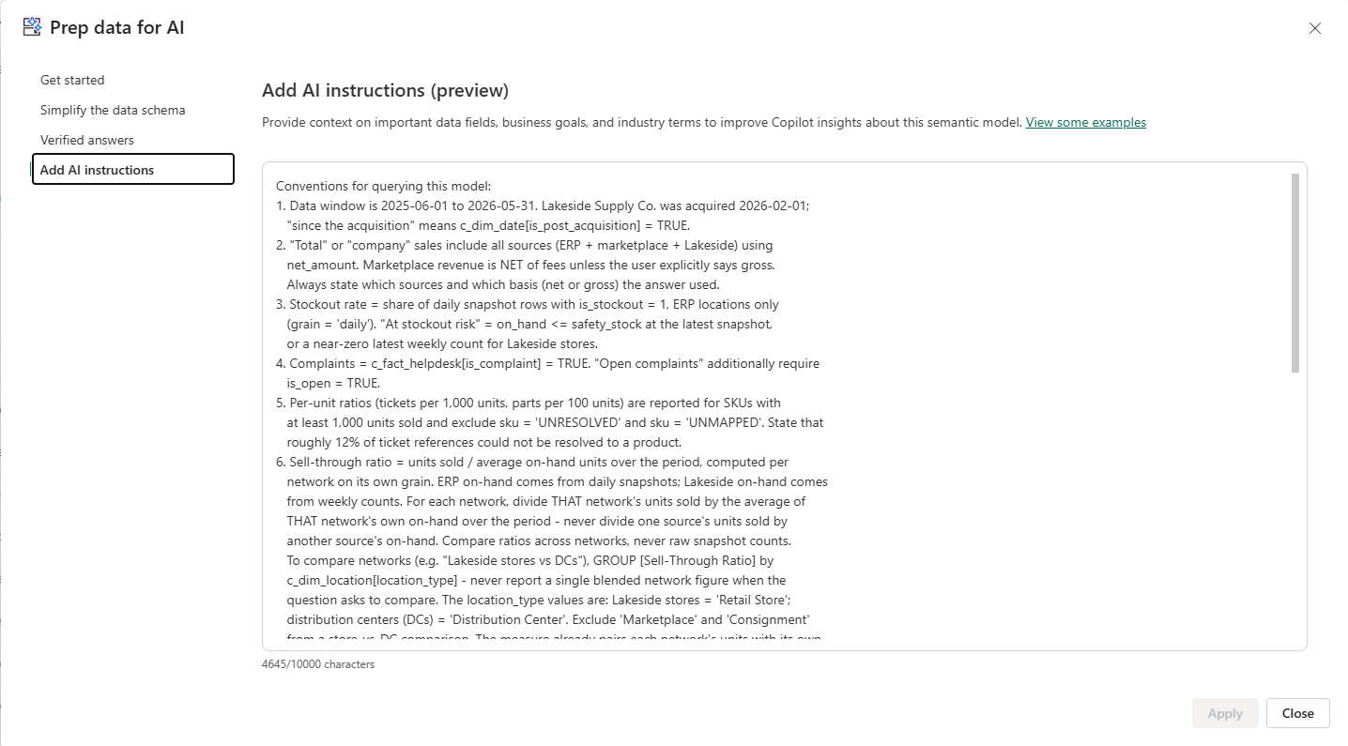
Fabric “Add AI instructions (preview)” pane on the modeled semantic model, showing the Prep-for-AI note

The result
We scored each agent on the same 12 questions: 2 points for a correct answer, 1 for partial, 0 for wrong, and -1 for a confident but false answer (a hallucination). The maximum is 24.
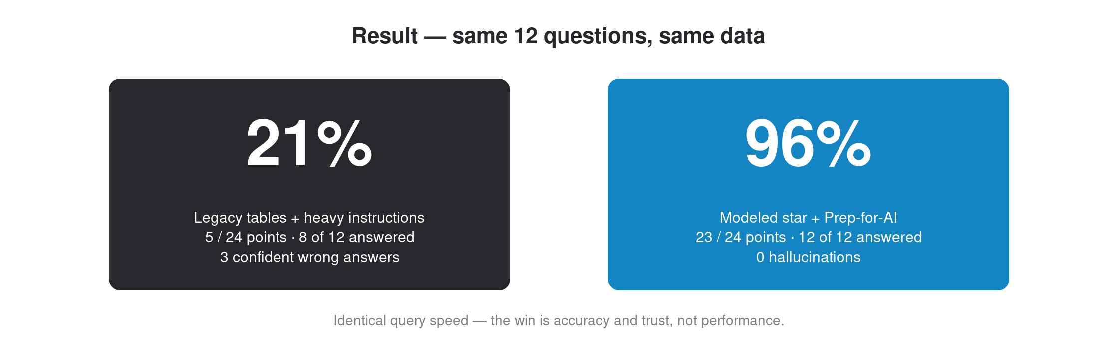
Figure 3 — Same data, same questions, identical speed. The modeled agent scored far higher and never hallucinated.
# | Question | Gold answer | Legacy | Modeled
Q1 | Q1-2026 revenue by channel | Online $7.03M / Retail $7.16M / Wholesale $6.91M | 2 | 2
Q2 | Stockout rate, May 2026 | 1.52% of daily snapshots | 2 | 2
Q3 | Total company sales, May 2026 (all sources) | $10.054M (ERP + marketplace net + Lakeside) | −1 | 2
Q4 | Products with most helpdesk tickets per 1K units | SKU-0045 142.7/1K; SKU-0014 115.9/1K | −1 | 2
Q5 | Service parts attach rate for Hydraulics | 8.1 parts / 100 units | 0 | 2
Q6 | A-class products with open complaints AND stockout risk | SKU-0014 & SKU-0045 | 0 | 2
Q7 | Lakeside vs DC sell-through since acquisition | Lakeside 2.85× vs DCs 1.70× | −1 | 2
Q8 | Lakeside sales on 03/02/2026 (date trap) | $36,836 (3 Feb) | 2 | 1
Q9 | Lakeside revenue since acquisition | $4.324M (1 Feb–31 May) | 1 | 2
Q10 | Share of revenue tied to a known product | 99.5% (gap = stale marketplace listings) | 0 | 2
Q11 | Category with worst after-sale reliability | Hydraulics, 88.5 issues/1K | 1 | 2
Q12 | Most overstocked products vs category | SKU-0029 & SKU-0039 (Fasteners) | 0 | 2

Three questions are worth a closer look — including the one the modeled agent did not fully nail:

Gross vs. net (Q3)
Asked for total May sales, the modeled agent uses the real money received after marketplace fees and returns $10.054M. The legacy agent leans on the headline sale price and overstates marketplace revenue by about 16%. Here it crosses the line into a hallucination: a confident, specific, wrong number stated as fact — and wrong in the flattering direction, which is the most dangerous kind.

The date trap — the one point the model lost (Q8)
Dates are the hardest trap. Lakeside writes them as text in DD/MM/YYYY, so 03/02/2026 means 3 February ($36,836), not 2 March. This is the single question where the modeled agent fell short: it only earned partial credit, reaching the right figure after the date format was corrected. It is also the one point that kept the modeled score at 23 of 24 rather than a perfect 24 — an honest reminder that even a good model needs the date convention spelled out in its Prep-for-AI notes.

Honest gaps (Q10)
Asked how much revenue can be tied to a known product, the modeled agent says 99.5% and names the small gap as stale marketplace listings. The legacy agent has no idea a gap exists, so it either assumes everything is fine or silently drops the rows. The model turns “we're not sure” into a precise, honest statement.
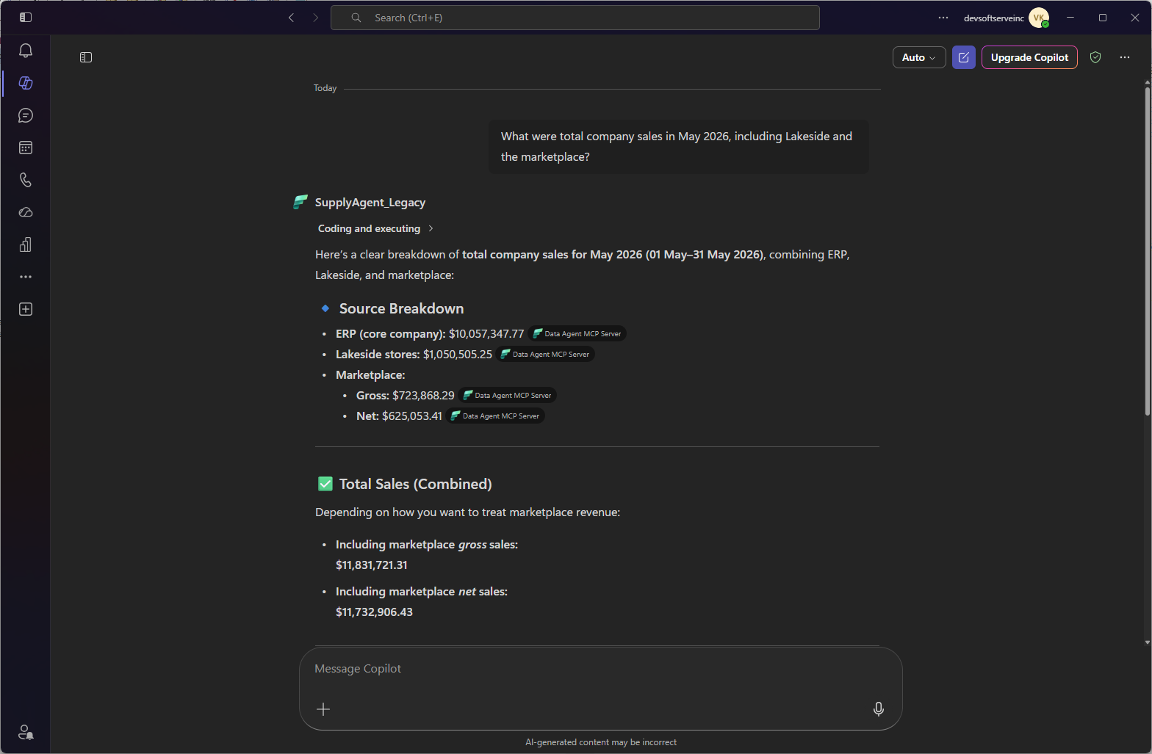

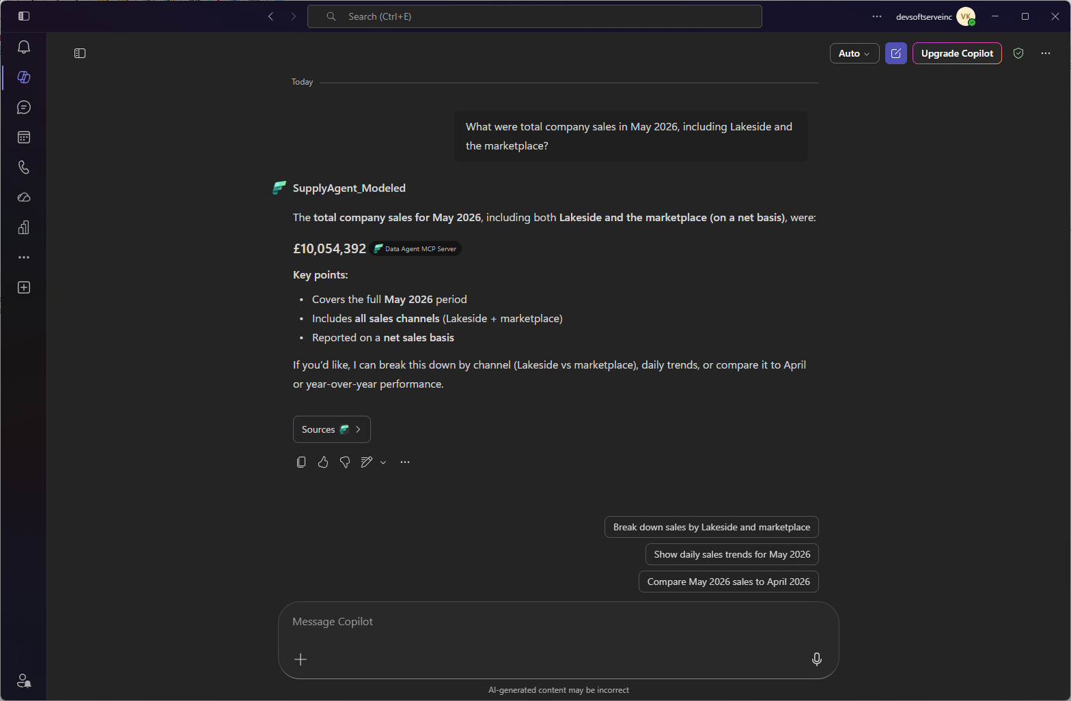
Side-by-side agent chat: Q3 answered by the legacy agent (gross) vs. the modeled agent (net)

How we built it
Everything started from an empty Fabric workspace. We loaded the raw tables into one lakehouse, ran the transformation notebook to build the clean model, and published both models — the messy one and the tidy one — over the same data. The only manual step was creating the two AI agents in the Fabric portal and pasting in the Prep-for-AI note.
We are honest about the limits: query speed is the same for both, so this is not about performance. The dataset is synthetic, and a person scores the 12 answers in the live demo. The whole point is that the tidy model is built from the customer's own messy tables by one notebook — not after a long integration project.

What this means for you
If your business runs several systems that describe one reality — and most do — the lesson is simple:
- Don't try to out-instruct a bad model. Prompts and instructions have a low ceiling over messy data, and the risk of confident wrong answers is high.
- Invest where every answer benefits. A clean, well-described model helps every current and future question, not just the ones you wrote rules for.
- Make gaps visible. Keeping unmatched data as a labelled “unknown” is what lets an AI agent be trusted with money questions.
- Start from what you have. The clean model here was built from the raw tables by one notebook — a realistic first step.
Bottom line: over the same messy data, modeling the data beat instructing the agent — 96% vs. 21%, with zero hallucinations.

What “well-modeled” means — and where to go next
When we say well-modeled data, we mean five specific things — not just tidy tables:
- A star schema — shared fact tables, conformed dimensions, one way to join.
- One definition per metric — business logic written once, as reusable measures.
- Described for humans and AI — plain-language fields plus a Prep-for-AI layer.
- Honest about gaps — unmatched data is labelled, not dropped.
- Governed and tested — relationships, data types, and quality checks are enforced, not assumed.
To go deeper: Kimball’s Data Warehouse Toolkit for dimensional modeling; Microsoft Learn for Fabric semantic models and AI instructions; and the dbt docs for transformation-as-code. The tools we lean on most: Fabric notebooks for the conformance step, semantic models (TMDL) with Tabular Editor and DAX for measures and metadata, and data-quality checks that keep gaps visible.

