**E AUCTIONING**

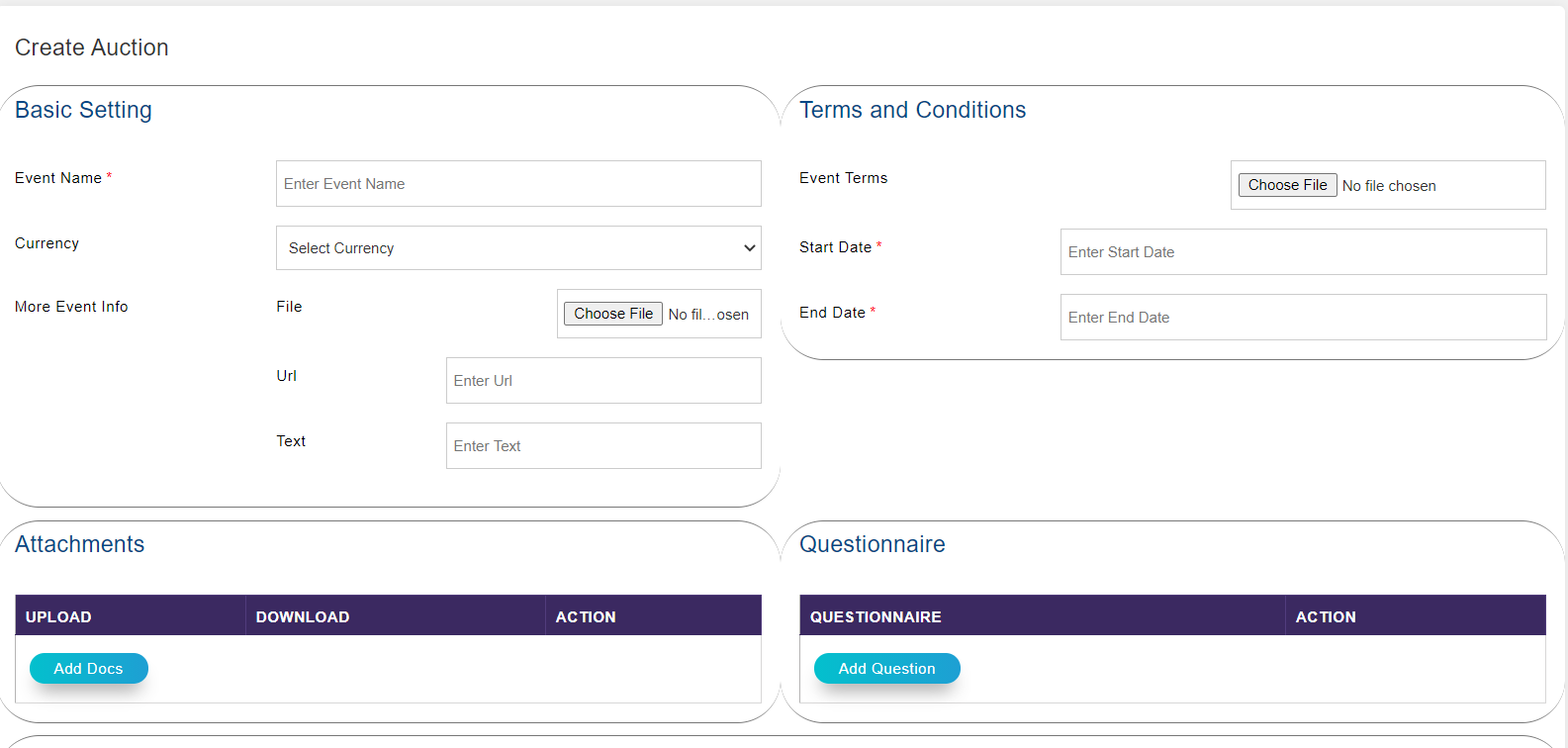

1. Auction can be created with name by mentioning start date and end date.
2. Files can be attached along with URL and text in auction.
3. Multiple currencies option.
4. There will be Option to set Questionnaire, Terms and Conditions and Add Document.

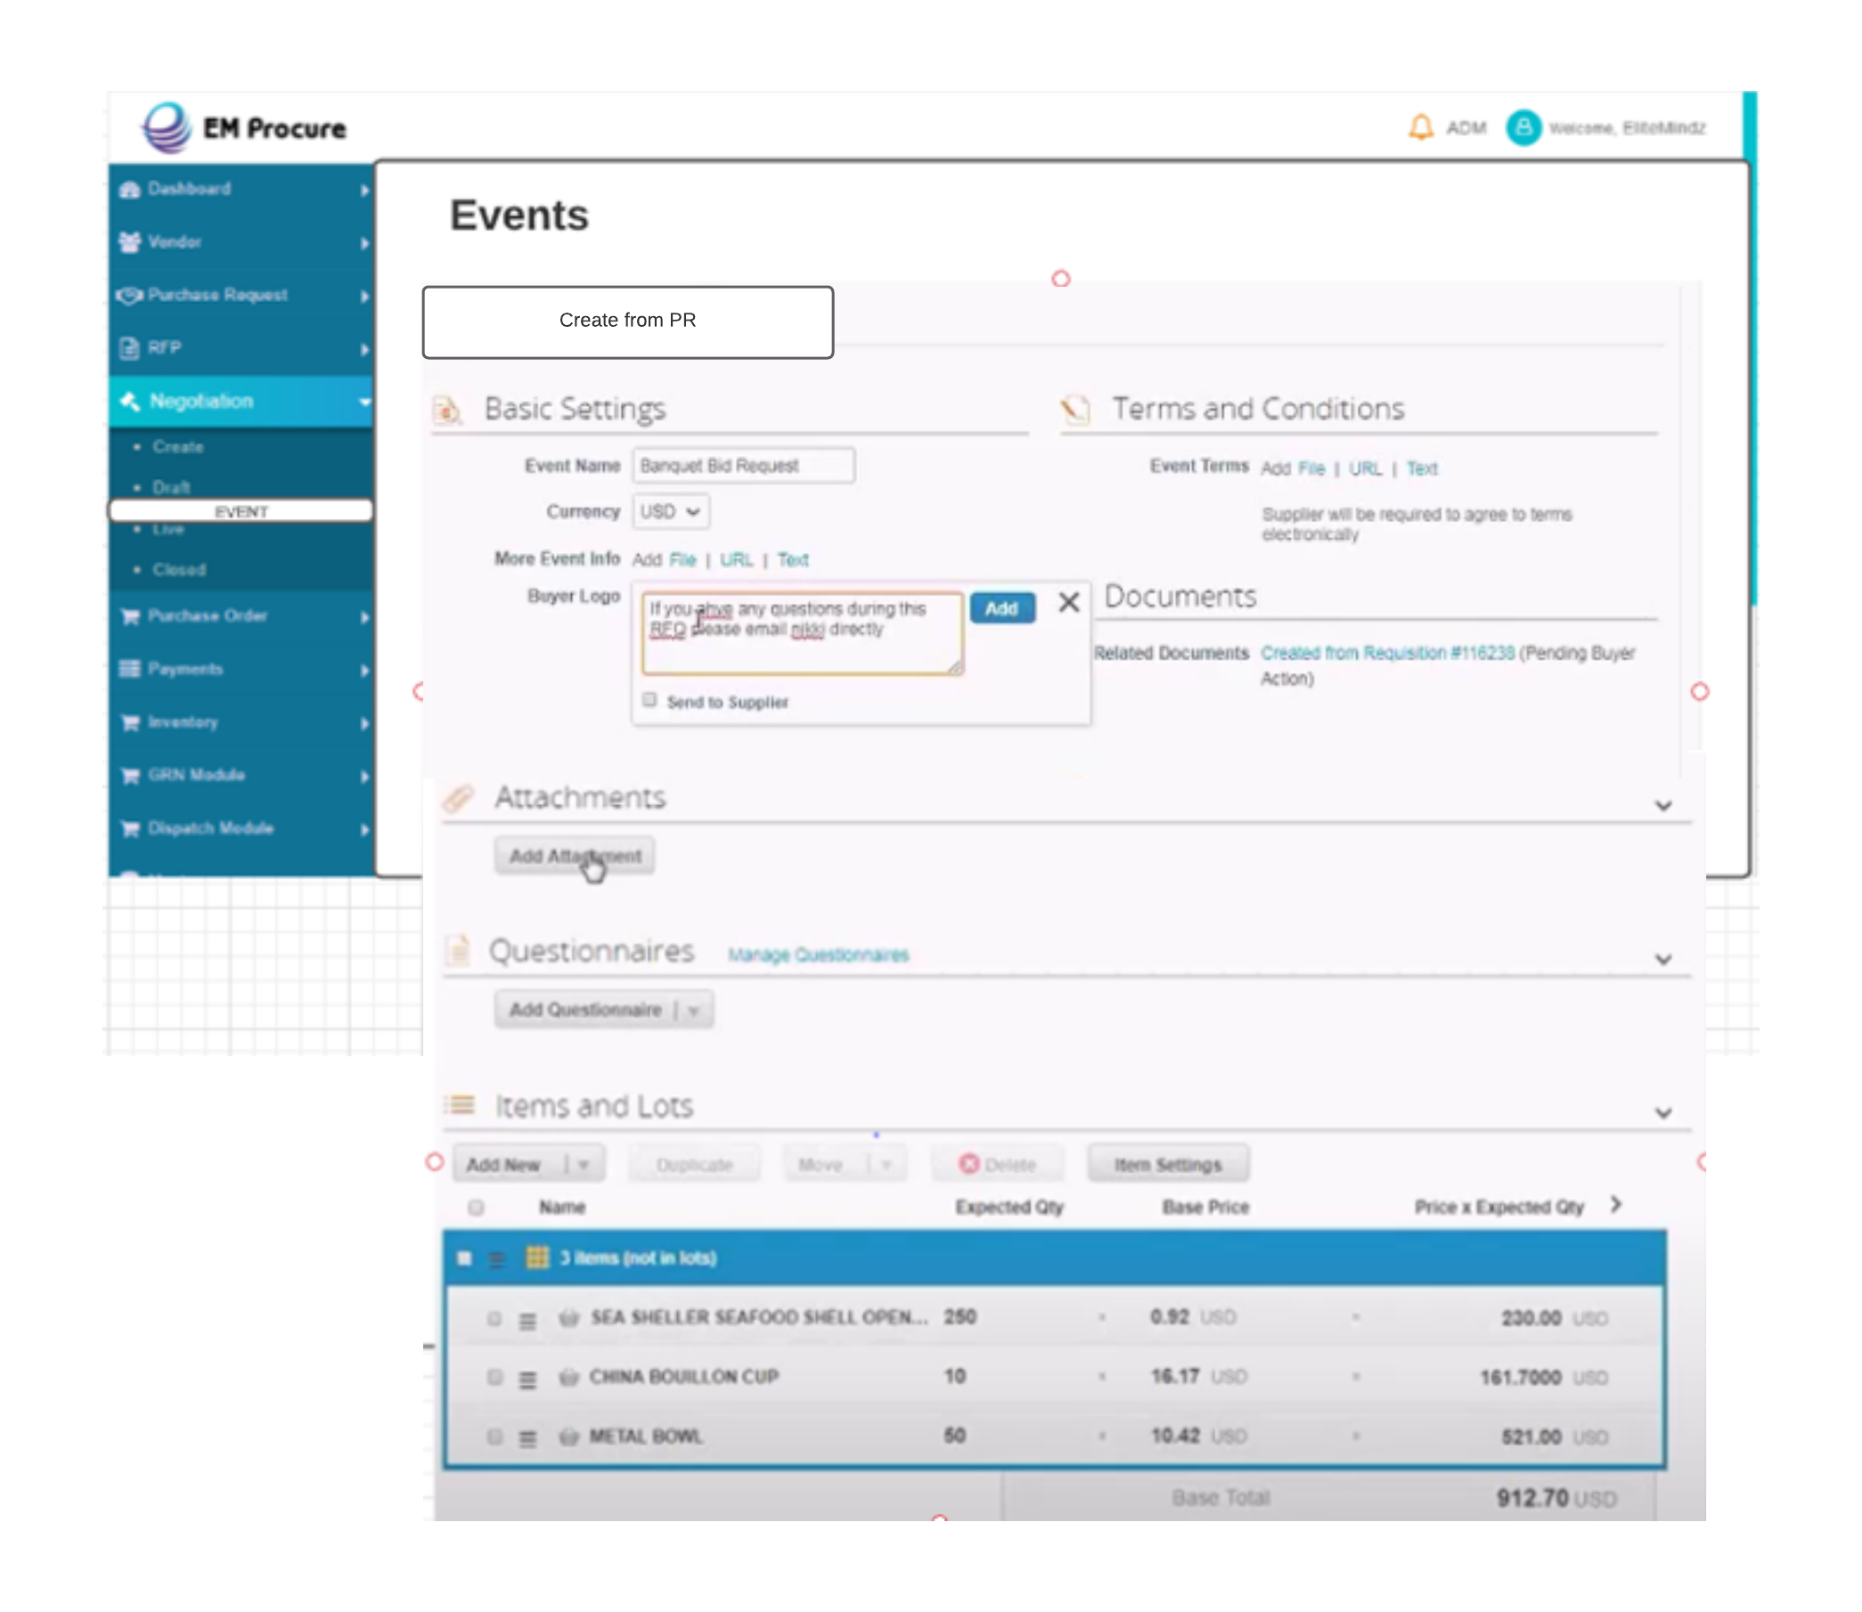

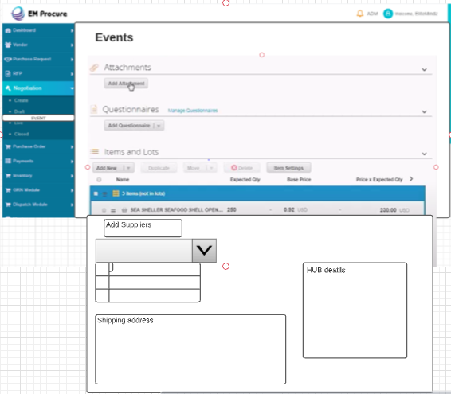

* After Creating Event Invitation will be sent to Different Vendor by Email.

Format;

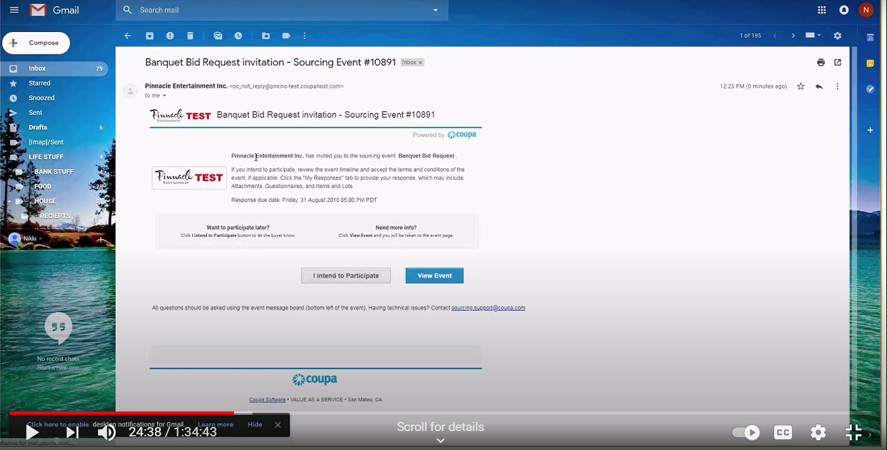

* After Choosing the View Event option Vendor will be directed to Vendor portal with this

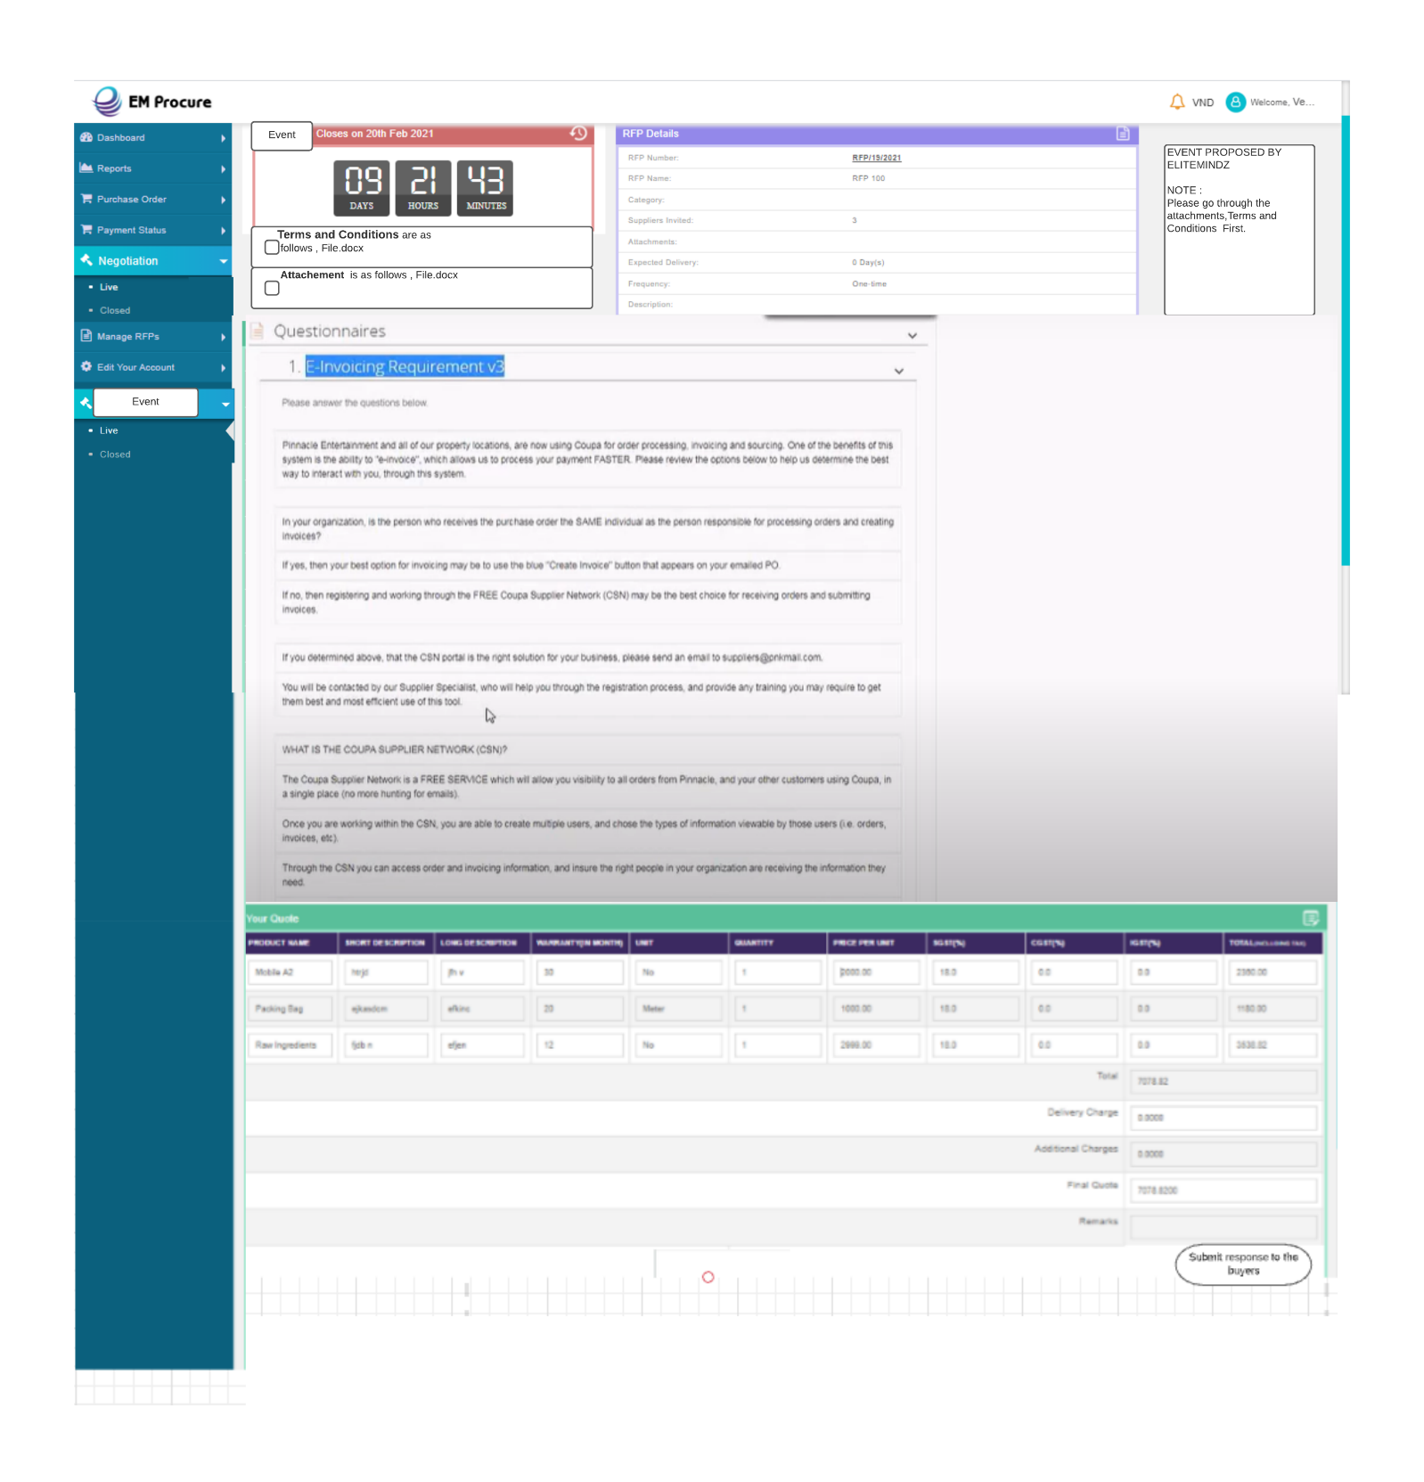

* After agreeing to the check boxes Vendor can participate in the Event (also the countdown will be mentioned in the portal)
* Now vendor can do the quoting till the countdown ends.

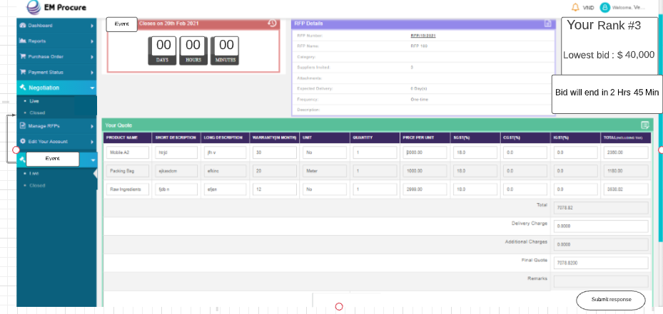

Closed Event tab on Vendor Portal

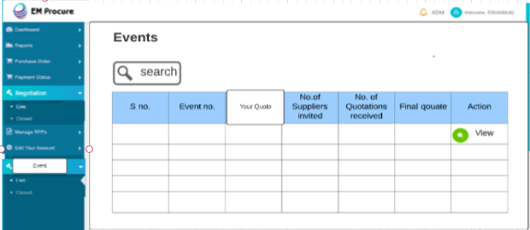

Then in a statement which Indicates Live E Auctioning will be done in the Vendor Portal in Event Module

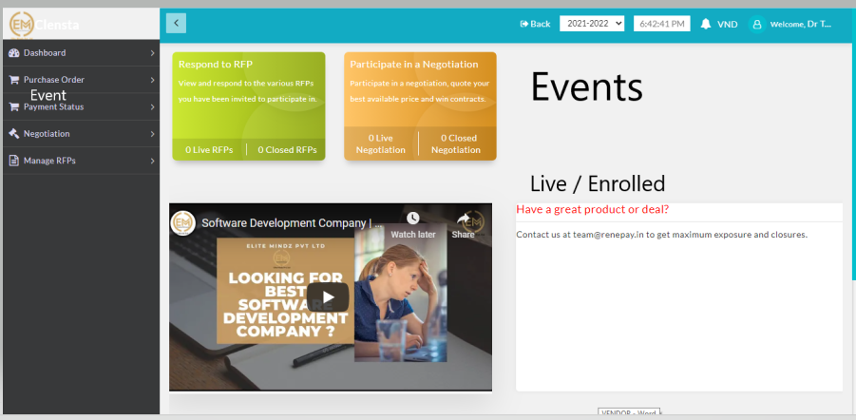

Live – Directed through Email button

Enrolled; Past Event Details in which he participated

* Vendor will be having 24 hrs.(configurable) to change the biding according and will be having real time track of other Vendors Track

Responses

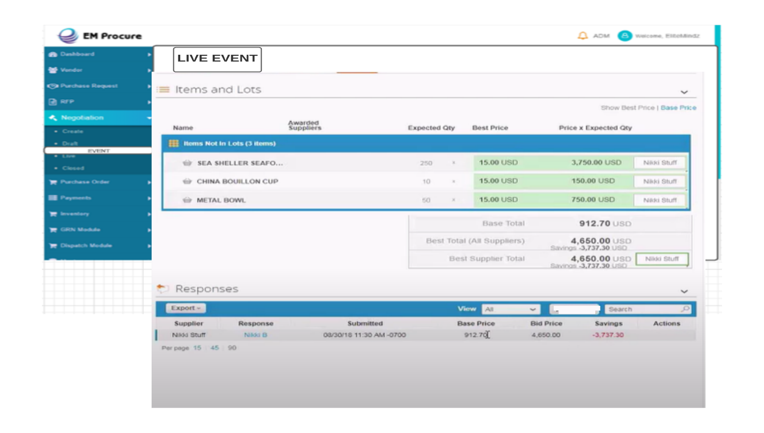

Vendors can see their current rankings for individual product in the live auction.

Bid history can be seen and all previous bids of auction of an individual vendor can be seen at their end.

Vendors can update their bids multiple time in a live auction.

Complete view of base price and quote price of all the items.

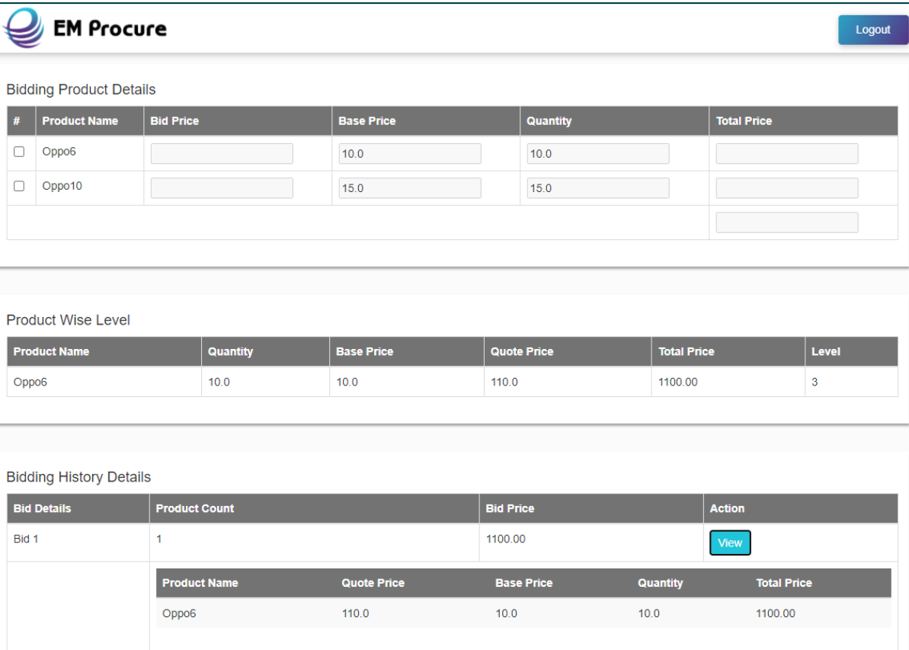

Best quotations can be seen at admin end in L1, L2 and L3 level on the basis of best prices.

Auction list of all the auctions along with the start date and end date.

Number of suppliers invited and number of quotations received along with final quotation can be seen.

