RANKING

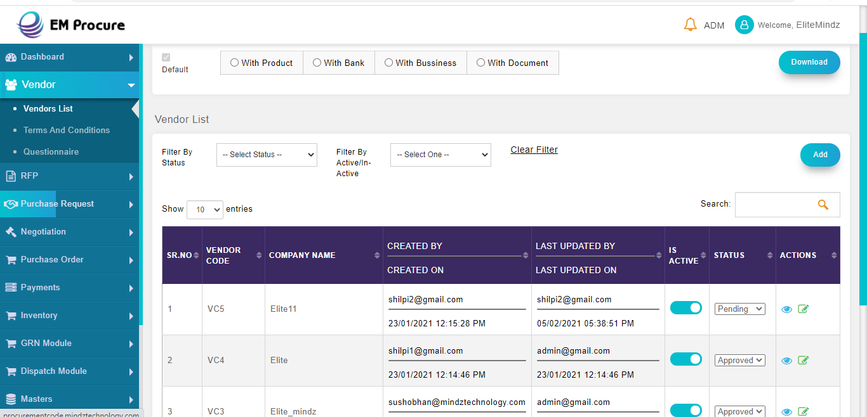

1. A TABULAR FORMAT FOR THE RANKING ACCORDING TO THE BELOW PARAMETERS
   * Quality on the basis of rejected quantity. Source : QC form
   * Price on the basis previous purchase details. Source: Past POs
     + These two parameters will work after 45 days of working with the organization.
2. Delivery Time. Source : Vendor Registration Form
3. Year of establishment or age of company. Source : Vendor Registration Form
4. Contract Management like terms and conditions they are agreed. Source : Vendor Registration Form

* Vendor parameters weightage can be customized in Masters>Bulk Orders.(to be renamed as Vendor Control)

**E AUCTIONING**

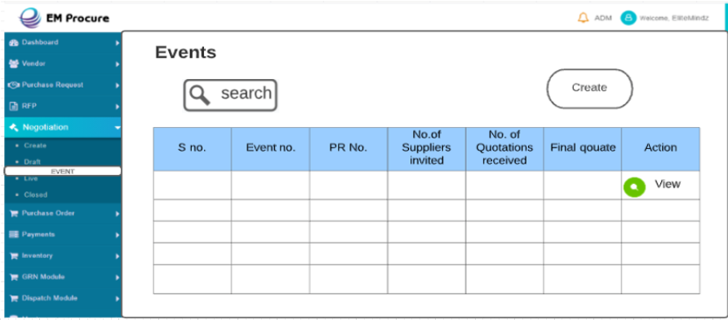

1. Negotiation will have a sub module – Event
2. Data will be retrieved from RFP
3. After selecting the PR, There will be Option to set Questionnaire, Terms and Conditions and Add Document.

For Instance:

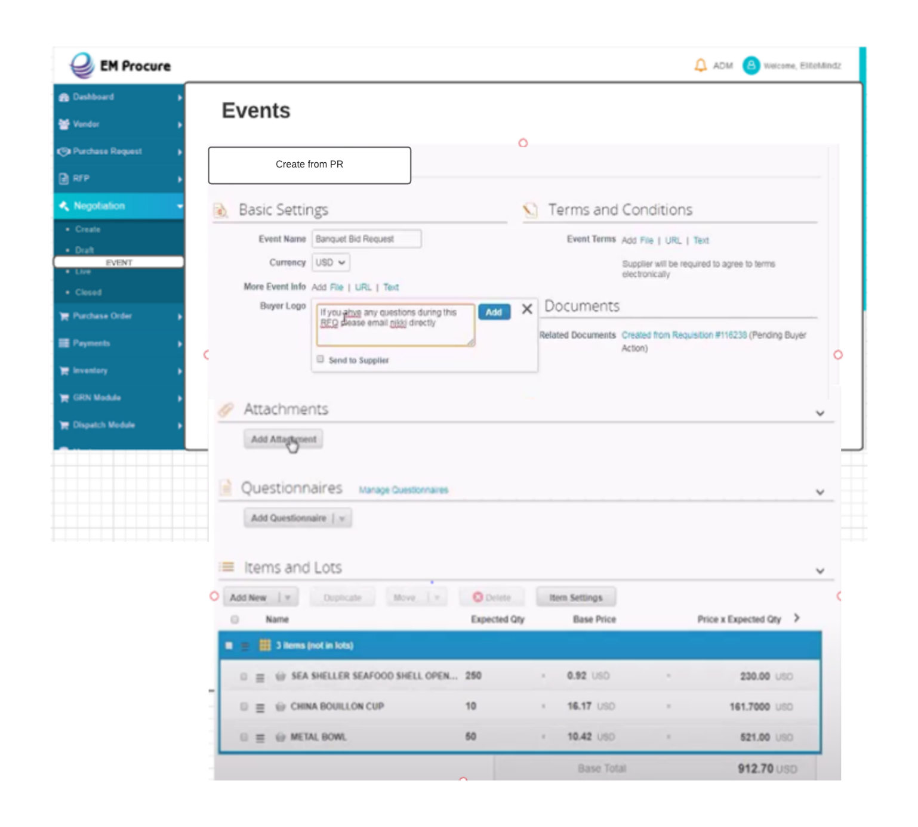

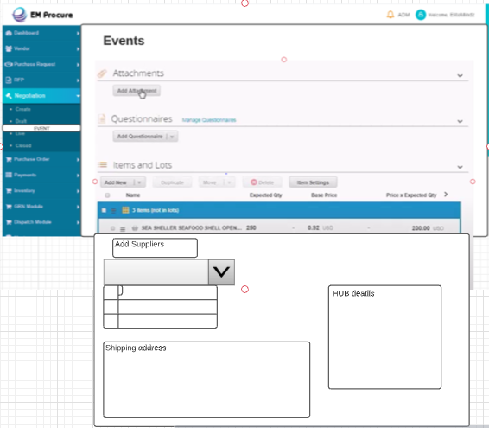

* After Creating Event Invitation will be sent to Different Vendor by Email.

Format;

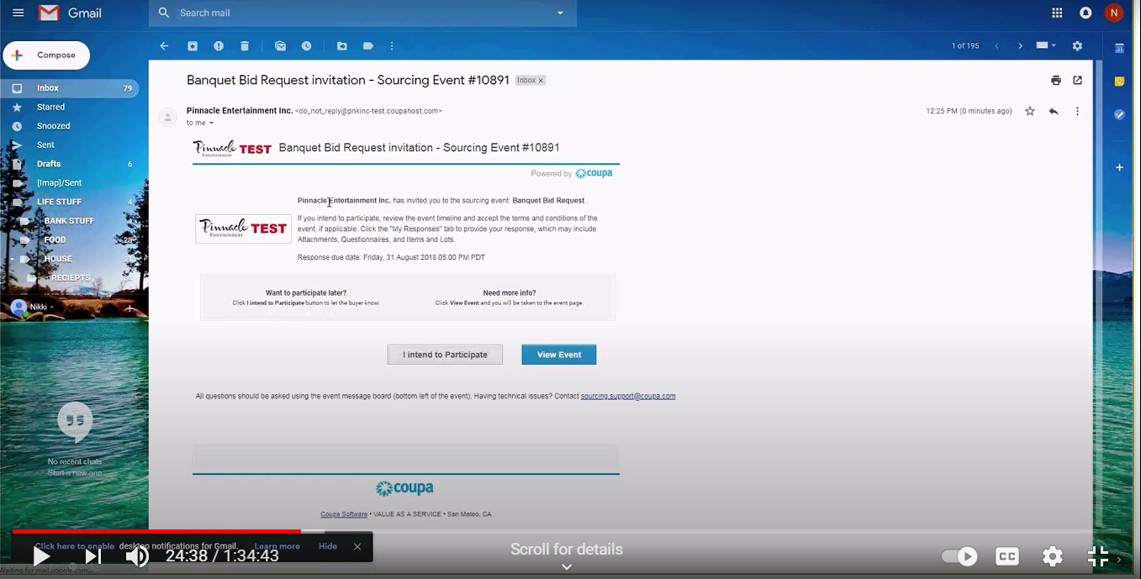

* After Choosing the View Event option Vendor will be directed to Vendor portal with this

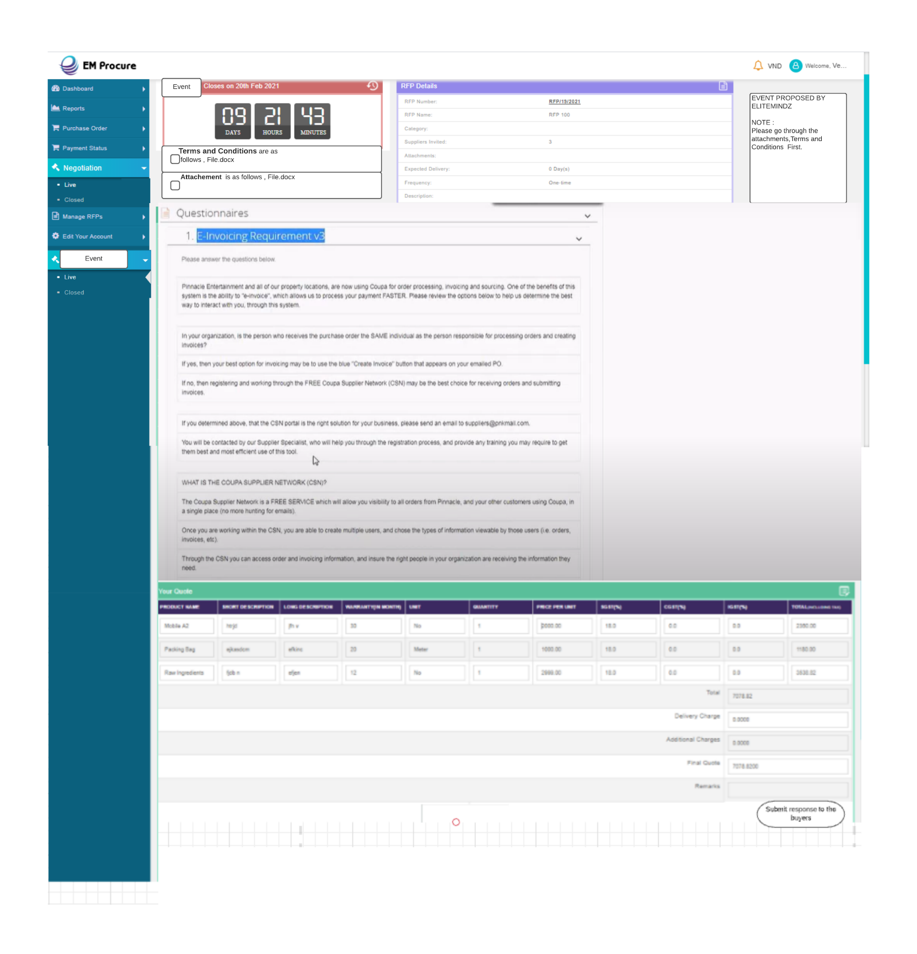

* After agreeing to the check boxes Vendor can participate in the Event (also the countdown will be mentioned in the portal)
* Now vendor can do the quoting till the countdown ends.

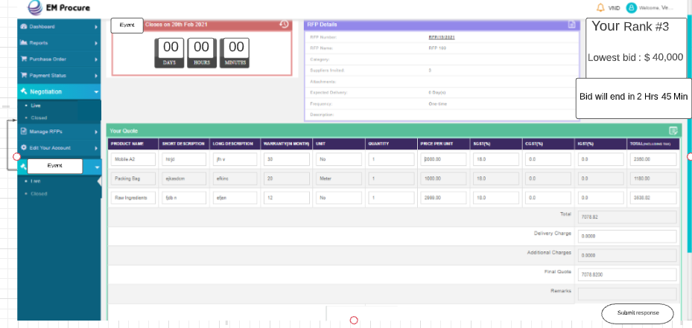

Closed Event tab on Vendor Portal

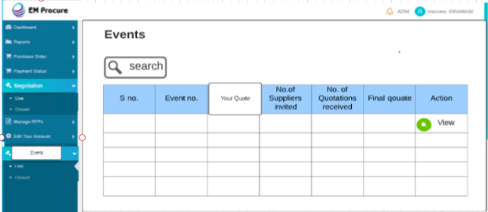

Then in a statement which Indicates Live E Auctioning will be done in the Vendor Portal in Event Module

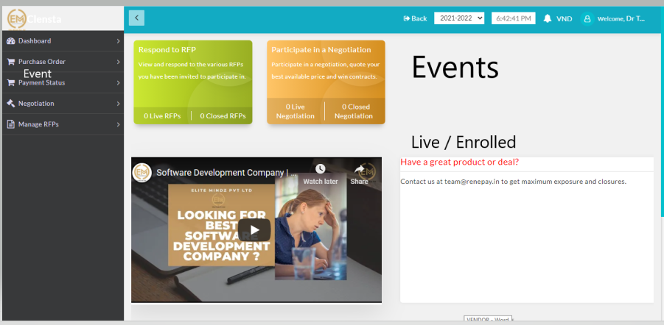

Live – Directed through Email button

Enrolled; Past Event Details in which he participated

* Vendor will be having 24 hrs.(configurable) to change the biding according and will be having real time track of other Vendors Track

Responses

