May 13, 2019

Valerie Saunders

Data Analysis Info 640

Professor McSweeney

How Safe Are Our City Parks Today?

Abstract

For residents of New York City in the 1980s and 1990s, it was widely believed that city parks were places of danger and illicit behavior. That theme has stubbornly remained embedded in the public consciousness up to this day, even as city crime rates have fallen sharply. This research project uses NYPD crime complaints data for 2014-2018 to analyze crime rates and trends for two Brooklyn neighborhood parks compared to the crime rates and trends for the precincts directly surrounding the two parks. An analysis of how many crimes have occurred relative to the populations of these areas show that fear of victimization in these parks has little statistical basis in fact. Prospect Park and Fort Greene Park were opened in the 19th Century in Brooklyn to bring nature, beauty, and refuge to its growing number of residents. The data here indicates that this mission is largely being fulfilled and may help overcome unfavorable and outdated belief systems that prevent some New Yorkers from enjoying the city’s green spaces.

Borough of Brooklyn: Parks and Historic Context

For residents of New York City in the 1980s and 1990s, it was understood that city parks were places of danger and illicit behavior. The common belief was if you went there at night you were likely inviting trouble, or worse. That theme has stubbornly remained embedded in the public consciousness up to this day, particularly among older generations of New Yorkers. As a resident of the Grand Army Plaza area, I regularly see joggers and dog owners heading to the park for a run or walk at night. Male or female, together or alone, summer or winter, there are consistently individuals who choose to enjoy the park after hours, and presumably feel safe doing so. Statistically speaking, how big is the risk?

Prospect Park was designed by Frederick Law Olmsted and Calvert Vaux at the direction of the then Brooklyn Parks Commissioner, James T. Stranahan, and opened to the public in 1867. As the population in Brooklyn steadily grew and Manhattan’s Central Park had been recently completed by the same designers, Stranahan proposed a park for Brooklyn that “would become a favorite resort for all classes of our community, enabling thousands to enjoy pure air, with healthful exercise, at all seasons of the year.” (Prospect Park Alliance) The park encompasses 585 acres of trails, water features, forests, and open green spaces, as well as man-made features including the carousel, bandshell, zoo, and the LeFrak skating center. Prospect Park is adjacent to five police precincts (70, 71, 72, 77 and is assigned to 78). The park has begun to collect sensor data on park visitor usage, but the specific numbers of people entering Prospect Park every day are not yet available. Sue Donoghue, President of the Prospect Park Alliance, estimates 10 million visitors passed through the park in 2018, up from 9 million estimated in 2010, and just 2 million in 1980. (Fahim, 2010)

A much smaller, but also historically significant neighborhood green space is Fort Greene Park, located in precinct 88. Fort Greene Park was the very first park designated in Brooklyn, in 1847. It encompasses 30 acres in the Fort Greene neighborhood, close to downtown Brooklyn. Olmsted and Vaux brought a fresh re-design to this park 20 years after it was initially created, in 1867, around the same time as the opening of Prospect Park (Fort Greene Park Conservancy). Both parks are in populous, diverse areas of the borough and their development was promoted as a haven and fresh escape for the “common man” to find relief from the urban throng. (Colley, 2013, p35) At the time, Brooklyn was culturally bereft and considered the uncivilized cousin to Manhattan. Stranahan and Walt Whitman were instrumental in pressing for Prospect Park and Fort Greene Park, respectively, to bring progress and a higher quality of life to the borough’s residents. (Colley, p43) Olmsted and Vaux’s thoughtful and stunning designs for these public spaces cemented their importance in Brooklyn’s growth and history.

New York has become a safer city over the past 20 years by nearly every available public measure. Murders peaked in 1990 at 2,245 citywide. In 2018 that number fell almost 90% to just 287 (Mustian, 2018). All major crime categories have fallen over this period (Kaufman, 2017). It is reasonable, therefore, to expect crime rates in New York’s parks to align with this trend. However, large parks create different opportunities for bad actors than other, more tightly observed areas of urban neighborhoods. Drilling down into the data reveals how our parks and park populations are evolving.

If we look at felony and misdemeanor crime rates over time in Prospect Park and Fort Greene Park and compare these rates to the individual crime trends in each neighborhood directly surrounding the parks, may we discern any meaningful differences? Is a city park still a dark and dangerous terrain when compared to nearby streets? Whether the answer is “yes” or “no” provides a basis for evaluating a common public space whose purpose is to serve many residents from very diverse circumstances. Overall city crime trends are known to have fallen consistently since 1990, but individual precincts may show different levels and rates of change and may not correlate to the overall city data each year. The investigation for this study looks specifically at the 5 most recent years of crime complaint data: 2014-2018 to determine crime rates for the areas listed above. Is it possible that going for a run in the park after dark in 2019 may be safer than a run after dark in your neighborhood streets (statistically speaking)?

Examining data about crime in the park may give us a springboard from which to consider our commitment to nurturing a healthy and safe common, natural, and neutral space accessible to all Brooklyn residents. The 19th Century parks design team set noble goals for these parks. “Magnificent” parks were central to the re-envisioning of Brooklyn for the promotion of “health, strength, comfort, morality and future wealth of the city” of Brooklyn. (Colley, p43) A case can be made to prioritize this rare refuge through further funding, support, or even expansion of additional green spaces. Residents from increasingly divergent economic realities rely on public parks for exercise, games, fresh air, and improved life quality. We may use current data to analyze how we are doing as a city to uphold our green space aspirations, and to determine whether a midnight jog is advised.

Data Analysis Methods

NYPD Crime Complaint data is open and available to the public. Every reported crime is catalogued in this data set. However, we must keep in mind that not all crimes are reported. I will refer to “crimes” and “crime rates” here, with the understanding that all data is purely from what has been officially recorded by the NYPD. The variables included in the NYPD Complaints of concern here are: date, time, crime level (violation, misdemeanor, felony), precinct of occurrence, park name (if applicable). I performed all analysis using R programming language.

The NYPD started separating park crimes from their related precincts in 2014 to better track offenses in a consistent fashion. This enables greater accuracy in my study to isolate park crimes from other precinct crimes. Therefore, the analysis of this data will filter for years 2014-2018. Crime complaints are continually added to the available data. There are two datasets: historical and current. Complaints for 2018 are included in the “current” dataset. The “historic” set includes 2017 complaints and earlier. There are 35 variables in the data, but for this research we only need CMPLNT_FR_DT (Date offense occurred), CMPLT_FR_TM (Time offense occurred), ADDR_PCT_CD (Precinct number), LAW_CAT_CD (Level of crime: Felony, Misdemeanor, Violation), OFNS_DESC (Description of offense), PARKS_NM (Park name).

I include data analysis of Prospect Park and its adjacent precincts: 70, 71, 72, 77, 78, and Fort Greene Park and its surrounding precinct 88. This sample can give us an idea of crime rates as they relate to population size, geographic square area coverage, and two different, but similarly neighborhood-focused parks. Crime numbers should be examined as raw numbers to understand the scope, and within the context of population for each area. In order to analyze the rates for the parks, we will use estimated annual visitor populations, divided by 365 days, to provide an average daily population number for each park. Prospect Park’s annual visitors are estimated at 10 million, Fort Greene Park is estimated at 1 million.

Precincts have specific residential population counts. However, precincts are not a traditional measure in the census counts. Therefore, using 2010 Census block data with a key which identifies the dedicated precinct for every city block, we may calculate the number of people living in each precinct. In most cases, whole census blocks belong to one precinct. However, there are a few instances where one census block is split between two precincts. This is the case for the 78th precinct. When doing calculations, the blocks which are shared between two precincts get counted twice in this dataset—the total block population is attributed to each

precinct that the block belongs to. The total number of people involved in this

case is 56. Therefore, cut that number in half (by 28 people) and subtract it

from the total for the 78th. The other half of those 56 residents are being attributed

to other precincts that are not being studied here. (Keefe, 2011) The numbers studied here are based on 2010 data and population is almost certainly higher by 2018 due to the enormous amount of development in Brooklyn over the last 10 years. Greater population size would mean that the actual current crime rate is lower than the calculations show.

In order to create side-by-side comparisons, each park is separated as its own precinct in this study. Prospect Park will be 78PP and Fort Greene Park will be FGP88, and calculations for crime rates will be normalized to calculate rates that incorporate population size for each precinct area (including the “park precincts” with their visitor numbers).

After merging the current and historic crime complaint datasets, we filter for the years 2014-2018 and replace “NA” values in the Parks_NM column with “NotPark.” NA values can disrupt the data analysis. There are no null values in the set other than for the PARKS_NM variable. Acreage for the precincts can be calculated using QGIS. Precinct shapefiles are imported, and square area is calculated in the data table within NY State Plane projection. At this point we create a new CSV with precincts and parks as observations, and area and population as variables. The acres of each park are subtracted from the acres of its precinct. Prospect Park is 585 acres and Fort Greene Park is 30 acres.

Crime “levels” are an important factor for this study. Felony crimes are the most serious category and include violent crimes such as assault, murder, and rape, as well as grand larceny (thefts of property exceeding a value of $1000). Misdemeanors include damaging property, non-violent harassment, disorderly conduct, and theft of property valued at less than $1000. Violations include littering, open containers of alcohol, and noise complaints. (Bureau of Justice Statistics) I have decided to analyze felonies and misdemeanors only, therefore I filter out violation complaints.

In most of the analyses, I group by crime level and facet by precinct in order to compare raw numbers, means, and rates of crimes reported. Grouping observations by month and by year allows us to examine trends over time from 2014-2018, and trends for months within the year when crimes have spiked. Dividing the number of crimes over a specified time frame and then dividing by precinct populations gives us the crime rates for each area. We multiply this rate by 1000 to get the number of crimes per 1000 people. Dividing the number of crimes by each precinct’s acres, give us the rate per geographic acre for each precinct.

I also develop a risk profile for each park: which months are statistically safest, and which hours of the day/night have been historically safest. Grouping the data by hour over five years for each park, we can see the sum of all crimes reported during each 1-hour slot. Plotting this shows which hours have historically had the most crime activity. Grouping the data by month over five years for each park, we can see the sum of all crimes per month for five years. Plotting this gives us a visualization that shows crime rises during warmer summer months in the parks.

Qualitative data for crime descriptions will also be shared to understand what crimes are most often committed in the parks, and whether they are felonies or misdemeanors. I looked specifically at “Murder” first, filtering for the word in the description variable, grouping by year, and faceting by precinct. To find the top 5 crime descriptions for each park I filtered by precinct name 78PP and 88FGP, grouped the data by description, and ordered them by highest count first. This provides the total for each crime description for the five years, for each park.

These measures must be analyzed with the understanding that the data is historic and observational, not predictive. (Links for data and list of specific steps are in Appendix 1)

Brooklyn Precincts and parks for this research project:

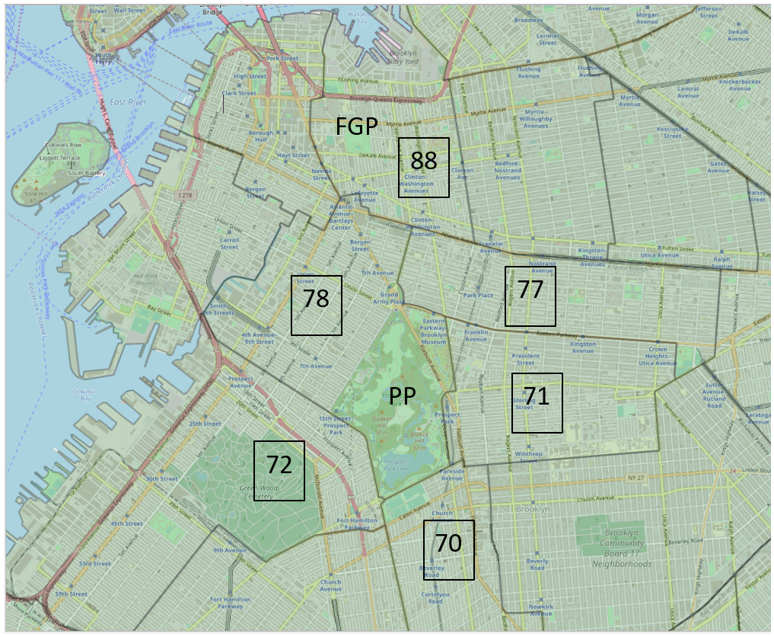

Prospect Park and Fort Greene Park are circled in the map above, precincts are labeled by number.

We are studying: PP, 70,71,72,77,78 and FGP, 88

Crime Complaints Results

A look at raw numbers, averages and trends

Raw Numbers

An initial look at the data of crimes shows that there are many more crimes in the precincts than in the parks. Separating by crime level, indicates that misdemeanors are the most frequently occurring offenses over the 5-year span. Crimes are aggregated by date and plotted here.

A look at each precinct showed a similar composition as Precinct 72 (below). Upper limits for felonies range 12-15 in one day, misdemeanors 16-20.

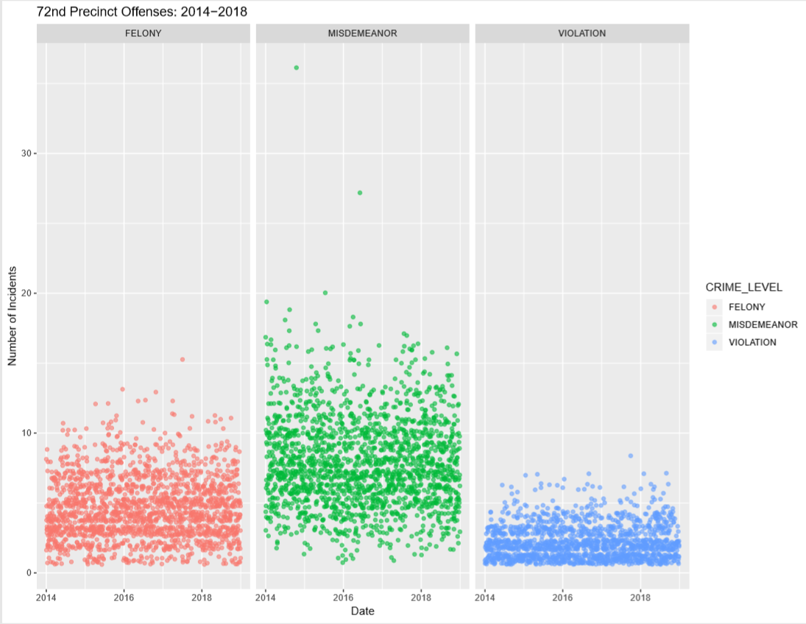

The raw numbers of crime complaints for Prospect Park and Fort Greene Park are smaller and less consistent. Maximums for the parks show 3-5 incidents in one day, and many dates with no incidents.

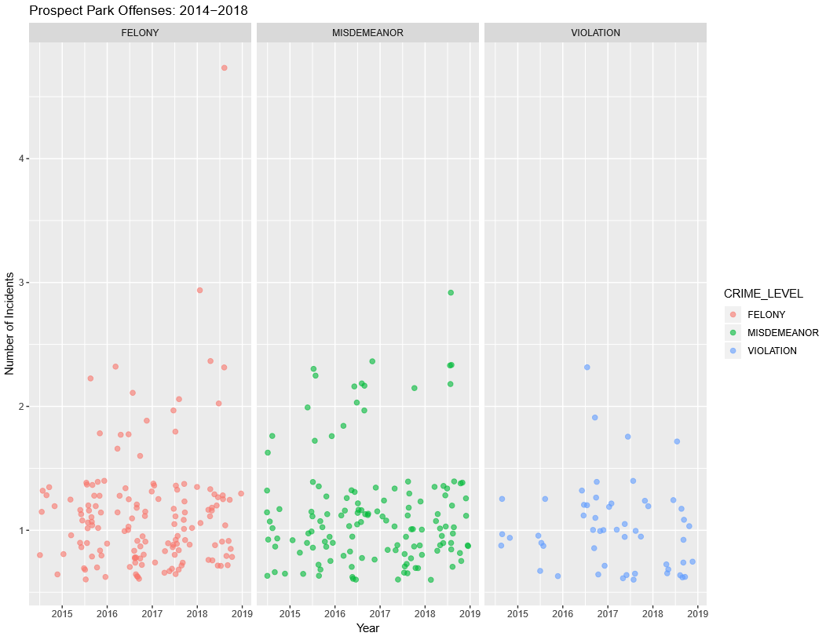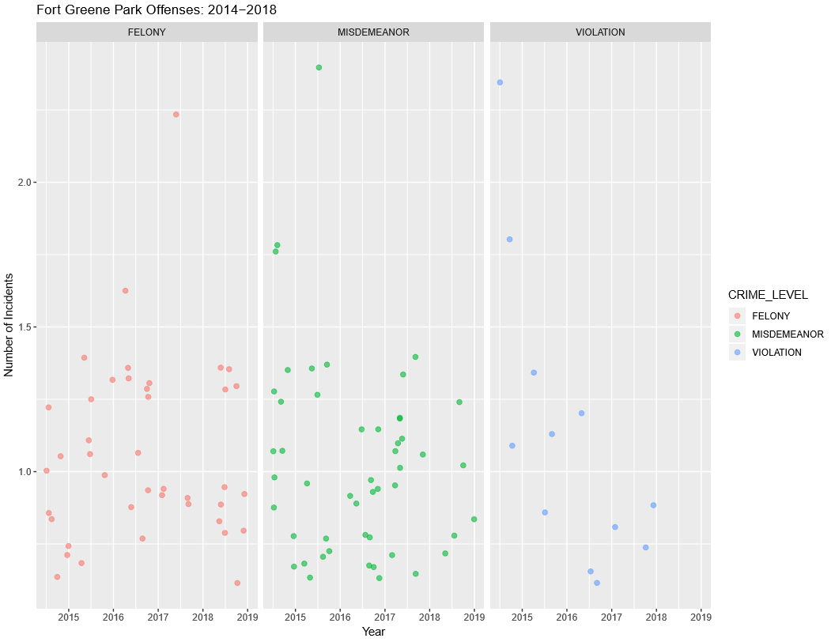

The monthly sums shown over 5 years are exhibited in the graph below. The parks have so many fewer crimes that it is hard to compare them with the precincts in one visualization.

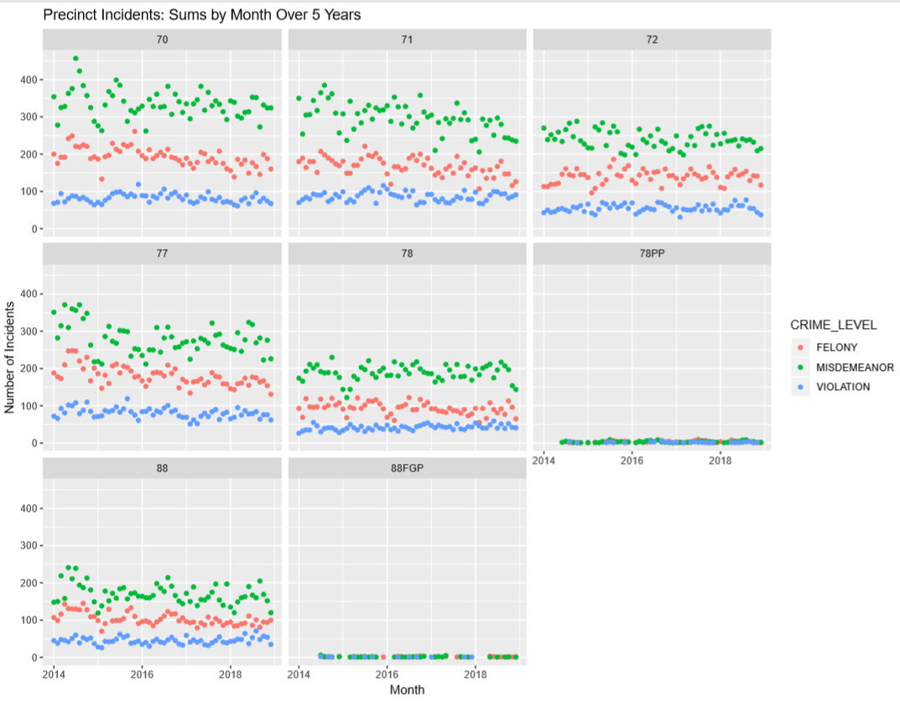

Averages

Average number of crimes per month for the non-park precincts:

A decision was made here to focus on more serious felonies and misdemeanors, and stop tracking the violations, to keep efforts trained on the most significant crime offenses.

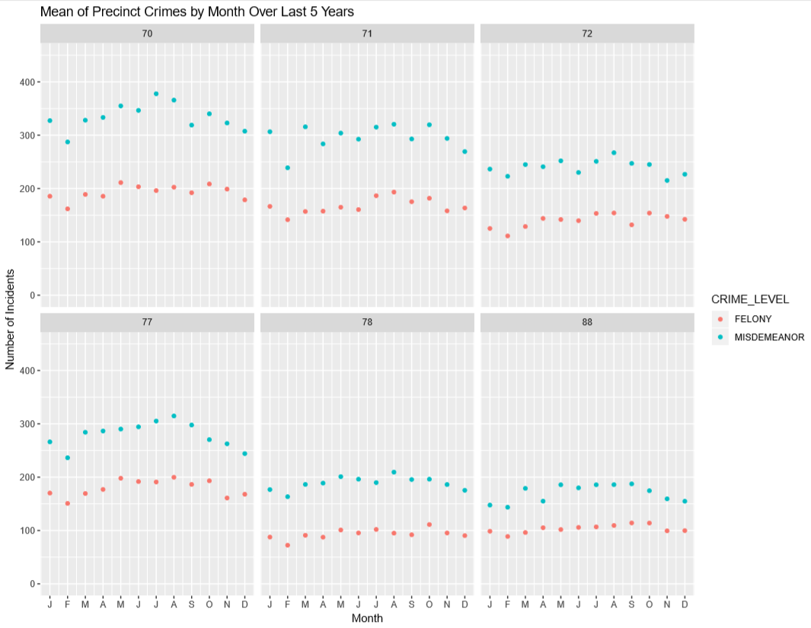

Average number of crimes by month for the parks:

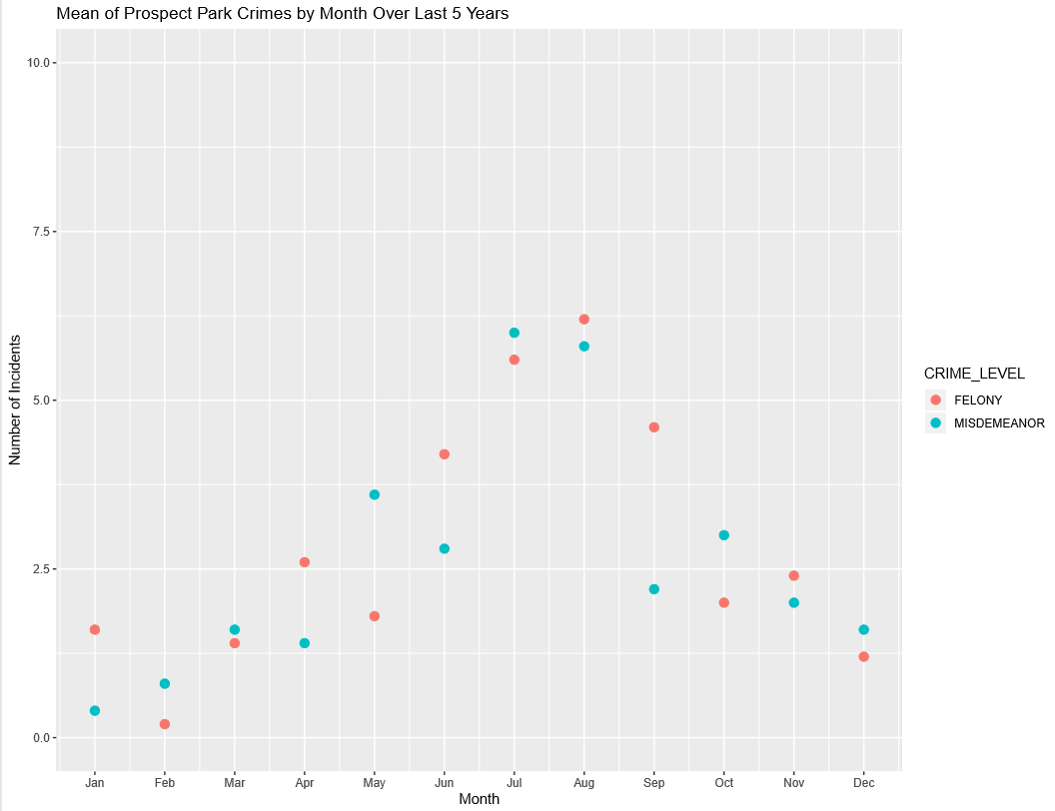 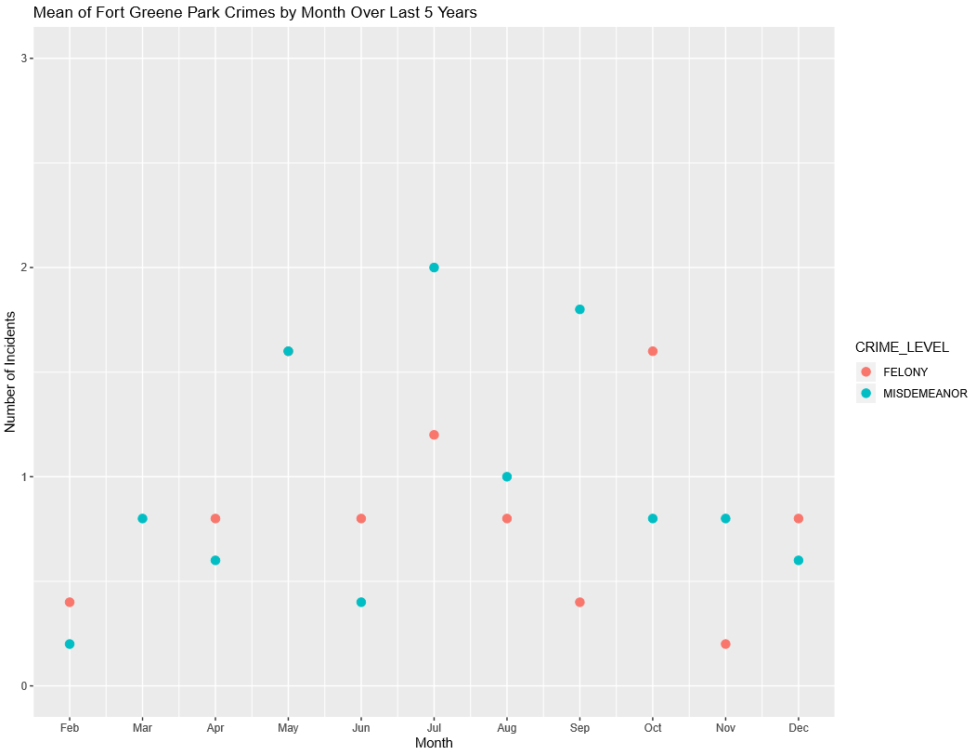

The averages in the parks peak during summer months but the mean is fewer than ten per month even in August, far lower than the averages in the precincts, which are in the hundreds.

Trends year over year:

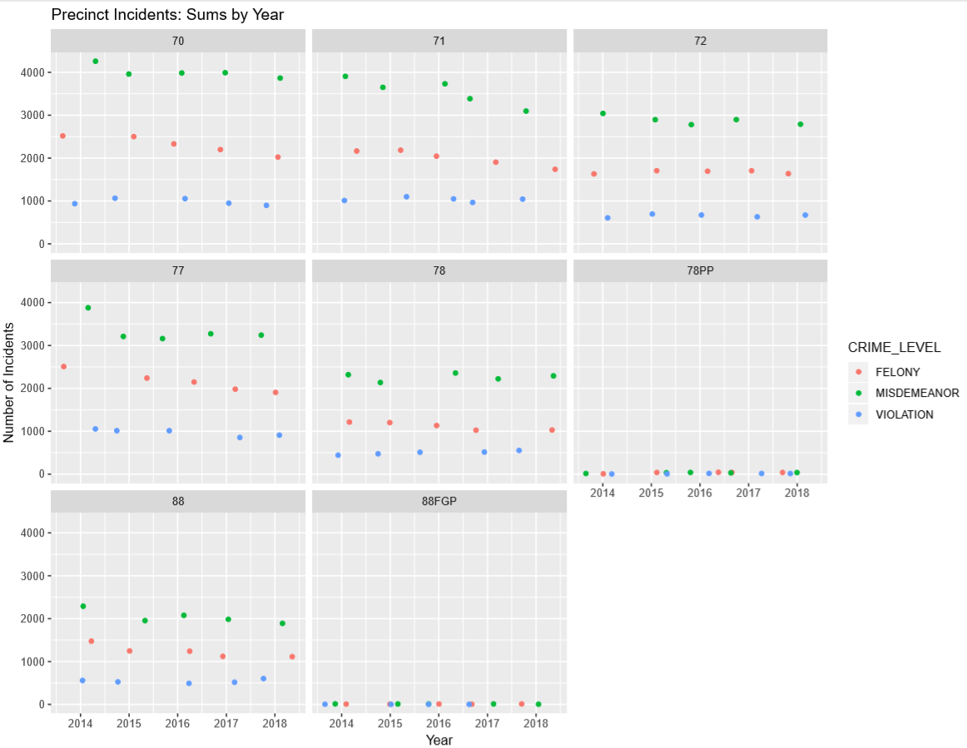

Precincts are showing mostly downward crime trends over time for felonies and misdemeanors with the 72nd and 78th closer to flat. Again, because the raw numbers are so much lower for the parks, we will look at them separately below.

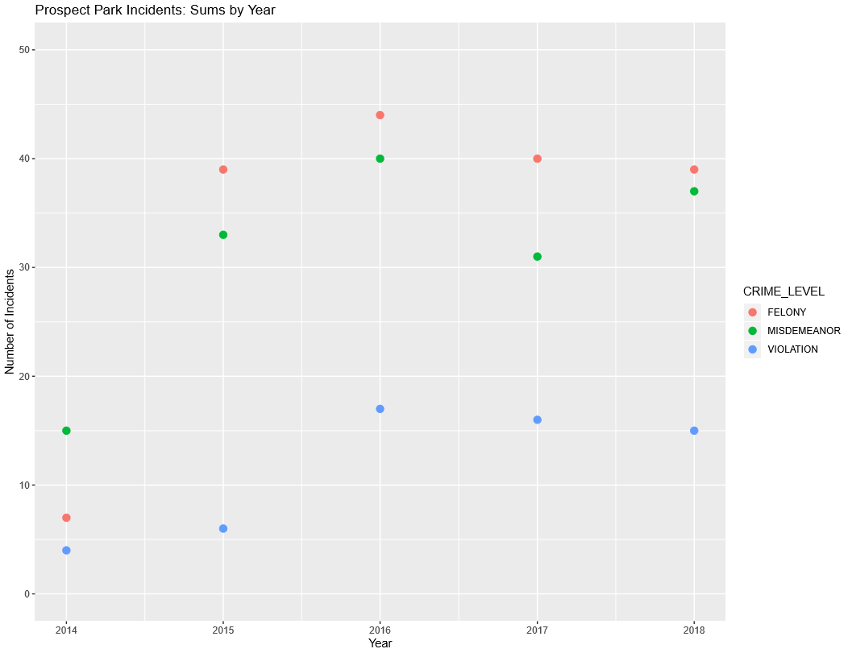 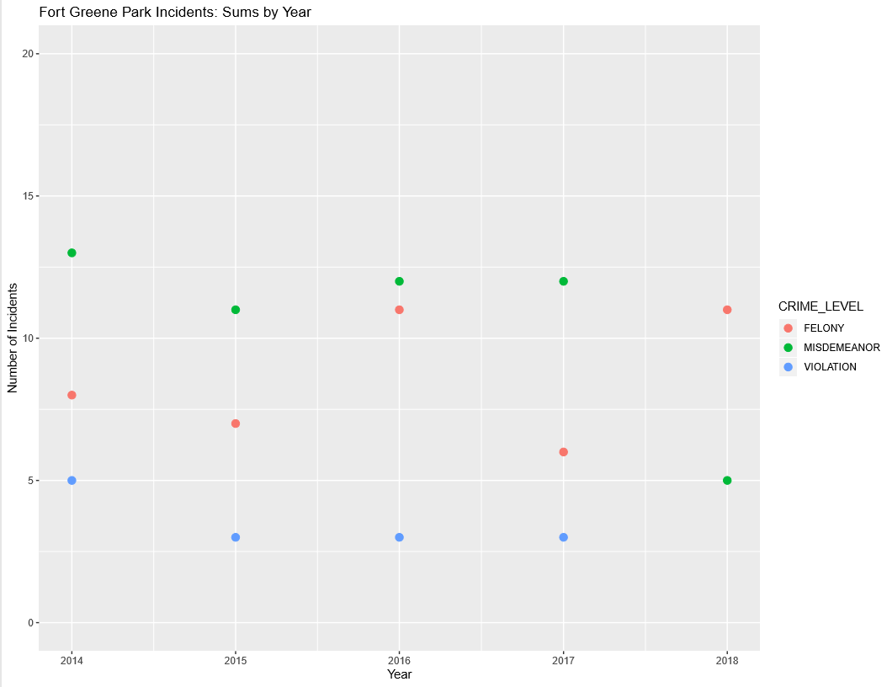

It is hard to decipher a trend for the parks. There simply may not be enough data.

In order to understand the crime complaints in context and to accurately compare the precincts, we must calculate crime rates that use population size to normalize the data.

|  |  |  |  |
| --- | --- | --- | --- |
| Precinct | Population | Acreage | Density (people per acre) |
| 70th | 160,664 | 1887 | 85 |
| 72nd | 126,230 | 2402 | 53 |
| 71st | 98,429 | 1041 | 95 |
| 77th | 96,309 | 979 | 98 |
| 78th | 61,071 | 969 | 63 |
| 88th | 51,421 | 943 | 55 |
| 78PP | 27,397 | 585 | 47 |
| 88FGP | 2,740 | 30 | 91 |

Crime rates are calculated based on the population of each area, in this case the population of each precinct (sociologyindex.com). Population density is not used in calculating crime rates but can be studied separately to see how density affects crime rates (Steinmetz, 2016). For this study we will base our conclusions on rates by population size (per 1,000 people) and will include rate by square area as an additional metric to compare the parks with the precincts.

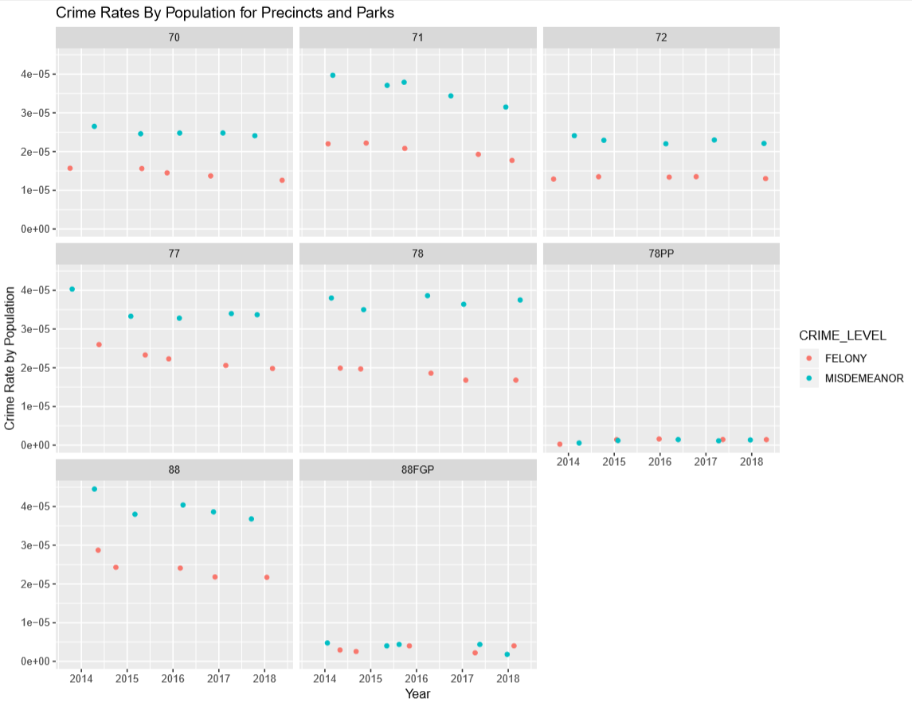

Precinct (non-parks) upper limits: .00004

The below graphs show the parks alone to better see their rates and trends.

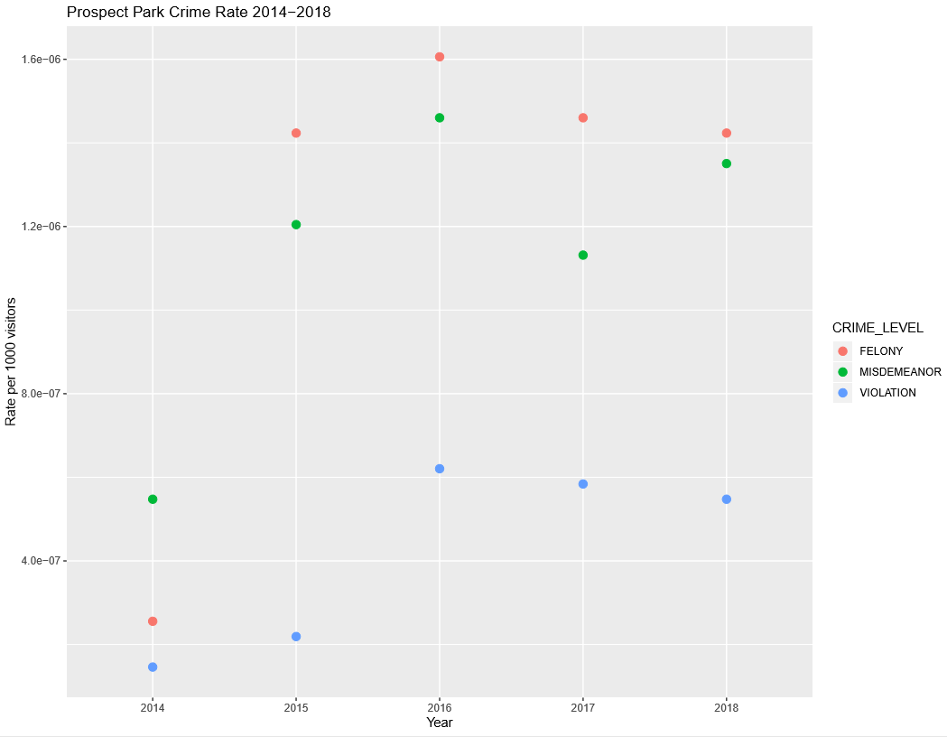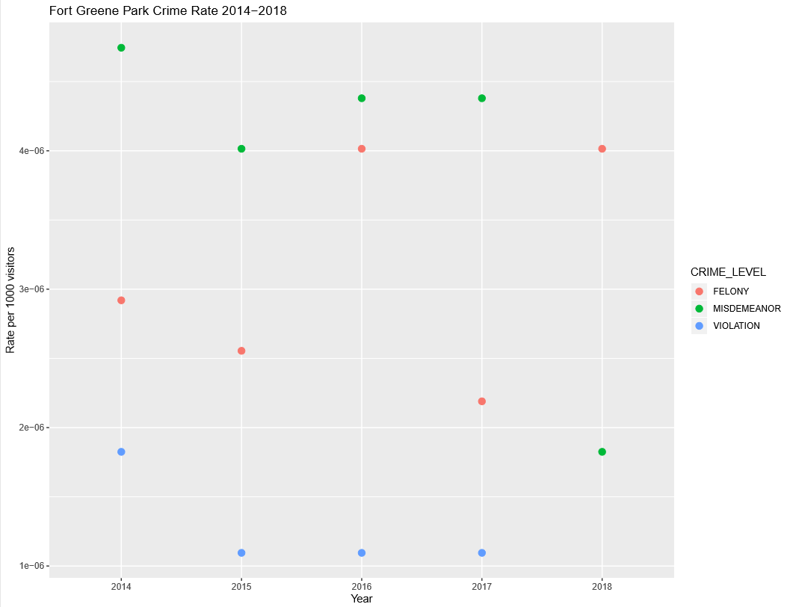

PP upper limits: .0000016 FGP upper limits: .000005

The crime rates for the parks don’t show a clear trend up or down over the five years, but the rates are much lower than what was calculated in the non-park precincts.

Crime rates by acreage for each precinct and park:

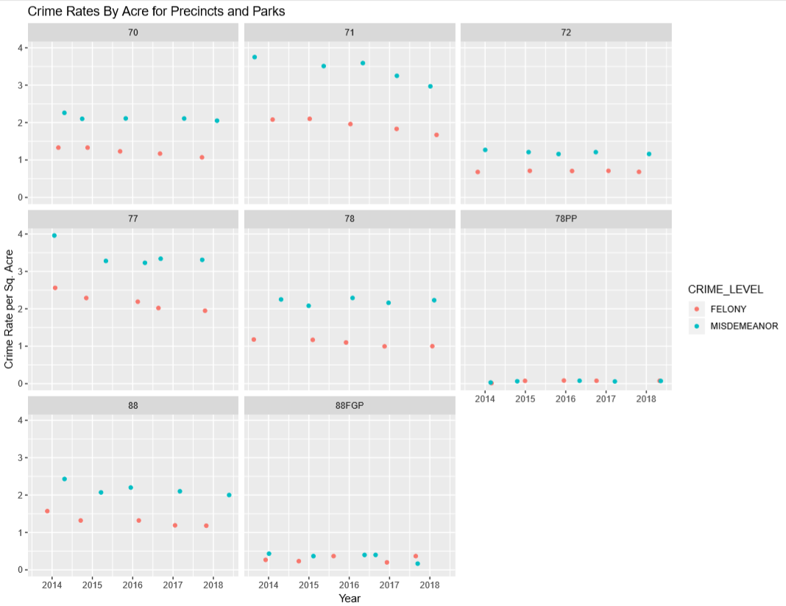

The points here indicate how many crimes occurred per acre for each year.

Based on geographic square area, the crime rates for the parks is much lower than for the surrounding precincts. The 77th precinct, for example, shows an average of 3-4 misdemeanors per acre for each year of the study. Fort Greene Park shows fewer than .5 misdemeanors per acre over the same years, and Prospect Park hovers just above the 0 mark.

Creating a Risk Profile for the Parks

Because of the available date and time data in our crime complaints, we may also develop a risk profile for when the parks are safest and least safe, based on months of the year and times of day. Although this data is observational and not predictive, we could base recommendations on past experiences. Adding up all crimes for each crime level over these time increments, we can see when criminal activity has been most prevalent. I am only interested in this analysis for the parks, not the precincts, as we imagine our lone jogger heading into the park.

Prospect Park by month, sum totals over five years:

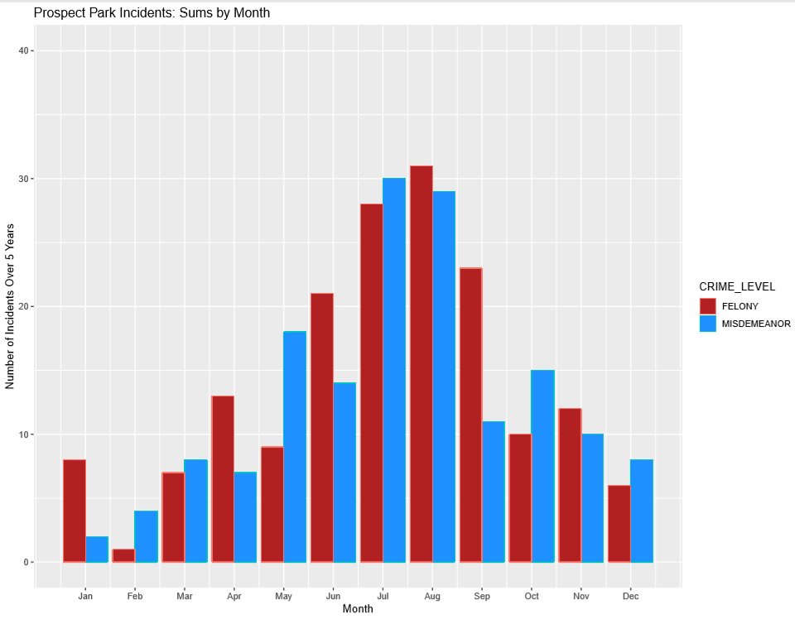

Prospect Park shows a clear uptick in crimes during the summer months, particularly July and August. February is historically the safest.

Prospect Park by hour:

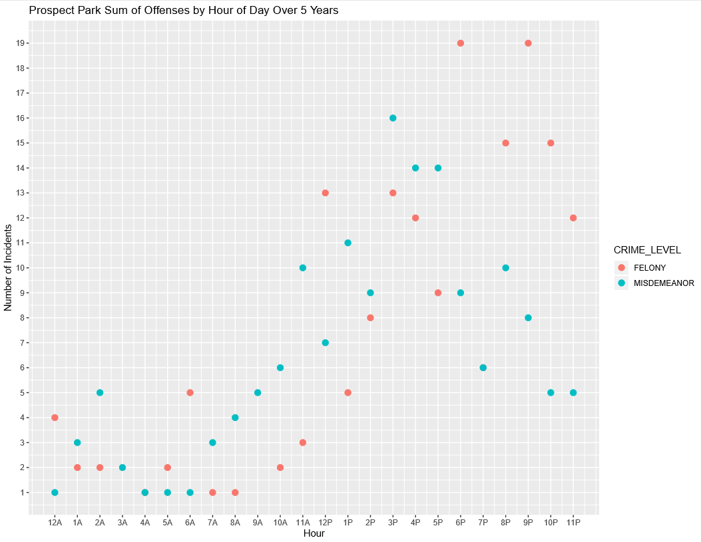

While there are no hours that reflect zero crime activity in Prospect Park over the last five years, the morning hours show low crime numbers up until 11:00AM. The 9:00-10:00AM and 7:00-8:00PM show no felonies. Interestingly, the 7:00-8:00PM slot has a history of only 6 total offenses reported over the five years. Aside from that hour, the afternoon and evening hours have the most offenses, dropping off at midnight.

Fort Greene Park by month:

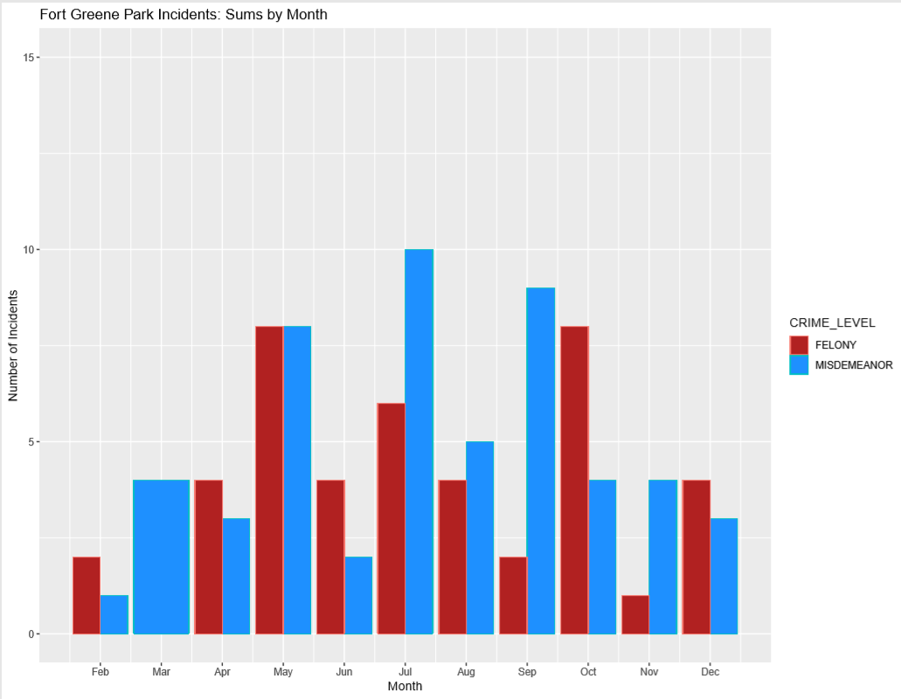

Fort Greene Park may not have enough incidents to decipher a pattern, but we can still offer some take-aways. There have been no reported misdemeanors or felonies in January over the past five years and February has had a total of only three crimes reported over the same years. Warmer months bring more trouble with May, July, September, and October seeing the most criminal activity.

Fort Greene Park by hour:

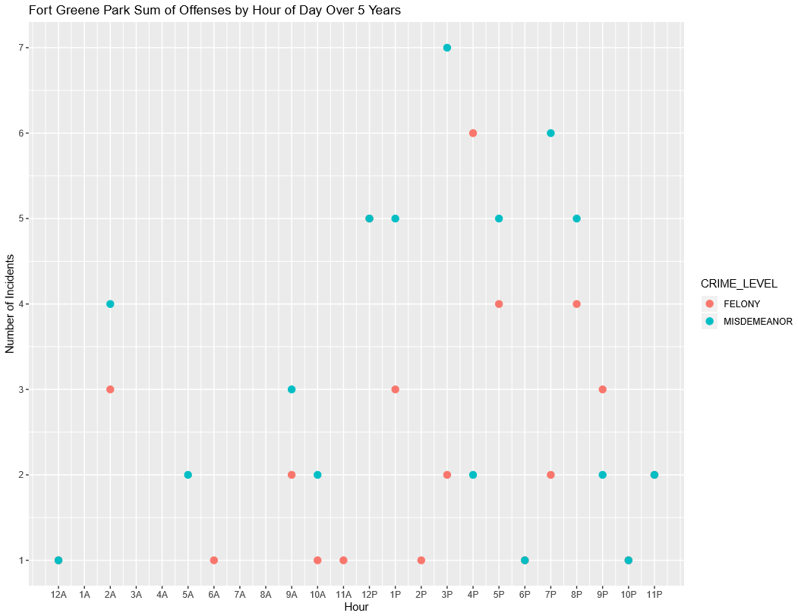

Overnight there are several hours that have been crime-free (1:00AM-2:00AM, 3:00AM-5:00AM). More reasonable, 6:00-7:00AM has only had one reported crime in five years and the hours of 7:00-9:00AM have seen no reported crimes over the past five years. 2:00-3:00PM and 6:00-7:00PM have had a total of just one crime reported over the same five years.

Considering the most serious and punishable crime: Murder

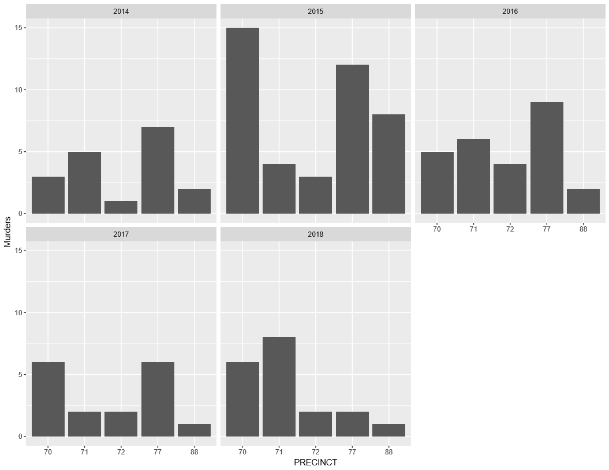

There were no murders in either park for the last five years.

What crime descriptions were most often perpetrated in our data over the last five years?

Prospect Park

Prospect Park 2014-2018 Top 5 Crime Categories by Description:

Grand Larceny (Felony): 69

Petit Larceny (Misdemeanor): 61

Robbery (Felony): 53

Assault 3 (Misdemeanor): 47

Felony Assault (Felony): 28

Fort Greene Park

Fort Greene Park 2014-2018 Top 5 Crime Categories by Description:

Grand Larceny (Felony): 16

Assault 3 (Misdemeanor): 16

Dangerous Drugs (Misdemeanor): 12

Robbery (Felony): 11

Petit Larceny (Misdemeanor): 9

Discussion

The initial look at raw crime numbers for the precincts and parks reveals that there are more misdemeanors than felonies or violations recorded. The precincts experience thousands of incidents per year, whereas the parks are in the low hundreds. We can quickly see that there is higher volume of criminal activity in the precincts compared to the parks. In terms of raw numbers, the 77th precinct has almost 100 times the number of incidents as Prospect Park when we look at annual sums.

After these initial looks at the data, I decided to focus on Felonies and Misdemeanors, dropping observations of the less serious Violations. Perceptions of personal safety would likely be more closely tied to the higher-level offenses. This helps to limit distraction in the analysis phase. In most precincts the crime complaints for felonies and misdemeanors appear to be trending lower over the five years from 2014 to 2018. The trend in the parks crimes is not clear. Particularly in the case of Fort Greene Park, the volume is so low, that there may not be enough data present to make a meaningful deduction about the trends.

In our first set of graphs showing raw numbers of crime complaints, the 70th and 71st precincts show the highest numbers. However, once we normalize to account for the greater populations of these precincts, the 78th and 88th precincts exhibit the higher crime *rates* per resident. This illustrates the importance of normalizing our data to accurately match up data measurements. These crime rates are based on fixed population numbers for all years, based on the 2010 Census data, calculated per 1,000 people. Most of the precincts show declining crime rates over the five-year period. They all show a decline from the year 2014 compared to 2018, but the trend line for some precincts is not a straight year over year decline. Specifically, the 78th (Park Slope) and 72nd (Windsor Terrace and some of Sunset Park) show little change over the time period, though slightly down overall.

The large amount of real estate development in many Brooklyn neighborhoods would suggest that the population is currently larger than it was in 2010. Therefore, the crime trends will almost certainly show a sharper decline when we can apply new, more accurate population totals to these calculations. For the purpose of comparing park crime rates with surrounding precinct rates, the parks show a far lower rate for felonies and misdemeanors, even though the trendline is less decipherable. Just as there are more people living in the precincts, this would lead to more of those people using the parks. We use the flat visitor estimate numbers for all five years, but those totals have probably increased from 2014 to 2018. We don’t know how accurate our population numbers for the parks are, based on the estimates provided. We know that many more people use the park in the summer than the winter, so population numbers are not as consistent in the parks as in the precincts where residents sleep every night. But with the dispersion of crimes as great as it is between parks and precincts, I am comfortable that with even months of fewer visitors, the crime rate would still be lower for the parks than the surrounding areas.

The 71st and 77th precincts have the highest population density, which would accurately lead us to predict that those precincts have more crimes per square acre than the other precincts. Fort Greene Park, based on our visitor estimate population, has the third highest population density. However, the park still shows a much lower crime rate than all other areas except for Prospect Park. Based on the geographic square area data analyzed, I can conclude that the parks are statistically safer than the surrounding precincts.

The goal for looking at monthly averages was to identify which months were safer or less safe in the parks. The data clearly reflects what we might expect. There is more criminal activity during the summer. More Brooklynites will be in the parks during warm summer months. I also averaged monthly crimes for the precincts and there are not the same spikes over the summer months. Winter is a bit less active for criminal activity, but the pattern is not meaningful for this study when we compare it to the parks. Again, the monthly averages, like the yearly averages, is far greater for the precincts. Seeing that winter is so much quieter could be an endorsement for running in the park during colder months. February shows the lowest crime numbers in both parks. Even in March and April in Prospect Park, the total sum of crimes for each month over five years is fewer than 20. That means an average of just 4 crimes occurring per March or April for felonies plus misdemeanors. That number is between 60-100 for the surrounding precincts in the same months.

I did not analyze time of day for offenses in the precincts. As far as the parks, criminal activity is lightest in the morning. Between 6:00AM and 11:00AM in Prospect Park, no 1-hour time slot has had more than ten total crimes committed (sum of felonies and misdemeanors). Fort Greene Park has only reported one crime over the 5 years between 6:00AM and 9:00AM, only one crime between 2:00-3:00PM over five years, and just two crimes from 6:00-7:00PM.

The most dangerous times of day in Prospect Park are 3:00-7:00PM and 8:00-10:00PM, as far as total number of crimes committed for the five years. The most felonies in Fort Greene Park have occurred at 4:00-5:00PM for a total of 6 over five years.

Understanding the types of crimes happening in the parks and precincts may help us establish a more detailed understanding of what is going on so that we can recognize the most pressing risks and determine whether our fears are grounded. Felony assault drives much of the fear for New Yorkers. When we look at some of the high-profile crimes that have occurred in the city’s parks, the case of the Central Park jogger assault comes to mind. A gruesome description of a gang rape and beating captured the imagination for many New Yorkers with sensational headlines and a jury trial. The testimony turned out to be coerced and wrongful convictions were assessed in a very dark chapter for NYC history. The crime occurred in 1989 and the record was not corrected until 2014 (Weiser, 2014). One man is guilty of the terrible assault, but for 25 years New Yorkers stewed in the memories of an even more horrific (and false) description that added to collective fears about urban parks.

Violent crimes such as murder, rape, and felony assault have great costs for victims. Physical injuries can be devastating and long-lasting. The psychological trauma associated with violence often has even more serious long-term consequences and costs than the physical repercussions, with no guarantee that quality of life can get back to the pre-assault level (Miller, Cohen, and Rossman 1993). It is this emotional trauma that stirs fears for New Yorkers. For those who remember more violent times in the city, there is every impulse to avoid the risk.

Filtering the data for murder incidents in our areas of interest, we find that no murders have occurred in either of the parks, but each precinct has reported at least one murder each of the years. Most crimes that have occurred in the two parks involve stealing property. Larceny is stealing where the property-owner is unaware of the theft at the time of the occurrence (ie pickpocketing, car theft, stealing personal property when the owner is distracted or asleep). Larceny does not generate the same level of fear as robbery, which involves confrontation and intimidation by the perpetrator on the victim. Over one-third of all crimes in Prospect Park over the last five years are in the larceny category.

In Prospect Park there have been an average of just over five felony assaults per year. When we consider our estimate of 10 million people flowing through the park in a year, this makes the probability of experiencing this category of violent crime very low for any one person. There are considerably more “Assault 3” charges which is a misdemeanor. Assault 3 includes shoving someone or kicking someone where physical harm is minimal (CriminalDefenseLawyer.com). Serious beatings are in the felony category. When we examine the data as we have done here, our faith may be restored to align with the original purpose for developing and designing the parks.

Looking to next steps in this research project, the 2020 census data will be available in the next 3 years. This will give updated population numbers for the precincts, allowing for greater accuracy in crime rates and trends. Prospect Park is beginning to collect sensor data for visitors which can potentially allow us to get very specific about how many people are in the park during each month of the year and at certain times of the day. The biggest potential inaccuracy in this project is in the estimates of people in the park. If we can get accurate numbers, we can make our case for park safety much more compelling.

A wider examination of all significant New York parks could further our understanding of crime rates and whether parks are safer than precincts in other areas of Brooklyn and in other boroughs. To make a comprehensive evaluation of park safety for the city we need to apply this analysis to additional neighborhoods. As time marches on we will have access to more years of data for Prospect Park and Fort Greene Park, as well as other city parks. A larger data set over more time will increase our confidence in the findings.

A large, dense city such as New York will likely never be free of crime, but we should not cling to outdated assumptions that are based in fear. Whether due to increased police presence, growing affluence, cultural shifts, or all the above, New York has made strides in meaningfully reducing crime across the city. Residents in the precincts we have examined here should enjoy their Brooklyn neighborhood parks knowing that they are relatively secure by recent historical statistical crime measures.

Appendix 1: Data and Methods

**Data**

A Precinct Map may be seen here: <https://www1.nyc.gov/site/nypd/bureaus/patrol/find-your-precinct.page>

NYPD Historic Complaint Data(2006-2017): <https://data.cityofnewyork.us/Public-Safety/NYPD-Complaint-Data-Historic/qgea-i56i>

6.04 million observations, 35 variables

NYPD Current Complaint Data(2018): <https://data.cityofnewyork.us/Public-Safety/NYPD-Complaint-Data-Current-Year-To-Date-/5uac-w243>

464,000 observations, 35 variables

Census block data including precinct number for each block, compiled from 2010 (most recent) Census Population Data by John Keefe : <https://fusiontables.google.com/DataSource?dsrcid=767562#rows:id=1>

39,149 observations, 153 variables

Precincts Blocks Key: <https://fusiontables.google.com/DataSource?dsrcid=749930>

Spreadsheet of GeoIDs for every city block with their assigned precinct number

GIS data for precinct boundary shapefile <https://data.cityofnewyork.us/Public-Safety/Police-Precincts/78dh-3ptz/data>

**Time Frame**

5 years: 2014 through 2018

**Calculations**

Calculate the crime rate from the raw crime index represented in the NYPD complaint data.

(number of offenses) / (population) X 1,000 - crime rate per 1,000 people

Calculate crime rate per square area (acre)

(number of offenses) / (acres per park/precinct) – crime rate per acre

**Methods**

1. **Find the population of each precinct.**

US Census Bureau data for population is measured by blocks and tracts, but not by precinct. Therefore, to analyze crime rates by population size, we use a [NYC_Blocks_2010CensusData_Plus_Precincts dataset](https://fusiontables.google.com/DataSource?dsrcid=767562#rows:id=1) compiled from the block data that has an additional variable column of precinct number.

We are using three variables: geoid10 (city block ID), precinct number, P001001(total population).

Using R, we read in the csv, and filter for the precincts concerned with our research question, then sum the population column for each precinct. Additionally, check for any NA values.

**Note**: In most cases, whole census blocks belong to one precinct. However, there are a few instances where one census block is split between two precincts. This is the case for the 78th precinct. When doing calculations, the blocks which are shared between two precincts get counted twice in this dataset—the total block population is attributed to each precinct that the block belongs to. The total number of people involved in this case is 56. Therefore, cut that number in half (by 28 people) and subtract it from the total for the 78th. The other half of those 56 residents are being attributed to other precincts that are not being studied here. (Keefe, 2011)

Write a new CSV with 2 variables: the precinct numbers of interest and their total populations

1. **NYPD Offense Data**

There are two CSVs of NYPD complaint data for this research. The “historic” data includes all complaints in the city from 2006-2017, the “current” data is for all complaints in 2018.

Of the 35 available variables, the following will be filtered for inclusion in this investigation:

CMPLNT_FR_DT – Date offense occurred

CMPLNT_FR_TM – Time offense occurred

ADDR_PCT_CD – Precinct number

LAW_CAT_CD – Level of crime: Felony, Misdemeanor, Violation

OFNS_DESC – Description of offense

PARKS_NM – Park name

1. **Merge historic crime data with current crime data into one dataset**
2. **Clean data with R**

Use Lubridate to store date variable as date

Filter data for the precincts we need: 70, 71, 72, 77, 78, 88

Replace empty values in PARKS_NM with “NA” then replace all NA with “NOTPARK” (counts and analysis are accurate when we have no null values)

Change variable names to understandable labels:

Date, Time, Precinct, Crime_Level, Description, Park_Name

Filter for dates 2014-2018 only

Save as CSV: crime1418.csv

1. **Filter the crime data for analysis**

Separate parks data by isolating Prospect Park and Fort Greene Park from their precincts. Give each set a precinct name: 78PP and 88FGP. Now we have 8 precincts in our data for comparison.

For Precinct 78 and 88 (the precincts that cover the two parks), filter the data where PARK NAME != PROSPECT PARK for 78th and != FORT GREENE PARK for 88th (this will remove the observations for the park crimes from their totals so that offenses are not double counted in those precincts).

1. **QGIS to measure square area of each precinct by acres**

Download shapefile, import into QGIS, open field values, create new calculated field that divides the square feet column by 43,560.

Subtract 585 acres from 78 pct (for Prospect Park), 30 acres from 88 (Fort Greene Park)

Create a new CSV of the precinct acreage for 70,71,72,77,78 and add two rows for the parks with areas.

1. **Calculations**

Join crime data to precinct population data, mutate columns to separate crimes by each precinct, crime rate by population for each precinct and (separately) crime rate per acre for parks and precincts

1. **Analysis**

Quantitative

Total crimes for each year across all precincts, separated by crime level

Total crimes for each year, grouped by crime level, faceted by precinct/park

Mean of felonies and misdemeanors for each month of the year precincts/parks

Crime rates by population for each year, grouped by crime level, for each precinct/park

Crime rates by geographic square area, grouped by crime level, for each precinct/park

Parks: Felony and misdemeanor sums by month, over five years

Count of felony and misdemeanor incidents by time of day for each park, over five years

Qualitative

Number of murders which have occurred each year for each precinct and park

Top 5 Descriptions (in counts) felonies and/or misdemeanors for each park, total over five years

Scripts and Visualizations:

R scripts available on Github [here](https://github.com/vksaunders/BKpctcrime).

<https://github.com/vksaunders/BKpctcrime>

A selection of the most significant findings is visualized in a Tableau story available [here](https://public.tableau.com/profile/valerie.saunders#!/vizhome/CrimeComplaintsProspectParkSurroundingPcts/Story1?publish=yes).

<https://public.tableau.com/profile/valerie.saunders#!/vizhome/CrimeComplaintsProspectParkSurroundingPcts/Story1?publish=yes>

Sources:

Bureau of Justice Statistics retrieved from <https://www.bjs.gov/index.cfm?ty=tp&tid=31>

Colley, David (2013) Prospect Park: Olsted & Vaux’s Brooklyn Masterpiece. Princeton Architectural Press, New York.

Crime rate calculation retrieved from <http://www.sociologyindex.com/rate.htm>

Criminal Defense Lawyer. Criminal Law Information retrieved from <https://www.criminaldefenselawyer.com/>

Fahim, Karim (April 5, 2010) *Returning Prospect Park to the People*. The New York Times retrieved from <https://www.nytimes.com/2010/04/06/nyregion/06tupper.html>

Fletcher, Lance (2019) Grand Larceny in New York. Retrieved from <https://grandlarcenyny.com/>

Fort Greene Park Conservancy, retrieved from <https://www.fortgreenepark.org/fort-greene-park>

Kaufman, Ellie (December 28, 2017) New York City on Pace to Record Lowest Murder Tally in Decades. CNN retrieved from <https://www.cnn.com/2017/12/26/us/new-york-2017-crime-stats/index.html>

Keefe, John (2011) Sharing NYC Police Precinct Data. Retrieved from: <http://johnkeefe.net/nyc-police-precinct-and-census-data>

Miller, Ted R,, Mark A. Cohen, and Shelli B. Rossman (1993) Victim Costs of Violent Crime and Resulting Injuries. Health Affairs, Project Hope: The People-to-People Health Foundation, Inc retrieved from <https://www.healthaffairs.org/doi/full/10.1377/hlthaff.12.4.186>

Mustian, Jim (December 31, 2018) *NYC Homicide Tally May Be Lowest in Several Decades in 2018*. US News & World Report retrieved from <https://www.usnews.com/news/us/articles/2018-12-31/nyc-killings-may-be-lowest-in-several-decades-in-2018>

Prospect Park Alliance, retrieved from <https://www.prospectpark.org/learn-more/park-history-slideshow/>

Steinmetz, David R. (July 20, 2016). *The Pressure Cooker: Population Density and Crime*. NYC Data Science Academy retrieved from <https://nycdatascience.com/blog/student-works/pressure-cooker-higher-population-densities-increase-crime/>

Weiser, Benjamin (June 19, 2014) *Five in Central Park Jogger Case Agree to Settle Suit for 40 Million*. New York Times retrieved from <https://www.nytimes.com/2014/06/20/nyregion/5-exonerated-in-central-park-jogger-case-are-to-settle-suit-for-40-million.html>