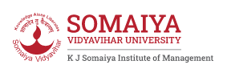

Department of Data Science & Technology

Certificate

Masters in Computer Applications
Trimester IV (2022 – 23)

This is to certify that Mr. Vaibhav Kumar Roll No. 19 of MCA, has satisfactorily completed the practical course “Big Data Analytics” prescribed by the College for the Partial fulfilment of the Degree by the Somaiya Vidyavihar University, during the academic year 2022-23.

Signature of the Faculty-Incharge Signature of the Programme
Coordinator

Date of Examination Signature of the External Examiner/s

