K. J. SOMAIYA INSTITUTE OF MANAGEMENT STUDIES AND RESEARCH,
Vidyavihar, Mumbai- 400077

Program: MCA Sem-IV
Subject: Image Processing & Computer Vision
(End Term Examination)

Maximum Marks: 50
Duration: 3 Hrs
Date: 21st July 2020

Instructions

- Question No.1 is compulsory.
- Write Roll No. and Name in every page of the answer sheet
(3) Answer any four from Q.2 to Q.6.
(4) Draw diagrams wherever necessary.
(5) Mixing up the sub questions not allowed.
(6) Legible handwriting should be followed
(7) Submit all the answer sheet as one single PDF file

QUESTION 1

- Obtain the digital negative of the following figure (05 Marks)
1 | 2 | 3
6 | 5 | 4
7 | 3 | 1

- What is the use of correlation and convolution. When convolving a filter with an impulse image, we get the filter back as the result. So, if we convolve an image with an impulse what would be the possible output. (05 Marks)

QUESTION 2

- Explain the steps and algorithms required to segment the color from the following image. (05 Marks)

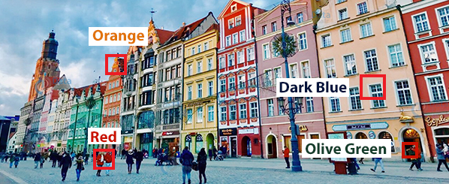

- Calculate the image size of the following image. (05 Marks)

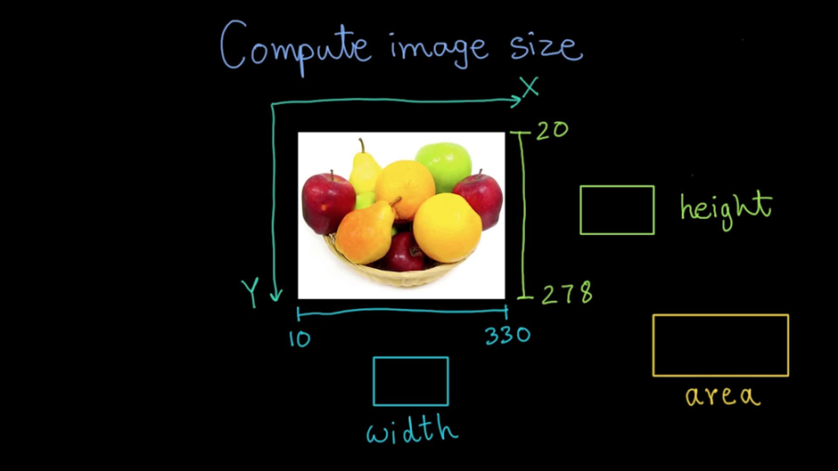

QUESTION 3

- Define Histogram of Image. Perform Histogram equalization of the following image.
Gray levels rk_{i} : 0 1 2 3 4 5 6 7
No.of Pixels Pk_{i} : 6 8 11 12 3 5 15 6
(05 Marks)
- Why do we say that the Harris corner detector is not scale-invariant?
(05 Marks)

QUESTION 4

- How is hysteresis thresholding used in the Canny Edge detector? Is the Canny edge operator is sensitive to noise? Justify your answer.
(05 Marks)
- Explain any one algorithm describes feature description and feature matching.
(05 Marks)

QUESTION 5

- How many and which basic image processing processes are performed by a Laplacian of Gaussian (LoG) filter. (05 Marks)
- In what situations is it useful to apply a smoothing operation to an image? Compare averaging and median filtering as methods of smoothing. What are the advantages and disadvantages of each? (05 Marks)

QUESTION 6

- Write an algorithm using the Hough transform to detect circles. Discuss whether the algorithm is suitable for tracking circles. Which other methods can you think of to detect circles? (05 Marks)

- Define 4, 8 and m-adjacency. Compute the lengths of the shortest 4, 8, and m-path between p and q in the following image segment by considering V={0,1}.

(05 Marks)

3 1 2 1 (q)
2 2 0 2
1 2 1 1
(p) 1 0 1 2

----------------------------End of Paper---------------------------

