**AJAX CRUD**

[**https://www.studentstutorial.com/ajax/crud**](https://www.studentstutorial.com/ajax/crud)

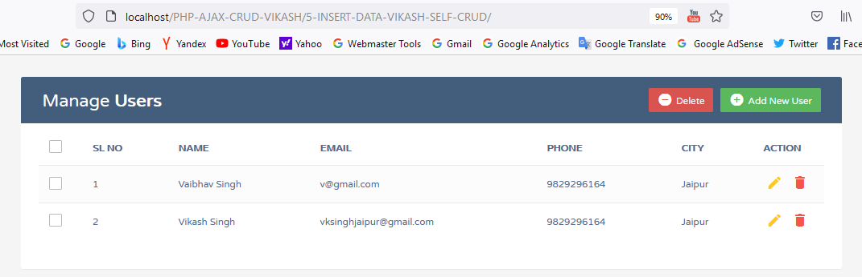

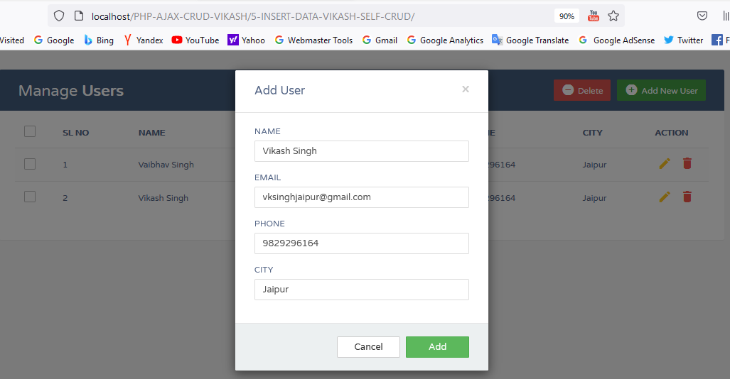

INDEX.PHP

|  |
| --- |
| <?php  include 'backend/database.php';  ?>  <!DOCTYPE html>  <html lang="en">  <head>  <meta charset="utf-8">  <meta http-equiv="X-UA-Compatible" content="IE=edge">  <meta name="viewport" content="width=device-width, initial-scale=1">  <title>User Data</title>  <link rel="stylesheet" href="https://fonts.googleapis.com/css?family=Roboto|Varela+Round">  <link rel="stylesheet" href="https://fonts.googleapis.com/icon?family=Material+Icons">  <link rel="stylesheet" href="https://maxcdn.bootstrapcdn.com/font-awesome/4.7.0/css/font-awesome.min.css">  <link rel="stylesheet" href="https://maxcdn.bootstrapcdn.com/bootstrap/3.3.7/css/bootstrap.min.css">  <link rel="stylesheet" href="css/style.css">  <script src="https://ajax.googleapis.com/ajax/libs/jquery/1.12.4/jquery.min.js"></script>  <script src="https://maxcdn.bootstrapcdn.com/bootstrap/3.3.7/js/bootstrap.min.js"></script>  <script src="ajax/ajax.js"></script>  </head>  <body>  <div class="container">  <p id="success"></p>  <div class="table-wrapper">  <div class="table-title">  <div class="row">  <div class="col-sm-6">  <h2>Manage <b>Users</b></h2>  </div>  <div class="col-sm-6">  <a href="#addEmployeeModal" class="btn btn-success" data-toggle="modal"><i class="material-icons"></i> <span>Add New User</span></a>  <a href="JavaScript:void(0);" class="btn btn-danger" id="delete_multiple"><i class="material-icons"></i> <span>Delete</span></a>  </div>  </div>  </div>  <table class="table table-striped table-hover">  <thead>  <tr>  <th>  <span class="custom-checkbox">  <input type="checkbox" id="selectAll">  <label for="selectAll"></label>  </span>  </th>  <th>SL NO</th>  <th>NAME</th>  <th>EMAIL</th>  <th>PHONE</th>  <th>CITY</th>  <th>ACTION</th>  </tr>  </thead>  <tbody>    <?php  $result = mysqli_query($conn,"SELECT * FROM crud");  $i=1;  while($row = mysqli_fetch_array($result)) {  ?>  <tr id="<?php echo $row["id"]; ?>">  <td>  <span class="custom-checkbox">  <input type="checkbox" class="user_checkbox" data-user-id="<?php echo $row["id"]; ?>">  <label for="checkbox2"></label>  </span>  </td>  <td><?php echo $i; ?></td>  <td><?php echo $row["name"]; ?></td>  <td><?php echo $row["email"]; ?></td>  <td><?php echo $row["phone"]; ?></td>  <td><?php echo $row["city"]; ?></td>  <td>  <a href="#editEmployeeModal" class="edit" data-toggle="modal">  <i class="material-icons update" data-toggle="tooltip"  data-id="<?php echo $row["id"]; ?>"  data-name="<?php echo $row["name"]; ?>"  data-email="<?php echo $row["email"]; ?>"  data-phone="<?php echo $row["phone"]; ?>"  data-city="<?php echo $row["city"]; ?>"  title="Edit"></i>  </a>  <a href="#deleteEmployeeModal" class="delete" data-id="<?php echo $row["id"]; ?>" data-toggle="modal"><i class="material-icons" data-toggle="tooltip"  title="Delete"></i></a>  </td>  </tr>  <?php  $i++;  }  ?>  </tbody>  </table>    </div>  </div>  <!-- Add Modal HTML -->  <div id="addEmployeeModal" class="modal fade">  <div class="modal-dialog">  <div class="modal-content">  <form id="user_form">  <div class="modal-header">  <h4 class="modal-title">Add User</h4>  <button type="button" class="close" data-dismiss="modal" aria-hidden="true">×</button>  </div>  <div class="modal-body">  <div class="form-group">  <label>NAME</label>  <input type="text" id="name" name="name" class="form-control" required>  </div>  <div class="form-group">  <label>EMAIL</label>  <input type="email" id="email" name="email" class="form-control" required>  </div>  <div class="form-group">  <label>PHONE</label>  <input type="phone" id="phone" name="phone" class="form-control" required>  </div>  <div class="form-group">  <label>CITY</label>  <input type="city" id="city" name="city" class="form-control" required>  </div>  </div>  <div class="modal-footer">  <input type="hidden" value="1" name="type">  <input type="button" class="btn btn-default" data-dismiss="modal" value="Cancel">  <button type="button" class="btn btn-success" id="btn-add">Add</button>  </div>  </form>  </div>  </div>  </div>  <!-- Edit Modal HTML -->  <div id="editEmployeeModal" class="modal fade">  <div class="modal-dialog">  <div class="modal-content">  <form id="update_form">  <div class="modal-header">  <h4 class="modal-title">Edit User</h4>  <button type="button" class="close" data-dismiss="modal" aria-hidden="true">×</button>  </div>  <div class="modal-body">  <input type="hidden" id="id_u" name="id" class="form-control" required>  <div class="form-group">  <label>Name</label>  <input type="text" id="name_u" name="name" class="form-control" required>  </div>  <div class="form-group">  <label>Email</label>  <input type="email" id="email_u" name="email" class="form-control" required>  </div>  <div class="form-group">  <label>PHONE</label>  <input type="phone" id="phone_u" name="phone" class="form-control" required>  </div>  <div class="form-group">  <label>City</label>  <input type="city" id="city_u" name="city" class="form-control" required>  </div>  </div>  <div class="modal-footer">  <input type="hidden" value="2" name="type">  <input type="button" class="btn btn-default" data-dismiss="modal" value="Cancel">  <button type="button" class="btn btn-info" id="update">Update</button>  </div>  </form>  </div>  </div>  </div>  <!-- Delete Modal HTML -->  <div id="deleteEmployeeModal" class="modal fade">  <div class="modal-dialog">  <div class="modal-content">  <form>    <div class="modal-header">  <h4 class="modal-title">Delete User</h4>  <button type="button" class="close" data-dismiss="modal" aria-hidden="true">×</button>  </div>  <div class="modal-body">  <input type="hidden" id="id_d" name="id" class="form-control">  <p>Are you sure you want to delete these Records?</p>  <p class="text-warning"><small>This action cannot be undone.</small></p>  </div>  <div class="modal-footer">  <input type="button" class="btn btn-default" data-dismiss="modal" value="Cancel">  <button type="button" class="btn btn-danger" id="delete">Delete</button>  </div>  </form>  </div>  </div>  </div>  </body>  </html> |