Article Title: Bronx, NY

Article Content:
With a population of over 1,430,000, Bronx, New York is a booming area for families, business people, and individuals. It is the northernmost of the five New York City boroughs. The Bronx is full of history and culture: it’s where the Yankees became big, and hip-hop was born. Here you’ll also find the Bronx Zoo, the New York Botanical Gardens, and Woodlawn Cemetery.
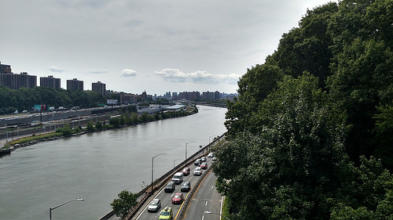
Image via Flickr by Karen Green
In The Bronx you’ll find a variety of shopping options that range from big box stores to small boutiques. You’ll never want for something great to eat, no matter what type of food you’re in the mood for. The nightlife is perfect, with a variety of bars, grills, and lounges.
Source — http://ilovethebronx.com/

Relocation
A move to Bronx, New York is a great decision. If you’re a sports fan, you’ll be in good company, especially if you love the Yankees. Yankee Stadium is located in The Bronx, so you’ll have opportunities to see your favorite team. In addition, you’ll be close to the heart of New York City, simply a bus or train ride away.
There are many neighborhoods in The Bronx that you can choose from. In fact, the Department of City Planning says that there are 49 different neighborhoods here. The West Bronx is closer to Manhattan, while East Bronx is less populous. Each of these areas has different neighborhoods inside of it, including Riverdale and Van Corlandt Village in West Bronx, and Pelham Parkway and Willamsbridge in East Bronx.
Source — http://grandconcourse100.org/brief/geography

School District Information
The Bronx public schools are run by the New York City Department of Education. There are 332 public schools in The Bronx, with a total of 188,000 students. There are six school districts in the city, the largest of which is New York City District 10, with 78 schools. The smallest is New York City District 7, with only 37 schools. In addition to public schools, there are several private schools in the city that parents can choose from.
Source — http://www.newyorkschools.com/counties/bronx.html
Find out more on Bronx schools, depending on the district:
http://insideschools.org/districts/bronx/district-7
http://insideschools.org/districts/bronx/district-8
http://insideschools.org/districts/bronx/district-9
http://insideschools.org/districts/bronx/district-10
http://insideschools.org/districts/bronx/district-11
http://insideschools.org/districts/bronx/district-12
http://www.newyorkschools.com/private-schools/bronx-county.html

City Resources
Moving to a new city can be intimidating, especially a city as large as The Bronx. Here is some more information to help you in your move and for learning more about the city itself. These resources will help you decide where to move, learn more about the area, and get around the city.
Quick Facts
Health and Quality of Life
Utilities
Housing Resources - Realtors, apartment guides, homebuilders
Weather
Transportation
DMV

Housing Information
There are many housing options in The Bronx. You can choose from single family homes to apartment buildings, and more. Whether you’re looking for low-income options or high-class penthouses, there are many choices.
Source — http://www.nyc.gov/html/housing/pages/home/index.shtml
Find the perfect homes for sale or rent with these helpful links:
http://www.zillow.com/bronx-new-york-ny/
http://www.homes.com/for-sale/bronx-ny/
http://www.trulia.com/NY/Bronx/
http://www.nychdc.com/pages/Now-Renting.html
http://www.lowincomehousing.us/NY/bronx.html

Employment Resources
If you’re considering moving to The Bronx, you’ll likely need to find a new job. There are jobs all over the city for skilled trades, customer service, business, and more. Whether you want to find a job before you move or wait until you’re in the area, you can find the perfect job by using these links:
http://www.indeed.com/l-Bronx,-NY-jobs.html
http://www.snagajob.com/job-search/w-bronx,+ny
http://jobs.monster.com/l-bronx,-ny.aspx
http://www.careerbuilder.com/jobs/bronx,ny
http://www.simplyhired.com/local-jobs/bronx-ny

Bronx News
When you’re new to a city, it’s easy to feel like you have no idea what’s going on. Stay up to date on the latest information in the city. Keeping track of the local news is easy with these links:
http://www.ny1.com/nyc/bronx.html
http://bronx.news12.com/
http://abc7ny.com/tag/bronx-news/
http://www.bronxnet.org/

