Article Title: Brooklyn, NY

Article Content:
Brooklyn is one of New York City's most recognizable boroughs, and it is also the most populous, with an estimated 2.5 million residents. Brooklyn's population alone would place it in the top most populous cities in the entire country. However, it is also very small in terms of land area, with only 71 square miles within its borders. The small land area and large population make it second in terms of population density behind Manhattan, which has more residents but a larger land area. Brooklyn encompasses the entirety of Kings County, the second largest county in the United States in terms of population.
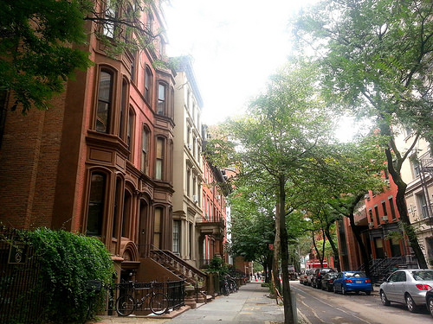
Image via Flickr by Alessandra A.
Brooklyn was settled by Dutch Europeans in the 17th century, and called Breuckelen. Up until 1898 Brooklyn was its own city incorporated in the state of New York, then it became one of the five boroughs to form modern-day New York City. Today, it's a thriving center of culture, arts, entertainment, and dining. The city has seen a recent resurgence after decades of general decline.
Sources: http://www.point2homes.com/US/Neighborhood/NY/Brooklyn-Demographics.html
http://www.brooklyn.com/population.html
http://ny.curbed.com/archives/2014/07/24/brooklyns_evolution_from_small_town_to_big_city_to_borough.php

Relocation
If you plan on moving to Brooklyn there are a few things you need to know. First of all, Brooklyn is not the dangerous crime-ridden city it once was. Today, residents enjoy peaceful parks, diverse culture ripe with entertainment opportunities, and a full array of some of the best eateries and finer restaurants in the country. It's a great place for professionals looking to start careers in one of the hundreds of companies located here or in the surrounding area. But keep in mind these top facts on moving to Brooklyn:
- Brooklyn has many different neighborhoods, each one offering something for everyone. Some neighborhoods are extremely pricey, while others are affordable for young and mid-level career professionals.
- Brooklyn is an energetic place with a thriving arts community, and it is becoming a haven for young and talented musicians, entertainers and artists. Alongside this cultural growth, new companies and start-ups are springing up daily, so opportunity abounds no matter what you do for a living.
- Space is at a premium in Brooklyn because of its small land area, so be ready to either trim down your belongings or rent extra storage space.
- Some residents do not have cars in Brooklyn simply because they don't need them. Parking is a hassle and is not provided at all residencies, so many Brooklyners just use public transportation or taxis.
Brooklyn information: Neighborhoods

School District Information
Brooklyn's schools are as diverse as the city itself. Brooklyn has 858 schools teaching grades K-12. There are 540 public schools and 340 private schools. While some school districts lag behind in terms of education, others excel, and those that excel are not only private schools. Elementary schools like William Penn, a public school, and Excellence Girls Charter School, a public charter, top the list, and there are many more.
Source — http://www.education.com/schoolfinder/us/new-york/brooklyn/

School Information Resources
You can find more information on the schools in Brooklyn here:
http://schools.nyc.gov/community/default.htm

City Resources
Find everything you are looking for about Brooklyn at these websites:
Official NYC website
Utilities and information on energy
Mayor of New York City
Jobs and careers
Real Estate information and homes for sale

Housing Information
The market for homes in Brooklyn is rising fast and there's no end in sight. This is due to a large influx of new residents, the thriving economy, new professional opportunities and the general improvement in everyday life. You can find affordable homes in a few of the neighborhoods in Brooklyn, but expect to pay more than you would anywhere else for a similar size and style of home.
Source — http://www.businessinsider.com/brooklyn-is-officially-the-most-unaffordable-housing-market-in-america-2015-1
Find more on Brooklyn homes for sale and housing market information:
http://www.zillow.com/brooklyn-new-york-ny/home-values/

Employment Resources
Find jobs in Brooklyn:
http://www.indeed.com/l-Brooklyn,-NY-jobs.html
http://www1.nyc.gov/jobs/index.page
http://www.dreamjobsnyc.com/

Brooklyn News
Keep informed of local news events in Brooklyn:
http://brooklyn.news12.com/
http://www.nydailynews.com/new-york/brooklyn

