Article Title: Colorado Springs Overview

Article Content:
Colorado Springs, once called Fountain Colony, is now known to locals as "The Springs." It was Founded in 1871 by General William Jackson Palmer, who visualized it as a city of beauty and culture. His plan was that this new city at the base of Pike’s Peak should offer a better quality of life for well-to-do and elite residents. He didn’t want any rowdy people or poor areas. A dream city? Possibly. To help with his dream, his wife, Queen, who was from London’s high society, had her comments too. To make sure his vision became reality, she invited London's elite for a visit. This utopia lasted for a while until the Gold Rush hit the area in 1891. With it, poor people arrived in droves, many of them becoming instant millionaires who settled in the area and built grand mansions. Entrepreneurs who didn't strike it rich in the gold fields built hotels, stores, and other businesses. Thus The Springs became the beneficiary of instant wealth in more ways than one.
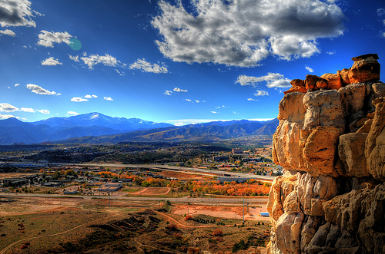
Photo via Flickr by Jasen Miller
Today, the area has five military bases, high-tech companies, institutions of higher education, recreation, and has hosted the birth of many small businesses.
Sources:
http://www.visitcos.com/colorado-springs/travel/history-heritage
http://www.city-data.com/us-cities/The-West/Colorado-Springs-History.html

Relocation
Why do people move to Colorado Springs? Many come for the weather, while others note lower living expenses and taxes, the excellent schools and colleges, or the tech-savvy environment where electrical, software, and aeronautical engineers mingle with people talented in creative arts. Whatever the reason, and there are plenty, all agree that it's a great place to live. Without a doubt, there are plenty of things to do at the base of Pikes Peak, including watching a free Thunderbird air show, fine dining, or hiking up the mountain.
Here are a couple of fun videos:
Colorado Springs Overview
Colorado Springs -- Lifestyle
Finding out about the demographics, weather, population, and utility information before you move is advisable. It’s smart to compare your current cost of living with Colorado Springs before you decide to make the change.
According to Forbes, the metro population is 687,900, of whom 35.3 percent have an advanced degree. The average age is 36, and 41 percent are married.
Sources:
http://www.forbes.com/places/co/colorado-springs/
http://coloradosprings.com

School District Information
There are 190 K-12 schools in Colorado Springs, including 159 public schools and 31 private schools. In higher education, Colorado Springs offers a range of fine colleges and universities. Click on the links below for more information.
Sources: http://www.education.com/schoolfinder/us/colorado/colorado-springs/
http://www.citytowninfo.com/places/colorado/colorado-springs/colleges

School Information Resources
http://www.trulia.com/real_estate/Colorado_Springs-Colorado/schools/
http://www.citytowninfo.com/places/colorado/colorado-springs/colleges

City Resources
Review the below links. Here you’ll find everything you need to make the move, including resident services, business, transportation, building permits, city data, and utility information.
https://coloradosprings.gov/
https://hr.coloradosprings.gov/

Housing Information
Today, popular neighborhoods include East Colorado Springs, Southeast Colorado Springs, and Briargate. The median sale price for homes in Colorado Springs from Aug 15 to Nov 15, 2015 was $217,500. Home prices have been fairly stable over the past 10 years, with a slight increase since 2012.
Rental rates for a one-bedroom apartment average $754, while a two-bedroom comes in at about $910 per month. Three-bedroom apartments average $1,315 each month.
AreaVibes.com gives Colorado Springs a livability score of 78 out of 100.
Sources: http://www.areavibes.com/colorado+springs-co/housing/
http://www.trulia.com/real_estate/Colorado_Springs-Colorado/market-trends/
http://www.areavibes.com/colorado+springs-co/livability/
For more information, see the links below.
http://www.realtor.com/local/Colorado-Springs_CO/home-prices
http://www.zillow.com/homes/for_sale/Colorado-Springs

Employment Resources
With five Military installations, high technology, and tourism, the job market has seen a slight increase recently. The culture and economy of Colorado Springs is largely dependent on the military. According to Forbes, it’s the 37th best place for business and careers. Use the links below to begin your search.
Sources: http://www.forbes.com/places/co/colorado-springs/
Check out the job openings below:
Snag A Job
Simply Hired
Monster
Career Builder

Colorado Springs News
http://www.kktv.com/
http://www.krdo.com/
http://gazette.com/

