Article Title: Getzville, NY

Article Content:
Getzville is a small community located within the city of Amherst, in the western part of the state of New York. It is located within Erie County and in the Buffalo-Cheektowaga metro area. Getzville was named after Jacob and Franklin Goetz, who bought a parcel of land in the area in 1854 and built a large cooper shop and stave factory there. Getzville also had a railway line, dubbed the Peanut by locals, however this was discontinued as railway freight gave way to the trucking industry.
Getzville is conveniently located close to the University of Buffalo's North Campus, the Lockport Expressway, and popular tourist attractions including Niagara Falls and the Buffalo Zoological Gardens. The community supports people of a variety of faiths, with places of worship for Roman Catholic, Jewish, Baptist, Protestant, Hindu, and non-denominational spiritual people all close to Getzville.

Image via Flickr by asokolik
Source – http://nyheritage.nnyln.net/cdm/ref/collection/R6A001/id/2791
http://traveltips.usatoday.com/hotels-getzville-new-york-33697.html

Relocation
If you're considering moving to Getzville, New York, you're in good company. People have been flocking to this friendly city that offers low unemployment, pleasant summer weather, and a range of nearby artistic, cultural, and recreation facilities. Planning your move to a new community can be taxing, so we've provided links to resources on the cost of living, housing, health care, recreation, entertainment, and more.
Employment opportunities abound in Getzville, with plenty of commercial centers in and near this New York community. The cost of living is only slightly higher than the national average and real estate experts say it's a good time to buy in Getzville. Locals also save money and time with shorter commutes than the national average.
The Bryant & Stratton College – Amherst, which is located on Millersport Highway, gives Getzville a strong intellectual base. Many businesses are attracted to Getzville's central location, educated population, and motivated work force. A number of large firms are based in Getzville, including Paychex, KanJam, and Legacy Studios. This diverse range of employers helps bring economic stability to Getzville.
Getzville has been named one of the best cities to relocate to in America, one of the most energetic cities, and also one of the most secure large metro areas to live in the United States.
Source - http://www.bestplaces.net/zip-code/new_york/getzville/14068

School District Information
Getzville is serviced by the Williamsville Central School District. There are no schools in Getzville itself, but local families are just a short drive from the district's elementary, middle, and high schools based in Williamsville and East Amherst. Getzville does have a number of early learning centers to give young children a head start on their education.
Source - http://www.williamsvillek12.org/schools.cfm
Williamsville Central School District received an impressive 9 out of 10 school ranking on GreatSchools.org.
http://www.greatschools.org/new-york/east-amherst/williamsville-central-school-district/

School Information Resources
Here are some helpful resources for more information on Getzville schools:
http://www.greatschools.org/new-york/getzville/

City Resources
You'll find everything you need here to make moving to Getzville easier:
Quality of Life
Utilities
Housing Resources - Realtors, apartment guides, homebuilders
Find Realtors in Getzville, New York
Request a Buffalo Niagara Visitor's Guide
Weather
Transportation

Housing Information
Getzville's attractive residential homes which are competitively priced, especially when compared to the rest of New York, make buying here very desirable. Many of its streets have excellent housing, close to shopping, schools, and other local amenities. Large family homes with at least two bedrooms and generous plots of land are more common than condos and apartments in Getzville.
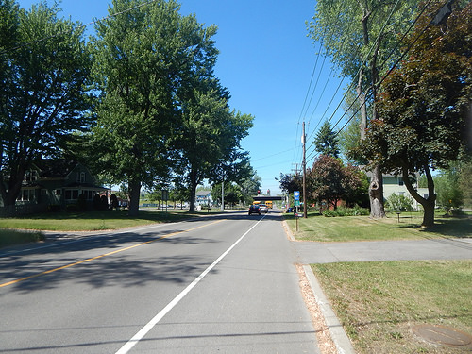
Image via Flickr by Roadgeek Adam
Source - http://www.bestplaces.net/zip-code/new_york/getzville/14068
Check out these helpful links to help with your search:
http://www.homes.com/for-sale/getzville-ny/
http://www.zillow.com/getzville-ny/
http://www.realtor.com/realestateandhomes-search/Getzville_NY

Employment Resources
Find a job in Getzville:
http://www.indeed.com/l-Getzville,-NY-jobs.html
http://jobs.monster.com/l-getzville,-ny.aspx
http://www.careerbuilder.com/jobs/getzville,ny
http://www.snagajob.com/jobs/new-york/getzville_jobs.html

Getzville News
Keep up with local news about Getzville and its surrounds here:
http://www.buffalonews.com/
http://wivb.com/
http://www.topix.com/city/getzville-ny

