Article Title: Hanover Park, IL

Article Content:
Hanover Park is a suburb of Chicago, but the village has maintained a distinct identity and a high quality of life since the 19th century. Hanover Park began to grow in earnest in the 1950s, when the formerly rural village began to evolve into a more residential setting. Its proximity to Chicago has long made Hanover Park a desirable home, as the village is about 45 minutes from downtown Chicago and 15 miles from the city’s O’Hare International Airport.
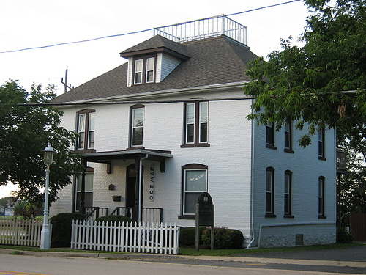
Image via Flickr by Endomental Artistry
Today, Hanover Park residents are the youngest of all Chicago suburbs, with a median age of residents younger than 30. This youthful energy is clear throughout the village, especially with its many family-friendly amenities and activities. The Hanover Park area also contains many parks, country clubs, and cultural institutions, making it a popular home for a variety of residents.
Source: Village of Hanover Park

Relocation
Whether a new job draws you to Hanover Park or you’re beginning to search for work, the village is home to many large-scale employers. From food service to technology and manufacturing, you’ll find an industry represented in Hanover Park. Maines, a paper and food service company, is Hanover Park’s largest employer, while scientific equipment distributor Fisher Scientific is a close second. Other major employers in Hanover Park include computer hardware assembly company Insight Enterprises and precision component parts manufacturer Camcraft.
Source: Village of Hanover Park
Numerous industries thrive in both Hanover Park and the Chicago metropolitan area. The metro area’s largest industries include government, trade and transportation, education and health services, and professional and business services. If you’re considering looking for work in Hanover Park, keep an eye on the area’s fastest growing industries, which include construction, professional and business services, and education and health services.
Source: U.S. Bureau of Labor Statistics
The cost of living in Hanover Park matches the national average almost exactly. While utilities, health care, and groceries are on par with costs nationwide, housing in the village averages about 12 percent lower than the national average. In contrast, transportation costs about 12 percent more than the national average, likely due to the cost of commuting to nearby Chicago.
Source: Sperling’s Best Places

School District Information
Students who live in Hanover Park attend one of seven school districts that serve students of all ages. Districts include Keeneyville School District 20, School District U-46, Community Consolidated School District 54, School District 87, Community Consolidated School District 93, Lake Park High School District 108, and Palatine Township High School District 211. Postsecondary students can also attend one of five area colleges, universities, and trade schools.
Source: Village of Hanover Park
Based on test scores, GreatSchools has ranted Hanover Park schools six out of 10. Select schools received higher ratings from GreatSchools, but most bear average ratings.
Source: GreatSchools

City Resources
Get a head start on planning your move to Hanover Park with the following resources:
Cable and Internet
Event Calendar
Parks and Recreation
Recycling
Trash
Utilities

Housing Information
From new apartment buildings to tree-lined residential streets, you’ll find the right home for you in Hanover Park, generally for an affordable price. The median home value here is about $150,000, and the average age of the village’s housing stock is 37 years. Most Hanover Park residents are homeowners, but about 20 percent rent their homes. The average cost for a one-bedroom rental in the village is $865.
Source: Sperling’s Best Places
Use the following links to help with your housing search:
Apartment Guide
Homes
Realtor
Zillow

Employment Resources
Turn a job into a career with the following employment resources:
CareerBuilder
Indeed
Monster
Simply Hired
Snagajob

Hanover Park News
Follow the local news in Hanover Park with the following media sources:
WBBM-TV
WLS-TV
WMAQ-TV
Daily Herald
Footnotes:
http://www.hpil.org/Our-community.aspx
http://www.hanoverparkillinois.org/Development/Village-Information/Major-Employers.aspx
http://www.bls.gov/regions/midwest/il_chicago_md.htm
http://www.hanoverparkillinois.org/Our-Community/Education.aspx
http://www.greatschools.org/illinois/hanover-park/
http://www.bestplaces.net/cost_of_living/city/illinois/hanover_park
http://www.bestplaces.net/housing/city/illinois/hanover_park

