Article Title: Herndon, VA

Article Content:
Just 25 miles northwest of Washington, D.C., Herndon has a lengthy history in Northern Virginia. Established in the early 19th century, the town received a boost when the railroad arrived in the 1850s. Herndon became a town of more than four square miles in 1879, and although the railroad ceased to stop at Herndon in 1968, the town continued to expand.
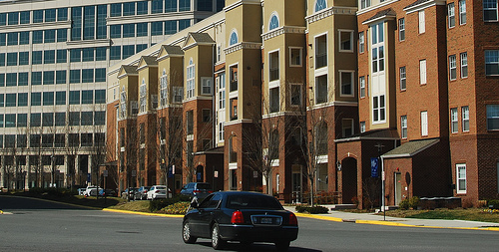
Image via Flickr by pscf11
Today, Herndon is one of the largest towns in Virginia with more than 23,000 residents. The town features a pleasant mix of transit hubs, industrial complexes, office buildings, and residential areas. Herndon, named one of the nation’s friendliest towns, makes an ideal home for professionals and families who want to live in a welcoming Northern Virginia community that balances its history with its future.
Source: Town of Herndon

Relocation
Herndon has some of Northern Virginia’s best office and retail space, and the downtown area features a desirable mix of restaurants, retail, markets, and festivals. With two major highways connecting Herndon with Washington, D.C. and the rest of Northern Virginia, the town is also easy to access for businesses and consumers alike. The largest employers in the area include Boeing, Verizon, Air Line Pilots Association, Northwest Federal Credit Union, and the federal government.
Source: Fairfax County Economic Development Authority
Herndon and Fairfax County are also home to many booming industries. The largest in the area include professional and business services, education and health services, trade and transportation, and government. Industries that show signs of growing the most quickly include education and health services, professional and business services, and construction.
Source: U.S. Bureau of Labor Services
In Herndon, the cost of living is about 60 percent more than other places around the country. Most essentials, including health care, transportation, and utilities, are on par with the national average, but in Herndon, housing costs nearly three times the national average.
Source: Sperling’s Best Places

School District Information
Fairfax County Schools is a large district that includes almost 200 schools and more than 165,000 students. The district has 25 secondary and high schools, 23 junior high schools, and 139 elementary schools. For nontraditional students, the Fairfax County Public Schools system has seven special education centers and two alternative high schools. Nearly three-quarters of students enroll in college after graduating from high school.
Source: Fairfax County Public Schools
Herndon schools have earned a rating of six out of 10 from GreatSchools. Some of the town’s schools have average ratings, but a handful received awards of 10 out of 10, based on student test scores.
Source: GreatSchools

Town Resources
Use the following list resources to help you with your move to Herndon:
Parking
Public Transit
Trash and Recycling
Visitor Guide
Water and Sewer

Housing Information
Nestled between Dulles Access Road and Fairfax County Parkway, Herndon is a relatively quiet town with ample residential development. Whether living in Herndon town center or on a quiet residential street, residents have many parks and green spaces at their disposal.
In the Herndon area, the median housing value is $480,000, and prices continue to climb slowly. Homes in the Herndon area averages about 32 years old.
In addition to homeowners, about 35 percent of Herndon residents rent their homes. The average cost to rent a one-bedroom unit is $1,500 per month.
Source: Sperling’s Best Places
Check out the following links as you search for housing in the Herndon area:
Apartment Guide
Homes
Realtor
Zillow

Employment Resources
Find precisely the job you’re seeking in Herndon:
CareerBuilder
Glassdoor
Indeed
Monster
Simply Hired
Snagajob

Herndon News
Keep up with the latest news in Herndon with the following resources:
The Washington Post
WJLA-TV
WRC-TV
WUSA-TV
Footnotes
http://www.herndon-va.gov/Content/AboutHerndon/History.aspx?cnlid=21
http://www.fairfaxcountyeda.org/town-herndon-business-area
http://www.bls.gov/regions/mid-atlantic/dc_washington_msa.htm#eag
http://www.fcps.edu/about/index.shtml
http://www.greatschools.org/virginia/herndon/
http://www.bestplaces.net/cost_of_living/city/virginia/herndon
http://www.bestplaces.net/housing/city/virginia/herndon

