Article Title: Hopkins, MN

Article Content:
Located within the larger Minneapolis-St. Paul metropolitan area, Hopkins is a lively, growing community of about 17,000 residents. The Hopkins area was first settled in the mid-19th century. When the manufacturing industry entered the community, the area began to experience greater growth. Hopkins received its current name in 1928 after the village’s first postmaster, Harley Hopkins, and became a city in 1947..
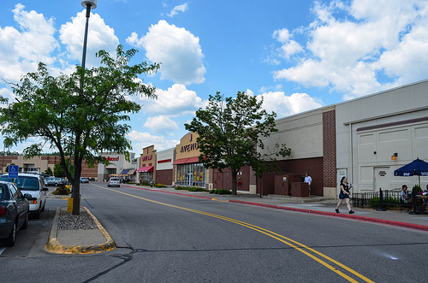
Image via Flickr by m01229
Today, Hopkins is still small, about four square miles, but it’s at the center of a booming Midwest region. Although Hopkins retains its own strong sense of community and a welcoming culture, it’s only 15 minutes west of Minneapolis and St. Paul. Residents can immerse themselves in the friendly Hopkins community, but they’re never far from the attractions and amenities of a large city.
Source: City of Hopkins

Relocation
The larger Minneapolis-St. Paul metro area has many major employers in the health care, finance, and manufacturing industries. UnitedHealth Group, U.S. Bancorp, 3M, and Ameriprise Financial are some of the most profitable companies in the Hopkins area. In addition, several Fortune 500 companies have their headquarters in the metro area, including Target, Best Buy, SuperValu, and General Mills.
Source: Greater MSP
Overall, the largest industries in the Hopkins area include professional and business services, trade and transportation, manufacturing, and leisure and hospitality. In recent years, the fastest growing industries have included leisure and hospitality, professional and business services, and education and health services. Finance is also a rapidly growing field in Hopkins.
Source: U.S. Bureau of Labor Statistics
In Hopkins, the cost of living is about seven percent more than the national average. Housing prices are about 10 percent higher in Hopkins than prices elsewhere in the nation, and other essential costs for everyday living are about five percent higher than the national average.
Source: Sperling’s Best Places

School District Information
Students who live in Hopkins, Minnesota, attend Hopkins Public Schools. The district enrolls about 7,500 students and has six elementary schools, two junior high schools, and one high school. The district is also home to XinXing Academy, a Chinese immersion school. Students interested in learning more language skills can also take part in Juntos Spanish immersion at one of the district’s junior high schools.
Source: Hopkins Public Schools
Based on test results, Hopkins schools have a rating of four out of 10 from GreatSchools. Since the organization has rated only a few of the district’s schools, however, parents may wish to do more research before committing to a school district.
Source: GreatSchools

City Resources
Below you'll find the following resources you'll need to make moving to Hopkins easier:
Community Events
Garbage and Recycling
Move-In Guide
Parks and Recreation
Public Transit
Water System
Yard Waste

Housing Information
Hopkins, Minnesota, is home to 19 neighborhoods, seven of which have active neighborhood associations. Some, such as Park Valley, have a long history and a strong neighborhood identity, while others, like Meadow Creek, are newer neighborhoods centered on condominium or townhouse complexes.
Source: City of Hopkins
In the Hopkins area, homes have a median value of $187,000, and recent trends show that values are appreciating at a rate that’s higher than normal. On average, the median home age is 41 years old. About 60 percent of Hopkins’ population are renters, and a one-bedroom apartment costs about $800 per month.
Source: Sperling’s Best Places
The links below will help with your housing search in Hopkins:
Apartment Guide
Homes
Realtor
Zillow

Employment Resources
Find a job by using the following Hopkins employment resources:
CareerBuilder
Indeed
Monster
Simply Hired
Snagajob

Hopkins News
Stay on top of news affecting the community with these news outlets:
KARE-TV
KSTP-TV
Sun Sailor
WCCO-TV
Footnotes
http://www.hopkinsmn.com/about/history.php
http://www.hopkinsmn.com/residents/neighborhoods/associations.php
http://www.hopkinsschools.org/
http://www.greatschools.org/minnesota/hopkins/
https://www.greatermsp.org/doing-business/major-employers/
http://www.bls.gov/eag/eag.mn_minneapolis_msa.htm
http://www.bestplaces.net/cost_of_living/city/minnesota/hopkins
http://www.bestplaces.net/housing/city/minnesota/hopkins

