Article Title: Manassas Park, VA

Article Content:
Located in Northern Virginia, Manassas Park is just 30 miles southwest of Washington, D.C. The area has been settled for centuries, but Manassas Park didn’t see significant development until the 1950s, when the first homes were built and the area became a town. Manassas Park then became a city in 1975, the final town in Virginia to incorporate as a city.
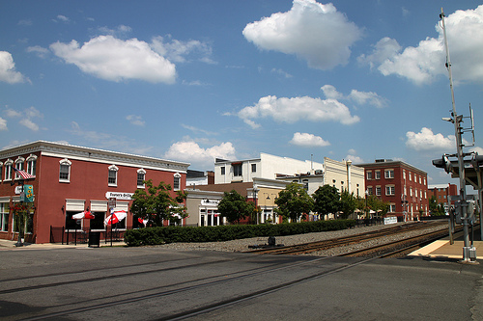
Image via Flickr by Mr.TinDC
Today Manassas Park is home to about 15,000 residents in just over two and a half square miles. The city is primarily residential and offers quick access to Washington, D.C. and other Northern Virginia locales with an efficient bus and rail system. Manassas Park is an established city, but it also tempts new residents with plenty of potential to become an even more developed Northern Virginia community.
Source: City of Manassas Park

Relocation
The largest employers in the Manassas Park area are in the education, government, construction, and engineering industries. Manassas Park City School Board is the city’s largest employer, followed by the City of Manassas Park. Construction companies C.W. Strittmatter, James River Equipment, and JSC Concrete Construction are some of Manassas Park’s top 10 employers.
Source: Virginia Employment Commission
New Manassas Park residents will want to keep on top of economy drivers and industry game changers. Some of the largest industries in Northern Virginia include professional and business services, education and health services, and government. In the coming years, fast-growing industries like construction and trade and transportation may also be some of the largest in the area.
Source: Bureau of Labor Services
In Manassas Park, the cost of living is about 20 percent more than the national average, which makes it a relative bargain in Northern Virginia. Most essentials like utilities, health care, and groceries don’t have particularly high price tags in the Manassas Park area, but housing in this area costs about 50 percent more than the national average.
Source: Sperling’s Best Places

School District Information
Students who reside in this area attend the Manassas Park City Schools, a small district that includes Cougar Elementary School, Manassas Park Elementary School, Manassas Park Middle School, and Manassas Park High School. The most innovative in the district, Cougar Elementary serves students from pre-kindergarten through second grade and uses high-quality technology and small group instruction to educate and inspire students. The district is considered one of the top 30 in Virginia.
Source: Manassas Park City Schools
Based on test scores, GreatSchools gives Manassas Park Schools a rating of three out of 10.
Source: GreatSchools

City Resources
Take a closer look at these resources to make moving to Manassas Park easier:
Parks and Recreation
Public Transit
Trash and Recycling
Voter Registration
Water and Sewer

Housing Information
Manassas Park is divided into more than a dozen subdivisions, each with a unique identity. Neighborhoods like Belmont Station and Point at the Park feature newer apartment and townhouse complexes. New residents can find single family homes in neighborhoods like Bloom’s Crossing and central Manassas Park.
Source: City of Manassas Park
In Manassas Park, homes have a median value of about $255,000, and the average age of the housing stock is just 24 years. About 70 percent of the residents in this area own their homes, and about 30 percent rent. On average, the cost to rent a one-bedroom unit is about $1,300 per month.
Source: Sperling’s Best Places
Use these links to help in your housing search:
Apartment Guide
Homes
Realtor
Zillow

Employment Resources
Find the right job for you in Manassas Park:
CareerBuilder
Indeed
Monster
Simply Hired
Snagajob

Manassas Park News
Keep up with happenings in Manassas Park here:
ABC Affiliate
CBS Affiliate
NBC Affiliate
Washington Post
Footnotes:
http://www.cityofmanassaspark.us/index.php/about-manassas-park/overview-and-history
http://www.cityofmanassaspark.us/index.php/city-services/planning-a-zoning/147-general-information/175-city-subdivisions
http://mpark.schooldesk.net/
http://www.greatschools.org/virginia/manassas-park/
http://virginialmi.com/report_center/community_profiles/5104000685.pdf
http://www.bls.gov/regions/mid-atlantic/dc_washington_msa.htm#eag
http://www.bestplaces.net/cost_of_living/city/virginia/manassas_park
http://www.bestplaces.net/housing/city/virginia/manassas_park

