Article Title: Raleigh, NC

Article Content:
Raleigh, North Carolina, offers the best of both worlds: an excellent place to raise a family and a great home base for business owners and employees. Nicknamed the City of Oaks thanks to its abundance of oak trees, Raleigh serves as the county seat of Wake County and offers numerous options for shopping, dining, and entertainment. It's close to two other cities that form what is known as the Triangle: Chapel Hill and Durham.
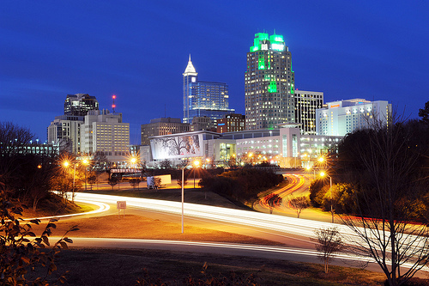
Image via Flickr by NCDOTcommunications
Within the city limits of Raleigh, you'll find 16 grocery stores, 15 parks and green spaces, and a host of community gems like libraries, museums, art galleries, and shopping venues. The great outdoors offers plenty of opportunities to blow off steam and meet your fitness goals, including places to ski, snowboard, fish, hike, and camp. There are also plentiful bars, nightclubs, and live music venues for fun after dark.
Sources:
http://www.citytowninfo.com/places/north-carolina/raleigh
http://www.areavibes.com/raleigh-nc/local-businesses/

Relocation
Moving to a new city always takes some adjustment, but you'll find a welcoming and comfortable home in Raleigh. The city consistently appears at the top of Best Places to Live lists, partly due to its friendly community feel and its access to excellent amenities. Area Vibes gives the city a livability score of 80 thanks to its consistent real estate market and its access to local resources.
Although Raleigh has a somewhat heightened cost of living compared to the rest of North Carolina and to the nation, you'll enjoy excellent weather, top educational opportunities, and beautiful scenery. Neighborhoods in Raleigh feature older homes with plenty of charm as well as newer construction. Thanks to population surges in the city, new neighborhoods continue to develop in suburban areas.
Below, you'll find information on city resources, schooling, employment, housing, and other necessities that will help make your relocation to Raleigh as effortless as possible.
Sources:
http://www.movoto.com/guide/raleigh-nc/moving-to-raleigh/
http://www.areavibes.com/raleigh-nc/livability/
http://www.greatamericancountry.com/places/local-life/great-neighborhoods-in-raleigh

School District Information
Men's Health magazine named Raleigh the third-most educated city in the United States, behind Madison, Wisconsin, and Plano, Texas. Students in Raleigh, North Carolina, attend schools in the Wake County Public School System. In 2014's graduating class, students earned more than $100 million in scholarships, and in 2013, the school system received nearly $60 million in grants. Great Schools gives the Raleigh area educational institutions a combined rating of seven out of 10, citing Underwood Elementary, Oak Grove Elementary, and Quest Academy among the most successful schools.
Sources:
http://newsfeed.time.com/2011/09/15/americas-most-educated-cities-madison-and-boulder-face-off/
http://www.wcpss.net/domain/13
http://www.greatschools.org/north-carolina/raleigh/

School Information Resources
To learn more about education options in Raleigh, visit the Wake County Public School System's website:
http://www.wcpss.net/

City Resources
Setting up in a new city can prove difficult, but you'll find it easier if you avail yourself of these resources:
Utility Payments
Trash and Recycling
Local Environment and Sustainability
Public Safety
Raleigh Chamber of Commerce
Local Parks and Green Spaces
Weather Forecast
Transit
For more information about Raleigh, visit this website:
http://www.raleighnc.gov/

Housing Information
This is an excellent time to purchase real estate in Raleigh, North Carolina. Steady home appreciation has created excellent investment opportunities for Raleigh residents. Although a lack of real estate inventory has made finding a home slightly more difficult in 2015, there are still plenty of homes available for sale through traditional means as well as foreclosures and short sales. Popular neighborhoods in Raleigh include Glenwood, Wade, Five Points, Six Forks, and North Central.
Sources:
http://www.newsobserver.com/news/business/real-estate-news/article14971745.html
http://www.bestplaces.net/city/north_carolina/raleigh
http://www.zillow.com/raleigh-nc/home-values/
If you're shopping for a new home in Raleigh, check out listings through these sources:
http://www.realtor.com/realestateandhomes-search/Raleigh_NC
http://www.trulia.com/NC/Raleigh/
http://www.homes.com/for-sale/raleigh-nc/
http://www.remax.com/realestatehomesforsale/raleigh-nc-p001.html

Employment Resources
You can find a job in Raleigh using these websites:
http://www.indeed.com/l-Raleigh,-NC-jobs.html
http://jobs.monster.com/l-raleigh,-nc.aspx
http://www.trianglejobs.com/raleigh/
http://www.careerbuilder.com/jobs/raleigh,nc

Raleigh News
If you're interested in Raleigh, North Carolina, news, check out these trusted news sources:
http://www.wral.com/
http://www.newsobserver.com/news/local/
http://wncn.com/
http://abc11.com/raleigh/

