Article Title: Rolling Meadows, IL

Article Content:
Rolling Meadows has more than 24,000 residents in the Golden Corridor of Illinois. Incorporated in 1955, the city was originally designed to provide affordable housing for World War II veterans and their families. Rolling Meadows has since become a diverse community with a thriving recreational system and enough major businesses to support a workforce of 44,000 people.
Source - http://www.ci.rolling-meadows.il.us/300/Community-Overview

Relocation
Rolling Meadows is a desirable destination for those looking to escape the bustle of Chicago for a more suburban experience. This city has a diverse blend of both white-collar and blue-collar workers. The median household income is $60,952; the average household makes $85,731. Rolling Meadows has experienced a steady growth rate of about 0.4 percent over the last five years, and the growth trend is expected to continue through at least 2020.
Source - http://illinois.hometownlocator.com/il/cook/rolling-meadows.cfm
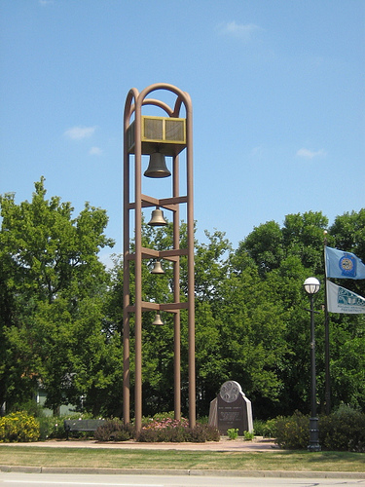
Image via Flickr by Endomental Artistry
Rolling Meadows is particularly sought after for its recreation and amenities. The Rolling Meadows park district is a four-time finalist for the National Gold Medal award for excellence in parks and recreation management. This district has 11 parks covering 151 acres. Learn more about the city's thriving parks district: http://rmparks.org/District-Info/mission-history.htm
Uncover the best shopping and dining in the area with the Rolling Meadows Visitor's Guide: http://www.ci.rolling-meadows.il.us/472/Visitors-Guide

School District Information
The public schools in Rolling Meadows are divided between Palatine CCSD 15 and Township HSD 214. Students also can attend private school at the Harvest Christian Academy of Rolling Meadows or St. Colette School. The city has six elementary schools, four middle schools, and two high schools.
Source - http://www.education.com/schoolfinder/us/illinois/rolling-meadows
Based on test results, Rolling Meadows schools received an 8 out of 10 from GreatSchools.org. Plum Grove Junior High School and Willow Bend Elementary School have the highest rankings in the city, each receiving a full 10. Rolling Meadows High School is close behind with a 9 out of 10.
Source - http://www.greatschools.org/illinois/rolling-meadows

School Information Resources
Learn more about the schools available in Rolling Meadows, Illinois, with the following resources:
http://www.d214.org
http://www.ccsd15.net/pages/CCSD15
http://www.harvestchristianacademy.org
http://www.stcolette.com

City Resources
Streamline your move to Rolling Meadows with access to all the essential information you need for a smooth move.
Trash and Recycling
Curbside recycling pickup happens the same day as your refuse pickup to make your life easier. Get the guidelines and contact information you need: http://www.ci.rolling-meadows.il.us/311/Refuse-Recycling
Utilities
Rolling Meadows offers optional electronic billing for your utilities so you can go a little greener with this paperless option. Find your utility providers and get your utilities set up: http://www.ci.rolling-meadows.il.us/232/Utility-Service-Providers
Vehicle Stickers
Rolling Meadows residents need to display a current vehicle sticker. These stickers can be renewed annually between June 1 and June 30. New residents have 60 days from the time of their move to get the proper sticker. Learn more about vehicle sticker requirements: http://www.ci.rolling-meadows.il.us/229/Vehicle-Stickers

Housing Information
The average home price in Rolling Meadows is $215,000, but the average sold price is about 10 percent lower at $195,500. Use the following links to aid your search for the perfect home:
http://www.zillow.com/rolling-meadows-il/
http://www.homes.com/for-sale/rolling-meadows-il/
http://www.realtor.com/local/Rolling-Meadows_IL/home-prices

Employment Resources
The income in Rolling Meadows is 4.7 percent higher than the average for Illinois and poverty levels are 32.1 percent lower. Unemployment is at 5.5 percent compared to 6.6 percent for the state overall. Many residents are sales and office workers, professionals, and service providers. Education and health care also employ a significant part of the work force. Find a job in the Rolling Meadows area with the following resources:
http://www.indeed.com/l-Rolling-Meadows,-IL-jobs.html
http://jobs.monster.com/l-rolling-meadows,-il.aspx
http://www.careerbuilder.com/jobs/rolling-meadows,il
http://www.snagajob.com/jobs/illinois/rolling_meadows_jobs.html

Rolling Meadows News
Keep up with official Rolling Meadows news: http://www.ci.rolling-meadows.il.us/civicalerts.aspx
Other sources for news in the area include the following sources:
http://www.chicagotribune.com/suburbs/arlington-heights/
http://www.journal-topics.com/news/rolling_meadows/
http://www.dailyherald.com/community/rolling-meadows/

