# Test plan

Our group test plan is talking about the plan of project test ting are discussed in test plan file.

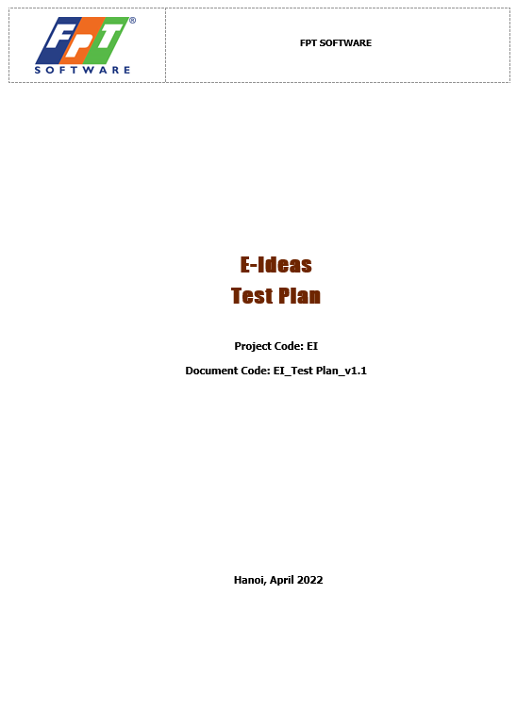

Figure 1: Test Plan Cover page

Test plan signature page:

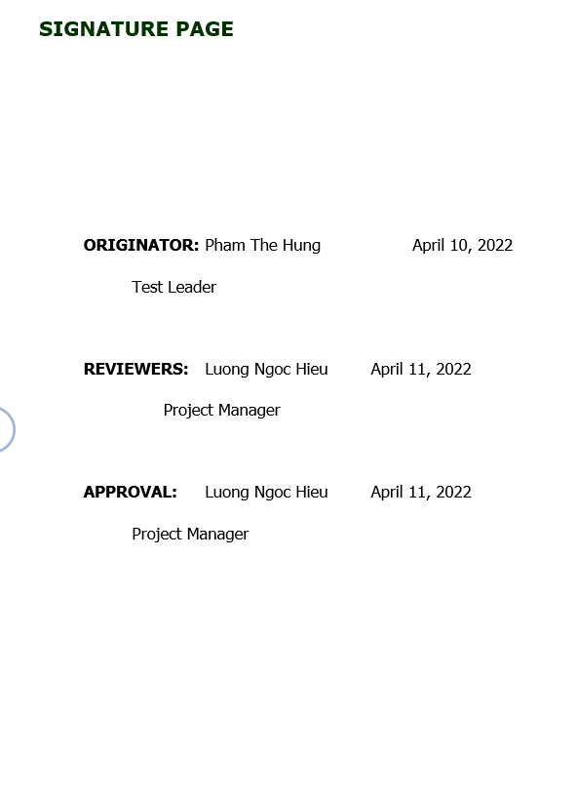

Figure 2: Test Plan Signature page

Test plan table contents:

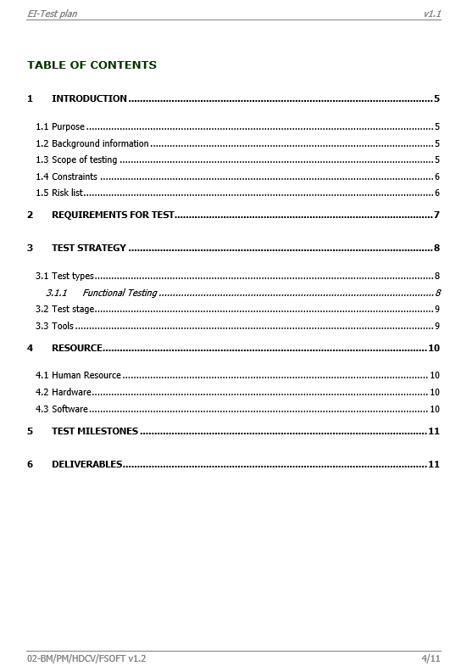

Figure 3: Test plan Table of content

# Unit test

After done the code of project, our team need to test for the project. Unit test is an automatic method to check each function in system. The result of unit test using NUnit Test is shown below:

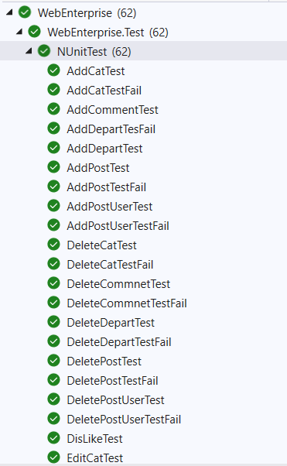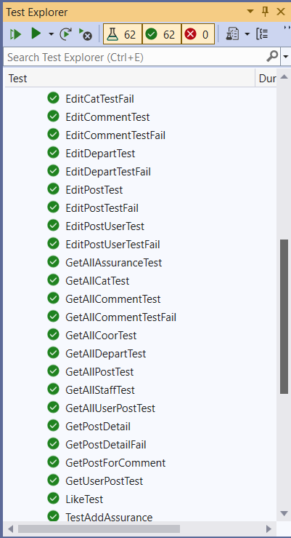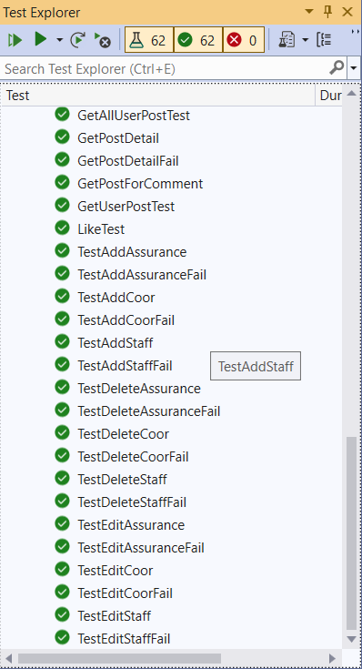

Figure 4: NUnit Test Result

There are 62-unit test function in test file for our project, it includes correct input case function and incorrect case function. With case Correct, the Assert result is “IsTrue” case and the incorrect input case, the Assert result is “IsFalse” case. For example, a 2 test functions correct and incorrect cases:

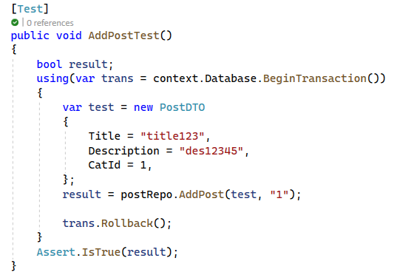

Figure 5: Test case correct

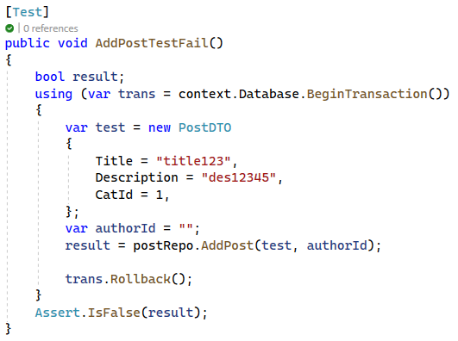

Figure 6: Test case fail

In test correct, input data is entered fully with title, description, categoryId of idea and authorId who create the idea so that the result return is true correct with the Assert.IsTrue.

In case fail, input data is entered lack of authorId, so that new idea cannot be added, result is false, correct with the Assert.IsFalse

# Test Cases

This part is showing the test case when we making test for E-Ideas project.

## Test Environment

**Client:**

|  |  |  |  |
| --- | --- | --- | --- |
| **Test Device** | **Type** | **Test Tool** | **OS Version** |
| Galaxy S9 Plus | Mobile | OS Browser | Android 11 |
| iPhone 8 Plus | Mobile | OS Browser | IOS 14 |
| MSI Modern 14 | Laptop | Chrome | Windows 11 |
| Acer Predator 300 | Laptop | Chrome | Windows 10 |

**Server**:

|  |  |  |  |
| --- | --- | --- | --- |
| **Name** | **CPU** | **RAM** | **OS Version** |
| Virtual machine on Azure | Xeon 2.6 GHz | 4GB | Windows 10 |

## Test case

|  |  |  |  |  |  |  |
| --- | --- | --- | --- | --- | --- | --- |
| **No** | **Test Description** | **Test Procedure** | **Test Data** | **Expected Output** | **Actual output** | **Status** |
|  | Login Test | Input username and password and click to login button | Username and password are existing in system | Login success | Login success | Pass |
|  | Login test Fail | Input wrong username and password and click to login button | Username and password are not existing in system | Show message: Invalid attempt | Show message: Invalid attempt | Pass |
|  | Access denied test | Using staff role and type the link of Admin page | Using staff account go to Admin page | Show Access Denied page | Show Access Denied page | Pass |
|  | Authorization test | Go to any page in system without login | Type any link of system without login | Push user to login page | Push user to login page | Pass |
|  | Create Assurance account | Admin click to create assurance account button | Enter fully assurance information | Show successfully message and new assurance is shown in the list | Show successfully message and new assurance is shown in the list | Pass |
|  | Create Assurance Account fail | Admin click to create assurance account button | Enter assurance information without department | Show message: department is required | Show message: cannot add new assurance | Fail |
|  | Edit Assurance information | Admin click to edit button on any assurance in list | Change assurance information | Show message: Edit successfully | Show message: Edit successfully | Pass |
|  | Edit Assurance information fail | Admin click to edit button on any assurance in list | Change assurance information but make phone number field empty | Show error message below phone number textbox: Phone number is required | Show error message below phone number textbox: Phone number is required | Pass |
|  | Delete Assurance | Admin click to delete button on any assurance in list | Click to confirm button in confirm box | Show message: delete successfully | Show message: delete successfully | Pass |
|  | Delete Assurance fail | Admin click to delete button on any assurance in list | Click to cancel button in confirm box | Not delete | Not delete | Pass |
|  | Delete Assurance Fail | Admin enter wrong assurance id on URL bar | Enter wrong assurance id on URL bar | Go to list assurance page | Go to list assurance page | Pass |
|  | Search assurance | Admin enter keyword want to search to search box and click to search button | Enter true keyword | Show assurance accounts has full name match with keyword | Show assurance accounts has full name match with keyword | Pass |
|  | Search assurance fail | Admin enter keyword want to search to search box and click to search button | Enter “{” character | Show not found message | Show none assurance in the list without any message | Fail |
|  | Pagination test | User click to number of paging page or next previous button | Click to any button in pagination bar | Go to page with number match with button | Go to page with number match with button | Pass |
|  | Create Staff account | Admin click to create Staff account button | Enter fully Staff information | Show successfully message and new Staff is shown in the list | Show successfully message and new Staff is shown in the list | Pass |
|  | Create Staff Account fail | Admin click to create Staff account button | Enter Staff information without department | Show message: department is required | Show message: cannot add new Staff | Fail |
|  | Edit Staff information | Admin click to edit button on any Staff in list | Change Staff information | Show message: Edit successfully | Show message: Edit successfully | Pass |
|  | Edit Staff information fail | Admin click to edit button on any Staff in list | Change Staff information but make phone number field empty | Show error message below phone number textbox: Phone number is required | Show error message below phone number textbox: Phone number is required | Pass |
|  | Delete Staff | Admin click to delete button on any Staff in list | Click to confirm button in confirm box | Show message: delete successfully | Show message: delete successfully | Pass |
|  | Delete Staff fail | Admin click to delete button on any Staff in list | Click to cancel button in confirm box | Not delete | Not delete | Pass |
|  | Delete Staff Fail | Admin enter wrong Staff id on URL bar | Enter wrong Staff id on URL bar | Go to list Staff page | Go to list Staff page | Pass |
|  | Search Staff | Admin enter keyword want to search to search box and click to search button | Enter true keyword | Show Staff accounts has full name match with keyword | Show Staff accounts has full name match with keyword | Pass |
|  | Search Staff fail | Admin enter keyword want to search to search box and click to search button | Enter “{” character | Show not found message | Show none Staff in the list without any message | Fail |
|  | Create Coordinator account | Admin click to create Coordinator account button | Enter fully Coordinator information | Show successfully message and new Coordinator is shown in the list | Show successfully message and new Coordinator is shown in the list | Pass |
|  | Create Coordinator Account fail | Admin click to create Coordinator account button | Enter Coordinator information without department | Show message: department is required | Show message: cannot add new Coordinator | Fail |
|  | Edit Coordinator information | Admin click to edit button on any Coordinator in list | Change Coordinator information | Show message: Edit successfully | Show message: Edit successfully | Pass |
|  | Edit Coordinator information fail | Admin click to edit button on any Coordinator in list | Change Coordinator information but make phone number field empty | Show error message below phone number textbox: Phone number is required | Show error message below phone number textbox: Phone number is required | Pass |
|  | Delete Coordinator | Admin click to delete button on any Coordinator in list | Click to confirm button in confirm box | Show message: delete successfully | Show message: delete successfully | Pass |
|  | Delete Coordinator fail | Admin click to delete button on any Coordinator in list | Click to cancel button in confirm box | Not delete | Not delete | Pass |
|  | Delete Coordinator Fail | Admin enter wrong Coordinator id on URL bar | Enter wrong Coordinator id on URL bar | Go to list Coordinator page | Go to list Coordinator page | Pass |
|  | Search Coordinator | Admin enter keyword want to search to search box and click to search button | Enter true keyword | Show Coordinator accounts has full name match with keyword | Show Coordinator accounts has full name match with keyword | Pass |
|  | Search Coordinator fail | Admin enter keyword want to search to search box and click to search button | Enter “{” character | Show not found message | Show none Coordinator in the list without any message | Fail |
|  | Create Category | Admin click to create Category button | Enter fully information | Show successfully message and new Category is shown in the list | Show successfully message and new Category is shown in the list | Pass |
|  | Create Category fail | Admin click to create Category button | Enter Category information with name has 2 characters length | Show message: Name must be 4 to 10 digits | Show message: cannot add new Category | Fail |
|  | Edit Category information | Admin click to edit button on any Category in list | Change Category information | Show message: Edit successfully | Show message: Edit successfully | Pass |
|  | Edit Category information fail | Admin click to edit button on any Category in list | Change Category information but make Description field empty | Show error message below description textbox: Description is required | Show error message below description textbox: Description is required | Pass |
|  | Delete Category | Admin click to delete button on any Category in list | Click to confirm button in confirm box | Show message: delete successfully | Show message: delete successfully | Pass |
|  | Delete Category fail | Admin click to delete button on any Category in list | Click to cancel button in confirm box | Not delete | Not delete | Pass |
|  | Delete Category Fail | Admin enter wrong Category id on URL bar | Enter wrong Category id on URL bar | Go to list Category page | Go to list Category page | Pass |
|  | Search Category | Admin enter keyword want to search to search box and click to search button | Enter true keyword | Show Category accounts has full name match with keyword | Show Category accounts has full name match with keyword | Pass |
|  | Search Category fail | Admin enter keyword want to search to search box and click to search button | Enter “{” character | Show not found message | Show none Category in the list without any message | Fail |
|  | Create Department | Admin click to create Department button | Enter fully information | Show successfully message and new Department is shown in the list | Show successfully message and new Department is shown in the list | Pass |
|  | Create Department fail | Admin click to create Department button | Enter Department information with name has 2 characters length | Show message: Name must be 4 to 10 digits | Show message: cannot add new Department | Fail |
|  | Edit Department information | Admin click to edit button on any Department in list | Change Department information | Show message: Edit successfully | Show message: Edit successfully | Pass |
|  | Edit Department information fail | Admin click to edit button on any Department in list | Change Department information but make Description field empty | Show error message below description textbox: Description is required | Show error message below description textbox: Description is required | Pass |
|  | Delete Department | Admin click to delete button on any Department in list | Click to confirm button in confirm box | Show message: delete successfully | Show message: delete successfully | Pass |
|  | Delete Department fail | Admin click to delete button on any Department in list | Click to cancel button in confirm box | Not delete | Not delete | Pass |
|  | Delete Department Fail | Admin enter wrong Department id on URL bar | Enter wrong Department id on URL bar | Go to list Department page | Go to list Department page | Pass |
|  | Search Department | Admin enter keyword want to search to search box and click to search button | Enter true keyword | Show Department accounts has full name match with keyword | Show Department accounts has full name match with keyword | Pass |
|  | Search Department fail | Admin enter keyword want to search to search box and click to search button | Enter “{” character | Show not found message | Show none Department in the list without any message | Fail |
|  | Create Idea | Admin click to create Idea button | Enter fully information | Show successfully message and new Idea is shown in the list | Show successfully message and new Idea is shown in the list | Pass |
|  | Create Idea fail | Admin click to create Idea button | Enter Idea information with title has 2 characters length | Show message: Title must be 5 to 100 digits | Show message: cannot add new Idea | Fail |
|  | Edit Idea information | Admin click to edit button on any Idea in list | Change Idea information | Show message: Edit successfully | Show message: Edit successfully | Pass |
|  | Edit Idea information fail | Admin click to edit button on any Idea in list | Change Idea information but make Description field empty | Show error message below description textbox: Description is required | Show error message below description textbox: Description is required | Pass |
|  | Delete Idea | Admin click to delete button on any Idea in list | Click to confirm button in confirm box | Show message: delete successfully | Show message: delete successfully | Pass |
|  | Delete Idea fail | Admin click to delete button on any Idea in list | Click to cancel button in confirm box | Not delete | Not delete | Pass |
|  | Delete Idea Fail | Admin enter wrong Idea id on URL bar | Enter wrong Idea id on URL bar | Go to list Idea page | Go to list Idea page | Pass |
|  | Search Idea | Admin enter keyword want to search to search box and click to search button | Enter true keyword | Show Idea accounts has full name match with keyword | Show Idea accounts has full name match with keyword | Pass |
|  | Search Idea fail | Admin enter keyword want to search to search box and click to search button | Enter “{” character | Show not found message | Show none Idea in the list without any message | Fail |
|  | Confirm term | User add new idea and a term box to confirm is shown | Click to Accept check box | Accept button is Enable | Accept button is Enable | Pass |
|  | Confirm term | User add new idea and a term box to confirm is shown | Don’t click to Accept checkbox | Accept button is disable | Accept button is disable | Pass |
|  | Like | User like an idea in View Post Page | Click to like button | Like button change color, count in like button +1, if dislike button is active, count in dislike button -1 | Like button change color, count in like button +1, if dislike button is active, count in dislike button -1 | Pass |
|  | Dislike | User dislike an idea in View Post Page | Click to dislike button | Dislike button change color, count in dislike button +1, if like button is active, count in like button -1 | Dislike button change color, count in dislike button +1, if like button is active, count in like button -1 | Pass |
|  | Add Comment test | User click to comment at any idea to go to view comment page, click to comment button again to add comment | Enter description | Show message: Add successfully | Show message: Add successfully | Pass |
|  | Add Comment fail | User click to comment at any idea to go to view comment page, click to comment button again to add comment | Make description box to empty | Show message: description is required | Show message: Cannot add comment | Fail |
|  | Edit Comment | User click to “…” mark and click to edit button | Change description | Show message: Edit comment successfully | Show message: Edit comment successfully | Pass |
|  | Edit Comment fail | User click to “…” toolbox mark and click to edit button | Make description box to empty | Show message: description is required | Show message: Cannot edit comment | Fail |
|  | Show “…” toolbox mark | User in comment list | View “…” toolbox mark | Show toolbox in user own comment, comment of other users is hidden | Show toolbox in user own comment, comment of other users is hidden | Pass |
|  | Delete Comment | User click to delete button in toolbox on comment that they own | Click to confirm button in confirm box | Show message: delete successfully | Show message: delete successfully | Pass |
|  | Delete comment fail | User click to delete button in toolbox on comment that they own | Click to cancel button in confirm box | Not delete | Not delete | Pass |
|  | Delete comment fail | User enter wrong comment id on URL bar | Enter wrong comment id on URL bar | Go to list comment page | Go to list comment page | Pass |

## Interface responsive test

This part to test the user interface of E-Ideas project using client testing devices above, the test is divided to mobile and desktop (laptop).

### Login interface

**Desktop**:

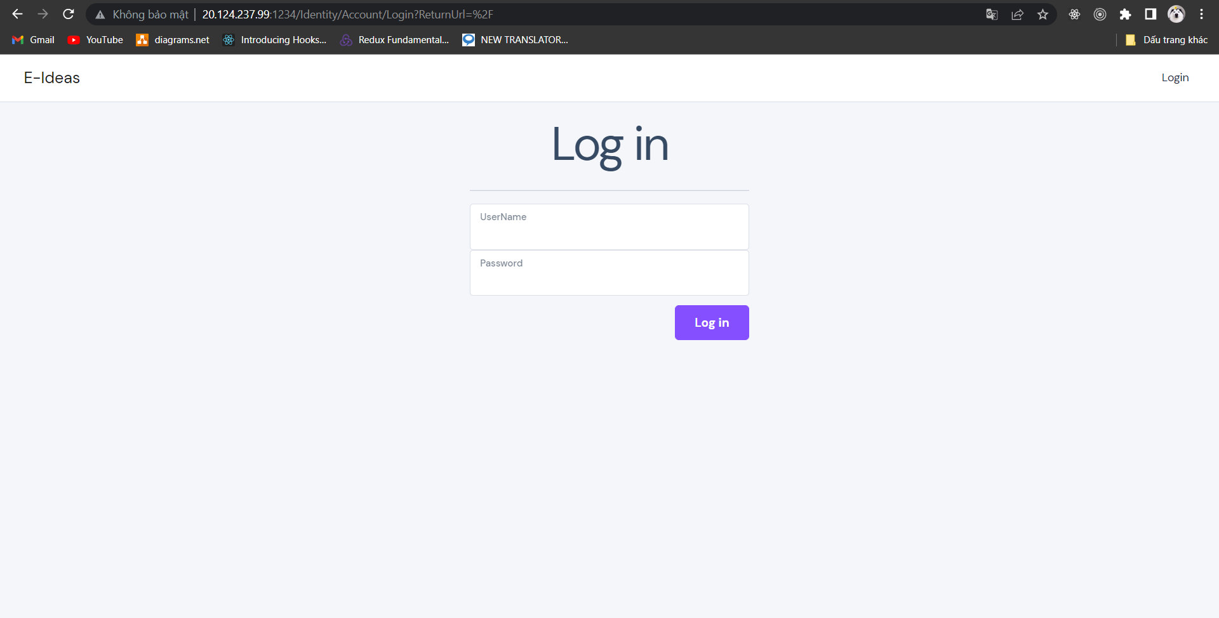

Figure : Login desktop interface

**Mobile**:

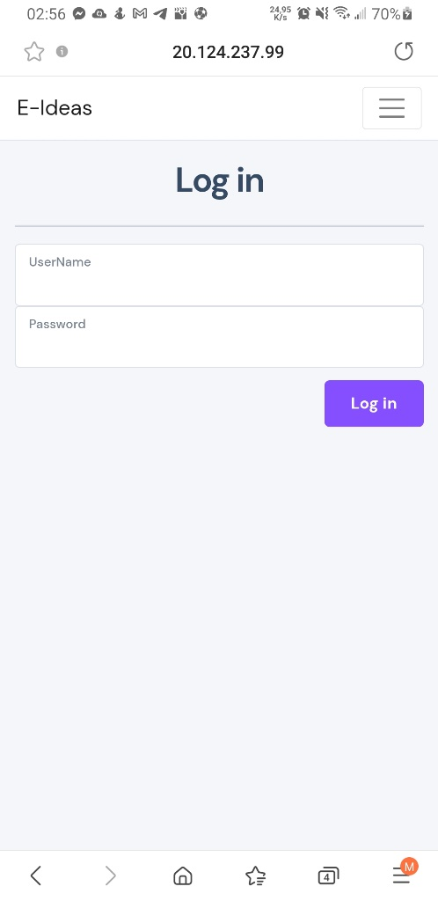

Figure : Login on Mobile

### Admin Page Interfaces

**Desktop**:

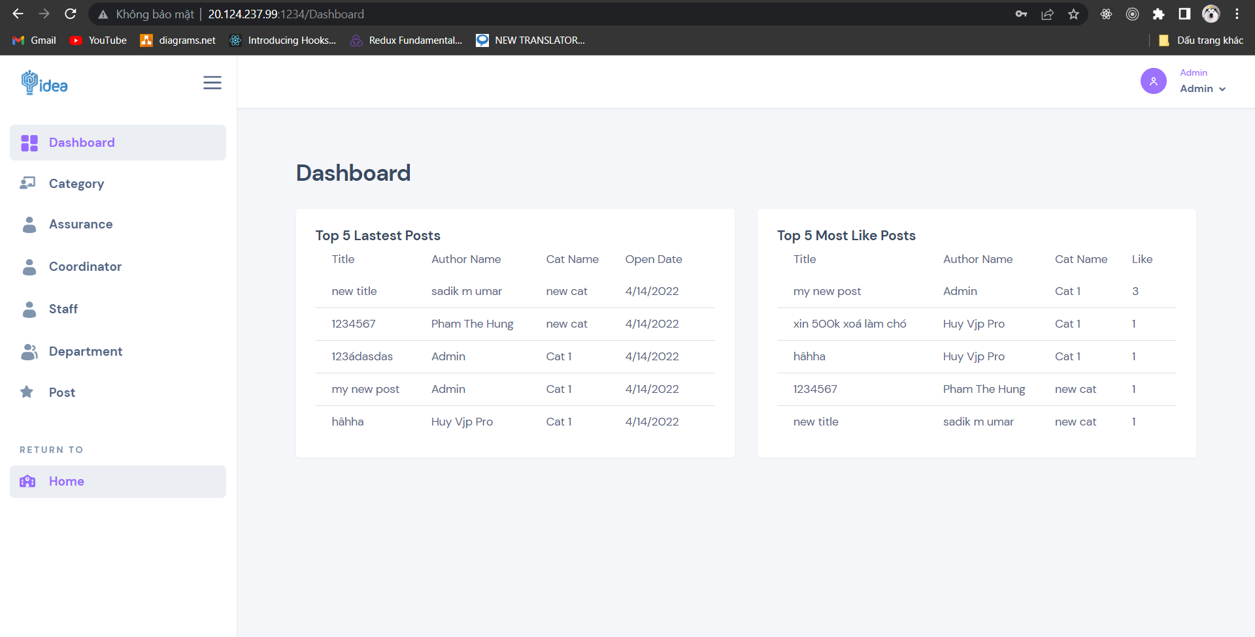

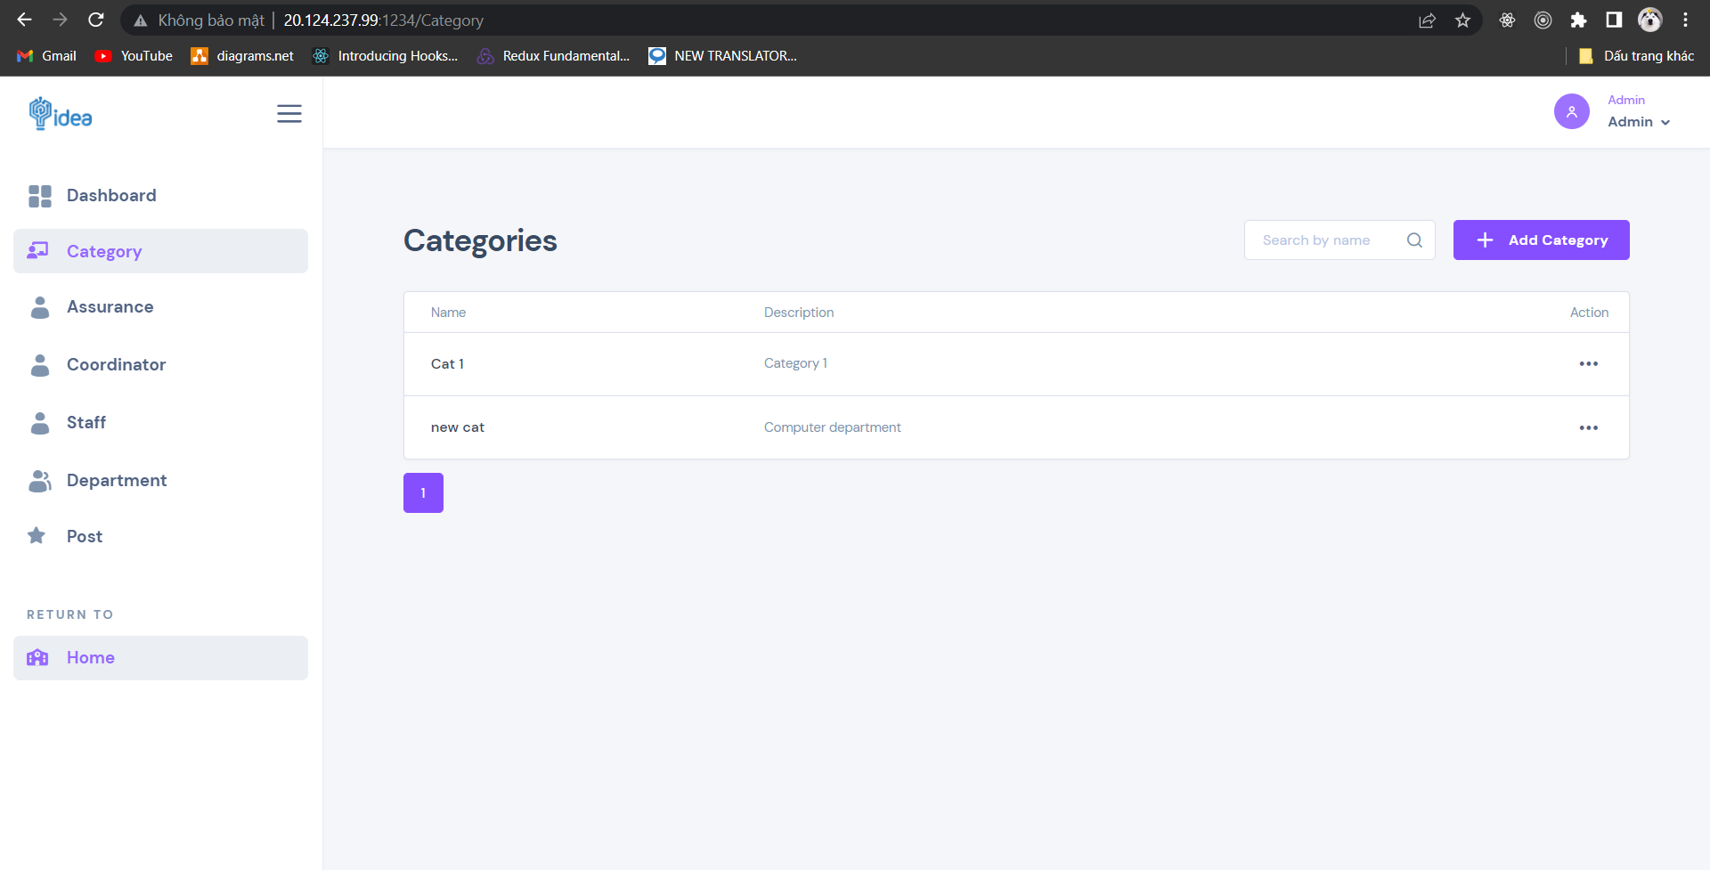

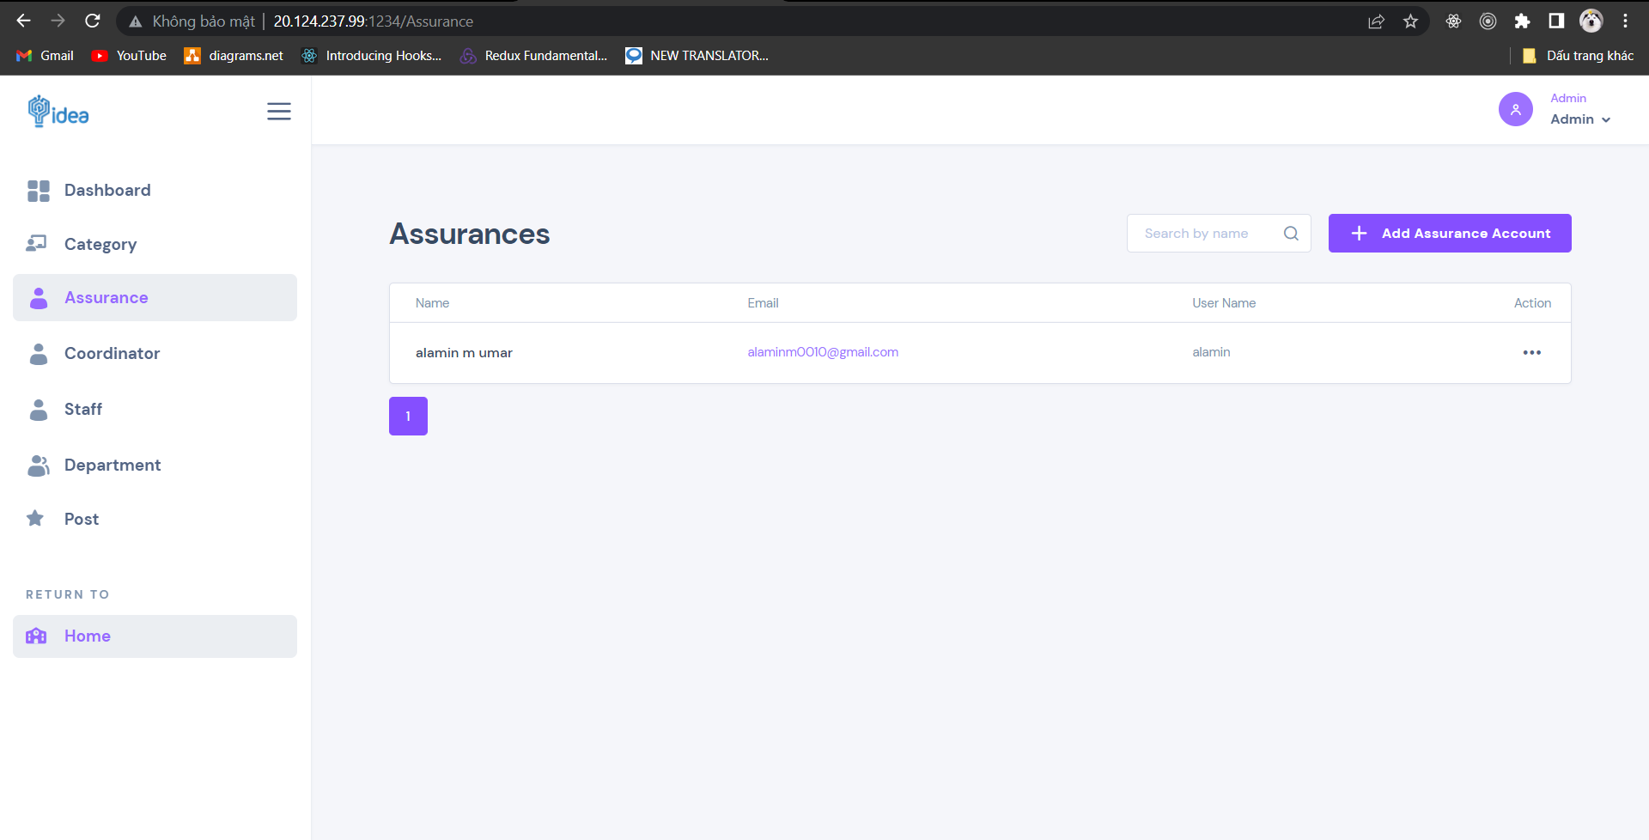

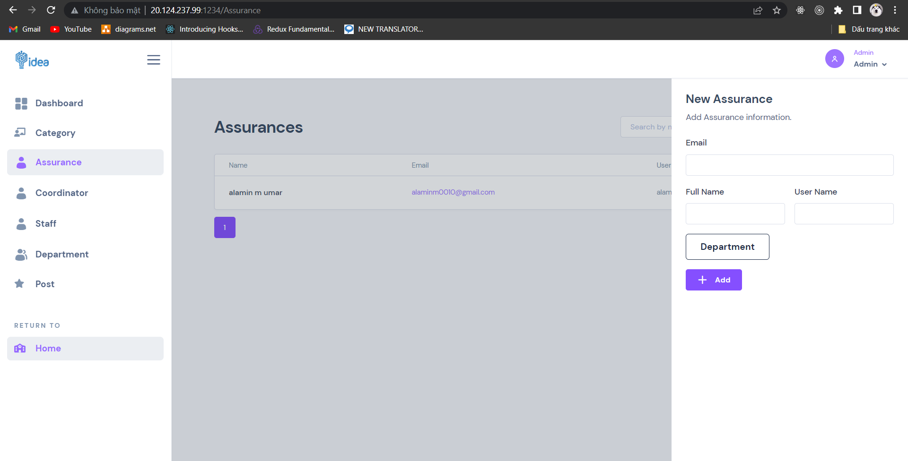

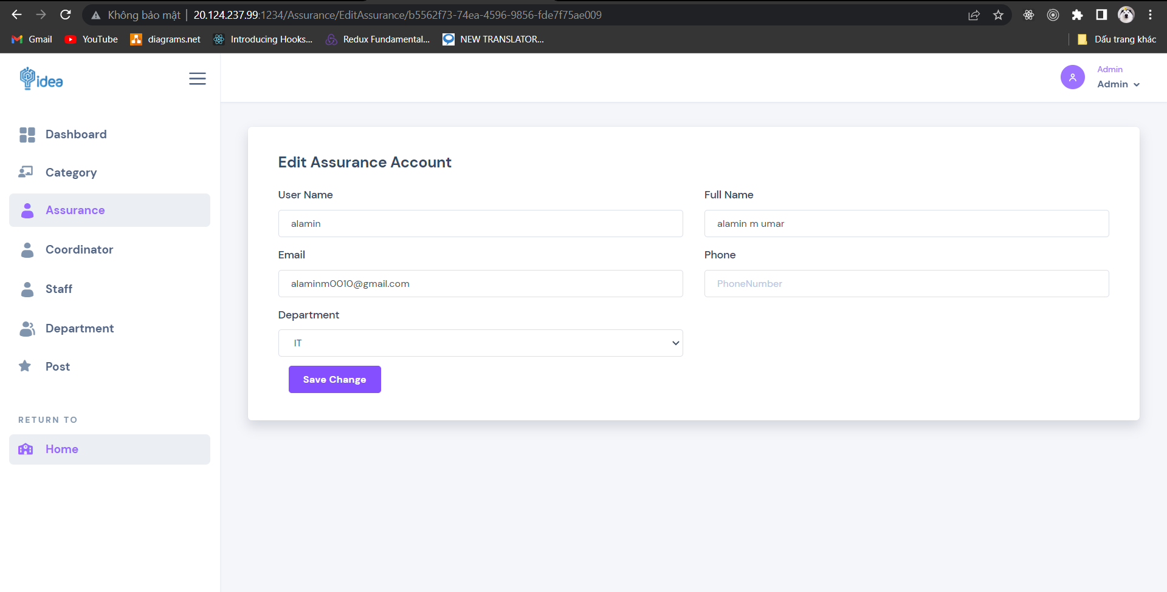

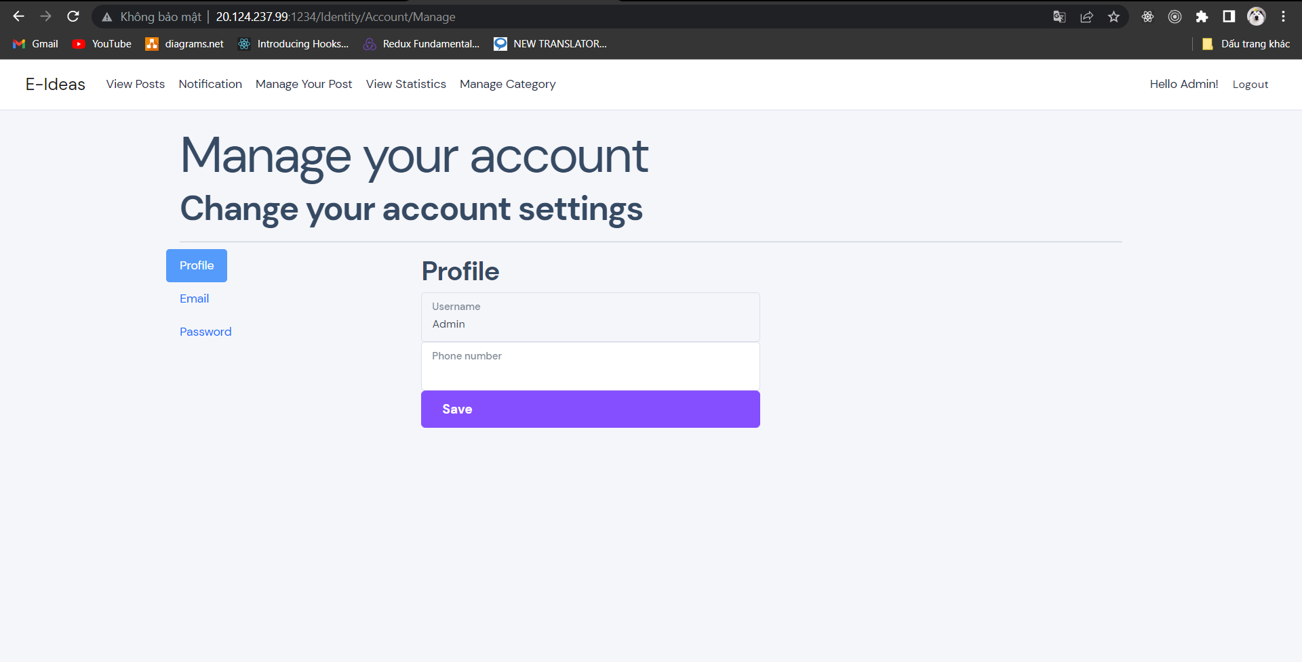

Figure : Admin Interfaces on desktop

**Mobile**:

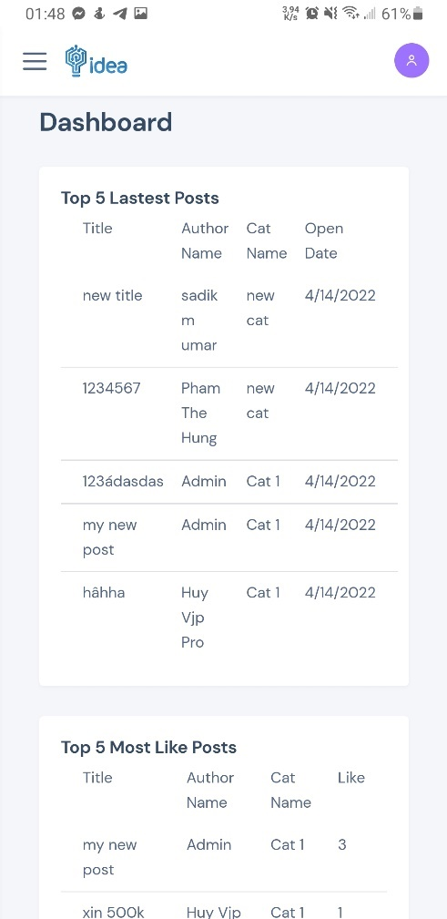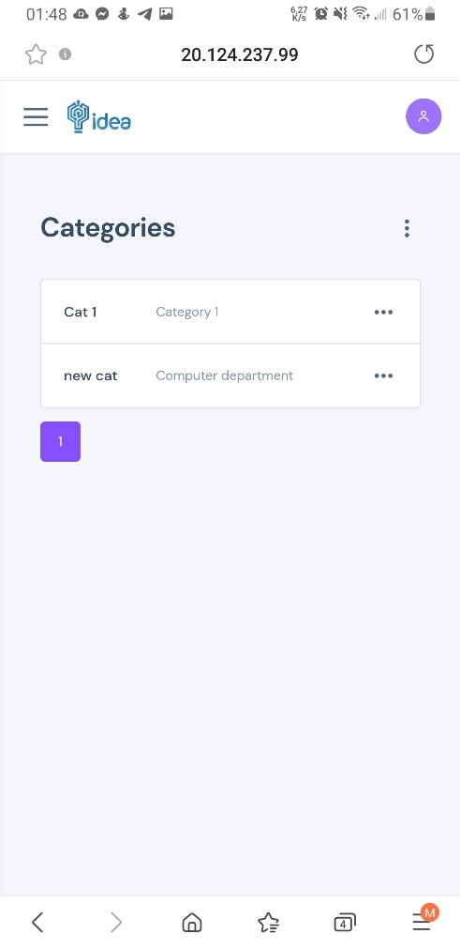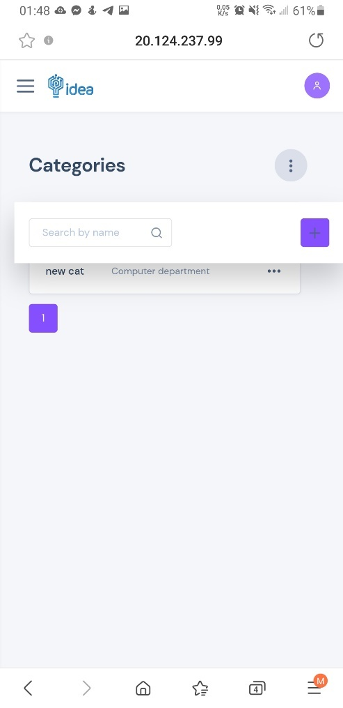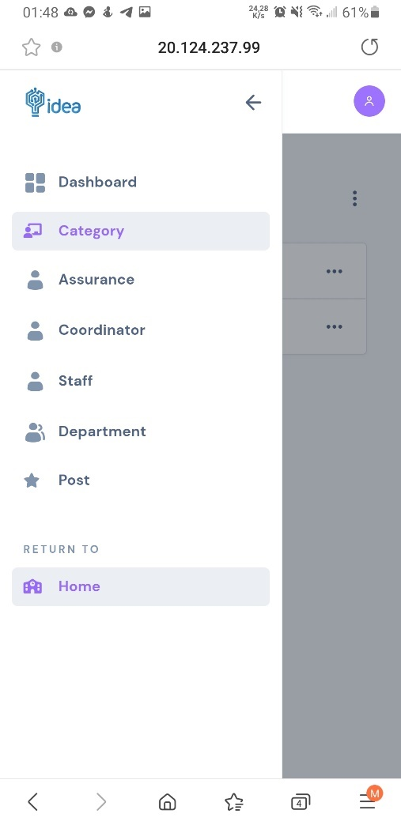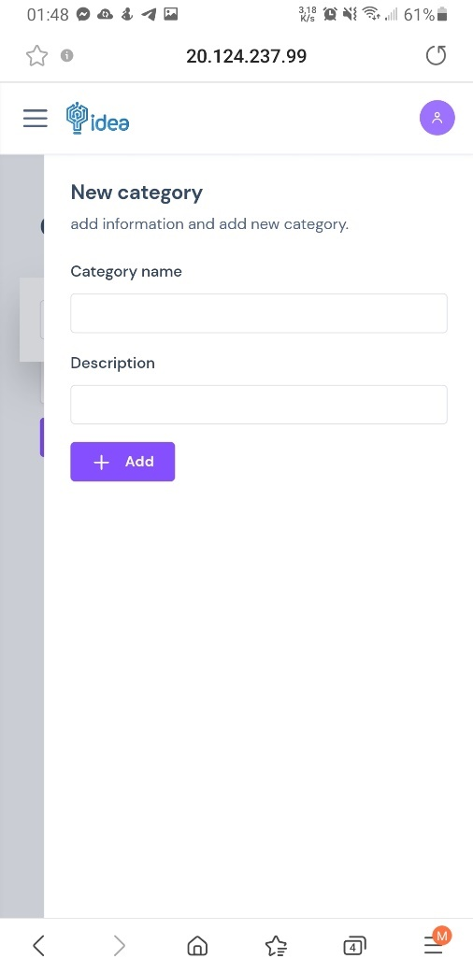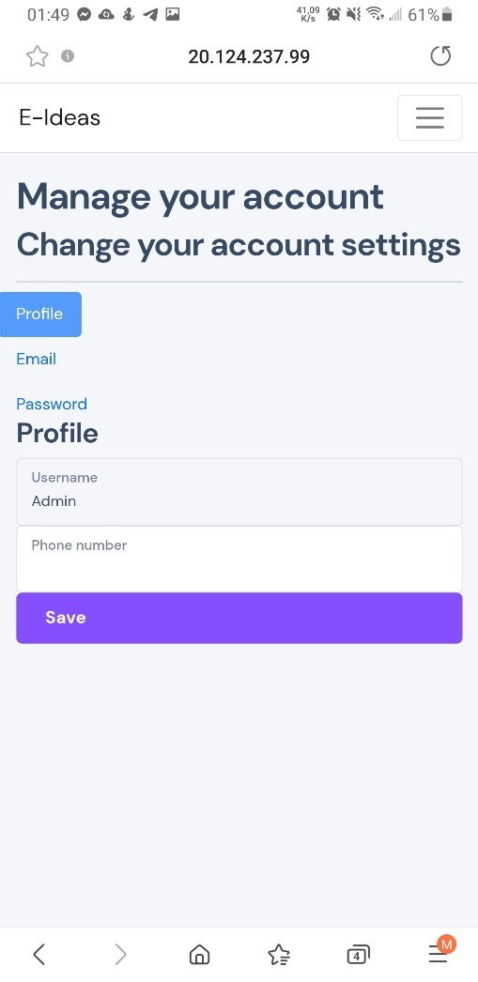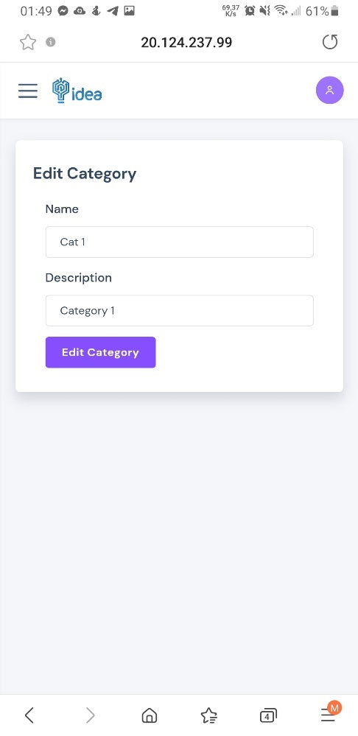

Figure : Admin Interfaces on mobile

### User Page Interfaces

**Desktop**:

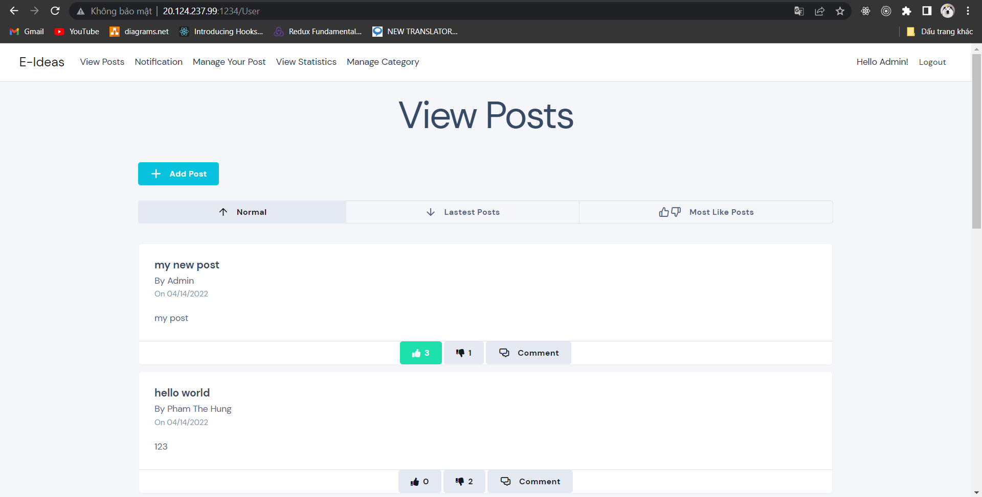

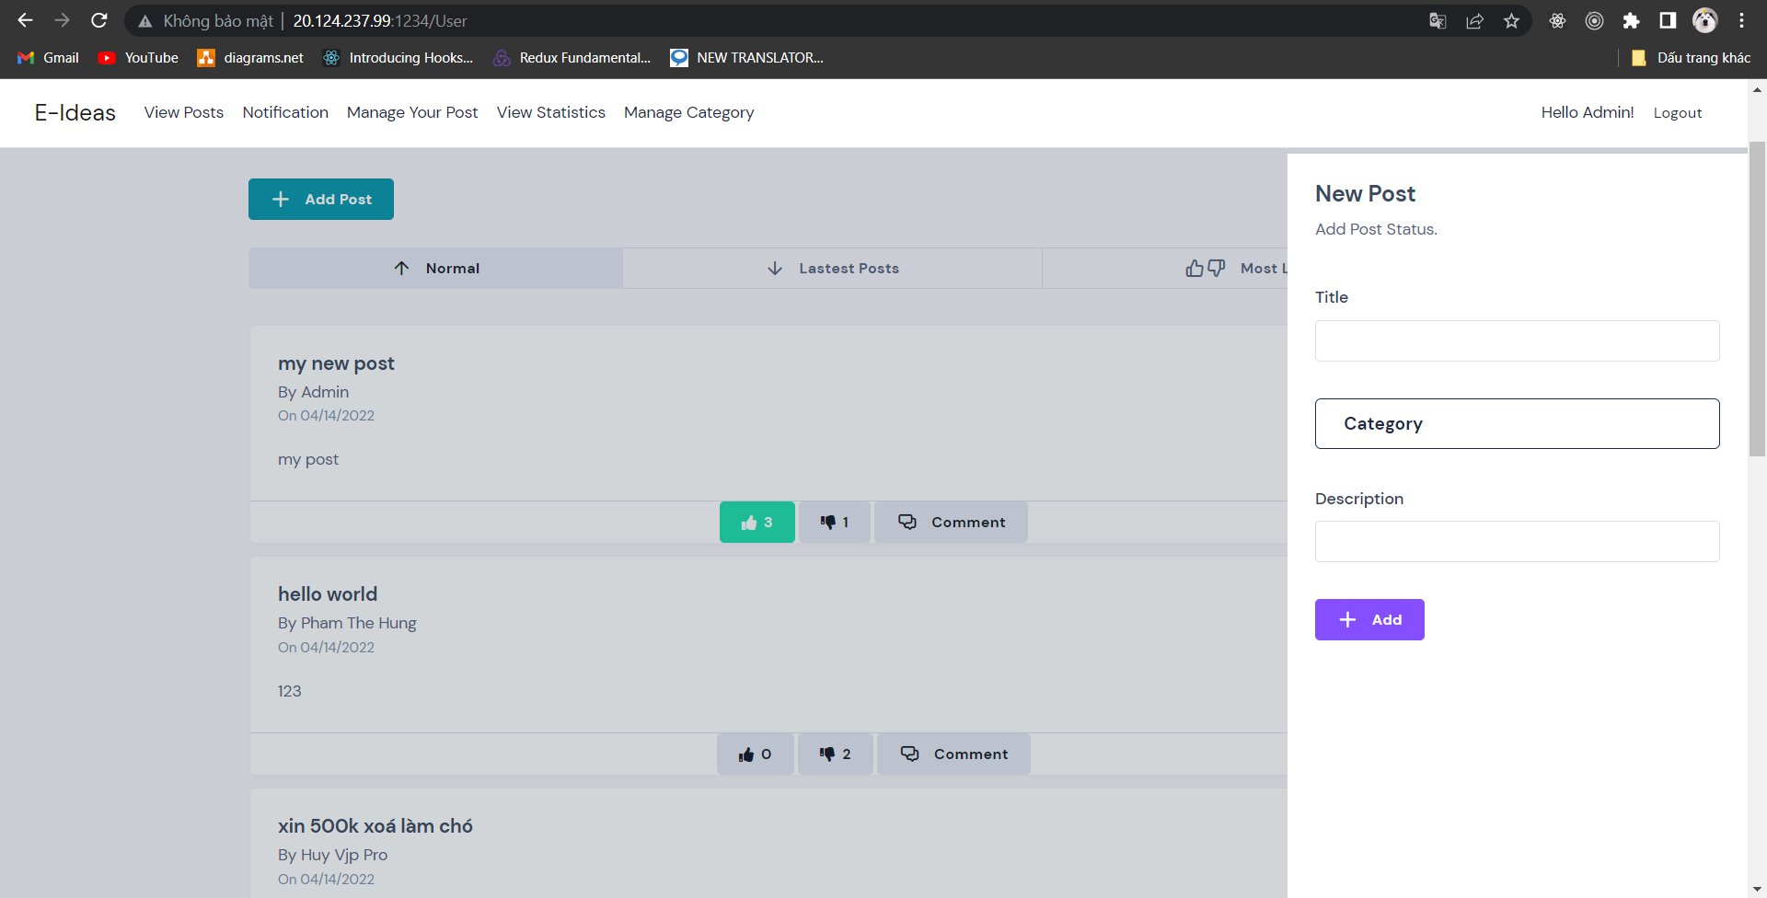

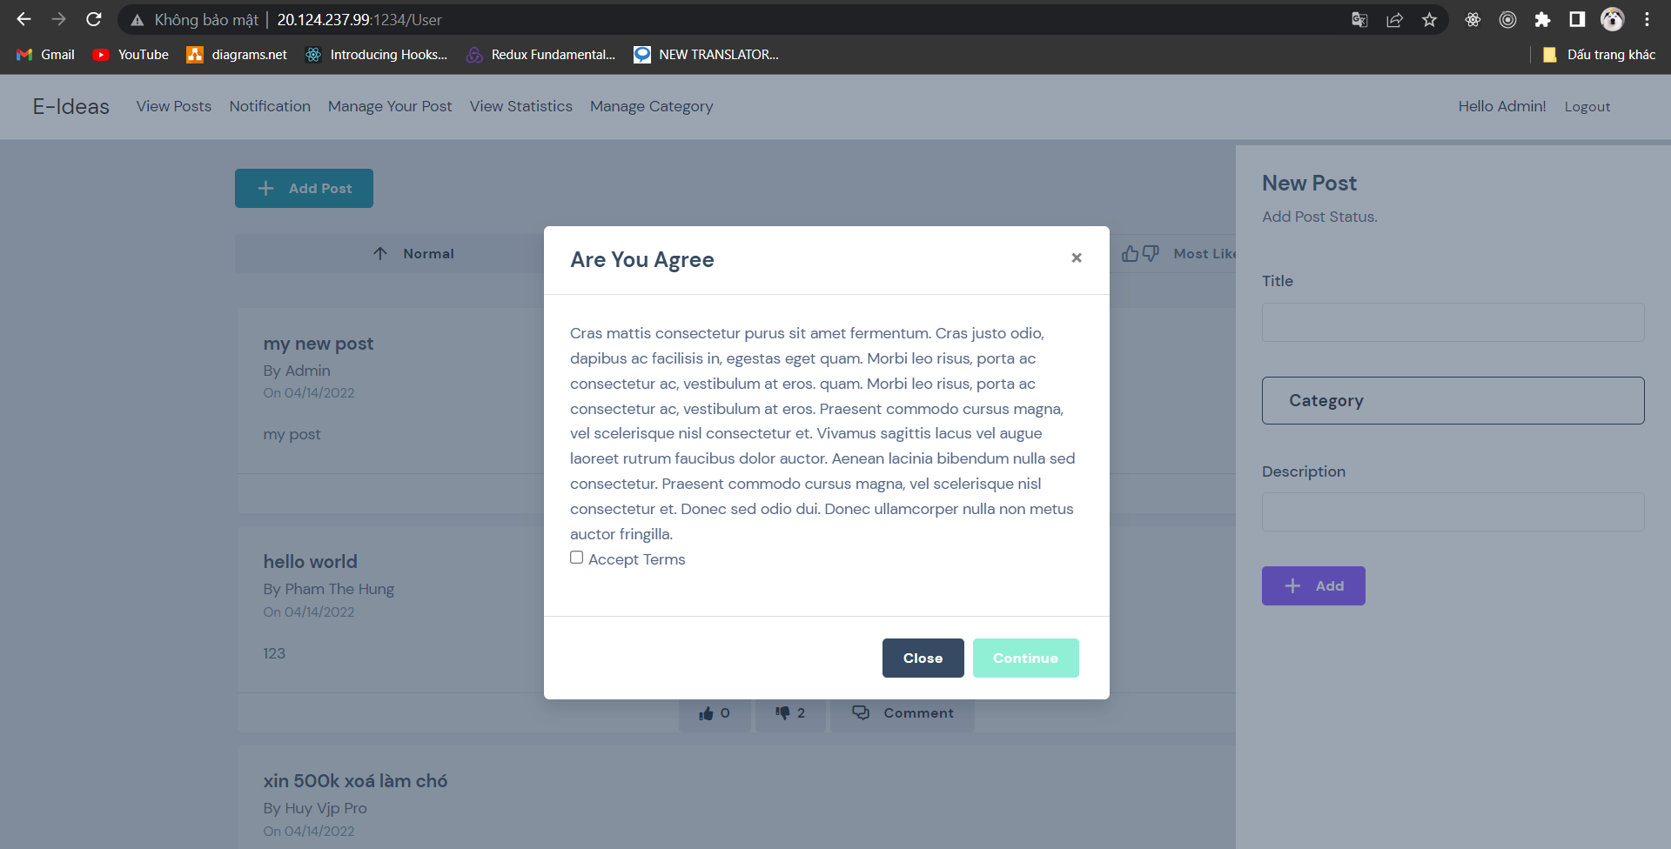

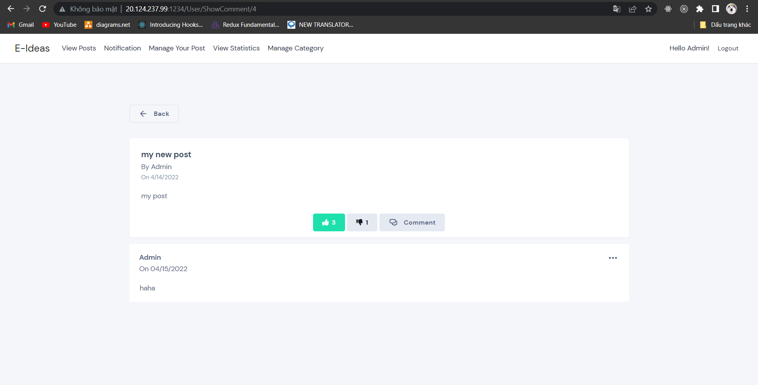

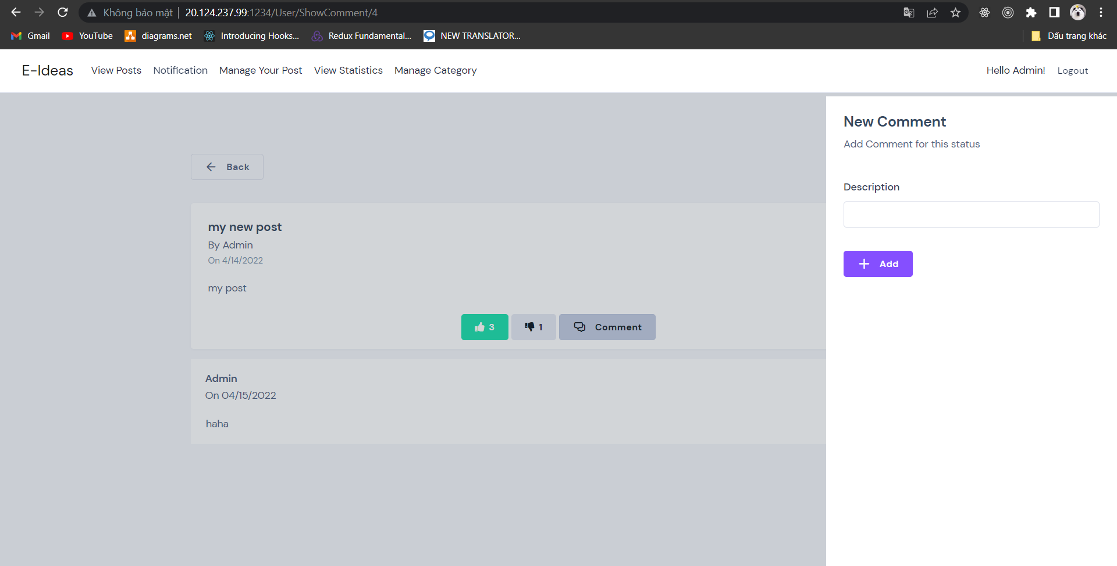

Figure : User interfaces on desktop

**Mobile**:

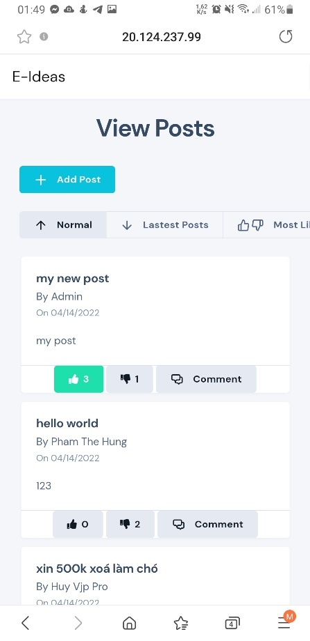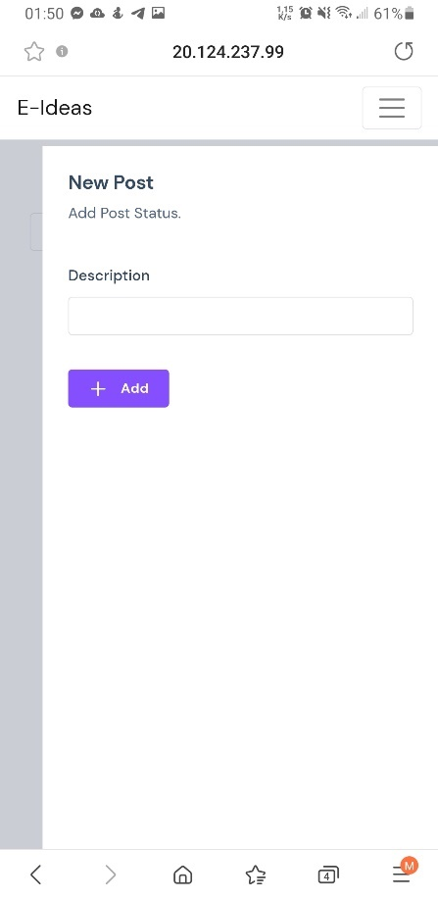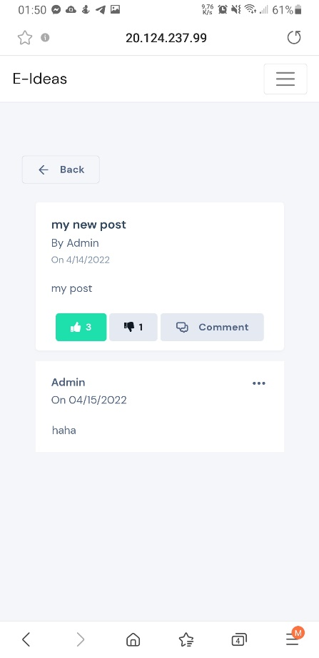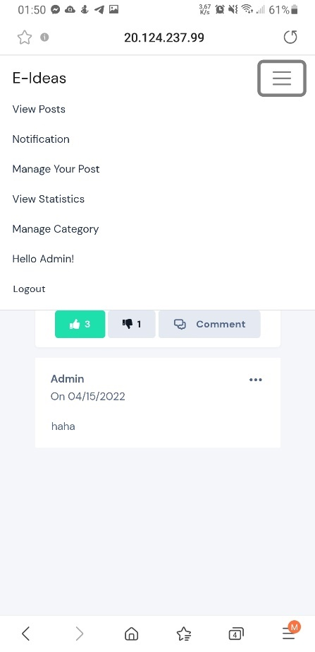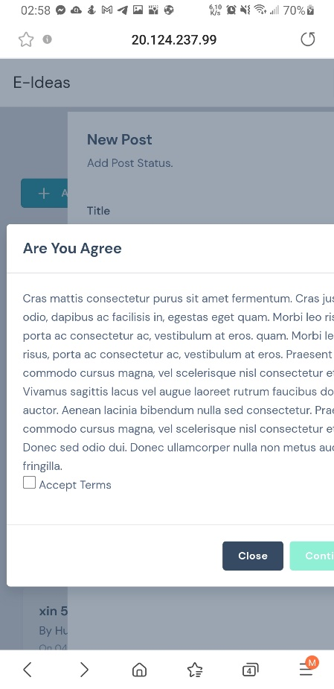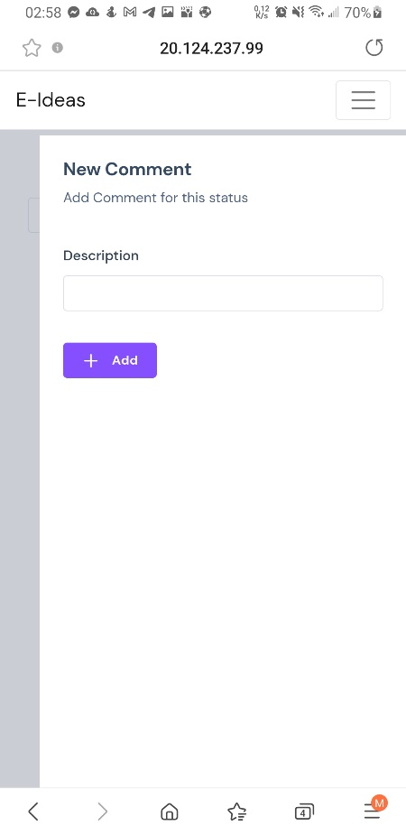

Figure : User interfaces on mobile

### Assurance Interface

**Desktop**:

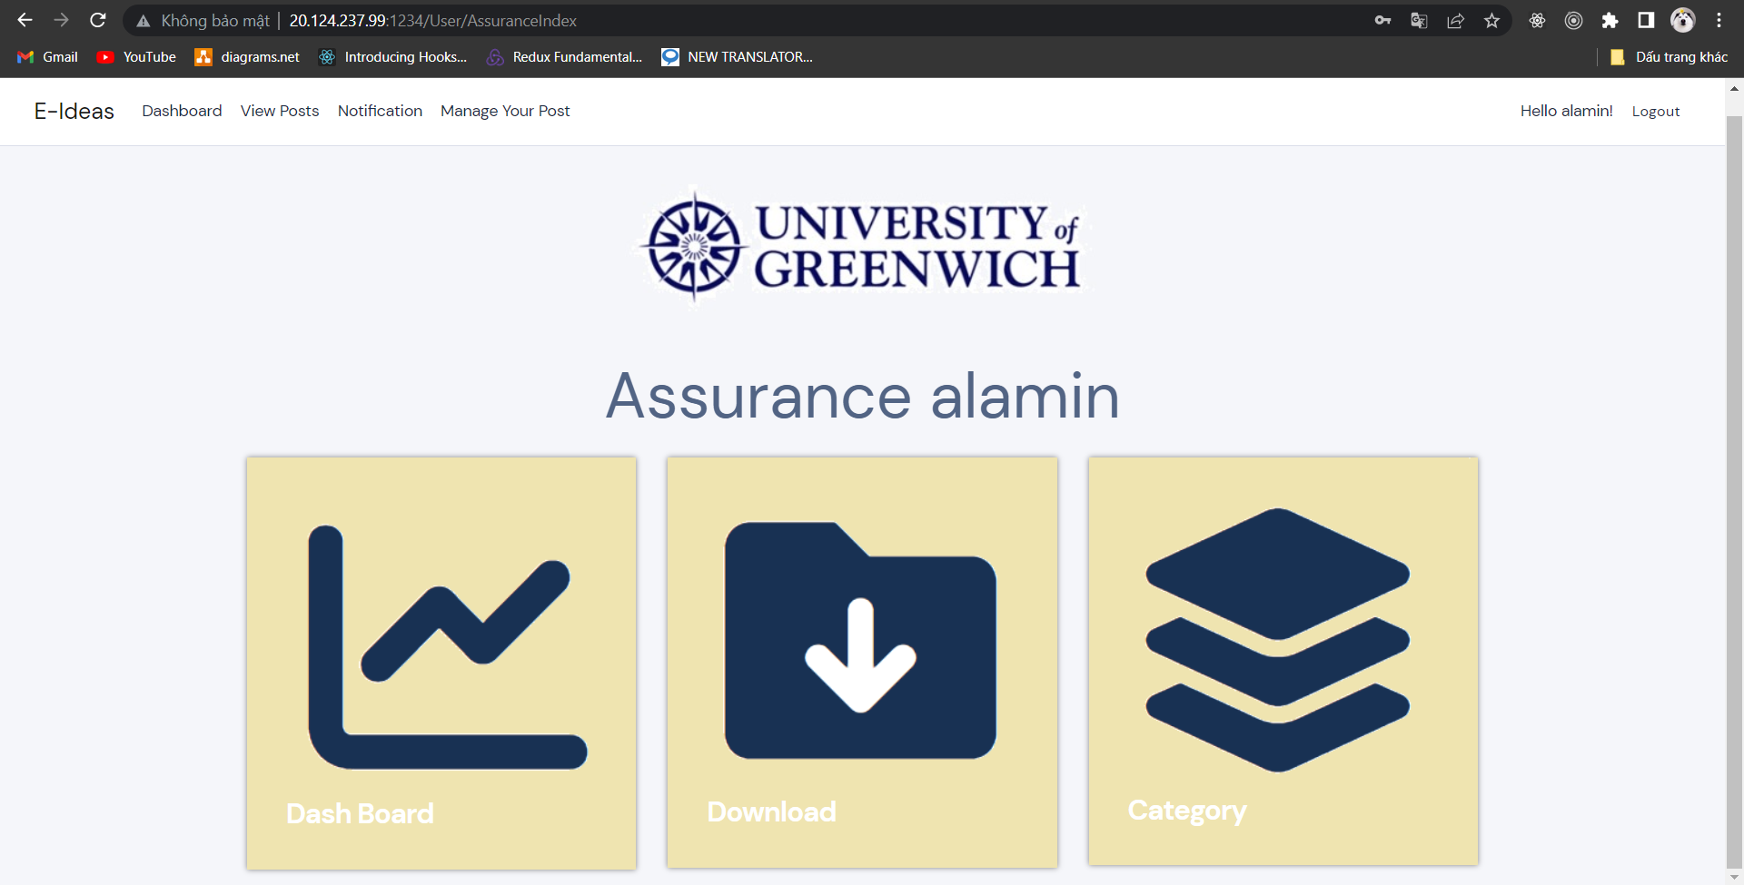

Figure : Assurance interface on desktop

**Mobile**:

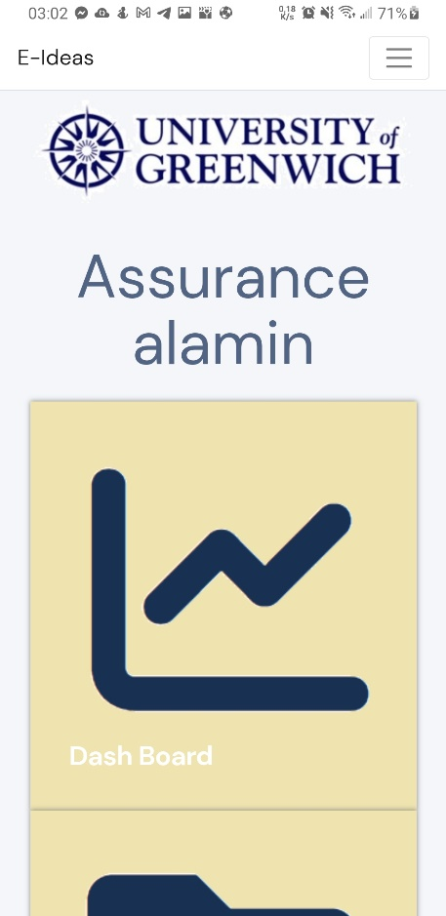

Figure : Assurance Interface Mobile

### Interfaces Test Summary

After interfaces test for 2 platforms is mobile and desktop, the summarize result of testing phase are:

* All interfaces are working very well on desktop.
* Most of interfaces are working good add 2 platforms.
* User interfaces has some bad responsive on mobile as same as User page view idea, term box, and sort idea bar.