BharatTrip Refund Escalations: Business Case & Solution Proposal
Executive Summary (TL;DR) BharatTrip is experiencing a spike in customer/agent refund escalations despite stable refund volumes. Our analysis identified a severe operational disconnect between Support and Finance, leading to 100 dropped tickets and 149 short payments. By implementing a Single Source of Truth (SSOT) and an AI-Driven Data Reconciliation Workflow, we can eliminate manual data leakage, automate agent communications, and project an 80% drop in escalations over the next quarter without adding headcount.

1. Defining the Problem
Customer and agent escalations regarding refunds are rising. The core underlying problem is a severe operational disconnect between the Support and Finance teams, characterized by siloed tracking systems and inconsistent definitions of refund statuses.

Key Communication Failures:
- Data Leakage: Informal requests via WhatsApp and Email bypass the tracker altogether, meaning they are never reviewed or processed.
- “Closed” Status Ambiguity: The Support team marks tickets as “Closed” once handed off to Finance, misleading the agent into believing the refund has been disbursed.
- Hidden Policy Deductions: Finance applies necessary deductions (e.g., cancellation fees) and processes payouts, but this information is never relayed back to the agent by Support, causing “short payment” escalations.

2. Data Analysis & Insights
By cross-referencing the Support_Tracker, Finance_Tracker, and Escalations logs via a deep database join, we identified the specific patterns driving the 155 total escalations.
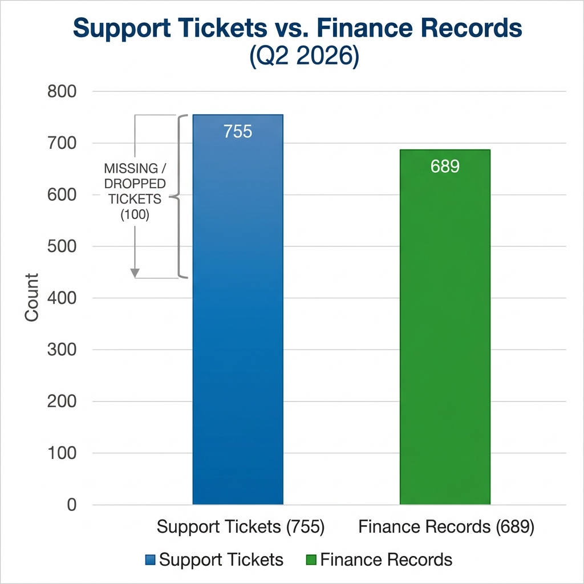
Metrics Data Leakage Visualization

The Discrepancy Breakdown
Escalation Driver | Ticket Volume | Description
Dropped Handoffs | 100 | Logged by Support, but entirely missing from Finance tracking.
Deduction Mismatches | 149 | Amount promised by Support differs from amount disbursed by Finance.
Off-Tracker Leakage | 24 | Escalations with “no ref” originating from unlogged WhatsApp/Email.
Asynchronous Closure | 47 | Processed by Finance but missing from Support.
Insight: While a naive net volume calculation (755 Support - 689 Finance) suggests only 66 missing tickets, our deep ID-to-ID database reconciliation reveals the true scale of the failure is 100 dropped tickets, masked by duplicate records and asynchronous closures.

3. Designing a Zero-Headcount Solution
To permanently bring escalations down, BharatTrip must establish a unified Single Source of Truth (SSOT) and automate the communication loop.

The Proposed Workflow:
- Unified SSOT Tracking: Migrate both teams onto a single shared database.
- AI-Powered Ingestion: Deploy an AI agent to monitor the Support Email and WhatsApp. The AI will parse unstructured messages and log them as structured tickets, eliminating “no ref” leakage.
- Automated Communication: A system trigger automatically emails the travel agent when the status changes to Paid, detailing the exact payout amount and any deductions.
- Strategic Trade-offs: We automate data entry and outbound communication, but deliberately keep Finance payout execution and Support’s initial vetting manual to ensure strict financial compliance.

4. The AI Prototype: Advanced Multi-Agent Architecture
To deliver a production-ready solution, I have developed app.py, a zero-friction Streamlit Web Application showcasing an advanced Multi-Agent architecture powered by gemini-3.5-flash.
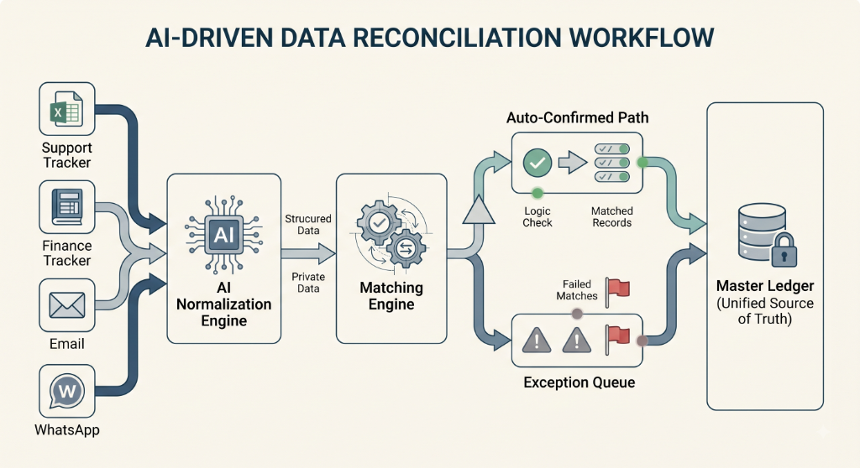
System Architecture Flowchart

Secure Integration (MCP)
In a production environment, the LLM will bridge with the internal SSOT database via the Model Context Protocol (MCP). This guarantees that raw database credentials are never exposed to the LLM’s context window, ensuring enterprise-grade security while allowing the AI to read/write records.

The Prototype Features
- Metrics Dashboard: Live KPIs tracking Escalations and Discrepancies to prove ROI.
- HITL Workflow: A UI for support staff to review AI-generated explanatory messages before they are sent to external agents.

5. Measuring Success
To ensure the solution is working, we will monitor two primary metrics over the next month: 1. Escalation Rate: The percentage of refund requests that result in a formal escalation. Target: >50% drop within 30 days. 2. Tracker Discrepancy Count: The number of tickets marked “Closed” by Support without a matching payout record in Finance. Target: Zero.

