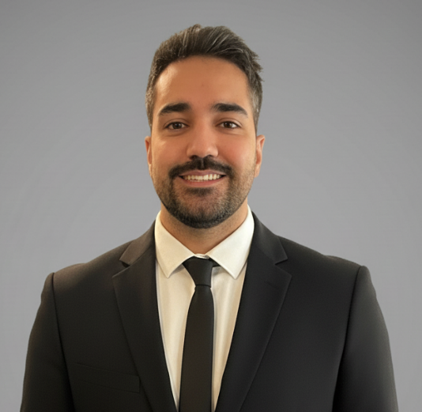
Volkan Kilinc, Ph.D.
Polyvalent Scientist & Entrepreneur
Age: 32 years
French & Turkish citizen
contact@researchvyk.com
+33 7 68 73 93 91
ORCID: https://orcid.org/0009-0006-4402-1024
Google Scholar: https://scholar.google.com/citations?user=RzkSCecAAAAJ&hl=en
GitHub: https://github.com/vktr93
Website: www.researchvyk.com

Polyvalent and autonomous Ph.D. with entrepreneurship mindset and core expertise in hardware development (chemical sensors), soft-material and surface chemistry. Soft skills in full-stack application development with vibe-coding. I have a proven ability to lead complex projects from concept to peer-reviewed publication, secure competitive international funding, and write patents. I now bridge deep science with AI technologies. Most recently, I directed generative AI to deploy Open AI Science, a multi-agent platform for automated scientific peer-review. I am seeking to apply this unique blend of scientific expertise and AI product development to solve high-impact challenges in science.

CORE COMPETENCIES

Scientific Expertise: Biosensors & Field-Effect Transistors (FETs); Surface Chemistry & Functionalization; Drug Delivery & Molecular Encapsulation; Soft Materials (DNA, lipids) & Polymer Science; Analysis Chemistry (Chromatography, Spectroscopy, Microscopy)

Software Skills: Generative AI for full-stack coding; Python script; SQL database management; Web Sockets real-time interactivity; Cloud deployment; Website management; JavaScript game development; Canva video generation.

Project Management: Full lifecycle scientific project management (concept to peer-reviewed publication), Grant writing for funding acquisition, Patent writing, Company creation.

RESEARCH EXPERIENCE

Researcher (JSPS Postdoc Fellowship and Invited Researcher) at NIMS, Tsukuba, Japan, 04/2022 – 04/2025
Supervisor: Dr. Jonathan P.Hill
Contribution: Secured a highly competitive ¥3M JSPS Postdoctoral Fellowship to pioneer the use of DNA Field-Effect Transistors (DNA-FETs) for data storage applications. Managed the full research lifecycle, resulting in corresponding-author publications and patent filing. Invited Researcher from January to April 2025 to work on research initiatives in DNA-based 2D materials and drug delivery systems.

Junior Researcher (PhD) at CINaM, Marseille, France, 03/2017 – 05/2020
Supervisors: Dr. Charrier and Prof. Raimundo
Contribution: I developed cesium sensor working in seawater for radioactive pollution purpose. I chemically synthesized molecules selective toward cesium used as probes. I designed organic nanoscale interface based on lipids/semi-conductive polymer. I made field-effect transistor-based sensor and performed sensing measurements.

Internship at ABB Corporate Research, Baden, Switzerland, 03/2016 – 09/2016
Supervisor: Dr. Di Gianni
Contribution: I thermally aged materials under electrically insulating gas and characterized by GC-MS, FTIR and tensile tests. I performed quality control and failure analysis of materials by SEM observation and XRD.

Internship at Nagaoka University of Technology, Nagaoka, Japan, 06/2015 – 09/2015
Supervisor: Dr. Maekawa
Contribution: I worked on new cross coupling reaction in organic chemistry, from synthesis to purification.

TRANSVERSAL EXPERIENCE

Independent Full-stack Application Developer, Paris, France, 06/2025 - Present
Open AI Science - AI-Powered Scientific Peer Review Platform: Conceived, designed, and engineered "Open AI Science," (https://www.openaiscience.com) a full-stack web application (Python) that uses a multi-agent AI system to automate and enhance the scientific peer-review process.
Crypto Gaming App - RoadToMars: Directed a generative AI (Gemini) to architect and build a full-stack, real-time Web3 application on the Solana blockchain (https://www.roadtomars.app/).
YouTube Channel - Giggle&GuessTV: Created YT channel publishing quiz games for kids.

CTO & co-founder at Gensor, Paris, France, 06/2021– 06/2023
Co-founded a deep-tech startup to commercialize a proprietary virus testing platform based on gene field-effect transistor technology.Secured non-equity funding and mentorship by gaining acceptance into the competitive MassChallenge global accelerator program.

Project Manager at CNRS Innovation, Paris, France, 01/2021– 01/2022
Manager: Miranda Delmotte
Contribution: Performed due diligence on early-stage (TRL 1-2) research projects to assess commercial viability and guide funding strategy. Developed technology valorization roadmaps by conducting market analysis, end-user needs assessment, and intellectual property (IP) analysis.
I supported researchers in writing their European funding applications (EIC Transition, ERC POC) and defined a roadmap of appreciation of their projects.

RESEARCH PROJECTS

DNA-FET for High-Speed Data Retrieval | Lead Researcher & Inventor
Developed and fabricated a proof-of-concept DNA Field-Effect Transistor (FET), demonstrating a novel, non-destructive electronic method for data location in DNA data storage. Validated the sensor's high performance, leading to a principal authored publication in Advanced Sensor Research and a Japanese patent application on the core technology. This foundational work established the basis for a next-generation platform envisioned to integrate multi-sensor arrays with an AI-powered indexing engine for large-scale, random-access data retrieval.

DNA-pods: Biomimetic Nanocarriers for Drug Delivery | Lead Researcher & Inventor
Designed and synthesized "DNA-pods," a novel class of self-assembled DNA condensates, as a cost-effective platform for therapeutic delivery. Engineered a unique, thermally-triggered exfoliation mechanism inspired by viral uncoating to enable stimulus-responsive payload release. Validated the platform by demonstrating efficient encapsulation of doxorubicin and its preferential localization within the nucleus of fixed cancer cells leading to a principal authored publication in ACS Chemistry of Materials.

EDUCATION

PhD Université Aix-Marseille, Nanoscience and condensed materials, 05/2020
Title of the thesis: « Development of Organic Field-Effect Transistor for the detection of cesium in seawater »
MSc Université Paris-Est Créteil, Polymer science (magna cum laude), 09/2016
BSc Université Paris-Est Créteil, Biology & Chemistry (magna cum laude), 09/2014
3rd year at Universidad de Murcia in Spain (Erasmus exchange program)

HIGHLIGHTED PUBLICATIONS & PATENTS

Kilinc, V*. et al., ACS Chemistry of Materials, 2026
Kilinc, V*. et al. ChemRxiv, 2025, 10.26434/chemrxiv-2025-9q3xk
Kilinc, V*. et al. Adv. Sensor Research, 2024, 3, 5,2300176, 10.1002/adsr.202300176
Nguy, T.P. ; Kilinc, V. (co-first author) et al. Sensors and Actuators B: Chemical, 2022, 351, 130956 10.1016/j.snb.2021.130956
Kilinc, V. et al. ACS Appl. Mater. Interfaces 2019, 11, 50, 47635-47641 10.1021/acsami.9b18188
Kilinc, V.* et al. “Dna detection substrate, fet-type dna sensor including the same, and method for manufacturing dna detection substrate”, JP, JP2025098524A, 2025
Wakayama, Y; Kilinc, V. et al. “Alkali metal ion detection sensor and radioactive cesium ion detection sensor”, JP, JP2022052613A, 2022

Total publications: 10 First authored: 5 Principal authored*: 3
Total patents: 2 First authored: 1

CONFERENCES & WORKSHOPS
Presented research at over 10 international conferences and workshops, including 5 oral presentations (one as an invited speaker) and a poster presentation to Nobel Laureates at the prestigious 15th HOPE Meeting in Kyoto (Japan).

GRANTS & AWARDS

Invited researcher at NIMS (Japan) 2025
15th HOPE Meeting with Nobel Laureates – Participation Award 2024
JSPS Postdoctoral Fellowship (P21747) – 3M ¥ 2022
Poster Award Giornate Italo-Francesi di Chimica (GIFC) 2018

