Upload csv_file and ask single question:
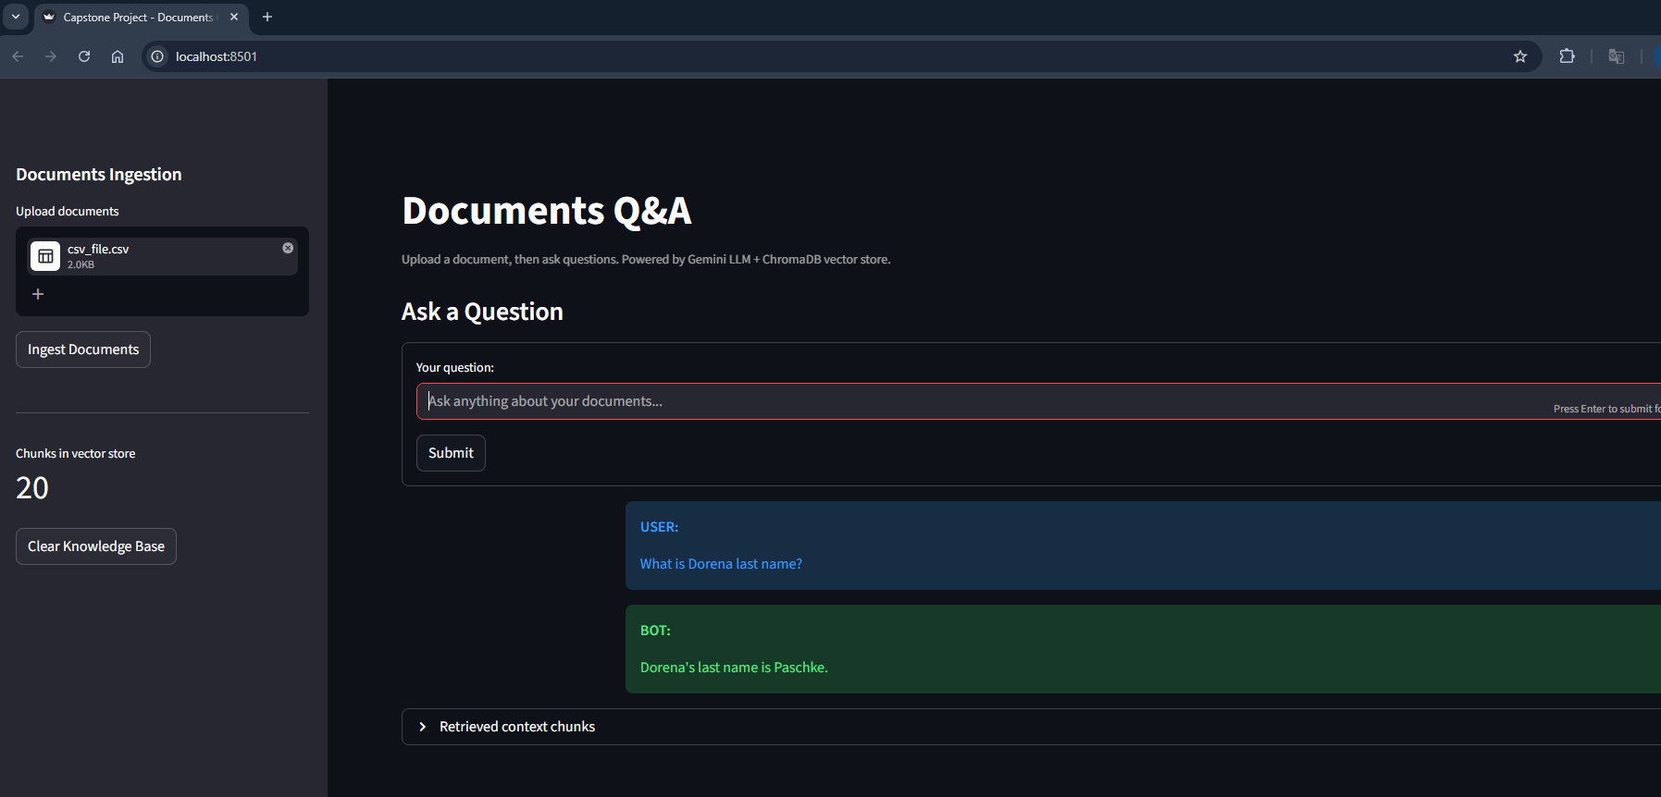

Upload csv_file and ask multiple question:
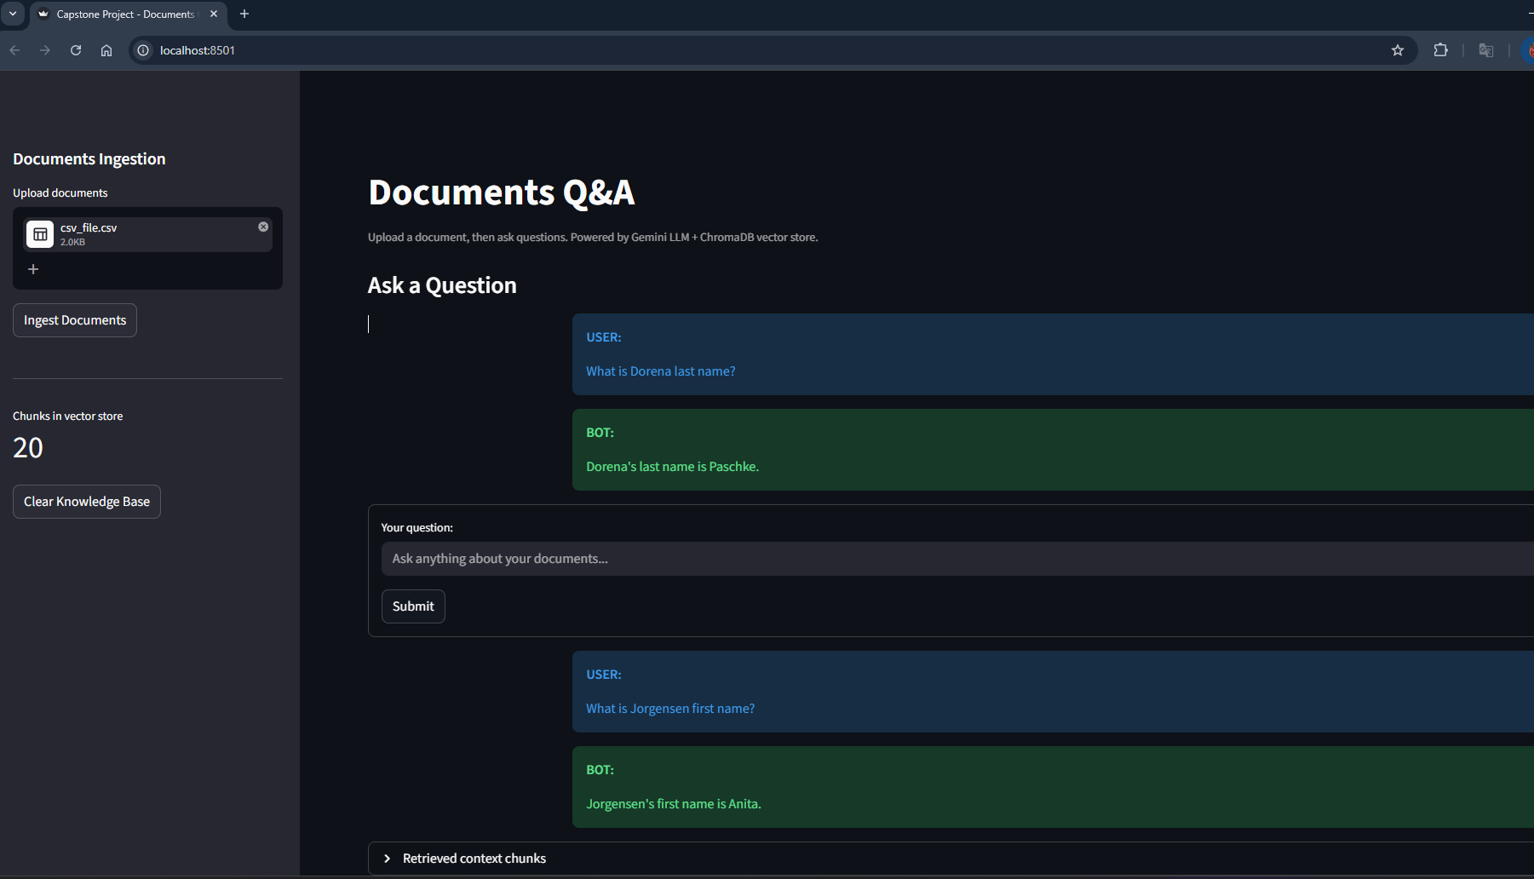

Upload excel_file and ask single question:
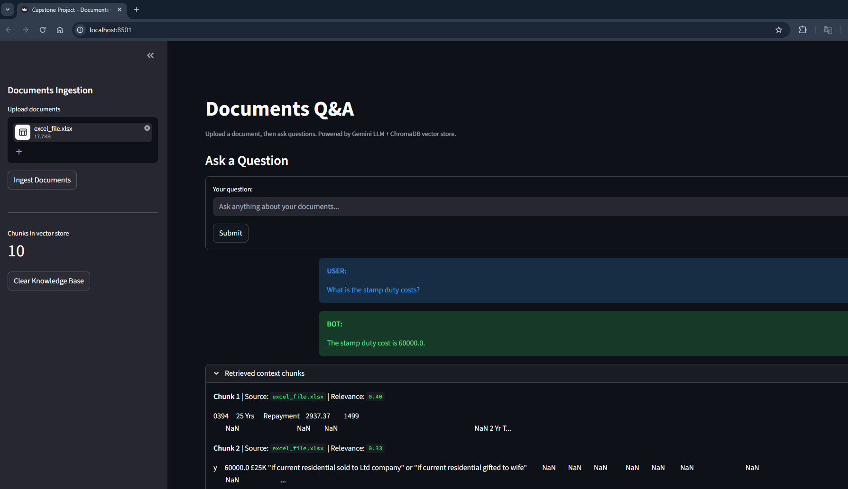

Upload excel_file and ask multiple question:
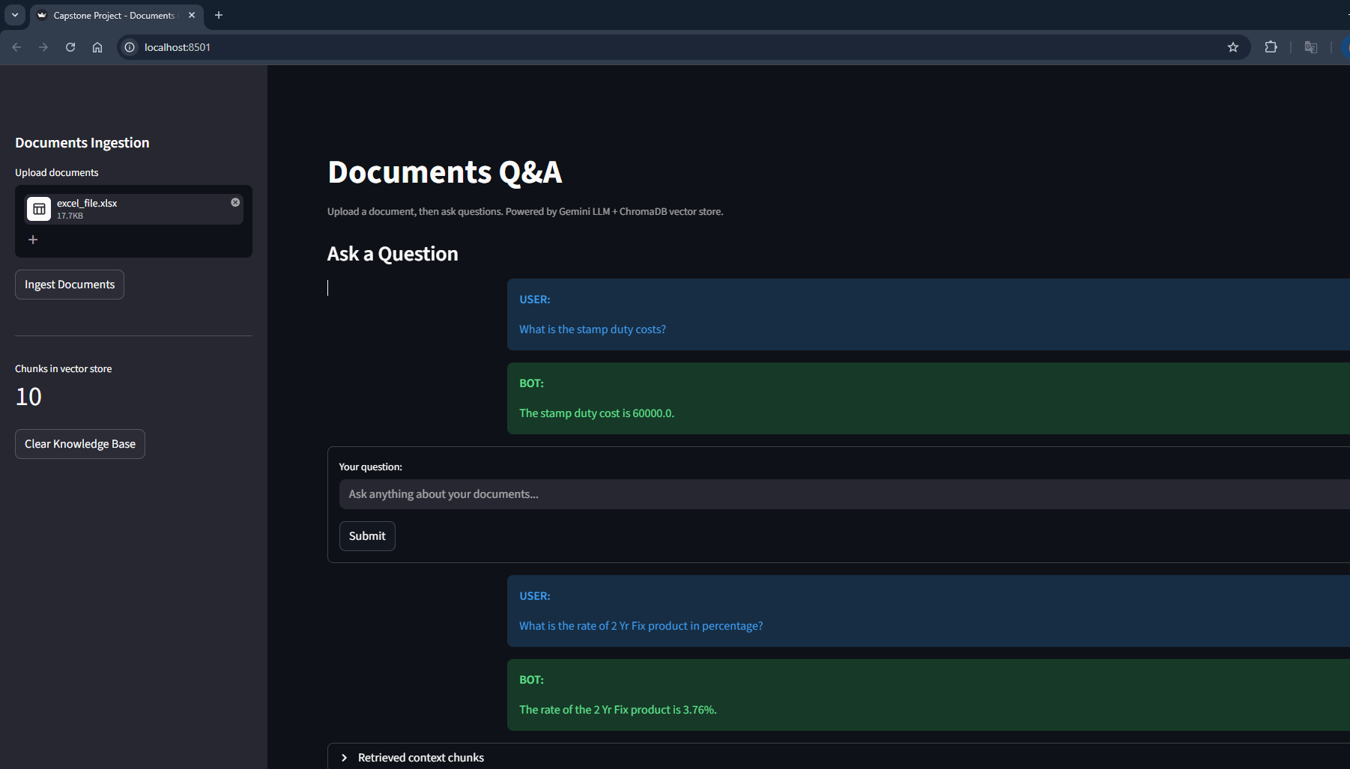

Upload text_file and ask single question:
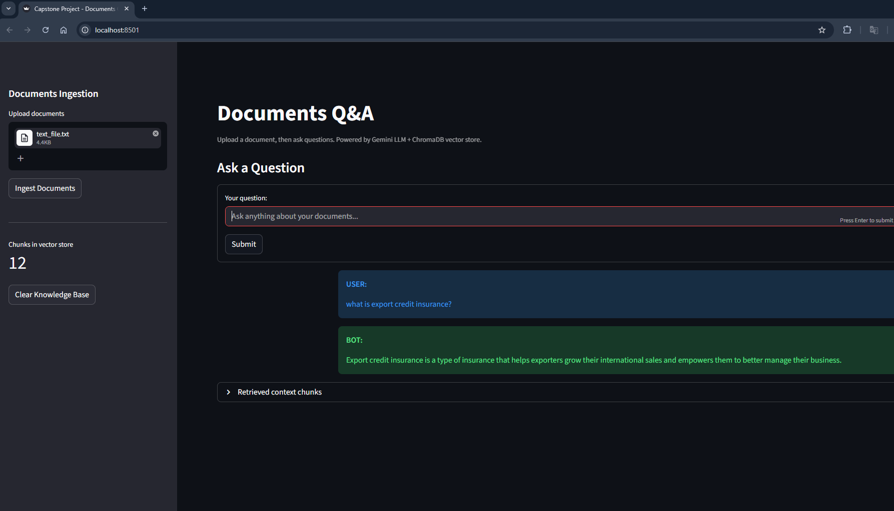

Upload text_file and ask multiple question:
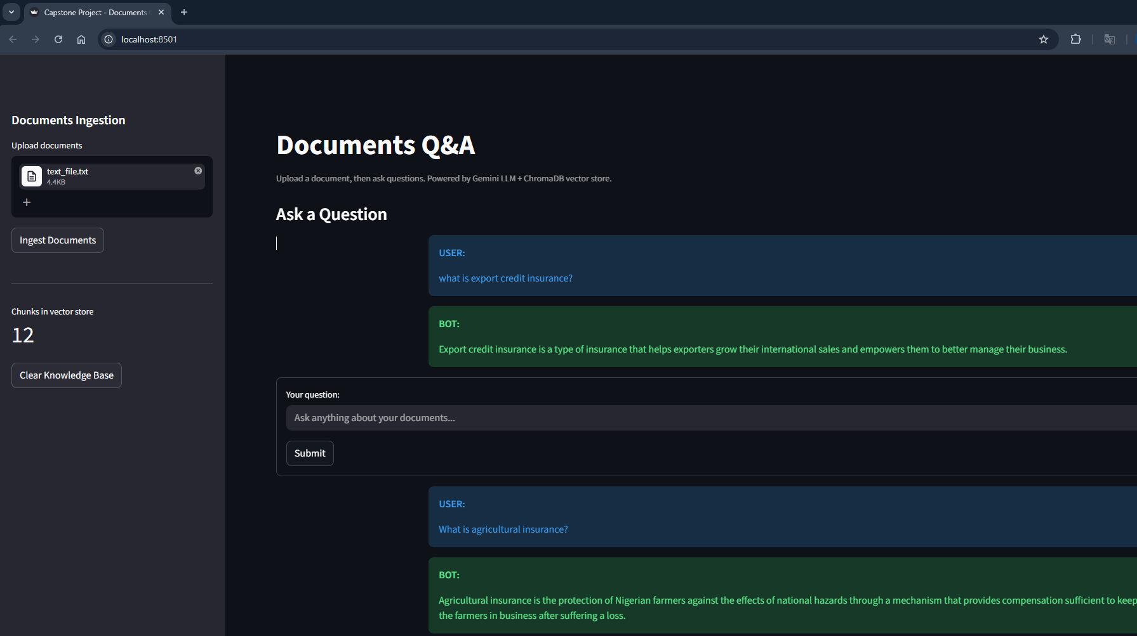

Upload pdf_file and ask single question:
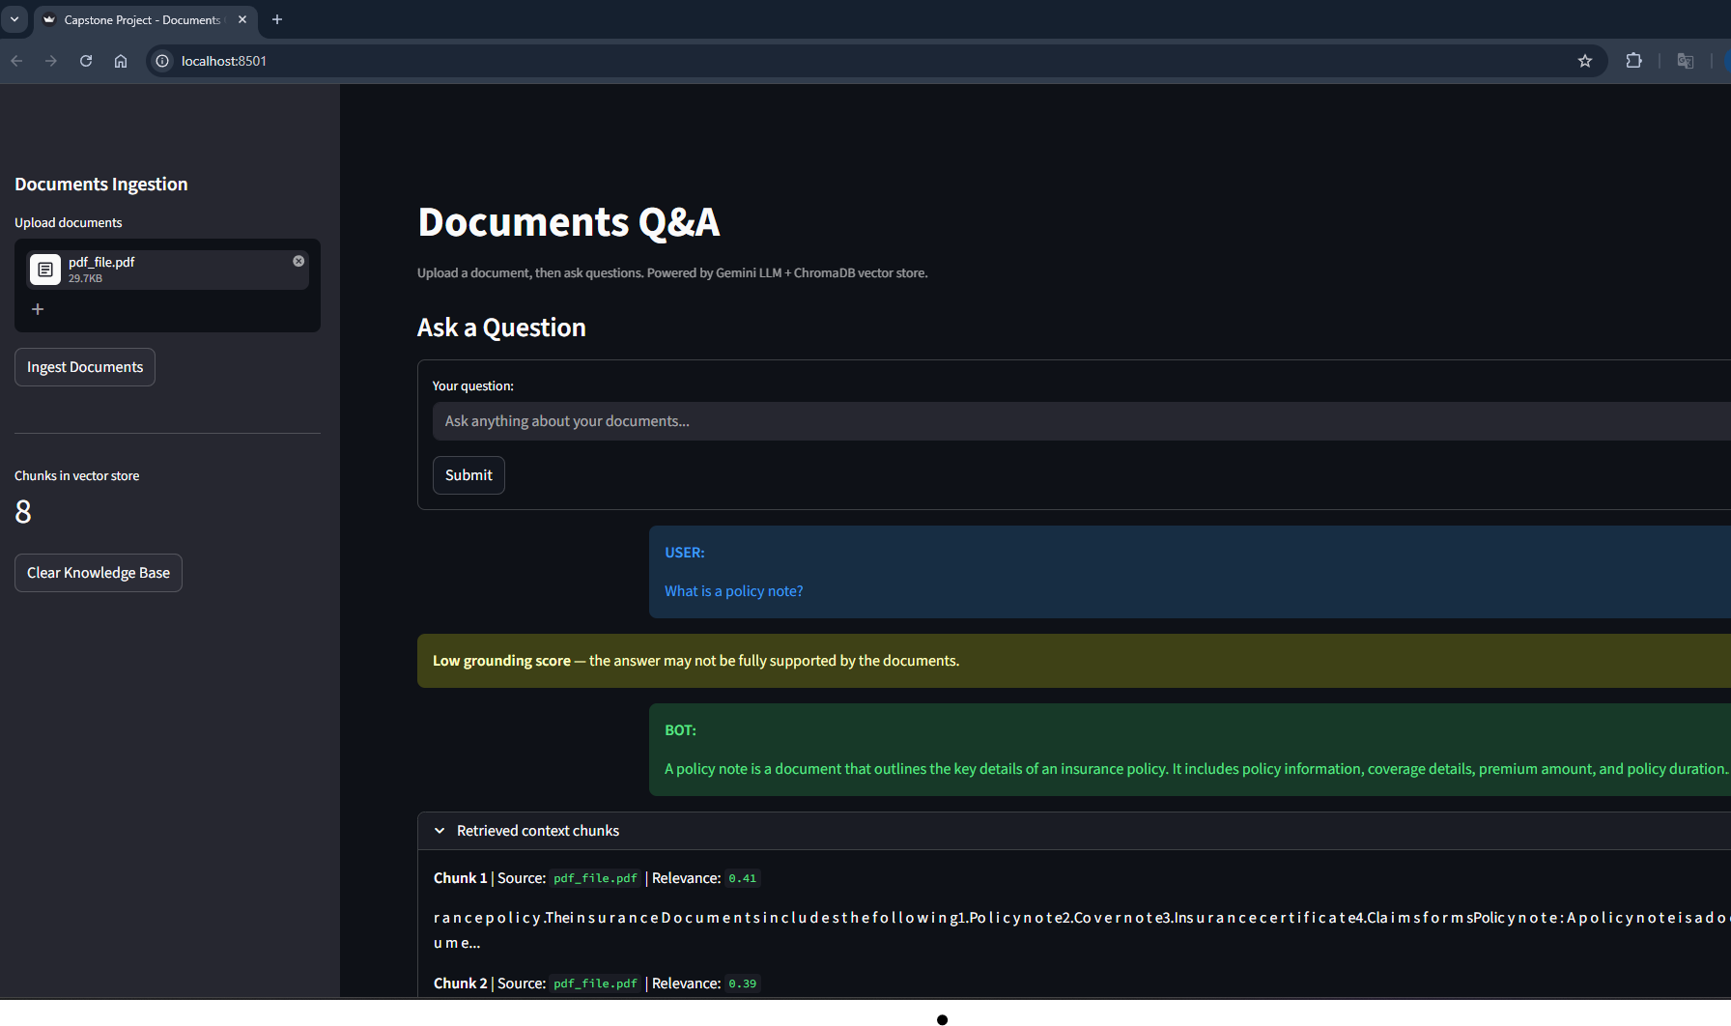

Upload pdf_file and ask multiple question:
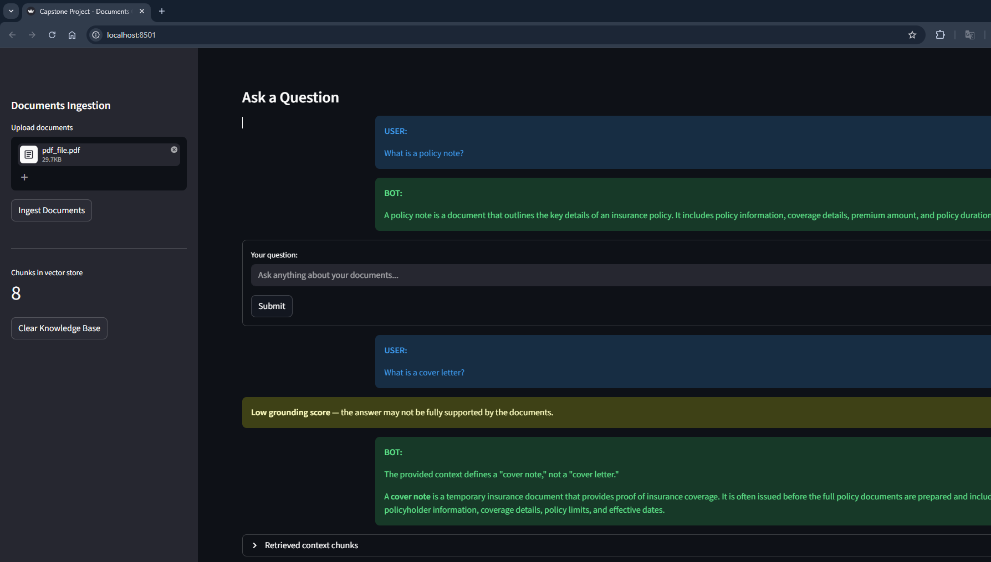

Upload csv_file, excel_file, text_file, pdf_file and ask single question:
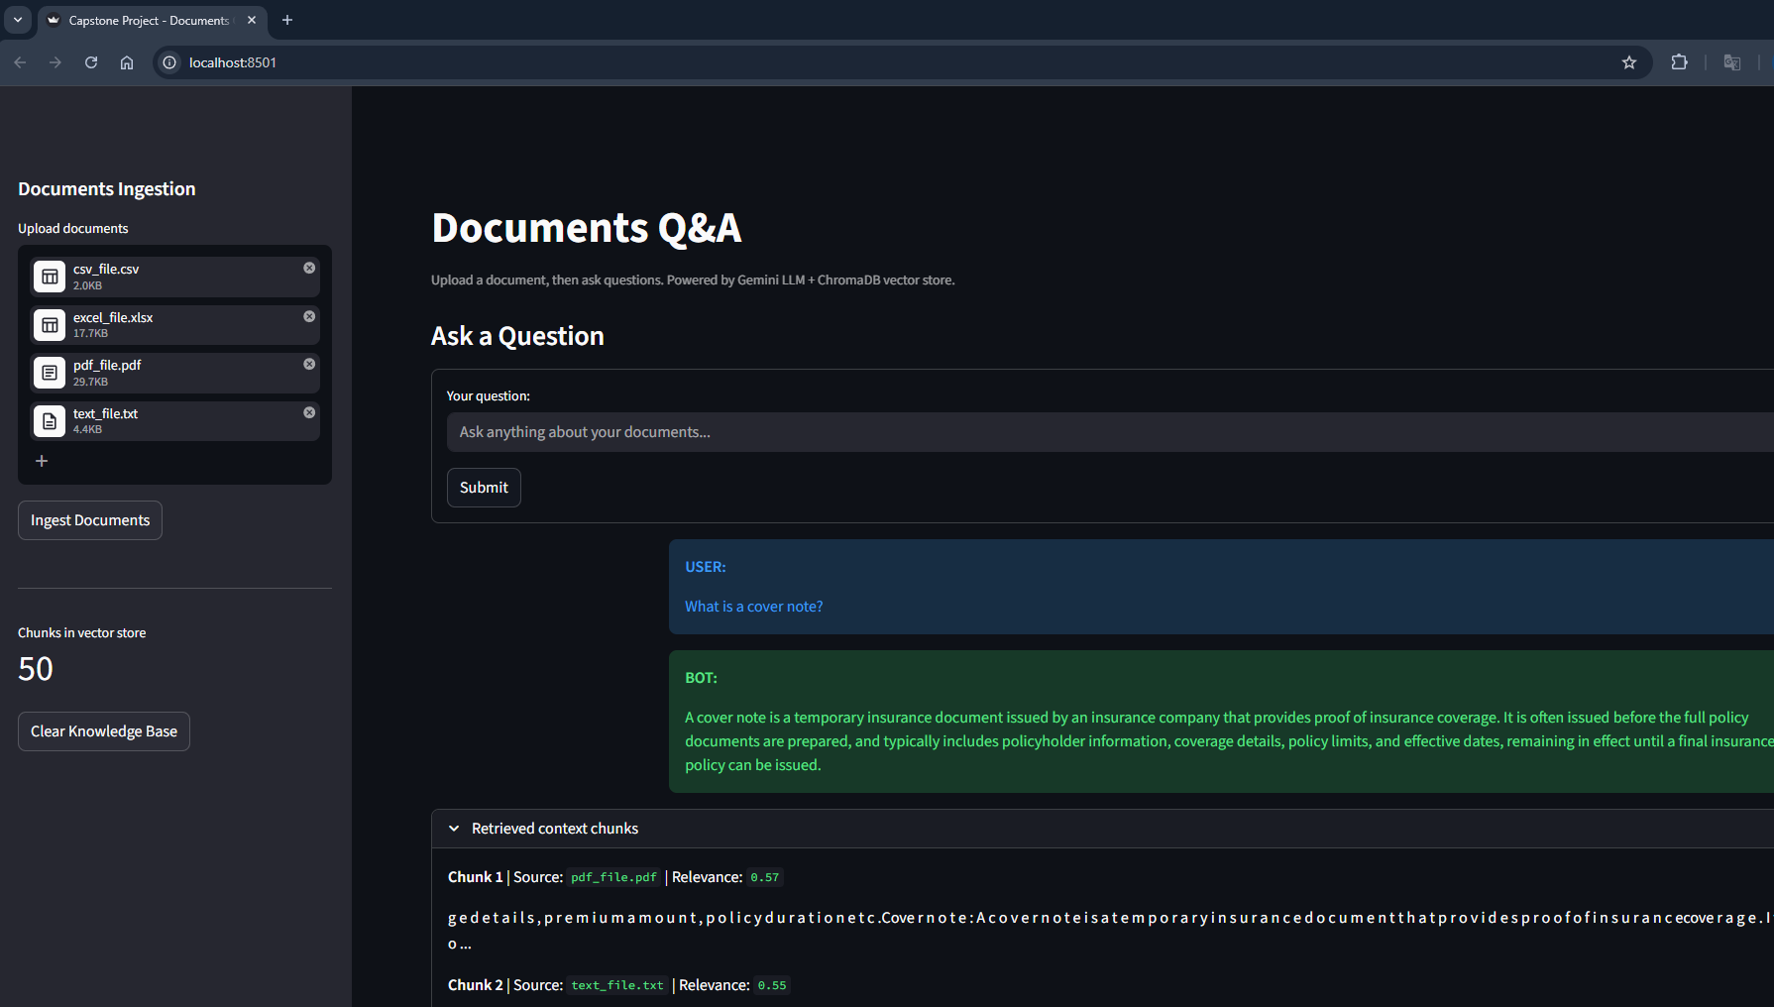

Upload csv_file, excel_file, text_file, pdf_file and ask multiple question:
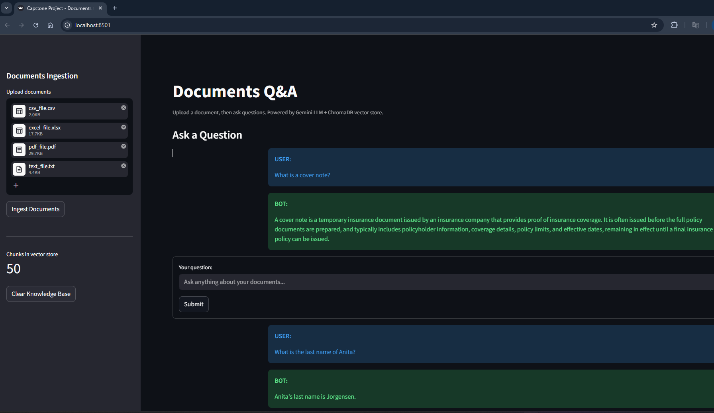

Guardrail:
