Valery’s comments

Page 8, line 152
s = (p + q) 2 is not the center-of-mass energy. It is squared of the center-of-mass energy.
Corrected

Page 14 line 277
Do you apply NP HE(HT CC) > 2 for electrons and positrons with P >4.9 GeV?
Yes, the cut is independent of momentum, I corrected it

Page 14 line 283
... final state particles
corrected

Page 16
It will be interesting to present the HTCC Nphe yield for the identified pions and electrons
for data and MC events. The expected yield is presented in Fig. 1.
A 2D plot could indeed further improve the lepton PID at high momentum. However, we believe that the neural network implemented for this analysis already provides a good PID.

Page 17
Please provide HTCC response to the simulated pions: Nphe as a function od θ and φ as in Fig. 2.5

The requested figures are provided here below, however HTCC response is very poorly reproduced by simulations

For MC-generated pions which are mis-identified as positrons:
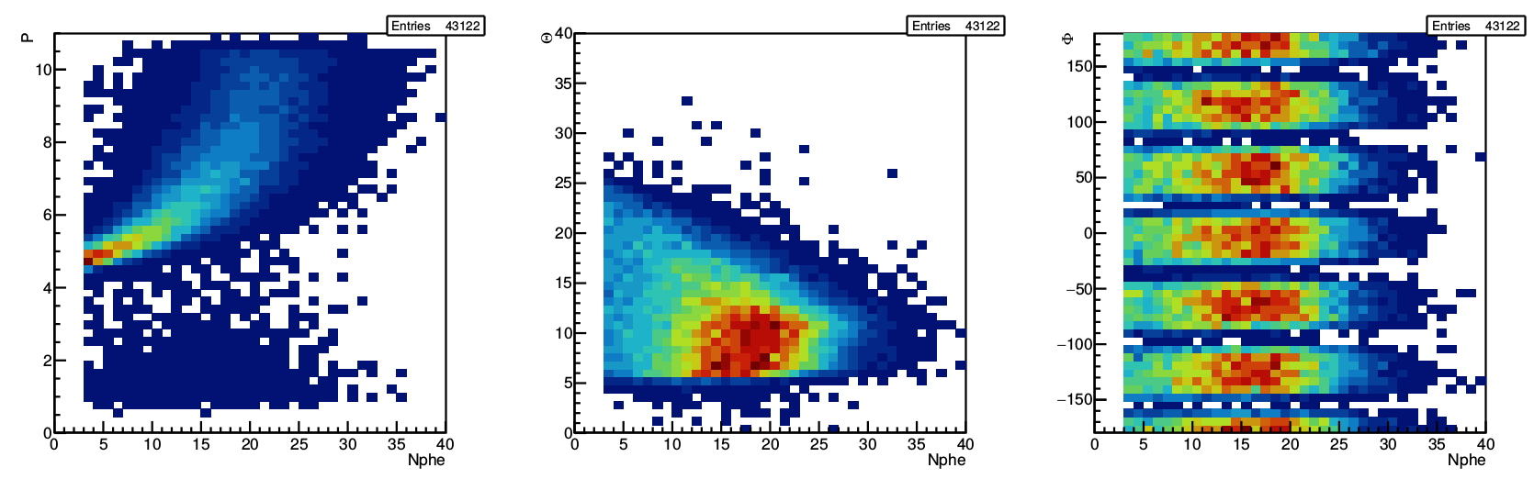
For true positrons:
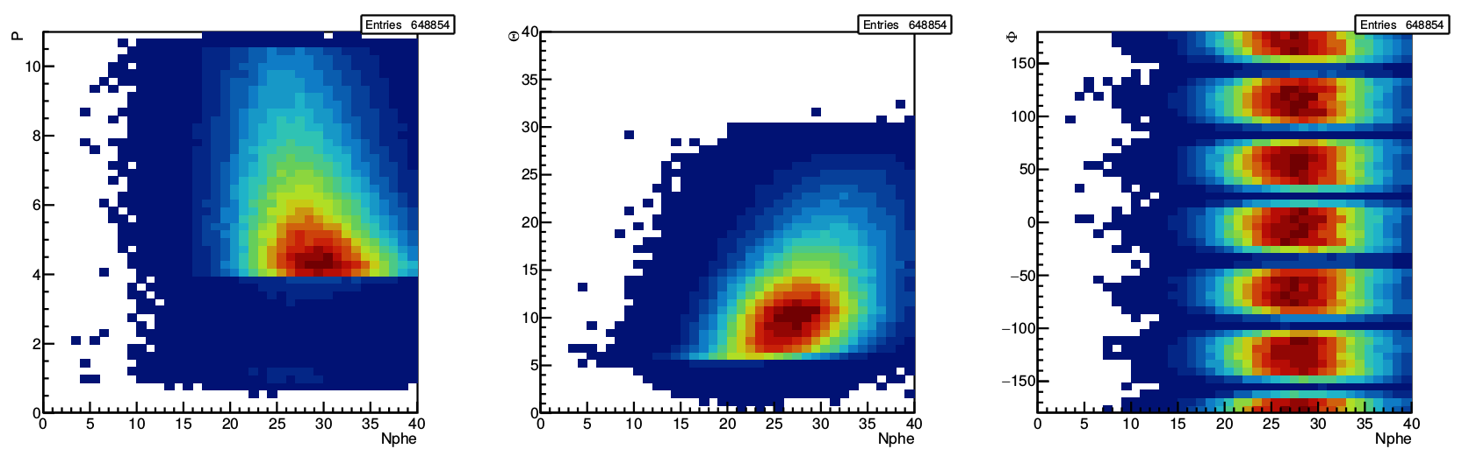

Page 19 : Multivariate analysis
MVA requires clean sample for the signal and background. The problem with positron ID
appears only for particles with momentum > 5 GeV. However, the variables that are used
in the analysis (SF, shower profile) have very weak dependence on the particle momentum.
It means that we can test the proposed PID method for particles with P < 5 GeV or even
apply MVA for low momentum particles. What is wrong with such approach?
I agree that such an approach could be used for smaller momenta, but further studies would have to be done. In particular the impact on training the MLP with events with small momenta should be checked. This goes beyond the scope of this analysis.

Page 26 Eq 2.16
Does pion contamination depend on the reaction kinematics, positron momentum and
angles?
I believe that you suggest here to do this analysis for several kinematic bins. This cannot be done in this case due to small statistics. Nevertheless, the effect of varying the neural network cut on the measured observables is studied in the systematic checks. No large variation is seen as a function of the considered kinematic variables. This gives us confidence that the possible kinematic dependence of the remaining background has no impact on the final result.

Page 29 Fig 2.21
The errors on the bottom plots are calculated incorrectly. It is obvious that the ratio
cannot be more than 1. The correct formula in your case is

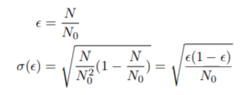

where N0 is the number of the events without cut and N is the number of the events with
cut.
I have changed the way to calculate these errors. I now use the root Tefficiency class which uses the correct formula (in the case of weighted histograms it uses the normal approximation that you mention, in the case of 1-weighted histogram it uses Clopper-Pearson method recommended by the PDG).

page 30 fig 2.22
What is the ratio? Nocut/cut or opposite?
The same note about the errors of the ratio
I changed all efficiency plot to passed/all events, and all error bars are now 1-sigma intervals as described in the previous point.

Fig 2.21, 2.23, 2.26
Could you please show the distributions starting from lower momentum (2-3 GeV?)?
The neural network approach is only used for positrons with P>4GeV. In the lower momentum region I do not apply any further cut than standard EB ones.

Fig 2.20 and 2.25
The MC efficiency (2.20) is close to 100%. Does 2.25 really present the signal efficiency?
What value of cut was used for the event’s selection?
Figure 2.20 is done for simulated positrons while 2.25 was done using the same neural network but for data positrons. In this case the positrons can be both real ones and mis-identified ones. The first drop is due to the bad positrons being removed by the MLP.

In the analysis, the cut on the output of the MLP is 0.5. This cut is varied and the resulting variation is included in the systematics (see section 3.13)

Page 28,29 line 543-550
I am not sure that the explanation of the low π− contamination (lines 543-550) is the only one possible. The obvious asymmetry between positrons and electrons is coming from the fact that we have electron beam. The reaction ep → e0p0π+(π−) is the source for the π+ contamination. The similar reaction ep → e0p0π−(π+) doesn’t give the π− contamination because we have e−e− final state. That is why we don’t have π− contamination compatible with π+. The photoproduction γp →0 p0π+π− doesn’t give the signiuficant background because we have to misidentify both particles π+ and π−. The lepton number conservation has nothing to do with the CLAS12 background I think.
The pi- pi+ does not give background because both leptons should be misidentified and thus have momentum bigger than 4.9 GeV which is not possible kinematically as shown in 2.27. The pi- contamination is only possible when the « positron » has momentum below 4.9 GeV. In this case the positron id is ensured by HTCC. So one should have e+, pi-, e- (beam) and p in the event. By lepton conservation there must be an additional electron, and by charge conservation an additional negative particle.

Page 29 section 2.3
Can we apply positron and electron PID for all momenta? What will be the result?
In principle yes, however in the note the neural network was validated only for positrons above 4 GeV. One would need to re-run simulations below 4 GeV and validate the process again. In the case of electrons, we tried the neural network developed for positrons on simulated and data electron (coming from TCS events) (see Fig 2,30). In this case the signal efficiencies for both sets agrees, showing that the contamination from pi- is minimal.

Page 34 Section 2.4.2
The data-driven correction are based on the e, π+ and π− momenta measured in the FD.
Did you apply corrections to the momenta of these particles? Missing mass fit may help
to understand the accuracy of the FD momenta measurements.
No correction is applied to pion momenta. The « detected photon » correction shown in Section 2.5.2 is applied to the electron.

Page 39 Fig 2.38
What are the units of the x-axis in the top plots? Do you have the same plots for positrons?
No units for Delta_P/P (in % if multiplied by 100). Plots for positron is added.

Page 40
It seems to me that the complicated cuts, based on the mean shower width, just remove 1
or two counters on the border of the detector in U, V and W strips.
Yes, that is true.

Page 44
Why are the efficiency corrections so irregular? Is it statistics or something else?
Yes it is low statistics

Page 48 Eq 3.5
Misprint in the equation: pbeam + ptarget = .....
Fixed

Page 49 Line 815
PX is the x-projection of the pe’ probably. In fact it is Z-projection as written in line 828
No, the X refers here to the missing system X, so P_X is the total momentum of the missing particle.
But there is a different mistake : it is sin and not tangent in formula 3.9, corrected.

Page 50 line 844
Usually we use low case letter for ψ; J/ψ.
Fixed

Page 52 line 584
Use φ for φ-meson.
Names of the meson are fixed, I now use low case greek letters

Page 52 Fig 3.6
Is there a possibility to compare cross sections?
The aim of these plots is mostly to compare the shape of the spectra to ensure the simulation agrees with the data, in order to obtain good acceptance later in the analysis. We have done a comparison of experimental and MC cross sections.

Line 948
Misprint: event.
Could not find the mistake…can you please clarify?

Page 74 Line 1181
There is a discrepancy between 3.31b figure capture and text. Probably the correct reference
is 3.31d. The color scheme is not defined.
Fixed

Page 75 Line 1181
Where is it coming from the range 0.5±0.1 in neural network systematic error study? How
do you choose the value 0.1?
According to Figure 2.25 the signal efficiency is fairly flat in the 0,4 to 0,6 cut region. We intend to stay in this region. Furthermore according to Figure 2,19 the background rejection is also failry constant in this region

Page 75 line 1207
Wrong reference to the Fig. 3.31.d. It is 3.31f
Fixed

Page 76 Lines 1212 and 1214
How do you choose the values 0.04 and 0.3 GeV2 for this study? I would like to note that
the FB-asymmetry was changed by 1 σ. It is a big step. What will be the result if we will
use 0.06 and 0.5 GeV2 cuts?
This point is discussed below to address Aram’s comments. Larger cuts 0,06/0,5 are now also included in the systematic checks. See updated systematics section, especially the part on exclusivity cuts.

Fig 4.1 to 4.12
Can we compare these measurements with the theoretical model predictions?
How do you calculate the average values for < t >, < M >, < Eγ >? It becomes
important when you are trying to compare your data with the theory predictions. If your
average is just weighted with the cross section (and/or acceptance) value it may give you
incorrect result. This is especially important when the cross section changes significantly
inside the kinematic bin. I believe it is your case. …

This point is delt with in a new section in Section 4,2

Page 105 Appendix A
The background/signal ratio is completely based on the MC. There is no systematic error
study connected with this method.
The quoted 5 % value for the background/signal ratio is not used directly in the final results. The systematic check connected with this is the one assessing how the results vary when the positron ID cut is varied.

Line 1410
There are no Eqs H.1 and H.2 in the text.
Fixed
Timelike Compton Scattering data analysis – Review
Aram Movsisyan
Section 3.1
---------------
It would be useful to specify which of the observables are implemented in MC generators.
This would help to better understand the further sections.
The generator attributes to each event a weight obtained as described in Section 3.1. Each time we compute MC observables in the following (i.e. the BH red points in the results plots), the analysis code is ran on simulated events, with the weight corresponding to each event.

Section 3.2.2
-----------------
It is claimed that the exclusivity cuts on Missing mass and transverse momentum are defined by
means of MC simulation. Where the numerical values from Eqs. 3.10-3.11 are coming from?
See below

Fig.3.1 does not give any clue on the numerical values of the cuts. In addition, 2D plots are not showing the consistency of resolutions in data and MC. Could you please provide 1D plots of missing mass and transverse momentum (comparison of data/MC) to show that the resolutions are properly reproduced in MC.
The data/MC comparison shows compatible resolutions for pt/p while the width of the MM peak is not as well reproduced. This is likely due to the fact that our protons are mainly in the CD and that the simulation is not yet well tuned to reproduce the CLAS12 performances. The MC was nonetheless necessary to guide the choice of the cuts. The values were picked in order to minimize the loss of good events on the MC, while at the same time cut out the background from non-photoproduction events on the data. To illustrate this statement see next picture where simulation and data 1D exclusivity cuts are shown, along the values of the cuts used.

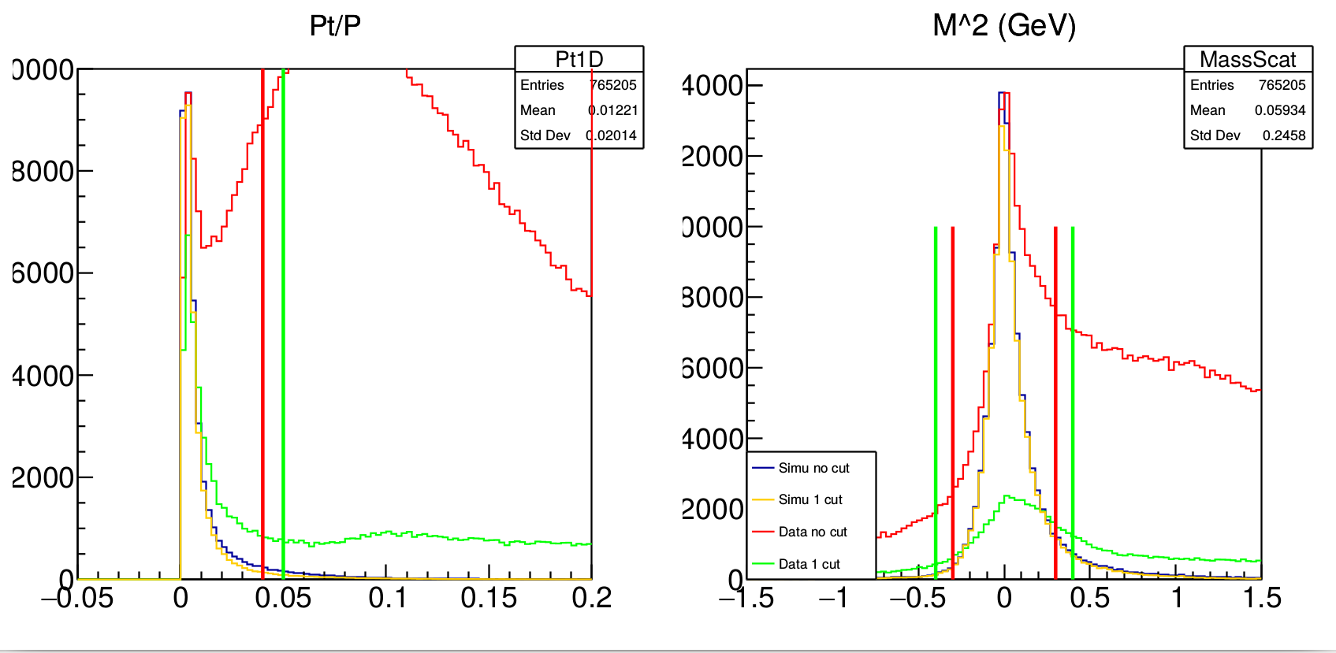

What are the additional cuts used to obtain the distribution (red) in Fig. 3.2 or right plots on Fig
3.3?
In these figures, « included in the analysis » means « within the kinematic ranges described in Section 3.3 ».

Statements provided in lines 848-854 look strange. According to the bottom plot of Fig. 3.5, MC
overshoots the data by approximately 15% in the mass range 1.1 – 1.5 GeV and the opposite effect
is visible in the mass range above 2 GeV. Is it possible to rebin the distributions on the plot, in order
to reduce the statistical errors.

Plot redone and with larger bin. The agreement is better, confirming this conclusion

Do I understand correctly from Fig. 3.7, that the average error of the acceptance estimation is
15% ?
There was a mistake here in the calculation of this error (see Valery’s comment). I have redone the plot using binomial approximation. The errors obtained are slightly smaller. Also I have increased the number of events in the simulation sample (more on this here below)

Is it sufficient, and how is it propagated into final systematic uncertainty?
To deal with this uncertainty I have increased the total amount of generated events for acceptance calculation from 16M to 36M. I have done again the systematic checks with this new sample and compared the results obtained for the « small » simulation sample (16M) and the new total sample. The difference is shown in a systematic paragraph of the note. It is always much smaller than any other systematic and thus ignored.

Section 3.6.
---------------
The discussed background channel`s contribution is estimated to be below 2%. Are there other
sizable background sources, or could you detail what is the purpose of exclusive cuts discussed in
section 3.2 ?
Excluvisity cuts constrain the missing particle to be light and to go in the beam pipe (to ensure quasi-real photoproduction if the missing particle is an electron). Once these exclusivity cuts are applied, background reactions are ep→ e’ p e+ (e-) (discussed in section 3.6) ; ep→ e’ p pi+ (pi-) (dealt with using the positron ID algorithm)

Section 3.13:
----------------
Line 1161. What is the expectation for FB asymmetry from BH in 4\pi, or what is the purpose of
green points on Fig. 3.31a, wouldn’t it be better to show them for the R’ observable?
The FB asymmetry is 0 for BH. The green points are obtained using MC events and they confirm what we expected from the phenomenology studies shown in Section 3.7, where the FB asymmetry for BH is zero

What kind of weights are used in the blue points of Fig. 3.31a (BH or BH + TCS)?
BH weights, therefore one expect the FB asymmetry to vanish

Line 1170-1171. Not clear, how the systematic uncertainty is calculated.
The uncertainty is the difference between the observable extracted directly from MC, and its value calculated after all the steps of the simulation (GEMC, COATJAVA). As I had two different MC samples coming from two different generators with different characteristics, I decided to test this procedure for both generators. The chosen uncertainty is the « worst » values of the difference in any of the two generated samples. Note that the difference between observables extracted from the two MC samples is always small. This method is redundant but provides a thorough cross check.

Lines 1177 – 1184. Is the reference to figure 3.31b correct? What is the effect of background
merging on the results?
This was tested in the manuscrpit of my thesis. The variation is minimal. However, BG merging should be used and included in the final results. Thus all the results shown in this note include it.

Why do you assume that background merging and proton detection efficiency in CD should be comparable?
As all the observables we extract in this analysis are ratios, one could expect the efficiency contributions in the numerator and denominator to cancel out. If this is the case then adding the proton efficiency should not have large effect on the extracted values. We wanted to verify this statement by producing this systematic uncertainty.

And way do you take the half of \Delta_Eff as a systematic uncertainty, rather then the RMS.
The RMS issue is dealt with below.

Lines 1196 – 1202. How the systematic uncertainty is applied. Are there mis-identified protons in
MC for \xi^2 beyond 3 \sigma (For TCS process)? If not, then why you apply 3\sigma cut in
simulation? If yes, then you need an estimate for proton mis-identification.
The systematic uncertainty is defined as the difference of the measured observable with or without a chi2 cut on the proton. The acceptance is also recalculated with the correct Monte Carlo cuts.
Yes, this 3 sigma cuts removes the tails in MC. The parameters of the gaussian are extracted both in MC and data to account for the difference in width of the distributions.

Lines 1203 – 1209. For the acceptance model there are at least three options
BH – from TCSgen
BH + TCS – from TCSgen
GRAPE
Why you choose phase-space generator to study model dependence of the acceptance?
One could use BH weights or BH+TCS weights (also TCS weights in TCS GEN were not validated at this point of the analysis). We decided to go with phase space weights to see if large variations on the weights lead to large variations of the measured observables. As it does not we assume the weights used for the acceptance do not affect the final results.

Also here I would suggest to use RMS, rather than the half difference.
If we use a bias estimator for the RMS than for two values RMS and half difference are equal as shown below. Unbiased estimator would pick a \sqrt(2). Do you suggest to use unbaised estimator (ie multiply all systematic uncertainties by sqrt(2) ?
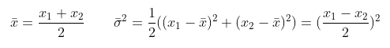

Furthermore the analysis on SIDIS submitted to PRL uses the difference |x1-x2| to assess the size of the systematics uncertainty. This is consistent with our method which adopts \pm |x1-x2|/2 as systematics.

Lines 1220 – 1222. How you define tighter cuts ? Where the numbers from Eqs. 3.36 – 3.37 come
from?
See above discussion on MC/data resolution. These tighter values were selected according to the simulations but no quantitative process was used. Larger cuts have now been added as a further systematic check.

Final results.
----------------
I would suggest to put the ranges of angular bins in FB plots.
Added in the figures that we plan to publish (4.16,4.17,4.18). The plot design will be reviewed and improved during the paper ad-hoc review.

What is the reason of large variations of systematic uncertainties from one bin to another, for the
given source? Like exclusivity in Figs. 4.3, 4.5, 4.8, proton id in Figs. 4.4, 4.5, 4.6, 4.8 and
acceptance in Figs. 4.4, 4.5, 4.6, 4.7.
These figures are all AFB. In this case a very low amount of events is used in each bin (typically a few tens). Any event that is removed from the bin or that will have been corrected by a diffferent acceptance weight will have an impact on the final results. We have carefully checked that even if these variation are important they are always within statistical errors. It is an artefact of the low statistics of the measurement, these systematics uncertainties are correlated with the statistical ones.
To mitigate this issue, we decided to follow the method developed for the SIDIS paper : averaging the systematic uncertainties for a given bin with the ones of the neighboring bins. This is now explained in the systematic chapter 3.12 page 77.
Timelike Compton Scattering data analysis – Review
Francesco Bossù
The analysis note is nicely written and it is easy to read. It describe an important measurement of
TCS off a proton target.
This first batch of comments is meant to help the readability, to suggest some improvements and to
clarify few aspects. Due to the length of this analysis note, a second batch of comments will be
produced soon after to complete this one.

Section 2.3
===========
line 328. Do these simulations contain a trigger particle, i.e. an electron ? If not, does this pose a
problem for the start time?
The trigger particle in CL AS12 EB can be either lepton or pions. In both cases there is a trigger particle.

Subsection 2.3.5
You say that the ML algorithms have been trained on simulations. And then you say that the
trained algorithms are applied to data.
Yes, this is how it was done.

- It is not clear to me that this can be done so easily: could you provide comparisons data-MC of
the input variables to show that the shapes are compatible?
The comparison is shown in Figures 2.27 and 2.28 of the updated note. One can see that the distributions are compatible, providing a further cross check.

- Since you can select a very clean sample of pi+ from data using the reactions ep->e pi+ n and
ep->e pi+ pi- p, I was wondering why you don't train the TMVA algorithms directly on data:
o) for the positron: since your classifier uses only information from the calorimeters, I am
expecting that the positron and electron signals are very similar. If the direction of entry of the
positron in the calorimeter is of any concern, then you can use electrons from outbending data.
This is a very nice idea, but when we did the analysis the outbending data were not calibrated nor cooked yet.

o) the calorimeter signals for the pi+ you have it from the reaction cited above
As shown in Figure 2.3 there is some background below the neutron peak. So the mis-identified pions cannot be identified at an event-by-event level.

Section 2.4
===========
Table 2.1. The coefficient values are reported with a lot of precision. Is this precision really
relevant? Could you add the uncertainty on the parameters from the fit, so that we can judge if all
these decimals are important?
Uncertainties added

Why for the CD, the a2 term is zero?
The fit is linear. Adding a x² term did not reduce the chi2. We decided to use linear fit.

Figure 2.30. The top right plot shows a second population below the fitted curve. What does this
population come from?

These are the events around 27° which, due to resolution, are reconstructed above 27°.

Section 2.4.2. At line 595, you write "Due to the detection inefficiencies of the CVT,". Actually,
thanks to the redundancy of the detection elements of the CVT and the rather lose requirement to
seed a track, the actual inefficiencies of the SVT or the MVT are not the main responsible for the
effect that you describe below.
It has been demonstrated (see CVT code review, Winter 2019) that the major contributor for
missing or mis-reconstruction of the proton momentum is the reconstruction algorithm. In
particular, the assumption that the proton comes from a specific vertex (reconstructed by the DCs).
So, I suggest to state this phrase differently.
I have reformulated to make sure that the issue is understood as a software related one.

Also, since the magnitude of this effect depends on the beam position, this study should be done
ideally run by run. Or at least, since in the run period that you analyzed, the beam spot moved (i.e.there are at least to CCDB tables for the beam postion), this study and this correction should be
done separately for the two sub-periods (or at least a cross check that this correction is independent
on the run period)

ccdb shows the following two beam shifts for the run period used in this analysis:

Run range: 4760-5277; based on 5038; x, y (cm) 0.0031 -0.041
Run range: 5278 5419; based on 5306; x, y (cm) 0.035 -0.10

There is therefore only a 300 microns variation between the two parts of the run. We don’t believe that our corrections can reach such a level of precision.

Table 2.2. Same as Table 2.1: uncertainties should be added.
Done

Section 2.5
===========
line 645. The "cone angle" should be defined somewhere.
Definition added in the text

Figure 2.37. Is the simulation done with background? What is the origin of the bins for |
Detla_theta|>1.5 deg?
These simulations were done before background merging was implemented.
Other bins come from other photons produced in the processes. One can see that using only photons within 1,5 deg (radiated at the target level) is sufficient to obtain a good measurement of the lepton momentum.

In data, one might expect to have random photons hitting the calorimeters that are close to the
electron/positron and that are wrongly added to the lepton. Did you estimate how likely this is and
what effect this could have to the lepton momentum? Did you use simulations with merged
background for this study?
Simple simulation were performed for this study. We have not estimated the impact of such background photon. One could compare the resolution of the plots in figure 2,38 with/and without BG merging.

Section 2.8
===========
Equation 2.25. This is not an efficiency. The efficiency should be defined as eff = N_rec / ( N_rec
+ N_miss ).
If equation 2.25 is actually used, then I do not understand how the following figures (like 2.42)
are bounded to 1.
Here « missing » means ep→ e (p) pi- pi+ events where the ***missing proton*** can either be detected or remain undetected. In other word it is the total number of events where a proton is expected to be detected.

In general, the "integrated efficiencies" are actually the product of many factors. In particular, you
are folding the geometrical acceptance together with efficiencies (like detector efficiencies,
reconstruction efficiency, PID efficiency...). Since the geometrical acceptance is not actually an
efficiency, I find a nice common use the spelling "A \times E", where A is the acceptance and E is
the efficiency.
I have changed the formulas to make this point more understandable.

Chapter 3
=========
line 790. "with exactly [...]" seems to me not in agreement with the later "We allow any other
particle". I suggest to say "with at least one proton, one electron and one positron".
Rephrased

Equation 3.5. It seems that there is a typo in the first term. It should be "p_beam + p_target"
Corrected

Line 821, Equation 3.10. If the simulation used is a clean simulation, then I assume that what it is
shown in Figure 3.1(a) represents just signal data. So, why you chose |Ptx/Px| < 0.05 when there are
simulated data up to about 0.3?
We want |Ptx/Px| to be small to ensure quasi-real photoproduction. This cut ensures the virtuality of the initial photon Q’2 to be small (see picture 3.2)

Since Ptx and Px are computed from the momenta of three
reconstructed particles, is the momentum resolution good enough to justify this strict cut of Eq
3.10?
This question is similar to Aram’s one on exclusivity cuts. Please refer to the answer in Aram’s section.

Line 858. The chosen mass range 1.5 GeV < M < 3 GeV includes also the radiative tail of the J/psi
decays. Is it a problem for this analysis? Was it recovered completely with the photon recovery for
the leptons? It would be nice to see a pure Jpsi simulation to assess the size of such tail.
J/psi simulation by Joseph Newton shows that 8 % of the total number of Jpsi are in the radiative tail. With the exclusivity cuts of this analysis I have 82 events above 3GeV (all coming from Jpsi). Thus there are potentially 82*8/92 = 7 Jpsi in the 1.5 GeV < M < 3 GeV region. That is to say 7/2921 = 0,2 %. We believe this has close to no impact on the final measurement. All this was added in the note in the new section « Jpsi contamination ».

Line 867 and following. Again, the term "Acceptance" here is somehow misleading. Usually, in
high energy physics, the "acceptance" is the geometrical/detector configuration one and it is defined
as the number of events that can be reconstructed (because they hit enough detector elements) over
the number of generated events.
Here, instead, you are computing the product of the acceptance and the efficiencies.
I have added a line after this statement to make it clear that the product of the two is calculated. However for clarity and practicality, the term acceptance is still used. Moreover, in the CLAS and CLAS12 collaboration traditionally the word « acceptance » is used to include both geometrical acceptance and efficiency.

Line 890, Equation 3.18. Please, define delta_Acc: what are the sources of this uncertainty? (In
general, it is better to use the word uncertainty rather then error, because error sounds like a
mistake)
The overall statistics of the simulation might have effect on the value of the acceptance (higher statistics reduces statistical fluctuations). I have redone this figure, increased the statistics of the simulation and added a section in the note about this. (see the answer to the very similar comment by Aram).

Line 893. Why this should be a subsection? I think that the subsection 3.5 is the natural
continuation of section 3.4, I would suppress this title for the subsection 3.5.

Fixed, this was an artefact of the layout of my thesis.

