

“Prenatal Care Timing and Maternal Sociodemographic Factors Associated with U.S. Birth Outcomes”
HDS 5310 – Analytics and Statistical Programming
04-29-2025

Venkata Sai Krishna Kukkapalli

Introduction and Background
This study investigates how maternal sociodemographic factors and timing of prenatal care initiation relate to birth outcomes in the United States. The study uses natality data from 2017-2023, collected through the National Center for Health Statistics (NCHS), a database of natality data containing birth-related information managed by Centers for Disease Control and Prevention to evaluate the influence of few variables such as maternal education, marital status, plurality, delivery method, maternal age and BMI on two key outcomes like Birth weight and Gestational Age. Understanding the characteristics of mothers and the care they receive during pregnancy allows for a deeper exploration of factors influencing neonatal health, which could inform policy and intervention strategies to improve birth outcomes nationwide.
Population of Interest
This study focuses on pregnant woman across the United States. The population is understood to be diverse from the source we collected, National Center for Health Statistics (NCHS) database. It offers a wider scope to understand and evaluate birth outcomes across key maternal characteristics like education, marital status, etc. which allows for identification of inequities and trends relevant to public health and prenatal care.
Outcomes of Interest
The primary outcomes assessed in this study are birthweight (measured in grams) and gestational age (measured in weeks). These outcomes are used in studies and clinical settings as indicators of neonatal health, with low birth weight (<2500g) and preterm birth (<37 weeks) being major risk factors for infant morbidity, long term developmental and health complications. We also considered the APGAR score to verify the outcomes of our model.
Independent Variables
Maternal-level predictors include, Prenatal Care Start: The trimester in which prenatal care was first initiated (1st, 2nd, 3rd trimester, or no care), Education Level: The mother’s highest education level (Less than HS, HS Grad, Some College, College+), Marital Status: Whether the mother is married or unmarried, Plurality: Whether the birth was a singleton or involved multiples (e.g., twins, triplets), Delivery Method: The method of delivery (vaginal or C-section), Maternal Age: The age of the mother in years at the time of delivery, and BMI Category: The body mass index classification of the mother (Underweight, Normal, Overweight, Obese) are our independent variables. We plan to conduct both descriptive and inferential analyses to explore patterns and relationships in our data.
Existing Literature and Gaps
Prior Research has shown there is effective influence of prenatal care start timing in improving birth outcomes. Reichman and Teitler (2005) found that initiation of prenatal care in the first trimester was associated with modest gains in birthweight and gestational age; however, they also concluded that prenatal care alone may not substantially reverse the effects of pre-existing risk factors.¹ Similarly, Partridge et al. (2012) conducted a large retrospective analysis and reported that inadequate prenatal care substantially increased the risk of infant mortality and low birthweight.² The existing knowledge also highlights the influence of maternal education and marital status on pregnancy outcomes, suggesting that social factors are also critical mediators of maternal and infant health and well-being.
While these studies show the importance of prenatal care and maternal characteristics, a few have explored the combined effects of sociodemographic and clinical variables using national, population-level data spanning multiple years. Additionally, most studies do not integrate predictors such as plurality (Single, Twin, Triplets, etc.) and delivery method into a unified multivariate framework. Our study addresses this gap by examining the joint contribution of prenatal care timing, education, marital status and other maternal factors to birth outcomes across seven years of U.S. natality data (2017-2023).
Research Question and Hypothesis
This study investigates the following research question :
“How does the timing of prenatal care initiation relate to birth outcomes (birthweight and gestational age) in the United States, after accounting for maternal sociodemographic factors?”
We hypothesize that earlier initiation of prenatal care is associated with more favorable outcomes like higher birthweights and longer gestational durations. Additionally, factors like higher maternal education level and being married during pregnancy also have positive effects on birth outcomes.

Methodology
Data Source and Description
The dataset we are working on contains data about birth outcomes in the US between 2017 and 2023. It was sourced from the National Center for Health Statistics (NCHS), a database of natality data containing birth related information managed by Centers for Disease Control and Prevention.³ The dataset consists of variables related to maternal and infant characteristics, including birth weight, gestational weeks, prenatal care start, marital status, education level, plurality, Apgar score, delivery method, Mother’s Age, Mother’s BMI before pregnancy and year. When we collected the data, we had over 25 million observations across seven years (2017-2023), so we sampled data only to 70000, which is 10000 observations for each year. This is still a large enough data to analyze and predict the hypothesis.
Variables:
The variables we are going to use in this study are classed into Dependent and Independent variables. Birth Weight (grams): The weight of the newborn, measured in grams. Gestational Weeks: The number of weeks the mother was pregnant at the time of birth are our dependent variables, while Prenatal Care Start: The trimester in which prenatal care was first initiated (1st, 2nd, 3rd trimester, or no care), Education Level: The mother’s highest education level, Marital Status: Whether the mother is married or unmarried, Plurality: Whether the birth was a singleton or involved multiples (e.g., twins, triplets), Delivery Method: The method of delivery (vaginal or C-section), Maternal Age is measured in years, Body Mass Index (BMI) is categorized into underweight, normal, overweight, and obese based on CDC guidebook are our independent variables. We conducted both descriptive and inferential analyses to explore patterns and relationships in our data.
Descriptive Statistics:
We ran descriptive statistics on both continuous and categorical variables and summarized the characteristics of the dataset. For continuous variables, we have reported Mean and Standard Deviation, while for categorical variables we reported percentages of each category along with their count. The table below has the results of our descriptive statistics. Few key findings are the mean birthweight of the infants in our data is 3252 grams with a Standard Deviation of 580.1 and majority of mothers (60.1%) initiated prenatal care in their First Trimester.
Table 1. Descriptive Characteristics of the Study Sample (n=70000)
VARIABLE | N=70000
 | Mean(SD)
Maternal Age | 29.3(5.8)
Birthweight (grams)  (Missing) | 3252.3(592.3)  57
Gestational weeks  (Missing) | 38.5(2.5)  52
 | n(%)
Prenatal Care Start  1st Trimester  2nd Trimester  3rd Trimester  No Prenatal Care  (Missing) | 52,841 (77%)  11,135 (16%)  3,103 (4.5%)  1,353 (2.0%)  1,568
Marital Status  Married  Unmarried  (Missing) | 36,708 (60%)  24,934 (40%)  8,358
Education Level  ≤8th grade  9–12, no diploma  Associate  Bachelor  Doctorate  HS Grad  Master  Some College  (Missing) | 2,162 (3.1%)  6,040 (8.8%)  5,787 (8.4%)  14,704 (21%)  2,007 (2.9%)  18,117 (26%)  6,904 (10%)  13,185 (19%)  1,094
Maternal BMI  Normal  Obesity I  Obesity II  Obesity III  Overweight  Underweight  (Missing) | 27,417 (40%)  10,897 (16%)  5,462 (8.0%)  3,976 (5.8%)  18,683 (27%)  2,032 (3.0%)  1,533
Plurality  Quadruplet  Singleton  Triplet  Twin | 2 (<0.1%)  67,737 (97%)  63 (<0.1%)  2,198 (3.1%)
Apgar Score  0–3  4–6  7–8  9–10  (Missing) | 424 (0.6%)  1,053 (1.5%)  9,273 (13%)  58,924 (85%)  326
Delivery Method  C-Section  Vaginal  (Missing) | 22,580 (32%)  47,363 (68%)  57
Table 1: Continuous variables are presented as mean (standard deviation). Categorical variables are presented as number (percentage). Maternal age is reported in years, birthweight in grams, and gestational age in completed weeks.
Data Handling and Management
Before proceeding with the Bivariate and Multivariate tests we performed data cleaning, Observations with missing or unknown values were excluded. Rare categories like plurality (triplets or higher) were clubbed together into “Triplets+” group. These were done to variables where necessary, before performing the Bivariate or Multivariate tests.
- Bivariate Analysis:
In our study we conducted two bivariate analyses: - One-Way ANOVA: To test differences in mean birthweight across prenatal care initiation groups and Chi-Square Test: To test for association between plurality and delivery method.
These analyses will help us understand key relationships before multivariate modeling.
- ANOVA: In our study we did a one-way ANOVA test for comparing birthweight across prenatal care start groups, with Tukey’s Honest Significant Difference (HSD) test to evaluate group differences while controlling multiple comparisons. To check the normal distribution, we did a visual inspection of Histogram which indicated normal distribution. Levene’s test for homogeneity of variances was non-significant (p > 0.05), confirming that the assumption of equal variances was satisfied. Therefore, standard ANOVA was appropriate. The ANOVA revealed a statistically significant difference in mean birthweight between the groups (F(3, 68384) = 114, p < 2e-16), indicating that timing of prenatal care initiation is associated with differences in birthweight. Post hoc analysis using Tukey’s Honest Significant Difference (HSD) test showed Second trimester care births weighed significantly less than those with first trimester care (mean difference = –48.8g, p < 0.001). No prenatal care was associated with the largest deficit, with infants weighing 278.4g less on average than those whose mother’s-initiated care in the first trimester (p < 0.001). The third trimester did not significantly differ from the first trimester (p = 0.49) but was significantly higher than second trimester (p = 0.026), and lower than the no-care group (p < 0.001). Results are presented in Table I(a), and visualized in Figure I(a), which displays birthweight distributions across the four care groups using boxplots.
Table I(a):
One-Way ANOVA and Post Hoc Analysis: Birthweight by Prenatal Care Start Timing
Comparison | Mean Difference (g) | 95%CI (Lower, Upper) | Adjusted p-value
2nd Trimester – 1st Trimester | –48.8 | (–64.5, –33.0) | <0.001
3rd Trimester – 1st Trimester | –15.4 | (–43.2, 12.5) | 0.49
No Prenatal Care – 1st Trimester | –278.4 | (–320.1, –236.8) | <0.001
3rd Trimester – 2nd Trimester | +33.4 | (2.8, 64.0) | 0.026
No Prenatal Care – 2nd Trimester | –229.6 | (–273.2, –186.1) | <0.001
No Prenatal Care – 3rd Trimester | –263.1 | (–312.3, –213.8) | <0.001

One-way ANOVA comparing group means; post hoc Tukey HSD results included for all pairwise comparisons.
Figure I(a): Boxplot of Birthweight by Timing of Prenatal Care Initiation
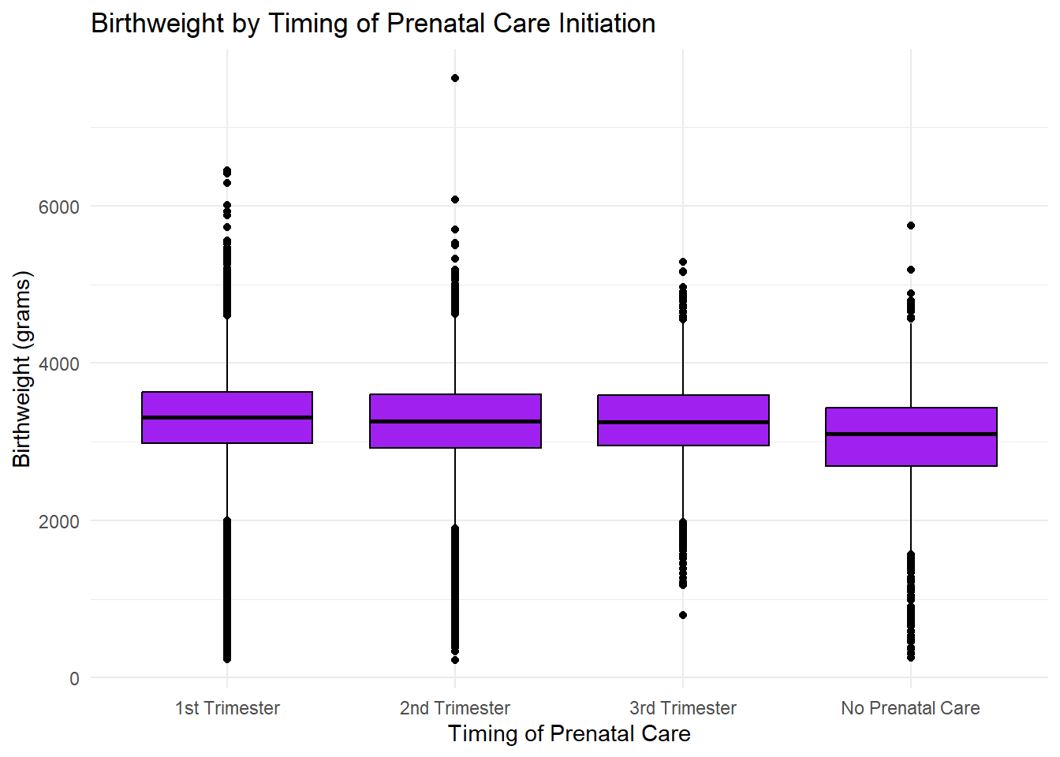
Distributions show median, interquartile range, and outliers. Birthweight measured in grams.
The Box plot shows infants whose mothers initiated prenatal care during the first trimester had the highest median birthweight, followed by those who began care in the second and third trimesters. Infants whose mothers received no prenatal care had the lowest median birthweight and exhibited greater variability in birthweight values, with numerous low birthweight outliers. Despite the presence of outliers, the distributions across groups remained symmetrical, and the observed differences in medians visually supported the statistically significant results obtained from the ANOVA and post-hoc analyses. These findings suggest that earlier initiation of prenatal care is associated with improved birthweight outcomes.
- Chi-Square Test: We compared 2 categorical variables to test independence for plurality and delivery methods. Plurality (singletons vs. multiples) is a known factor influencing delivery methods. Multiple pregnancies often involve more complicated deliveries, which can be associated with a higher likelihood of C-section. Assumptions for the chi-square test were checked and satisfied. Specifically, all expected cell frequencies were greater than five, and observations were independent. Therefore, the Pearson’s Chi-square test was appropriate for this analysis. The test revealed a statistically significant association between plurality and delivery method, χ²(2, N = 69,943) = 2034.2, p < 2.2e-16. Cesarean delivery was more common in multiple births. For singleton pregnancies, vaginal delivery was more prevalent (46813 vs. 20867), whereas among twins and triplets or higher, cesarean section was the dominant mode of delivery. In fact, all triplet+ deliveries in the dataset were by the cesarean section.
These results are presented in Table I(b), and visualized in Figure I(b), which uses a stacked bar chart to display the proportion of vaginal versus cesarean deliveries by plurality group.
Table I(b): Chi-Square Test: Observed Counts of Delivery Method by Plurality
Plurality | C-Section | Vaginal | Total
Singleton | 20,867 | 46,813 | 67,680
Twin | 1,648 | 550 | 2,198
Triplet+ | 65 | 0 | 65
Total | 22,580 | 47,363 | 69,943
Values reflect the number of births by mode of delivery. Pearson’s chi-square test p-value < 2.2e-16.
Figure I(b): Stacked Bar Chart of Delivery Method by Plurality
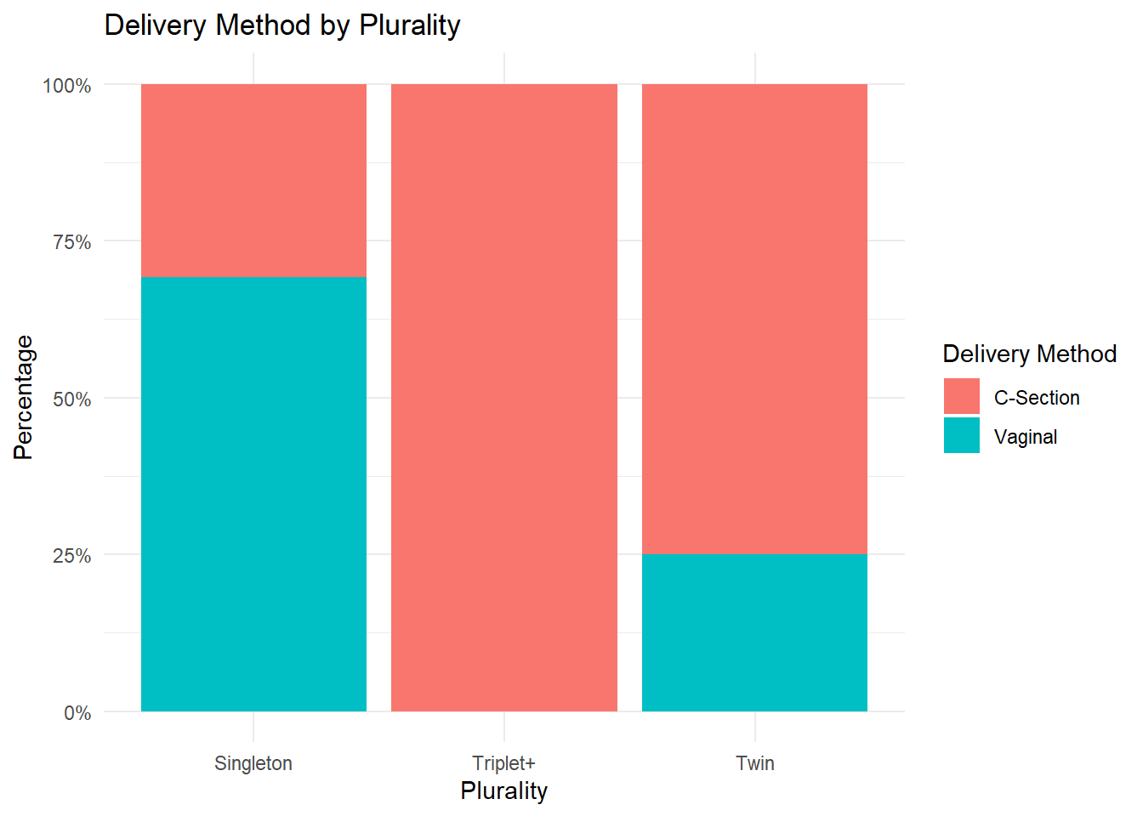
Each bar represents the proportion of deliveries by mode for each plurality category. Cesarean delivery is more common in multiple births.
The plot illustrates that singleton births were more likely to be delivered vaginally (approximately 70%), whereas the majority of twin and triplet+ births were delivered via C-section. The percentage of C-sections increased dramatically with the number of infants: over 75% of twin births and 90% of triplet+ births were delivered via C-section. These patterns visually reinforce the significant association found in the Chi-Square test, highlighting that higher plurality is associated with a greater likelihood of C-section delivery.

- Multivariate Analysis:
We conducted a multivariable linear regression to evaluate how maternal demographic, and clinical factors influence infant birthweight. Predictors included maternal age, marital status, education level, prenatal care timing, BMI category, delivery method, plurality, and gestational age. Assumptions of linearity, homoscedasticity, and normality of residuals were verified using residual plots and Q-Q plots.
The overall model was significant (F(21, 58,651) = 1423, p < 2.2e-16), with an adjusted R² of 0.337. Gestational weeks (B = +116.22, 95% CI: [114.59, 117.84]) and maternal BMI (e.g., Obesity III: B = +117.17, CI: [100.11, 134.23]) were the strongest positive predictors of birthweight. Being a twin (B = –578.81, CI: [–601.52, –556.09]) or triplet+ (B = –818.79, CI: [–952.65, –684.94]) significantly reduced birthweight. No prenatal care was associated with a 107.74g reduction (CI: [–136.38, –79.11], p < 0.001), while marital status and lower educational attainment also showed significant negative associations. Full regression results with exact 95% confidence intervals are provided in Table II and visualized in Figure II.
Table II: Multivariable Linear Regression Predicting Birthweight (grams)
Predictor | Estimate (g) | 95% CI (Lower, Upper) | p-value
Intercept | –1278.61 | (–1351.06, –1206.17) | <0.001
Maternal Age (years) | +2.11 | (1.34, 2.88) | <0.001
Unmarried | –88.79 | (–97.90, –79.68) | <0.001
Education: 9–12, no diploma | –38.23 | (–64.14, –12.32) | 0.0038
Education: Associate | +2.18 | (–23.70, 28.05) | 0.869
Education: Bachelor | +22.07 | (–1.97, 46.12) | 0.072
Education: Doctorate | +7.85 | (–24.30, 39.99) | 0.632
Education: HS Grad | –27.11 | (–50.67, –3.55) | 0.024
Education: Master | +23.15 | (–2.64, 48.94) | 0.078
Education: Some College | –20.57 | (–44.55, 3.42) | 0.093
2nd Trimester Prenatal Care | +4.12 | (–6.44, 14.67) | 0.444
3rd Trimester Prenatal Care | +7.20 | (–11.43, 25.83) | 0.449
No Prenatal Care | –107.74 | (–136.38, –79.11) | <0.001
BMI: Underweight | –139.53 | (–163.11, –115.94) | <0.001
BMI: Overweight | +72.69 | (63.06, 82.32) | <0.001
BMI: Obesity I | +100.04 | (88.54, 111.54) | <0.001
BMI: Obesity II | +108.94 | (93.87, 123.99) | <0.001
BMI: Obesity III | +117.17 | (100.11, 134.23) | <0.001
Vaginal Delivery | +3.73 | (–4.86, 12.31) | 0.395
Twin | –578.81 | (–601.52, –556.09) | <0.001
Triplet+ | –818.79 | (–952.65, –684.94) | <0.001
Gestational Weeks | +116.22 | (114.59, 117.84) | <0.001

Coefficients represent changes in birthweight relative to reference categories.
Figure II: Forest Plot of Adjusted Regression Coefficients for Predictors of Birthweight
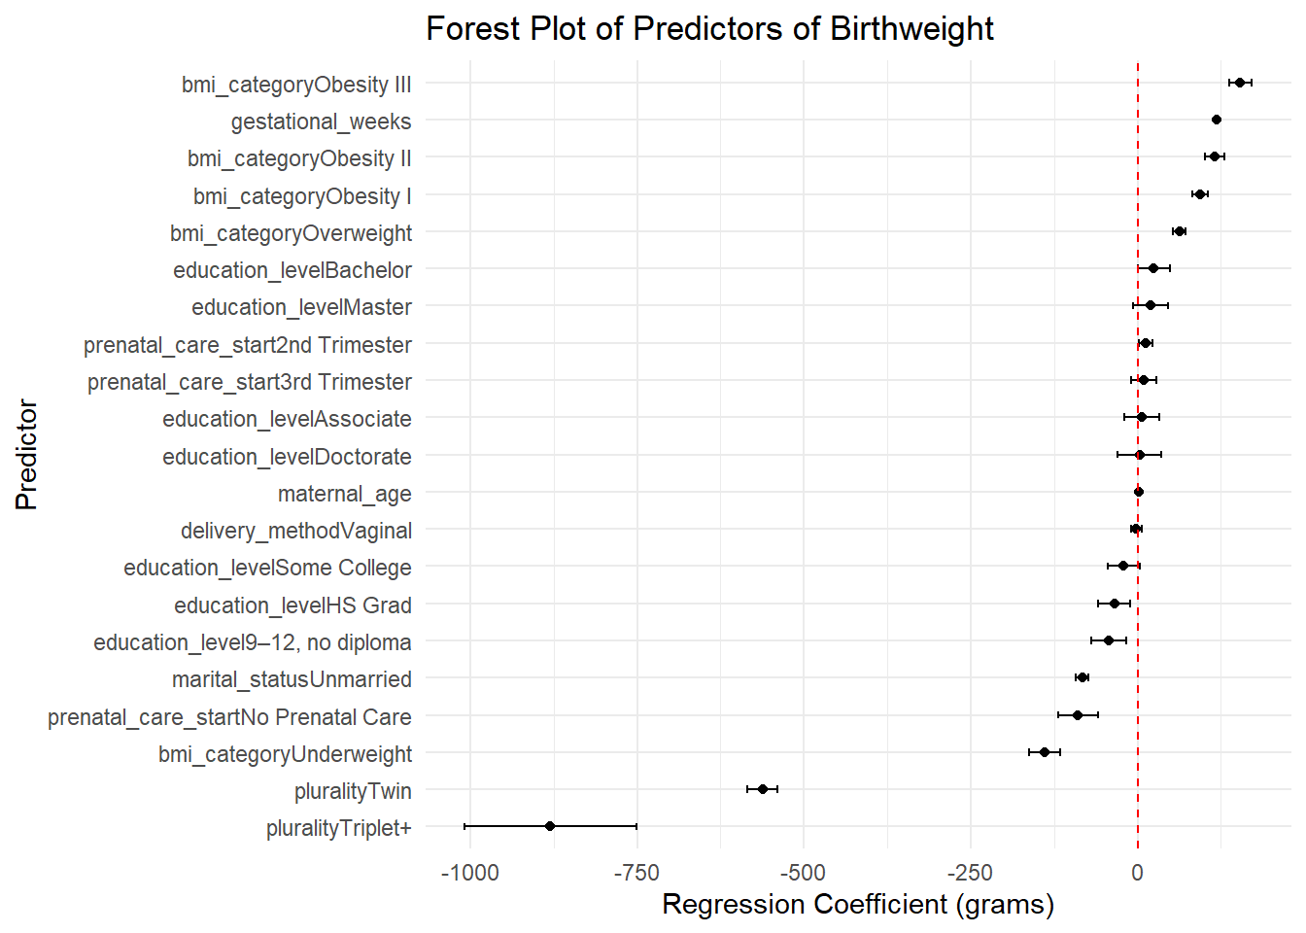
Each dot represents the regression coefficient for a predictor variable. Error bars indicate 95% confidence intervals. The red dashed line represents the null value (0 g).
Forest plot was created to visually display the estimated regression coefficients and their 95% confidence intervals. Predictors whose confidence intervals did not cross zero were considered statistically significant. The forest plot highlighted that gestational age had the strongest positive association with birthweight, while higher plurality (twins, triplets+) had the strongest negative impact.
Conclusion:
The results of this study provide enough evidence that maternal sociodemographic and clinical characteristics significantly influence birthweight outcomes in the United States. Our central research question asked how the timing of prenatal care initiation, education level, marital status, and other maternal factors relate to birthweight and gestational age. Consistent with our hypothesis, we found that earlier prenatal care initiation and higher educational attainment were associated with improved birth outcomes. Initiating prenatal care in the first trimester corresponded to higher mean birthweights in ANOVA analysis, and regression modeling confirmed that receiving no prenatal care was associated with a statistically significant decrease in birthweight. Additionally, being married and having a normal or higher maternal BMI were positively associated with birthweight, whereas multiple gestations (twins or triplets) were linked to large, clinically meaningful reductions in birthweight. Notably, gestational weeks emerged as the strongest predictor of birthweight, reinforcing its significant role in neonatal health.
The chi-square analysis revealed a significant relationship between plurality and delivery method, with multiple births being disproportionately delivered by the cesarean section. This finding aligns with clinical practices and underscores the elevated risks associated with non-singleton pregnancies. The multivariable regression confirmed that even after adjusting for gestational age and other covariates, sociodemographic variables like marital status and education remained important predictors of birthweight. While some categories (e.g., associate degree, doctorate education, and vaginal delivery) were not statistically significant, their directionality matched previous literature and warrant further exploration in more targeted subpopulations. Overall, these findings highlight the need for early prenatal care interventions and continued efforts to reduce disparities tied to education and marital support.
In conclusion, this study demonstrates that early prenatal care, maternal education, marital status, and clinical characteristics such as BMI, gestational age, and plurality are significant contributors to birthweight. These results support the use of sociodemographic variables in public health surveillance and maternal-child health programming. By identifying high-risk groups and reinforcing the importance of early intervention, healthcare systems and policymakers can better allocate resources to improve neonatal outcomes across the United States.

Appendix and Citations:
- JO; RN. Timing of enhanced prenatal care and birth outcomes in New Jersey’s HealthStart program. Maternal and child health journal. Accessed April 29, 2025. https://pubmed.ncbi.nlm.nih.gov/15965620/.
- HA; PSJC. Inadequate prenatal care utilization and risks of infant mortality and poor birth outcome: A retrospective analysis of 28,729,765 U.S. deliveries over 8 years. American journal of perinatology. Accessed April 29, 2025. https://pubmed.ncbi.nlm.nih.gov/22836820/.
- DATA Source: Data Access - Vital Statistics Online. Centers for Disease Control and Prevention. April 10, 2025. Accessed April 29, 2025. https://www.cdc.gov/nchs/data_access/vitalstatsonline.htm.

Additional Figures:
- To Check Assumption: Normality of Outcome for ANOVA Test:
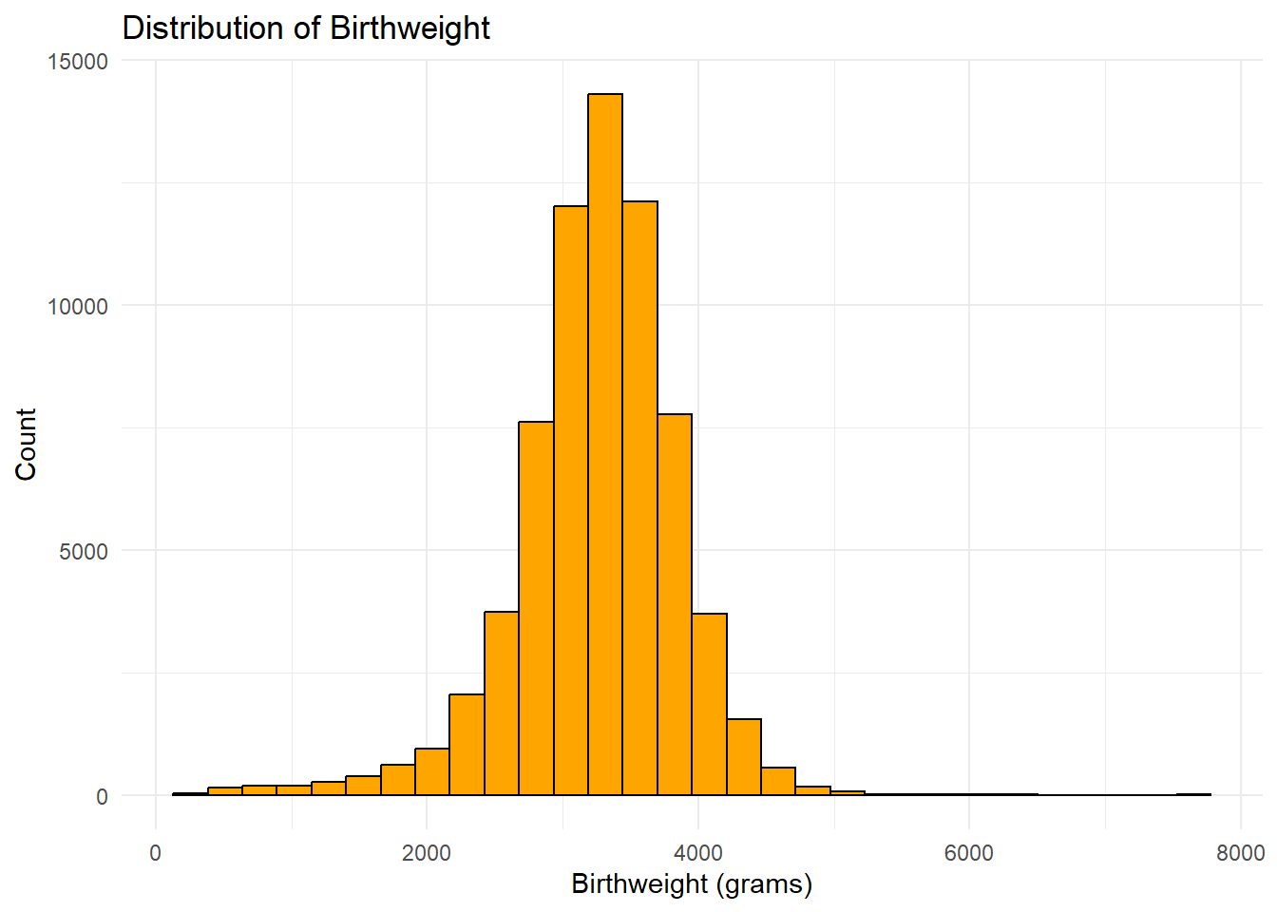
- The visualization for birthweight distribution we got is symmetrical or bell-shaped. The normality assumption for ANOVA is satisfied.
- Normality of Residuals for Linerar Regression:
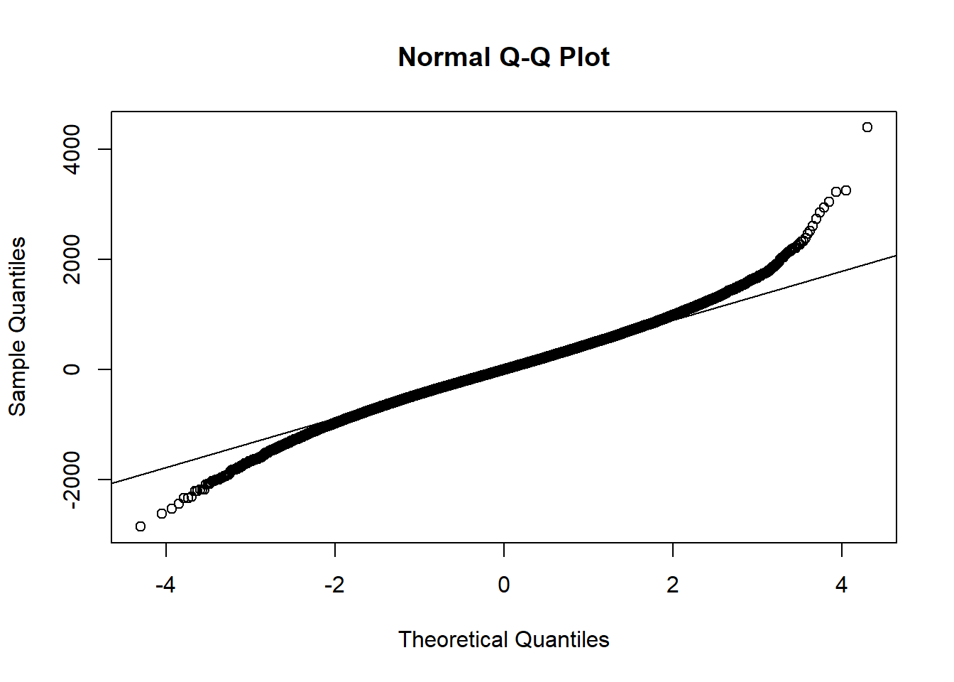
The QQ plot shows that residuals follow a normal distribution, with slight deviations at the tails, which is acceptable given the large sample size.

