Assignment 3 Screenshot Report
Vitaliy Kulesh • Student ID 301559060 • Web Application Development
Source: https://github.com/vkulesh-netizen/COMP229-Assignment3-Portfolio. Live site: https://comp229-assignment3-portfolio.onrender.com/.
The original React design and Express/Mongoose backend are retained. The first eight sections show local workflows at http://localhost:3003. The final three sections show the live Render application connected to MongoDB Atlas.
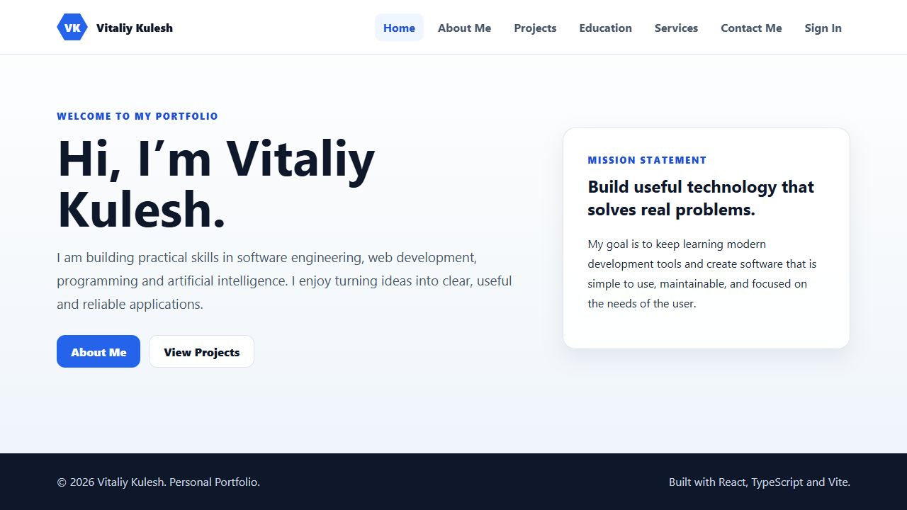
Figure 1. Portfolio overview. Route: http://localhost:3003/.

Account registration
A new account is created as a regular user. Passwords are hashed before storage. The registration flow was exercised with a demonstration account.
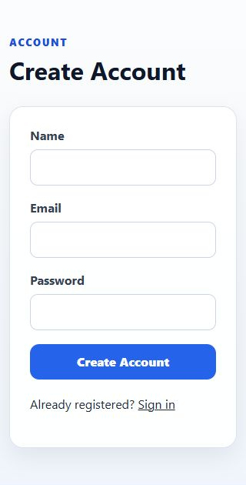 | 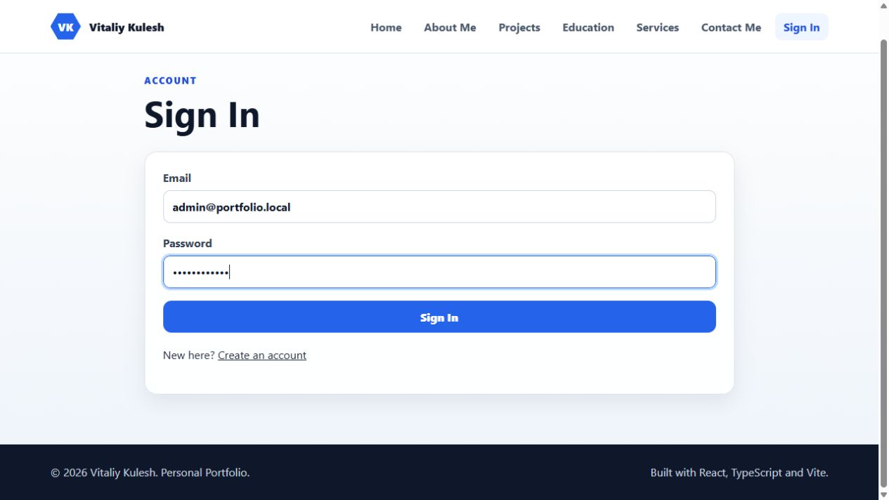  Left: registration form detail in a narrow browser. Above: sign-in form. Both forms use React state and connect to the authentication API.
Figure 2. Account registration. Route: http://localhost:3003/signup.

Role based access
A signed-in regular user sees an administrator access message at /admin. Protected API mutation requests also reject ordinary users with HTTP 403.
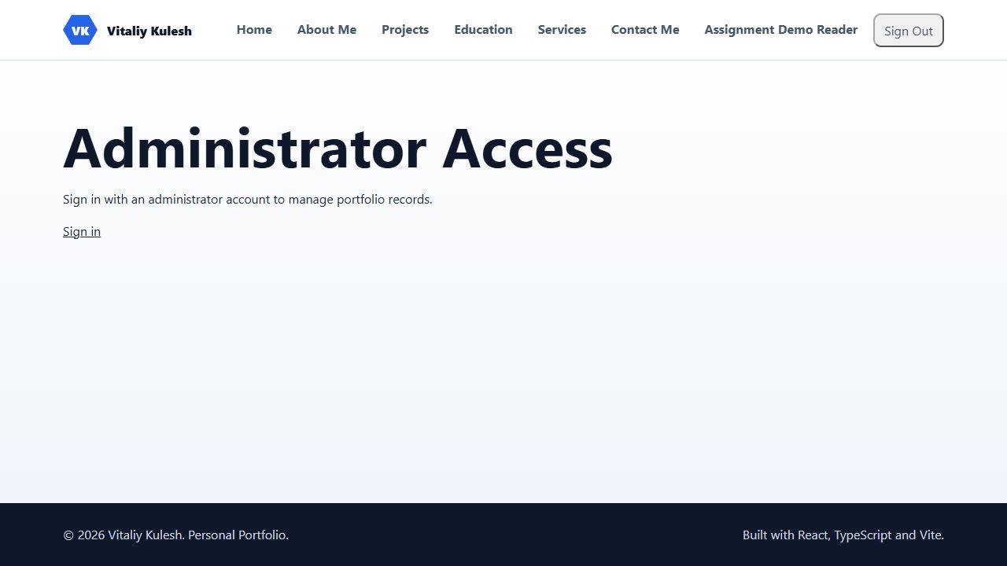
Figure 3. Role based access. Route: http://localhost:3003/admin.

Projects from MongoDB
Project records are fetched from /api/projects and displayed using the original cards and illustrations. Content is no longer maintained as a hardcoded React array.
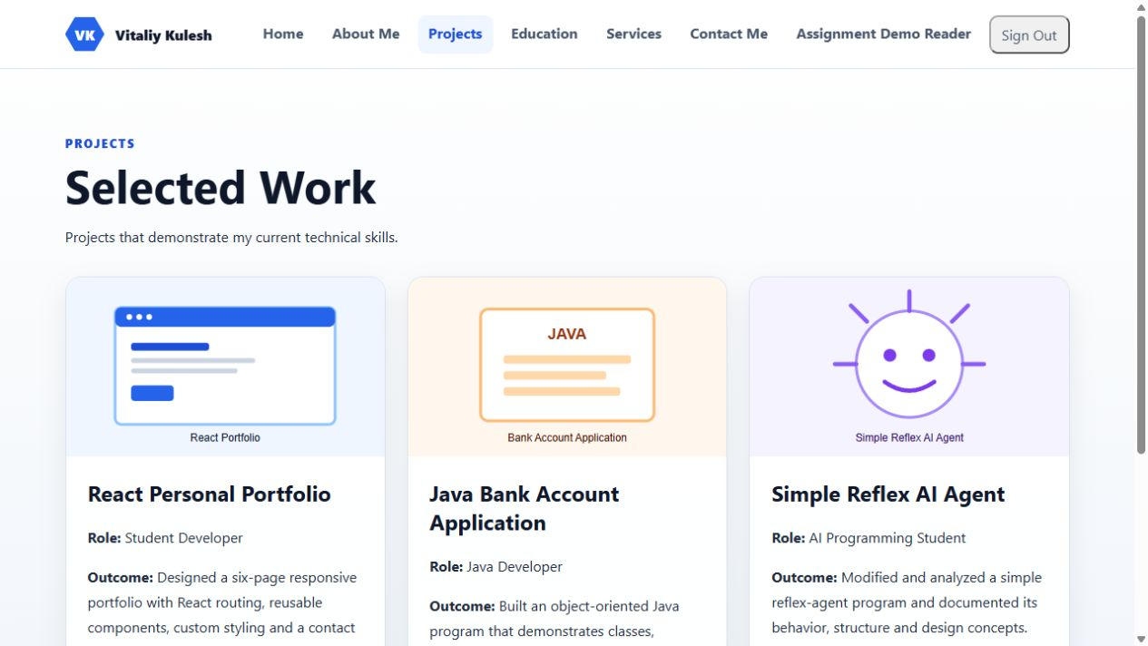
Figure 4. Projects from MongoDB. Route: http://localhost:3003/projects.

Education from MongoDB
Education records are fetched from /api/qualifications. The seed retains all six original education and training entries.
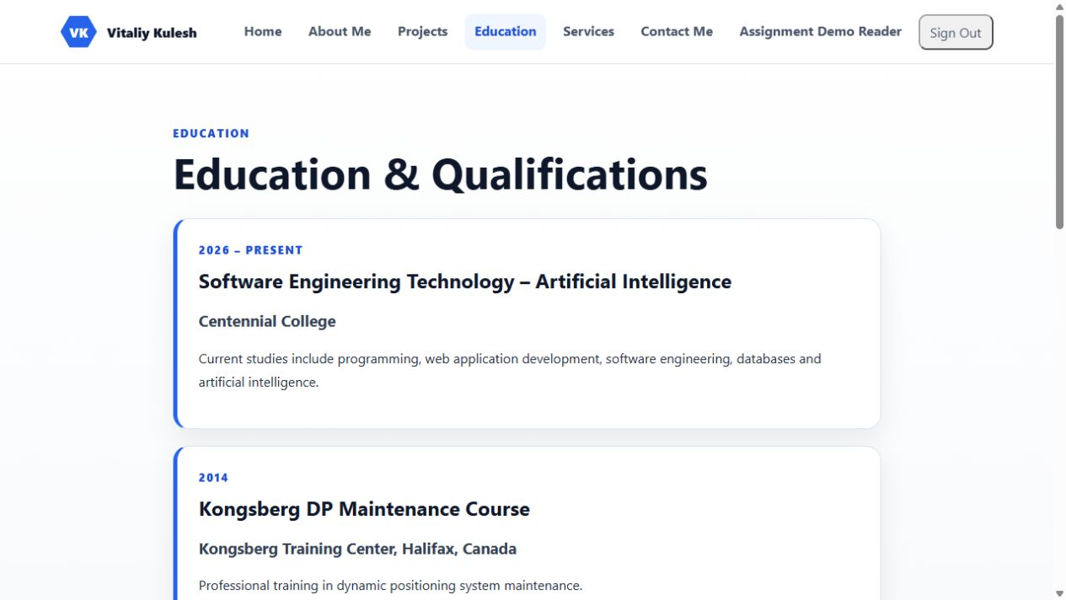
Figure 5. Education from MongoDB. Route: http://localhost:3003/education.

Administrator management
Only an administrator can manage project, education and contact records. The Express routes enforce authentication and the administrator role independently of the user interface.
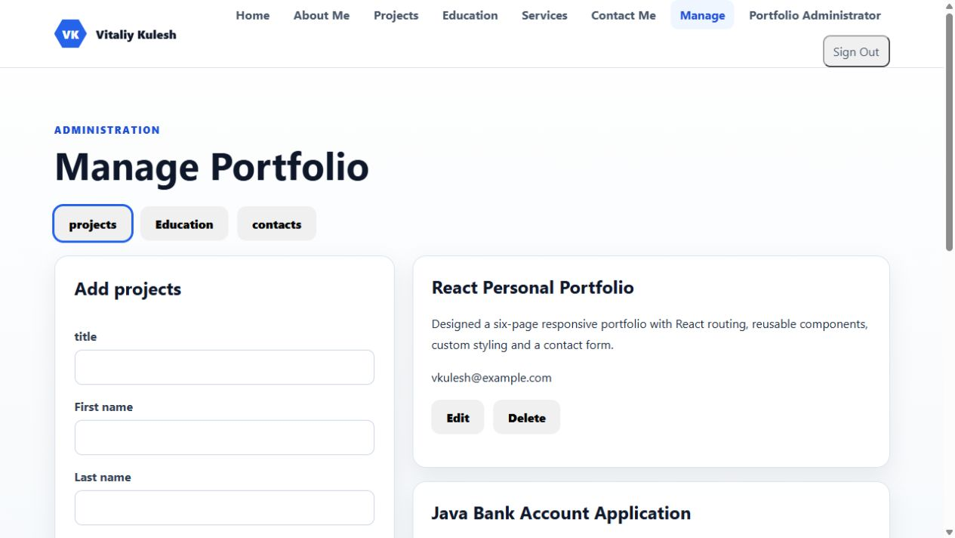
Figure 6. Administrator management. Route: http://localhost:3003/admin.

Project update workflow
The temporary walkthrough project was created through the React form. Edit populated its saved fields; the title was then changed and saved successfully. The temporary record was subsequently removed through the protected API.
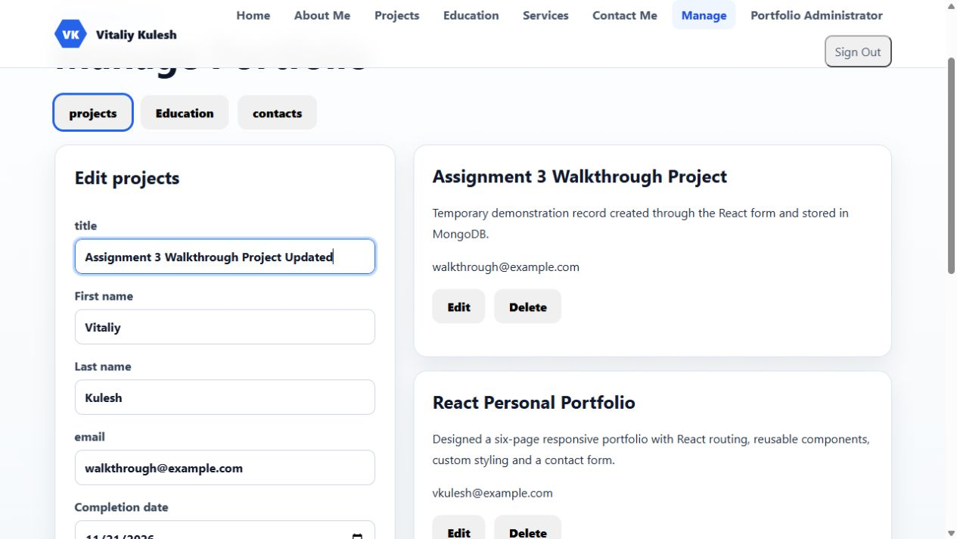
Figure 7. Project update workflow. Route: http://localhost:3003/admin.

Contact message persistence
A contact message submitted through the public React form is visible in administrator management. The message and phone number are retained alongside name and email.
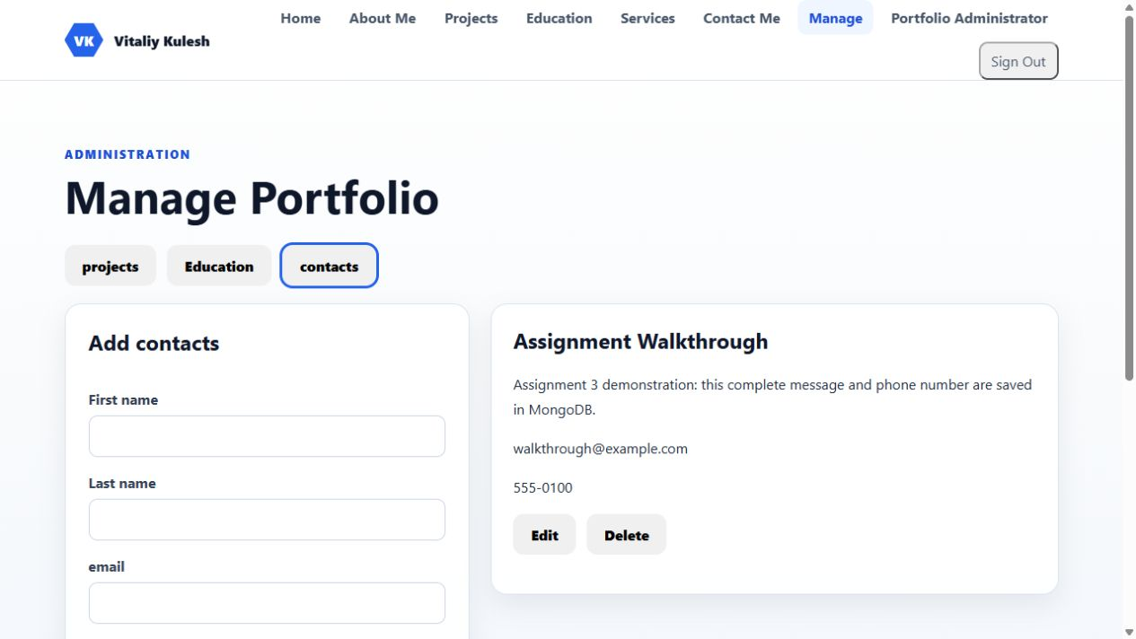
Figure 8. Contact message persistence. Route: http://localhost:3003/admin.

Live deployment on Render
Live site: https://comp229-assignment3-portfolio.onrender.com/. Render deployed the Express application over HTTPS and connected it to MongoDB Atlas.
Figure 9. Live deployment on Render. Route: https://comp229-assignment3-portfolio.onrender.com/.

Hosted portfolio data
The live Projects page returned the three original projects from MongoDB Atlas. A separate API check returned three project records and six qualification records.
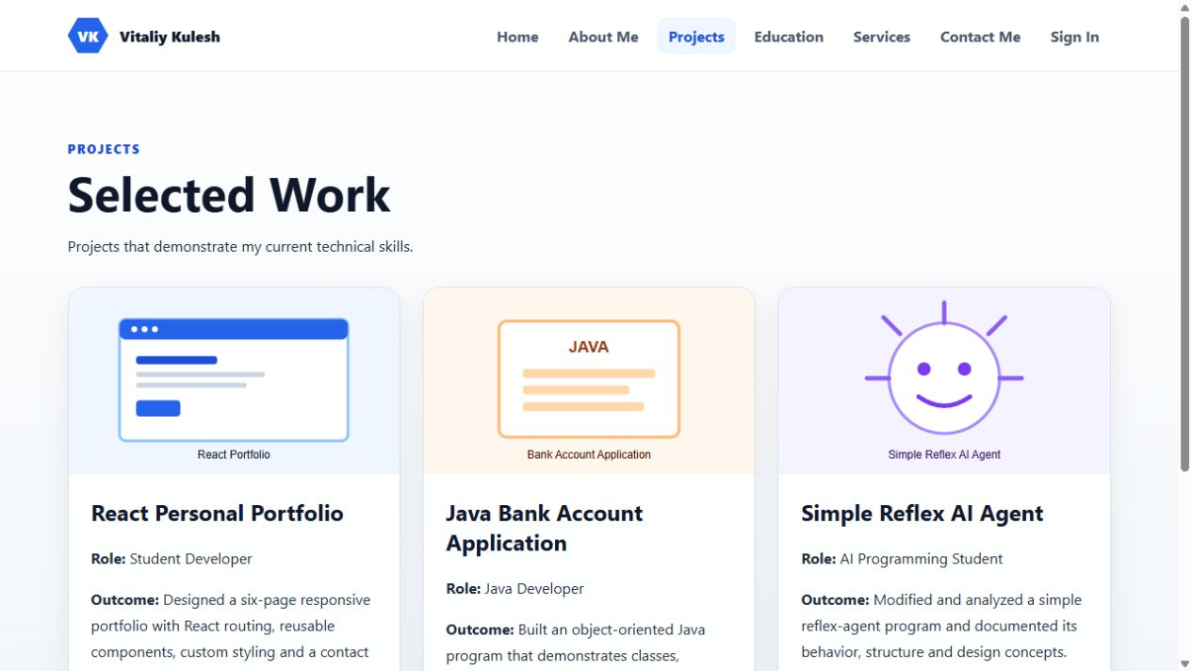
Figure 10. Hosted portfolio data. Route: https://comp229-assignment3-portfolio.onrender.com/projects.

Hosted education data
The hosted Education page displays stored qualification records. Anonymous write requests to the hosted project API returned HTTP 401 as expected. Hosted administrator sign-in and CRUD still require a separate interactive check.
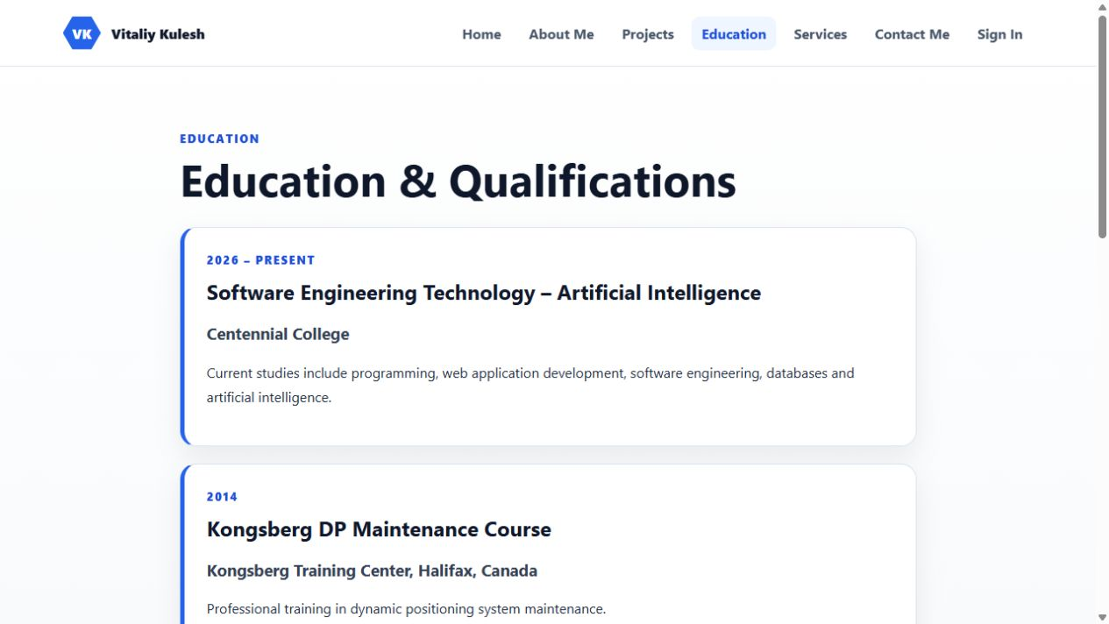
Figure 11. Hosted education data. Route: https://comp229-assignment3-portfolio.onrender.com/education.

