Assignment 3 Portfolio Application
  - Snapshot Report and Submission Index
Vitaliy Kulesh | Student ID 301559060 | COMP229 Web Application Development
This report follows Parts I, II and III of the supplied Assignment 3 instructions. It documents backend authentication, React forms and state, role-based CRUD, and integration with MongoDB. Local evidence and hosted evidence are identified separately.

Required submission items
- A ZIP archive of the portfolio project files: Assignment3_SOURCE.zip.
- A GitHub repository link containing the project source.
- A Word document showing snapshots: this report.
GitHub source repository
Download the portfolio source ZIP
Live portfolio on Render
Supplementary local and hosted walkthrough video

Verification and remaining check
Local integration tests passed for registration, JWT sign-in, sign-out, protected routes, reader restrictions and administrator CRUD for projects, qualifications and contacts. Hosted checks returned a healthy API, three projects, six qualifications and HTTP 401 for anonymous writes. Hosted administrator sign-in was not verified successfully; confirm the seeded account credentials before final submission.

Part I Backend Authentication
Local evidence
The backend implements POST /auth/signin and GET /auth/signout. Sign-in verifies the stored password hash, creates a JWT, and sets an HTTP-only session cookie. The pictured React sign-in form connects to this backend. Integration tests accepted a valid login, rejected an incorrect password and exercised the sign-out endpoint.
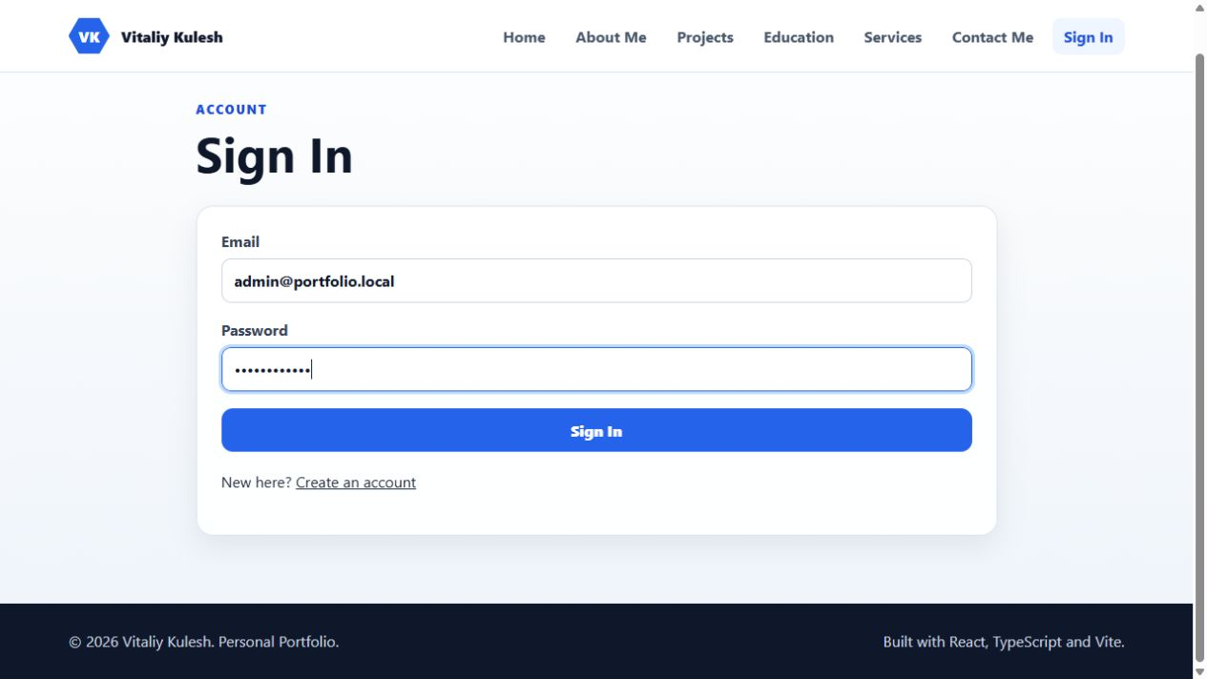
Figure 1. Part I Backend Authentication. Local application snapshot.

Part I Protected Routes
Local evidence
JWT middleware protects authenticated routes. Administrator middleware checks the database role before mutations. A regular user is blocked from /admin, as shown. Tests rejected anonymous project writes with HTTP 401 and regular-user writes with HTTP 403. The database seed creates an administrator; public signup forces the user role.
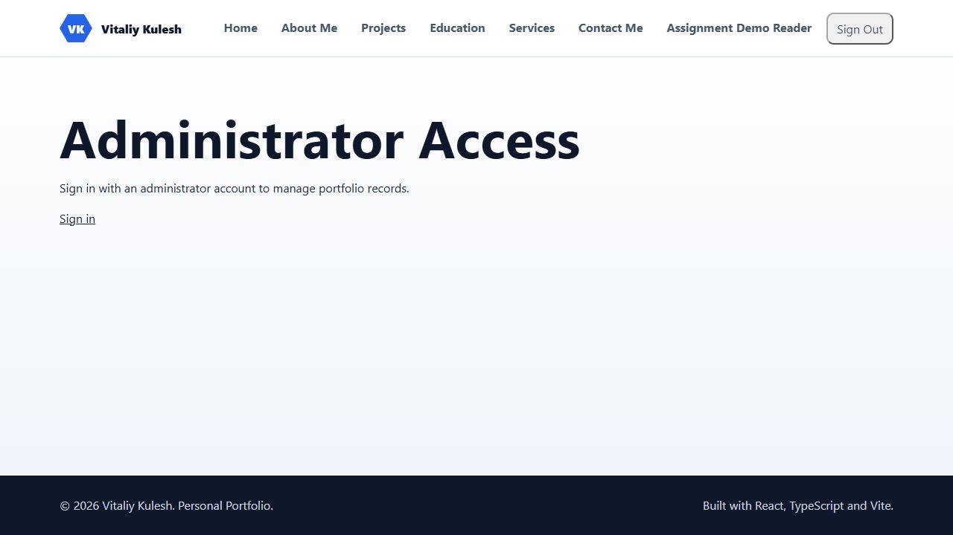
Figure 2. Part I Protected Routes. Local application snapshot.

Part II Signup Signin and State Management
Local evidence
React forms collect account data and display loading and error states. The authentication provider restores the current session through /auth/me. Signup creates a normal user and then signs in. The left image shows the registration form detail; the right image shows the sign-in form.
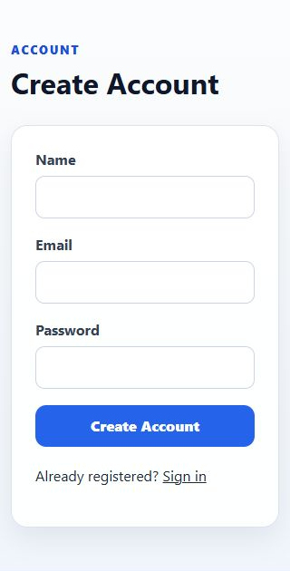
Figure 3. Part II Signup Signin and State Management. Local application snapshot.

Part II Project Forms and CRUD
Local evidence
The administrator management page creates, reads, updates and deletes project records through protected backend APIs. Selecting Edit populates the form from a stored record; this snapshot shows its title being changed before saving. Local tests verified the complete CRUD cycle and reader restrictions. The temporary demonstration record was removed after testing.
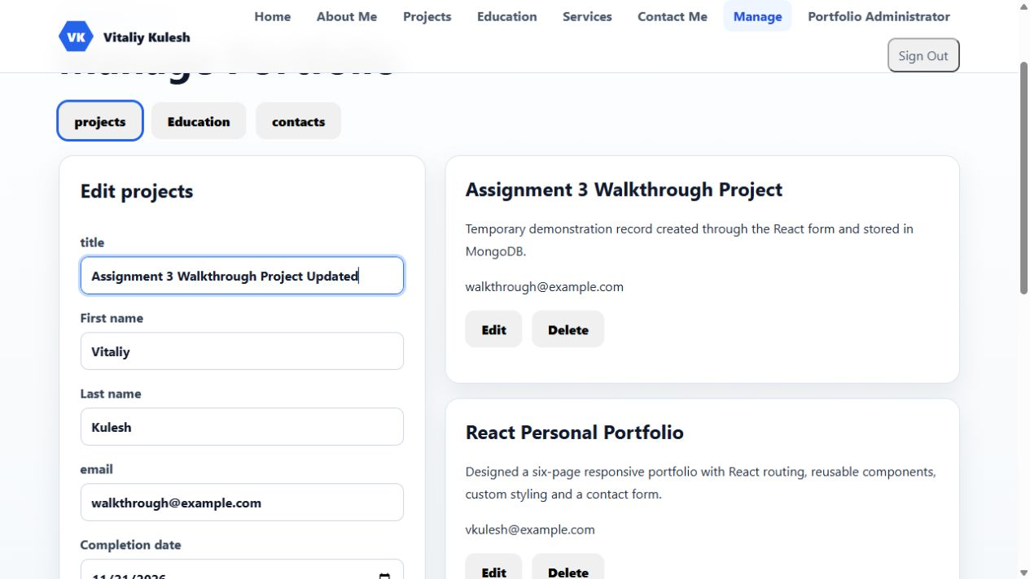
Figure 4. Part II Project Forms and CRUD. Local application snapshot.

Part II Education Forms and CRUD
Local evidence
The Education management tab provides qualification fields, including title, completion date, description, school and study period. React state controls the form. Its requests use /api/qualifications. Local integration tests verified administrator create, read, update and delete operations for qualification records.

Figure 5. Part II Education Forms and CRUD. Local application snapshot.

Part II Contact Form and State
Local evidence
The contact form stores field values in React state and submits first name, last name, email, phone number and message to /api/contact-messages. It includes submission and error states. The public contact-submission endpoint is distinct from the administrator-only contact-management CRUD endpoints.
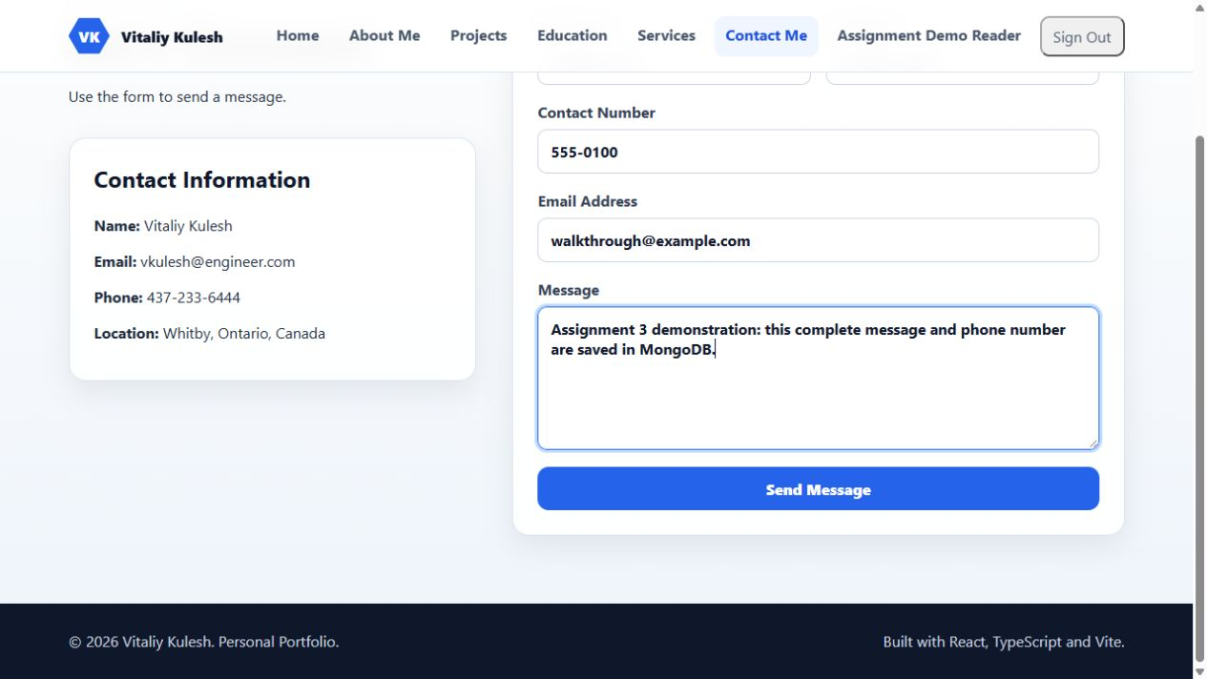
Figure 6. Part II Contact Form and State. Local application snapshot.

Part II Contact Storage and Management
Local evidence
The contact message submitted through the frontend is visible in administrator management. Its full message and phone number were retained. Administrators can edit and delete contacts, while regular users cannot read the private contact-management endpoints. Tests verified contact persistence and the administrator CRUD cycle.
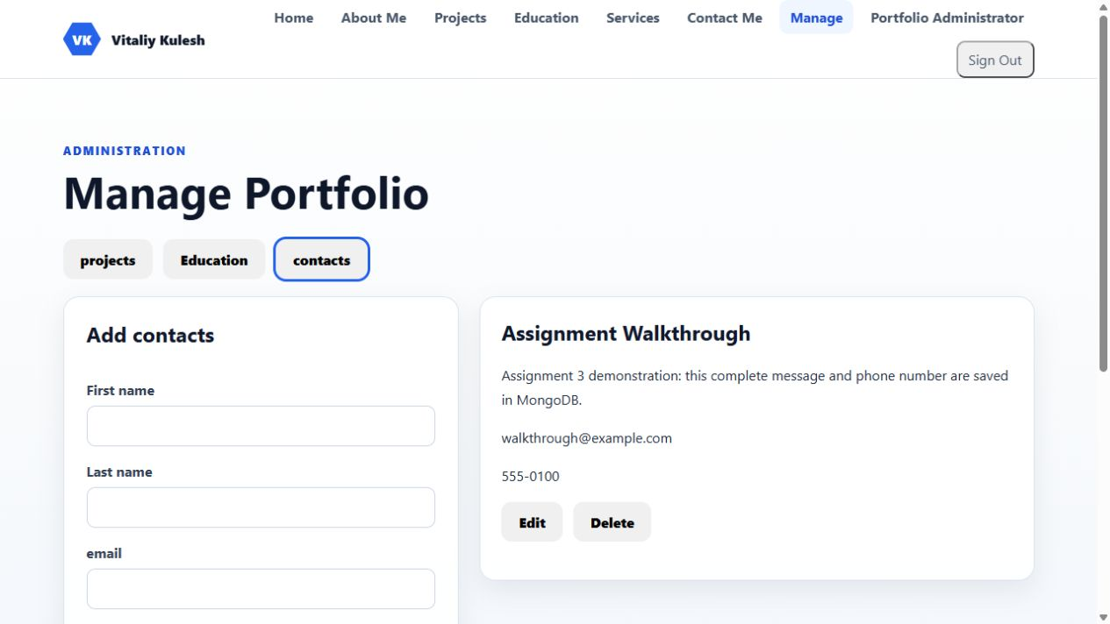
Figure 7. Part II Contact Storage and Management. Local application snapshot.

Part III Frontend and Backend Integration
Local evidence
The React Education page consumes the Express qualification API and renders database records. The six original education and training entries were preserved in the seed data. Projects likewise load through /api/projects. These displays are no longer hardcoded arrays in React.

Figure 8. Part III Frontend and Backend Integration. Local application snapshot.

Part III Hosted Full Stack Portfolio
Hosted evidence
Live URL: https://comp229-assignment3-portfolio.onrender.com/ The application runs as a Node web service on Render. Express serves the built React client and backend API from one HTTPS origin. The service connected successfully to the Portfolio database on MongoDB Atlas.
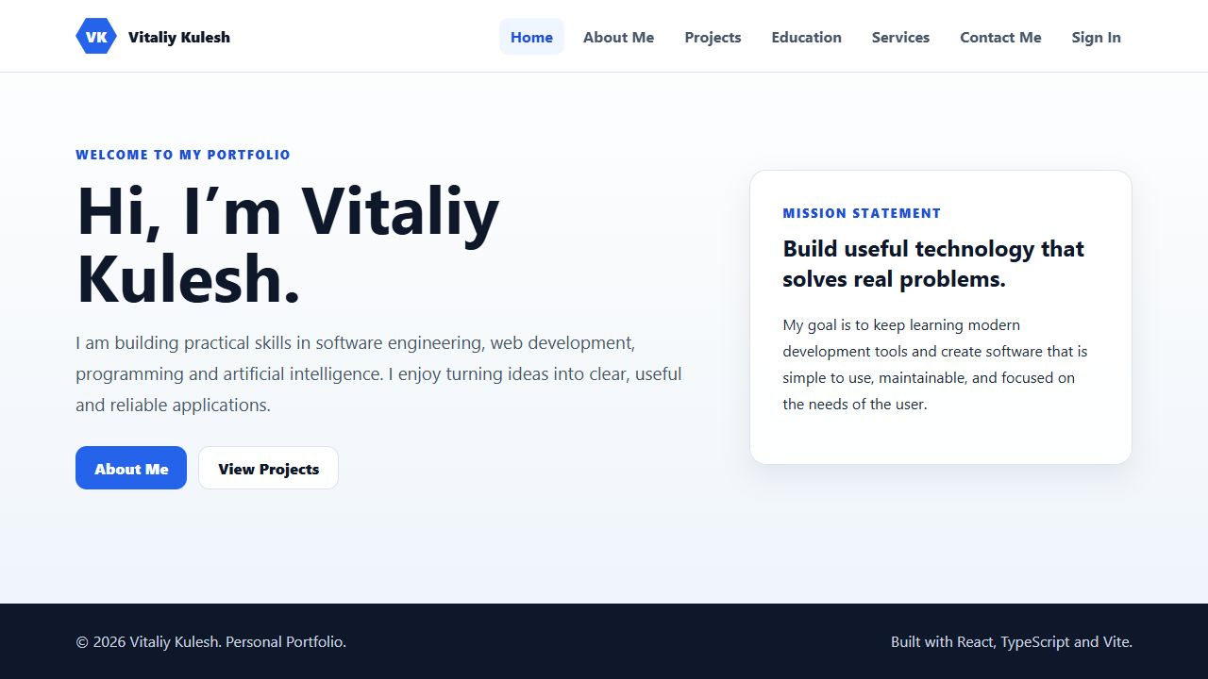
Figure 9. Part III Hosted Full Stack Portfolio. Hosted application snapshot.

Part III Hosted API Consumption
Hosted evidence
The deployed Projects page loads the three seeded project records through the hosted backend. The API health endpoint returned status ok. A request to create a project without authentication was rejected with HTTP 401. The GitHub repository includes the source, seed script, tests and Render deployment configuration.
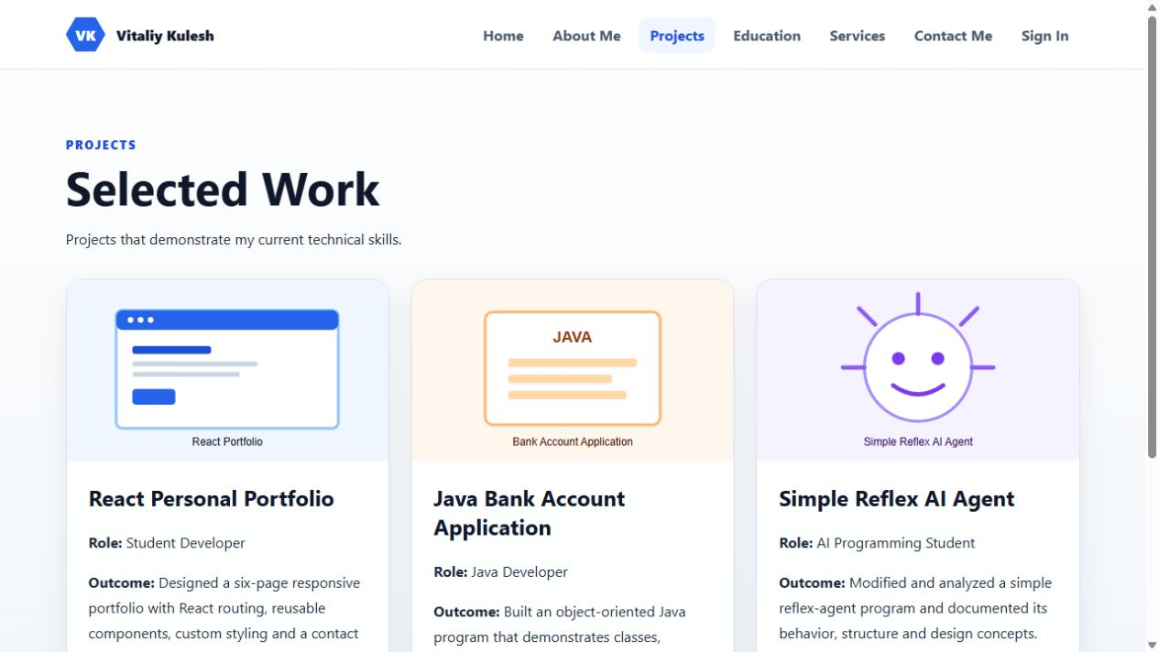
Figure 10. Part III Hosted API Consumption. Hosted application snapshot.

Part III Hosted Data and Final Review
Hosted evidence
The deployed Education page displays saved qualification records from MongoDB Atlas. Hosted endpoints returned six qualifications. The attached assignment also requires an error-free application: hosted administrator sign-in and authenticated CRUD remain a credential-verification check before submission; the local administrator tests and snapshots do not establish that hosted check.

Figure 11. Part III Hosted Data and Final Review. Hosted application snapshot.

