Assignment 4 Portfolio Testing and Deployment
  - Release Verification and Snapshot Report
Vitaliy Kulesh | Student ID 301559060 | COMP229 Web Application Development
This report covers the four parts of Assignment 4: testing, performance optimization, deployment and CI/CD. The existing React design and Express/MongoDB foundation were retained. Six React unit tests and five Cypress E2E tests passed. The release branch was merged into main, automatically deployed by Render, and the new homepage content was verified at the live URL.
Live portfolio
GitHub repository
Merged Assignment 4 release pull request
Successful CI run and original Cypress artifact
Download the actual Cypress E2E recording

Scope of evidence
Unit tests use jsdom and mocked fetch responses. Cypress ran against a production build with an isolated MongoDB database on a GitHub-hosted Ubuntu runner. Hosted checks separately verified the homepage update, API health, database reads and rejection of anonymous writes. After password recovery, the owner confirmed hosted administrator sign-in and create, read, update and delete operations for Projects, Education and Contacts. This manual confirmation is separate from the automated results. No secrets are included.

Required submission
Submit the deployed application link, GitHub repository link and this Word report. The accompanying package includes the Cypress video, screenshots, test source, results and source ZIP. AI assisted test authoring; results and recordings come from executed tests.

Part I React Unit Testing
Vitest and React Testing Library exercised the Contact and Home pages. The six tests cover required-field validation, submission of all contact fields, success/reset behavior, server-error retry, prevention of duplicate submissions, navigation links and the contact-success announcement. The screenshot is a readable rendering of the actual saved Vitest JSON, rather than a fabricated terminal display. Run: npm run test:unit.
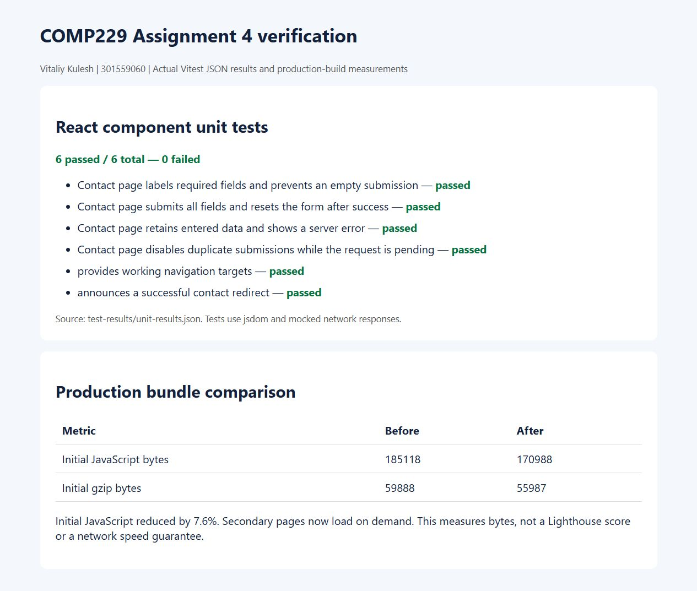
Part I React Unit Testing evidence

Part I Cypress End to End Testing
Five Cypress tests passed with zero failures in GitHub Actions. They cover page navigation and database-backed content, invalid credentials and protected writes, contact API error handling, mobile navigation without horizontal overflow, and health/database endpoints. The contact error response is deliberately intercepted; the other API checks use the running backend and isolated database. The recording is Cypress-generated browser video, with no synthetic narration.
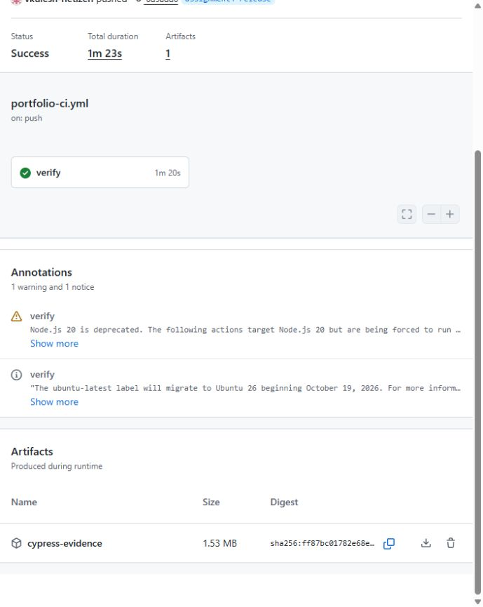
Part I Cypress End to End Testing evidence

Part I Cypress Navigation and Data
The screenshot was produced by Cypress during its successful run. The Education page shows seeded qualifications returned through the real Express API. The test file is cypress/e2e/portfolio.cy.cjs and configuration is cypress.config.cjs. Although the test name refers to cloud data, this recorded CI run used an isolated local MongoDB service on the cloud runner, not the production Atlas database.

Part I Cypress Navigation and Data evidence

Part I Cypress Error and Mobile Checks
Cypress deliberately returns HTTP 503 from the contact endpoint and verifies that the form displays the server error while retaining the message for retry. A separate test uses a 390 by 844 viewport and asserts that the page does not overflow horizontally. Both tests passed; their screenshots and JUnit XML are included with the recording.
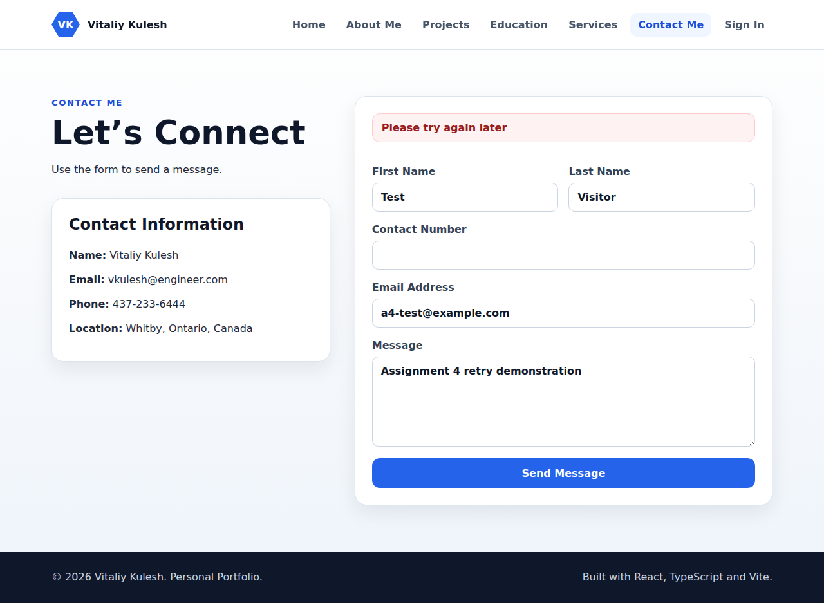
Part I Cypress Error and Mobile Checks evidence

Part II Performance Optimization
Production builds were measured before and after the change. React lazy and Suspense defer seven secondary pages. Fingerprinted assets receive one-year immutable caching; HTML remains immediately revalidatable. Project images use lazy loading, asynchronous decoding and dimensions. The design and core application behavior remain intact.
Metric | Before | After
Initial JavaScript bytes | 185118 | 170988
Initial gzip bytes | 59888 | 55987
JavaScript chunks | 1 | 8
Hashed asset cache lifetime | 0 seconds | 31536000 seconds immutable
Initial JavaScript decreased by 14130 bytes or 7.6%; gzip bytes decreased by 3901 bytes or 6.5%. Secondary chunks are downloaded when their pages are opened, so total JavaScript is not reduced by the same amount. These are reproducible build-size and cache-header measurements, not a Lighthouse score or a guarantee of faster network timing.
Reproduce with npm --prefix client run build. Exact measurements are saved in performance-before.json, performance-after.json and cache-headers.json. The hosted JavaScript was also checked and matched the new 170988-byte entry bundle.
React lazy documentation
Cypress recording configuration

Part III Cloud Deployment
Render deployed merge commit 4e8704357a921af34ad577820fa5f07ef6184841 automatically after the branch was merged. Express serves the production React build and APIs over one HTTPS origin. The database remains on MongoDB Atlas. Render reports Deploy succeeded and Live for this release.
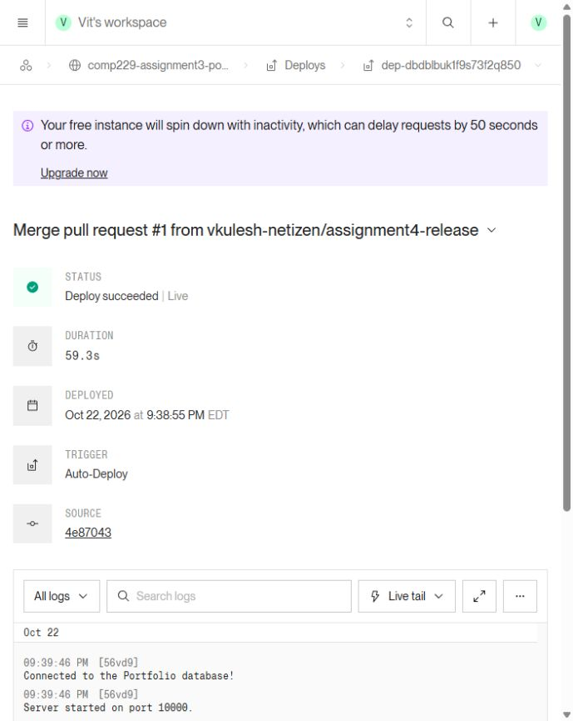
Part III Cloud Deployment evidence
Hosted checks returned API status ok, three projects, six qualifications and HTTP 401 for anonymous writes. The new homepage content and asset caching were verified. After password recovery, the owner confirmed administrator sign-in and temporary-record CRUD for Projects, Education and Contacts. The earlier credential-verification item is resolved by that manual confirmation.

Part IV Before the Content Update
This screenshot of the previous public Render release was captured during Assignment 3 verification, before the Assignment 4 content update. The original introduction and navigation were retained. At this point there was no additional paragraph beneath the About Me and View Projects buttons.
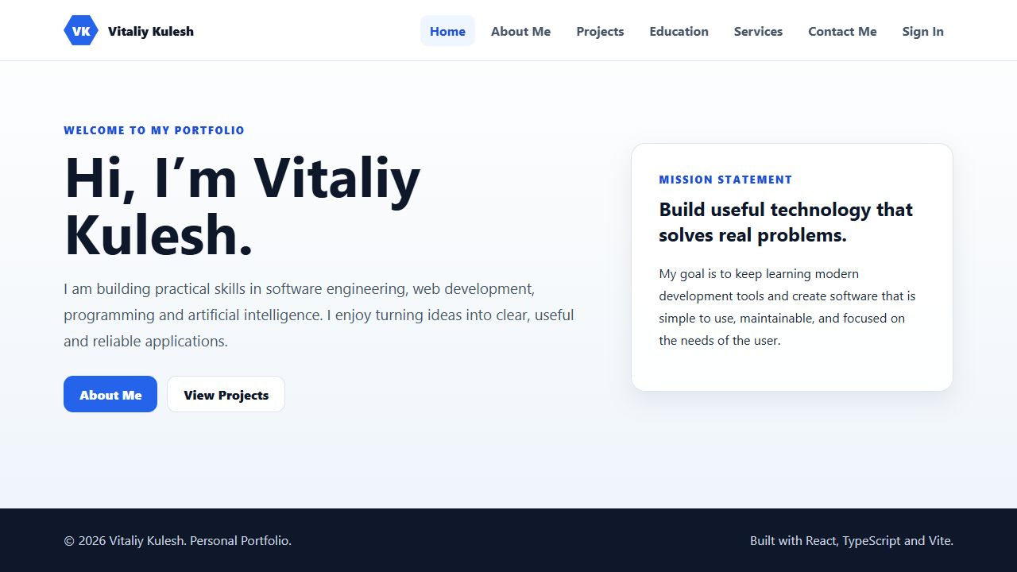
Part IV Before the Content Update evidence

Part IV Branch Merge and Continuous Integration
The assignment4-release branch contained the tests, optimization and homepage content change. Pull request 1 passed both push and pull-request checks before merging into main. The GitHub Actions workflow installs dependencies, runs component and API tests, builds the client, seeds an isolated database, starts the production server and runs Cypress with video enabled.
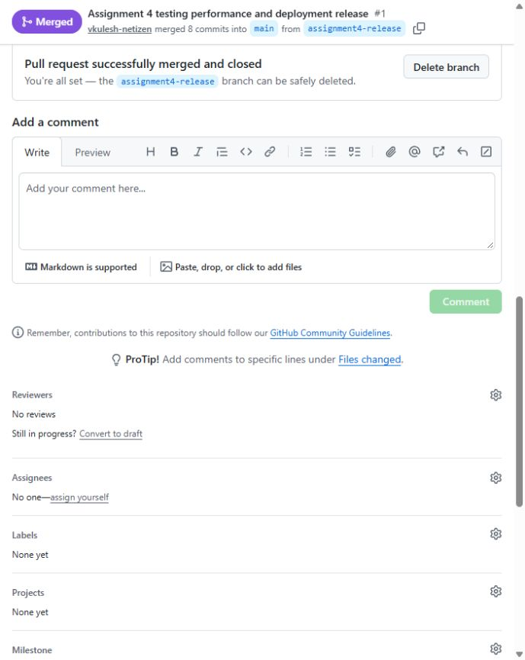
Part IV Branch Merge and Continuous Integration evidence

Part IV After the Deployed Update
After the successful automatic Render deployment, the live URL was refreshed and the new paragraph was visible beneath the navigation buttons. This verifies the branch-to-main-to-cloud path with a real content change. The matching merge commit and Render deployment are linked in the submission index.
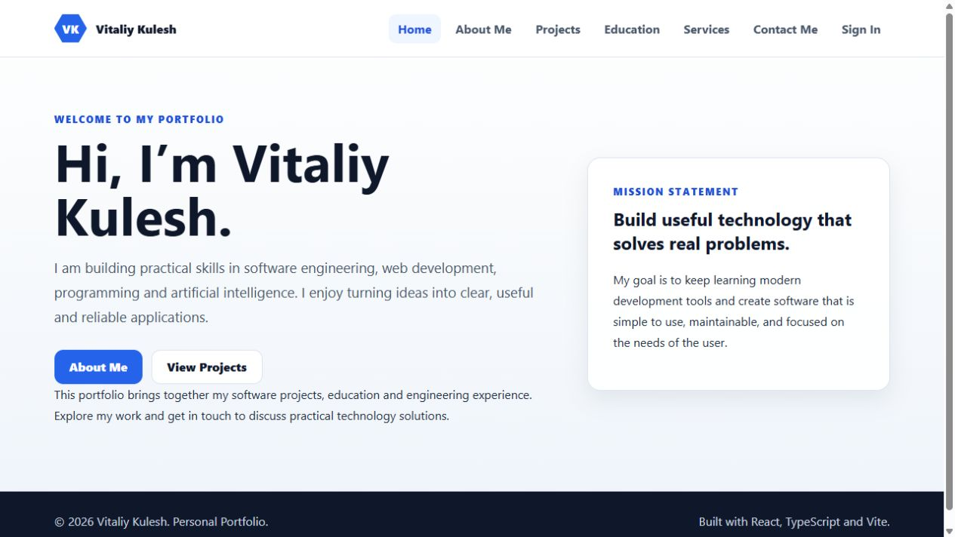
Part IV After the Deployed Update evidence

