Jenkins Assignment 1
Step 1 click on new item and give the job name and type
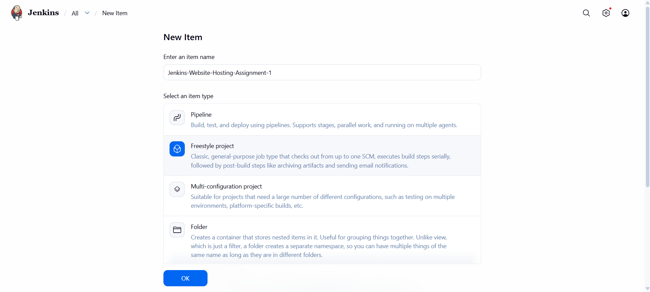
Step 2 describe about job
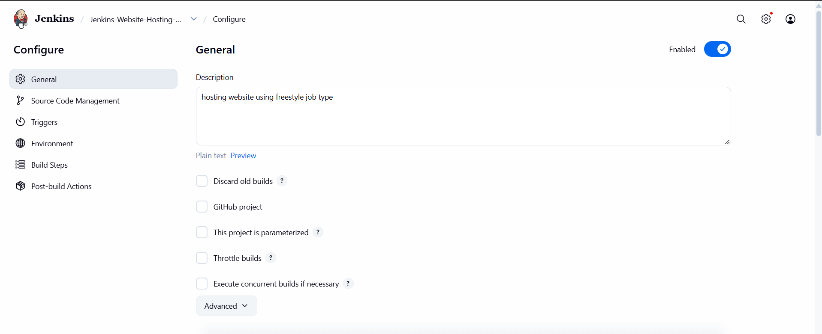

Step 3 select the build type and written the website hosting script and click on apply and save
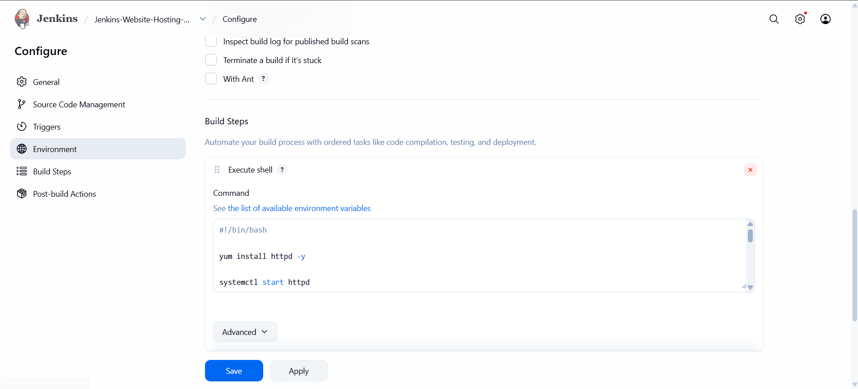
Step 4 coming back to Jenkins dashboard and click on the job
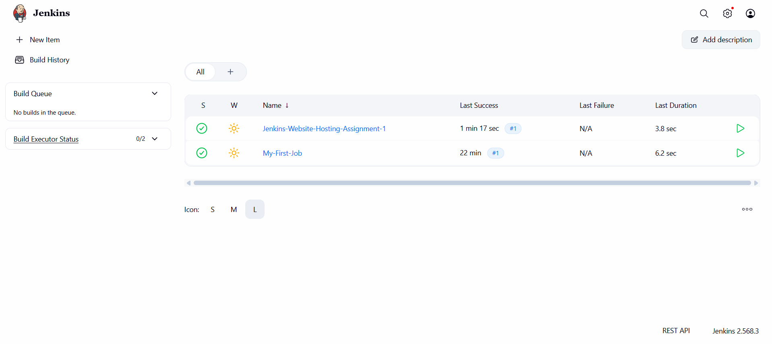
Step 5 to run the job click on the build now button
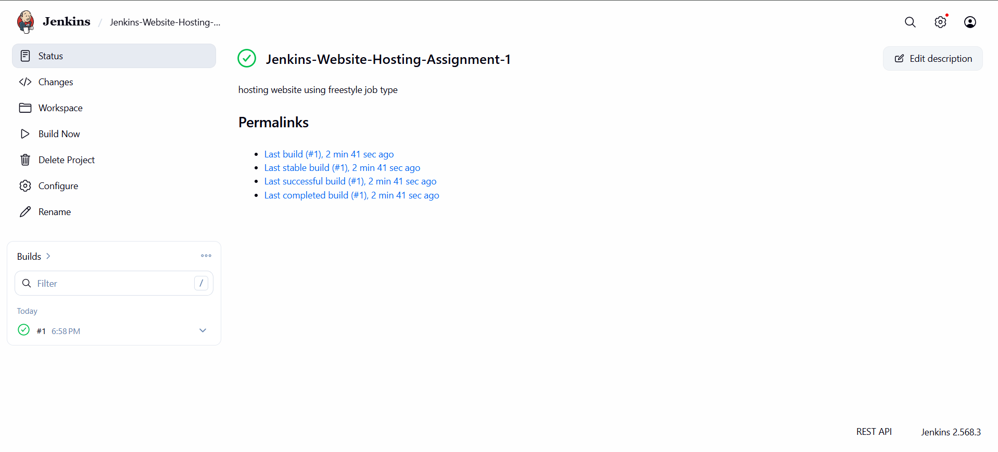
Once its run the click on generated builds like #1 then to check the output click on console output.
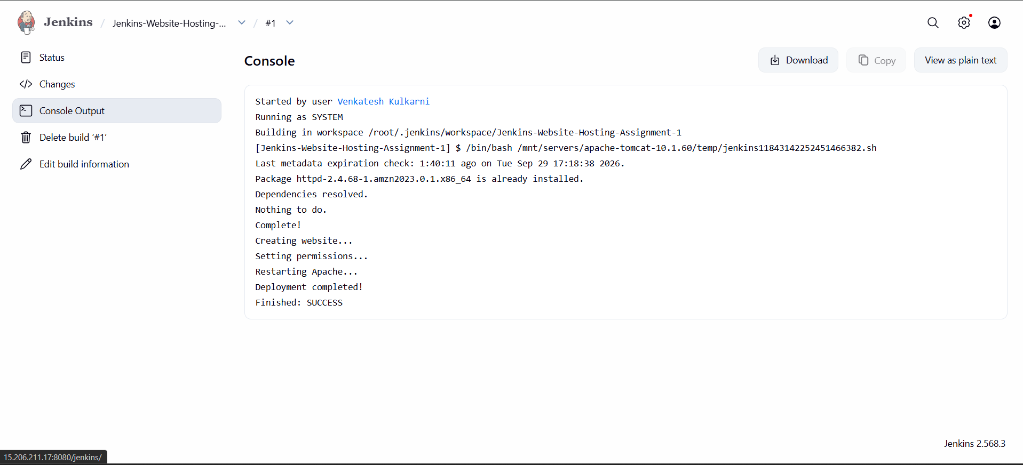
Output :-
The website is running successfully
