SHOPPING SYSTEM USING MOBILE AGENT

TABLE OF CONTENTS

- Introduction 3 1.1 Mobile Agent 3
1.2 J-APPI 4
1.3 Aglet object model Abstractions 5
1.4 Aglet object model Behavior 6
1.5 Security Considerations 7
1.6 Usage Scenarios 7
1.7 Agent Transfer Protocol 7

- Project Objective 8
2.1 SYSTEM SPECIFICATIONS : 8
2.2 Application 8

- Scope of the project 8

- Literature Survey
4.1 Implementation Details of the System 9
4.2 INTRODUCING THE ASDK 9
4.3 What is aglet 10
4.4 TAHITI SERVER 15
4.5 AGLET CREATION 17
4.6 AGLET DISPOSAL 20
4.7 AGLET MOBILITY 23
4.8 MOBILITY RETRACTING 26
4.9 AGLET CLONING 27 4.10 PERSISTENCY 28
4.11 EVENT 29
- Requirement Specification 31
- Proposed Design 34

- Test Cases 36

- Conclusion 37

1. Introduction

This application consists of three interacting agents: one Buyer agent and two Store agents. Each kind of agent has a different role and different capabilities. Although this example features only two Store agents, the Buyer agent is able to interact with any number of Store agents.

The Buyer agent sends requests for price quotes to all the Store agents, waits for responses, and then buys the specified product from the store with the lowest price

  - Mobile Agent
In computer science, a mobile agent is a composition of computer software and data which is able to migrate (move) from one computer to another autonomously and continue its execution on the destination computer.

Mobile agents are active in that they may choose to migrate between computers at any time during their execution. This makes them a powerful tool for implementing distributed applications in a computer network.
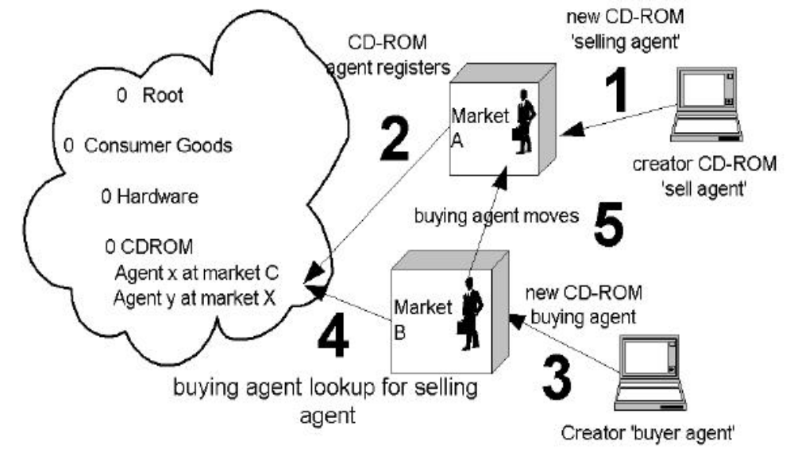

1.2 J-APPI

The Java Aglet Application Programming Interface (J-AAPI) is a standard for interfacing aglets and their environment.

J-AAPI methods

- for aglet creation,
- message handling in the aglet, and
- initialization,
- dispatching,
- retraction,
- deactivation/activation,
- cloning, and
- disposing of the aglet

Important Interfaces and Classes

J-AAPI Interfaces

- AgletContext
- FutureReply
- MessageManager

J-AAPI Classes

- Aglet
- AgletIdentifier
- AgletProxy
- Itinerary
- Message

1.3 Aglet object model Abstractions

- Aglet
- Context
- Proxy
- Message
- Message manager
- Itinerary
- Identifier

Aglets

Aglets are Java objects that can move from one host on the Internet to another. That is, an aglet that executes on one host can suddenly halt execution, dispatch to a remote host, and resume execution there. When the aglet moves, it brings along its program code as well as its state (data). A build-in security mechanism makes it safe to host untrusted aglets.

Context

A context is an aglet's workplace. It is a stationary object that provides a means for maintaining and managing running aglets in a uniform execution environment where the host system is secured against malicious aglets. One node in a computer network may host multiple contexts

Proxy

A proxy is a representative of an aglet. It serves as a shield for the aglet that protects the aglet from direct access to its public methods. The proxy also provides location transparency for the aglet. That is, it can hide the real location of the aglet.

Message

A message is an object exchanged between aglets. It allows for synchronous as well as asynchronous message-passing between aglets. Message-passing can be used by aglets to collaborate and exchange information in a loosely coupled fashion.

Message Manager, Itinerary

A message manager allows for concurrency control of incoming messages

An itinerary is an aglet's travel plan. It provides a convenient abstraction for non-trivial travel patterns and routing.

1.4 Aglet object model Behavior

Creation

Cloning

Dispatching

Retraction

Deactivation

Messaging

Naming

Creation and Cloning

The creation of an aglet takes place in a context. The new aglet is assigned an identifier, inserted in the context, and initialized. The aglet starts executing as soon as it has successfully been initialized.

The cloning of an aglet produces an almost identical copy of the original aglet in the same context. The only differences are the assigned identifier and that execution restarts in the new aglet. Notice that execution threads are not cloned.

Dispatching and Retraction

Dispatching an aglet from one context to another will remove it from its current context and insert it into the destination context, where it will restart execution (execution threads will not migrate). We say that the aglet has been pushed to its new context.

The retraction of an aglet will pull (remove) it from its current context and insert it into the context from which the retraction was requested.

Deactivation, Messaging, Naming

The deactivation of an aglet is the ability to temporarily remove it from its current context and store it in secondary storage. Activation of an aglet will restore it in a context.

Messaging between aglets involves sending, receiving, and handling messages synchronously as well as asynchronously.

A naming mechanism automatically assigns immutable identities to new aglets. These identities should be guaranteed to be globally unique

1.5 Security Considerations

A host needs to ensure that an aglet does not compromise its security. We classify aglets into two categories: trusted and untrusted. The aglet security manager checks whether the aglet is allowed to access the file system, network, and other aglets. The decision to trust an aglet is entirely up to the host.

1.6 Usage Scenarios

Accessing Databases

Web Site Monitor

Distributed Meeting Scheduling

Auction

1.7 Agent Transfer Protocol

TAHITI

Tahiti is an application program that runs as an agent server. You can run multiple servers (Tahiti) on a single computer by assigning them different port numbers. Tahiti provides a user interface for monitoring, creating, dispatching, and disposing of agents and for setting the agent access privileges for the agent server.

2. Project Objective

2.1 SYSTEM SPECIFICATIONS :

  - This application consists of three interacting agents: one Buyer agent and two Store agents. Each kind of agent has a different role and different capabilities. Although this example features only two Store agents, the Buyer agent is able to interact with any number of Store agents.

  - The Buyer agent acts on behalf of a human user and attempts to buy products specified by that user. The Buyer agent sends requests for price quotes to all the Store agents, waits for responses, and then buys the specified product from the store with the lowest price.

2.2 Application

The Online Shopping System using Mobile Agent makes it easy for the buyer to purchase the best possible product for the cheapest possible price.
Each Store agent represents one retail store and knows the prices and available quantities of the products in its store. Store agents receive requests for price quotes from the Buyer agent and respond by telling the Buyer agent the prices and quantities that they can deliver.

Scope of the Project

This project is mainly intended to avoid network latency problem and to utilize the network bandwidth in more proper way. Beside that it provides intelligence to program to independently work without human intervention and return information to client program

4.Literature Survey

4.1 Implementation Details of the System :

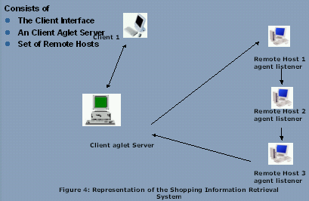

4.2 INTRODUCING THE ASDK :

- ASDK is Aglet Software Development Kit.
- ASDK facilitates flexible code distribution, that is factoring functionality and communications.
- ASDK enables programs to be developed that are code in demand.
- ASDK provides an event model that supports mobility-oriented and mobility-triggered operations.
- ASDK is a set of API that enables all of the above.
- ASDK is Extensive.

- Aglet API is an agent development kit.
- A set of Java classes and interfaces that allows create mobile Java agents.
- “write once, go anywhere”.
- Once you have written an aglet, it will run on every machine that supports the Aglet API.
- Aglet API mirrors the applet model in Java.

4.3 What is aglet

Light weight agent

Aglet = Agent + Applet

Aglet :

- Aglet is a java based autonomous software agent.
- Mobile agent – supports the ideas of autonomous execution and dynamic routing on its itinerary.
- A Java object that can be transported along with state information.
- Can receive request from external sources, but each individual aglet decides whether or not to comply with external requests
- Executable in any aglet environment. operating within any Java environment.
- Java programs that can halt execution, travel across the network (with both code and state in tact) and continue execution at another host.
- Hosted by an Aglet Server i.e. Tahiti Server.

Aglet versus Applets

- Like an applet, the class files for an aglet can migrate across a network.
- Unlike applets, when an aglet migrates it also carries with it its state.
- An applet is code that can move across a network from a server to a client.
- Aglet is a running Java program (code and state) that can move from one host to another on a network.
- Aglet carries its state wherever it goes, it can travel sequentially to many destinations on the network, including eventually returning back to its original host.

Aglet Object Model :Model

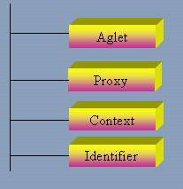

Aglet

Aglet is a java based autonomous software agent.

Proxy

- Shields the aglet from direct access to its public methods.
- Provides location transparency for the aglet, that is, it can hide the aglet’s real location. This means that an aglet and its proxies can be separated so that a local proxy hides the address of the aglet.

Context

- aglet’s workplace.
- Stationary object provides a means for maintaining and managing running aglets in a uniform execution environment where the host system is secured against malicious aglets. I.e. the Tahiti Server provides context to aglets created in it.

Identifier

- a globally unique and immutable throughout the lifetime of the aglet. An id.

AGLET LIFE CYCLE MODEL :

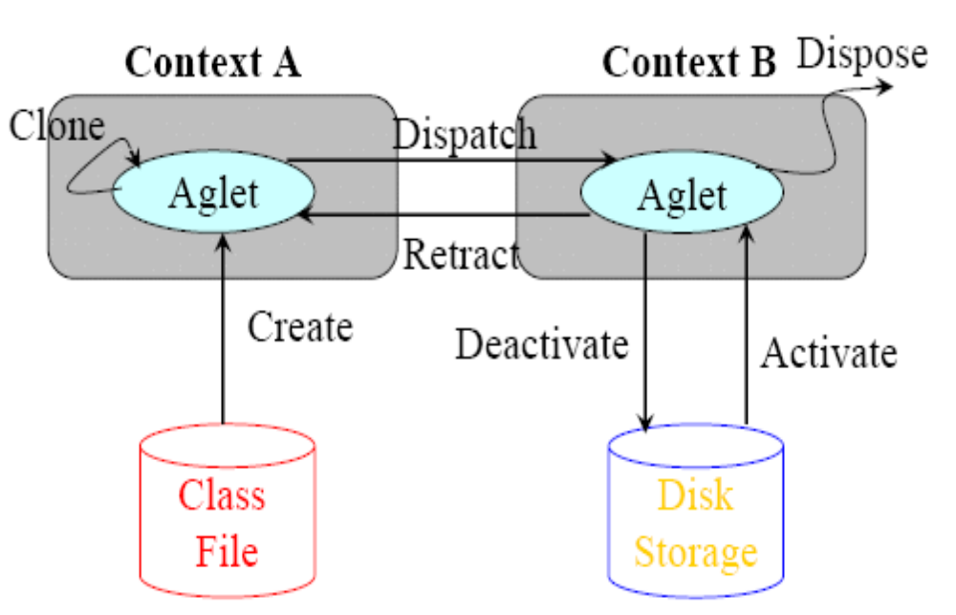

AGLET OPERATIONS :

Fundamental life cycle-related operations:

Create
- within an aglet context; each aglet is assigned a unique identifier.

Clone
- a distinct aglet with a unique identifier is produced.
- The clone gets a new thread of execution.

Dispose

- Terminates execution and removes the aglet from the context. When no references to the aglet remain, it will be subject to garbage collection.

Dispatch
- An aglet is removed from its current context and forwarded to another, typically remote context.
- At the target site, its execution (its run() method) begins a new.

Retract
- An AgletID must be known to be able to perform a retraction.
- An aglet is removed from its “dispatched-to”,typically remote, context and reintroduced to its “home” context. At home, its execution begins a new.

Deactivate
- Halts execution. Its state is transferred to secondary storage.
- The aglet is not removed from the aglet context. The aglet sleeps for at least the specified dormancy period.

Activate
- When a deactivated aglet’s sleep cycle expires. It is activated and its execution begins.

AGLET EVENT MODEL :

Aglet programming – event-based

- Programmers write listeners into an Aglet
- Listeners catch particular events in the life-cyle of an Aglet
- This allows a particular action (which has been coded) to take place when a specified event occurs

Three types of Events

- Clone Event – clone operation

- Mobility Event – dispatch, arrival, retraction operation

- Persistency Event – activate & deactivate operation

RELATIONSHIP BETWEEN AGLET AND ITS LISTENERS :

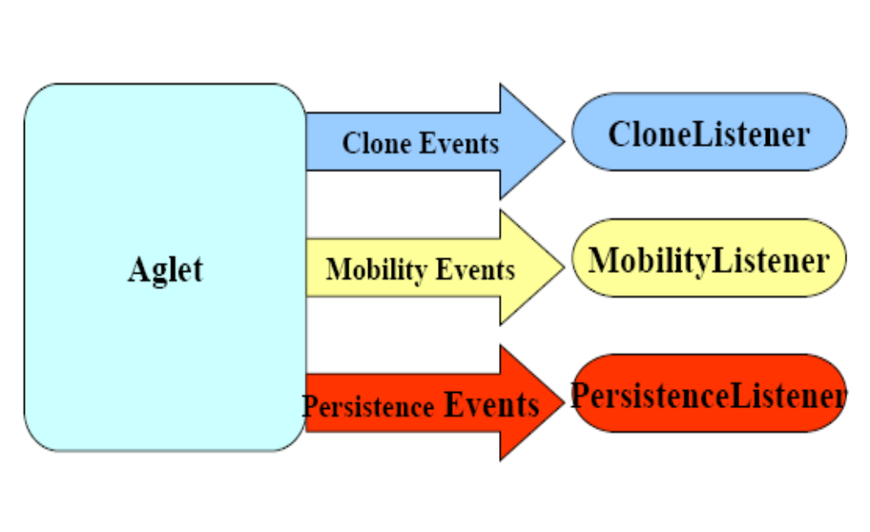

R

AGLET PACKAGE :

- com.ibm.aglet

- com.ibm.aglet.event

- com.ibm.aglet.security

- com.ibm.aglet.system

- com.ibm.aglet.util
- com.ibm.agletx.util

AGLET PROXY INTERFACE :

- Acts as the handle of an aglet
- Provides a common way of accessing the aglet
- Aglet class
several public methods
- should not be accessed directly from other aglets
- security reasons
- For Aglet A to communicate with Aglet B
- The proxy of Aglet B must be obtained
- Interact with Aglet B through the Interface
- Proxy is a shield that protects Aglets from malicious Aglets
- The AgletProxy object consults the Security Manager
- Check whether current execution context is allowed to perform the method
- AgletProxy Interface also provides Location Transparency
- If the Aglet is on a remote host, then the proxy forwards a request to the Aglet and returns the results

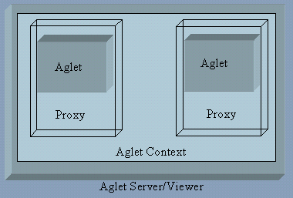

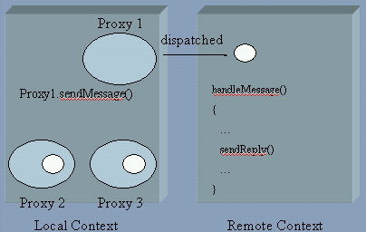

4.4 TAHITI SERVER :

- Creates and loads aglets.
- Dispatches and retracts.
- Process of creating an aglet.
- Loading the class file.
- Instantiating the aglet.
- Establishing the aglet in the context.
- Invoking onCreation().
- Invoking run().

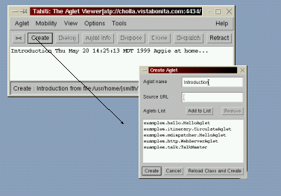

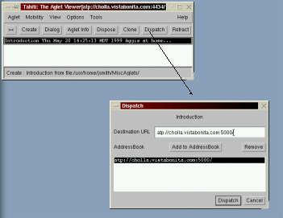

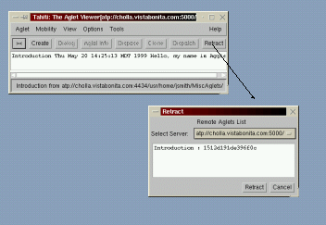

AgletID Class :

- Every Aglet is assigned a Globally Unique Identity
- Kept throughout its lifetime
- AgletID class – convenient abstraction for this ID
- Hides the implementation specific representation of the aglet identity
- It cannot be changed
- Retrieved directly from the Aglet and its proxy
- AgletID aid = proxy.getAgletID()
- If you know the ID and the context, you can query the context to retrieve the aglet
- proxy = context.getAgletProxy(aid);

4.5 AGLET CREATION :

- Gets created in a place (i.e. Context)
- Creation can be initiated either by another agent residing in the same place or by another agent or non agent system outside the place.
- Instantiation and Identifier assignment
- Initialization
- Autonomous execution

- Creation & Initialization Methods

public void onCreation(Object init)

public void run()

called every time the aglet arrives at or is activated in a new context.

PARAMETERS EXPLAINED :

Codebase

- Specifies base URL of the aglet class file.
- The aglet search path works in a similar way to Java’s class path.
- It is typically an environment variable that specifies a list of directories to be searched for aglet class files.

Code
- Gives the name of the class of the aglet being instantiated.

Init
- It is an object passed on the aglet’s onCreation method.

CREATING AN AGLET :

When an aglet has been successfully created, it is inserted into the current context and started:
- invocation of onCreation()
- followed by run().
- The method returns a handle(Aglet Proxy) for the new aglet as soon as the aglet’s constructor method finishes

- Aglet Constructor

protected Aglet.Aglet()

- Creates an Uninitialised Aglet
- Method is called only once in the life cycle of an Aglet
- As a rule, avoid overriding the constructor
- Preferred usage is the onCreation() method for Initialisation

Public void Aglet.onCreation(Object init)
- Initialises the new Aglet
- Method is called only once in the life-cylce of an Aglet
- Overide this method for customising the initialisation of the Aglet

public void Aglet.run()
- Entry point for the Aglet’s own execution thread
- Method is invoked upon successful creation, dispatch, cloning, retraction or activation of the Aglet

ORDER OF EXECUTION FOR CREATION :

1.createAglet()
2. Aglet() – preferable not to override
3. onCreation()
4. run()

CODEBASE :

- Important role as a reference point for the aglet class loader.
- The aglet uses the code base to search for the class file of the indicated class.
- Eg. Codebase – http://somehost/path, the class loader will look for the compiled code of some class on the Web Server on somehost with the path path/SomeClass.class
- If the code of SomeClass is located on the local machine, codebase will be something like. File://c:/somepath
- •Codebase is null -> local host aglet search path (AGLET_PATH) is used-works very similar to Java’s class path.

CODEBASE AND CLASS TRANSFER :

- Rely on classes from codebase as well as the CLASSPATH.
- Only classes from code base are transferred along with the aglet when it moves in the network.
- Not all classes from the code base is transferred at the same time.
- When an aglet is dispatched to a remote location, only classes in use are transferred.
- Aglet arrives at the remote location, it may require additional classes to continue execution. A network connection is needed for the remote aglet to fetch needed classes from the codebase.
- JAR(Java archive) is a file that contains the class and resources, such as image and sound file for a Java program, all gather into a single file and possibly compressed for faster downloading from a remote host. All classes in the jar file are transferred at one time along with the aglet.
- If the aglet requires additional classes that are not included in the JAR file, the codebase without the JAR file specification is used to fetch the required classes.

CREATION EXAMPLE :

limport com.ibm.aglet.*;
import java.net.*;
public class BasicMasterAglet extends Aglet {
public void onCreation(Object init) {
try {
AgletContext ac = getAgletContext();
URL homeBase = ac.getHostingURL();
AgletProxy mobileAgletProxy = ac.createAglet(null,
"cps720.mobile.BasicMobileAglet”,
homeBase);
mobileAgletProxy.dispatch(new URL("atp://jupiter.scs.ryerson.ca"));
} catch (Exception ex) {
ex.printStackTrace();
}
}
}

4.6 AGLET DISPOSAL :

- When an Aglet is in a Context, it takes up various resources
- Therefore, you need to properly dispose of it, once its task has been completed
- public final void Aglet.dispose();
- Dispose and remove the Aglet from its current context
- Kill all threads created by the Aglet
- public void Aglet.onDisposing()
  - Called when an attempt is made to dispose of an Aglet. You can suv-class and customise this method to do any cleaning up

ORDER OF EXECUTION FOR DISPOSAL :

1.dispose()
- onDisposing()

PROXY RETRIEVAL :

- Focus in methods that retrieve aglet proxies.
- Play an important role as convenient handles for aglets.
- Use to gain access to and communicate with its corresponding(possible remotely located) aglet.
- There are number of ways in which you can retrieve proxies from local as well as remotely located aglets.

Public abstract Enumeration AgletContext.getAgletProxies()

- Get the proxies of all aglets in the current context.
- Returns an Enumeration of proxies. Which may include currently deactivated aglets.
- Enumeration has two methods that support iteration: hasMoreElements() and nextElement().

EXAMPLE CODE – PROXY RETRIEVAL :

Method 1:
public abstract AgletProxy AgletContext.getAgletProxy(AgletID identity)

- Retrieves the proxy of an aglet in the current context. The identity of the aglet must be known.

EXAMPLE 1 – GETTING A LOCAL PROXY :

AgletProxy proxy = getAgletContext().createAglet(getCodeBase(),”RetrievalChild1”,null);
Agletid aid = proxy.getAgletID();
getAgletContext().createAglet(getCodeBase(), “RetrievalChild2”,aid);
Public class RetrievalChild1 extends Aglet
{ public boolean handleMessage(Message msg)
{
return true; //message handles
}
}

Public class RetrievalChild2 extends Aglet
{
private AgletID aid;
public void onCreation(Object init)
{
aid = (AgletID)init;
}
public void run()
{
//Retrieves the proxy of my brother
AgletProxy proxy = getAgletContext().getAgletProxy(aid);
proxy.sendMessage(new Message(“Hello brother”);
}

Inter-Aglet Communication :

- Direct Communication Among Aglets in the Same Place
- If Agelts are in the same place (server) they can communicate without messages
- Aglet can call the public methods of another via its proxy
- One aglet to leave a message in the environment to be picked up by another Aglet when it arrives.

EXAMPLE OF DIRECT COMMUNICATION :

package aglets.mystuff.testtalk;
import com.ibm.aglet.*;

public class SayItAglet extends Aglet {
private String [] msg = new String[2];
public void onCreation(Object init) {
msg[0] = new String("David Grimshaw");
msg[1] = new String("says Hello");
AgletContext ac = getAgletContext();
ac.setProperty("SayItID", getAgletID());
}
public String [] getmsg() {
return msg;
}
}

package aglets.mystuff.testtalk;
import com.ibm.aglet.*;
public class HearItAglet extends Aglet {
public void run() {
AgletContext ac = getAgletContext();
AgletID aid = (AgletID) ac.getProperty("SayItID");
AgletProxy ap = ac.getAgletProxy(aid);
Aglet sayItAglet;
try {
sayItAglet = ap.getAglet();
} catch (InvalidAgletException iae) {
sayItAglet = null;
}

if(sayItAglet != null) {
String [] itSaid = ((SayItAglet)sayItAglet).getmsg();
setText(itSaid[0] + " " + itSaid[1]);
} else {
setText("Oops .. no Say It aglet here.");
}
}
}

4.7 AGLET MOBILITY :

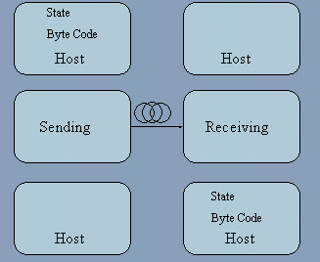

MOBILITY – DISPATCHING :

public final void Aglet.dispatch(URL destination)

e.g.
dispatch (new URL(“atp://some.host.com:port”));

Add Listeners
–public final void Aglet.addMobilityListener(MobilityListener listener)

Remove Listeners

public final void Aglet.removeMobilityListener(MobilityListener listener)
public MobilityAdapter.MobilityAdapter()

Creates an instance of the mobility adapter

public void MobilityAdapter.onDispatching(MobilityEvent m)

Called when an attempt is made to dispatch

public void MobilityAdapter.onArrival(MobilityEvent m)

Called after arriving in a new location

ORDER OF EXECUTION FOR DISPATCH :

- Origin
1.run()
2. dispatch()
3. onDispatching()

- Destination
4. onArrival()
5. run()

MOBILITY EXAMPLE :

package examples.cpe5010;
import java.io.*;
import java.lang.*;
import java.net.*;
import java.util.*;
import com.ibm.aglet.*;
import com.ibm.aglet.event.*;

public class HelloWorldAglet extends Aglet
{
private Vector curItinVect;
private URL destination;
String strDest;

public void onCreation(Object itin)
{
System.out.println("Hi! I have been created..");

/* INSERT YOUR SERVER & PORT NO: e.g: atp://electra.csse.monash.edu.au:9000 */
strDest = new String("atp://------------");

try {
destination = new URL(strDest);
}
catch (MalformedURLException malURL1){
System.out.println("mal URL...");
}

addMobilityListener(
new MobilityAdapter() {
public void onArrival(MobilityEvent e) {
System.out.println("I have arrived at " + strDest);
dispose();
}
} );
}
public void run()
{
try {
dispatch(destination); }
catch (Exception e){
System.out.println(e.getMessage());
}
System.out.println("I am finished....!");
}
}

4.8 MOBILITY RETRACTING :

AgletContext.retractAglet(URL contextAddress, AgletID aid)

public void MobilityAdapter.onArrival(MobilityEvent m)

Called when an Aglet arrives in a new location

public void MobilityAdapter.onReverting(MobilityEvent e)

Called when someone from a remote location attempts to retract the Aglet. Subclasses can override this method to implement actions that should be taken when this is requested.

ORDER OF EXECUTION FOR RETRACTION :

- Local
1.retractAglet()
2. onArrival()
3. run()
- Remote
4. run()
5. onReverting()

AGENT TRANSFER

PROTOCOL :

- Simple application-level protocol modelled on HTTP.
- ATP is designed to transmit an agent independently on the agent system. ATP defines the following .
- Standard request methods:
- Dispatch – requests a destination agent system to reconstruct an agent from the content of a request and to start executing the agent. If the request is successful, the sender must terminate the agent and release any resources consumed by it.

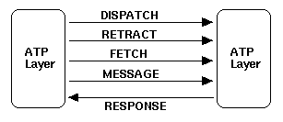

- Retract – requests that a destination agent system send the specified agent back to the sender. The receiver is responsible for reconstructing and resuming the agent. If the agent is successfully transferred, the receiver must terminate the agent and release any resources consumed by it.
- Fetch is similar to the GET method in HTTP, it requests that a receiver retrieve and send any identified information.

4.9 AGLET CLONING :

- public final object Aglet.clone()
  - Create an identical copy of it in the current context
  - The method returns the proxy of the clone Aglet
- Add Listeners
  - public final void Aglet.addCloneListener(CloneListener listener)
- Remove Listeners
  - public final void Aglet.removeCloneListener(CloneListener listener)
  - public CloneAdapter.CloneAdapter()
- Creates an instance of the clone adapter
  - public void CloneAdapter.onCloning(CloneEvent e)
  - public void CloneAdapter.onClone(CloneEvent e)
  - public void CloneAdapter.onCloned(CloneEvent e)

ORDER OF EXECUTION FOR CLONING :

- Original
1. run()
2. onCloning()
3. onCloned()

- Clone
4. onClone()
5. run()

CLONING EXAMPLE :

public class CloningExample extends Aglet
{
boolean theClone = false;
public void onCreation (Object o) {
addCloneListener(
new CloneAdapter() {
public void onCloning(CloneEvent e)
{
System.out.println(“OnCloning Event!”);
}
public void onClone(CloneEvent e)
{
theClone= true;
System.out.println(“OnClone Event!”);
}

public void onCloned(CloneEvent e)
{
System.out.println(“OnCloned Event!”);
}

} );
}

public void run() {
try {
clone();
} catch (Exception e) {
System.out.println(e.getMessage());
}
}

4.10 PERSISTENCY :

- public final void deactivate(long duration)
  - Deactivates the aglet. It will resume execution in the current context after the duration.
- Add Listeners
  - public final void Aglet.addPersistencyListener(PersistanceListener listener)
- Remove Listeners
  - public final void Aglet.removePersistencyListener(PersistanceListener listener)
- public PersistencyAdapter. PersistencyAdapter()
  - Creates an instance of the clone adapter

- public void PersistencyAdapter.onDeactiivating(PersistencyEvent e)
  - Called when an attempt is made to Deactivate an Aglet

- public void PersistencyAdapter.onActivation(PersistencyEvent e)
  - Called when an attempt is made to activate an Aglet

ORDER OF EXECUTION FOR PERSISTENCE :

- Before
1. run()
2. deactivate()
3. onDeactivating()

- After
4. onActivation()
5. run()

4.11 EVENT :

- Event objects carry additional information that may be useful for the Aglet

- CloneEvent
  - Has a method – getAgletProxy – that gives the proxy of the Aglet that is being cloned
  - public AgletProxy CloneEvent.getAgletProxy()

- Print the identity of the Aglet that is being cloned
public void onCloning(CloneEvent e) {
try {
System.out.println(e.getAgletProxy().getAgletID().toString());
}
catch (Exception e1) {
System.out.println(e1.getMessage());
}
}

- MobilityEvent
public AgletProxy MobilityEvent.getAgletProxy()
public URL MobilityEvent.getLocation()

- Example
public void onDispatching(MobilityEvent e) {
System.out.println(e.getLocation().toString());
}

- PersistencyEvent
public AgletProxy PersistencyEvent.getAgletProxy()
public long PersistencyEvent.getDuration()

- Example
public void onDeactivating(PersistencyEvent e) {
System.out.println(e.getDuration());
}

REFERENCES :

- http://www.vistabonita.com/papers/DCAglets/

- http://www.trl.ibm.com/aglets/

- http://www.ryerson.ca/~dgrimsha/courses/cps720/api/com/ibm/aglet/package-summary.html

- http://www.geocities.com/SiliconValley/Lakes/8849/roaming.htm

- http://www.ryerson.ca/~dgrimsha/courses/cps720/agletcommunication.html

SOFTWARE REQUIREMENT SPECIFICATION

PURPOSE :

This application consists of three interacting agents: one Buyer agent and two Store agents. Each kind of agent has a different role and different capabilities. Although this example features only two Store agents, the Buyer agent is able to interact with any number of Store agents.

The Buyer agent sends requests for price quotes to all the Store agents, waits for responses, and then buys the specified product from the store with the lowest price.

SCOPE :

The Online Shopping System using Mobile Agent makes it easy for the buyer to purchase the best possible product for the cheapest possible price.
Each Store agent represents one retail store and knows the prices and available quantities of the products in its store. Store agents receive requests for price quotes from the Buyer agent and respond by telling the Buyer agent the prices and quantities that they can deliver.

Definitions, Acronyms, Abbreviations :

Aglets

Aglets are Java objects that can move from one host on the Internet to another. That is, an aglet that executes on one host can suddenly halt execution, dispatch to a remote host, and resume execution there. When the aglet moves, it brings along its program code as well as its state (data). A build-in security mechanism makes it safe to host untrusted aglets.

Context

A context is an aglet's workplace. It is a stationary object that provides a means for maintaining and managing running aglets in a uniform execution environment where the host system is secured against malicious aglets. One node in a computer network may host multiple contexts

Proxy

A proxy is a representative of an aglet. It serves as a shield for the aglet that protects the aglet from direct access to its public methods. The proxy also provides location transparency for the aglet. That is, it can hide the real location of the aglet.

Message

A message is an object exchanged between aglets. It allows for synchronous as well as asynchronous message-passing between aglets. Message-passing can be used by aglets to collaborate and exchange information in a loosely coupled fashion.

Message Manager, Itinerary

A message manager allows for concurrency control of incoming messages

An itinerary is an aglet's travel plan. It provides a convenient abstraction for non-trivial travel patterns and routing.

REFERENCES :

- http://www.vistabonita.com/papers/DCAglets/

- http://www.trl.ibm.com/aglets/

- http://www.ryerson.ca/~dgrimsha/courses/cps720/api/com/ibm/aglet/package-summary.html

- http://www.geocities.com/SiliconValley/Lakes/8849/roaming.htm

- http://www.ryerson.ca/~dgrimsha/courses/cps720/agletcommunication.html

Overview :

The agents are constructed by using the TAHITI server where the aglets are created,
Retracted, disposed, activeated and deactivated.

This application consists of three interacting agents: one Buyer agent and two Store agents. Each kind of agent has a different role and different capabilities. Although this example features only two Store agents, the Buyer agent is able to interact with any number of Store agents.

The Buyer agent sends requests for price quotes to all the Store agents, waits for responses, and then buys the specified product from the store with the lowest price.

OVERALL DESCRIPTION :

Product Prospective :

The mobile agents which we are using here are very effective as it reduces the burden of asking so many queries on the part of the user. It also helps to conserve the bandwidth of the network and network latency.

SPECIFIC REQUIREMENTS

Design Constraint

There are certain constraints enforced on the system design like it is compulsory to have a Tahiti Server to use our system.

PROPOSED DESIGN

Data Flow Diagram :

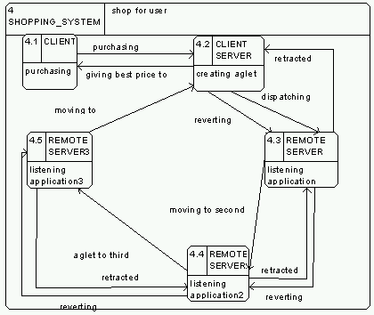

DIRECT MESSAGE COMMUNICATION :

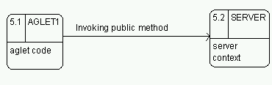

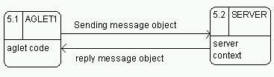
MESSAGE PASSING MODEL :

7) TEST CASES :

- TESTING THE SYSTEM FOR SECURITY :

Though there is in-built security provided in the system, but the system should still be tested with various protocols for absolutely secured transactions.

- TESTING THE SYSTEM FOR PERFORMING EFFECTIVE TRANSACTIONS :

The system should ensure that the purchaser of the product should get the best possible price for the product he has ordered. This should be ensured by the mobile agents developed.

CONCLUSION

The system being developed is very effective for purchasing the desired product for the cheapest possible price. It involves the use of mobile agents for performing the task of finding the lowest possible price for the desired product.

To develop the mobile agent, we are using the Tahiti server which helps to create, retract, activate, deactivate aglets.

The Java Aglet Application Programming Interface (J-AAPI) is a standard for interfacing aglets and their environment.

Security Considerations :

A host needs to ensure that an aglet does not compromise its security. We classify aglets into two categories: trusted and untrusted. The aglet security manager checks whether the aglet is allowed to access the file system, network, and other aglets. The decision to trust an aglet is entirely up to the host.

APPLICATION :

The Online Shopping System using Mobile Agent makes it easy for the buyer to purchase the best possible product for the cheapest possible price.
Each Store agent represents one retail store and knows the prices and available quantities of the products in its store. Store agents receive requests for price quotes from the Buyer agent and respond by telling the Buyer agent the prices and quantities that they can deliver.

