Natural language processing
Natural language processing (NLP) is a field of computer science that studies how computers and humans interact. In the 1950s, Alan Turing published an article that proposed a measure of intelligence, now called the Turing test. More modern techniques, such as deep learning, have produced results in the fields of language modeling, parsing, and natural-language tasks.

Natural Language Processing gives you a better understanding of available free forms of corpus and different types of dataset. After this, you will know how to choose a dataset for natural language processing applications and find the right NLP techniques to process sentences in datasets and understand their structure. You will also learn how to tokenize different parts of sentences and ways to analyze them.

What is Natural Language Processing?
Natural Language Processing (NLP) is a branch of AI that helps computers to understand, interpret and manipulate human language.
NLP helps developers to organize and structure knowledge to perform tasks like translation, summarization, named entity recognition, relationship extraction, speech recognition, topic segmentation, etc.
NLP is used to analyze text, allowing machines to understand how human’s speak. This human-computer interaction enables real-world applications like automatic text summarization, sentiment analysis, topic extraction, named entity recognition, parts-of-speech tagging, relationship extraction, stemming, and more. NLP is commonly used for text mining, machine translation, and automated question answering.

Components of NLPa. Natural Language Understanding (NLU)
Natural Language Understanding revolves around machine reading comprehension. This is an AI-hard problem. An NLU system needs the following components-
- Lexicon, Parser, and Grammar rules.
- Semantic theory- to guide comprehension.

b. Natural Language Generation (NLG)
NLG is concerned with generating natural language. It uses a machine representation system like a knowledge base or a logical form. You can think of it as a translator between data and natural language representation; this is the opposite or NLU. This involves three tasks-
- Text Planning- To extract relevant content from the knowledge base.
- Sentence Planning- To choose appropriate words, form meaningful phrases, and set sentence tone.
- Text Realization- To map the sentence plan into sentence structure.

a. Natural Language Understanding (NLU)
Natural Language Understanding revolves around machine reading comprehension. This is an AI-hard problem. An NLU system needs the following components-
- Lexicon, Parser, and Grammar rules.
- Semantic theory- to guide comprehension.

b. Natural Language Generation (NLG)
NLG is concerned with generating natural language. It uses a machine representation system like a knowledge base or a logical form. You can think of it as a translator between data and natural language representation; this is the opposite or NLU. This involves three tasks-
- Text Planning- To extract relevant content from the knowledge base.
- Sentence Planning- To choose appropriate words, form meaningful phrases, and set sentence tone.
- Text Realization- To map the sentence plan into sentence structure.

What are the benefits of learning NLP?
As all of you know, millions of gigabytes every day are generated by blogs, social websites, and web pages.
There are many companies gathering all of this data to better understand users and their passions and make appropriate changes.
These data could show that the people of Brazil are happy with product A, while the people of the US are happier with product B. With NLP, this knowledge can be found instantly (i.e. a real-time result). For example, search engines are a type of NLP that give the appropriate results to the right people at the right time.
But search engines are not the only implementation of natural language processing (NLP). There are a lot of even more awesome implementations out there.

NLP Libraries
There are many open source Natural Language Processing (NLP) libraries. These are some of them:
- Natural language toolkit (NLTK)
- Apache OpenNLP
- Stanford NLP suite
- Gate NLP library
Natural language toolkit (NLTK) is the most popular library for natural language processing (NLP). It was written in Python and has a big community behind it.
NLTK also is very easy to learn, actually, it's the easiest natural language processing (NLP) library that you'll use.

Components of NLP
Five main Component of Natural Language processing are:
- Morphological and Lexical Analysis
- Syntactic Analysis
- Semantic Analysis
- Discourse Integration
- Pragmatic Analysis
Morphological and Lexical Analysis
Lexical analysis is a vocabulary that includes its words and expressions. It depicts analyzing, identifying and description of the structure of words. It includes dividing a text into paragraphs, words and the sentences
Individual words are analyzed into their components, and no word tokens such as punctuations are separated from the words.
Semantic Analysis
Semantic Analysis is a structure created by the syntactic analyzer which assigns meanings. This component transfers linear sequences of words into structures. It shows how the words are associated with each other.
Semantics focuses only on the literal meaning of words, phrases, and sentences. This only abstracts the dictionary meaning or the real meaning from the given context. The structures assigned by the syntactic analyzer always have assigned meaning
E.g.. "Colorless green idea." This would be rejected by the Symantec analysis as colorless here; green doesn't make any sense.
Pragmatic Analysis
Pragmatic Analysis deals with the overall communicative and social content and its effect on interpretation. It means abstracting or deriving the meaningful use of language in situations. In this analysis, the main focus always on what was said in reinterpreted on what is meant.
Pragmatic analysis helps users to discover this intended effect by applying a set of rules that characterize cooperative dialogues.
E.g., "close the window?" should be interpreted as a request instead of an order.
Syntax analysis
The words are commonly accepted as being the smallest units of syntax. The syntax refers to the principles and rules that govern the sentence structure of any individual languages.
Syntax focus about the proper ordering of words which can affect its meaning. This involves analysis of the words in a sentence by following the grammatical structure of the sentence. The words are transformed into the structure to show how’s the word are related to each other.
Discourse Integration
It means a sense of the context. The meaning of any single sentence which depends upon that sentence. It also considers the meaning of the following sentence.
For example, the word "that" in the sentence "He wanted that" depends upon the prior discourse context.

NLP and writing systems
The kind of writing system used for a language is one of the deciding factors in determining the best approach for text pre-processing. Writing systems can be
- Logographic: a large number of individual symbols represent words. Example Japanese, Mandarin
- Syllabic: Individual symbols represent syllables
- Alphabetic: Individual symbols represent sound
Majority of the writing systems use the Syllabic or Alphabetic system. Even English, with its relatively simple writing system based on the Roman alphabet, utilizes logographic symbols which include Arabic numerals, Currency symbols (S, £), and other special symbols.
This pose following challenges
- Extracting meaning(semantics) from a text is a challenge
- NLP is dependent on the quality of the corpus. If the domain is vast, it's difficult to understand context.
- There is a dependence on the character set and language

How to implement NLP
Below, given are popular methods used for Natural Learning Process:
Machine learning: The learning NLP procedures used during machine learning. It automatically focuses on the most common cases. So when we write rules by hand, it is often not correct at all concerned about human errors.
Statistical inference: NLP can make use of statistical inference algorithms. It helps you to produce models that are robust. e.g., containing words or structures which are known to everyone.

NLP Implementations
These are some successful implementations of natural language processing (NLP):
- Search engines like Google, Yahoo, etc. Google's search engine understands that you are a tech guy, so it shows you results related to that.
- Social website feeds like your Facebook news feed. The news feed algorithm understands your interests using natural language processing and shows you related ads and posts more likely than other posts.
- Speech engines like Apple Siri.
- Spam filters like Google spam filters. It's not just about your usual spam filtering; now, spam filters understand what's inside the email content and see if it's spam or not.
- Grammar Correction: NLP technique is widely used by word processor software like MS-word for spelling correction & grammar check.
- Text Summarization :The process of summarising important information from a source to produce a shortened version

Future of NLP
- Human readable natural language processing is the biggest Al- problem. It is all most same as solving the central artificial intelligence problem and making computers as intelligent as people.
- Future computers or machines with the help of NLP will able to learn from the information online and apply that in the real world, however, lots of work needs to on this regard.
- Natural language toolkit or NLTK become more effective
- Combined with natural language generation, computers will become more capable of receiving and giving useful and resourceful information or data.

Advantages of NLP
- Users can ask questions about any subject and get a direct response within seconds.
- NLP system provides answers to the questions in natural language
- NLP system offers exact answers to the questions, no unnecessary or unwanted information
- The accuracy of the answers increases with the amount of relevant information provided in the question.
- NLP process helps computers communicate with humans in their language and scales other language-related tasks
- Allows you to perform more language-based data compares to a human being without fatigue and in an unbiased and consistent way.
- Structuring a highly unstructured data source.

Disadvantages of NLP
- Complex Query Language- the system may not be able to provide the correct answer it the question that is poorly worded or ambiguous.
- The system is built for a single and specific task only; it is unable to adapt to new domains and problems because of limited functions.
- NLP system doesn't have a user interface which lacks features that allow users to further interact with the system

What is NLTK?
NLTK stands for Natural Language Toolkit. This toolkit is one of the most powerful NLP libraries which contains packages to make machines understand human language and reply to it with an appropriate response. Tokenization, Stemming, Lemmatization, Punctuation, Character count, word count are some of these packages which will be discussed in this document.

POS (Part-Of-Speech) Tagging & Chunking with NLTK

POS Tagging
Parts of speech Tagging is responsible for reading the text in a language and assigning some specific token (Parts of Speech) to each word.
e.g.
Input: Everything to permit us.
Output: [('Everything', NN),('to', TO), ('permit', VB), ('us', PRP)]
Steps Involved:
- Tokenize text (word_tokenize)
- apply pos_tag to above step that is nltk.pos_tag(tokenize_text)

Some examples are as below:
Abbreviation Meaning
CC coordinating conjunction
CD cardinal digit

Chunking
Chunking is used to add more structure to the sentence by following parts of speech (POS) tagging. It is also known as shallow parsing. The resulted group of words is called "chunks." In shallow parsing, there is maximum one level between roots and leaves while deep parsing comprises of more than one level. Shallow Parsing is also called light parsing or chunking.
The primary usage of chunking is to make a group of "noun phrases." The parts of speech are combined with regular expressions.
Rules for Chunking:
There are no pre-defined rules, but you can combine them according to need and requirement.
For example, you need to tag Noun, verb (past tense), adjective, and coordinating junction from the sentence. You can use the rule as below
chunk:{<NN.?>*<VBD.?>*<JJ.?>*<CC>?}
Following table shows what the various symbol means:
Name of the Symbol Description
. Any Character except new line
* Match 0 or more repetitions
? Match 0 or 1 repetitions
What is Tokenization?
Tokenization process means splitting bigger parts to small parts.
Tokenization is the process of breaking up the given text into units called tokens. The tokens may be words or number or punctuation mark.
Tokenization does this task by locating word boundaries. Ending point of a word and beginning of the next word is called word boundaries. Tokenization is also known as word segmentation.
Natural Language toolkit has very important module tokenize which further compromises of sub-modules
- word tokenize
- sentence tokenize
CHALLENGES IN TOKENIZATION
Challenges in tokenization depend on the type of language. Languages such as English and French are referred to as space-delimited as most of the words are separated from each other by white spaces. Languages such as Chinese and Thai are referred to as unsegmented as words do not have clear boundaries. Tokenizing unsegmented language sentences requires additional lexical and morphological information. Tokenization is also affected by writing system and the typographical structure of the words. Structures of languages can be grouped into three categories:
Isolating: Words do not divide into smaller units. Example: Mandarin Chinese
Agglutinative: Words divide into smaller units. Example: Japanese, Tamil
Inflectional: Boundaries between morphemes are not clear and ambiguous in terms of grammatical meaning. Example: Latin.

What is Stemming?
Stemming is a kind of normalization for words. Normalization is a technique where a set of words in a sentence are converted into a sequence to shorten its lookup. The words which have the same meaning but have some variation according to the context or sentence are normalized.
In another word, there is one root word, but there are many variations of the same words. For example, the root word is "eat" and it's variations are "eats, eating, eaten and like so". In the same way, with the help of Stemming, we can find the root word of any variations.
Errors in Stemming:
There are mainly two errors in stemming – Overstemming and Understemming.
Overstemming occurs when two words are stemmed to same root that are of different stems.
Under-stemming occurs when two words are stemmed to same root that are not of different stems.

Applications of stemming are:
- Stemming is used in information retrieval systems like search engines.
- It is used to determine domain vocabularies in domain analysis.
Stemming is desirable as it may reduce redundancy as most of the time the word stem and their inflected/derived words mean the same.

What is Lemmatization?
Lemmatization is the algorithmic process of finding the lemma of a word depending on their meaning. Lemmatization usually refers to the morphological analysis of words, which aims to remove inflectional endings. It helps in returning the base or dictionary form of a word, which is known as the lemma. The NLTK Lemmatization method is based on WorldNet's built-in morph function. Text preprocessing includes both stemming as well as lemmatization. Many people find the two terms confusing. Some treat these as same, but there is a difference between these both. Lemmatization is preferred over the former because of the below reason.

Why is Lemmatization better than Stemming?
Stemming algorithm works by cutting the suffix from the word. In a broader sense cuts either the beginning or end of the word.
On the contrary, Lemmatization is a more powerful operation, and it takes into consideration morphological analysis of the words. It returns the lemma which is the base form of all its inflectional forms. In-depth linguistic knowledge is required to create dictionaries and look for the proper form of the word. Stemming is a general operation while lemmatization is an intelligent operation where the proper form will be looked in the dictionary. Hence, lemmatization helps in forming better machine learning features.

What is Wordnet?
Wordnet is an NLTK corpus reader, a lexical database for English. It can be used to find the meaning of words, synonym or antonym. One can define it as a semantically oriented dictionary of English.

Corpus:
A corpus is a large and structured set of machine-readable texts that have been produced in a natural communicative setting. Its plural is corpora.
Corpora often include extra information such as a tag for each word indicating its part-of-speech, and perhaps the parse tree for each sentence.
They can be derived in different ways like text that was originally electronic, transcripts of spoken language and optical character recognition, etc.
Lexicon:
A lexicon is a collection of information about the words of a language about the lexical categories to which they belong.
A lexicon is usually structured as a collection of lexical entries, like ("pig" N V ADJ). "pig" is familiar as a N, but also occurs as a verb ("Jane pigged herself on pizza") and an adjective, in the phrase "pig iron", for example.
In practice, a lexical entry will include further information about the roles the word plays, such as feature information - for example, whether a verb is transitive, intransitive, ditransitive, etc., what form the verb takes (e.g. present participle, or past tense, etc.)
WordNet is a lexical database that has been used by a major search engine. From the WordNet, information about a given word or phrase can be calculated such as
- synonym (words having the same meaning)
- hypernyms (The generic term used to designate a class of specifics (i.e., meal is a breakfast), hyponyms (rice is a meal)
- holonyms (proteins, carbohydrates are part of meal)
- meronyms (meal is part of daily food intake)
WordNet also provides information on co-ordinate terms, derivates, senses and more. It is used to find the similarities between any two words. It also holds information on the results of the related word. In short or nutshell one can treat it as Dictionary or Thesaurus. Going deeper in wordnet, it is divided into four total subnets such as
- Noun
- Verb
- Adjective
- Adverb
It can be used in the area of artificial intelligence for text analysis. With the help of Wordnet, you can create your corpus for spelling checking, language translation, Spam detection and many more.

Tagging Sentences
Tagging Sentence in a broader sense refers to the addition of labels of the verb, noun,etc.by the context of the sentence. Identification of POS tags is a complicated process. Thus generic tagging of POS is manually not possible as some words may have different (ambiguous) meanings according to the structure of the sentence. Conversion of text in the form of list is an important step before tagging as each word in the list is looped and counted for a particular tag.
In Corpus there are two types of POS taggers:
- Rule-Based
- Stochastic POS Taggers
1.Rule-Based POS Tagger:
For the words having ambiguous meaning, rule-based approach on the basis of contextual information is applied. It is done so by checking or analyzing the meaning of the preceding or the following word. Information is analyzed from the surrounding of the word or within itself. Therefore words are tagged by the grammatical rules of a particular language such as capitalization and punctuation. e.g., Brill's tagger.
2. Stochastic POS Tagger:
Different approaches such as frequency or probability are applied under this method. If a word is mostly tagged with a particular tag in training set then in the test sentence it is given that particular tag. The word tag is dependent not only on its own tag but also on the previous tag. This method is not always accurate. Another way is to calculate the probability of occurrence of a specific tag in a sentence. Thus the final tag is calculated by checking the highest probability of a word with a particular tag.
TAGSET
Tagset is the set of tags from which the tagger is supposed to choose to attach to the relevant word.
Every tagger will be given a standard tagset. The tagset may be coarse such as N (Noun), V(Verb), ADJ(Adjective), ADV(Adverb), PREP(Preposition), CONJ(Conjunction) or fine-grained such as NNOM(Noun-Nominative), NSOC(Noun-Sociative), VFIN(Verb Finite),VNFIN(Verb Nonfinite) and so on. Most of the taggers use only fine grained tagset.
ARCHITECTURE OF POS TAGGER
1.Tokenization: The given text is divided into tokens so that they can be used for further analysis. The tokens may be words, punctuation marks, and utterance boundaries.
2.Ambiguity look-up: This is to use lexicon and a guessor for unknown words. While lexicon provides list of word forms and their likely parts of speech, guessors analyze unknown tokens. Compiler or interpreter, lexicon and guessor make what is known as lexical analyzer.
3.Ambiguity Resolution: This is also called disambiguation. Disambiguation is based on information about word such as the probability of the word. For example, power is more likely used as noun than as verb. Disambiguation is also based on contextual information or word/tag sequences. For example, the model might prefer noun analyses over verb analyses if the preceding word is a preposition or article. Disambiguation is the most difficult problem in tagging.

APPLICATIONS OF POS TAGGER
The POS tagger can be used as a preprocessor. Text indexing and retrieval uses POS information. Speech processing uses POS tags to decide the pronunciation. POS tagger is used for making tagged corpora.

COUNTING POS TAGS
Counting tags are crucial for text classification as well as preparing the features for the Natural language-based operations.

Frequency Distribution
Frequency Distribution is referred to as the number of times an outcome of an experiment occurs. It is used to find the frequency of each word occurring in a document.

What is Collocations?
Collocations are the pairs of words occurring together many times in a document. It is calculated by the number of those pair occurring together to the overall word count of the document.
Collocation can be categorized into two types-
Bigrams combination of two words and Trigrams combination of three words
Bigrams and Trigrams provide more meaningful and useful features for the feature extraction stage. These are especially useful in text-based sentimental analysis.

What is Word Embedding?
Word Embedding is a type of word representation that allows words with similar meaning to be understood by machine learning algorithms. Technically speaking, it is a mapping of words into vectors of real numbers using the neural network, probabilistic model, or dimension reduction on word co-occurrence matrix. It is language modeling and feature learning technique. Word embedding is a way to perform mapping using a neural network. There are various word embedding models available such as word2vec (Google), Glove (Stanford) and fastest (Facebook).
Word Embedding is also called as distributed semantic model or distributed represented or semantic vector space or vector space model. As you read these names, you come across the word semantic which means categorizing similar words together. For example fruits like apple, mango, banana should be placed close whereas books will be far away from these words. In a broader sense, word embedding will create the vector of fruits which will be placed far away from vector representation of books.

Where is Word Embedding used?
Word embedding helps in feature generation, document clustering, text classification, and natural language processing tasks. Let us list them and have some discussion on each of these applications.
- Compute similar words: Word embedding is used to suggest similar words to the word being subjected to the prediction model. Along with that it also suggests dissimilar words, as well as most common words.
- Create a group of related words: It is used for semantic grouping which will group things of similar characteristic together and dissimilar far away.
- Feature for text classification: Text is mapped into arrays of vectors which is fed to the model for training as well as prediction. Text-based classifier models cannot be trained on the string, so this will convert the text into machine trainable form. Further its features of building semantic help in text-based classification.
- Document clustering is another application where word embedding is widely used
- Natural language processing: There are many applications where word embedding is useful and wins over feature extraction phases such as parts of speech tagging, sentimental analysis, and syntactic analysis.
Now we have got some knowledge of word embedding. Some light is also thrown on different models to implement word embedding. This whole tutorial is focused on one of the models (word2vec).

What is word2vec?
Word2vec is the technique/model to produce word embedding for better word representation. It captures a large number of precise syntactic and semantic word relationship. It is a shallow two-layered neural network.
word2vec is a two-layer network where there is input one hidden layer and output.

What word2vec does?
Word2vec represents words in vector space representation. Words are represented in the form of vectors and placement is done in such a way that similar meaning words appear together and dissimilar words are located far away. This is also termed as a semantic relationship. Neural networks do not understand text instead they understand only numbers. Word Embedding provides a way to convert text to a numeric vector.
Word2vec reconstructs the linguistic context of words. Before going further let us understand, what is linguistic context? In general life scenario when we speak or write to communicate, other people try to figure out what is objective of the sentence. For example, "What is the temperature of India", here the context is the user wants to know "temperature of India" which is context. In short, the main objective of a sentence is context. Word or sentence surrounding spoken or written language (disclosure) helps in determining the meaning of context. Word2vec learns vector representation of words through the contexts.

Why Word2vec?

Before Word Embedding
It is important to know which approach is used before word embedding and what are its demerits and then we will move to the topic of how demerits are overcome by Word embedding using word2vec approach. Finally, we will move how word2vec works because it is important to understand it's working.

Word2vec Architecture
There are two architectures used by word2vec
- Continuous Bag of words (CBOW)
- skip gram
Before going further, let us discuss why these architectures or models are important from word representation point of view. Learning word representation is essentially unsupervised, but targets/labels are needed to train the model. Skip-gram and CBOW convert unsupervised representation to supervised form for model training.

What is Seq2Seq?
Seq2Seq is a method of encoder-decoder based machine translation that maps an input of sequence to an output of sequence with a tag and attention value. The idea is to use 2 RNN that will work together with a special token and trying to predict the next state sequence from the previous sequence.
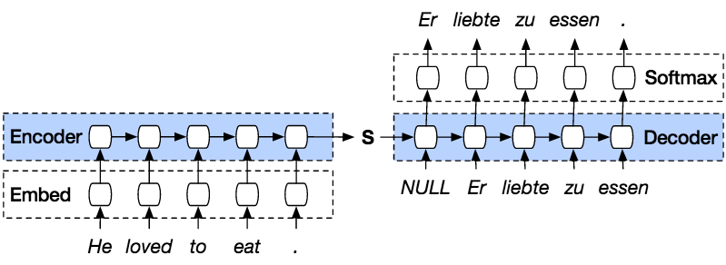

Seq2Seq Model
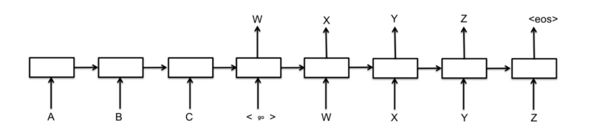
Seq2Seq Model is a kind of model that use Encoder and a Decoder on top of the model. The Encoder will encode the sentence word by words into an indexed of vocabulary or known words with index, and the decoder will predict the output of the coded input by decoding the input in sequence and will try to use the last input as the next input if its possible. With this method, it is also possible to predict the next input to create a sentence. Each sentence will be assigned a token to mark the end of the sequence. At the end of prediction, there will also be a token to mark the end of the output. So, from the encoder, it will pass a state to the decoder to predict the output.
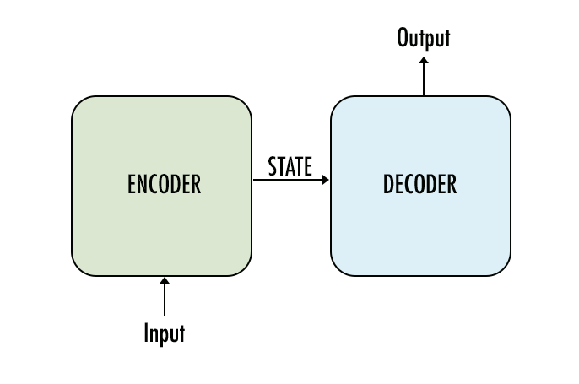
The Encoder will encode our input sentence word by word in sequence and in the end there will be a token to mark the end of a sentence. The encoder consists of an Embedding layer and a GRU layers. The Embedding layer is a lookup table that stores the embedding of our input into a fixed sized dictionary of words. It will be passed to a GRU layer. GRU layer is a Gated Recurrent Unit that consists of multiple layer type of RNN that will calculate the sequenced input. This layer will calculate the hidden state from the previous one and update the reset, update, and new gates.
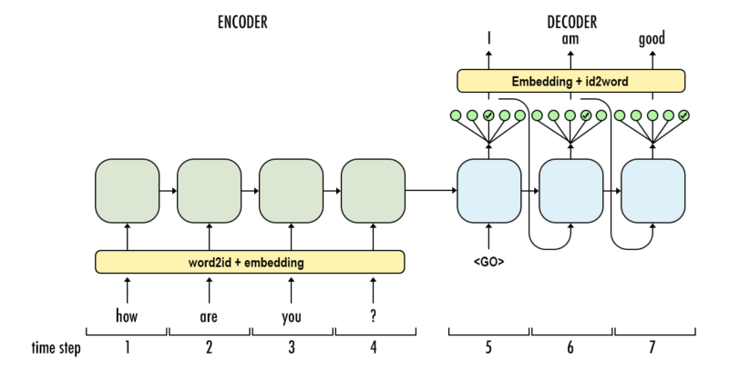
The Decoder will decode the input from the encoder output. It will try to predict the next output and try to use it as the next input if it's possible. The Decoder consists of an Embedding layer, GRU layer, and a Linear layer. The embedding layer will make a lookup table for the output and passed into a GRU layer to calculate the predicted output state.

