Домашнее задание N1. Установка и настройка Suricata
Contents
Введение (цель работы) 1
Установка и базовая настройка Suricata 1
Подготовка 1
Установка Suricata 2
Настройка Suricata 3
Создание и проверка трёх собственных сигнатур 6
Настройка файла local.rules 6
Первое правило. HTTP-запрос 8
Второе правило. Обнаружение попытки SSH-подключения 8
Третье правило. Обнаружение TCP-сканирования портов через nmap 10
Четвертое правило. Временная блокировка новых SSH-подключений при brute force 12
Создаем правило local.rules 12
Настраиваем rate_filter 12
Переключаем Suricata в режим IPS/NFQUEUE 13
Настраиваем iptables 14
Имитация brute-force и проверка блокировки 15
Итоговый результат 18
Выводы и сложности 19

Введение (цель работы)
Установка и настройка Suricata, создание и проверка трех собственных сигнатур, написание отчета.

Установка и базовая настройка Suricata

Подготовка
Работаем в виртуальной машине Ubuntu 24.04.5 LTS.
Смотрим имеющиеся интерфейсы:
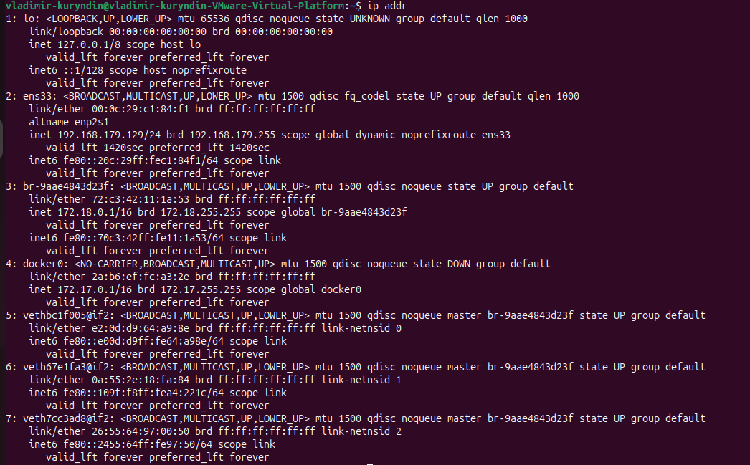
Понимаем, что основной ens33. На нем адрес 192.168.179.129/24.

Установка Suricata
Ставим Suricata из репозитория Ubuntu.
vladimir-kuryndin@vladimir-kuryndin-VMware-Virtual-Platform:~$ sudo apt install suricata

vladimir-kuryndin@vladimir-kuryndin-VMware-Virtual-Platform:~$ suricata -V
This is Suricata version 7.0.3 RELEASE
Подтверждение.
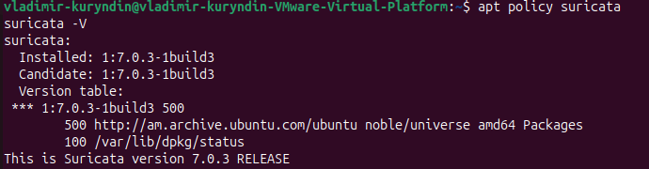

Настройка Suricata
Сразу не заработало.
vladimir-kuryndin@vladimir-kuryndin-VMware-Virtual-Platform:~$ sudo systemctl status suricata --no-pager
× suricata.service - Suricata IDS/IDP daemon
Loaded: loaded (/usr/lib/systemd/system/suricata.service; enabled; preset: enabled)
Active: failed (Result: exit-code) since Wed 2026-09-09 10:44:25 +04; 45s ago
Duration: 58ms
Docs: man:suricata(8)
man:suricatasc(8)
https://suricata.io/documentation/
Process: 302474 ExecStart=/usr/bin/suricata -D --af-packet -c /etc/suricata/suricata.yaml --pidfile /run/suricata.pid (code=exited, status=0/SUCCESS)
Main PID: 302479 (code=exited, status=1/FAILURE)
CPU: 92ms

Sep 09 10:44:25 vladimir-kuryndin-VMware-Virtual-Platform systemd[1]: suricata.service: Scheduled restart job, restart counter is at 5.
Sep 09 10:44:25 vladimir-kuryndin-VMware-Virtual-Platform systemd[1]: suricata.service: Start request repeated too quickly.
Sep 09 10:44:25 vladimir-kuryndin-VMware-Virtual-Platform systemd[1]: suricata.service: Failed with result 'exit-code'.
Sep 09 10:44:25 vladimir-kuryndin-VMware-Virtual-Platform systemd[1]: Failed to start suricata.service - Suricata IDS/IDP daemon.

Разбираемся в причинах. Смотрим логи.
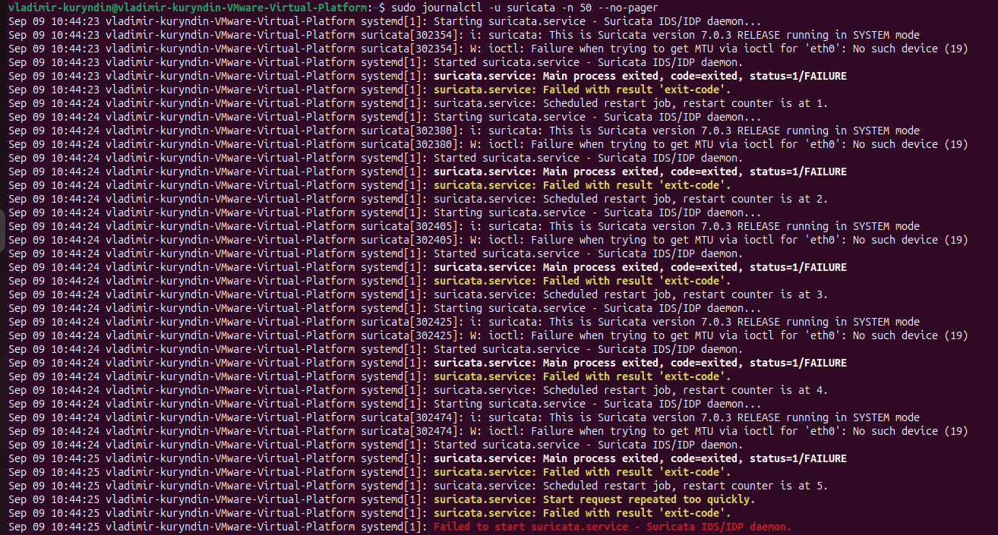

Понимаем, что suricata по умолчанию слушает интерфейс eth0. А у нас ens33.
Меняем интерфейс. Для этого сначала делаем бэкап файл конфигурации и далее правим файл с помощью nano
vladimir-kuryndin@vladimir-kuryndin-VMware-Virtual-Platform:~$ sudo cp /etc/suricata/suricata.yaml /etc/suricata/suricata.yaml.bak
vladimir-kuryndin@vladimir-kuryndin-VMware-Virtual-Platform:~$ sudo nano /etc/suricata/suricata.yaml

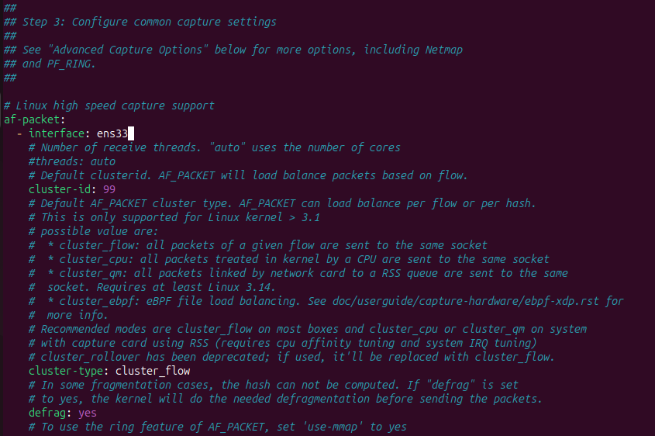

После этого:
vladimir-kuryndin@vladimir-kuryndin-VMware-Virtual-Platform:~$ sudo suricata -T -c /etc/suricata/suricata.yaml
i: suricata: This is Suricata version 7.0.3 RELEASE running in SYSTEM mode
W: detect: No rule files match the pattern /var/lib/suricata/rules/suricata.rules
vladimir-kuryndin@vladimir-kuryndin-VMware-Virtual-Platform:~$ sudo systemctl restart suricata
vladimir-kuryndin@vladimir-kuryndin-VMware-Virtual-Platform:~$ sudo systemctl status suricata --no-pager
● suricata.service - Suricata IDS/IDP daemon
Loaded: loaded (/usr/lib/systemd/system/suricata.service; enabled; preset: enabled)
Active: active (running) since Wed 2026-09-09 10:52:30 +04; 6s ago
Docs: man:suricata(8)
man:suricatasc(8)
https://suricata.io/documentation/
Process: 304851 ExecStart=/usr/bin/suricata -D --af-packet -c /etc/suricata/suricata.yaml --pidfile /run/suricata.pid (code=exited, status=0/SUCCESS)
Main PID: 304852 (Suricata-Main)
Tasks: 8 (limit: 7659)
Memory: 42.7M (peak: 43.1M)
CPU: 121ms
CGroup: /system.slice/suricata.service
└─304852 /usr/bin/suricata -D --af-packet -c /etc/suricata/suricata.yaml --pidfile /run/suricata.pid

Создание и проверка трёх собственных сигнатур

Настройка файла local.rules
Выясним, где нам нужно создать правило.
ladimir-kuryndin@vladimir-kuryndin-VMware-Virtual-Platform:~$ grep -n "default-rule-path" /etc/suricata/suricata.yaml
2150:default-rule-path: /var/lib/suricata/rules
Выясним, какую секцию файла suricata.yaml менять:
vladimir-kuryndin@vladimir-kuryndin-VMware-Virtual-Platform:~$ grep -n -A 10 "^rule-files:" /etc/suricata/suricata.yaml
2152:rule-files:
2153- - suricata.rules
2154-
2155-##
2156-## Auxiliary configuration files.
2157-##
2158-
2159-classification-file: /etc/suricata/classification.config
2160-reference-config-file: /etc/suricata/reference.config
2161-# threshold-file: /etc/suricata/threshold.config
2162-
Настраиваем, чтобы Suricata использовала local.rules.
vladimir-kuryndin@vladimir-kuryndin-VMware-Virtual-Platform:~$ sudo touch /var/lib/suricata/rules/local.rules
[sudo] password for vladimir-kuryndin:
vladimir-kuryndin@vladimir-kuryndin-VMware-Virtual-Platform:~$ ls -l /var/lib/suricata/rules/
total 0
-rw-r--r-- 1 root root 0 Sep 9 11:58 local.rules
vladimir-kuryndin@vladimir-kuryndin-VMware-Virtual-Platform:~$ sudo nano /etc/suricata/suricata.yaml
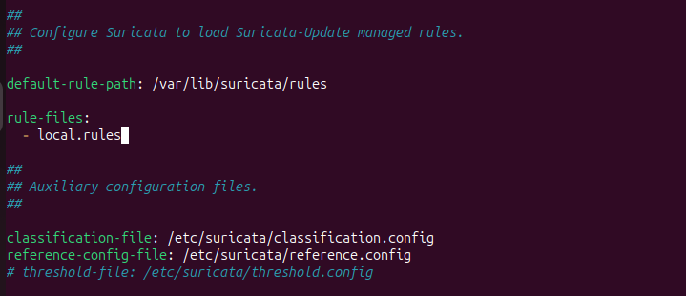

Перезапускаем и убеждаемся, что все работает
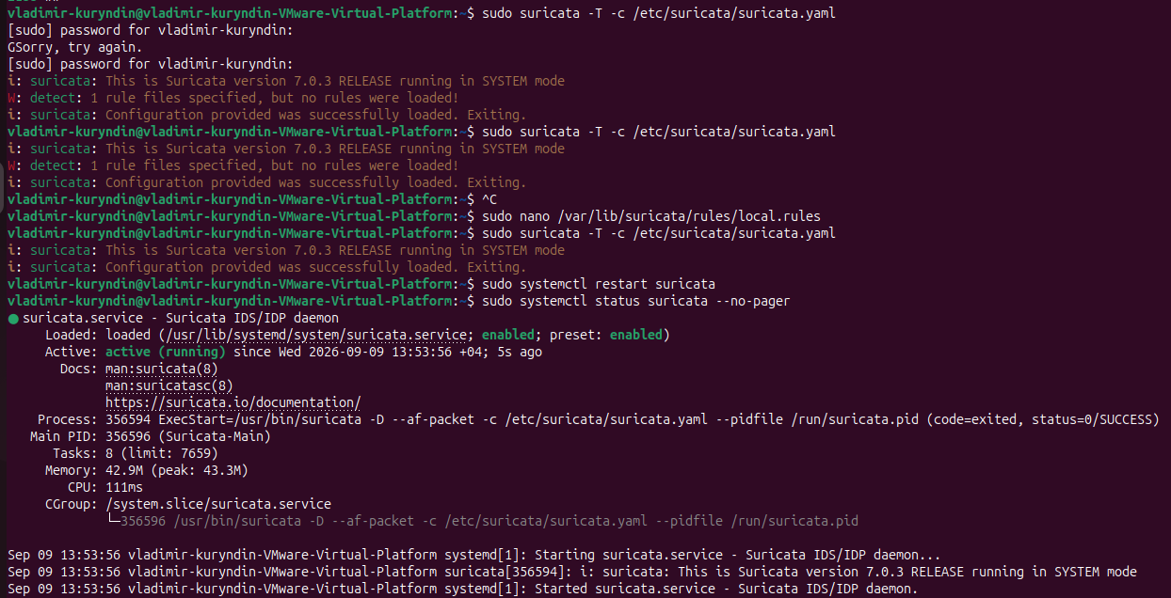

Первое правило. HTTP-запрос
Сделаем первое правило
alert http any any -> any any (msg:"LOCAL Suspicious HTTP URI"; http.uri; content:"/suricata-test"; sid:1000001; rev:1;)
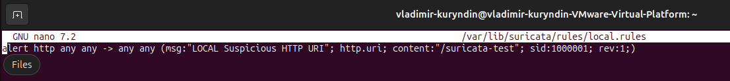
Это правило означает: если Suricata увидит HTTP-запрос, содержащий URI /suricata-test, она создаст alert с SID 1000001.
Проверяем:
vladimir-kuryndin@vladimir-kuryndin-VMware-Virtual-Platform:~$ curl http://example.com/suricata-test
<!doctype html><html lang="en"><head><title>Example Domain</title><link rel="icon" href="data:,"><meta name="viewport" content="width=device-width, initial-scale=1"><style>body{background:#eee;width:60vw;margin:15vh auto;font-family:system-ui,sans-serif}h1{font-size:1.5em}div{opacity:0.8}a:link,a:visited{color:#348}</style></head><body><div><h1>Example Domain</h1><p>This domain is for use in documentation examples without needing permission. Avoid use in operations.</p><p><a href="https://iana.org/domains/example">Learn more</a></p></div></body></html>
vladimir-kuryndin@vladimir-kuryndin-VMware-Virtual-Platform:~$ sudo tail -n 20 /var/log/suricata/fast.log
09/09/2026-13:54:14.704257 [**] [1:1000001:1] LOCAL Suspicious HTTP URI [**] [Classification: (null)] [Priority: 3] {TCP} 192.168.179.129:43236 -> 172.66.147.243:80
Первое правило успешно сработало.

Второе правило. Обнаружение попытки SSH-подключения
Делаем следующее правило
alert tcp any any -> any 22 (msg:"LOCAL SSH Connection Attempt"; flow:to_server; flags:S; sid:1000002; rev:2;)
Правило делает следующее: отслеживает TCP-пакеты, направленные на порт 22. Параметр flags:S означает, что правило реагирует на TCP SYN-пакет — начало попытки установить соединение.
Проверяем:
vladimir-kuryndin@vladimir-kuryndin-VMware-Virtual-Platform:~$ ssh -o ConnectTimeout=5 test@example.com
ssh: connect to host example.com port 22: Network is unreachable
vladimir-kuryndin@vladimir-kuryndin-VMware-Virtual-Platform:~$ sudo tail -n 20 /var/log/suricata/fast.log
09/09/2026-13:54:14.704257 [**] [1:1000001:1] LOCAL Suspicious HTTP URI [**] [Classification: (null)] [Priority: 3] {TCP} 192.168.179.129:43236 -> 172.66.147.243:80
09/09/2026-14:05:44.277115 [**] [1:1000002:1] LOCAL SSH Connection Attempt [**] [Classification: (null)] [Priority: 3] {TCP} 192.168.179.129:36664 -> 104.20.23.154:22
09/09/2026-14:05:45.291470 [**] [1:1000002:1] LOCAL SSH Connection Attempt [**] [Classification: (null)] [Priority: 3] {TCP} 192.168.179.129:36664 -> 104.20.23.154:22
09/09/2026-14:05:46.315172 [**] [1:1000002:1] LOCAL SSH Connection Attempt [**] [Classification: (null)] [Priority: 3] {TCP} 192.168.179.129:36664 -> 104.20.23.154:22
09/09/2026-14:05:47.339416 [**] [1:1000002:1] LOCAL SSH Connection Attempt [**] [Classification: (null)] [Priority: 3] {TCP} 192.168.179.129:36664 -> 104.20.23.154:22
09/09/2026-14:05:48.363126 [**] [1:1000002:1] LOCAL SSH Connection Attempt [**] [Classification: (null)] [Priority: 3] {TCP} 192.168.179.129:36664 -> 104.20.23.154:22
09/09/2026-14:05:49.280842 [**] [1:1000002:1] LOCAL SSH Connection Attempt [**] [Classification: (null)] [Priority: 3] {TCP} 192.168.179.129:49714 -> 172.66.147.243:22
09/09/2026-14:05:50.283153 [**] [1:1000002:1] LOCAL SSH Connection Attempt [**] [Classification: (null)] [Priority: 3] {TCP} 192.168.179.129:49714 -> 172.66.147.243:22
09/09/2026-14:05:51.307448 [**] [1:1000002:1] LOCAL SSH Connection Attempt [**] [Classification: (null)] [Priority: 3] {TCP} 192.168.179.129:49714 -> 172.66.147.243:22
09/09/2026-14:05:52.331132 [**] [1:1000002:1] LOCAL SSH Connection Attempt [**] [Classification: (null)] [Priority: 3] {TCP} 192.168.179.129:49714 -> 172.66.147.243:22
09/09/2026-14:05:53.355343 [**] [1:1000002:1] LOCAL SSH Connection Attempt [**] [Classification: (null)] [Priority: 3] {TCP} 192.168.179.129:49714 -> 172.66.147.243:22

Второе правило успешно сработало.

Третье правило. Обнаружение TCP-сканирования портов через nmap
Делаем следующее правило:
alert tcp any any -> 192.168.179.2 any (msg:"LOCAL Possible TCP SYN Port Scan"; flow:stateless; flags:S; detection_filter:track by_src,count 10,seconds 5; sid:1000003; rev:2;)
Проверяем:
vladimir-kuryndin@vladimir-kuryndin-VMware-Virtual-Platform:~$ sudo nmap -sS -p 1-100 192.168.179.2
Starting Nmap 7.94SVN ( https://nmap.org ) at 2026-09-09 15:29 +04
Nmap scan report for _gateway (192.168.179.2)
Host is up (0.00091s latency).
Not shown: 99 closed tcp ports (reset)
PORT STATE SERVICE
53/tcp open domain
MAC Address: 00:50:56:E7:CF:03 (VMware)

vladimir-kuryndin@vladimir-kuryndin-VMware-Virtual-Platform:~$ sudo jq -c 'select(.event_type=="alert" and .alert.signature_id==1000003) | {timestamp,src_ip,dest_ip,dest_port,action:.alert.action,signature:.alert.signature}' /var/log/suricata/eve.json | tail -n 20
{"timestamp":"2026-09-09T15:29:25.513419+0400","src_ip":"192.168.179.129","dest_ip":"192.168.179.2","dest_port":79,"action":"allowed","signature":"LOCAL Possible TCP SYN Port Scan"}
{"timestamp":"2026-09-09T15:29:25.513450+0400","src_ip":"192.168.179.129","dest_ip":"192.168.179.2","dest_port":57,"action":"allowed","signature":"LOCAL Possible TCP SYN Port Scan"}
{"timestamp":"2026-09-09T15:29:25.513474+0400","src_ip":"192.168.179.129","dest_ip":"192.168.179.2","dest_port":34,"action":"allowed","signature":"LOCAL Possible TCP SYN Port Scan"}
{"timestamp":"2026-09-09T15:29:25.513496+0400","src_ip":"192.168.179.129","dest_ip":"192.168.179.2","dest_port":3,"action":"allowed","signature":"LOCAL Possible TCP SYN Port Scan"}
{"timestamp":"2026-09-09T15:29:25.513499+0400","src_ip":"192.168.179.129","dest_ip":"192.168.179.2","dest_port":88,"action":"allowed","signature":"LOCAL Possible TCP SYN Port Scan"}
{"timestamp":"2026-09-09T15:29:25.513499+0400","src_ip":"192.168.179.129","dest_ip":"192.168.179.2","dest_port":43,"action":"allowed","signature":"LOCAL Possible TCP SYN Port Scan"}
{"timestamp":"2026-09-09T15:29:25.513500+0400","src_ip":"192.168.179.129","dest_ip":"192.168.179.2","dest_port":86,"action":"allowed","signature":"LOCAL Possible TCP SYN Port Scan"}
{"timestamp":"2026-09-09T15:29:25.513536+0400","src_ip":"192.168.179.129","dest_ip":"192.168.179.2","dest_port":83,"action":"allowed","signature":"LOCAL Possible TCP SYN Port Scan"}
{"timestamp":"2026-09-09T15:29:25.513536+0400","src_ip":"192.168.179.129","dest_ip":"192.168.179.2","dest_port":19,"action":"allowed","signature":"LOCAL Possible TCP SYN Port Scan"}
{"timestamp":"2026-09-09T15:29:25.513537+0400","src_ip":"192.168.179.129","dest_ip":"192.168.179.2","dest_port":29,"action":"allowed","signature":"LOCAL Possible TCP SYN Port Scan"}
{"timestamp":"2026-09-09T15:29:25.513539+0400","src_ip":"192.168.179.129","dest_ip":"192.168.179.2","dest_port":48,"action":"allowed","signature":"LOCAL Possible TCP SYN Port Scan"}
{"timestamp":"2026-09-09T15:29:25.513986+0400","src_ip":"192.168.179.129","dest_ip":"192.168.179.2","dest_port":37,"action":"allowed","signature":"LOCAL Possible TCP SYN Port Scan"}
{"timestamp":"2026-09-09T15:29:25.513989+0400","src_ip":"192.168.179.129","dest_ip":"192.168.179.2","dest_port":66,"action":"allowed","signature":"LOCAL Possible TCP SYN Port Scan"}
{"timestamp":"2026-09-09T15:29:25.513990+0400","src_ip":"192.168.179.129","dest_ip":"192.168.179.2","dest_port":33,"action":"allowed","signature":"LOCAL Possible TCP SYN Port Scan"}
{"timestamp":"2026-09-09T15:29:25.513991+0400","src_ip":"192.168.179.129","dest_ip":"192.168.179.2","dest_port":98,"action":"allowed","signature":"LOCAL Possible TCP SYN Port Scan"}
{"timestamp":"2026-09-09T15:29:25.513982+0400","src_ip":"192.168.179.129","dest_ip":"192.168.179.2","dest_port":46,"action":"allowed","signature":"LOCAL Possible TCP SYN Port Scan"}
{"timestamp":"2026-09-09T15:29:25.513986+0400","src_ip":"192.168.179.129","dest_ip":"192.168.179.2","dest_port":12,"action":"allowed","signature":"LOCAL Possible TCP SYN Port Scan"}
{"timestamp":"2026-09-09T15:29:25.513988+0400","src_ip":"192.168.179.129","dest_ip":"192.168.179.2","dest_port":40,"action":"allowed","signature":"LOCAL Possible TCP SYN Port Scan"}
{"timestamp":"2026-09-09T15:29:25.513990+0400","src_ip":"192.168.179.129","dest_ip":"192.168.179.2","dest_port":65,"action":"allowed","signature":"LOCAL Possible TCP SYN Port Scan"}
{"timestamp":"2026-09-09T15:29:25.513991+0400","src_ip":"192.168.179.129","dest_ip":"192.168.179.2","dest_port":32,"action":"allowed","signature":"LOCAL Possible TCP SYN Port Scan"}
Третье правило успешно сработало.

Четвертое правило. Временная блокировка новых SSH-подключений при brute force
Сделаем следующее правило: имитируем SSH brute force серией частых подключений и временно заблокируем новые SSH-подключения от источника, генерирующего слишком много попыток соединения.

Создаем правило local.rules
Создаем правило:
alert tcp any any -> 192.168.179.129 22 (msg:"LOCAL SSH Brute Force Protection"; flow:to_server; flags:S,12; sid:1000004; rev:2;)
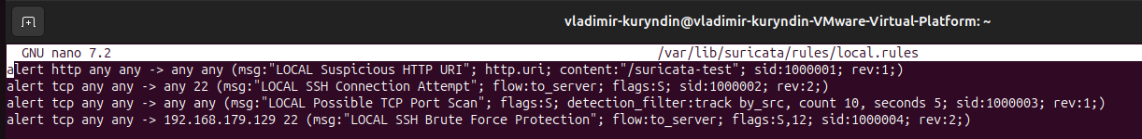

Настраиваем rate_filter
Сделали соответствующий фильтр:
rate_filter gen_id 1, sig_id 1000004, track by_src, count 5, seconds 60, new_action drop, timeout 300
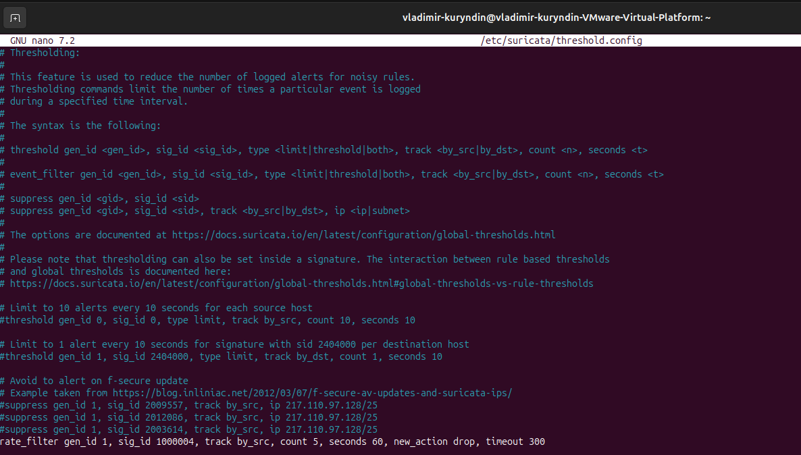
Подключаем threshold.config в suricata.yaml
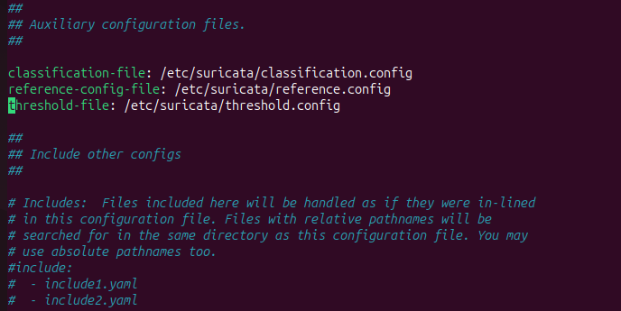

Переключаем Suricata в режим IPS/NFQUEUE
Далее переключаем нашу Suricata в режим IPS/NFQUEUE
Для этого делаем system override
vladimir-kuryndin@vladimir-kuryndin-VMware-Virtual-Platform:~$ cat /etc/systemd/system/suricata.service.d/override.conf
[Service]
ExecStart=
ExecStart=/usr/bin/suricata -D -q 0 -c /etc/suricata/suricata.yaml --pidfile /run/suricata.pid
Перезапускаем suricata
sudo systemctl daemon-reload
sudo systemctl restart suricata
и убеждаемся, что наша suricata работает в правильном режиме
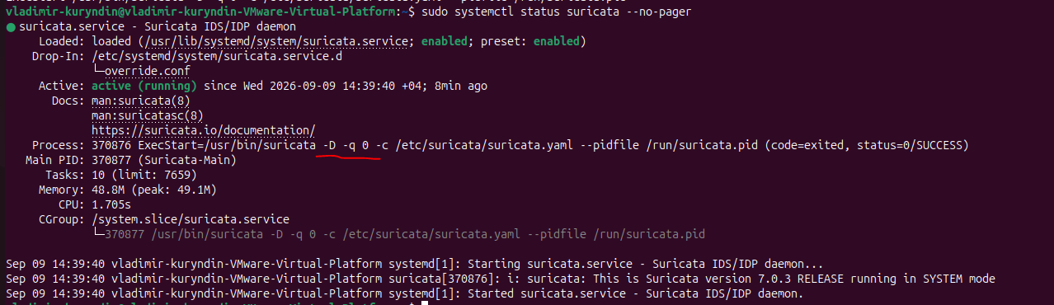

Настраиваем iptables
Далее настраиваем iptables. Добавляем следующее правило:
vladimir-kuryndin@vladimir-kuryndin-VMware-Virtual-Platform:~$ sudo iptables -I INPUT 1 -i ens33 -p tcp --dport 22 -j NFQUEUE --queue-num 0 --queue-bypass
Проверяем правило firewall
vladimir-kuryndin@vladimir-kuryndin-VMware-Virtual-Platform:~$ sudo iptables -vnL INPUT --line-numbers
Chain INPUT (policy ACCEPT 0 packets, 0 bytes)
num pkts bytes target prot opt in out source destination
1 0 0 NFQUEUE 6 -- ens33 * 0.0.0.0/0 0.0.0.0/0 tcp dpt:22 NFQUEUE num 0 bypass
vladimir-kuryndin@vladimir-kuryndin-VMware-Virtual-Platform:~$ sudo iptables -vnL INPUT --line-numbers
Далее с другой машины пробуем подключиться по ssh:
vladimirkuryndin@fedora:~$ ssh vladimir-kuryndin@192.168.179.129
The authenticity of host '192.168.179.129 (192.168.179.129)' can't be established.
ED25519 key fingerprint is SHA256:CnIt8B8Xyxdg3yL/iwXgvgLrtR3GilEkIODe/8JmjZ0.
This key is not known by any other names.
Are you sure you want to continue connecting (yes/no/[fingerprint])? y
Please type 'yes', 'no' or the fingerprint: yes
Warning: Permanently added '192.168.179.129' (ED25519) to the list of known hosts.
vladimir-kuryndin@192.168.179.129's password:
Permission denied, please try again.
vladimir-kuryndin@192.168.179.129's password:
Welcome to Ubuntu 24.04.5 LTS (GNU/Linux 7.0.0-31-generic x86_64)

* Documentation: https://help.ubuntu.com
* Management: https://landscape.canonical.com
* Support: https://ubuntu.com/pro

Expanded Security Maintenance for Applications is not enabled.

4 updates can be applied immediately.
To see these additional updates run: apt list --upgradable

15 additional security updates can be applied with ESM Apps.
Learn more about enabling ESM Apps service at https://ubuntu.com/esm

vladimir-kuryndin@vladimir-kuryndin-VMware-Virtual-Platform:~$
Фиксируем, что firewall отработал
vladimir-kuryndin@vladimir-kuryndin-VMware-Virtual-Platform:~$ sudo iptables -vnL INPUT --line-numbers
Chain INPUT (policy ACCEPT 46 packets, 29194 bytes)
num pkts bytes target prot opt in out source destination
1 48 6941 NFQUEUE 6 -- ens33 * 0.0.0.0/0 0.0.0.0/0 tcp dpt:22 NFQUEUE num 0 bypass
Проверка прошла успешно

Имитация brute-force и проверка блокировки
Далее на машине с Fedora запускаем:
vladimirkuryndin@fedora:~$ for i in {1..8}; do
echo "Attempt $i"
ssh -o BatchMode=yes \
-o PubkeyAuthentication=no \
-o PasswordAuthentication=no \
-o KbdInteractiveAuthentication=no \
-o ConnectTimeout=2 \
vladimir-kuryndin@192.168.179.129 exit
done
Attempt 1
vladimir-kuryndin@192.168.179.129: Permission denied (publickey,password).
Attempt 2
vladimir-kuryndin@192.168.179.129: Permission denied (publickey,password).
Attempt 3
vladimir-kuryndin@192.168.179.129: Permission denied (publickey,password).
Attempt 4
vladimir-kuryndin@192.168.179.129: Permission denied (publickey,password).
Attempt 5
ssh: connect to host 192.168.179.129 port 22: Connection timed out
Attempt 6
ssh: connect to host 192.168.179.129 port 22: Connection timed out
Attempt 7
ssh: connect to host 192.168.179.129 port 22: Connection timed out
Attempt 8
ssh: connect to host 192.168.179.129 port 22: Connection timed out
vladimirkuryndin@fedora:~$
Замечание. Перед запуском серии уже выполнялось тестовое SSH-подключение, которое попало в 60-секундное окно rate_filter. Поэтому в данном запуске порог был достигнут на пятой попытке. При повторной проверке после истечения временного окна первые пять соединений были разрешены, а блокировка началась с шестого
Видим в логах на основном Ubuntu:
vladimir-kuryndin@vladimir-kuryndin-VMware-Virtual-Platform:~$ sudo jq -c 'select(.event_type=="alert" and .alert.signature_id==1000004) | {timestamp,src_ip,dest_ip,action:.alert.action,signature:.alert.signature}' /var/log/suricata/eve.json | tail -n 20
{"timestamp":"2026-09-09T14:52:43.585179+0400","src_ip":"192.168.179.130","dest_ip":"192.168.179.129","action":"allowed","signature":"LOCAL SSH Brute Force Protection"}
{"timestamp":"2026-09-09T14:59:24.966965+0400","src_ip":"192.168.179.130","dest_ip":"192.168.179.129","action":"allowed","signature":"LOCAL SSH Brute Force Protection"}
{"timestamp":"2026-09-09T15:00:08.769686+0400","src_ip":"192.168.179.130","dest_ip":"192.168.179.129","action":"allowed","signature":"LOCAL SSH Brute Force Protection"}
{"timestamp":"2026-09-09T15:00:08.837808+0400","src_ip":"192.168.179.130","dest_ip":"192.168.179.129","action":"allowed","signature":"LOCAL SSH Brute Force Protection"}
{"timestamp":"2026-09-09T15:00:08.902858+0400","src_ip":"192.168.179.130","dest_ip":"192.168.179.129","action":"allowed","signature":"LOCAL SSH Brute Force Protection"}
{"timestamp":"2026-09-09T15:00:08.968037+0400","src_ip":"192.168.179.130","dest_ip":"192.168.179.129","action":"allowed","signature":"LOCAL SSH Brute Force Protection"}
{"timestamp":"2026-09-09T15:00:09.034516+0400","src_ip":"192.168.179.130","dest_ip":"192.168.179.129","action":"blocked","signature":"LOCAL SSH Brute Force Protection"}
{"timestamp":"2026-09-09T15:00:10.073878+0400","src_ip":"192.168.179.130","dest_ip":"192.168.179.129","action":"blocked","signature":"LOCAL SSH Brute Force Protection"}
{"timestamp":"2026-09-09T15:00:11.041641+0400","src_ip":"192.168.179.130","dest_ip":"192.168.179.129","action":"blocked","signature":"LOCAL SSH Brute Force Protection"}
{"timestamp":"2026-09-09T15:00:12.058234+0400","src_ip":"192.168.179.130","dest_ip":"192.168.179.129","action":"blocked","signature":"LOCAL SSH Brute Force Protection"}
{"timestamp":"2026-09-09T15:00:13.051111+0400","src_ip":"192.168.179.130","dest_ip":"192.168.179.129","action":"blocked","signature":"LOCAL SSH Brute Force Protection"}
{"timestamp":"2026-09-09T15:00:14.106277+0400","src_ip":"192.168.179.130","dest_ip":"192.168.179.129","action":"blocked","signature":"LOCAL SSH Brute Force Protection"}
{"timestamp":"2026-09-09T15:00:15.057028+0400","src_ip":"192.168.179.130","dest_ip":"192.168.179.129","action":"blocked","signature":"LOCAL SSH Brute Force Protection"}
{"timestamp":"2026-09-09T15:00:16.090152+0400","src_ip":"192.168.179.130","dest_ip":"192.168.179.129","action":"blocked","signature":"LOCAL SSH Brute Force Protection"}
vladimir-kuryndin@vladimir-kuryndin-VMware-Virtual-Platform:~$
Четвертое правило успешно сработало
Дополнительные скриншоты для фиксации:
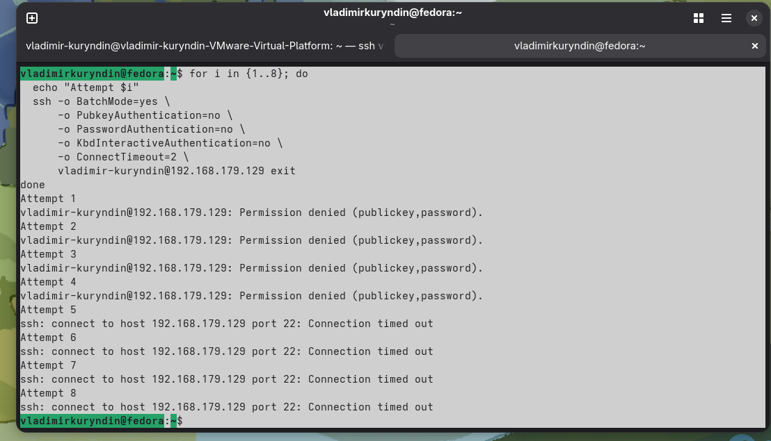

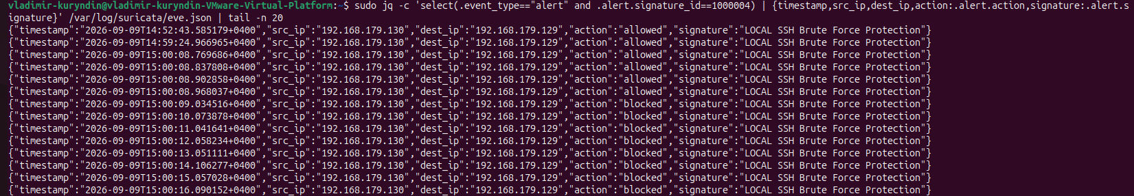

Итоговый результат
В результате получили следующую картинку:
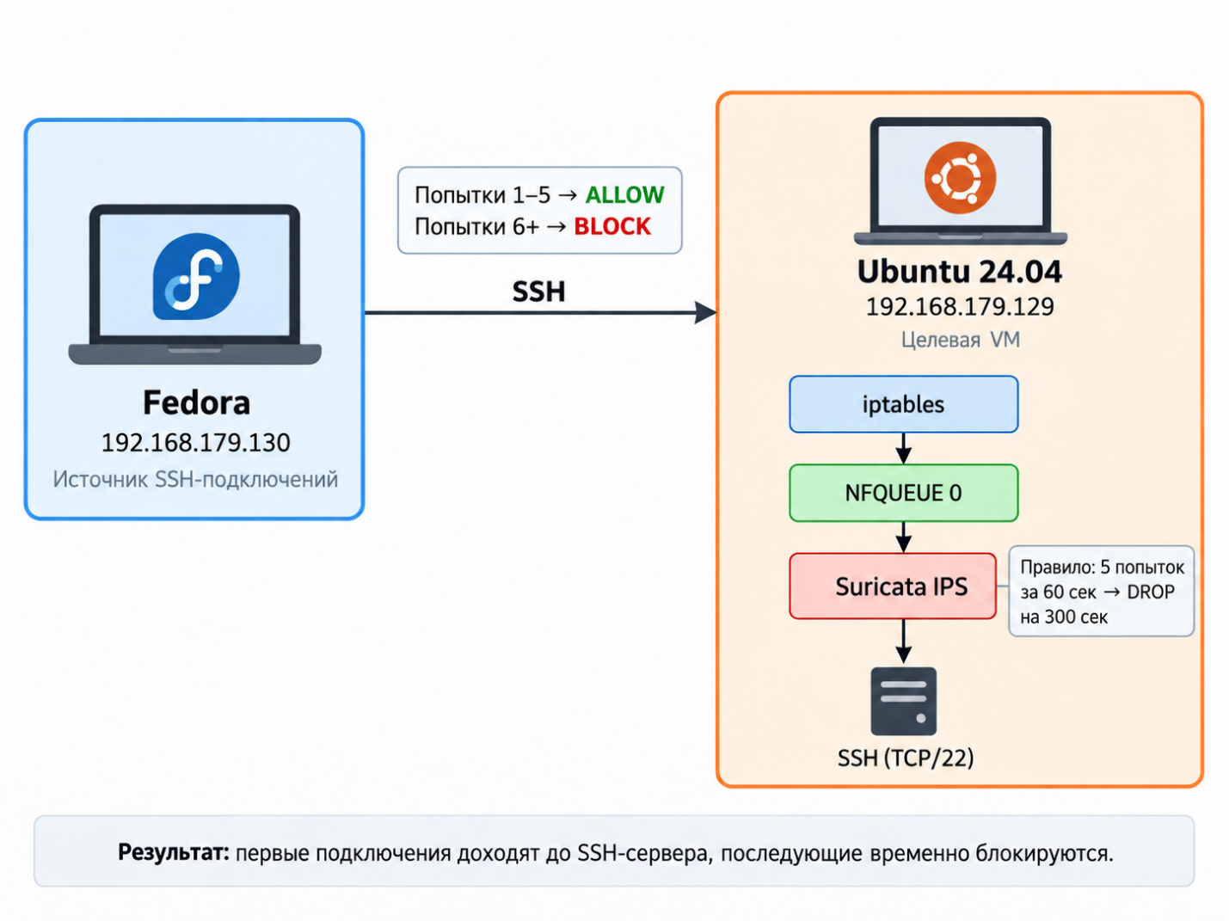

Выводы и сложности
В ходе работы мы настроили систему обнаружения и предотвращения сетевых атак на базе Suricata 7.0.3 под Ubuntu 24.04 LTS. Основной сетевой интерфейс — ens33, IP-адрес виртуальной машины — 192.168.179.129.
Разработали и успешно протестировали собственные правила для обнаружения HTTP-запроса, SSH-подключения, TCP-сканирования портов и SSH brute force. Для проверки использовали curl, ssh и Nmap 7.94SVN. Срабатывания подтверждены журналами fast.log и eve.json.
Дополнительно Suricata перевели из IDS-режима AF_PACKET в IPS-режим NFQUEUE. С помощью iptables 1.8.10 (nf_tables) реализовали передачу входящего SSH-трафика в Suricata. При достижении пяти SSH-подключений за 60 секунд последующие SSH-подключения от этого источника блокировались в течение 300 секунд.
Основные сложности были связаны с неверным интерфейсом eth0 в исходной конфигурации, подключением файла local.rules и настройкой NFQUEUE. После изменения интерфейса на ens33 и проверки конфигурации командой suricata -T все правила и IPS-блокировка работали корректно.

