Comparison of Matrix Multiplication

Matrin Nešněra
Monday, 14:30
Open Informatics
nesnemar@fel.cvut.cz

Methodology

Warm-up
For each method (multiply, multiply1D, multiplyTrans) I generated random n*m matrices of fixed size using class attributes. Then I ran 3 forks with 30 iterations for each method. Next step was creation of graph - I did 1 graph for each method. According to character of each graph, I determined what warmup would be. First two iterations of each fork were significantly higher/lower than the others, so I set probable warmup iterations to number 2.

Predefined value | Value
Matrix 1 rows | 500
Matrix 1 column | 1000
Matrix 2 rows | 750
Matrix 2 columns | 500
Max Matrix Value | 1000

Measurements
After I determined count of warmup iterations, I set number of measured iterations to 30 and number of forks to 10. When all forks ended, I processed measurements.json file using provided Python script, which gave me average time and confidence intervals for each multiply method.

Comparison
When I got confidence intervals and average time, I wrote Python script, which implemented mathematic formula from PDF. I calculated ratio and lower bound and upper bound values for each multiply method.

Machine specification
CPU - Apple M1 Pro
memory - 16GB
OS - Ventura 13.2.1
JDK version – 19.0.1
JVM – OpenJDK 64-bit Server VM

results

Warm-up

Method | Forks | Iterations | Determined warmup time
Multiply | 3 | 30 | 2
Multiply1D | 3 | 30 | 2
MultiplyTrans | 3 | 30 | 2

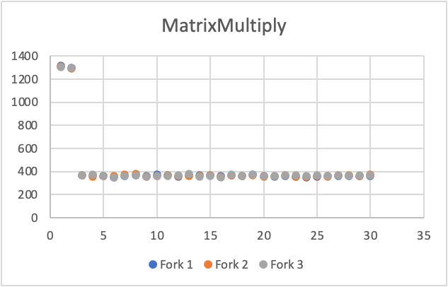

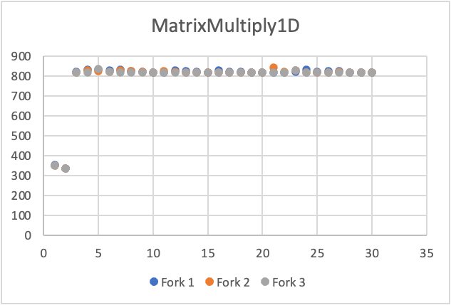
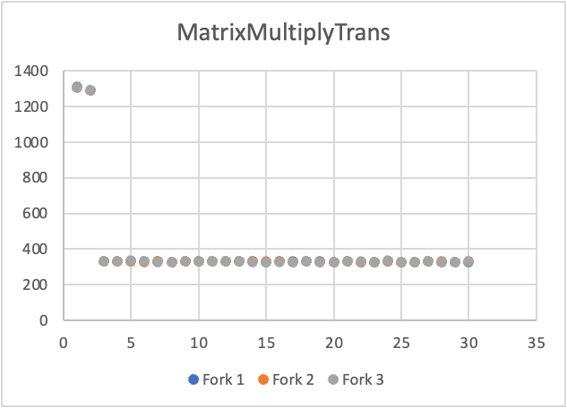

Measurements

Method | Mean | Confidence interval half-width
MatrixMultiply | 364,6002907 | 1,263367383
MatrixMultiply1D | 823,0841137 | 2,772367032
MatrixMultiplyTrans | 330,6189018 | 0,931655889

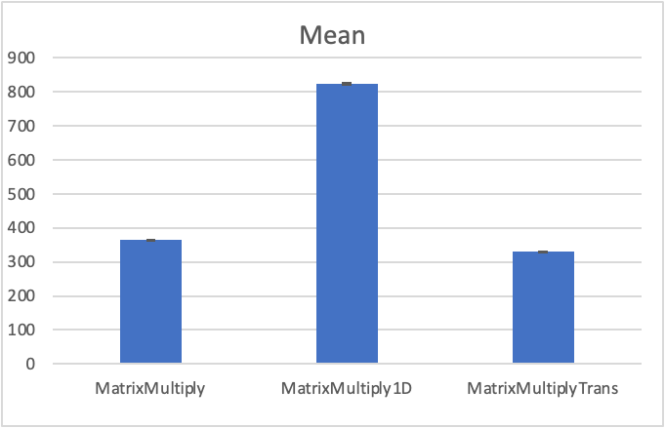

Comparison

Ratio (row / column) | Multiply | Multiply1D | MultiplyTrans
Multiply | X | 2.257524246078943 | 0.9068091276184885
Multiply1D | 0.4429734715424353 | X | 0.4016875642693296
MultiplyTrans | 1.1027899005801798 | 2.489545047198445 | X

Lower bound (row / column) | Multiply | Multiply1D | MultiplyTrans
Multiply | X | 2.246615046240194 | 0.9027591010342816
Multiply1D | 0.4408328583761696 | X | 0.39992353029360495
MultiplyTrans | 1.0978645769612234 | 2.47861206734545 | X

Upper bound (row / column) | Multiply | Multiply1D | MultiplyTrans
Multiply | X | 2.2684334459176916 | 0.9108591542026955
Multiply1D | 0.44511408470870106 | X | 0.4034515982450543
MultiplyTrans | 1.1077152241991364 | 2.5004780270514395 | X

Conclusion
- Summary of the results with a discussion

