Thesis Project Update

Purpose (Advisor Review)
This document summarizes the project architecture and core design decisions to support an advisor review of:
- Scope appropriateness
- Thesis reasonableness
- Defensible claims

1) Architecture Overview
MVP: Event-driven retraining loop with delayed labels and multi-objective signals. The key property is strict separation between signals, decisions, and outcomes to enable delayed-label learning without leakage.
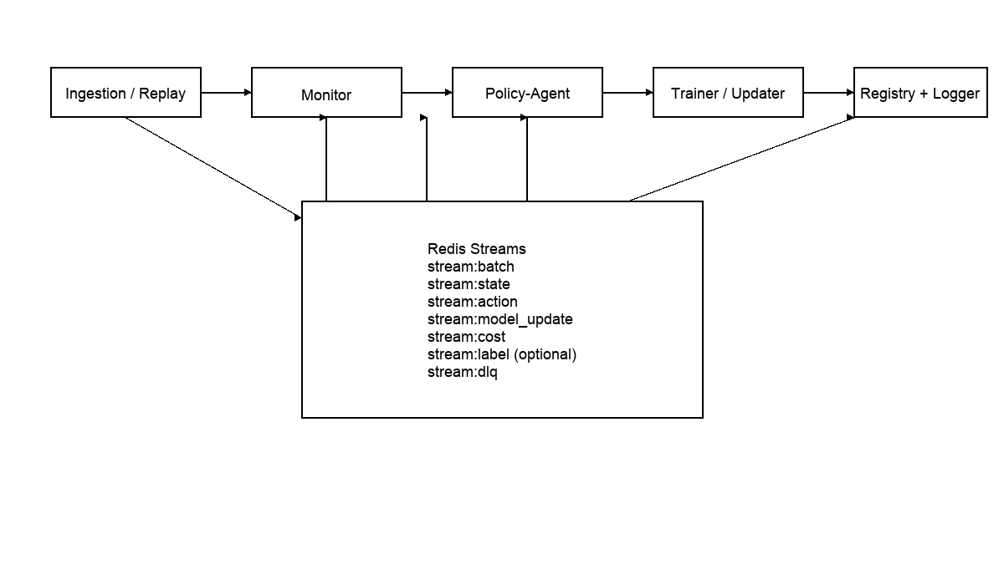

2) Design Decisions Summary (2–3 pages max)

2.1 Core Architecture
Services (Compose-first MVP):
- Ingestion: emits time-ordered batch events with label-availability flags
- Monitor: computes drift/perf/fairness signals and emits state events
- Policy-agent: consumes state and emits action events
- Trainer: executes actions and emits model_update + cost events
- Registry-logger: consumes all streams and writes an append-only log
Message bus: Redis Streams for low-overhead deterministic replay. Replay uses stream IDs + checkpointed offsets. Invalid events route to stream:dlq with reason codes.

2.2 State / Action / Reward
State vector (fixed core + extensible extras). Core fields include: state_id, batch_id, window_id, decision_timestamp, model_version, label_available, state_mode, drift_core, perf_core, fairness_core, budget_status, label_delay. Extras namespace supports expanded signals and is excluded from primary policy decisions.
Each state event represents a snapshot of the system’s current condition; the policy-agent produces at most one action in response to each state, and actions do not modify the state directly.
Action semantics (intent-level): defer, fine_tune, partial_retrain, full_retrain. Trainer logs effective_action_type, executed_as_requested, and reason_code if constraints force adjustment. Defer emits a zero-cost event for trace completeness.
Reward / objectives (Phase-1 baseline):
R = w1 * ΔO_perf - w2 * O_cost - w3 * O_energy - w4 * O_fair_gap - w5 * action_penalty
(This scalar reward is used only for training the decision policy; results are reported using the full objective vector.)
Terms are normalized over a sliding window; ground-truth metrics supersede proxies when available.

2.3 Evaluation Scope
Primary: offline replay (deterministic). Appendix: synthetic online simulation to stress bursty drift and label delays. Baselines: fixed-interval, drift-threshold, no-retrain, fairness-threshold, cost-aware retrain. Metrics: per-decision objective vector + aggregate trends; bootstrap confidence intervals. Ablations: policy and system ablations to isolate fairness/cost/telemetry effects.

2.4 Non-Goals (Explicit)
- No production deployment on Kubernetes in the thesis MVP.
- No attempt to claim real-world causal impact beyond benchmark-based evaluation.
- No full observability or testing sections included here (kept concise for advisor review).
- No long literature survey or implementation code included in this summary.

Advisor Checkpoints
- Is the architecture appropriate and defensible for a thesis?
- Is the scope reasonable for completion?
- Are the evaluation claims defensible with offline replay + stress appendix?

