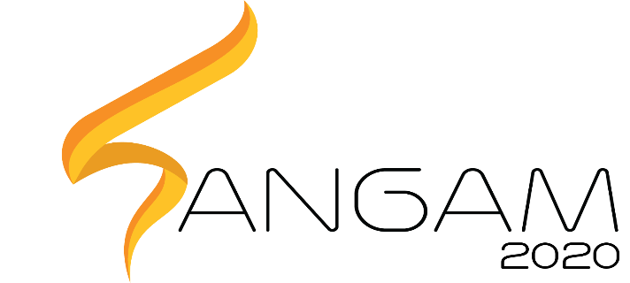

PRAGYAN HARDWARE HACKATHON

**HEALTH CARE AND AGRICULTURE**

**MARKO**

**Machine Assisted Rehabilitation for Knee Osteoarthritis**

**Name** **College ID/Roll UG/PG** **Course/Branch Semester**

|  |  |  |  |  |
| --- | --- | --- | --- | --- |
| Name | Roll Number | UG/PG | Branch | Semester |
| Viekash V K | 110118104 | UG | ICE | III |
| Pramoth Arun | 107118074 | UG | EEE | III |
| S Manimozhi | 107118099 | UG | EEE | III |
| Gaurav Devendra Nagotanekar | 108181066 | UG | ECE | III |

1. **Project Abstract:**

Knee-osteoarthritis is one of the most common forms of arthritis that people above the age of 40 and even a few youngsters suffer from. Physiotherapy, pain-relief, anti-inflammatory medications are the few available treatments. The permanent solution is to do surgeries like osteotomy, knee-joint replacement.

Post-surgery rehabilitation can be divided into 2 stages:

Stage 1 (THERAPY): To gain control over the knees.

Stage 2 (TRAINING): To strengthen the muscles around the knees.

These are usually done under the guidance of a therapist.

Robotic therapeutic tools such as CPM (continuous passive motion) machines exist, cutting down the huge expenditure of frequent consultations, but they support only the stage 1 of rehabilitation and not stage 2, which again requires a trainer to guide the person to do heavy-exercises such as cycling. Sometimes patients lose their motivation and hope of complete recovery because of its lengthy recovery period.

MARKO aims to Automate both stages of rehabilitation, integrate them in the same device and make the recovery process interesting and motivating by interfacing stage 2 with a gaming context. The electric linear actuator controls the motion of the leg, which is attached to links connecting to the actuator. For stage 1, a four-bar linkage slider-crank mechanism assists the leg, performing physiotherapy in a CPM. For stage 2, EMG signals are taken to know the intent and direction in which the person puts the effort to move his/her leg, which is a parameter of control for the game, allowing the person to train while gaming.

***Keywords— Rehabilitative robotics, Knee-osteoarthritis, electric linear actuators, Electromyography, continuous passive motion, four-bar linkage slider-crank mechanism.***

1. **Proposed Design:**
2. **Objective:**

The objective is to rehabilitate patients with knee-osteoarthritis and patients who have undergone surgeries for knee-osteoarthritis by fabricating a mechanism, controlled using electric linear actuators to perform physiotherapy and also train the legs because of the effort put by the person to control the game.

1. **Proposed Solution:**
   1. **Block Diagram:**

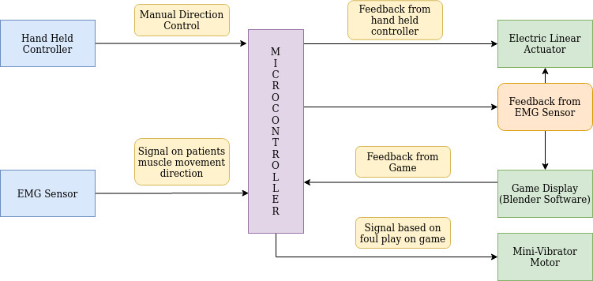

1. **Components Required:**

|  |  |
| --- | --- |
| COMPONENTS/PARTS | How is it being used in the proposed solution? Explain its role/functionality. |
| Microcontroller | To control the position of linear actuators, as well as to get feedback from the EMG signals, force sensor and send it as a parameter for the game and also trigger the mini vibrator motor. |
| Electromyographic (EMG) sensor | To measure the electrical activity of muscles |
| Force sensors | To measure the magnitude of effort applied |
| Mini vibrator motor | To alert the patient by producing vibrations in the patient’s legs in-case if he/she does any foul move in the game |
| Heavy duty motor | To move and position the links, acts as the slider. |
| Encoder | To know the position of the leg and feed it into the game |

1. **Innovativeness of the Proposed Solution**

MARKO gives the patients the comfort of doing physiotherapy even in the case of being bed-ridden, without the assistance of any therapist, making the recovery process easy, cost-effective, interesting and motivating through a gaming interface. The existing automated therapeutic tools serve good only in doing basic therapy. MARKO has better functionality than the existing tools, helps the patient to improve his/her muscular strength because of the effort his/her leg puts to control its position while playing the game. Compared to traditional rehabilitation methods, the cost will be greatly decreased due to the one-time investment.

1. **Impact of the proposed solution (Application):**

Ease of rehabilitation for a large number of people affected with Knee-osteoarthritis, which is over 70 million in India alone and those who have undergone surgeries for the same. Therapist/trainer guided Physiotherapy is a costly and continuous process, whereas a robotic solution will be a one-time investment. Because of its compliant nature, MARKO is easier to use and better for complete recovery, contrary to traditional rigid approaches.

1. **References** 
   * + 1. Trochimczuk, R., and T. Kuźmierowski. “Kinematic Analysis of Cpm Machine Supporting to Rehabilitation Process after Surgical Knee Arthroscopy and Arthroplasty.” *International Journal of Applied Mechanics and Engineering*, vol. 19, no. 4, Jan. 2014, pp. 841–848., doi:10.2478/ijame-2014-0059.
       2. “Continuous Passive Motion Machine - What You Need to Know.” *Drugs.com*, Drugs.com, 24 Sept. 2019, <https://www.drugs.com/cg/continuous-passive-motion-machine.html>.
       3. Rajestari, Z., et al. “Kinematic Synthesis and Optimization of Continuous Passive Motion Mechanisms for Knee.” 2017 7th International Conference on Modeling, Simulation, and Applied Optimization (ICMSAO), 2017, doi:10.1109/icmsao.2017.7934896.