DIANA & LOKI
VOICE-FIRST AI CONVERSATIONAL AVATAR WEBSITE
PROJECT DESIGN • FEATURES • SCREEN REFERENCES

A friendly, voice-driven AI experience with two distinct virtual companions.

1. Project Overview
The Diana & Loki project is a voice-first AI conversational website. Users interact naturally by speaking instead of typing. The website offers two selectable AI identities, multilingual conversations, avatar-based responses, and voice-led access to photos, documents, and camera features.

2. Main AI Characters
DIANA — FEMALE AI  Warm, friendly and supportive personality. Uses the Diana avatar and the selected female voice. | LOKI — MALE AI  Friendly and confident personality. Uses the Loki avatar and the selected male voice.

3. Visual Design References
The following images are the uploaded reference images included in this document. The visual direction is a black background, neon-green highlights, glowing green borders, and bold white text.
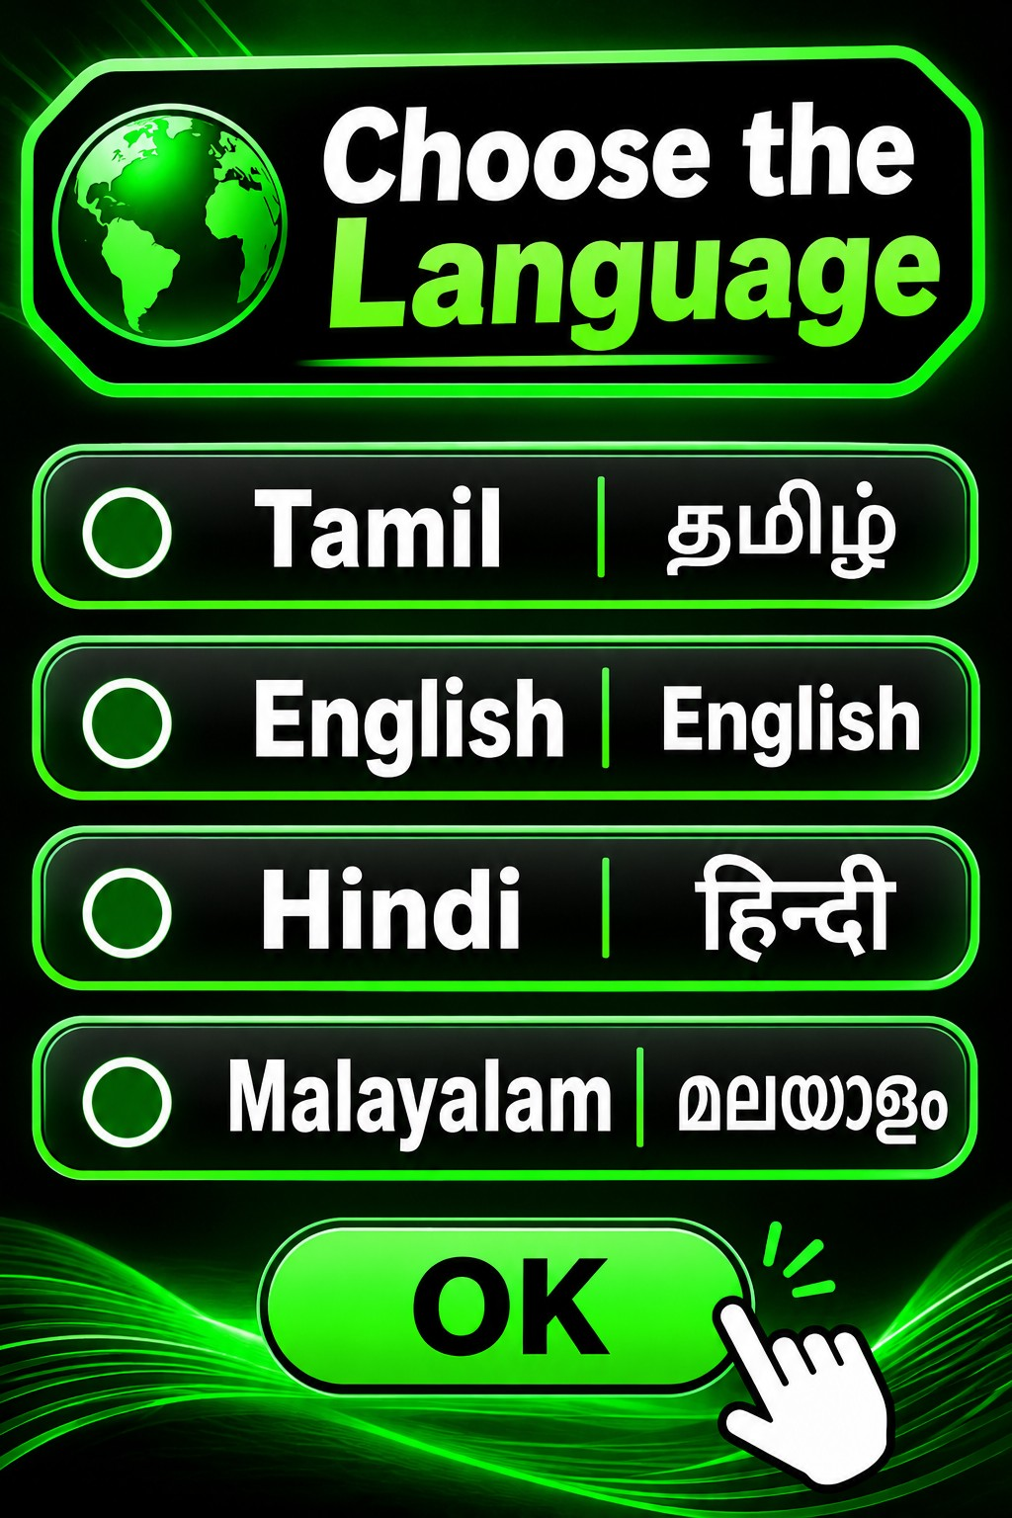
Reference 1 — Language selection: Tamil, English, Hindi and Malayalam
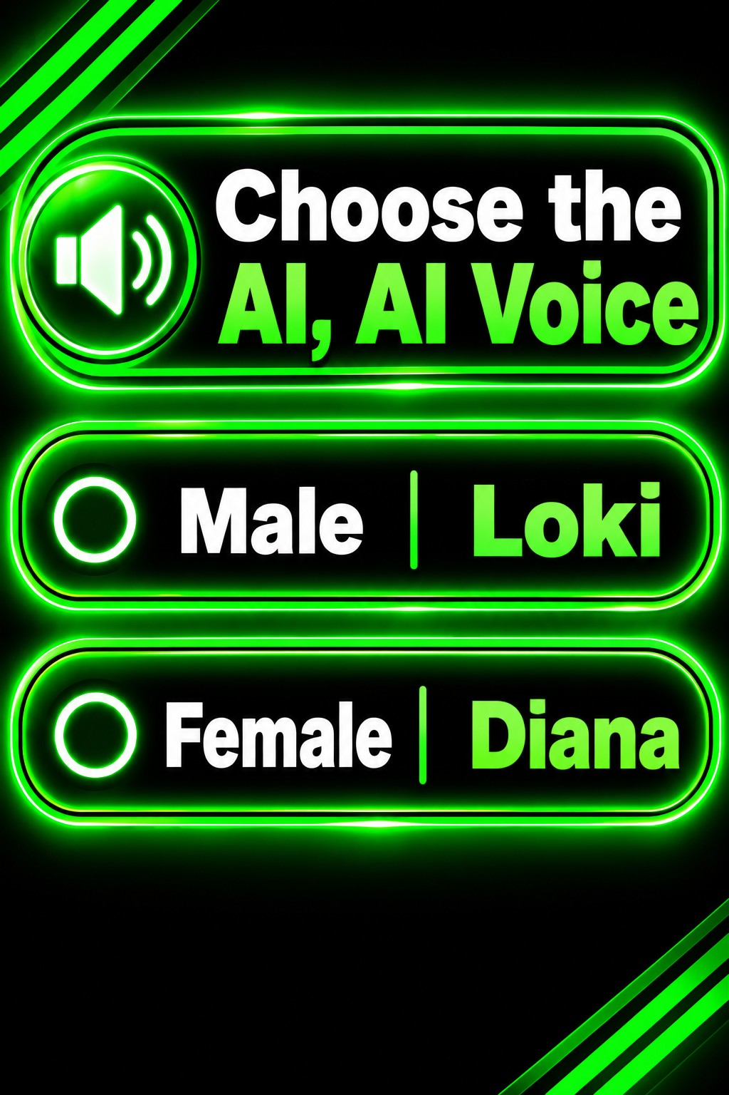
Reference 2 — AI voice selection: Male / Loki and Female / Diana
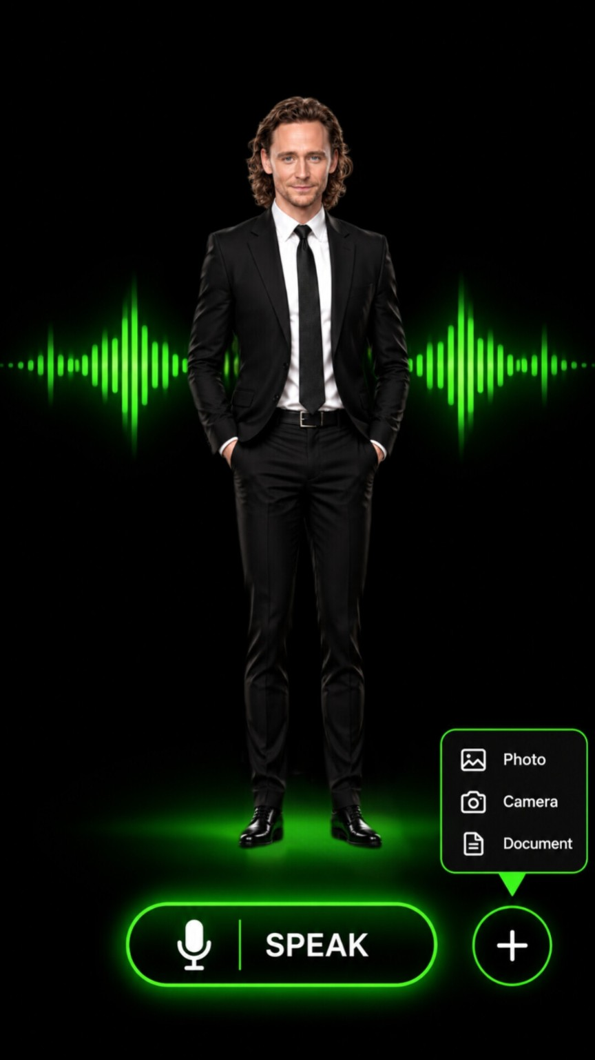
Reference 3 — Loki male avatar main screen
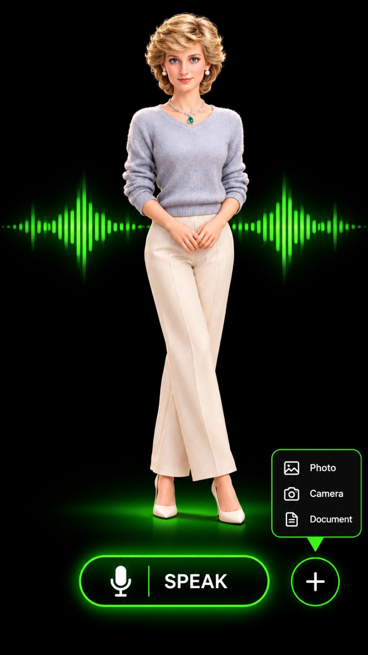
Reference 4 — Diana female avatar main screen

4. User Journey and Main Screens
- Email entry and account registration.
- Language selection: Tamil, English, Hindi, Malayalam.
- Gender selection, followed by the matching AI voice/character selection.
- Character selection: Male — Loki; Female — Diana.
- Main conversation screen with the selected avatar, microphone/speak control, voice waveform, and quick actions for Photo, Camera, and Document.
- Subtitles can be switched ON or OFF.

5. Core Features
- Continuous voice conversation: One tap starts the voice session; the system listens, processes speech, speaks the response, and resumes listening until stopped.
- AI intelligence: General knowledge, education, science, technology, mathematics, programming, reasoning, and everyday assistance.
- Four-language support: Tamil, English, Hindi, and Malayalam, with mixed-language understanding where supported.
- Avatar animation and lip-sync: Mouth movement synchronized with generated audio, natural blinking, eye movement, head movement, and speaking animation.
- Facial expressions: Normal, happy, big smile, sad, crying, angry, surprised, confused, excited, thinking, worried, and laughing.
- Emotion-aware responses: Estimate conversational tone from wording and permitted audio cues; respond empathetically without claiming certainty about a person's feelings.
- AI memory: Retain relevant user preferences and conversation context with user controls to review and delete stored memory.
- Document understanding: Upload supported files such as PDF, DOCX, and TXT; ask spoken questions, request summaries, and get explanations.
- Photo understanding: Upload a photo and ask by voice for descriptions, object explanations, or text reading (OCR).
- Camera assistance: Capture an image and ask questions by voice. Clearly show when the camera is active.
- Voice waveform and subtitles: Show listening/thinking/speaking states and an audio-responsive waveform; optionally show spoken-response subtitles.
- Accessibility and responsive design: Large controls, clear icons, high contrast, audio feedback, and layouts for phones, tablets, and computers. No traditional chat box.

6. Voice Conversation Flow
USER SPEAKS → SPEECH RECOGNITION → AI PROCESSING → TEXT-TO-SPEECH → AVATAR LIP-SYNC → LISTEN AGAIN

7. Technical Architecture
- Frontend: preserve the existing website framework, components, screens, and assets.
- Backend: secure server-side API routes for AI, speech, vision, and document processing.
- Authentication and database: Firebase or Supabase, selected to fit the existing project.
- AI services: language model, speech-to-text, text-to-speech, and vision-capable model.
- Avatar layer: existing Diana and Loki assets with suitable 2D/3D animation and audio-driven lip-sync.
- Storage: private user-specific file storage with access rules.

8. Security and Privacy
- Keep API keys on the server; never expose secret credentials in browser code.
- Request microphone and camera permission explicitly and show clear active indicators.
- Do not secretly record or retain audio unnecessarily.
- Validate uploaded files and enforce user-specific access permissions.
- Provide controls for conversation history and memory management.

9. Development Plan
- Stage 1: inspect and preserve the existing project; verify login, language, character selection, and current screens.
- Stage 2: connect the AI backend and continuous multilingual voice conversation.
- Stage 3: implement avatar lip-sync, expressions, waveform, and subtitles.
- Stage 4: integrate document, photo, and camera understanding.
- Stage 5: add memory, privacy controls, accessibility improvements, and full testing.

10. Final Requirements
Preserve the existing website and its working interface. Do not rebuild it unnecessarily, remove existing controls, or replace the uploaded Diana and Loki reference assets with unrelated images. The only two initial AI identities are DIANA (female) and LOKI (male). Inspect the existing source code before implementation, explain the integration plan, and clearly identify any external API, account, subscription, or API key that is required.

