

**K.L.E SOCIETY’S**

**CHIDANAND.B.KORE POLYTECHNIC,CHIKODI**

**KARNATAKA 2024-2025**

DEPARTMENT OF COMPUTER SCIENCE & ENGINEERING

A SYNOPSIS REPORT ON

**“CAFE MANAGEMENT SYSTEM”**

Submitted for partial fulfillment of the requirements of the award of the

**DIPLOMA IN COMPUTER SCIENCE & ENGINEERING**

UNDER THE GUIDENCE OF

Miss, Sarita Khot(Lecturer)

Mr. Rajshekar Bendawade(Lecturer)

**A**

**Synopsis**

Submitted by:-

Tanushree Muddappagol 339CS22055

Vaishnavi Kalal 339CS22057



**K.L.E SOCIETY’S**

**CHIDANAND.B.KORE POLYTECHNIC ,CHIKODI**

**DEPARTMENT OF COMPUTER SCIENCE & ENGINEERING**

**CERTIFICATE**

Certified that This Synopsis report entitled “CAFE MANAGEMENT SYSTEM” Which is submitted by Miss Vaishnavi Kalal Reg No.339CS22057,

a bonafide student of Chidanand B Kore polytechnic in partial fulfilment for

the award of Diploma in Computer Science & Engineering during the year 2024-25 is record of student own work carried out under my/our guidance.

It is certified that all corrections/suggestions. The indicated for internal.

Assessment have been incorporated in the Report and one copy of being

deposited in polytechnic library.

The Synopsis report has been approved as it satisfies the academic

requirements in respect of Project work prescribed for the said diploma. It

is further understood that by this certificate the undersigned do not endorse

or approve any statement made, opinion expressed or conclusion draw there

in but approve the project only for purpose for which it is submitted.

Guide Head of Department Principle

Name and Signature of Examiner

1

2

|  |  |  |
| --- | --- | --- |
| **Sl.no** | **Content** | **Page no** |
| 1 | Introduction |  |
| 2 | Abstract of project |  |
| 3 | Literature Survey |  |
| 4 | Objective of the Project |  |
| 5 | Scope of the Project |  |
| 6 | System Design |  |
| 7 | Input/Output Requirement |  |
| 8 | Hardware & Software Requirement |  |
| 9 | E-R Diagram (use case diagram) |  |
| 10 | Advantages and Disadvantages |  |
| 11 | Future Scope of the Project |  |
| 12 | conclusion |  |
| 13 | Reference of Bibliography |  |

Table Content

Introduction

Cafe Management System is based on a concept to maintain orders and management of a particular items. This project is developed in C#.NET using C# language and Microsoft SQL database used. The role of the User is to maintain information including operations like modifying, deleting, updating the items records and customer order records in the system.

Cafe Management System is a windows form application developed in C# programming language to carry out and manage basic cafe operations efficiently. This win application is perfect for a cafe or small coffee shop owners where they are in need of an application to run and simply ease out their day to days managerial task.

Abstract of project

Cafe Management System is based on a concept to

maintain order and management of a particular coffee shop.

The aim of the cafe management is to create communication between rural area people and coffee management.

This project is the process of manually maintaining the records related to transaction flows, user details, payment details. It is very needy for Coffee Shop. This project helps the owners of Café Shops to maintain day to day transactions in computer.

This project deals with management of the cafe it deals the purchase and sale of coffee.

Literature Survey

A literature review evaluates the information within any published literature to the topic or research question you choose. The literature reviews reflect upon what has already been written about (methodical or theoretical), what the existing literature contributes to the field, and how your topic corresponds with the literature. If your topic exposes a gap in the existing research in your field, make note of that in the literature review.

Objective:-

* To develop a web based system that will help to manage the cafe information about the cafe.
* It takes the suggestion from the user.
* This system is helpful for area people.
* It takes less processing time.
* To provide the fresh coffee and healthy product to the people.

Scope of the System.

This management system will be designed to minimize the manual work in maintaining Managing Employee & Customer details, working of Token system, working with Offers to be applied in coffee shop, generating Reports according to the working of system and Menu Card for cafe shop and other managements in coffee shop.

It aims to maximize the productivity and provide improved managed System. This System will be easy to understand and use.

More specifically, this system is designed to allow an admin to manage the employee records, Customer records, Products and other management in coffee shop.

Whereas, it maintains the relationship between customer and the admin in the technical way with the help of café shop management software. The Customer report & Product report.

System Design

The system development life cycle (SDLC)

The system development life cycle (SDLC), also referred to as the application development life-cycle, is a term used in system engineering, information system and software engineering to describe a process for planning, creating, testing, and deploying an information system. The systems development life-cycle concept applies to a range of hardware and software configurations, as a system can be composed of hardware only, software only, or a combination of both.

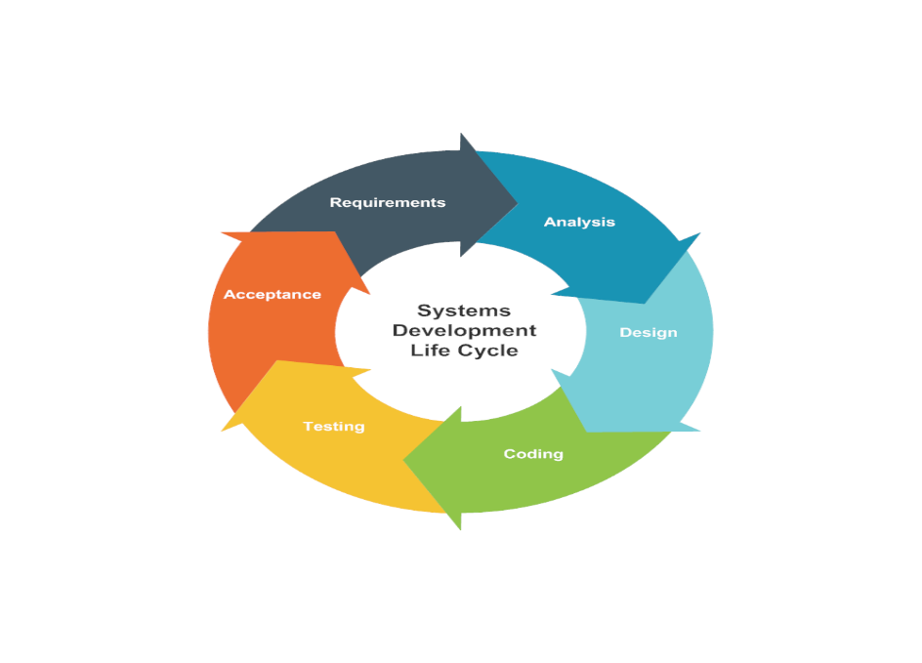

Planning and Requirement Analysis

Requirement analysis is the most important and fundamental stage in SDLC. It is performed by the senior member of the team with inputs from the customer and expert in the industry.

Input/Output Requirement

Input Requirement:-

* Customer Orders
* Payment Details
* Customer Details
* Staff Login
* Promotions and Discounts

Output Requirement:-

* Order Details
* Daily Reports
* Staff Performance Reports
* Order Confirmation

Hardware/Software Requirement

Hardware

* **CPU:** Modern multi-core processor (e.g., Intel Core i5 or equivalent)
* **RAM:** Minimum 4GB (8GB preferred)
* **Storage:** SSD with at least 128GB (256GB or more preferred for future growth)
* **Display:** Touchscreen monitor (15-22 inches)
* **Peripherals:** Barcode scanner, receipt printer, cash drawer

Software

* **Operating System**: Microsoft Windows/Linux
* **Data Base Server**: MYSQL
* **Software Used**: Visual Studio or above using ASP.NET

ERD Diagram:

The ER Diagram was originally proposed by peter for the design of the relation data have system. Components is identified for the ERD; data objects, attributes, relationships and various types of indicators. The primary purpose of the E-R-D is to the E-R Diagram was originally proposed by peter Chen for the design of Relational Database System. The E-R model is extremely useful in mapping and interactions of real worlds enterprise.

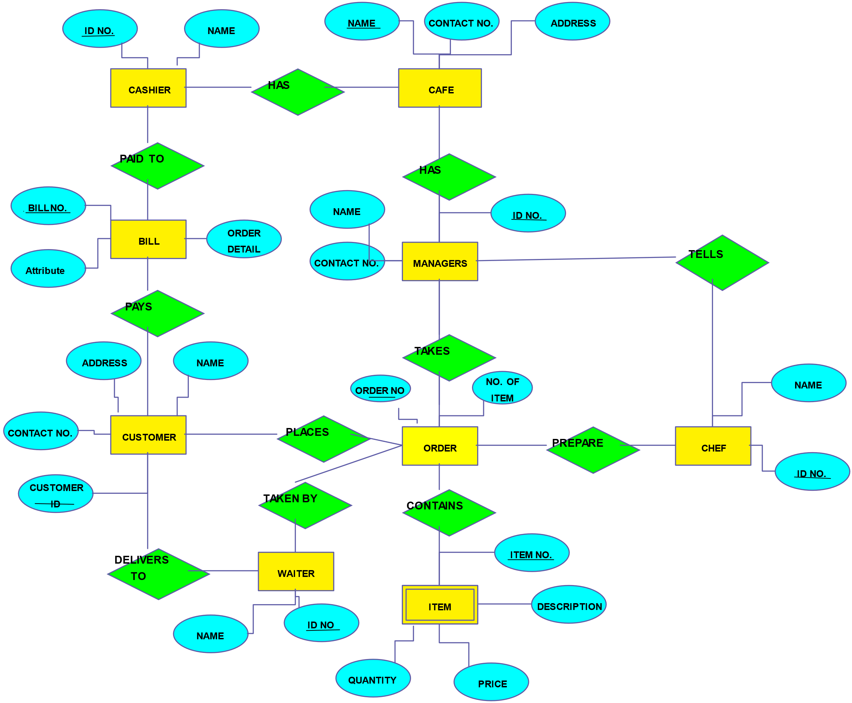

Advantages

**Improved Efficiency:**

* Automates routine tasks like order taking, billing, and inventory management, reducing manual effort and errors.

**Inventory Management:**

* Tracks stock levels in real-time, helping to reduce wastage and ensuring that ingredients are always available.

**Enhanced Customer Experience:**

* Faster service and accurate orders lead to higher customer satisfaction.

**Data Analysis:**

* Generates reports on sales, customer preferences, and peak hours, helping management make informed decisions.

**Financial Management:**

* Helps in monitoring cash flow and profitability through detailed financial reports.

**Employee Management:**

* Tracks employee hours, performance, and scheduling, reducing administrative overhead.

**Scalability:**

* Can easily adapt to the growing needs of the business, whether by adding new menu items, expanding to multiple locations, or integrating with online ordering platforms.

Disadvantages

**Initial Cost:**

* The upfront cost of purchasing and installing a café management system can be significant.

**Learning Curve:**

* Staff may require training to use the system effectively, which could temporarily disrupt operations.

**Dependence on Technology:**

* The system's reliance on technology means that technical issues, like software glitches or hardware failures, could disrupt operations.

**Data Security Risks:**

* Storing sensitive customer data, such as payment information, requires robust security measures to prevent data breaches.

**Customization Limitations:**

* Some systems might not offer the flexibility needed to tailor features to specific business needs, limiting their usefulness.

Future Scope

A café management system is essential for streamlining operations, improving customer service, and increasing profitability. As the food and beverage industry evolves, the future scope for such systems includes several promising trends and technological advancements.

Conclusion

In conclusion a café management system is a vital tool for modernizing operations, enhancing customer satisfaction, and driving business growth. As the café industry continues to evolve, embracing emerging technologies such as AI, IoT, and cloud-based solutions will be crucial for staying competitive. These systems not only streamline day-to-day tasks but also provide valuable insights through data analytics, helping café owners make informed decisions.

References

* <http://www.bigresource.com/>
* <https://html.scribdassets.com/9926wjkoao7ovm85/images/37-e1e484b173.png>