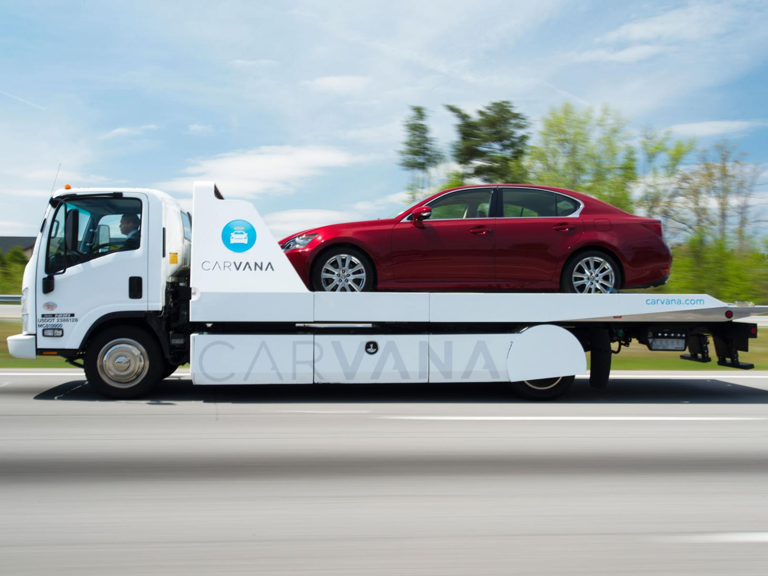
HBR - CARVANA: IS BADBUY?
Assignment 2.8
May 31, 2025
Vilan kvyat
BIA-610 APPLIED ANALYTICS
Stevens Institute of Technology – Summer 2025
Table of Contents
1 HBR Case STUDY - CARVANA: Is BADBUY? 2
1.1 UVA CASE STUDY QUESTIONS 2
1.1.1 What is Data Science? 2
1.1.2 What Do You Think of Carvana’s Mission, Business Model, And Achievements? 2
1.1.3 Would you invest in Carvana? Why? 4
1.1.4 Have Carvana’s Algorithms Been Effective in Predicting Which Cars Are Kicks and Not Kicks? 5
1.1.5 What is Kaggle? 5
1.1.6 How can Kaggle help Carvana? 5
1.1.7 How can Kaggle help other companies? 6
1.1.8 What are Visual Analytics? How Can It Been Applied in Carvana’s Data Set in Kaggle? 7
1.1.9 What Makes Hans Rosling’s Visualization So Effective? 8

Table of Figures
Figure 1 Carvana's Car Vending Machine in Tennessee. 4
Figure 2 Carvana Analysis of Bad Buys vs. Good Buys………………………………………………………………..7

HBR Case STUDY - CARVANA: Is BADBUY?

UVA CASE STUDY QUESTIONS

What is Data Science?
Data science is a multidisciplinary field that studies predictive analysis, statistical analysis, and the utilization of advanced analytical tools and algorithms. Data scientists are also responsible for techniques that require deeper knowledge of algorithms, such as data mining, knowledge discovery, or machine learning. Data scientists need to be skilled in web-oriented programming languages such as Java or Python, or statistical programming languages such as R. Data scientists have expertise in statistical modeling, experimentation, and analysis. Data scientists also work with predictive and prescriptive analytics (Sharda et al. 2020, p. 36).

What Do You Think of Carvana’s Mission, Business Model, And Achievements?
Carvana’s mission is customer-centric because it offers several features that target consumers’ frustrations with the used car industry, such as a seven-day return guarantee, no-haggle pricing, and e-commerce features. I was surprised at how quickly the company grew, but I also wondered if the seven-day return guarantee would be too generous to sustain. Carvana also allowed customers to research information about their cars online as well as make purchases. I think that this e-commerce feature helped set them apart from other car dealerships because they made car purchasing easier (Nelson et al. 2006, p. 1).
Their business model allows consumers to research information about Carvana’s vehicles online, obtain financing and warranty coverage, see what the cars look like, make purchases, and schedule deliveries or pick-up times. Carvana used tall, glass buildings as “vending machines” where consumers can pick up their vehicles or have them delivered. Carvana’s business model reminded me of Amazon’s because they do source their cars from auctions and from the CEO’s father’s company, DriveTime. This is like how Amazon is known for being an e-commerce titan that sources its products from third-party vendors. Ultimately, the goal was to “change the way people buy cars”, which I believe it did.
I question Carvana’s relationship with DriveTime because their CEO was convicted of bank fraud in the 1990s, holds a huge 71% share in Carvana, and his son is Carvana’s CEO. I think that this creates a lack of transparency and potential conflicts of interest. Additionally, I find it concerning that the CEO of DriveTime, Ernest Garcia II, and his son own nearly all Carvana’s voting shares, making any kind of change impossible without their involvement. I think that this is far too much control for two people to have in a company (Nelson et al. 2006, p. 3). I also wonder what the difference in quality and price would be if Carvana sought out third-party car vendors as opposed to auctions.
Carvana achieved rapid scale in a short period. After four years in business, Carvana generated $365.1 million in revenue against a loss of $93.1 million while selling 27,500 vehicles. Carvana also employed 1,000 people, which I thought was impressive considering that they had not been in business very long. However, I question how sustainable such growth can be, considering how reliant Carvana is on DriveTime (Nelson et al. 2006 p. 5).
I questioned whether the winners of the Kaggle competitions were offered jobs or hired. I thought that it would make sense for Carvana to hire them because, as the company grows and the industry changes, they would need a team of capable data scientists to continue to improve their algorithms. Additionally, given their 16% IPO drop in 2017, I began to think that Carvana took the company public too fast. I do not think that Carvana achieved the maturity and sustained growth necessary to take the company public at that time (Nelson et al. 2006, p. 1).
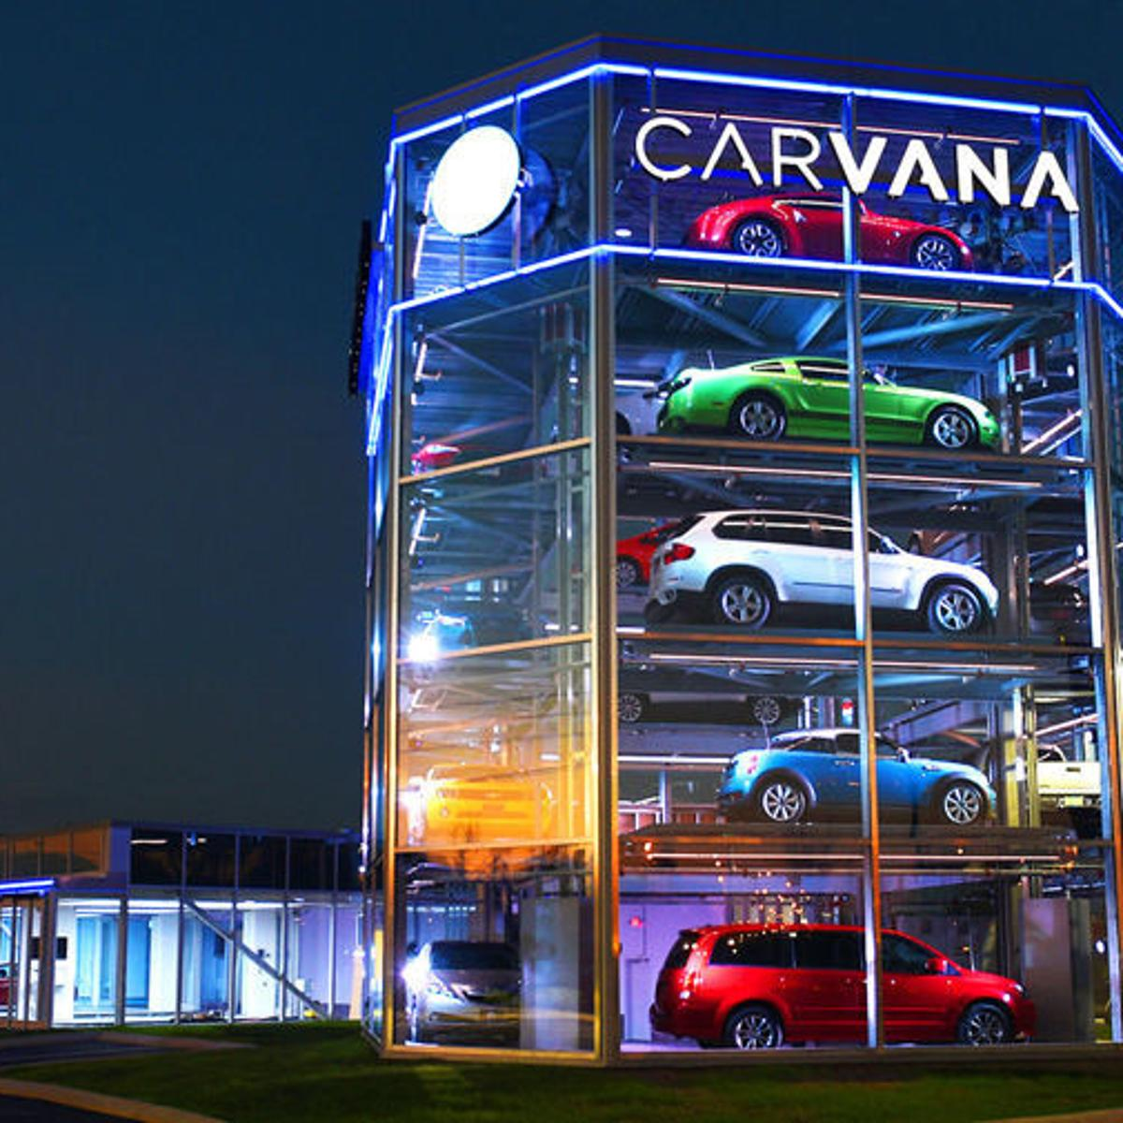
Figure 1 Carvana's Car Vending Machine in Tennessee.

Would you invest in Carvana? Why?
Based on the knowledge I have of the company from the case study, I would not invest in Carvana because there are too many risks involved. I think that the company’s mission, which is to transform a painful car purchasing process through greater transparency, new technology, and convenience, is a very interesting business model that has potential. I am, however, particularly concerned about the significant losses that Carvana suffered in 2016, the 16% drop on IPO day, and return rates that fall under its seven-day guarantee that chip away at thin margins.
I am also hesitant about the level of capital that would be needed to build and sustain Carvana’s infrastructure, namely its vending machine towers, rapid scaling strategy, and maintaining an inventory pool of nearly 10,000 vehicles. One of my main concerns that alarms me the most is Carvana’s operational ties to DriveTime, which is owned and controlled by Ernest Garcia II. Ernest Garcia II was convicted of bank fraud in the 1990s, is the father of Carvana’s CEO, and is also a major Carvana shareholder. There are no guarantees that Carvana is financially independent or that its operations are continuing to be outsourced to DriveTime (Nelson et al. 2006, p. 1).
The father-son relationship creates transparency issues, in addition to the elder Garcia’s history of bank fraud. There are already potential conflicts of interest because Carvana relied heavily on DriveTime for critical early infrastructure, such as vehicle reconditioning and financing services. In a publicly traded company, such issues can undermine confidence in management’s objectivity, long-term autonomy, and scalability. Carvana also has a history of burning through its cash flow to sustain its operations. It has burned through $2.4 billion in cash since 2016 and Forbes predicts that it has only eleven months of cash to operate before running it our diluting its investors by raising more capital (Trainer).

Have Carvana’s Algorithms Been Effective in Predicting Which Cars Are Kicks and Not Kicks?
Carvana’s algorithms have been somewhat effective, but they are not entirely foolproof in predicting kicks. The company’s first Kaggle competition, held before launch, was specifically designed to build predictive models that would be able to identify defective vehicles or other complications that would render them unsellable. The models were able to avoid the more obvious kicks, such as older vehicles and faulty odometer readings.
However, the training data’s return rate was 12.3%, which indicates that there are still many kicks that slipped through their predictive models. This means that the predictive models that Carvana would use in real business practice would not consistently deliver profitable decisions as the company scaled. Carvana has not fully solved the kick problem if their return rate is 12.3% and the company is incurring ongoing losses of $93.1 million in 2016 (Nelson et al. 2006, p. 5).
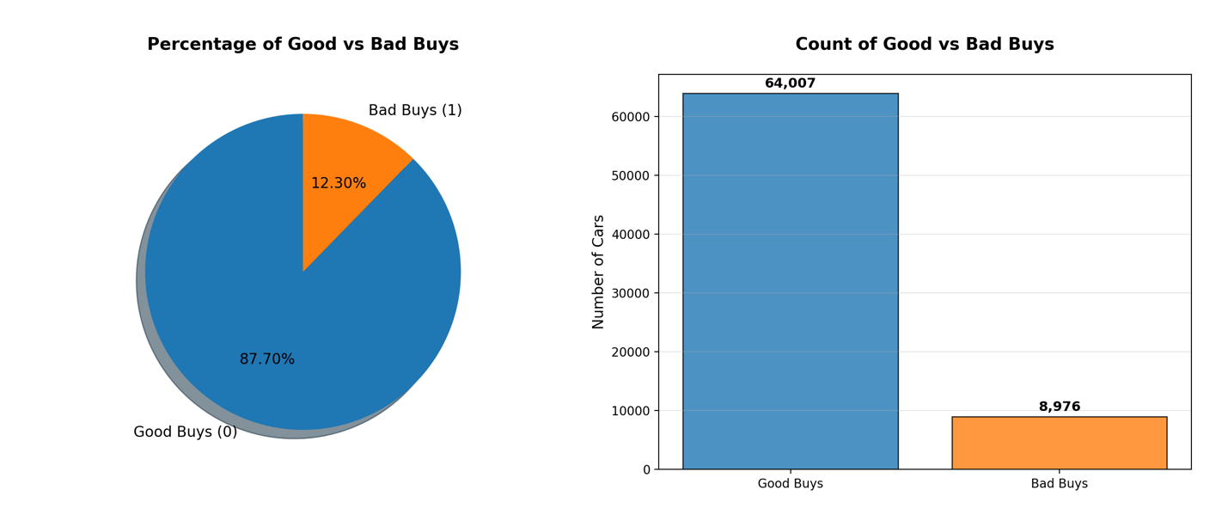
Figure 2 Carvana Analysis of Good Buys vs. Bad Buys

What is Kaggle?
Kaggle is a crowdsourcing platform for data scientists to develop algorithms. It hosted competitions for Carvana where hundreds of teams competed to predict whether a car purchased at an auction was defective or not. Carvana also used Kaggle to develop an algorithm to superimpose cars on different backgrounds (Nelson et al. 2006, p. 2).

How can Kaggle help Carvana?
Kaggle can help Carvana by hosting competitions that present an opportunity for teams of data scientists to build machine learning algorithms to evaluate the cars in Carvana’s inventory daily. These algorithms will help Carvana determine whether their cars fit consumer demand, profitability targets, and their existing inventory mix (Nelson et al. 2006, p. 1). Kaggle’s data scientists help Carvana determine which cars are ‘kicks’, or those that have major defects. By developing machine learning algorithms that help Carvana remove cars that are unsellable, or more likely to be returned, from its inventory, it will help the company gain a competitive advantage.
These algorithms will allow Carvana to optimize its inventory by predicting which cars will be more likely to sell and at what margins (Nelson et al. 2006, p. 2). Additionally, Carvana can then recruit the top talent from Kaggle by offering jobs to the winners of each Kaggle competition. The data scientists who get hired can then continue to build upon and improve their algorithms as they gain experience and more understanding of Carvana’s business.

How can Kaggle help other companies?
Kaggle can help other companies in the same way that it helped Carvana. Kaggle can offer crowdsourcing solutions to companies in a variety of industries, such as healthcare, finance, and retail. Kaggle can offer companies in these industries top talent to recruit and algorithms that can help them make better decisions. Crowdsourcing solutions will also be cheaper than companies trying to develop machine learning algorithms and doing the research on their own. Kaggle can offer companies high-quality machine learning algorithms with a quicker turnaround that solve some of their most complex problems. Because these challenges are public, the companies that participate will have the opportunity to market themselves as committed to innovation and using technology to find ways to improve.
For example, healthcare companies can participate in a global Kaggle competition to help them develop machine learning algorithms that predict immune responses to different vaccine candidates based on genomic or patient demographic data. Data scientists competing in the Kaggle competition can use different techniques such as clustering or deep learning, to identify potential adverse effects to the vaccine. Machine learning algorithms can help healthcare companies speed up clinical trials and make their vaccines more effective.

What are Visual Analytics? How Can It Been Applied in Carvana’s Data Set in Kaggle?

Visual analytics transforms raw data into statistical analyses that are depicted in visual form, such as line charts, scatterplots, pie charts, and other data visualizations. It is the combination of visualization and predictive analytics. Visual analytics aims to answer the questions “why is it happening?” and “what is more likely to happen?” It is usually associated with business analytics in the form of segmentation, forecasting, and correlation analysis (Sharda et al. 2020, p. 178). Visual analytics has already been applied to Kaggle because in 2017, data scientists entered a competition hosted by Carvana to develop an algorithm that would enable the company to superimpose cars on different backgrounds (Nelson et al. 2006, p. 2).
However, there are other ways that Kaggle could have used visual analytics. For example, you can generate a heatmaps that correlate hot spots in geographic locations where vehicles are the most frequently returned in comparison to where vehicles have the lowest return rates. These two heatmaps will allow you to dig deeper into the data to understand why cars are being returned more frequently in certain locations and compare them to what the locations that have the lowest return rates are doing well. Kaggle could also create scatterplots that correlate vehicle ages, odometer readings, acquisition price, and return rates for cars to determine the cause of the returns. If cars that are old and cheaply acquired are being returned more often, Kaggle might be able to find a threshold for how old and how cheap the car can be before it reaches the point of being unprofitable. Kaggle can also create a scatterplot of car return rates by brand, make, and year to determine which cars are the least popular. This data visualization will allow Kaggle to determine which vehicles it can remove from its inventory.

What Makes Hans Rosling’s Visualization So Effective?
Hans Rosling’s data visualizations are very effective because they can depict a narrative over time with animations and color coding that make complex time series data more intuitive to both technical and non-technical audiences alike. His time series models mapped different-sized bubbles to each country to represent population size and color-coded them by region. He then demonstrated how each bubble moved across the chart throughout each year, with each bubble’s position on the axis representing life expectancy and wealth, as well as the number of children they had.
By showing the change over time, Hans Rosling created an intuitive, multivariate time-series model that told a story of how in the 1950s, families in African and some Asian countries had lower life expectancy, wealth, and more children, while the reverse was true in Western countries. He used this model to show that his students’ assumptions were misinformed, because much of the world over time has caught up in these metrics to Western countries. Rosling used data storytelling to challenge his students’ assumptions that Eastern countries in the present day were still poor and their families had many children. The time series model showed how, many years ago, that may have been true, but also over time, Eastern countries caught up to the West (Rosling).
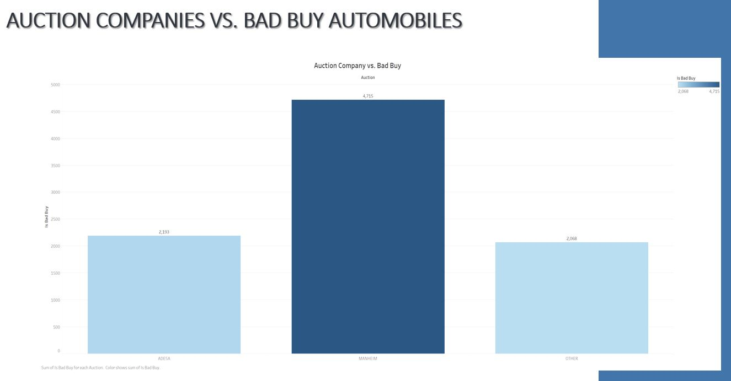
Figure 3 Auction Companies vs. Bad Buys Comparison Chart.

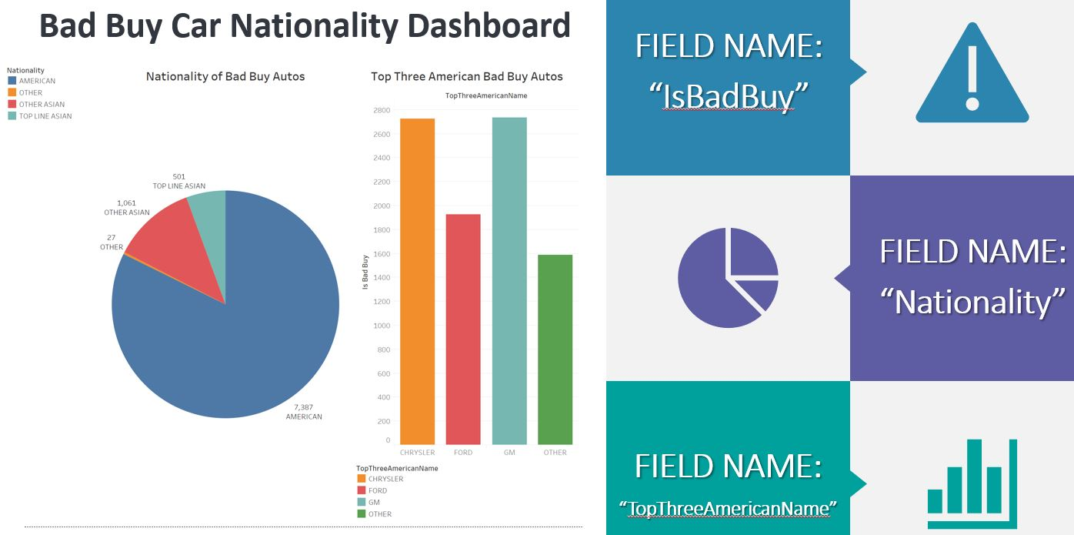
Figure 4 Dashboard of Bad Buy Cars by Nationality.

References
Nelson, Ryan, et al. “Carvana: Is BadBuy?” Harvard Business Review, vol. 9, no. 695, ser. 022, 15 Aug. 2006. 022.
Sharda, Ramesh, et al. Analytics, Data Science, & Artificial Intelligence. 11th ed., Pearson, 2020.
Trainer, David. “You Won't Find A Bargain With Carvana.” Forbes, Forbes Magazine, 10 Sept. 2020, www.forbes.com/sites/greatspeculations/2020/09/10/you-wont-find-a-bargain-with-carvana/?sh=7bc4f7133922.
“TEDTalks: Hans Rosling--Let My Dataset Change Your Mindset.” Performance by Hans Rosling, TED Talk, 2009.

