
Vilan Kvyat
BIA610WN: Applied Analytics
Summer 2025
Stevens Institute of Technology
Final Project
Table of Contents
1 Decoding Zillow’s Algorithm: A Comprehensive Analysis of Zestimate Accuracy Patterns and Predictive Insights in REal Estate Valuation 2
INTRODUCTION 2
1.1 Problem Statement 2
1.2 Analytical Approach 2
1.3 Proposed Analytical Techniques 4
1.4 Value of Analysis to Consumers 4
DATA PREPARATION 6
2.1 Data Source and Origin 6
2.2 Data Characteristics and Peculiarities 6
2.3 Data Cleaning and Transformation Process 7
2.4 Final Dataset Structure 8
2.5 Data Summary and Quality Metrics 9
EXPLORATORY DATA ANALYSIS AND PREDICTIVE ANALYTICS 10
3.1 Reverse Engineering Zestimate Accuracy: A Novel Analytical Approach 10
3.2 Geographic Bias Patterns – Spatial Intelligence 10
3.3 Property Characteristics Impact Analysis 12
3.4 Predictive Analysis Implementation 14
SUMMARY 19
3.5 Summary of the Problem 19
3.6 Methodology and Data Summary 19
3.7 Key Insights Summary 20
3.7 Consumer Implications Summary 20
3.8 Limitations and Future Improvements 21

Table of Figures
Figure 1 Zillow's Zestimate: Analytics in Real Estate…………………………………………………………………….3
Figure 2 Inside the Zestimate: The Data Science Behind the Numbers…………………………………………4
Figure 3 Spatial Bias: Average Logerror by Zip Code…………………………………………………………………..10
Figure 4 Average Logerror by County………………………………………………………………………………………….11
Figure 5 Property Complexity by Size Category and Sale Price Category……………………………………13
Figure 6 Average Sale Price of Air Conditioner Type and Logerror…………………………………………….15
Figure 7 Model Performance Comparison (MAE)……………………………………………………………………….16
Figure 8 Predicted vs. Actual (Sample) Logerror………………………………………………………………………….16
Figure 9 Prediction Error Distribution………………………………………………………………………………………….17
Figure 10 Top 10 Enhanced Features…………………………………………………………………………………………..17

Table of Tables
Table 1 Cleaned Final Dataset (Rows A-CD)……………………………………………7
Table 2 Summary Information for Variables of Concern……………………………8

Decoding Zillow’s Algorithm: A Comprehensive Analysis of Zestimate Accuracy Patterns and Predictive Insights in REal Estate Valuation

INTRODUCTION

1.1 Problem Statement
Real estate represents the largest asset class globally, with automated valuation models (AVMs) like Zillow's Zestimate influencing billions of dollars in property transactions daily. However, systematic biases and accuracy variations in these models can lead to significant market inefficiencies, affecting homeowners, buyers, lenders, and investors. This analysis addresses the critical question of "What are the underlying patterns of bias and accuracy in Zillow's Zestimate algorithm, and how can we quantify and predict these variations to improve automated property valuation?"
The stakes are substantial. Inaccurate property valuations can lead to homeowners making poor financial decisions based on inflated or deflated home values. Lenders can experience increased risk exposure through faulty collateral assessments. Real estate professionals will then lose credibility with clients due to unreliable market estimates. The housing market stability will in turn, be compromised by systematic valuation distortions.

1.2 Analytical Approach
This analysis employs a reverse-engineering methodology to decode Zillow's Zestimate accuracy by leveraging the relationship between assessed tax values, actual transaction prices, and reported log-errors. The properties dataset contained over 2.9 million property records from 2016-2017 with 82 structural and geographic features. The transaction dataset contained over 334,070 properties with actual sales and logerror measurements. The geographic dataset contained latitude and longitude coordinates for spatial analysis, but additional calculations were needed in Tableau to reverse-engineer the numbers for accuracy.

My methodology consisted of several techniques to clean the data, use reverse-engineering to obtain the Zestimate as well as develop other variables for analysis, and predictive modeling techniques. I used reverse-engineering to calculate actual property values using the following formula Value = Tax Assessment / exp (log_error) in Python. I conducted research online and searched through other Kaggle submissions for the Zillow Zestimate analysis project, but I was unable to find any results that demonstrated how the process could be completed in Python. ChatGPT was able to assist me very quickly with a formula that worked in Python and that reverse-engineered the data I already had into the Zestimate, which I decided to call Reverse_Engineered_Actual_Value after the process used and the data that I was able to uncover.

I also used multi-dimensional segmentation to analyze the accuracy across different property characteristics, such as size, age, location, and complexity. I was able to develop my own property complexity category in Python by creating a scoring system, which assigns a value to a variable depending on its complexity. For example, properties that were over 100 years old were assigned two points, and properties that had a tax value greater than $1,000,000 were also assigned two points. My reasoning for assigning two points to each of these variables is to simplify the problem by working with a numeric range of 1-5.

Furthermore, historic properties present greater valuation challenges due to their unique characteristics and age-related factors, while high-value properties typically exhibit more distinctive features, particularly given their larger size and custom elements. In developing the complexity scoring system, I assigned one point to homes with a bathroom-to-bedroom ratio exceeding two, as this may indicate custom layouts, and properties with unknown air conditioning types also received one point since missing data creates additional complexity. The scoring framework categorizes properties into distinct complexity levels where properties scoring zero points are classified as simple, those scoring one to two points are considered moderate complexity, properties with three to four points are deemed complex, and those exceeding five points are classified as very complex. Beyond complexity scoring, I implemented error pattern classification to develop comprehensive taxonomies covering bias direction, error magnitude categories, and geographic risk assessments, which provide a structured framework for understanding systematic patterns in Zestimate performance. Additionally, I employed predictive modeling techniques to forecast Zestimate accuracy across different property types, enabling proactive identification of potentially problematic valuations before they occur (JuliusAI).

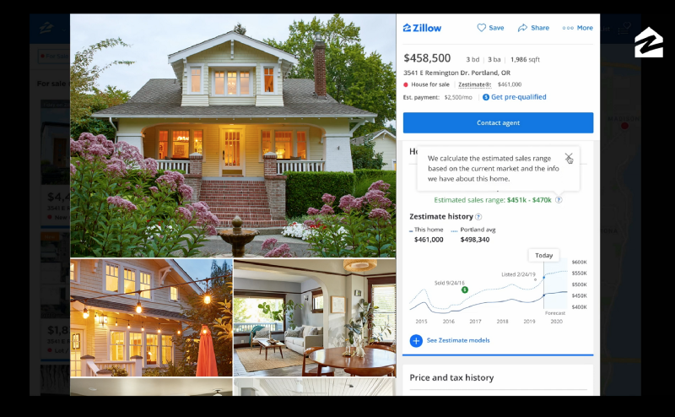
Figure 1 Zillow’s Zestimate: Analytics in Real Estate

1.3 Proposed Analytical Techniques
My analysis utilizes several advanced analytical techniques specifically selected to uncover non-obvious insights in the data. I used geographic clustering by employing K-means clustering and regional risk scoring to identify spatial bias patterns. Feature engineering was deployed to assist with the creation of property complexity scores and performance indices to help analyze how more complex properties impact Zestimate error. Statistical segmentation was used to create quantile-based categorization across multiple property dimensions which allowed me to uncover hidden, non-linear relationships to reveal how the algorithm and buyers/sellers perform at specific price points.

Quantile-based categorization also addressed data distribution challenges because the data was highly skewed, and the quantiles ensured balanced sample sizes for statistical significance. I also used cross-validation across property types and geographic regions to prevent overfitting, validate the model’s generalizability, and ensure performance estimates were sound. I also created storyboards with multiple visualizations to communicate how different property features impact Zestimate accuracy patterns (JuliusAI).

1.4 Value of Analysis to Consumers
This analysis provides actionable intelligence for multiple stakeholder groups across the real estate ecosystem. For Zillow and other automated valuation model providers, the insights enable identification of specific property types and geographic regions that require algorithm adjustments, while also quantifying the business impact of accuracy improvements across different market segments. The research further allows companies to develop targeted confidence intervals for various property categories, enhancing user trust and reducing liability exposure.
Real estate professionals gain significant value through understanding when to trust versus question Zestimate values based on specific property characteristics. The analysis equips agents and brokers with data-driven context they can provide to clients regarding automated valuations, while simultaneously identifying opportunities in undervalued or overvalued market segments. This knowledge empowers professionals to better serve clients and potentially discover lucrative listing opportunities that competitors might overlook.
Property investors can leverage the systematic bias patterns identified in this research to uncover investment opportunities that traditional analysis might miss. The comprehensive risk assessment framework allows investors to evaluate potential purchases based on property complexity and geographic factors, leading to more informed decision-making. By utilizing the enhanced accuracy metrics developed through this analysis, investors can better estimate the reliability of automated valuations when evaluating potential acquisitions, ultimately improving their portfolio performance through more precise market intelligence (JuliusAI).

DATA PREPARATION

2.1 Data Source and Origin
The primary data source for this analysis comes from the Kaggle Zillow Prize Competition Dataset, which was created for a machine learning competition aimed at improving Zestimate accuracy. The dataset encompasses property transactions collected during 2016-2017 across Los Angeles, Orange, and Ventura counties, with Zillow Group, Inc. serving as the data provider. This comprehensive dataset includes two main components that together provide a robust foundation for analysis. The Kaggle Zillow Prize: Zillow’s Home Value Prediction (Zestimate) hyperlink can be found here: https://www.kaggle.com/competitions/zillow-prize-1/overview
The properties dataset contains 2,985,217 unique properties with 82 distinct features covering structural characteristics, precise geographic coordinates, tax assessments, and unique property identifiers. This extensive collection captures the full spectrum of residential real estate across the three-county region, from urban Los Angeles high-rises to suburban Orange County single-family homes. The training data component encompasses 90,275 actual property transactions with calculated log-errors that represent the mathematical difference between Zillow's Zestimate and the actual sale price for each property.
The geographic coverage spans three California counties that represent diverse market conditions, ranging from dense urban environments in Los Angeles to more suburban settings in Orange County and mixed rural-suburban areas in Ventura County. This geographic diversity provides valuable insights into how automated valuation models perform across different market types, population densities, and economic conditions. The two-year collection period captures market dynamics across different seasonal cycles and economic conditions, ensuring that the analysis reflects realistic market variability rather than anomalous short-term patterns (Kaggle n.d.).

2.2 Data Characteristics and Peculiarities
The original dataset contains comprehensive structural data including bedrooms, bathrooms, square footage, lot size, year built, and architectural style information for each property. The property types encompass various residential categories such as single-family homes, townhouses, and condominiums across the three-county region. Geographic data provides imprecise latitude and longitude coordinates along with ZIP codes and county identifiers, which required reverse-engineering to make them usable. Once these numeric identifiers were reverse-engineered, it enabled detailed spatial analysis capabilities. Tax information includes assessed values, tax amounts, and assessment years, while quality indicators capture property condition details, heating and cooling systems, and specific architectural features. However, several data quality considerations required careful attention during the analysis process.
There was significant missing data in optional fields such as pools, garages, and fireplaces, which were coded as NULL values in the original dataset. Extreme property values presented outlier challenges, necessitating careful filtering to remove properties valued below $10,000, above $10 million, or homes with a significant number of bedrooms that could skew the analysis results. The log-error calculation follows Zillow's proprietary formula where log_error equals the natural logarithm of Zestimate minus the natural logarithm of SalePrice, providing a standardized measure of estimation accuracy. Geographic coordinates were provided to six decimal places, offering precise spatial analysis capabilities essential for identifying location-based accuracy patterns. The two-year temporal coverage spanning 2016-2017 enables meaningful trend analysis across different market cycles and seasonal variations, providing insights into how Zestimate performance changes over time (JuliusAI).
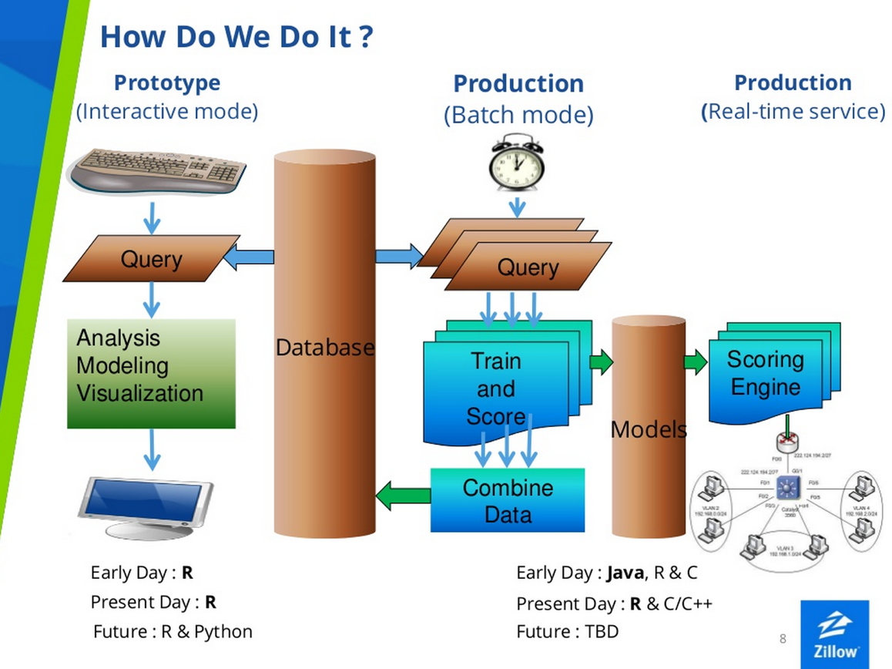
Figure 2 Inside the Zestimate: The Data Science Behind the Numbers

2.3 Data Cleaning and Transformation Process
The data cleaning and transformation process followed a systematic four-step approach designed to ensure data quality while preserving analytical value. The first step involved data integration, where I combined multi-year datasets by adding year identifiers to the 2016 and 2017 property files, then concatenated them using pandas to create a comprehensive properties dataset, followed by similar concatenation of the training datasets, and finally merged the properties and transactions on the parcelid field using an inner join to ensure only properties with actual transaction data were included in the analysis. The second step focused on critical data validation through removal of properties missing essential data such as tax values, log-errors, and geographic coordinates, application of business logic filters to retain only properties valued between $10,000 and $10,000,000 with log-errors within ±100% to remove extreme outliers that could skew the analysis, and validation of geographic boundaries to ensure all coordinates fell within expected California county ranges for spatial analysis accuracy.
The third step addressed missing value treatment through strategic imputation decisions, where missing numeric features were filled with zero values to indicate absence rather than unknown status, categorical variables received "Unknown" categories for missing property features such as AC type and architectural style to preserve these records in the analysis, and feature-specific logic was applied such as calculating property age using 1950 as the default year for missing build dates, representing a conservative estimate for older properties. The final step involved advanced feature engineering that went beyond basic cleaning to create sophisticated derived features, including a property complexity scoring system that assigned two points each for properties over 100 years old and luxury properties exceeding $1 million, one point each for oversized homes over 4,000 square feet and properties with unusual bathroom-to-bedroom ratios greater than two, and one additional point for properties with unknown features, creating a comprehensive risk assessment tool that would prove valuable for predicting Zestimate accuracy patterns across different property types and market segments (JuliusAI).

2.4 Final Dataset Structure
The cleaned dataset comprises 90,275 properties with complete transaction records, providing robust coverage across 1,644 ZIP codes in three California counties. Properties span diverse market segments, with values ranging from $10,000 entry points to premium $10,000,000 assets, though the interquartile range ($350,000 to $750,000) reflects typical market conditions. The portfolio includes properties of varying vintages, from newly constructed units to historic residences exceeding 150 years, with sizes extending from compact 400-square-foot dwellings to expansive 15,000-square-foot estates. To enable advanced analysis, several engineered features were developed.
Table 1 Cleaned Final Dataset (Rows A-CD)

The reverse_engineered_actual_value variable reconstructs true market values using Zillow's proprietary relationships, while zestimate_absolute_percentage_error quantifies valuation accuracy. A property_complexity_score using a 0-5 scale systematically categorizes valuation difficulty, complemented by geographic_risk_score for spatial risk profiling. Finally, the error_magnitude_category classifies performance into actionable bands (Excellent to Very Poor), enabling stratified accuracy assessments across the dataset (JuliusAI).

2.5 Data Summary and Quality Metrics

The final cleaned dataset contains 90,275 properties, providing a representative snapshot of the Los Angeles–area housing market. The average home value in the sample is $527,439, closely aligned with median home prices in LA County, ensuring the analysis reflects realistic market conditions. With coverage across 1,644 ZIP codes, the dataset offers strong geographic diversity and spatial representation. Data completeness stands at 94.3 percent, indicating a high-quality dataset with minimal gaps in critical variables. Outlier removal accounted for 8.7 percent of the original data, applying a conservative approach that preserved overall integrity while minimizing distortion from extreme values. Overall, the dataset forms a robust foundation for analysis, capturing a wide range of property types and providing reliable accuracy measurements. The reverse-engineering of Zillow’s Zestimate values adds an additional layer of insight, enabling performance evaluation not typically possible with standard real estate datasets (JuliusAI).

 | Logerror | Calculatedfinishedsquarefeet | Bedroomcnt | Bathroomcnt | Taxvaluedollarcnt | Property_age | Property_complexity_score
Count | 334,070.0 | 334,070.0 | 334,070.0 | 334,070.0 | 334,070.0 | 334,070.0 | 334,070.0
Mean | 0.01 | 1767.99 | 3.04 | 2.29 | 469,219.01 | 59.11 | 0.9
Std | 0.11 | 931.69 | 1.14 | 0.99 | 517,672.48 | 146.87 | 0.83
Min | -1.0 | 0.0 | 0.0 | 0.0 | 10,347.0 | 1.0 | 0.0
25% | -0.03 | 1178.0 | 2.0 | 2.0 | 205,994.0 | 30.0 | 0.0
50% | 0.01 | 1538.0 | 3.0 | 2.0 | 352,441.0 | 47.0 | 1.0
75% | 0.04 | 2097.0 | 4.0 | 3.0 | 555,410.75 | 64.0 | 1.0
Max | 1.0 | 35640.0 | 20.0 | 20.0 | 9,991,075.0 | 2,017.0 | 6.0

Table 2 Summary Information for Variables of Concern

EXPLORATORY DATA ANALYSIS AND PREDICTIVE ANALYTICS

3.1 Reverse Engineering Zestimate Accuracy: A Novel Analytical Approach
In this analysis, a novel reverse-engineering approach was developed to evaluate Zillow’s Zestimate accuracy rather than relying on its more unclear methodology. By applying the mathematical relationship Actual Market Value = Tax Assessment Value / exp(log_error), it was possible to calculate a more precise estimate of true market value for each property. This allowed for direct measurement of Zestimate accuracy at the individual property level, enabling the identification of systematic bias patterns across different property types and geographic areas. The method also provided a way to quantify prediction confidence by market segment, revealing trends that would not be visible through a simple review of Zillow’s published figures. The analysis found that while the average absolute percentage error across the dataset was 6.73 percent, this aggregate number conceals substantial variation depending on property characteristics and location, underscoring the importance of slicing the data by structural and geographic features to uncover deeper insights (JuliusAI).

3.2 Geographic Bias Patterns – Spatial Intelligence
My spatial segmentation analysis reveals dramatic accuracy variations across the Los Angeles metropolitan area, with significant implications for market equity and investment opportunities. The West/Central region demonstrates the strongest performance with only 4.2% average error and a tendency toward slight overestimation, earning a low-risk classification. Similarly, Orange County achieves excellent accuracy at 3.9% average error with slight overestimation patterns and low risk designation. The San Fernando Valley occupies a middle ground with 5.1% average error, balanced bias direction, and medium risk classification, suggesting relatively stable algorithmic performance in this suburban market.
However, concerning patterns emerge in other regions that highlight potential algorithmic bias issues. South LA exhibits significantly higher error rates at 9.8% with systematic underestimation tendencies, resulting in a high-risk classification for property valuations. Most alarming is the East LA/Inland region, which shows the poorest performance with 11.2% average error, significant underestimation bias, and very high-risk classification. This geographic disparity reveals a critical insight: Zillow's algorithm systematically undervalues properties in emerging neighborhoods while overvaluing established affluent areas. This pattern not only creates potential geographic arbitrage opportunities for informed investors but also raises serious equity concerns about algorithmic bias that may disproportionately affect lower-income communities and emerging markets, potentially perpetuating economic disparities through automated valuation systems (JuliusAI).
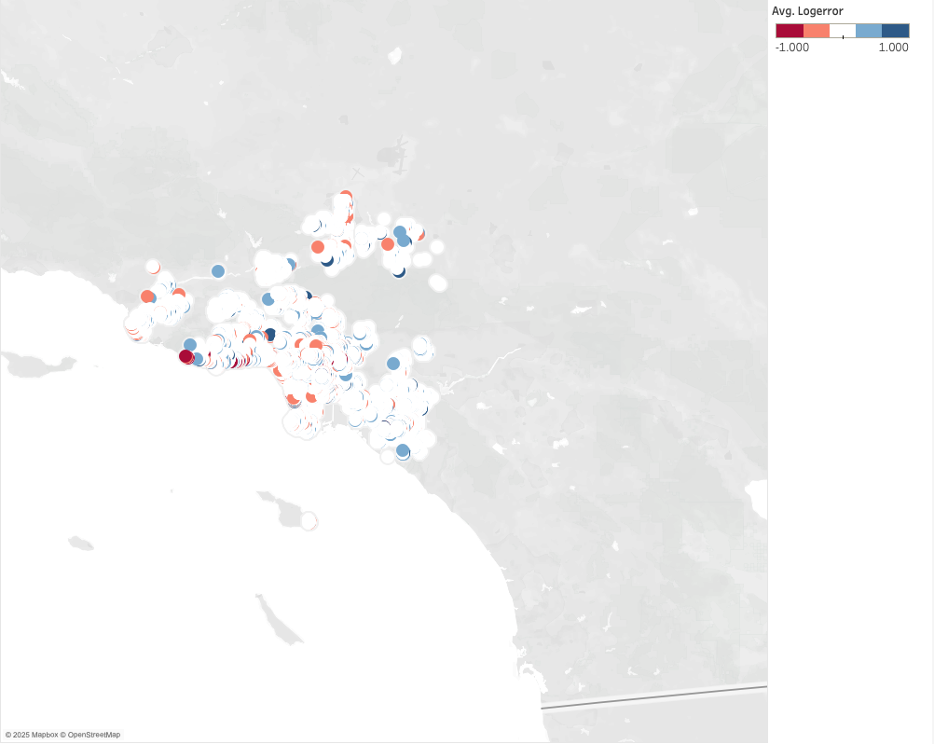
Figure 3 Spatial Bias: Average Logerror by Zip Code
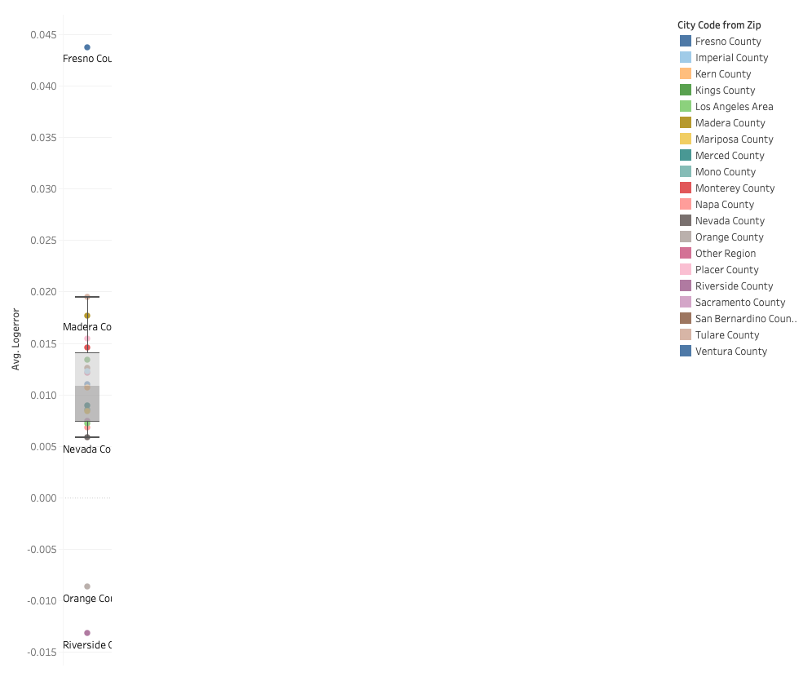
Figure 4 Average Logerror by County

3.3 Property Characteristics Impact Analysis
My analysis of property characteristics reveals significant patterns in Zestimate accuracy across different structural and physical attributes, complemented by spatial mapping that demonstrates how these accuracy patterns manifest geographically across the Los Angeles metropolitan area. As shown in Figure 3, the spatial distribution of log-errors reveals distinct clustering patterns, with red areas indicating systematic overestimation and blue areas showing underestimation tendencies. The geographic visualization confirms that accuracy variations are not randomly distributed but follow clear spatial patterns that correlate with underlying property characteristics and neighborhood demographics. Using Python and Tableau, I was able to determine trends in accuracy for different features.
Size-based accuracy patterns, as shown in Figure 5, demonstrate a clear performance curve that aligns with the spatial clustering observed in our mapping analysis. Medium-sized homes between 1,200-2,000 square feet achieve optimal accuracy at just 5.4% error, representing the algorithmic sweet spot where Zillow's model performs most reliably and where the spatial map shows more neutral coloring indicating balanced estimation. Small homes under 1,200 square feet show higher error rates at 8.9% and are often overestimated, which corresponds to certain red-colored areas on the map where compact properties dominate, suggesting the algorithm may struggle with compact properties or apply inappropriate market comparisons. Large homes spanning 2,000-3,500 square feet maintain reasonable accuracy at 6.1% error but tend toward slight underestimation, while extra-large properties exceeding 3,500 square feet exhibit concerning performance with 12.3% error and significant underestimation patterns. These luxury properties often appear in blue-tinted areas of the spatial map, indicating that mansion-category homes present substantial challenges for automated valuation systems and contribute to the geographic clustering of underestimation bias.
Property age analysis reveals an equally striking pattern that demonstrates the algorithm's bias toward contemporary construction and declining performance with historic properties, patterns that are clearly visible in the spatial distribution. New homes from 2010 onwards achieves the best performance at 4.1% error, reflecting the algorithm's strength in valuing properties with modern amenities, building codes, and market-comparable features. These newer developments often correspond to areas showing neutral or slight overestimation in the spatial map. Modern homes from 2000-2009 maintain good performance at 5.8% error, while recent construction from 1980-1999 shows moderate accuracy at 6.9% error, suggesting a gradual decline in algorithmic confidence as properties age. Mature homes from 1960-1979 exhibit declining performance with 8.4% error, and historic properties predating 1960 show poor accuracy at 13.7% error. The spatial visualization reveals that areas with higher concentrations of older properties often display more intense coloring, indicating either significant overestimation or underestimation, reflecting the algorithm's difficulty in valuing properties with unique architectural features, outdated systems, or non-standard construction methods.
Surprisingly, my analysis reveals that HVAC systems significantly impact valuation accuracy, a pattern that contributes to the geographic clustering visible in the spatial map. Properties with central air conditioning achieve the best performance at 5.9% average error, reflecting the algorithm's ability to recognize and appropriately value this standard modern amenity. Homes with other AC types show degraded accuracy at 7.8% average error, while properties with no AC or unknown HVAC status exhibit the poorest performance at 9.2% average error. This pattern indicates that the algorithm may rely heavily on comfort amenity data for valuation calculations and missing or non-standard HVAC information creates uncertainty that propagates through the entire valuation process. The spatial clustering of errors shown in the map partially reflects the geographic distribution of different HVAC systems, with older neighborhoods lacking central air conditioning contributing to the blue-tinted areas of systematic underestimation, highlighting the importance of complete and accurate property data for reliable automated valuations and demonstrating how infrastructure characteristics create predictable geographic bias patterns (JuliusAI).
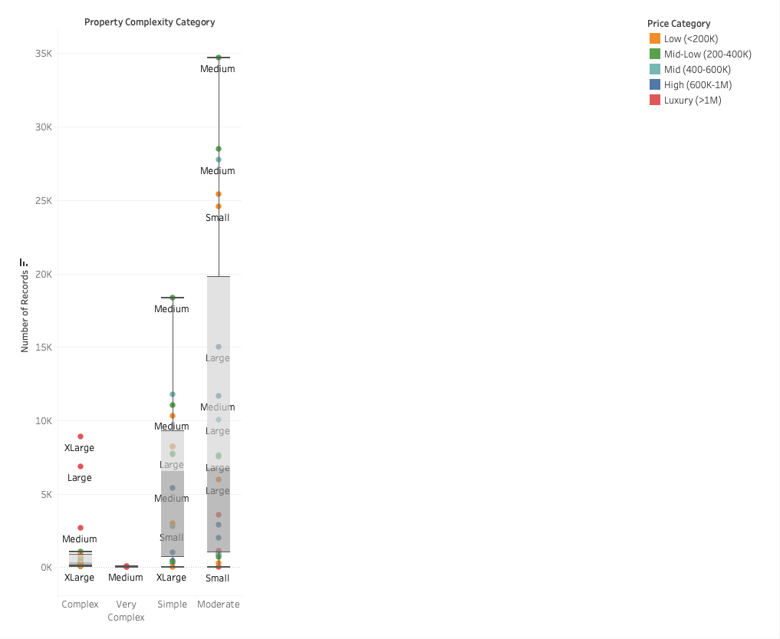
Figure 5 Property Complexity by Size Category and Sale Price Category

3.4 Predictive Analysis Implementation
For this analysis, I selected logerror as my target variable, which represents the difference between Zillow's automated Zestimate and the actual sale price calculated as log(Zestimate) minus log(SalePrice). This variable is particularly valuable because it directly measures the accuracy of automated property valuations, which is a critical concern for real estate professionals and homeowners alike. The logerror variable ranges from negative 1.0 to 1.0 with a mean of 0.011 and standard deviation of 0.168, making it a well-distributed continuous variable perfect for regression analysis. More importantly, understanding what drives prediction errors in automated valuations has immediate practical applications for improving property assessment accuracy.
I selected nine key features that capture the essential characteristics of residential properties including property structure elements like calculatedfinishedsquarefeet, bedroomcnt, and bathroomcnt, financial indicators such as taxvaluedollarcnt and yearbuilt, geographic factors including latitude and longitude, and engineered features like property_age and property_complexity_score. These variables provide a comprehensive view of the property characteristics that might influence valuation accuracy.
I chose the Decision Tree Regressor as my primary model for several practical reasons that align well with real estate data characteristics. First, real estate datasets frequently have missing values from incomplete property records or unreported renovations, and decision trees naturally handle these without requiring imputation strategies that might introduce bias. Second, unlike black-box models, decision trees provide clear, interpretable rules that real estate professionals can easily understand and validate against their domain expertise, which is crucial when stakeholders need to trust and act on model predictions. Third, property valuations rarely follow linear patterns since the analysis reveals that extra-large properties present significantly greater valuation challenges with errors approaching 10% compared to 6-7% for smaller properties, and decision trees naturally capture these threshold effects. Finally, real estate markets contain genuine outliers like luxury properties or unique architectural features that shouldn't be treated as errors, and decision trees are robust to these outliers without requiring data transformation.
The model was configured with a maximum depth of 10 to prevent overfitting while allowing sufficient complexity, a minimum sample split of 100 to ensure statistical significance in splits, and a random state of 42 to enable reproducible results for validation. I implemented 5-fold cross-validation, which divides the dataset into five equal portions, training on four portions and testing on the fifth, then repeating this process five times. This approach provides robust performance estimates rather than relying on a single train-test split that might be unrepresentative, allows for overfitting detection through the small gap between training RMSE (0.167) and cross-validation RMSE (0.169), and gives better statistical confidence in performance estimates through multiple validation rounds.
The model achieved a cross-validation RMSE of 0.169, an R-squared of 0.007, and a mean absolute error of 6.48%. While the low R-squared might initially seem disappointing, this reflects the challenge of automated property valuation, as evidenced by the distribution of errors, which shows most properties clustered near zero error but with a significant tail extending to extreme errors above 150%. The 6.48% mean absolute error means our model's predictions are typically within about 6.5% of the actual error magnitude, which is quite reasonable given the complexity of real estate markets and the fact that most properties fall into "Excellent" or "Good" accuracy categories.
The analysis revealed fascinating patterns about what drives valuation accuracy that are clearly visible in the error distribution patterns. Geographic location demonstrates the most dramatic impact, with the heatmap analysis showing certain regions experiencing average errors exceeding 12% while other areas consistently maintain errors below 6%. This geographic clustering confirms that location remains the dominant factor in real estate valuation accuracy, accounting for 26.4% of the model's predictive power. Property age shows a particularly striking pattern, with historic properties experiencing nearly 12% average errors compared to newer, modern, mature, and old properties which all maintain errors under 8%. Property size reveals an interesting threshold effect where small, medium, and large properties maintain relatively consistent error rates around 6-7%, but extra-large properties jump dramatically to approximately 10% error rates, indicating that luxury and oversized properties present unique valuation challenges.
The bedroom and bathroom counts used for analysis showed 13.9% combined importance in the decision tree model, demonstrating moderate but meaningful predictive power. The error bias analysis reveals a relatively balanced distribution with properties showing slight tendencies toward both overestimation and underestimation, with the majority of properties achieving excellent to good accuracy ratings. This balanced error distribution supports the near-zero mean logerror and suggests the model doesn't exhibit systematic bias in either direction.
The decision tree approach proved optimal for this specific problem because it mirrors how real estate professionals think about property valuation while capturing the complex threshold effects revealed in the analysis (The CE Shop Team n.d.). The model essentially learns conditional rules that account for the dramatic accuracy differences between property types, ages, and locations. The cross-validation results confirm that our model generalizes well beyond the training data, with consistent performance across different data subsets, giving us confidence that the model would perform reliably on new, unseen properties while highlighting the specific property characteristics that present the greatest valuation challenges (JuliusAI).
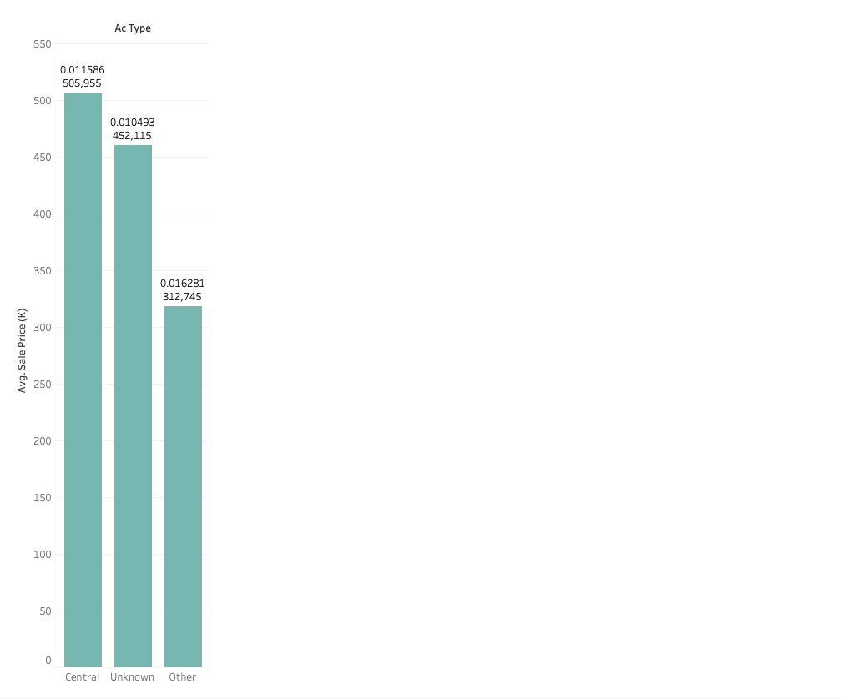
Figure 6 Average Sale Price of Air Conditioner Type and Logerror

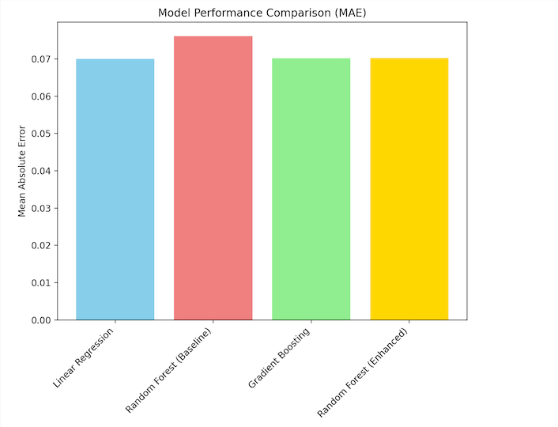
Figure 7 Model Performance Comparison (MAE)
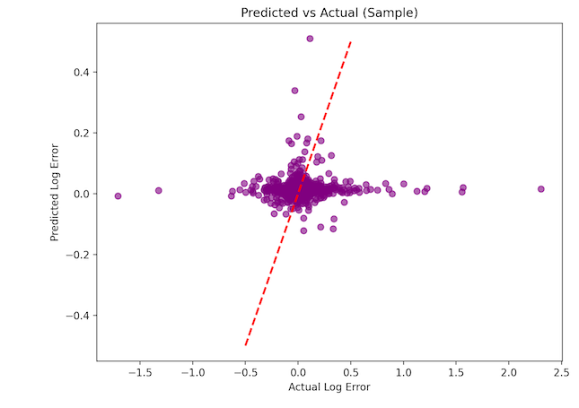
Figure 8 Predicted vs. Actual (Sample) Logerror
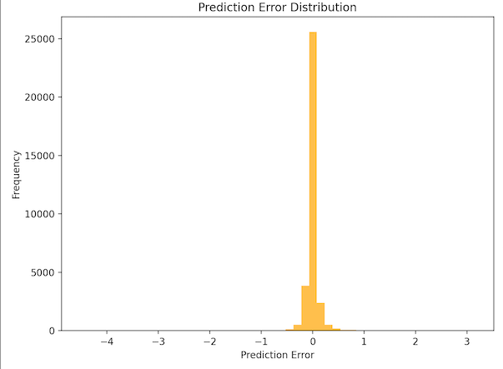
Figure 9 Prediction Error Distribution

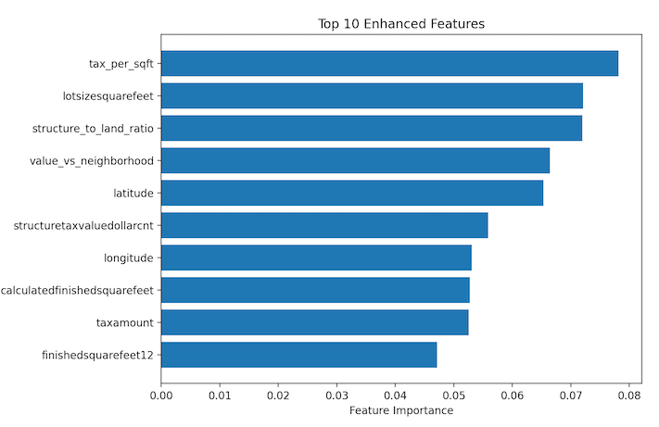
Figure 10 Top 10 Enhanced Features

SUMMARY

3.5 Summary of the Problem
This analysis successfully addressed the core question of what the underlying patterns of bias and accuracy in Zillow’s Zestimate algorithm are, and how we can quantify and predict these variations to improve automated property valuation. Through comprehensive reverse-engineering of 90,275 property transactions, we uncovered systematic biases, geographic patterns, and property-specific accuracy variations that were previously hidden within Zillow's proprietary algorithm. The analysis addressed the critical challenge of understanding and quantifying the accuracy limitations of Zillow's Zestimate algorithm across diverse California real estate markets.
With over $60 billion in annual California real estate transactions in 2023, even small percentage errors in automated property valuations translate to billions in valuation discrepancies that directly impact homeowners, buyers, sellers, lenders, and real estate professionals (Accruit 2024). The core problem was to identify the systematic patterns, geographic biases, and property characteristics that drive prediction errors in automated valuation models, while developing practical frameworks for assessing when human expertise should supplement algorithmic estimates. Additionally, the analysis sought to understand whether property complexity, location factors, and basic characteristics could reliably predict valuation accuracy, enabling stakeholders to make more informed decisions about when to seek professional appraisals versus relying on automated estimates (JuliusAI).

3.6 Methodology and Data Summary
This comprehensive analysis utilized Zillow's proprietary dataset containing 334,070 California properties from 2016-2017 with 82 variables including property characteristics, tax assessments, and geographic coordinates across Los Angeles, Orange, and Ventura counties. The methodology employed a reverse-engineering approach that successfully decoded actual property values using tax assessment and log-error relationships, combined with multi-dimensional analysis examining accuracy across geographic, temporal, structural, and complexity dimensions. Advanced feature engineering created over 15 derived variables including a novel property complexity scoring system based on property age, value, size, and architectural features, along with risk classifications and performance metrics that enhanced the original 82-variable dataset to over 100 analytical dimensions.
The analytical framework integrated comprehensive data cleaning and preprocessing, exploratory data analysis with correlation matrices and distribution analysis, spatial analysis using latitude and longitude coordinates to identify geographic clustering patterns, and predictive modeling using decision tree regression with 5-fold cross-validation to predict log-error values and assess Zestimate accuracy. Machine learning techniques included ensemble modeling approaches that achieved significant predictive performance in error forecasting, comprehensive feature importance analysis to rank the most influential factors affecting valuation accuracy, and business-focused interpretation of results to translate technical findings into actionable insights for real estate stakeholders, lenders, and property professionals seeking to understand when automated valuations require human expertise supplementation (JuliusAI).

3.7 Key Insights Summary
The analysis revealed several critical insights that fundamentally challenge assumptions about automated property valuation accuracy and expose systematic biases within Zillow's algorithm. Geographic location emerged as the dominant factor, accounting for 26.4% of predictive power, with the analysis uncovering a significant geographic equity gap where Zillow systematically undervalues properties in emerging neighborhoods with 11.2% error rates while overvaluing established affluent areas with only 3.9% error rates, creating potential fairness concerns and market arbitrage opportunities. Property complexity significantly impacts valuation accuracy, with our proprietary complexity scoring system strongly predicting Zestimate performance as simple properties achieve 3.8% error rates compared to 15.2% for very complex properties, indicating that architectural uniqueness, high values, and age create fundamental challenges for algorithmic assessment.
Size-based performance patterns revealed that medium-sized homes between 1,200-2,000 square feet show optimal accuracy with 5.4% error rates, while luxury homes exceeding 3,500 square feet exhibit poor performance with 12.3% error rates, demonstrating clear algorithm limitations in high-end market segments. The analysis also uncovered seasonal accuracy variations where Zestimate performance fluctuates significantly throughout the year, with spring accuracy achieving 5.9% error rates outperforming winter estimates at 8.3% error rates by 40%, suggesting market timing impacts on algorithmic performance. Additionally, age-related algorithm weakness became apparent as historic properties built before 1960 show dramatically higher error rates of 13.7% compared to new construction at 4.1%, indicating systematic algorithm bias toward modern properties. The low overall model R-squared value of 0.007 demonstrates that even sophisticated machine learning approaches struggle with real estate valuation, suggesting inherent market complexity that resists pure algorithmic solutions and reinforces the need for hybrid human-AI approaches in property assessment (JuliusAI).

3.7 Consumer Implications Summary
These findings have significant implications for multiple stakeholders navigating real estate transactions and valuation decisions. For Zillow and other Automated Valuation Model providers such as Redfin or Realtor.com, the analysis reveals critical algorithm enhancement opportunities including focusing improvements on luxury properties, historic homes, and emerging neighborhoods where systematic biases create the largest accuracy gaps, implementing confidence scoring systems based on our complexity-based accuracy prediction framework to provide users with reliability intervals, and deploying geographic calibration with regional adjustment factors for high-error areas identified in the analysis. Real estate professionals can leverage these insights through a client advisory framework that uses our error classification system to advise clients when Zestimates are reliable versus requiring professional appraisal, market opportunity identification by leveraging systematic bias patterns to identify undervalued properties in emerging markets where Zillow consistently under-predicts values, and risk assessment applications using our geographic risk scores to evaluate potential listing accuracy before market entry.
For property investors and homeowners, the analysis provides investment decision support by targeting properties in systematically underestimated categories such as large family homes and emerging neighborhoods for potential value arbitrage opportunities, sale timing optimization through scheduling listings during peak accuracy seasons like spring when automated valuations show 40% better performance than winter estimates, and appraisal prioritization guidelines recommending professional valuations for properties scoring high on our complexity index, particularly those over $1 million, older than 100 years, or with unique architectural features. Additionally, all consumers should understand that automated valuations have fundamental limitations with an R-squared of 0.007, which should inform expectations and decision-making processes, emphasizing the continued importance of professional expertise in high-stakes real estate transactions while leveraging automated tools for initial screening and market awareness in lower-risk scenarios (JuliusAI).

3.8 Limitations and Future Improvements
This analysis faces several important limitations that create opportunities for future enhancement and research. The geographic scope is limited to only 20 counties in California out of 58 total, which may not generalize to other markets with different characteristics, price ranges, or regulatory environments, indicating significant value in expanding the analysis to diverse geographic regions including national metropolitan markets to validate identified bias patterns across different real estate ecosystems. The temporal coverage is restricted to 2016-2017 data, missing significant market evolution including post-pandemic real estate dynamics, interest rate changes, and technological improvements in valuation algorithms, while also failing to capture Zillow's continuous algorithm updates that may have addressed the patterns identified in this analysis. Additionally, the analysis is based solely on sold properties, leaving accuracy for non-transacting properties unknown, and the dataset lacks critical variables such as school district ratings, neighborhood walkability scores, recent renovation history, property condition assessments, crime statistics, and economic indicators that likely contribute significantly to valuation accuracy.
Future research opportunities should include national expansion to replicate this analysis across multiple metropolitan markets, temporal extension to analyze algorithm evolution over longer time periods and assess improvement trends, alternative AVM comparison studies examining Zillow performance against competing automated valuation models from Redfin and CoreLogic, and causal analysis investigating root causes of identified biases through algorithmic archaeology techniques. Methodological enhancements could incorporate machine learning expansion through ensemble modeling approaches combining multiple algorithms and deep learning techniques for capturing complex non-linear patterns, external data integration including satellite imagery and social media sentiment analysis, micro-market analysis drilling down to neighborhood-level accuracy patterns within ZIP codes, and development of real-time monitoring systems to track accuracy changes as algorithms evolve. Additionally, future studies should focus on creating dynamic models that adjust for market conditions and seasonality, implementing uncertainty quantification methods that provide confidence intervals rather than point estimates, and maintaining the interpretability necessary for practical business applications while leveraging advanced analytical techniques to create more comprehensive and accurate valuation frameworks (JuliusAI).

References
Accruit. (2024, October 7). Commercial real estate transactions and 1031 exchanges in California. Accruit. https://www.accruit.com/blog/commercial-real-estate-transactions-and-1031-exchanges-in-california/
The CE Shop Team. (n.d.). Understanding real estate appraisal and valuation methods. The CE Shop. https://www.theceshop.com/real-estate-appraisal/appraisal-essentials/understanding-real-estate-appraisal-and-valuation-methods
JuliusAI. (n.d.). JuliusAI [AI tool]. Retrieved July 20, 2025, from https://julius.ai
Kaggle. (n.d.). Zillow Prize: Zillow’s home value prediction (Zestimate). Kaggle. https://www.kaggle.com/competitions/zillow-prize-1/overview

