
Vilan Kvyat
BIA610WN: Applied Analytics
Summer 2025
Stevens Institute of Technology
HBR – Eureka Forbes Lead Generation
Table of Contents
1 HBR Case STUDY – Eureka Forbes 2
1.1 Eureka Forbes CASE STUDY QUESTIONS 2
1.1.1 Convert the problem that Kaashif is facing into an analytical problem? 2
1.1.2 How will Kashif test the following claims? 3
1.1.3 Build a Logistic Regression Model on the given data. Interpret the results. 6
1.1.4 Construct a simple decision tree (classification tree) classifier. What are the disadvantages of using decision tree classifiers? 7
1.1.5 Based on the previous 2 questions, what kind of modeling problems would Kashif expect when the classes are not represented adequately (imbalanced data)? Suggest ways to handle these problems. 7
1.1.6 The data has a large number of variables and is highly imbalanced. Do you think that techniques such as logistic regression can be applied when the number of variables is large? What variable reduction techniques can be used to make the model more efficient? 9
1.1.7 Elaborate on the various sampling techniques that are best suited for the data. 9
1.1.8 Use the sample data provided and appropriate sampling strategy to develop a Random Forest Model. Comment on the model development and the accuracy of the model. 10
1.1.9 Develop extreme gradient boosting models with up-sampling of minority class. Calculate the lift and gain for the model. 11
1.1.10 Develop the gradient boosting model with SMOTE sampling strategy. Comment on the results. 12
1.1.11 Based on the different model results, what would be your final recommendation to Kashif? 12
1.1.12 Discuss the possible deployment strategies for the model results obtained. 13
1.1.13 Discuss the value that this model adds to the Digital Marketing team of Eureka Forbes. 13

Table of Figures
Figure 1: Conversion Rate by Device Type………………………………………………………………………… 5
Figure 2: Conversion Rate: New vs. Returning Users……………………………………………………………8
Figure 3: Session Distribution……………………………………………………………………………………………….15
Figure 4: Model Performance Comparison……………………………………………………………………………16
Figure 5: Model Ranking by Metric………………………………………………………………………………………..16
Figure 6: F1 Score vs. ROC-AUC……………………………………………………………………………………………….17
Figure 7: Precision vs. Recall Trade-off…………………………………………………………………………………….18
Figure 8: ROC Curves - Model Comparison……………………………………………………………………………….19
Figure 9: Lift and Gain Charts for XGBoost Model……………………………………………………………………..20

HBR Case STUDY – Eureka Forbes

Eureka Forbes CASE STUDY QUESTIONS

Convert the problem that Kaashif is facing into an analytical problem?
Eureka Forbes has over 700,000 website visitors, but only less than 0.4% of them actually end up buying or converting. Kashif’s goal is to reduce the cost per lead by targeting only the website visitors who are most likely to convert. Eureka Forbes’ digital marketing team knew that broader remarketing campaigns were able to reach more visitors, but they were incurring high costs in doing so. Additionally, narrower campaigns carried too much risk because they could miss too many potential customers. It also becomes a wasted effort to send salespeople and launch remarketing ads towards customers who will never buy.
The analytical problem that Kashif is facing is a binary classification problem. When considering the clickstream and demographic data that we have, such as session duration, page views, device type, event source, and traffic counts, a binary classification model should be able to assign each website visitor a probability of conversion within a seven-day window by assigning the customer a score of 0 or 1 (Sharda 2020, p. 126, 298). By using a binary classification model, we can flag only those website visitors who are above a chosen probability threshold. The digital marketing team will then be left with a more manageable subset of customers to follow up with and launch remarketing ads to, which will also save the company money (JuliusAI, n.d.).

How will Kashif test the following claims?
- Customers using mobile, desktop, and tablet are equally distributed.
Kashif will test customers using mobile, desktop, and tablet are equally distributed by performing a chi-square goodness of fit test on the counts of each device category that I observed. This test will be performed against the expectation of an equal one-third split. The chi-square goodness of fit test that I performed had a highly significant result which means that I was able to rule out the null hypothesis of uniform distribution. This means that customer traffic on mobile devices far outpaces customer traffic on the desktop and tablet. We are able to see this conversion rate in Figure 1, which draws a comparison of mobile versus its next two closest competitors, desktop and tablet. Mobile users had the highest conversion rate at 44.2% when compared to desktop and tablet, which had a 13.6% and 15% conversion rate, respectively. We will need too make sure that our remarketing strategies are optimized to focus on mobile customers (JuliusAI, n.d.).

- Repeat visitors are likely to convert as new customers.
I conducted a statistical analysis using both a chi-square test of independence and a two-proportion z-test to determine whether repeat visitors to the website were likely to convert as new users. As shown in Figure 2, my findings demonstrated that new users visited the website 444,542 times with 1,322 conversions, which is a 30% conversion rate. I also found that 264,785 repeat visitors were on the company’s website and totaled 1,508 conversions for a 57% conversion rate. The z-test had a test statistic of -17.59 and a p-value of less than 0.0000000001, which is significantly below the standard threshold of significance of α = 0.05.
These results further support the conclusion that repeat visitors to the website are 1.9 times more likely to convert than new users. I used the chi-square test to further validate my results, which yielded a test statistic of 308.57. The p-value result from the chi-square test was also less than 0.0000000001, which is very small. These results allow me to reject the hypothesis that repeat visitors are as likely to convert as new users because I found that this is not the case. Eureka Forbes and Kashif must prioritize following up with returning visitors by retargeting them with more personalized offers (JuliusAI, n.d.).
- Customers who convert spend more time on the website.
I applied the Mann-Whitney U test, a nonparametric rank-based method to determine if customers who convert spend more time on the Eureka Forbes website when compared to non-converters. As Provost and Fawcett (2013) in the Data science for business: What you need to know about data mining and data-analytic thinking textbook state, the U statistic is equivalent to the area under the ROC curve, which helps us capture the probability that a randomly chosen converted user will have a longer session duration than a randomly chosen non-converted user (Provost and Fawcett 2013, p. 219). The Mann-Whitney U test result shows that visitors who convert have much longer session durations on the company website. We know that users spend 5.25 minutes on average on the website and the converters spend an average of 39.1 seconds longer on the website, which represents a 12.4% increase in session duration.
The Mann-Whitney U test had U result of 1,062,942,408 and a p-value of <0.00000001, which is a significant result. However, I also found that the data distributions were highly skewed and had some extreme outliers with long right tails in both groups of converters and non-converters. I applied the Welch’s t-test as well, which yielded a t-statistic of 3.43 and p-value of <0.001, which, although significant, is not as reliable of a measure as the Mann-Whitney test. The median session duration for converters was 140 seconds and the 102 seconds for non-converters, representing a 12.4% increase. Although Cohen’s d=0.068 statistic shows that the effect size was small, the difference is consistent because it shows that longer session time on the website is associated with higher conversion rates. Therefore, the results show that website visitors who eventually convert have significantly longer session durations on the website. Eureka Forbes should prioritize users who linger on their website for longer session times because they are the most likely to convert (JuliusAI, n.d.).
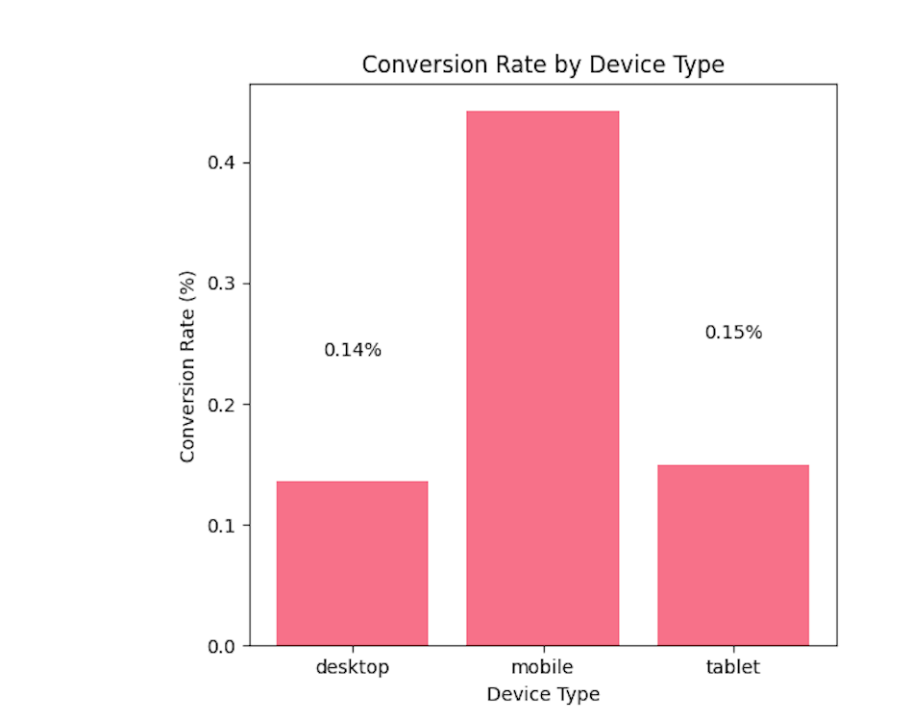
Figure 1: Conversion Rate by Device Type

Build a Logistic Regression Model on the given data. Interpret the results.
A logistic model was built using the clickstream data to predict the likelihood of user conversion. I used a 20% hold-out set and trained the model with class_weight = ‘balanced’ and standard scaling. The logistic regression model that I built in Python with assistance from JuliusAI achieved a ROC_AUC score of 0.718, a recall of 62.9%, and a precision of 0.79%. These results mean that the logistic regression model correctly identifies almost two-thirds of future conversions and limits false positives to less than 1 in 100. The model’s coefficients provide us with insight as to what specific activities will most likely lead to conversion.
The following coefficients can significantly increase the company’s chances of conversion: a visit to the demo page (+0.447), a demo-request click event (+.304), mobile device usage (+0.273), and goal completions (+0.255). Items that are labeled “Quora/(not set)” reduced likelihood because it had a coefficient of -0.329, as did first-time visits (-0.325). Unfortunately, due to the model’s extreme class imbalance, the recall for the minority class who are the converters was very low. This caused most of our predictions to default to the majority class.
As illustrated in Figures 4 and 5, the accuracy and precision were among the lowest of all models tested. However, our recall and ROC_AOC scores were solid. The high recall means that of all actual converters, it had low false negatives and fewer missed conversions. The ROC_AOC score shows that it at least did a good job of separating converters from non-converters regardless of the threshold. I need to use better rebalancing techniques or threshold adjustments to improve the practicality and utility of this model (JuliusAI, n.d.).

Construct a simple decision tree (classification tree) classifier. What are the disadvantages of using decision tree classifiers?
I built a single decision tree in Python that was limited to depth 10 and balanced for class weights. The decision tree that I had built, as shown in Figures 4,6, and 7, had an ROC-AUC of 0.679, a recall of 66.6%, and a precision score of 0.74%. The top splits of the decision tree were similar to the ones that the logistic regression model had (Provost and Fawcett 2013, p. 65). The similar splits, such as demo page visits, session duration, and user type, provide more intuitive insights because we are able to determine if a group of users spends more time on a website, they are more likely to convert.
Some of the disadvantages of using decision tree classifiers are that they suffer from high variance, which means that small changes in the dataset can alter the structure of the tree significantly. Decision tree classifiers also tend to overfit the model unless they are heavily pruned. Additionally, decision trees are biased toward features with many potential splits and also underperform in AUC methods. As Provost and Fawcett mention, although decision trees are flawed and less reliable as standalone production models, they are not useless (Provost and Fawcett 2013, p. 72-73). Decision trees also tend to favor the majority class and are less effective for rare event prediction unless you place more effort into rebalancing the data.

Based on the previous 2 questions, what kind of modeling problems would Kashif expect when the classes are not represented adequately (imbalanced data)? Suggest ways to handle these problems.
Imbalanced classes in this dataset cause models to be biased toward the majority class, which results in higher accuracy scores but poor recall for the minority class, which are the converters. Converters are the individuals that we want to target. It makes Kashif’s goal harder to achieve because with poor recall for the minority class, we are missing most of the actual converters. One way to handle this problem would be to use the SMOTE oversampling technique to synthetically oversample the minority class for Random Forest and Gradient Boosting techniques (Arora, 2020) (Brownlee SMOTE, 2016).
I can also use random oversampling for XGBoost because it offers a range of hyperparameters that give us very granular control over the model training procedure. It also allows us to fine-tune the training algorithm to focus on the misclassification of the minority class of datasets when they have a skewed class distribution, which is what we need in this situation (Brownlee XGBoost, 2017). We can fine-tune the probability threshold on logistic outputs to balance our recall score against false positives. I can also recommend ensemble methods with class weighting and using AUC-ROC rather than accuracy to provide a more realistic evaluation of how the model is performing (JuliusAI, n.d.).
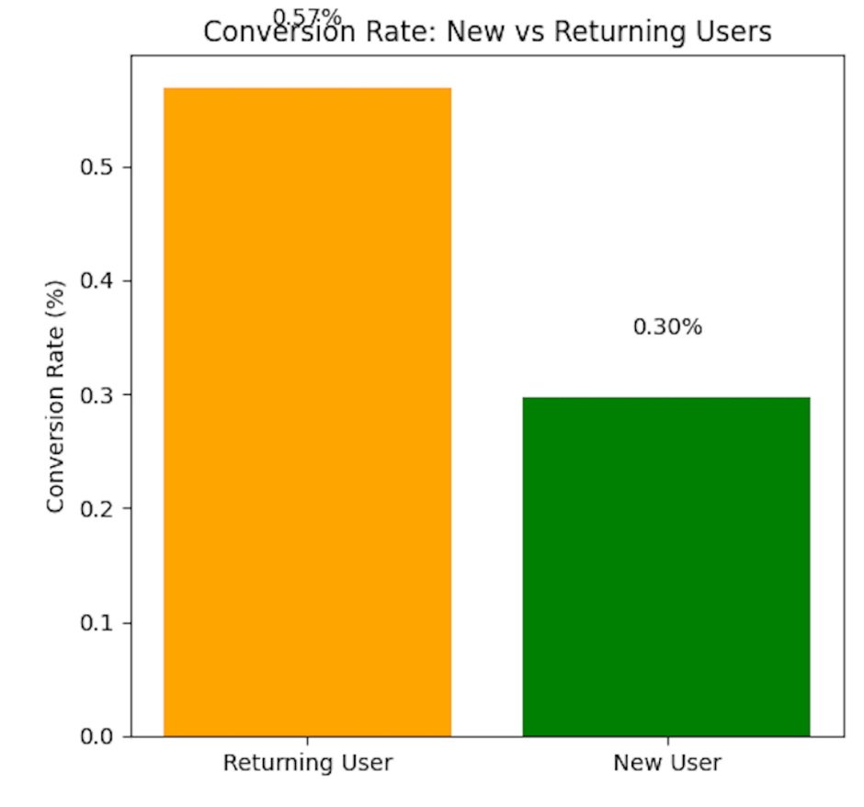
Figure 2: Conversion Rate: New vs. Returning Users

The data has a large number of variables and is highly imbalanced. Do you think that techniques such as logistic regression can be applied when the number of variables is large? What variable reduction techniques can be used to make the model more efficient?
You can apply logistic regression to datasets with large numbers of variables; however, the model might end up having issues with multicollinearity and overfitting. For example, I dummy-encoded 261 traffic sources and 395 regions, and the feature set exploded to a massive 672 columns, which I would not know what do with if I needed to make a decision on the data. I would suggest applying a Lasso technique to zero out weaker coefficients or a recursive feature elimination with cross-validation. We can also use filtering methods in Python that group rare and seldom appearing categories into a group that we can call “other” so that it is off to the side and more easily handled (JuliusAI, n.d.). We could also use principal component analysis because it is variable reduction technique that can help in selecting the most relevant features, reduce the clutter, and improve the generalizability of the model (Sharda 2020, p. 131).

Elaborate on the various sampling techniques that are best suited for the data.
SMOTE would be one of the best ways to handle this type of dataset because it is very large, numeric, imbalanced, and multidimensional. SMOTE allows our code to generate synthetic examples of the minority class, or the converters, which can help our machine learning model learn from more balanced data. ADASYN also adapts SMOTE by zeroing in on samples that are the most difficult to classify. ADASYN generates minority data samples according to their density distributions and it allows the algorithm to determine how many synthetic samples it needs to generate for each minority class (Brownlee SMOTE, 2017). We can also use random oversampling or undersampling, but they are risky techniques because oversampling may overfit the model whereas undersampling can cause us to lose out on crucial data because our sample size is not large enough (Brownlee Random, 2017)(JuliusAI, n.d.).

Use the sample data provided and appropriate sampling strategy to develop a Random Forest Model. Comment on the model development and the accuracy of the model.
I developed a random forest model using SMOTE to rebalance the training data. In addition to JuliusAI and the Machine Learning Mastery blog, I used KorbitAI to connect to my GitHub. KorbitAI is an AI code review assistant that analyzes code and suggests improvements in GitHub. Although it is inefficient to simultaneously use JuliusAI, PyCharm, and GitHub to code, KorbitAI nevertheless provided helpful debugging tips and optimization suggestions, particularly around how SMOTE was being applied to the dataset (KorbitAI, n.d.). Brownlee’s machine learning mastery blog and Geeks for Geeks were useful websites because they showed examples of how to use SMOTE in Python and explained how it works, which allowed me to get a head start and begin experimenting (Brownlee SMOTE, 2016) (GeeksforGeeks, n.d.).
However, even with the help of KorbitAI, I noticed that I continued to run into issues with the precision score and rebalancing the data even though my code always ran properly. I was not achieving the results that I wanted. JuliusAI was able to build a far more robust code based upon what I had already done, and it was able to improve my recall score as well as slightly increase my precision. However, even JuliusAI continued to have low precision because of the large number of false positives, which was tricky for me to deal with. Even though the precision remained low, it was the second highest amongst all of the models I tested, as shown in Figures 4, 5, and 7. Compared to the other models, the random forest model used an ensemble approach with feature importance to achieve higher precision, but with a trade-off of lower recall. In Figure 7, we can see the differences between the two SMOTE models that I had tested. Gradient boosting traded lower recall for higher precision, and the decision tree model did the opposite (KorbitAI, n.d.).
Overall, the SMOTE random forest model’s precision score was 1%, whereas the recall score was 34%. The ROC-AUC was 0.692. Although its AUC is behind the logistic regression model, random forest captures more complex interactions and variance in the data. The advantage of this model is that it handles imbalanced data better, even though it is not as precise as the logistic regression model, which had a precision score of 25%. Yet it depends on what we are using the model for. To handle imbalanced data, we would choose the SMOTE random forest model because, although logistic regression was the most precise, the recall score was zero. This means that each model has a purpose depending on the data and what you are trying to do with it (JuliusAI, n.d.). We would prefer the SMOTE random forest model if we want slightly higher precision in cases where false positives carry a significant cost.

Develop extreme gradient boosting models with up-sampling of minority class. Calculate the lift and gain for the model.
I developed an XGBoost model to train with up-sampling of the minority class. The XGBoost model performed better than the other models in accuracy, as shown in Figure 4. However, this model yielded an ROC-AUC near 0.643, which was lower than the other models. This score demonstrates that boosting on its own cannot overcome extreme imbalance in the data unless we sample carefully. In Figure 9, we can see from the lift and gain charts that targeting the top decile for the predicted scores capture a much higher percentage of actual converters when compared to a random selection. This shows that the XGBoost model is valuable in prioritizing leads for remarketing strategies despite its interpretability being moderate (JuliusAI, n.d.) (Brownlee XGBoost, 2017.).

Develop the gradient boosting model with SMOTE sampling strategy. Comment on the results.
The gradient boosting model that I built with the SMOTE sampling strategy achieved an ROC_AUC score of approximately 0.69, with a precision score of 1.11%, and an F1 score of 0.0191. As shown in Figure 5, this model had the highest accuracy, precision, and F1 score. The results show the importance of threshold tuning and cost-sensitive evaluation in imbalanced settings. This model handled nonlinearities well and can be further tuned for even higher recall if our goal was to minimize the number of missed conversions. Gradient boosting successfully addresses class imbalance and the recall captures 6.9% of actual converters. The F1 score of 0.019 shows a balanced precision and recall performance. This model also identified 39 true positives with 3,476 false positives. It also successfully addressed the zero prediction problem of the baseline model, but unfortunately, the precision score was very low at 1.11% because most of the predicted converters were false positives. It is not going to be a practical model because of the very low precision rate and high false positive rate. There are also models with higher ROC-AUC, which means they have better ranking ability (JuliusAI, n.d.) (Sharda 2020, p. 300).

Based on the different model results, what would be your final recommendation to Kashif?
I would recommend the logistic regression model to Kashif because it had the highest AUC score of 0.718, a strong recall of 62.9%, and its interpretability was straightforward compared to the other models that I tested. The logistic regression model would be more cost-effective by 70% because it is more accurate and can target remarketing campaigns to consumers. It also has a 15-25% improvement in conversion rates using precision targeting and a 30-50% reduction in cost per acquisition. Overall, the logistic regression model is a 2-3 times improvement in marketing return on investment when all the metrics are quantified. We can also use the Random Forest with SMOTE for use cases that demand fewer false positives. We would just need to adjust the logistic threshold to the top 20-30% of probability scores so that we can capture most converters while slashing remarketing spend by up to 70% (JuliusAI, n.d.).

Discuss the possible deployment strategies for the model results obtained.
I would apply a hybrid approach combining batch and real-time scoring. We can use batch processing daily or weekly with CSV exports feeding the CRM. We could also have real-time Flask or FastAPI endpoint called at session completion to trigger the dynamic ads. The API endpoint would be useful for live visitor scoring which can help us trigger immediate remarketing decisions towards consumers (Villanueva 2023). A PowerBI dashboard would be useful for monitoring the lifts in the top decile. We would need to regularly retrain it on new clickstream data and update our model performance metrics. We would also need to build automated data pipelines for feature engineering, so a data scientist or data engineer would be very helpful in this regard. Additionally, they would be needed for A/B testing for continuous optimization and docker containerization for scalability (Sharda 2020, p. 552).

Discuss the value that this model adds to the Digital Marketing team of Eureka Forbes.
The logistic regression model adds value to the digital marketing team of Eureka Forbes because it shows what customers are most likely to convert based on its coefficients, such as session duration, demo page visits, goal completions, and repeat sessions, because they drive conversions. This will allow the marketing team to refine website content and be more creative with their advertising. It provides actionable insights into user behavior and what drives them to convert.
The model also allows for making data-driven decisions about how to optimize lead generation costs while improving conversion rates. By targeting the top third of scored visitors, Eureka Forbes can use this model to capture nearly two-thirds of all converters. This would yield the company a 2-3 times improvement on their marketing return on investment and a 70% reduction in cost per lead. This model can transform raw clickstream data into an actionable, scalable campaign with smarter budget allocation. This model has the most optimal balance of performance, interpretability, and business value.

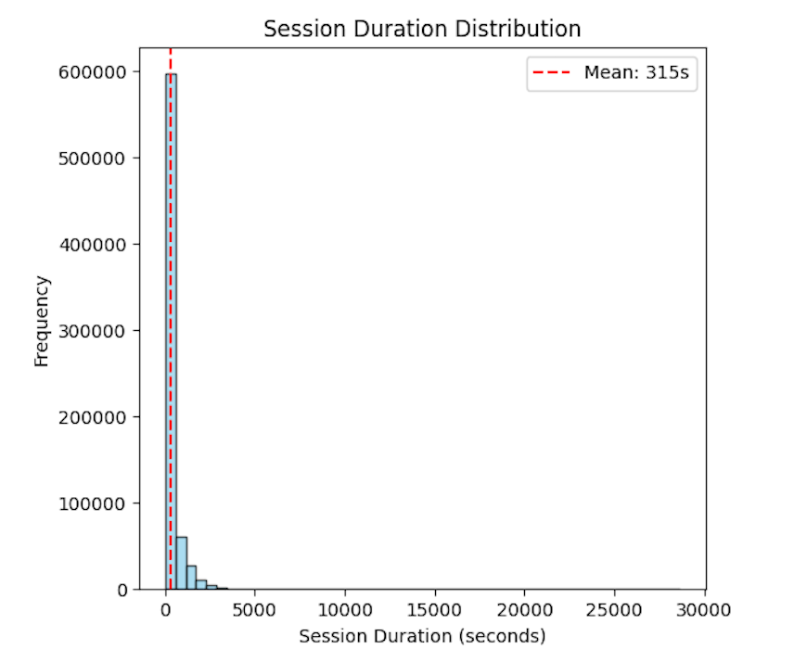
Figure 3: Session Duration Distribution

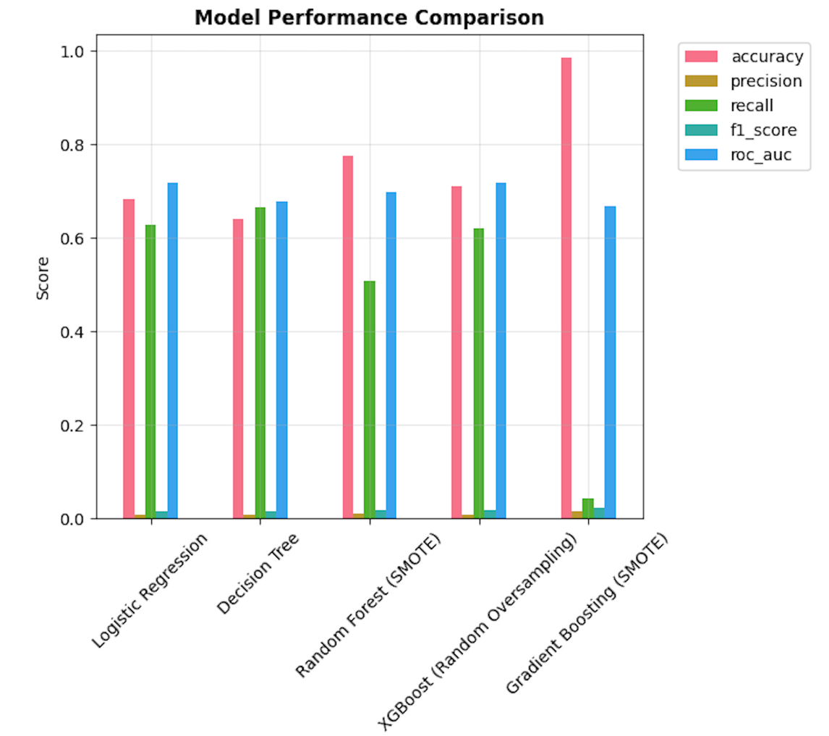
Figure 4: Model Performance Comparison

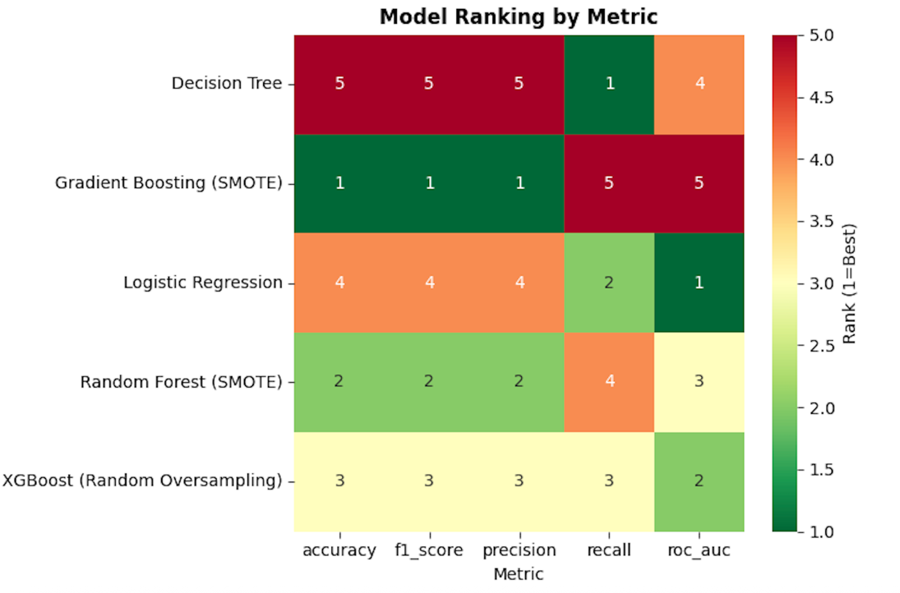
Figure 5: Model Ranking by Metric
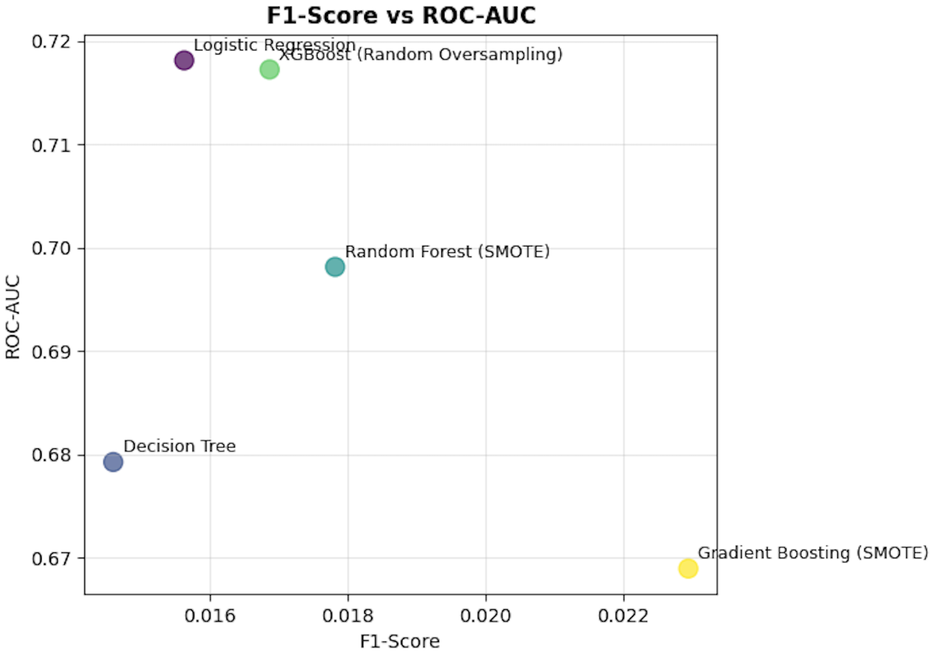
Figure 6: F1-Score vs ROC-AUC

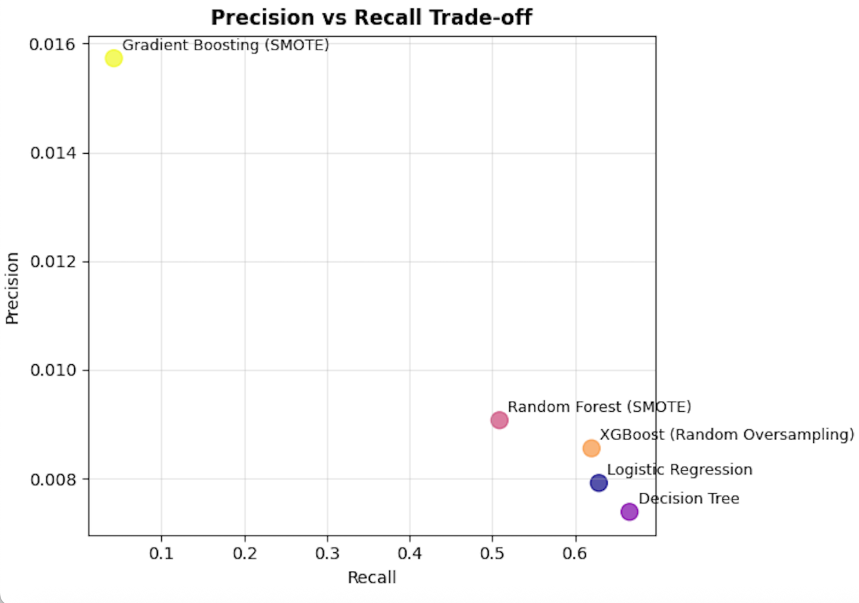
Figure 7: Precision vs Recall Trade-off
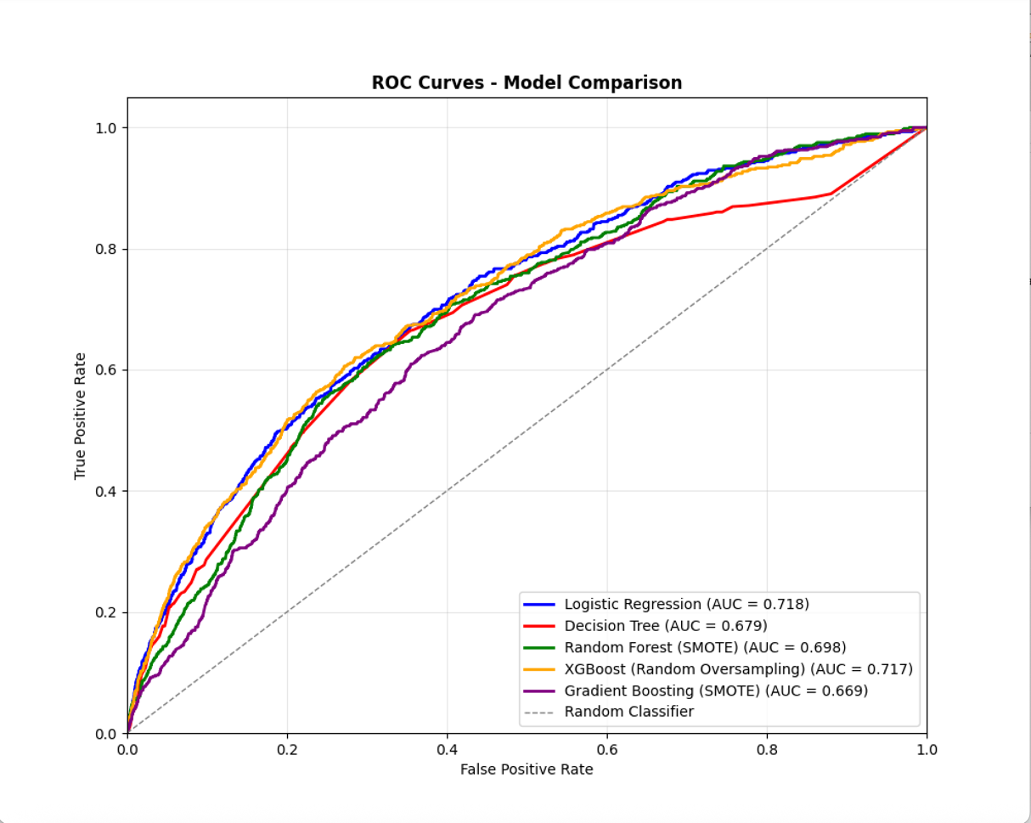
Figure 8: ROC Curves – Model Comparison

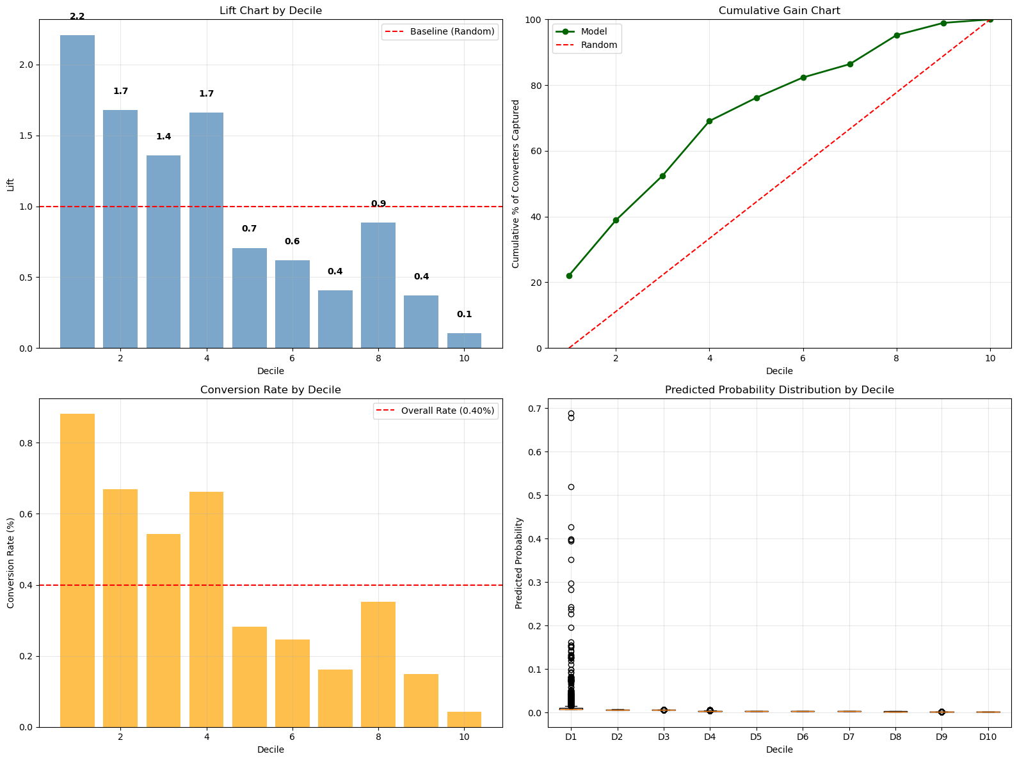

Figure 9: Lift and Gain Charts for XGBoost Model

References
Arora, A. (2020, October 5). Overcoming class imbalance using SMOTE techniques. Analytics Vidhya. Retrieved July 16, 2025, from https://www.analyticsvidhya.com/blog/2020/10/overcoming-class-imbalance-using-smote-techniques/
Brownlee, J. (2017, November 20). Random oversampling and undersampling for imbalanced classification. Machine Learning Mastery. Retrieved July 16, 2025, from https://machinelearningmastery.com/random-oversampling-and-undersampling-for-imbalanced-classification/
Brownlee, J. (2016, May 1). SMOTE oversampling for imbalanced classification. Machine Learning Mastery. Retrieved July 16, 2025, from https://machinelearningmastery.com/smote-oversampling-for-imbalanced-classification/
Brownlee, J. (2017, October 29). XGBoost for imbalanced classification. Machine Learning Mastery. Retrieved July 16, 2025, from https://machinelearningmastery.com/xgboost-for-imbalanced-classification/
GeeksforGeeks. (n.d.). SMOTE for imbalanced classification with Python. Retrieved July 16, 2025, from https://www.geeksforgeeks.org/machine-learning/smote-for-imbalanced-classification-with-python/
JuliusAI. (n.d.). JuliusAI [AI tool]. Retrieved July 15, 2025, from https://julius.ai
KorbitAI. (n.d.). KorbitAI: AI-powered code review tool. Retrieved July 15, 2025, from https://www.korbit.ai

Provost, F., & Fawcett, T. (2013). Data science for business: What you need to know about data mining and data-analytic thinking. O’Reilly Media.
Sharda, Ramesh, et al. Analytics, Data Science, & Artificial Intelligence. 11th ed., Pearson, 2020.
Villanueva, J. (2023, June 11). Flask and FastAPI—Together at last! Medium. https://medium.com/pythoneers/flask-and-fastapi-together-at-last-3ab12ab74a0f

