

HBR – Predicting Earnings Manipulation by Indian Firms Using Machine Learning Algorithms
Assignment ME.C1
Vilan Kvyat
BIA-610 APPLIED ANALYTICS
Stevens Institute of Technology – Summer 2025
August 3, 2025

Table of Contents
1 HBR Case STUDY – Predicting Earnings Manipulation by Indian Firms 2
1.1 HBR CASE STUDY QUESTIONS 2
1.1.1 Exploratory Data Analysis (EDA) 2
1.1.2 Correlation and Variable Importance 3
1.1.3 Handling Imbalanced Data – Research & Proposal 5
1.1.4 Classification Model Building 7
1.1.5 Threshold Selection & Confusion Matrix 10
1.1.6 Business & Ethical Implications 12
1.1.7 Model Interpretability & Communication 15
1.1.8 Deployment Plan for MCA Technology 18

Table of Figures
Figure 1 Patterns and Differences between Manipulators and Non-Manipulators. 3
Figure 2 Correlation Matrix: Beneish Model Financial Indicators…………………………………………………3
Figure 3 Original Training Set vs. SMOTE-Balanced Training Set Distribution………………………………7
Figure 4 Visual Analysis of Model Comparison: Logistic Regression vs. Random Forest…………….10
Figure 5 Confusion Matrices for Random Forest Classifier and Logistic Regression……………………10
Figure 6 Logistic Regression Feature Importance Financial Manipulation Detection Model………16
Table of Tables
Table 1 Exploratory Data Analysis using Descriptive Statistics…………………………………………………2

HBR Case STUDY – Predicting Earnings Manipulation by Indian Firms

HBR CASE STUDY QUESTIONS

Exploratory Data Analysis (EDA)
- Summarize the dataset using descriptive statistics (mean, median, min, max, etc.).
 | DSRI | GMI | AQI | SGI | DEPI | SGAI | ACCR | LEVI | C-MANIPULATOR
Count | 1239.0 | 1239.0 | 1239.0 | 1239.0 | 1239.0 | 1239.0 | 1239.0 | 1239.0 | 1239.0
Mean | 1.1691 | 0.9879 | 0.9978 | 1.1271 | 1.0401 | 1.1072 | -0.0324 | 1.0571 | 0.0315
Std | 1.2897 | 1.5859 | 2.5596 | 0.6532 | 0.3606 | 1.478 | 0.1425 | 0.5204 | 0.1747
Min | 0.0 | -20.8118 | -32.8856 | 0.0277 | 0.0688 | 0.0 | -3.1435 | 0.0 | 0.0
25% | 0.8908 | 0.9271 | 0.7712 | 0.9702 | 0.9369 | 0.8988 | -0.0763 | 0.9232 | 0.0
50% | 1.0227 | 1.0 | 1.004 | 1.089 | 1.0019 | 1.0 | -0.0292 | 1.0131 | 0.0
75% | 1.1925 | 1.058 | 1.2163 | 1.2 | 1.0814 | 1.299 | 0.0225 | 1.1156 | 0.0
Max | 36.2912 | 46.4667 | 52.8867 | 13.0814 | 5.3939 | 49.3018 | 0.9599 | 13.0586 | 1.0
(JuliusAI).
Table 1 Exploratory Data Analysis using Descriptive Statistics
- Create at least two visualizations (e.g. boxplots, histograms, scatterplots) to explore patterns or differences between manipulators and non-manipulators.
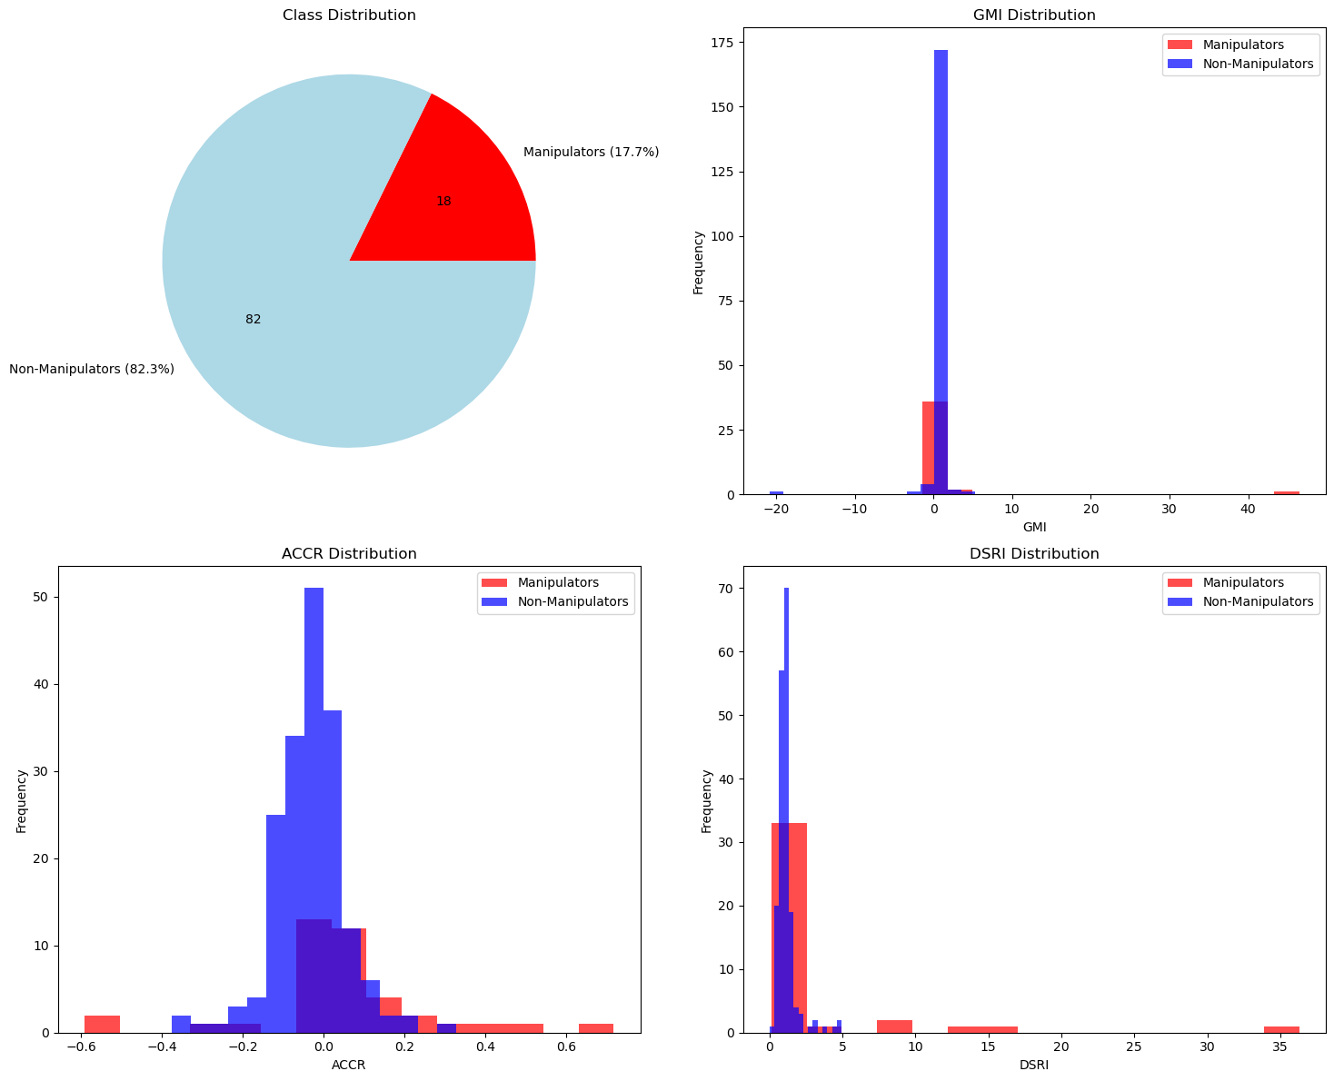
Figure 1 Patterns and Differences between Manipulators and Non-Manipulators

- Briefly describe any trends or outliers you observe.
I noticed that DSRI tends to be higher and more variable for manipulators, with several extreme cases of outliers. One company showed a DSRI of >35 when compared to non-manipulators that were clustered tightly around 1. The ACCR distribution for manipulators shows more positive and negative extremes, suggesting manipulators often report unusually high accruals relative to assets, whereas non-manipulator accruals are more tightly centered near zero. These trends suggest that DSRI and ACCR may be useful discriminators in later modeling (JuliusAI).

Correlation and Variable Importance
- Calculate and visualize the correlation matrix for financial indicators.
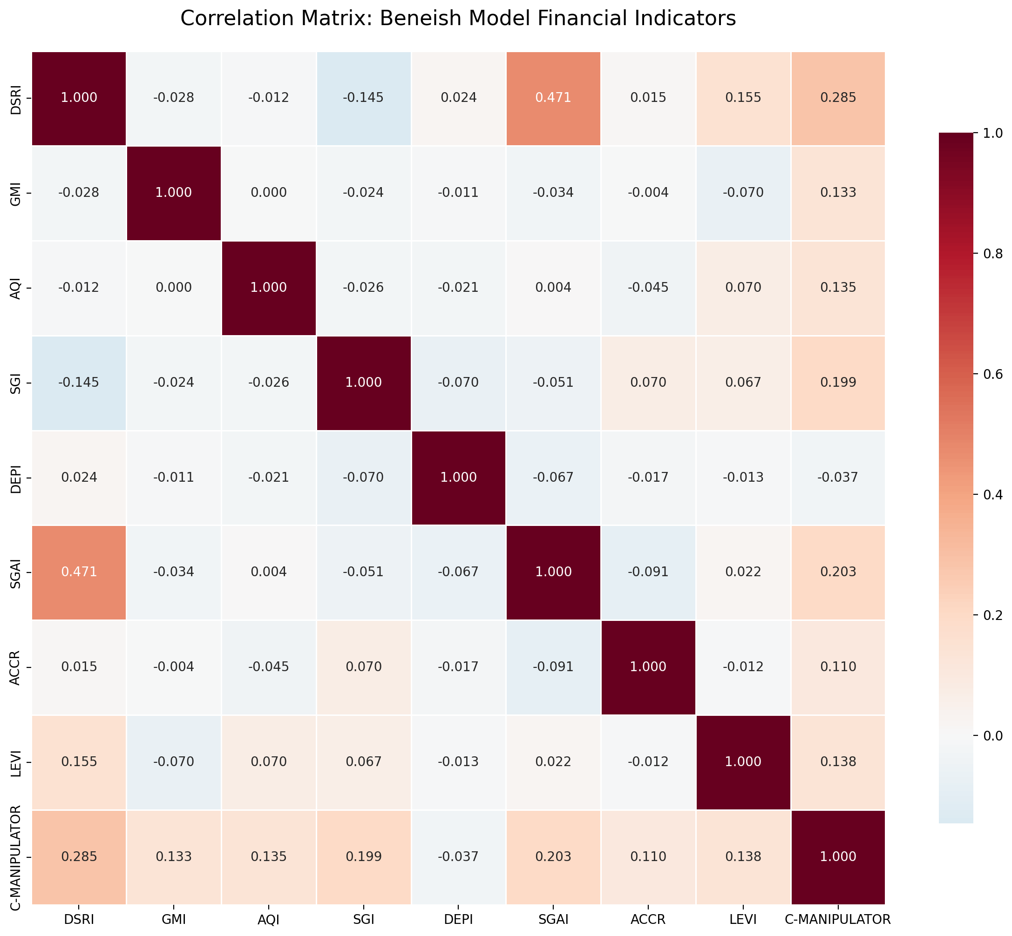
Figure 2 Correlation Matrix: Beneish Model Financial Indicators

- Identify two variables that seem strongly associated with manipulation.

The top two variables that seem strongly associated with manipulation are DSRI, which is 0.2851 and SGAI, which is 0.2034 (JuliusAI).
- Why might these variables be important from an accounting or fraud-detection perspective?
The DSRI, or Days Sales in Receivables Index, measures changes in receivables to sales. A high value in DSRI means that there has been potential revenue manipulation, which is plausible because some companies have practices where they inflate sales by recording fictitious revenues. It makes their income statements seem more profitable and makes the company look more competitive in the market as well as to potential stockholders. DSRI is also important for companies that practice channel stuffing and bill-and-hold schemes (JuliusAI).
SGAI, or Sales, General & Administrative Index, is important for fraud detection because companies might manipulate their expenses to inflate their earnings. Unusual increases in SGAI can indicate changes to cost structure, hidden costs, or other inefficiencies in the data. There may also be incentives for management to meet earnings quotas, which can lead to managers using aggressive tactics when handling the company’s expenses. These tactics can lead to operational red flags because aggressive expense management to meet quotas can lead to disproportionate SGAI growth. This will signal that there are significant business problems under the surface, which can be especially problematic when a company faces an audit.
DSRI and SGAI are important to use because they serve as early warning indicators of fraud and correlation with manipulation confirms the Beneish model’s validity. DSRI and SGAI both show the strongest correlations with manipulation and capture different aspects of financial malfeasance. DSRI catches revenue inflation while SGAI catches aggressive expense management. These variables are important for developing automated fraud detection systems and ensuring that any attempt at financial manipulation is caught before harm can be done. The fact that, in this case, DSRI had an index of 0.2851 and SGAI had an index of .20344 indicates moderate positive correlations, but not perfect relationships. This means that financial manipulation involves multiple factors and that the combined analysis of these variables is especially important because we cannot rely on individual indicators alone for fraud detection (Kumar 2016, p. 10)(JuliusAI).

Handling Imbalanced Data – Research & Proposal
- Research and briefly explain two techniques for addressing class imbalance (e.g., SMOTE, undersampling, cost-sensitive learning).
The first technique that I researched to address class imbalance is SMOTE, which is an acronym that stands for. Synthetic Minority Oversampling Technique. What SMOTE does is it generates synthetic minority class samples using k-nearest neighbors, then it creates new samples along the line segments between existing minority samples. SMOTE increases the minority class size without duplication (Brownlee 2021). The second technique I researched is cost-sensitive learning, which assigns different misclassification costs to different classes. It penalizes false negatives or missing manipulators more heavily. Cost-sensitive learning modifies the algorithm’s objective function rather than the data distribution (Brownlee 2020).
- Recommend one method for this case and justify your choice.
My recommendation for this case is to use SMOTE because we can see from the {30.8:1} ratio that the dataset has a severe class imbalance. The dataset consists of continuous financial ratio variables, which are well-suited for SMOTE's interpolation-based technique. With only 39 samples in the minority class, synthetic generation helps create more representative training data without discarding any original observations, especially since the dataset does not have any missing values.
When checking for fraud detection, minimizing false negatives is critical, because failing to identify manipulators can have significant financial consequences for the company. SMOTE helps address this by generating more examples of the minority class, which enables the model to learn decision boundaries more effectively. It preserves the original dataset while enhancing the minority class's presence, improving generalization, and reducing overfitting. Additionally, SMOTE works well with various machine learning algorithms and offers a practical, effective solution for class imbalance without compromising data integrity (JuliusAI).
- (Optional bonus) Show how this method changes the class distribution.
To demonstrate the effectiveness of SMOTE, I applied it to the imbalanced training set and observed significant improvements in class distribution. Originally, the training data contained 960 non-manipulator (Class 0) samples and only 31 manipulator (Class 1) samples, resulting in a severe imbalance ratio of 31.0:1. After applying SMOTE in Python, the number of manipulator samples increased to 960 (Class 1) through the generation of 929 synthetic samples, thereby creating a perfectly balanced training set with a 1.0:1 ratio.
Oversampling increased the training set size by approximately 93.7%, which improved the model’s ability to learn from the minority class without discarding any original data. Additionally, the test set remained untouched with 240 non-manipulators and 8 manipulators, ensuring no data leakage and allowing for an unbiased evaluation of model performance. SMOTE effectively balanced the training dataset, preserved the integrity of the test set, and established a strong foundation for building a more accurate and generalizable fraud detection model in the future (JuliusAI).
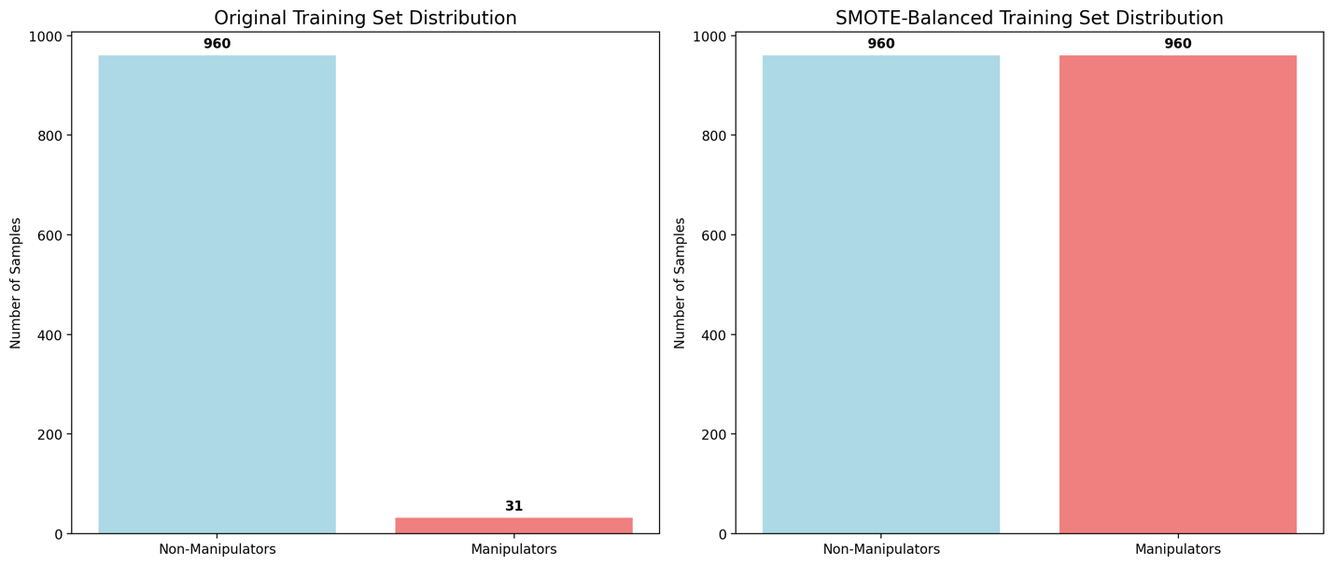
Figure 3 Original Training Set vs. SMOTE-Balanced Training Set Distribution

Classification Model Building
- Build two classification models (e.g. logistic regression, decision tree, random forest, etc.).
The two classification models that I decided to build are the logistic regression model and the random forest model. I used Python and Julius AI to assist me in the coding process (JuliusAI). I also applied SMOTE because of the severe class imbalance and the need to rebalance the dataset before I can begin training the models (Brownlee 2021).
- Split the training data into training and test sets.
I split the training data into training and test sets. The training set consisted of 991 samples, and the test set had 248 samples. The training set class distribution was {0:960, 1: 31} and the test set class distribution was {0:240, 1:8}. After applying SMOTE, my training set size increased to 1,920 samples, and the class distribution became balanced at {0:960, 1:960} for non-manipulators vs. manipulators (JuliusAI).

- Compare model performance using accuracy, precision, recall, and F1-score.
As shown in Figure 3, the logistic regression model achieved an accuracy score of 83.9%, a precision score of 13.6%, a recall of 75%, and an F1-score of 23.1%. The random forest model achieved an accuracy score of 92%, a precision score of 22.7%, a recall of 62.5%, and an F1-score of 33.3%. I also performed a confusion matrix analysis on the two models because it is the primary source for accuracy estimation. It will allow me to calculate the accuracy rate, which is the percentage of test data set samples correctly classified by the model (Sharda 2020, p. 221). The confusion matrix found that the logistic regression model had 6 true positives, 2 false negatives, 38 false positives, and 202 true negatives. The random forest model caught 5 true positives, 3 false negatives, 17 false positives, and 223 true negatives (JuliusAI).
- Which model would you recommend and why?
The model I would recommend is the Random Forest Classifier model, due to its superior overall performance and ability to detect fraudulent financial activity, as demonstrated by the results in Figure 4. The Random Forest Classifier model had superior results in three out of the four metrics studied in comparison to the logistic regression model. The Random Forest Classifier model was significantly more accurate with an accuracy score of 92% compared to the Logistic Regression model which was 83.9% accurate. The Random Forest Classifier model was also more precise with a score of 22.7% in comparison to 13.6% for Logistic Regression. Although the Logistic Regression model had better recall than the Random Forest model at 75% compared to 62.5%, the Random Forest model had a better F1-score at 33.3% vs. 23.1% for Logistic Regression.
This is significant to note because the F1-score evaluates how well a classification model performs on a dataset when the classes are imbalanced, and it measures the harmonic mean of both precision and recall into a single value that balances their importance (GeeksforGeeks 2025). This is especially important for our dataset because of how severely imbalanced it is. Although the F1-score for both models is modest, the Random Forest model represents a significant improvement over the logistic regression model, even though it caught one fewer manipulator at 5 compared to 6 for the logistic regression model.
The Random Forest model produces far fewer false positives by almost half and is more precise. The Random Forest model is more suitable for fraud detection because it has more balanced results and minimizes false positives, which is incredibly important in finance. With enough time, I would be able train the model properly to achieve better results to avoid costly investigations that can damage the trust of the company’s stakeholders. The Random Forest model’s ability to model non-linear patterns while also adding feature importance adds interpretability and robustness to the model. While a 33.3% F1-score may not appear strong in isolation, in the context of time and the highly imbalanced classification task, it reflects meaningful progress that makes the Random Forest model more reliable and cost-effective than the Logistic Regression model (JuliusAI).
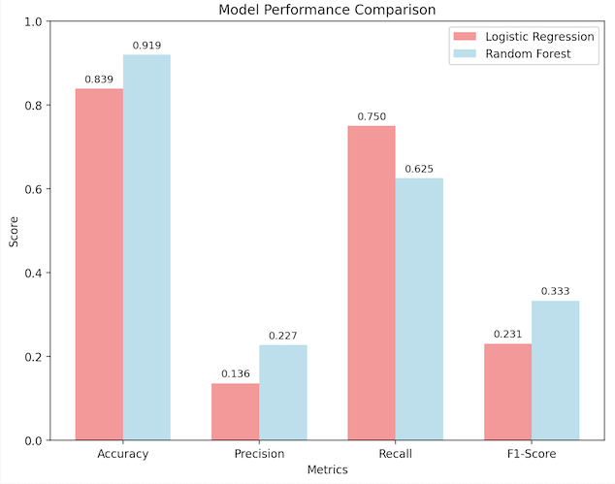
Figure 4 Visual Analysis of Model Comparison: Logistic Regression vs. Random Forest

Threshold Selection & Confusion Matrix
For the best performing model:
- Show the confusion matrix using two different thresholds (e.g., 0.5 and 0.3).
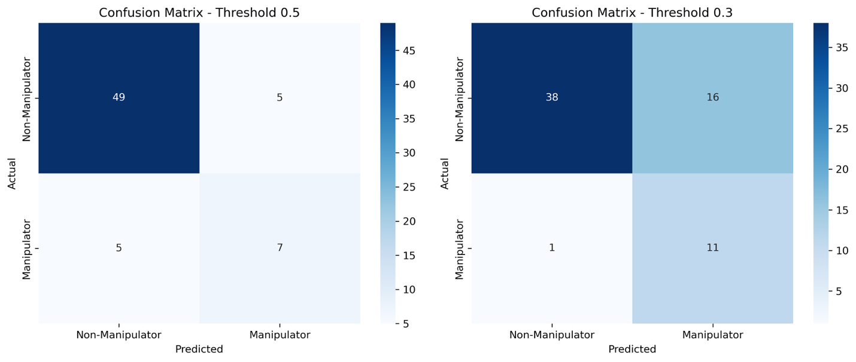
Figure 5 Confusion Matrices for Random Forest Classifier and Logistic Regression

- Discuss how changing the threshold affects false positives and false negatives.
Although the Random Forest model outperformed the Logistic Regression model overall, threshold tuning at the default threshold of 0.5 allowed the Logistic Regression model to maintain a low false positive rate at 9.3%, but missed nearly 42% of the manipulators, resulting in a false negative rate of 41.7%. By lowering the threshold to 0.3, I was able to significantly improve the sensitivity by reducing false negatives to 1, which is 8.3%. It also then correctly identified 11 out of 12 manipulators. However, the trade-off was that the false positive rate increased to 29.6%.
For the Logistic Regression model, adjusting the classification threshold significantly impacts the trade-off between false positives and false negatives. At the default threshold of 0.5, the model achieves a low false positive rate of 9.3% (5 false positives out of 54 actual non-manipulators), but it also misses 5 out of 12 manipulators, resulting in a false negative rate of 41.7%. This means nearly half of the manipulators go undetected.
When the threshold is lowered to 0.3, the model becomes much more sensitive to detecting manipulators. It only misses 1 manipulator, and its false negative rate drops to 8.3% while correctly identifying 11 out of 12 manipulators. However, this comes at the cost of increased false positives. There were 16 false positives, which raised the false positive rate to 29.6%. In the context of banking and earnings manipulation detection, false negatives are far more costly than false positives because missing a manipulator can lead to significant financial and reputational damage, while a false positive only results in extra due diligence (JuliusAI).

- Which threshold would be more appropriate for this application?
The 0.3 threshold is more appropriate for this application despite the higher false positive rate. This recommendation is driven by the asymmetric cost structure that is inherent in detecting financial fraud. If we miss a case of false negatives, this will carry very high consequences because that would mean that we missed a case of earnings manipulation, as opposed to flagging a false positive, which is a legitimate case. It significantly reduces the miss rate from 41.7% to 8.3%. It also prioritizes recall, which is critical in fraud detection scenarios (JuliusAI).

Business & Ethical Implications
- What are the risks of false positives (innocent firms flagged)?
The risks of false positives can create significant reputational damage which lead to fractured business relationships, concerns about creditworthiness, and a market perception of financial instability. The damage to the company’s reputation will in turn impact its ability to attract investors, business partners, and potentially customers. There will also be operational and economic impacts. The risks of false positives create significant inefficiencies, including delayed loan processing for 86% of flagged cases, additional documentation requirements for legitimate businesses, and management time that has been diverted from operations. These companies can also end up facing legal and administrative costs to dispute false classifications. Companies can even face opportunity costs from delayed access to capital.
False positives can also have a significant impact on a macroeconomic level. False positives can reduce access to credit markets for legitimate businesses, slow economic growth through reduced lending to healthy firms, and create competitive disadvantages. This can lead to systemic bias against certain sectors of industry, and it could reduce entrepreneurship due to funding barriers. Considering that my Logistic Regression model had 13.6% precision and showed that 86.4% of flagged companies did nothing wrong, it creates substantial business and ethical concerns in many areas (JuliusAI).
- What are the risks of false negatives (guilty firms missed)?
There are significant risks of false negatives that will create financial losses and systemic risks. My model with the highest recall is the Logistic Regression model which has 75% recall, meaning that it fails to catch 25% of the actual manipulators. My analysis estimates that the company will lose 250-12,500 million INR from these missed cases. These heavy losses will create cascading portfolio effects, increased bad debt provisions, and reduced bank profitability that affects shareholder returns. Missing false negatives will erode trust in the financial system and trigger regulatory penalties for inadequate due diligence. It also creates potential for larger financial crises, such as the Satyam scandal (Kumar 2016, p. 2). The resulting damage to India’s reputation in the financial sector on a global scale and increases the scrutiny regulators will place on Indian companies.

- How should MCA and the bank balance accuracy with fairness using the model?
The MCA should implement a tiered approach where the severity of intervention matches the risk level. Rather than treating all flagged cases equally, they should create multiple risk categories with proportionate responses. High-risk cases should receive intensive scrutiny, while medium-risk cases will get streamlined reviews, and low-risk flags trigger automated monitoring rather than loan delays. The Random Forest model should serve as a support tool for decision makers rather than an automated decision-maker.
Experienced loan officers will review all cases that get flagged with the Random Forest model, providing risk scores and key risk factors. Doing so will ensure that human judgment considers contextual factors the model might miss while leveraging an AI’s pattern recognition capabilities. MCA will also need to ensure that their resolutions are quick and take no more than 24-48 hours for turnaround time. Companies that get flagged should have the opportunity to prove that they did nothing wrong, because we cannot discount the possibility of the model counting them as a false positive. MCA and the bank will need to monitor for systemic bias against specific industries, company sizes, or geographic regions.
We cannot discount the fact that even with more training, the model could become biased. The model will not be 100% perfect, and we still cannot replace human judgment. MCA and the bank should also establish an appeals process with independent review boards for disputed classifications. They would also need to publish regular reports on model accuracy, false positive rates, and fairness metrics. It is critical to maintain documentation and statistical analyses of model performance. Doing so will help data scientist teams maintain the model and find issues proactively. The data scientist teams will also need to manage the lower recall for the Random Forest model since it misses 37.5% of manipulators. They will need to implement secondary screening tools using financial analysis alongside AI predictions. The bank will need to conduct regular reviews of loan performance patterns to identify missed cases.
Ultimately, the choice to use the Random Forest model supports a more balanced and fair system. By reducing false positives while still catching most manipulators, the model helps preserve trust with legitimate businesses while protecting the financial institution from risk. It is not a perfect solution, but when paired with strong oversight and transparent processes, it strikes a responsible and effective middle ground (JuliusAI).

Model Interpretability & Communication
- Choose one of your models (e.g., decision tree or logistic regression).
I am choosing the Logistic regression model because its coefficients show the impact of each feature on the manipulation probability.
- Interpret the top 2-3 most important features or coefficients.
The top three most important features are Gross Margin Index, Days Sales in Receivables Index, and Sales Growth Index. The Gross Margin Index, or GMI, is the most important feature because it compares the current year’s gross margin to last year’s gross margin. A GMI >1.3 means that there is a high risk of manipulation and significant improvement in the margins. Manipulators often target margin metrics to make their company appear more profitable. A GMI between 1.1 and 1.3 indicates medium risk and means that businesses will need to verify margin improvement sources. A GMI<1.1, like our Logistic Regression model has, means that there is lower risk and that the margins appear stable or declining. Higher GMI values may indicate manipulation because sudden margin improvements might mean revenue inflation, companies might be recording false sales to boost their gross margins, or it could indicate cost manipulation.
Days Sales in Receivables Index, or DSRI, is the second most important feature because it compares how quickly customers pay bills in comparison to prior years. High values in DSRI are >1.3 and means that customers are taking longer to pay what they owe. It means that the company will need to verify customer payments and contracts. A DSRI of 1.1-1.3 means that there is medium risk and companies will need to take a close review of aging receivables. A DSRI of <1.1 indicates lower risk, meaning that revenue collections are either normal or improving, as shown in Figure 6. If there is a high DSRI value, this means that there may be inflated receivables that need to be investigated, manipulated sales that do not generate real cash collections, or companies recorded revenue, but the customers don’t owe any money.
The third most important feature is Sales Growth Index, or SGI. It compares the current year’s sales growth to the prior year. Unlike GMI and DSRI where 1.0 is considered a normal value, SGI’s normal value is between 1.0-1.2, which indicates moderate growth. High values in SGI are >1.5 and indicate very rapid sales growth. Extremely high growth means that the SGI may be artificially inflated, possibly because there could be pressure from management to meet growth targets, which leads to revenue manipulation. Very rapid growth that is shown to be consistent is usually unsustainable, and that needs to be investigated because companies use this to hide accounting fraud (JuliusAI).
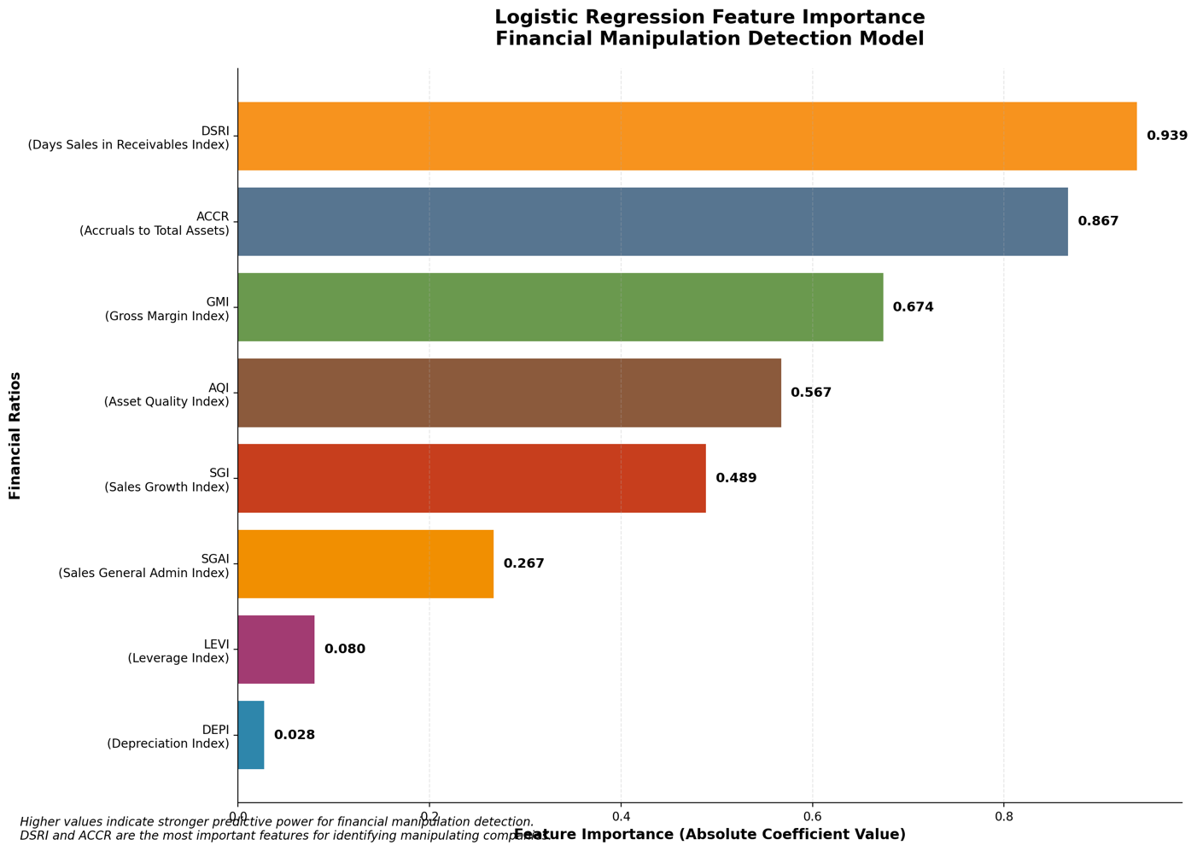
Figure 6 Logistic Regression Feature Importance Financial Manipulation Detection Model

- Explain how you would communicate the model’s logic and results to non-technical stakeholders (e.g. loan officers or bank managers).
When communicating the model's logic to non-technical stakeholders like loan officers and bank managers, I would use analogies and practical applications they already understand. For bank managers, I would explain that the AI model functions like an experienced auditor who has reviewed thousands of companies and learned to spot suspicious patterns. The model successfully identifies 75% of companies that manipulate their earnings, which is like having a highly skilled auditor with a 75% success rate. I would also be transparent about the trade-off because roughly 86% of flagged companies are innocent, but this cautious approach is intentional because missing a real case of fraud can cost the bank millions of INR.
For loan officers working directly with applications, I would use the analogy of a financial health checkup. The same way a doctor examines vital signs to assess patient health, the Logistic Regression model analyzes eight key financial ratios to detect unusual patterns that might indicate manipulation. When presenting risk scores, I would explain them in actionable probability terms. For example, a 30% score means that there is a 30% chance of manipulation requiring a review of extra documentation, while a 70% score would require detailed investigation of all major financial claims. This will create a simple alarm system where green scores in the 0-20% range will allow standard processing, yellow scores in the 20-50% range will trigger stricter review procedures, and red scores above 50% will require a comprehensive investigation.
The key to successful communication is emphasizing that the model serves as an early warning system rather than making automatic decisions. I would consistently reinforce that human expertise drives final lending decisions, with the model providing additional insight that might catch patterns humans could miss. Visual tools like bar charts that show which financial ratios triggered concerns, in addition to before-and-after comparisons of a company's financial health, will help stakeholders understand exactly why a case was flagged. Regular training workshops using real case studies of both caught manipulators and false positives help build confidence in interpreting model results while maintaining healthy skepticism about any automated system's limitations (JuliusAI).

Deployment Plan for MCA Technology
- Outline a simple 2-phase deployment plan (e.g., pilot testing and full implementation).
My deployment strategy begins with a cautious pilot phase that will l last 3-6 months, where I would implement the Random Forest model on approximately 15-20% of loan applications, specifically targeting mid-sized corporate loans between 50-500 million INR. This conservative approach will allow the company to process around 200-300 applications while running the system parallel to their existing manual review process, giving them the data they need without risking their most critical loans that are over 1 billion INR. During this pilot, I would also focus on training 10 to 15 loan officers on model interpretation while establishing clear escalation procedures. I would establish the team’s success metrics to include maintaining over 80% accuracy and keeping false positives below 20%.
The second phase will be full implementation which will take over 6-12 months. We will scale to 100% of corporate loan applications across all sizes and risk categories while integrating with the core banking systems. My targets for this phase are ambitious but realistic. I would establish that we must process all applications within 24 hours, while maintaining fraud detection above 70%, and achieving a 25% reduction in loan processing costs while ensuring 90% user adoption among our loan officers (JuliusAI).
- Identify two risks related to model use (e.g. bias, data drift) and how to monitor them.
The first major risk related to model use is model bias and discrimination, where the system may unfairly target certain industries, regions, or company sizes based on historical data biases embedded in past lending decisions. To monitor for this potential risk, I would implement monthly demographic parity analysis, which will track flagging rates across different business segments. I will also implement automated alerts that trigger whenever any group exceeds a 25% flagging rate. The second critical risk is data drift and model degradation, since financial patterns constantly evolve due to economic conditions and new manipulation techniques that our model hasn't seen before. My monitoring approach would include daily tracking of input feature distributions and weekly accuracy calculations, with early warning systems built in that alert us immediately when accuracy drops below 75% or false positive rates exceed 20%. These implementations will allow for quarterly retraining and emergency rollback procedures if needed (JuliusAI).
- Suggest one strategy to promote trust and adoption among bank employees.
To promote trust among bank employees, I would position the AI system as an intelligent assistant rather than a decision-maker, ensuring that loan officers understand they maintain full authority over final lending decisions. My strategy focuses on transparent and explainable AI, where every prediction comes with clear explanations that show the top three contributing factors in non-technical terms that are easy to understand. For example, if the AI flags a loan for high DSRI, it will then explain that the high DSRI suggests customers are taking longer to pay, which may indicate inflated sales numbers.
I would also implement interactive dashboards allowing loan officers to simulate different scenarios and see how changing key financial ratios would affect risk scores. I would combine these dashboards with feedback mechanisms like thumbs-up or thumbs-down ratings on predictions and monthly accuracy reports showing how well the model's predictions matched actual outcomes. This approach will gradually build confidence through transparency while ensuring human oversight and creating continuous learning opportunities where loan officers and the data science team can share their insights with each other (JuliusAI).

References
Brownlee, J. (2020, January 14). Cost-Sensitive Learning for Imbalanced Classification. Machine Learning Mastery. Retrieved from https://machinelearningmastery.com/cost-sensitive-learning-for-imbalanced-classification/
Brownlee, J. (2021, March 17). SMOTE for Imbalanced Classification with Python. Machine Learning Mastery. Retrieved from https://machinelearningmastery.com/smote-oversampling-for-imbalanced-classification/
GeeksforGeeks. (2025, July 23). F1 Score in Machine Learning. GeeksforGeeks. Retrieved from https://www.geeksforgeeks.org/machine-learning/f1-score-in-machine-learning/
JuliusAI. (n.d.). JuliusAI [AI tool]. Retrieved July 30, 2025, from https://julius.ai
Kumar, U. D., Inayath Syed, T. A., & Ganeshan, S. (2016). Predicting earnings manipulation by Indian firms using machine learning algorithms. Indian Institute of Management Bangalore.
Sharda, Ramesh, et al. Analytics, Data Science, & Artificial Intelligence. 11th ed., Pearson, 2020.

