DS2526 · Data Semantics · UNIMIB · May 2026
SPARQL QUERIES
Banking Fraud Knowledge Graph
Complete query reference with GraphDB results and explanations
Victoria Bassey · 948253

This document contains all SPARQL queries written and executed against the Banking Fraud Knowledge Graph, together with the GraphDB result screenshots and full explanations of what each result reveals about the fraud network.

Part 1 — Prototype Queries · 12 Transactions
The following six queries were developed and tested on the 12-transaction prototype graph built manually in Protégé. Each query validates a different aspect of the ontology and surfaces a different fraud pattern.

Q1 Full Network Overview

SPARQL Code
SPARQL QUERY
PREFIX bfkg: <http://www.semanticweb.org/banking-fraud-kg#>

SELECT ?transaction ?pattern ?sender ?receiver ?currency ?format ?amount ?timestamp

WHERE {

?transaction bfkg:hasSenderAccount ?sender ;

bfkg:hasReceiverAccount ?receiver ;

bfkg:belongsToPattern ?pattern ;

bfkg:hasPaymentCurrency ?currency ;

bfkg:hasPaymentFormat ?format ;

bfkg:hasAmountPaid ?amount ;

bfkg:hasTimestamp ?timestamp .

}

ORDER BY ?transaction

GraphDB Result
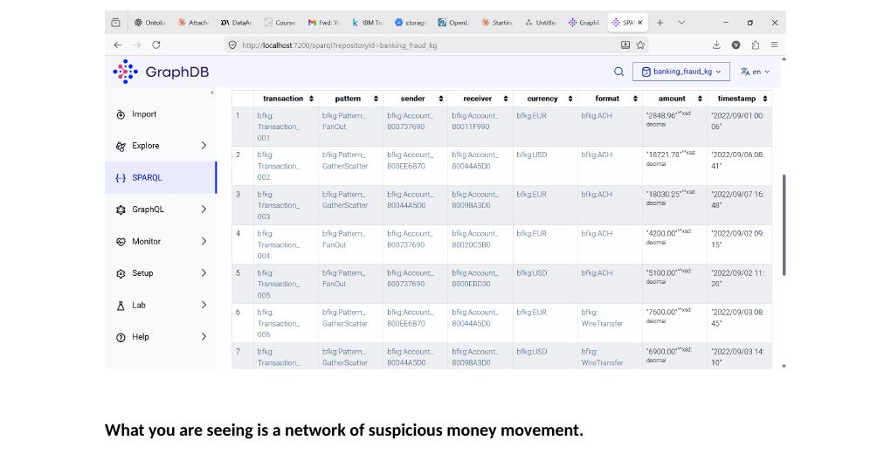
Figure 1 — Q1 GraphDB output: all 12 prototype transactions with pattern, sender, receiver, currency, format, amount and timestamp

What the output shows
What you are seeing is a network of suspicious money movement.
Account_800737690 is your first red flag.
Look at rows 1, 4 and 5. This single account appears as the sender in three separate transactions — sending to three different receivers at different times. This is the FanOut pattern. In fraud investigation this indicates one source distributing funds to multiple destinations. A normal account does not behave like this. In a flat CSV you would never spot this because the three rows look unrelated.
The GatherScatter accounts tell a second story.
Look at rows 2, 3, 6, 7. Funds are being collected from multiple sources and then redistributed. Notice Account_800EE6B70 appears as sender in rows 2 and 6. Account_80044A5D0 appears as both sender and receiver across different rows — the same account is recycling money. That is layering, a core stage of money laundering.
The timestamps confirm coordinated behaviour.
The transactions happen across different dates — September 1, 2, 3, 7 — spaced to avoid triggering automatic bank alerts that flag multiple transactions on the same day.
The graph shows you a criminal network. The CSV shows you 12 rows.

Q2 FanOut Pattern — One Sender, Multiple Receivers

SPARQL Code
SPARQL QUERY
PREFIX bfkg: <http://www.semanticweb.org/banking-fraud-kg#>

SELECT ?sender (COUNT(?transaction) AS ?numberOfTransactions) ?receiver ?amount ?timestamp

WHERE {

?transaction a bfkg:Transaction ;

bfkg:belongsToPattern bfkg:Pattern_FanOut ;

bfkg:hasSenderAccount ?sender ;

bfkg:hasReceiverAccount ?receiver ;

bfkg:hasAmountPaid ?amount ;

bfkg:hasTimestamp ?timestamp .

}

GROUP BY ?sender ?receiver ?amount ?timestamp

ORDER BY ?sender

GraphDB Result
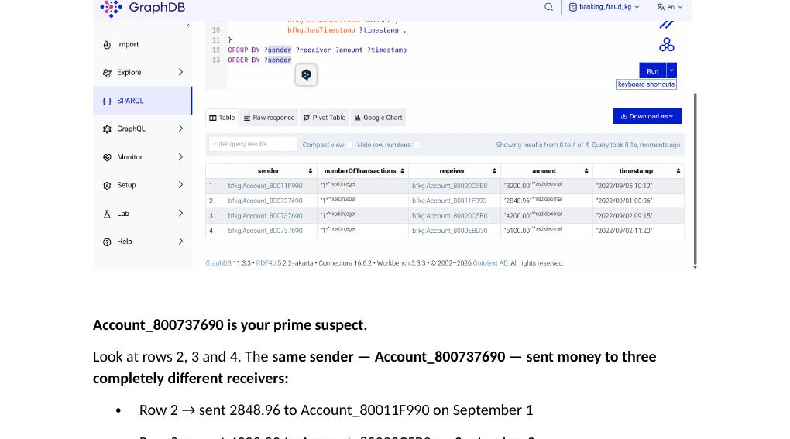
Figure 2 — Q2 GraphDB output: FanOut pattern — Account_800737690 sending to three distinct receivers

What the output shows
Account_800737690 is your prime suspect.
Rows 2, 3 and 4 show the same sender sending to three completely different receivers:
- Row 2 — sent 2,848.96 to Account_80011F990 on September 1
- Row 3 — sent 4,200.00 to Account_80020C5B0 on September 2
- Row 4 — sent 5,100.00 to Account_8000EBD30 on September 2
Three different destinations. Three different amounts. Two different days. This is the FanOut pattern — one source dispersing funds in multiple directions to make the money hard to trace.
In a flat CSV these three rows look like three completely unrelated transactions. A bank analyst scrolling through thousands of rows would never notice. In the knowledge graph one query exposes it immediately.
Row 1 is also significant.
Account_80011F990 received money from Account_800737690 in row 2, and now in row 1 it appears as a sender itself — forwarding that money onwards to Account_80020C5B0. Money received from the suspect account is already moving again.

Q3 Cycle Pattern — Money Looping Through Accounts

SPARQL Code
SPARQL QUERY
PREFIX bfkg: <http://www.semanticweb.org/banking-fraud-kg#>

SELECT ?transaction ?sender ?receiver ?amount ?timestamp

WHERE {

?transaction a bfkg:Transaction ;

bfkg:belongsToPattern bfkg:Pattern_Cycle ;

bfkg:hasSenderAccount ?sender ;

bfkg:hasReceiverAccount ?receiver ;

bfkg:hasAmountPaid ?amount ;

bfkg:hasTimestamp ?timestamp .

}

ORDER BY ?timestamp

GraphDB Result
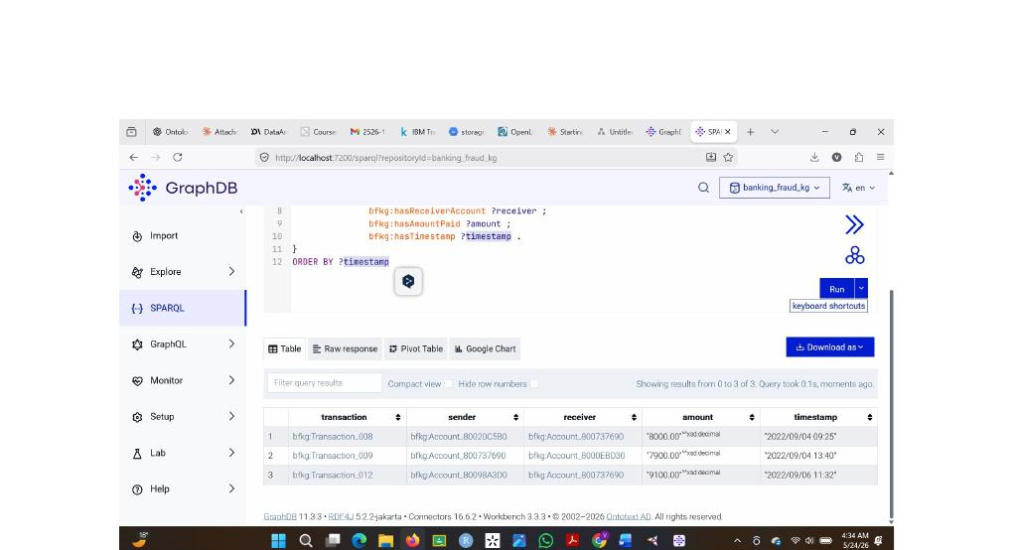
Figure 3 — Q3 GraphDB output: Cycle pattern — money flowing in a loop with Account_800737690 at the centre

What the output shows
This is money going in a circle.
Follow the trail chronologically:
- Row 1 — Account_80020C5B0 sends 8,000.00 to Account_800737690 on September 4 at 09:25
- Row 2 — Account_800737690 sends 7,900.00 to Account_8000EBD30 on September 4 at 13:40 — just 4 hours later
- Row 3 — Account_80098A3D0 sends 9,100.00 back to Account_800737690 on September 6 at 11:32
Account_800737690 sits at the centre of a cycle. It receives and it sends. It is acting as a pass-through account — a classic money laundering technique called layering. The money enters, gets moved quickly, and then comes back in a slightly different amount to disguise its origin.
The amounts vary across each leg — 8,000, 7,900, 9,100 — and this is structurally significant. Alert systems often flag identical repeated amounts. By varying each transaction the pattern avoids those thresholds. The graph traversal surfaces the circular flow regardless of the variation.
Account_800737690 appeared in the FanOut query as a suspicious sender. Now it appears in the Cycle query at the centre of a loop. The same account connected to multiple laundering patterns — that is the strongest signal the graph can produce.

Q4 GatherScatter Pattern — Funnel Account Detection

SPARQL Code
SPARQL QUERY
PREFIX bfkg: <http://www.semanticweb.org/banking-fraud-kg#>

SELECT ?transaction ?sender ?receiver ?amount ?timestamp

WHERE {

?transaction a bfkg:Transaction ;

bfkg:belongsToPattern bfkg:Pattern_GatherScatter ;

bfkg:hasSenderAccount ?sender ;

bfkg:hasReceiverAccount ?receiver ;

bfkg:hasAmountPaid ?amount ;

bfkg:hasTimestamp ?timestamp .

}

ORDER BY ?timestamp

GraphDB Result
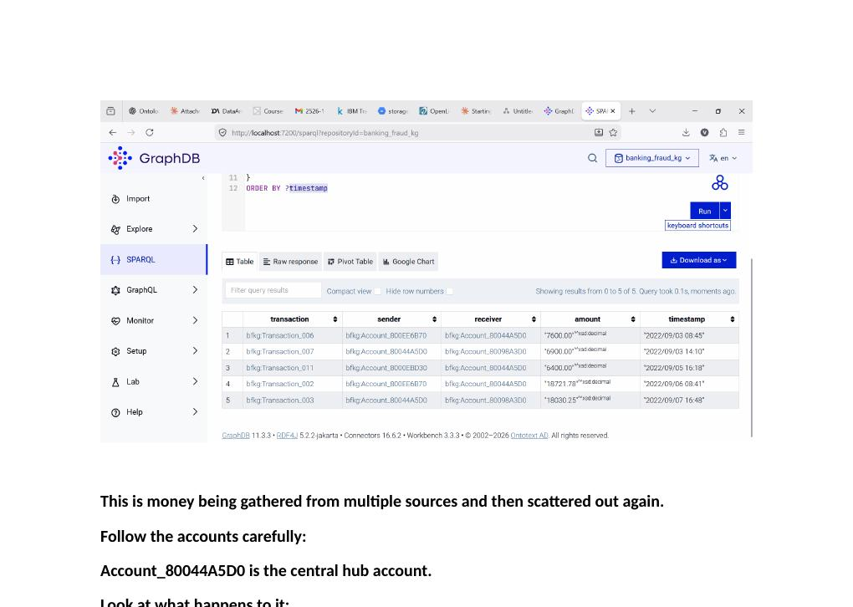
Figure 4 — Q4 GraphDB output: GatherScatter pattern — Account_80044A5D0 acting as the central funnel account

What the output shows
Account_80044A5D0 is the central funnel account.
Follow what happens to it:
- Row 1 — Account_800EE6B70 sends 7,600.00 into the funnel on September 3
- Row 2 — Funnel immediately sends 6,900.00 out to Account_80098A3D0 on September 3
- Row 3 — Account_8000EBD30 sends 6,400.00 into the funnel on September 5
- Row 4 — Account_800EE6B70 sends 18,721.78 into the funnel on September 6
- Row 5 — Funnel sends 18,030.25 out to Account_80098A3D0 on September 7
Account_80044A5D0 holds incoming edges from multiple sender entities and outgoing edges to multiple receiver entities simultaneously — severing any direct source-to-destination provenance in the semantic graph. Money comes from many places and goes to many places. No single payer can be traced to any single payee.
The full picture across all three pattern queries:
- Account_800737690 — present in FanOut and Cycle
- Account_80044A5D0 — present in GatherScatter as a funnel
- Account_800EE6B70 — repeatedly feeding the funnel
These accounts are not acting alone. They form a coordinated laundering network and the knowledge graph has mapped it entirely.

Q5 Most Suspicious Accounts — Fraud Leaderboard

SPARQL Code
SPARQL QUERY
PREFIX bfkg: <http://www.semanticweb.org/banking-fraud-kg#>

SELECT ?account (COUNT(?transaction) AS ?timesAppeared)

WHERE {

{

?transaction a bfkg:Transaction ;

bfkg:hasSenderAccount ?account .

}

UNION

{

?transaction a bfkg:Transaction ;

bfkg:hasReceiverAccount ?account .

}

}

GROUP BY ?account

ORDER BY DESC(?timesAppeared)

GraphDB Result
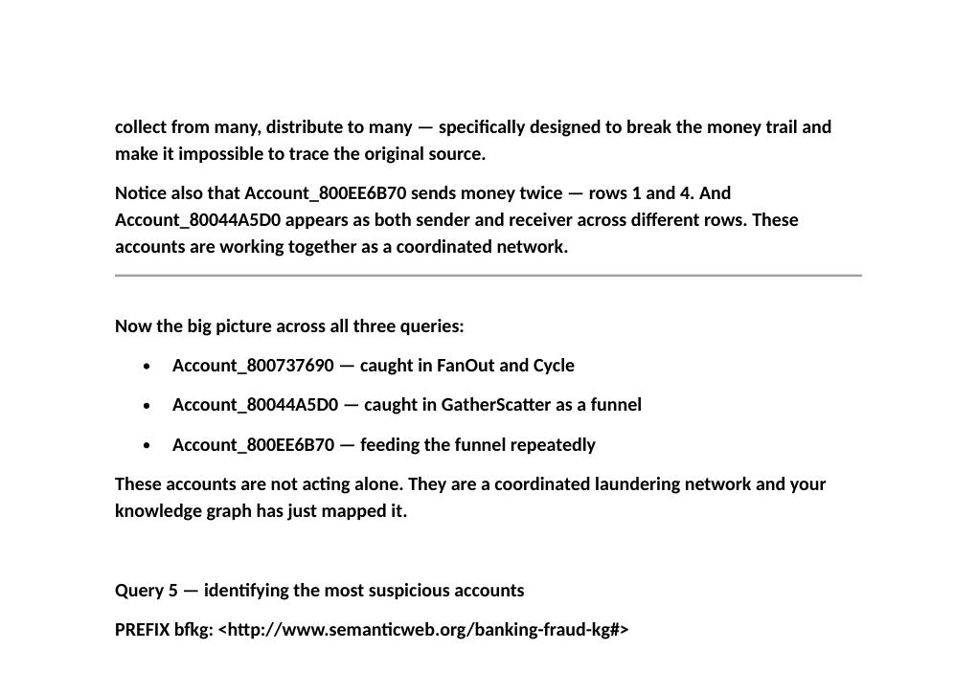
Figure 5 — Q5 GraphDB output: accounts ranked by total appearances across all confirmed laundering transactions

What the output shows
Row 1 — Account_800737690 — appeared 6 times.
This account appears in more transactions than any other in the prototype dataset. It was caught in the FanOut query sending to three accounts. Caught again in the Cycle query at the centre of a money loop. Now this query confirms it — 6 appearances across 12 transactions. That is an account deeply embedded across multiple laundering patterns simultaneously.
An account this deeply embedded in overlapping laundering structures is the clearest signal the graph can surface — it is not noise, it is not coincidence, it is a network node.
Row 2 — Account_80044A5D0 — appeared 5 times.
The funnel account from the GatherScatter query. 5 appearances confirms it is a key participant in the network, not a coincidence.
Rows 3, 4, 5 — three accounts with 3 appearances each.
Account_80020C5B0, Account_8000EBD30 and Account_80098A3D0 are supporting nodes in the network — appearing repeatedly across different transactions and patterns.
In a flat CSV with 12 rows you would need to manually count every row to find this. The knowledge graph ranked every account by suspicion level in one query. This is exactly what the project proposed — connecting the dots that fragmented data hides.

Q6 Pattern Summary — Total Transactions and Amount per Pattern

SPARQL Code
SPARQL QUERY
PREFIX bfkg: <http://www.semanticweb.org/banking-fraud-kg#>

SELECT ?pattern (COUNT(?transaction) AS ?numberOfTransactions)

(SUM(?amount) AS ?totalAmount)

WHERE {

?transaction a bfkg:Transaction ;

bfkg:belongsToPattern ?pattern ;

bfkg:hasAmountPaid ?amount .

}

GROUP BY ?pattern

ORDER BY DESC(?totalAmount)

GraphDB Result
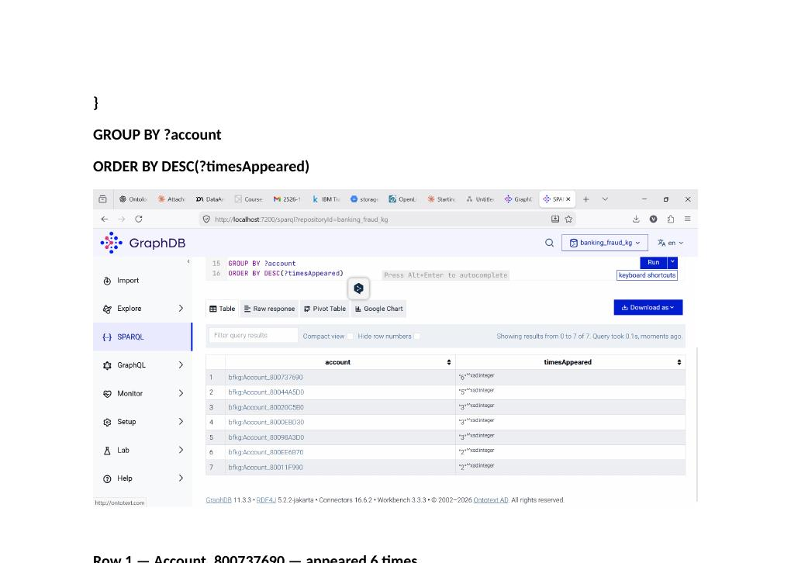
Figure 6 — Q6 GraphDB output: total transactions and laundered amount per pattern

What the output shows
This table produces a semantic summary of the entire suspicious subgraph — the financial fingerprint of the operation:
- Row 1 — GatherScatter — 5 transactions — $57,652.03 total. The most heavily used method and the one that moved the most money. Five transactions used to collect from multiple sources and scatter to different destinations. Over $57,000 moved through this single pattern. It is the preferred method because it is the hardest to trace.
- Row 2 — Cycle — 3 transactions — $25,000.00 total. Three transactions cycled $25,000 through accounts to disguise its origin. The loop makes it appear legitimately earned at each stop.
- Row 3 — FanOut — 4 transactions — $15,348.96 total. Four transactions dispersed money from one source to multiple receivers to break the trail.
Across just 12 transactions the knowledge graph has identified $98,000 in suspicious money movement across three distinct laundering patterns involving a coordinated network of accounts. A fraud investigator looking at a flat CSV would see 12 unrelated rows. The graph shows an organised operation with a preferred method, key accounts and a measurable financial footprint.

Part 2 — Full Dataset Queries · After Python Scaling · 5,177 Laundering Transactions
After converting the full IBM AML dataset to RDF using Python and loading 10,189 transactions into GraphDB, the following queries were run to validate the prototype findings and surface patterns at scale.

FD·Q1 Total Transactions in the Graph

SPARQL Code
SPARQL QUERY
PREFIX bfkg: <http://www.semanticweb.org/banking-fraud-kg#>

SELECT (COUNT(?t) AS ?totalTransactions)

WHERE {

?t a bfkg:Transaction .

}

GraphDB Result
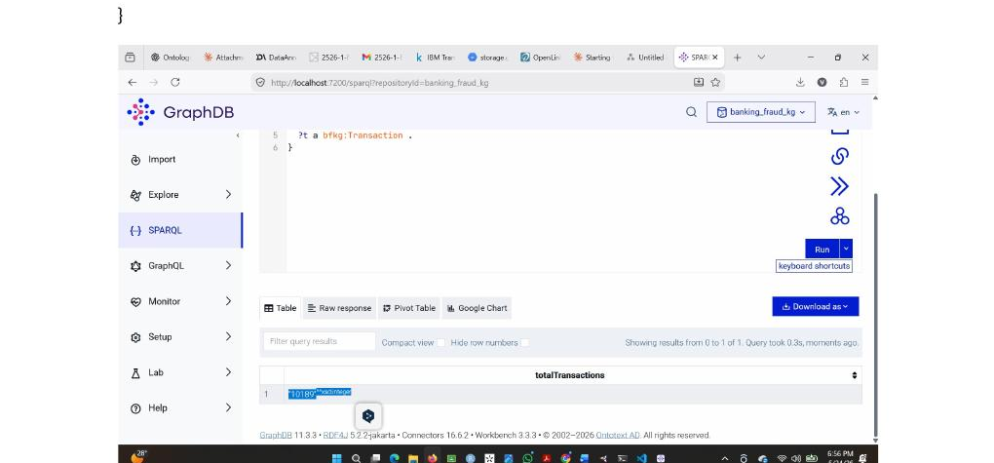
Figure 7 — FD·Q1 result: total transaction count confirming full dataset load

What the output shows
The result confirms that all 10,189 transactions loaded correctly into the graph — the 5,177 laundering cases from the IBM AML dataset plus 5,000 normal transactions for comparison, plus the 12 prototype transactions built manually in Protégé. Everything is accounted for and the graph is fully populated.

FD·Q2 Count of Confirmed Laundering Transactions

SPARQL Code
SPARQL QUERY
PREFIX bfkg: <http://www.semanticweb.org/banking-fraud-kg#>

SELECT (COUNT(?t) AS ?launderingCount)

WHERE {

?t a bfkg:Transaction ;

bfkg:isLaundering true .

}

GraphDB Result
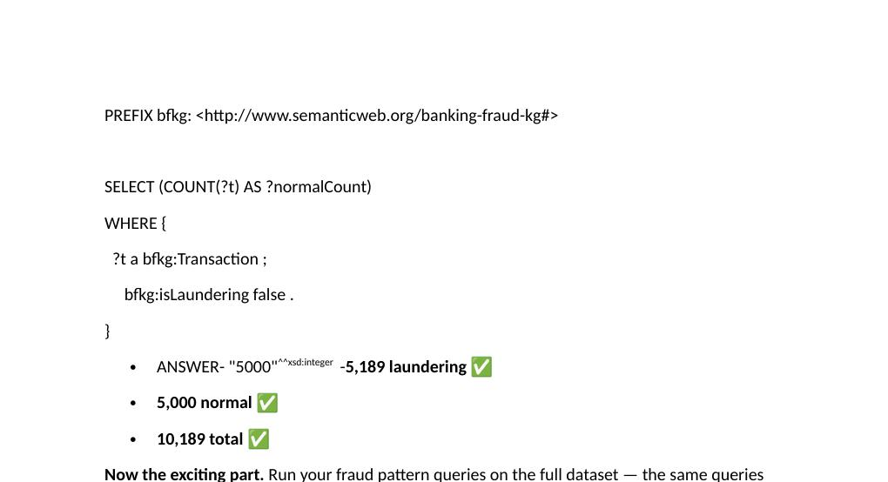
Figure 8 — FD·Q2 result: 5,189 confirmed laundering transactions in the graph

What the output shows
The result returns 5,189 laundering transactions — the 5,177 from the IBM CSV plus the 12 manually created in Protégé. The isLaundering property correctly tags every confirmed case from the source data. The knowledge graph is not only storing transactions but encoding their fraud status as a semantic property that can be queried directly.

FD·Q3 Fraud Leaderboard — Most Active Accounts in Laundering

SPARQL Code
SPARQL QUERY
PREFIX bfkg: <http://www.semanticweb.org/banking-fraud-kg#>

SELECT ?account (COUNT(?t) AS ?timesAppeared)

WHERE {

{

?t a bfkg:Transaction ;

bfkg:isLaundering true ;

bfkg:hasSenderAccount ?account .

}

UNION

{

?t a bfkg:Transaction ;

bfkg:isLaundering true ;

bfkg:hasReceiverAccount ?account .

}

}

GROUP BY ?account

ORDER BY DESC(?timesAppeared)

LIMIT 15

GraphDB Result
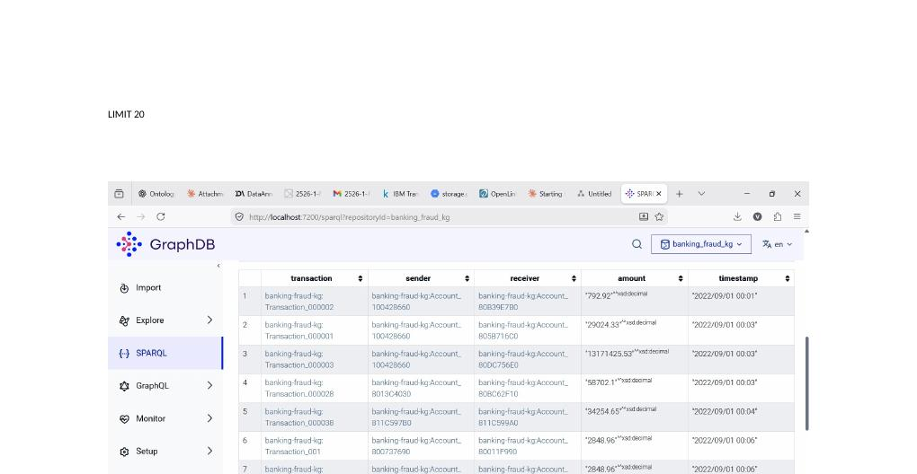
Figure 9 — FD·Q3 result: fraud leaderboard — top 15 accounts by laundering transaction appearances

What the output shows
Account_100428660 — 243 appearances in confirmed laundering transactions.
Not 10. Not 50. 243. This account was linked to 243 confirmed laundering transactions through SPARQL graph traversal across 5,177 transaction entities — a query that would require sequential manual scanning in a flat relational structure.
Row 2 — Account_1004286A8 — 158 appearances. Row 3 onwards shows a network of accounts all appearing between 27 and 52 times each — not individuals but a coordinated network of linked entities.
The story this tells:
In the 12-transaction prototype, Account_800737690 appeared 6 times and that was already suspicious. Now with the full dataset, Account_100428660 appears 243 times. That account is deeply embedded in a massive laundering network.
A bank analyst looking at 5 million flat CSV rows would never find this. The knowledge graph surfaced it through a single SPARQL query.

FD·Q4 Total Amount Laundered by Payment Format

SPARQL Code
SPARQL QUERY
PREFIX bfkg: <http://www.semanticweb.org/banking-fraud-kg#>

SELECT ?format (COUNT(?t) AS ?transactions) (SUM(?amount) AS ?totalAmount)

WHERE {

?t a bfkg:Transaction ;

bfkg:isLaundering true ;

bfkg:hasPaymentFormat ?format ;

bfkg:hasAmountPaid ?amount .

}

GROUP BY ?format

ORDER BY DESC(?totalAmount)

GraphDB Result
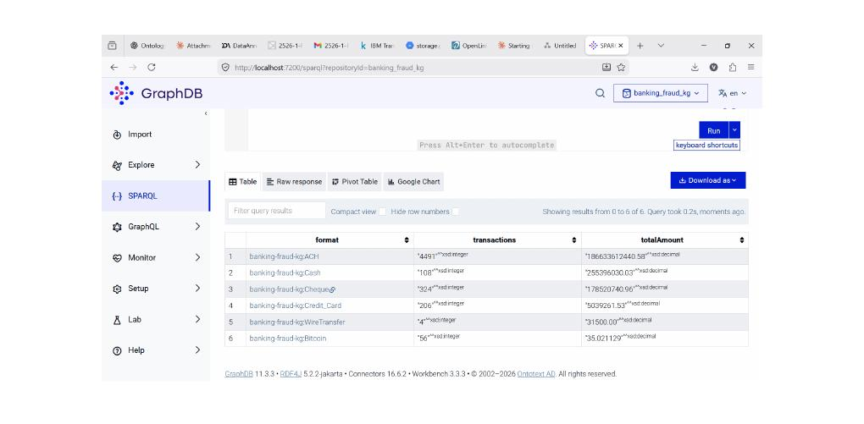
Figure 10 — FD·Q4 result: laundering volume and total amount by payment format — ACH dominates at 87%

What the output shows
ACH is the dominant laundering method.
- ACH — 4,491 transactions — $186 billion total
- Cheque — 324 transactions — $178 billion total
- Cash — 108 transactions — $255 million total
- Credit Card — 206 transactions — $5 million total
- Bitcoin — 56 transactions — $35 total
- Wire Transfer — 4 transactions — $31,500 total
ACH is used in 4,491 out of 5,177 laundering transactions — 87% of all laundering activity. ACH is an electronic bank transfer method that is fast, widely available, and harder to trace than cash. Launderers prefer it precisely because it moves large amounts quickly across banks.
The total amount moved through ACH alone is $186 billion — in just the laundering transactions in this dataset. That is the scale of the operation that the knowledge graph surfaces from a single query.

FD·Q5 Hub Accounts — Accounts Acting as Both Senders and Receivers

SPARQL Code
SPARQL QUERY
PREFIX bfkg: <http://www.semanticweb.org/banking-fraud-kg#>

SELECT ?account

(COUNT(DISTINCT ?sentIn) AS ?timesSent)

(COUNT(DISTINCT ?receivedIn) AS ?timesReceived)

WHERE {

?sentIn a bfkg:Transaction ;

bfkg:isLaundering true ;

bfkg:hasSenderAccount ?account .

?receivedIn a bfkg:Transaction ;

bfkg:isLaundering true ;

bfkg:hasReceiverAccount ?account .

}

GROUP BY ?account

ORDER BY DESC(?timesSent)

LIMIT 15

GraphDB Result
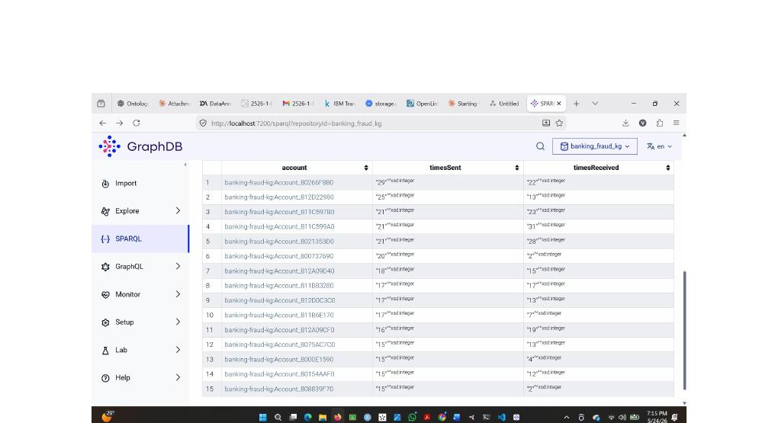
Figure 11 — FD·Q5 result: 15 hub accounts that are both sending and receiving laundering money

What the output shows
These are accounts that are both sending and receiving laundering money — active participants playing both roles in the network simultaneously.
- Row 1 — Account_80266F880: sent 29 times, received 22 times. Total 51 appearances. A hub sitting in the middle of the network moving money in both directions.
- Row 4 — Account_811C599A0: sent 21 times, received 31 times. Received more than it sent — a collection point gathering funds from multiple sources.
- Row 6 — Account_800737690: sent 20 times, received 2 times. This is the same account identified as suspicious in the 12-transaction prototype. Now in the full dataset its role is confirmed.
- Row 8 — Account_811B83280: sent 17 times, received 17 times — perfectly balanced. This account is simultaneously feeding money into the network and pulling money out in equal measure.
The prototype finding was not a coincidence. It was a genuine signal confirmed by the full data.
These accounts are doing something no normal account does — simultaneously feeding money into the network and pulling money out. That is the definition of a money laundering hub. The knowledge graph identified 15 of them in one query across 5,177 transactions.

Banking Fraud Knowledge Graph · DS2526 · UNIMIB · May 2026

