Experiment name:
To Study the Load Characteristics of a DC Shunt Generator.

Aim
To study the load characteristics of DC Shunt Generator. Draw the internal characteristics and external characteristics under different loading conditions.

Introduction
A DC shunt generator is a type of self-excited DC generator in which the field winding is connected in parallel (shunt) with the armature winding. As a result, the field current remains almost constant (since it depends only on the terminal voltage). The yoke of a DC generator is made of cast iron because it provides high magnetic permeability, good mechanical strength, and serves as a low-reluctance path for the magnetic flux.
The performance of a DC shunt generator is described using load characteristics, which illustrate how the terminal voltage and load current change as the load varies.

In a shunt generator, the field winding is connected in parallel with the armature winding so that the terminal voltage of the generator is applied across it. The shunt field winding has many turns of fine wire having high resistance. Therefore, only a part of the armature current flows through the shunt field winding, and the rest flows through the load. Fig. 1 shows the connections of a shunt wound generator. The armature current Ia splits up into two parts - a small fraction I_{sh} flowing through the shunt field winding, while the major part I_{L} goes to the external load.
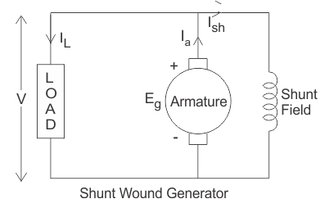
Fig. 1 Equivalent circuit of DC shunt generator for load characteristics

Losses in a DC Shunt Generator
In a DC shunt generator, various losses occur during operation, such as armature copper losses, shunt field copper losses, iron losses, and mechanical losses. Among these, armature copper losses constitute a significant portion of the total losses. The copper losses in the armature of a DC shunt generator are approximately 30% of the total full-load losses. These losses occur due to the resistance of the armature winding and increase with load current, thereby affecting the efficiency and voltage regulation of the generator.

Types of Characteristics

There are two main characteristics of a DC shunt generator:
- Internal characteristic
The internal characteristic curve represents the relation between the generated voltage (E_{g}) and the load current I_{L}. When the generator is loaded, the generated voltage decreases due to armature reaction. Therefore, the generated voltage will be lower than the emf generated at no load. Here, in Fig. 2, the AD curve shows the no-load voltage curve, and AB represents the internal characteristic curve.
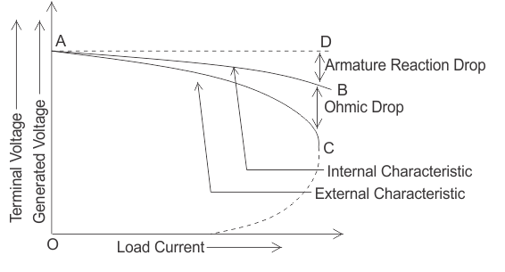Fig. 2 Characteristics of DC shunt generator

- External or Load characteristic
The external characteristic of a DC shunt generator represents the relationship between the terminal voltage (V) and the load current (I_{L}) while the generator is supplying power. It shows how the terminal voltage varies with changes in the load.
This characteristic is typically represented by a V–I_{L} graph. In Fig. 2, the AC curve represents the external characteristic of the DC shunt generator, showing the variation of terminal voltage with load current. Due to the ohmic drop in the armature resistance, the terminal voltage is lower than the generated voltage. Therefore, the external characteristic curve lies below the internal characteristic curve.
The terminal voltage is given by:
V = (E_{g} - I_{a} R_{a}) = Eg - (I_{L} + I_{sh})R_{a}
Where, V is the terminal voltage of the generator
Eg is the generated emf in the armature
Ia is armature current, and Ra is armature resistance
Ish is the current flowing through the shunt field winding
IL is the load current delivered to the external load connected to the generator

Behaviour of External Characteristics
When the load resistance of a DC shunt generator decreases, the load current (I_{L}) increases, as shown in the above figure. However, this increase in current is limited only up to point C, known as the breakdown point. Beyond this point, a further decrease in load resistance causes a decrease in load current, and the external characteristic curve reverses (shown by the dotted line). Eventually, the terminal voltage may drop to zero, except for a small value due to residual magnetism. The point at which the generator delivers maximum current is called the breakdown point (point C in the graph).
Advantages:
1. Provides nearly constant terminal voltage under light to medium load.
2. Stable operation within a certain load range.
3. Suitable for battery charging, lighting, and excitation purposes where steady voltage is required.
4. Simple voltage control by adjusting the field current.

Disadvantages:

1. Poor voltage regulation at high load current.
2. Stability decreases with decreasing load resistance.
3. Depends on residual magnetism for initial voltage build-up.
4. Breakdown point limitation: beyond a certain load current, the characteristic curve reverses.

- Procedure

STEP 1: Make Connections as per the instructions given below:
From | R | R | B | B | A2 | L | F | A | L2 | A4 | Z4 | I | J | H | H
To | C | E | G | A2 | Z2 | D | Z1 | A1 | A4 | Z4 | K | J | L1 | A3 | Z3

STEP 2: Click on the "Check" Button to check the connections.
STEP 3: If connections are correct, the Supply will be turned ON.
STEP 4: Select the No. of Bulbs from the Lamp load.
STEP 5: Click on the "Add" Button to add the values to the Observation Table.
STEP 6: Add different values to the Table by increasing the lamp load.
STEP 7: Click on the "Graph" Button to Create a Graph.
STEP 8: Click on the "Print" Button to print the webpage.
STEP 9: Click on the "Reset" Button to reset the webpage.

