SIMULATION

Components window: Now that you are familiar with all the components used in this experiment, you may now start the simulation. (In a One Time)

An AI guide is available to assist you at every step. - alert and audio

Autoconnect: Autoconnect completed. Click on the check button to verify the connections. - audio

DC Supply ON: DC supply has been turned ON. Now move the starter handle from left to right. - alert and audio

Between Exp. DC Supply OFF: You turned off the DC Supply. Turn it back on to continue the simulation. - alert and audio

After starter ON: Now, set the armature rheostat. -audio

Before adding reading, Add To Table: First, set the armature rheostat. -alert and audio

During First Reading

Armature Rheostat Set: Armature resistance is set. Voltage is 220 volt. Now, vary the field resistance by moving the rheostat knob to take the reading.

Field Rheostat Variation (1st time): Field current is 0.48 A and speed is 1100 RPM. Now, click on the add to table button to add the reading to the observation table. -audio

1st reading added: Reading added successfully. Now, vary the field resistance again to take the next reading. -audio

For Duplicate Reading: This reading is already added to the table. (Duplicate Reading for heading) -alert and audio

Field Rheostat 2nd time: Field current is 0.44 A and speed is 1130 RPM. Now, click add to table button again. -audio

2nd reading added: Reading added successfully. Now, vary the field resistance again to take the next reading. -audio

Field Rheostat 3rd time: Field current is 0.40 A and speed is 1153 RPM. Now, click add to table button again. -audio

3rd reading added: Reading added successfully. Now, vary the field resistance again to take the next reading. -audio

Field Rheostat 4th time: Field current is 0.38 A and speed is 1192 RPM. Now, click add to table button again to add reading in the table. -audio

Field Rheostat 5th time: Field current is 0.32 A and speed is 1222 RPM. Now, click add to table button again to add reading in the table. -audio

Field Rheostat 6th time: Field current is 0.30 A and speed is 1263 RPM. Now, click add to table button again to add reading in the table. -audio

Field Rheostat 7th time: Field current is 0.28 A and speed is 1312 RPM. Now, click add to table button again to add reading in the table. -audio

After 5 readings Graph: You have added five readings. Now you can plot the graph by clicking on the graph button or add more readings to the table. -audio

After 7 readings done: All 7 readings have been recorded. Now plot the graph and then click on the report button to generate your report. -audio

For max. readings: You can add a maximum of 7 readings to the table. Now, click the Graph button. -alert and audio

Graph: The graph of speed vs field current has been plotted successfully. Your experiment is now complete. You may view the report by clicking on the report button, then use print to print the page or reset to start again. -audio

Report: Your report has been generated successfully. Click OK to view your report. -alert and audio

Reset: The simulation has been reset. You can start again. -alert and audio

Print: Opening the print dialog. -audio

Progress Report: To access the progress report, first fill out the user form and generate the simulation report by performing the experiment.

Before connection, check button: Please make all the connections first. -alert and audio

Before connection, on-click DC Supply Alert: Make and check the connections before turning on the DC Supply. -alert

After making correct connections, check the button: Connections are correct, click on the DC Supply to turn it ON. -alert and audio
Turn_off_DCSupply_before_removing conn: Turn off the DC Supply before removing the connections. -alert and audio
Reading added: Reading added to the observation table. (without audio alert - 1st reading only)

Connections: Let’s connect the components.

Correct Connections:
- Connect point A to point P
- Connect point B to point K
- Connect point B to point Y
- Connect point B to point J
- Connect point Q to point L
- Connect point G to point R
- Connect point E to point M
- Connect point F to point D
- Connect point H to point I
- Connect point I to point C
- Connect point C to point H

Wrong connection: This connection is wrong. -audio

While clicking on the Check button

Multiple wrong connections: Some connections are wrong. -audio

PRETEST

1. The speed of a DC shunt motor is directly proportional to:
Answer: c) Back emf and inversely proportional to flux

2. Which of the following equations represents the speed of a DC motor?
Answer: a) N = V−I_{a}R_{a}/Kφn

3. In the field control method of speed control, speed is varied by:
Answer: c) Changing field current

4. When the field resistance of a DC shunt motor is increased, the speed:
Answer: a) Increases

5. The field control method is suitable for:
Answer: a) Speeds above rated speed

6. The torque of a DC motor is proportional to:
Answer: c) Product of armature current and flux

7. The flux in a DC motor is directly proportional to:
Answer: b) Field current

8. Which component controls the field current in a DC shunt motor?
Answer: b) Field rheostat

9. Which of the following is a disadvantage of the field control method?
Answer: d) All of the above

10. The speed of a DC motor increases if the field current is:
Answer: b) Decreased

11. If field resistance is increased too much, the motor may:
Answer: c) Run dangerously fast

12. The field control method is also known as:
Answer: c) Flux control method

13. In the field control method, power loss is:
Answer: b) Low

14. What will happen if the field winding of a DC motor opens during operation?
Answer: b) Motor speed will increase uncontrollably

15. Why is the field control method preferred for light loads?
Answer: d) Because the torque requirement is low

16. In field control of a DC shunt motor, which parameter is intentionally weakened to increase speed?
Answer: b) Field flux

17. Field control method is most effective in which type of DC motor?
Answer: b) Shunt motor

18. Which of the following remains approximately constant during field control speed regulation?
Answer: b) Supply voltage

19. In field control, weakening the field mainly affects which motor characteristic?
Answer: c) Torque capability

20. Field control is generally not suitable for heavy loads because:
Answer: c) Torque reduces with flux weakening

POSTTEST
1. What happens to the speed of a DC shunt motor when field resistance is increased?
Answer: b) Speed increases

2. The relation between speed (N) and flux (Φ) for a DC motor is:
Answer: b) N∝1/Φ

3. During the experiment, what variable is controlled to change the motor speed?
Answer: b) Field current

4. When the field current decreases, the flux:
Answer: b) Decreases

5. The field rheostat in the experiment is used to:
Answer: b) Vary the field current

6. In the speed vs field current curve obtained experimentally, the curve is:
Answer: c) Hyperbolic

7. Why does the motor speed increase when the field resistance is increased?
Answer: c) Flux decreases

8. In the field control method, the torque of the DC motor:
Answer: b) Decreases with a decrease in field current

9. What happens if the field circuit opens while the motor is running?
Answer: c) Motor speed rises dangerously

10. The experimental readings typically include measurements of:
Answer: a) Field current, armature current, speed

11. The constant k in the speed equation N = V−I_{a}R_{a}/kΦN depends on:
Answer: a) Motor construction

12. The maximum safe operating speed of the DC motor is called:
Answer: a) Rated speed

13. If the field resistance is decreased, the motor speed will:
Answer: b) Decrease

14. What is the typical range of speed control achieved using the field resistance method?
Answer: b) Above rated speed

15. What safety precaution must be ensured during the experiment?
Answer: b) Do not open the field circuit while the motor is running

16. From the experimental results, if the field current is reduced by 50%, the motor speed will:
Answer: c) Increase significantly depending on flux

17. Which conclusion can be drawn from the speed vs field current graph obtained in the experiment?
Answer: c) Speed is inversely proportional to field current

18. Why is field control not suitable for precise low-speed control?
Answer: b) Because flux cannot be increased beyond rated value

19. In the experiment, weakening the field beyond a limit may lead to:
Answer: c) Mechanical stress and unsafe operation

20. Based on the experiment, which statement is correct for practical applications?
Answer: b) Field control is suitable for high-speed, light-load operation
Aim
To study the speed control of a DC Motor by the field resistance control method, and plot the graph between the field current and motor speed by varying the field resistance.

Theory:
Introduction:
A DC motor is an electromechanical machine that converts electrical energy (DC) into mechanical energy (rotation). It works on the principle that when a current-carrying conductor is placed in a magnetic field, it experiences a mechanical force.

Methods of Speed Control of DC Motors
There are three primary methods to control the speed of a DC motor:
- Field resistance control method
- Armature resistance control method
- Voltage control method
In this experiment, we are using the field resistance control method to control the speed of a DC shunt motor.
A DC shunt motor is a direct-current motor in which the field winding is connected in parallel (shunt) with the armature winding. Because both windings receive the same supply voltage, the field current remains nearly constant, giving the motor good speed regulation.
In a shunt motor:
- The field winding has many turns of fine wire and produces the required magnetic field with a small current.
- The armature winding draws the main current needed for torque production.
- Since the flux remains almost constant, the speed mainly depends on the armature voltage and the load.

Field Resistance Control Method
The speed of a DC shunt motor is given by the equation:
N = (Va − IaRa) / (kΦ)
Where:
- N = Rotational speed of the motor (rpm)
- Va = Voltage applied across the armature
- Ia = Armature current
- Ra = Armature resistance
- Φ = Flux per pole
- k = Motor constant
The motor constant k depends on the construction of the motor, such as:
- Number of poles
- Number of armature conductors
- Type of winding (lap or wave)
In a shunt motor, the field flux Φ is directly proportional to the field current (If).
Φ ∝ If

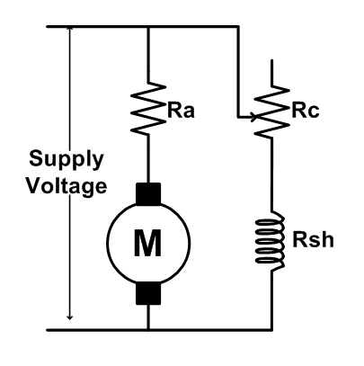

(Insert Fig. 1: Equivalent circuit for field control of DC shunt motor)

This method controls speed by adding an external resistance in series with the shunt field winding, as shown in Fig. 1.
The field winding produces the magnetic flux that interacts with the armature to develop torque. Because the flux Φ in a shunt motor is directly proportional to the field current (If), increasing the resistance in the field circuit reduces the field current.
When the field current decreases, the flux becomes weaker.
According to the speed equation of a DC motor, motor speed is inversely proportional to the flux. Therefore, a reduction in flux causes the speed to increase.
The detailed mechanism is as follows:
Weakening the flux initially reduces the back EMF:
Eb = KΦN
This momentarily increases the armature current (Ia). The increased armature current produces higher torque, which accelerates the motor.
As the motor accelerates, the back EMF rises again until it reaches a new equilibrium value where the electrical and mechanical conditions balance.
This new balance occurs at a higher speed because the weakened flux requires a higher speed to generate the necessary back EMF.
Thus, field resistance control allows smooth speed increase above the rated speed but cannot reduce speed below the normal value, since the field current cannot be increased beyond its rated safe limit.
Additionally, since torque is proportional to both flux and armature current, weakening the flux reduces the motor’s torque capacity. Therefore, this method is suitable mainly for light-load, high-speed applications.
Thus, the speed of the motor increases as the field current decreases, and speed control above the base speed can be achieved.

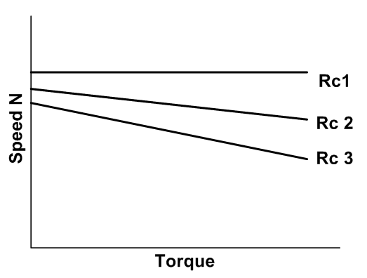
(Insert Fig. 2: Speed–Torque Characteristics of DC Shunt Motor)

Advantages
- By reducing the field flux, the motor can achieve speeds higher than its rated (base) speed without changing the armature voltage.
- Only a small variable resistor is required in the field circuit, making the method simple, inexpensive, and easy to implement.
- The low current in the field circuit causes very little loss and heat.

Disadvantages
- This method can only increase speed and cannot reduce it below the rated speed.
- Weakening the field reduces flux, leading to a proportional drop in torque, making the motor unsuitable for high-torque applications.
- Excessive field weakening may cause the motor to run dangerously fast and become unstable

