Aim
To study the speed control of a DC Motor by the field resistance control method, and plot the graph between the field current and motor speed by varying the field resistance.

Theory:
Introduction:
A DC motor is an electromechanical machine that converts electrical energy (DC) into mechanical energy (rotation). It works on the principle that when a current-carrying conductor is placed in a magnetic field, it experiences a mechanical force.

Methods of Speed Control of DC Motors
There are three primary methods to control the speed of a DC motor:
- Field resistance control method
- Armature resistance control method
- Voltage control method
In this experiment, we are using the field resistance control method to control the speed of a DC shunt motor.
A DC shunt motor is a direct-current motor in which the field winding is connected in parallel (shunt) with the armature winding. Because both windings receive the same supply voltage, the field current remains nearly constant, giving the motor good speed regulation.
In a shunt motor:
- The field winding has many turns of fine wire and produces the required magnetic field with a small current.
- The armature winding draws the main current needed for torque production.
- Since the flux remains almost constant, the speed mainly depends on the armature voltage and the load.

Field Resistance Control Method
The speed of a DC shunt motor is given by the equation:
N = (Va − IaRa) / (kΦ)
Where:
- N = Rotational speed of the motor (rpm)
- Va = Voltage applied across the armature
- Ia = Armature current
- Ra = Armature resistance
- Φ = Flux per pole
- k = Motor constant
The motor constant k depends on the construction of the motor, such as:
- Number of poles
- Number of armature conductors
- Type of winding (lap or wave)
In a shunt motor, the field flux Φ is directly proportional to the field current (If).
Φ ∝ If

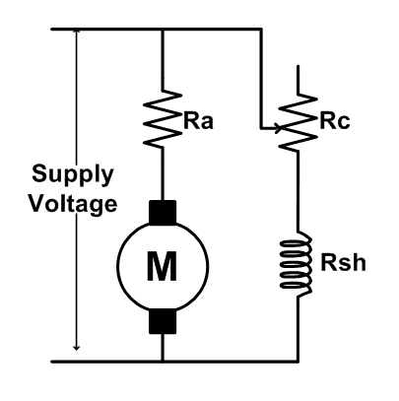

(Insert Fig. 1: Equivalent circuit for field control of DC shunt motor)

This method controls speed by adding an external resistance in series with the shunt field winding, as shown in Fig. 1.
The field winding produces the magnetic flux that interacts with the armature to develop torque. Because the flux Φ in a shunt motor is directly proportional to the field current (If), increasing the resistance in the field circuit reduces the field current.
When the field current decreases, the flux becomes weaker.
According to the speed equation of a DC motor, motor speed is inversely proportional to the flux. Therefore, a reduction in flux causes the speed to increase.
The detailed mechanism is as follows:
Weakening the flux initially reduces the back EMF:
Eb = KΦN
This momentarily increases the armature current (Ia). The increased armature current produces higher torque, which accelerates the motor.
As the motor accelerates, the back EMF rises again until it reaches a new equilibrium value where the electrical and mechanical conditions balance.
This new balance occurs at a higher speed because the weakened flux requires a higher speed to generate the necessary back EMF.
Thus, field resistance control allows smooth speed increase above the rated speed but cannot reduce speed below the normal value, since the field current cannot be increased beyond its rated safe limit.
Additionally, since torque is proportional to both flux and armature current, weakening the flux reduces the motor’s torque capacity. Therefore, this method is suitable mainly for light-load, high-speed applications.
Thus, the speed of the motor increases as the field current decreases, and speed control above the base speed can be achieved.

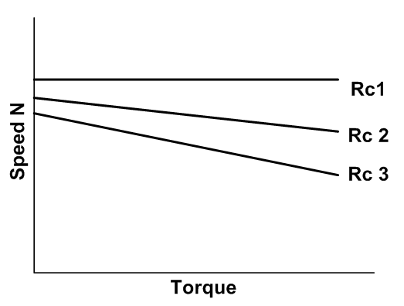
(Insert Fig. 2: Speed–Torque Characteristics of DC Shunt Motor)

Advantages
- By reducing the field flux, the motor can achieve speeds higher than its rated (base) speed without changing the armature voltage.
- Only a small variable resistor is required in the field circuit, making the method simple, inexpensive, and easy to implement.
- The low current in the field circuit causes very little loss and heat.

Disadvantages
- This method can only increase speed and cannot reduce it below the rated speed.
- Weakening the field reduces flux, leading to a proportional drop in torque, making the motor unsuitable for high-torque applications.
- Excessive field weakening may cause the motor to run dangerously fast and become unstable

