 {

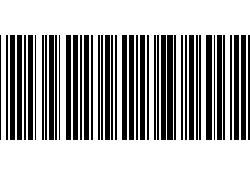 {{ record.product_id.odm_name or record.product_id.name }}

{{record.product_id.barcode|replace_barcode(type='code39',width=0.1,height=3,name='barcode')}}

PN: {{record.product_id.barcode}} {{(record.product_id.manufacturer_id.label_image_1920 or env.company.partner_id.image_1920)|replace_image(name=’logo’)}}