МИНИСТЕРСТВО НАУКИ И ВЫСШЕГО ОБРАЗОВАНИЯ  
РОССИЙСКОЙ ФЕДЕРАЦИИ

федеральное государственное автономное   
образовательное учреждение высшего образования  
«Самарский национальный исследовательский университет   
имени академика С.П. Королева»

(Самарский университет)

Институт информатики, математики и электроники

Факультет информатики  
Кафедра суперкомпьютеров и общей информатики

**Отчет по лабораторной работе № 1**

Дисциплина: «Enterprise Systems Development (Методы проектирования и поддержки требований к программному обеспечению)»

Тип предприятия: **Meeting App «TimeToMeet»**

Выполнил: Коршиков В. И.

Группа: 6133-010402D

Самара 2022

**СОДЕРЖАНИЕ**

1 Assignment #1. IDEF0 diagram Tasks 3

Assignment #1. IDEF0 diagram TimeToMeet IDEF0 4

# 1 Assignment #1. IDEF0 diagram Tasks

Tasks

1. Create valid IDEF0 diagrams for the general company processes up to 3d level detailing. At 3d decomposition level should be at least one process with at least two actors collaboration.

2. Add IDEF0 diagrams images to doc report.

For IDEF0 diagram plotting you can use:

* <https://app.diagrams.net/> (ex. draw.io)
* Draw.io desktop (<https://github.com/jgraph/drawio-desktop/releases>) for your Linux, Mac or Windows
* Ramus Educational (<https://github.com/Vitaliy-Yakovchuk/ramus>). Looks like dead and does not work with modern JRE.
* Microsoft Visio (non-Free).
* Another available software tools (Libre Office Impress, draw.io, etc.).

Notice

You have to prepare at least 4 diagrams: A-0, A0, 2 or more decomposed A0 blocks.

|  |  |
| --- | --- |
| Model level |  |
| 0 | Top level A-0, one block. Arrows show object connection with environment. |
| 1 | A0. First level, contain top processes. |
| 2 | Second level, top processes decompositions. You have to show at least 2 decomposed A0 blocks. |

References

1. IDEF0 <https://en.wikipedia.org/wiki/IDEF0>

2. FIPS PUB 183, Integration Definition for Function Modeling (IDEF0), National Institute for Standards and Technology, December 1993. <https://nvlpubs.nist.gov/nistpubs/Legacy/FIPS/fipspub183.pdf>

3. ISO/IEC/IEEE 31320-1:2012(en) Information technology — Modeling Languages — Part 1: Syntax and Semantics for IDEF0 [https://www.iso.org/obp/ui/#iso:std:iso-iec-ieee:31320:-1:ed-1:v1:en](https://www.iso.org/obp/ui/" \l "iso:std:iso-iec-ieee:31320:-1:ed-1:v1:en)

# Assignment #1. IDEF0 diagram TimeToMeet IDEF0

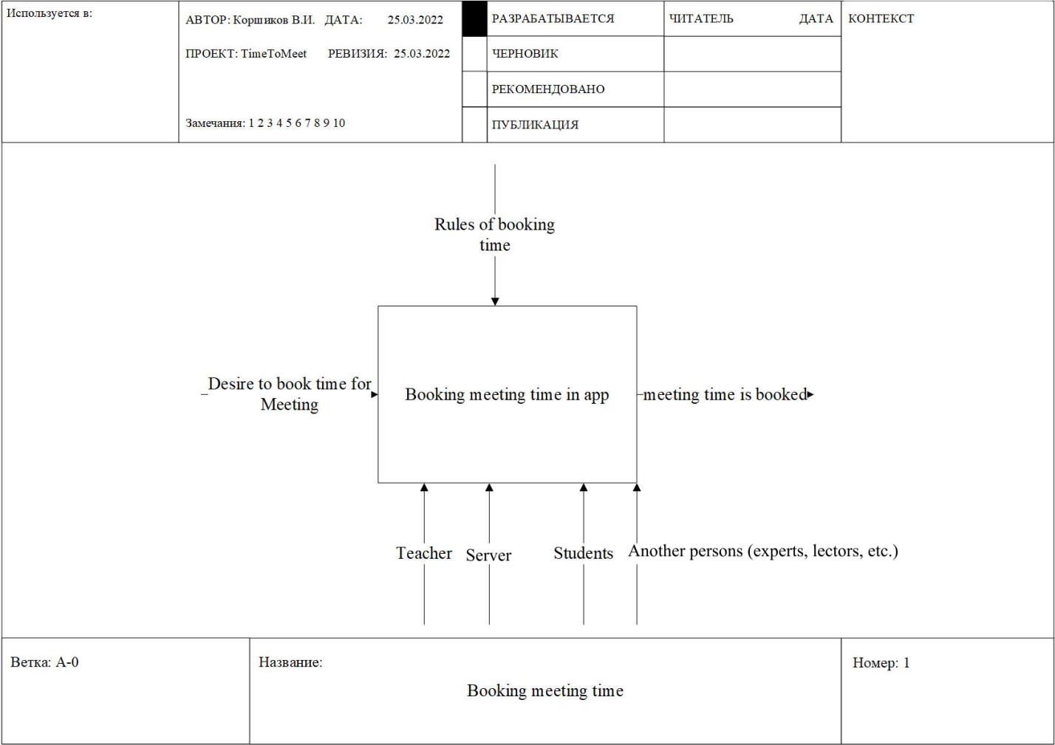

Purpose: Booking meetings and improving time management

Viewpoint: Technical Supporting Team of the University

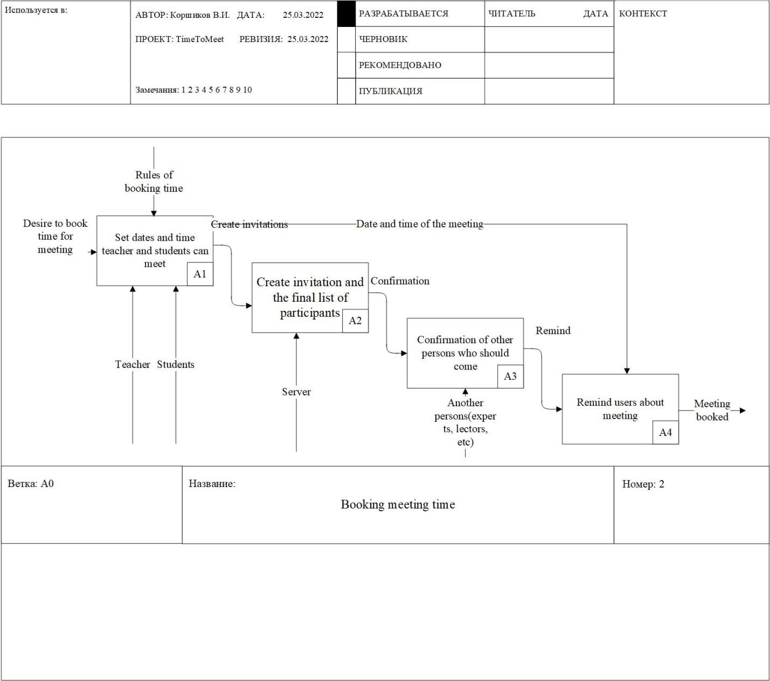

Purpose: Booking meetings and improving time management

Viewpoint: Technical Supporting Team of the University

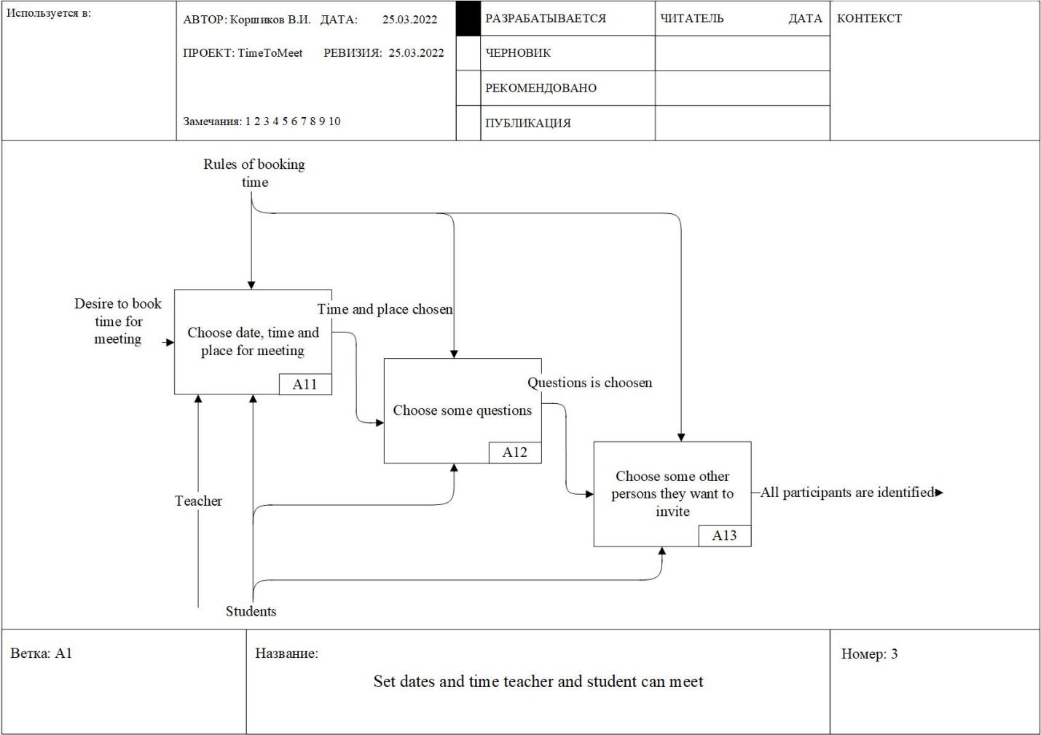

Purpose: Selecting date, time and place of meeting

Viewpoint: System administrator

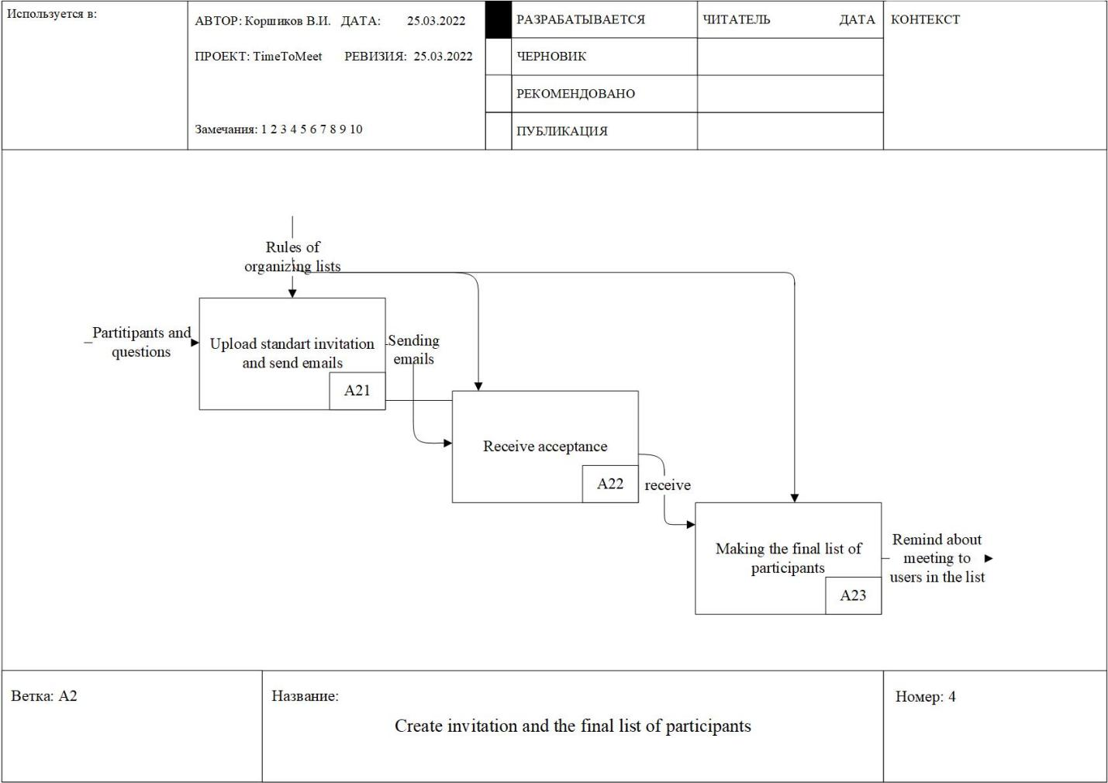

Purpose: Set up automatic sending of messages to specified emails

Viewpoint: System administrator