МИНИСТЕРСТВО НАУКИ И ВЫСШЕГО ОБРАЗОВАНИЯ  
РОССИЙСКОЙ ФЕДЕРАЦИИ

федеральное государственное автономное   
образовательное учреждение высшего образования  
«Самарский национальный исследовательский университет   
имени академика С.П. Королева»

(Самарский университет)

Институт информатики, математики и электроники

Факультет информатики  
Кафедра суперкомпьютеров и общей информатики

**Отчет по лабораторной работе № 2**

Дисциплина: «Enterprise Systems Development (Методы проектирования и поддержки требований к программному обеспечению)»

Тип предприятия: **Meeting App «TimeToMeet»**

Выполнил: Коршиков В. И.

Группа: 6133-010402D

Самара 2022

**СОДЕРЖАНИЕ**

1 Assignment #2. IDEF0 diagram Tasks 3

2 Assignment #2. IDEF0 diagram TimeToMeet IDEF0 4

3

# 4 Лабораторная работа №2. Specification of system requirements. Use Case diagram. Scenarios

## 1. Task №1.

A meeting app was chosen as the type of company.

The purpose of the system: booking meetings with teachers for students.

Actors: students, teacher, server.

## 2. Task №2.

The information system allows:

1. Registration and authorisation (login and logout);

2. Date and time selection;

3. Choice of the place;

4. Choose some questions (make agenda);

5. Send invitation to the participants(teacher, students, guests).

First of all, students and teachers have to log in, because we have to make a list of participants for meeting. This app is also collect meta information for every meeting. Invitation on meeting is a pdf file with a QR code, it includes an information about date, time and place.

## 3 Task №3.

Glossary:

Student - user, who can come to any meetings and add questions in agenda (qurestion list).

Teacher - user, who can arrange meeting, choose time and place nd add questions in agenda (qurestion list), and discuss some .

Guests - non-user, who was invited into the meeting.

Participants - teacher, students and guests.

Server - the app server, that provides to booking meetings.

## 4. Task №4.

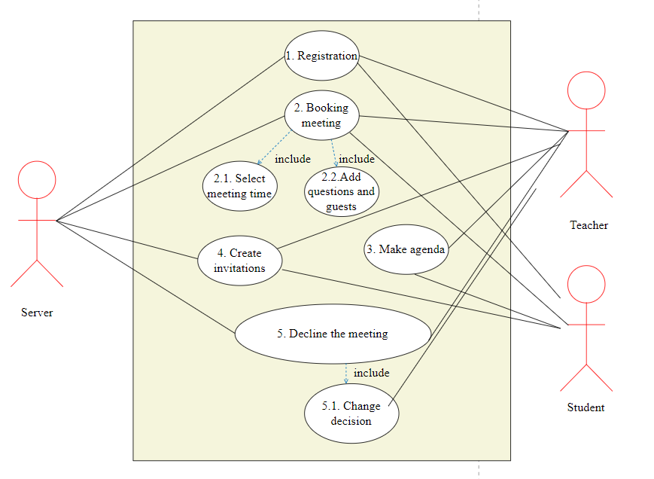  
 Use Case диаграмма

## 5. Task №5.

***Use Case 1***

**Use Case:** Registration

**Actors:** Server / Teacher/Student

**Goal:** Login to account or create new

**Short description:** Student or teacher login into account to book the meeting.

**Scenario:**

1. User connects to website to start book the meeting
2. User choose his role “Student/Teacher” and “I’m new”
3. User fills out form

Input form:

Email: __________

Password: _______

Full name:_______

Institute:__________

1. User choose his role “Student/Teacher” and “Start”
2. Client fills out form

Input form:

Email: _______

Password: ____

1. User click button “Go”

***Use Case 2***

**Use Case:** Booking meeting

**Actors:** Teacher/Students/Server

**Goal:**  Arrange meeting

**Short description:** Finalize details of the meeting

**Scenario:**

1. Teacher goes into app and decide date and time he can arrange meeting
2. Students decide, when they can go into meeting and choose one of the variants teacher offers

View: Meeting times listed one after another

Characteristics: Meeting times features shown in the meeting time list (full name of the teacher, date, time, maximum of participants).

Filters: Students can filter meeting times by the full name of the teacher, date, time and maximum of participants.

Search: The client can search for tickets by teacher’s name,date, time and maximum of participants.

***Use Case 2.1***

**Use Case:** Select meeting time

**Actors: Student**

**Goal:** The student chooses the meeting time he likes

**Short description:** The student selects the meeting time he likes using filters

**Scenario:**

1. The student uses filters or search
2. The student clicks the "Search" button
3. The student chooses a meeting time suitable for all his conditions
4. The student click “Next” button

***Use Case 2.2***

**Use Case:** Add questions and guests

**Actors:** Student / Server

**Goal:** Adding questions and guests

**Short description:** Adding questions and guests into lists

**Scenario:**

1. The student goes to the questions page
2. The student adding questions he like
3. The student goes to the guests page
4. The student adding guests he like

***Use Case 3***

**Use Case:** Make agenda

**Actors:** Teacher, students

**Goal:** Make a list of questions

**Short description:** The server generates a unique ticket

**Scenario:**

1. Teacher adds some questions into agenda
2. Students adds some questions into agenda

***Use Case 4***

**Use Case:** Create an invitations

**Actors:** Teacher, Students, Server

**Goal:** Send out invitations to the all participants

**Short description: A**utogenerate and send invitations

**Scenario:**

1. Teacher and students choose participants
2. Server autogenerate invitations
3. Server send emails into emails in participants list

***Use Case 5***

**Use Case:** Decline the meeting

**Actors:** Teacher, server

**Goal:** Choose place for a meeting

**Short description:** Send cancel notifications to the participants

**Scenario:**

1. Teacher click “Cancel of the meeting” and choose meeting to cancel

Input form: Reason: _____________

1. Server autogenerate cancel
2. Server send emails into participants in participants list

***Use Case 5.1***

**Use Case:** Change decision

**Actors:** Teacher, server

**Goal:** Change decision about cancelation

**Short description:** Teacher decided to arange meeting that was canceled

**Scenario:**

1. Teacher click “Change decision” and choose meeting he canceled

Input form: Reason: _____________

1. Server autogenerate invitations
2. Server send emails into participants in participants list

## 6. Task №6.

