МИНИСТЕРСТВО НАУКИ И ВЫСШЕГО ОБРАЗОВАНИЯ  
РОССИЙСКОЙ ФЕДЕРАЦИИ

федеральное государственное автономное   
образовательное учреждение высшего образования  
«Самарский национальный исследовательский университет   
имени академика С.П. Королева»

(Самарский университет)

Институт информатики, математики и электроники

Факультет информатики  
Кафедра суперкомпьютеров и общей информатики

**Отчет по лабораторной работе № 5**

Дисциплина: «Enterprise Systems Development (Методы проектирования и поддержки требований к программному обеспечению)»

Тип предприятия: **Meeting App «TimeToMeet»**

Выполнил: Коршиков В. И.

Группа: 6133-010402D

Самара 2022

**СОДЕРЖАНИЕ**

**СОДЕРЖАНИЕ**

1 Assignment #5. Class diagram. Tasks 3

2 Assignment #5 Class diagram TimeToMeet 4

3 Assignment #5 Table with comments TimeToMeet 5

# 1 Assignment #5. Class diagram. Tasks

Objective: To study the basic features for creating and editing class diagrams

Tasks

1. Study the possibility of describing the static structure of the information system. Learn how to allocate in the system of the basic classes and describe their properties and behavior. Create Class diagram. Describe at least 5 classes with relations.

2. Add Class diagram image to doc report.

3. Add table with comments:

|  |  |  |
| --- | --- | --- |
| Class name | Attributes/Methods | Data type/Comment about method assigment |
| Class1 | Attribute1 | Char[100] |
|  | Method1 | This method adds new list… |
|  | … |  |

**Assignment #5 Class diagram TimeToMeet**

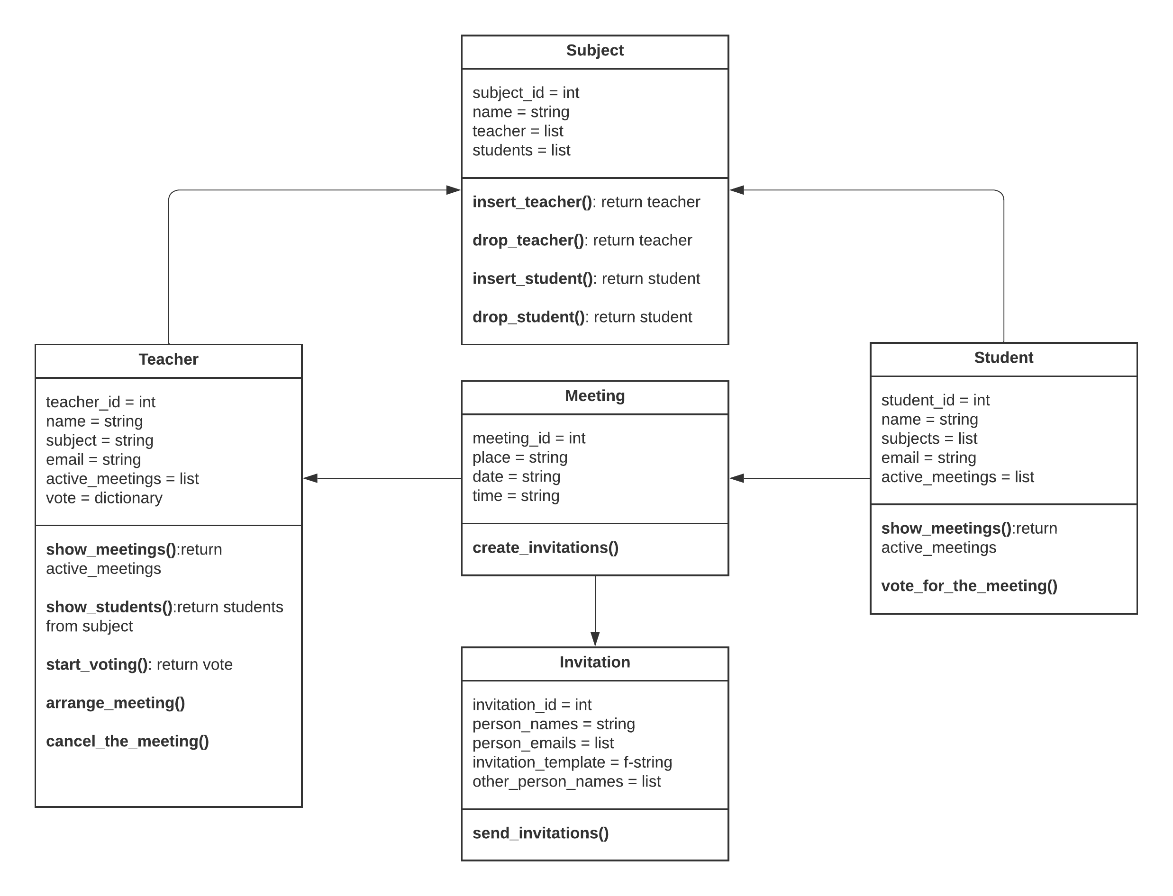

**Assignment #5 Table with comments TimeToMeet**

| Class name | Attributes/Method | Data type/Comment |
| --- | --- | --- |
| Teacher | teacher_id | int |
| name | string |
| subjects | list |
| email | string |
| active_meetings | list |
| vote | dictionary |
| show_meetings() | This method shows active meetings for teacher |
| show_students() | This method shows students who are subscribed for the subject |
| start_voting() | This method let teachers start voting for the meeting |
| arrange_meeting() | This method let teacher to arrange meeting |
| cancel_the_meeting() | This method let teacher cancel the meeting |
| Meeting | Meeting_id | int |
| place | string |
| date | string |
| time | string |
| teacher | string |
|  | create_invitation() | This method create invitations |
| Students | student_id | int |
| name | string |
| subjects | list |
| active_meetings | list |
| show_meetings() | This method shows active meetings for teacher |
| vote_for_the_meeting() | This method let student vote for a meeting |
| Invitation | invitation_id | int |
| persons_name | list |
| persons_emails | list |
| invitation_template | f-string |
| other_persons_list | list |
| send_invitations() | This method send invitations to emails on subject’s list + other persons’s list |
| Subject | subject_id | int |
| name | string |
| teacher | list |
| students | list |
| insert_teacher() | This method let subscribe teachers on subject |
| drop_teacher() | This method let unsubscribe teachers on subject |
| insert_student() | This method let subscribe students on subject |
| drop_student() | This method let unsubscribe students on subject |

**Task №1:** Sequence diagram: booking meeting time

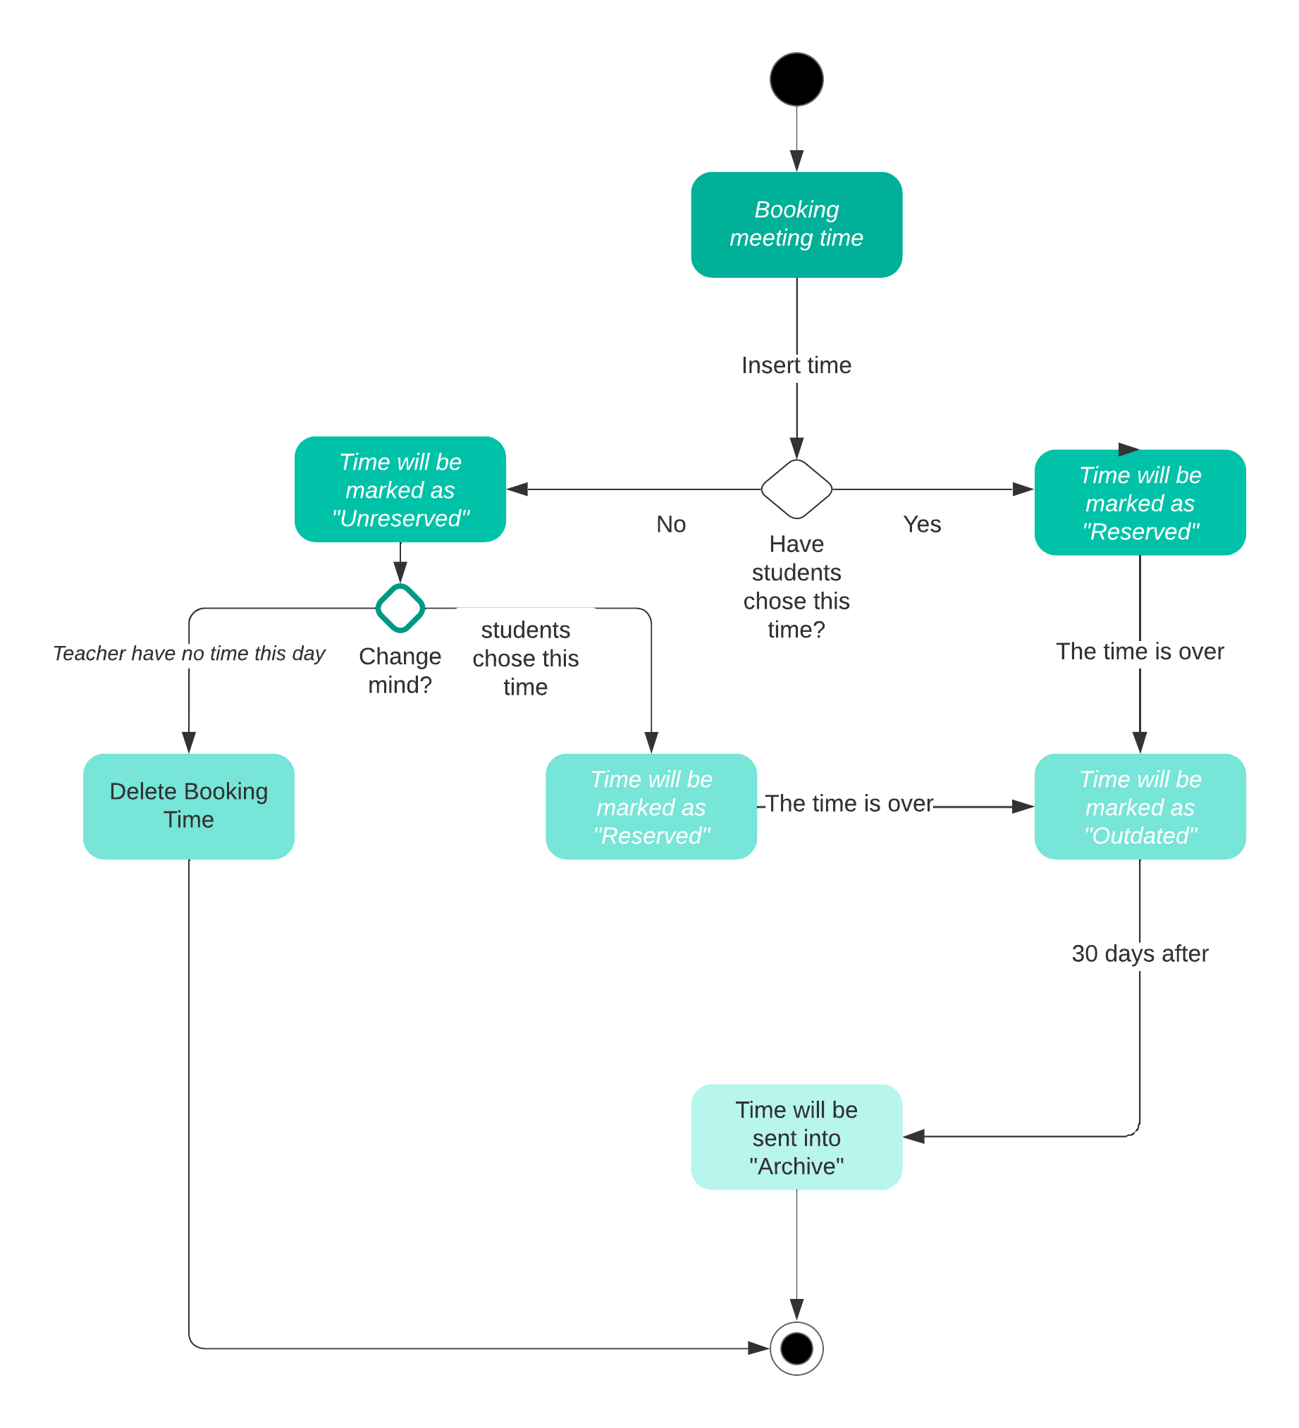

**Task №2:** State diagram: Choosing time and place

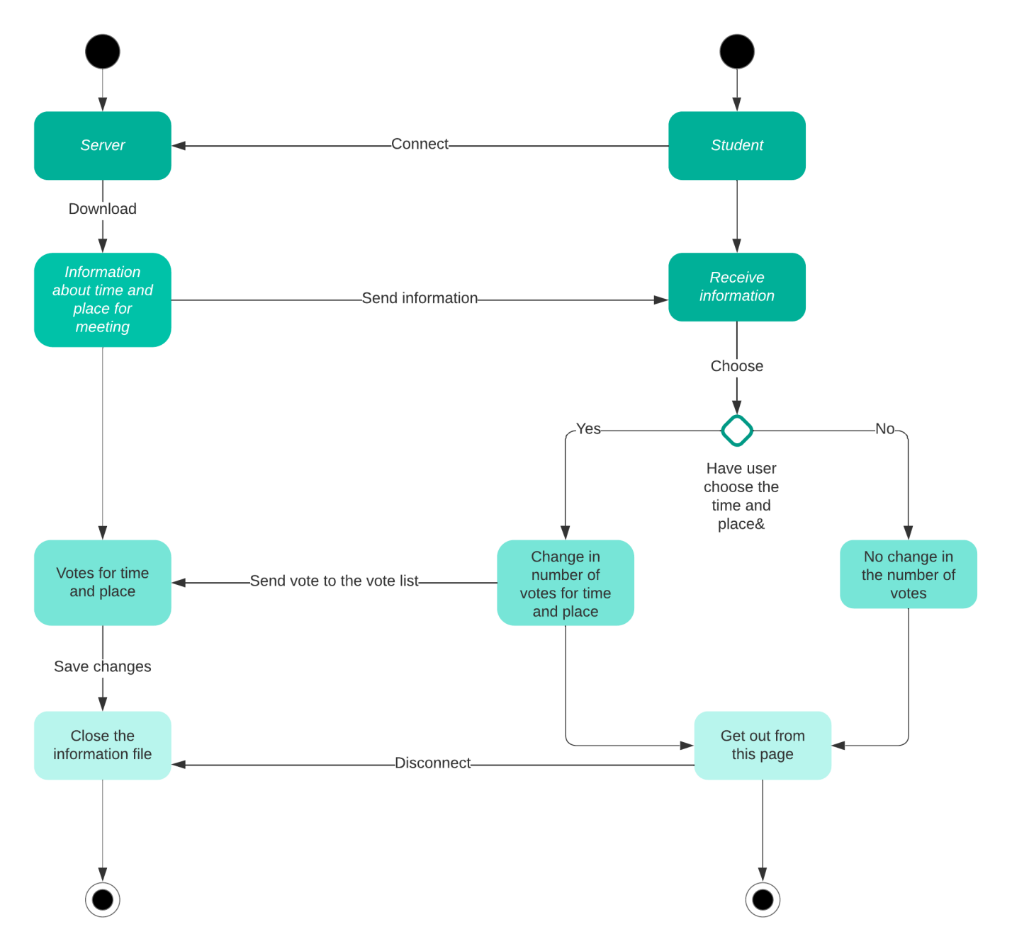

**Task 3:**