МИНИСТЕРСТВО НАУКИ И ВЫСШЕГО ОБРАЗОВАНИЯ  
РОССИЙСКОЙ ФЕДЕРАЦИИ

федеральное государственное автономное   
образовательное учреждение высшего образования  
«Самарский национальный исследовательский университет   
имени академика С.П. Королева»

(Самарский университет)

Институт информатики, математики и электроники

Факультет информатики  
Кафедра суперкомпьютеров и общей информатики

**Отчет по лабораторной работе № 6**

Дисциплина: «Enterprise Systems Development (Методы проектирования и поддержки требований к программному обеспечению)»

Тип предприятия: **«TimeToMeet»**

Выполнил: Коршиков В. И.

Группа: 6133-010402D

Самара 2022

**СОДЕРЖАНИЕ**

1 Assignment №6. Business process implementation 3

2 Assignment №6. Business process implementation 4

# 1 Assignment #1. Business process implementation

Objective: To study the business process implementation with Cuba Platform

Tasks

1. Create Cuba Platform project, which will implement one of business processes of previously selected organization.
2. Add section to doc report image, which should include:

* Selected business process description (several sentences). It is desirable that the business process be the same as business process described in previous assignment.
* Instructions how to run application, prerequisites.
* Step-by-step instruction with demonstration of business process automation using the application.

1. Send zipped files and doc report to j-avdeev@yandex.ru

Notice

Use Cuba Platform documentation (for example <https://doc.cuba-platform.com/bpm-latest/bpm.html> or <https://doc.cuba-platform.com/bpm-latest-ru/bpm.html> (on Russian)).

Yes, can use your preferable framework (not Cuba Platform) to create a web application to automate chosen business process.

# 2 Assignment №6. Business process implementation

In this laboratory work I made a prototype of meeting up, for appointing meetings with students. Teacher can appoint meeting and student can decide, which meeting they can come.

Start CUBA Application

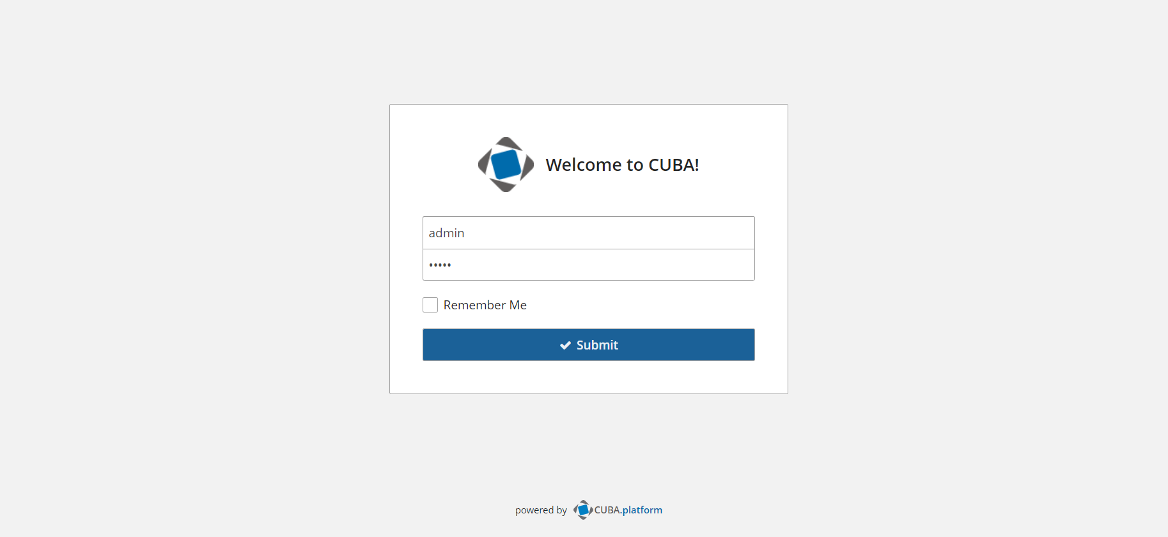

We have connected as Admin, we have three tabs in Application. We have three entities in prototype: Teacher, Student, Meeting

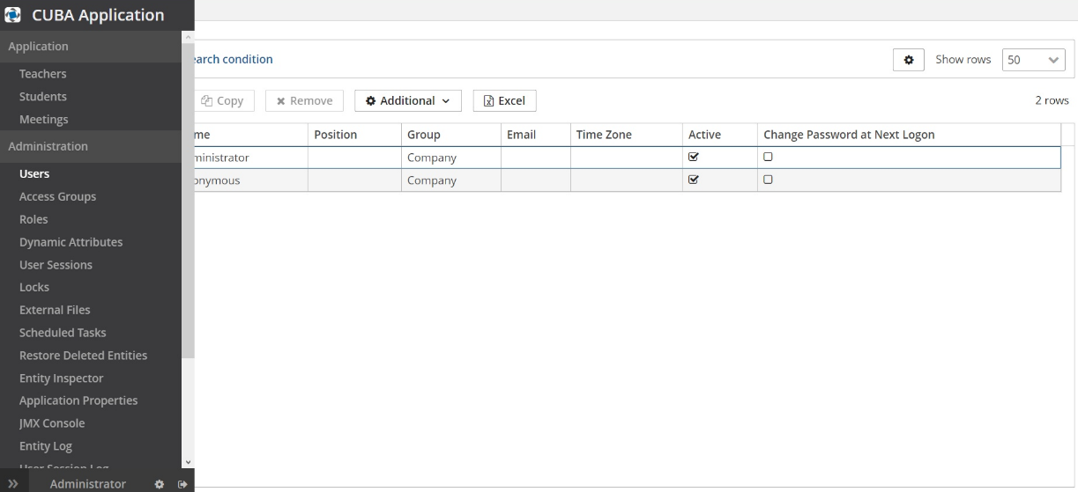

Let’s see the Teacher tab:

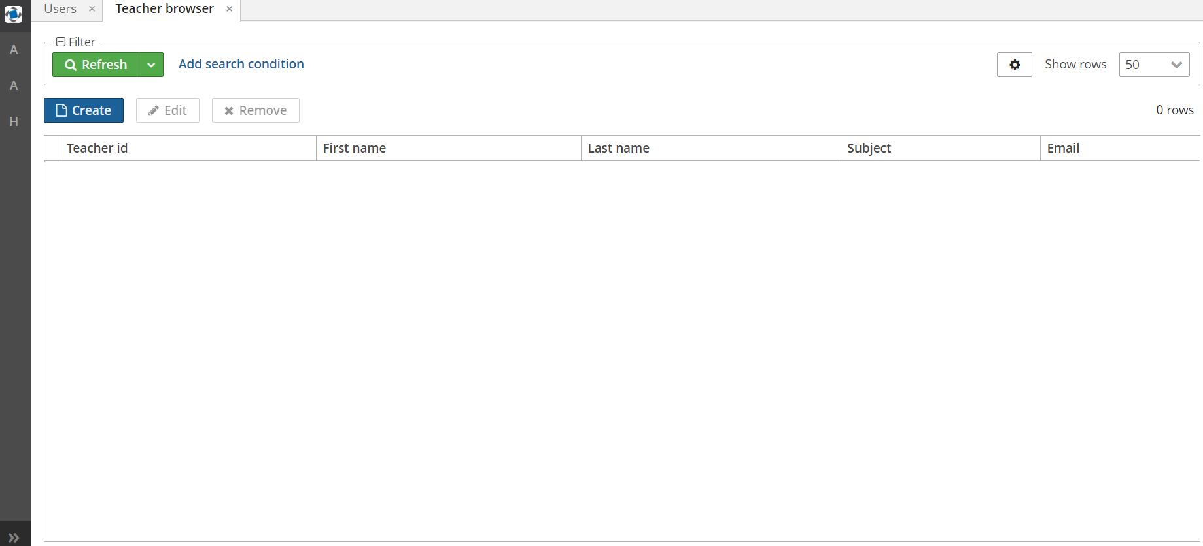

Let’s create some Teachers:

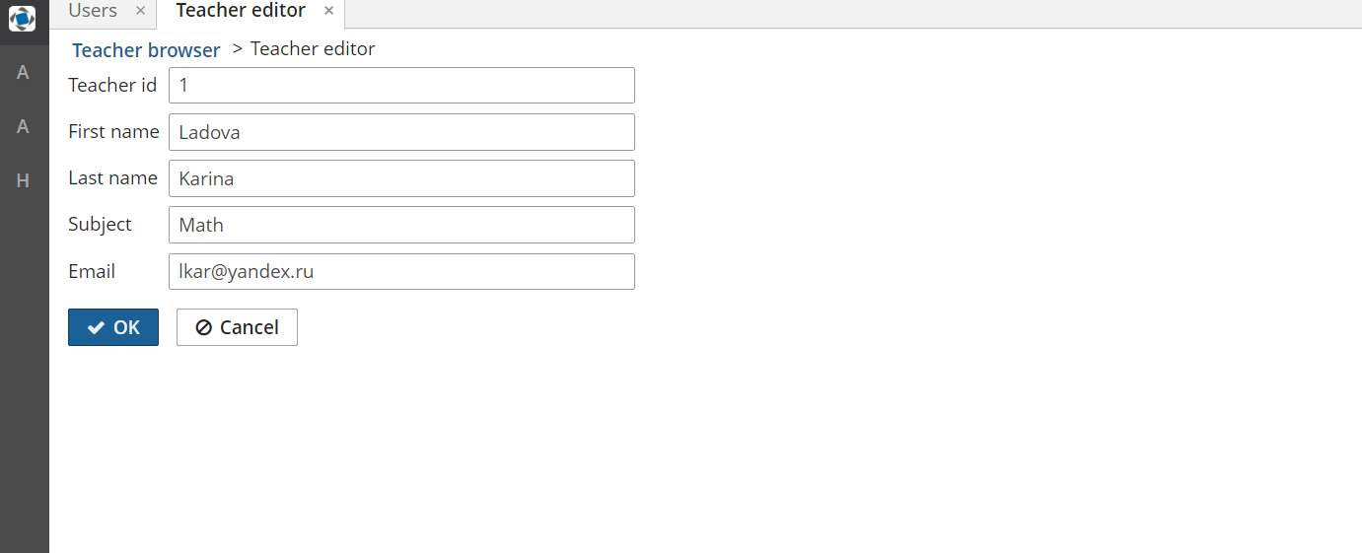

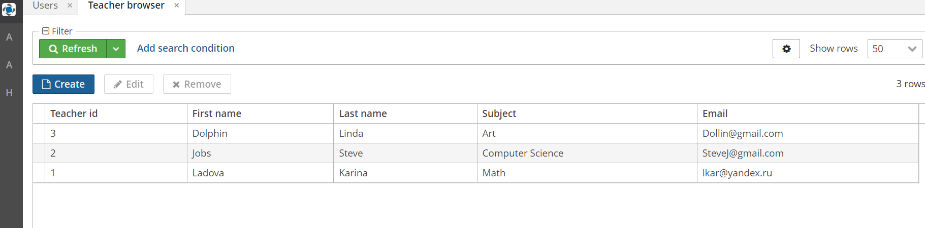

We can edit this users:

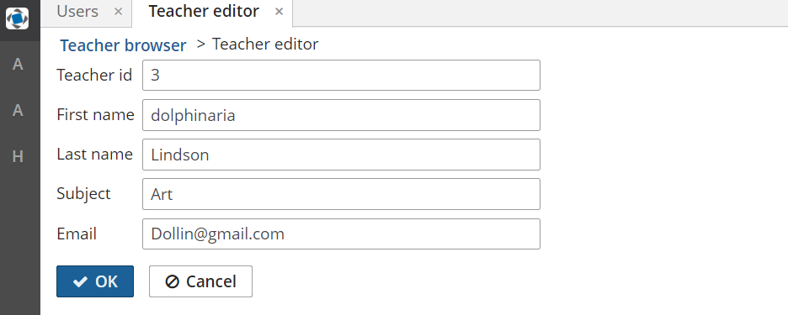

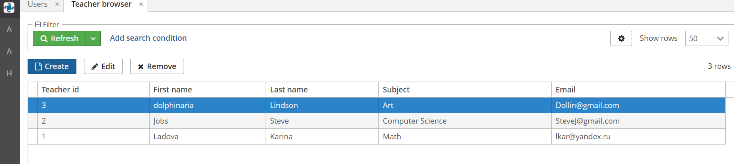

Also we can remove this users:

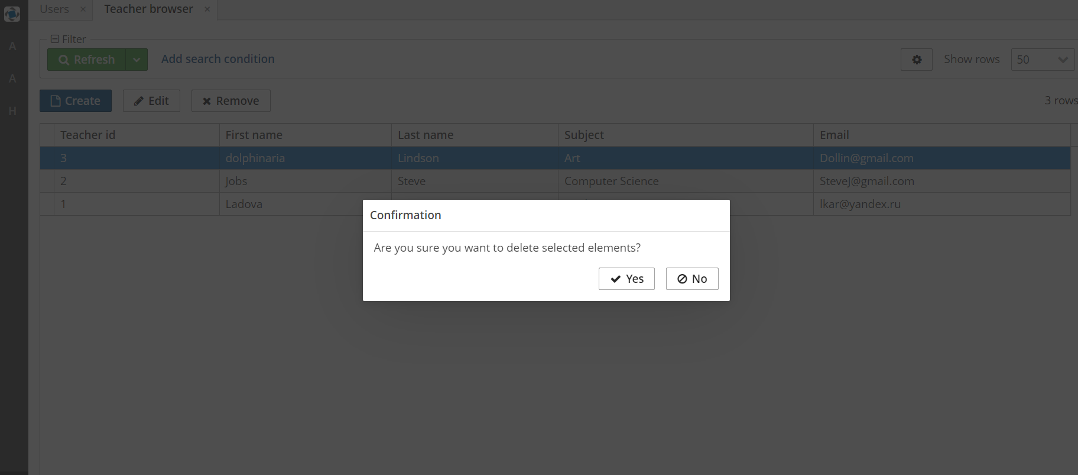

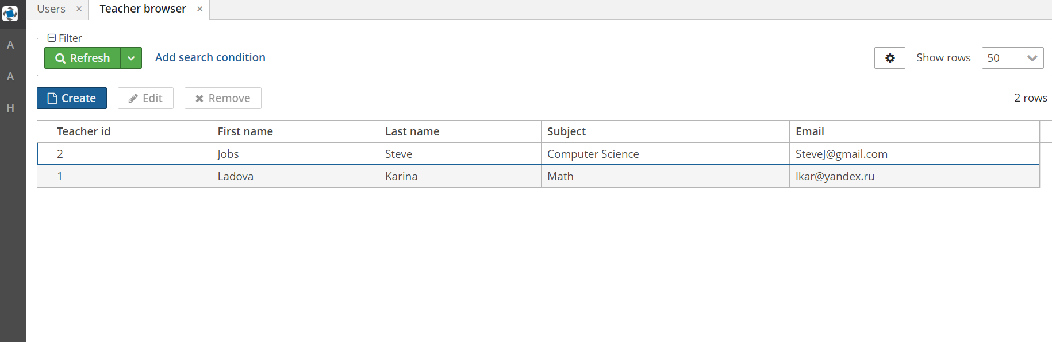

Students also can be created:

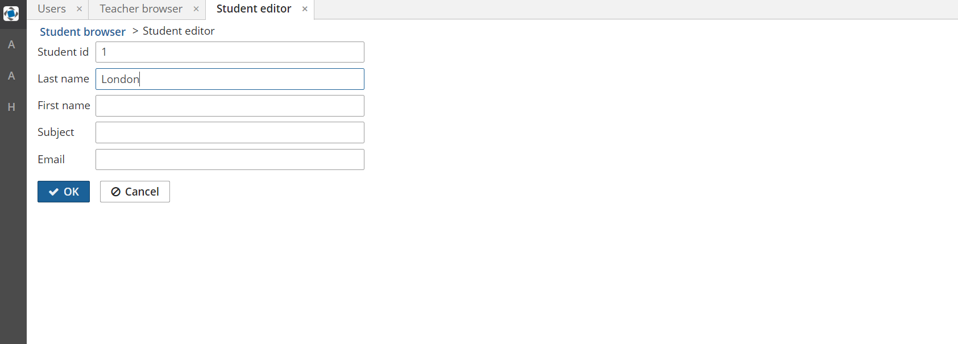

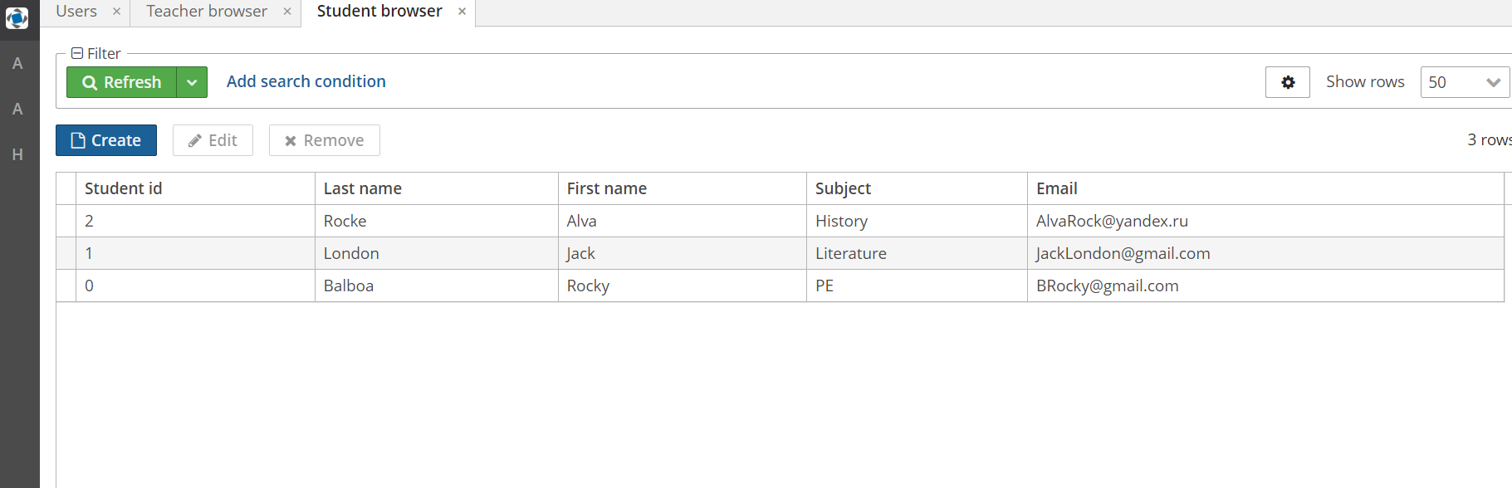

Edit:

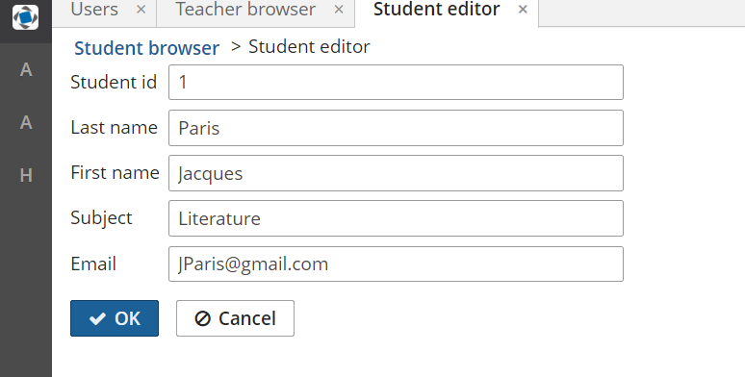

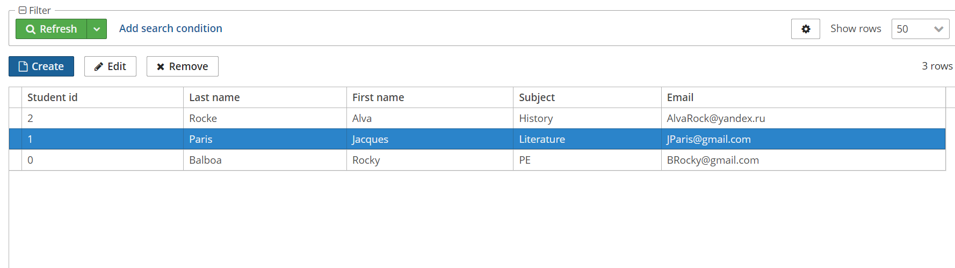

Delete Student:

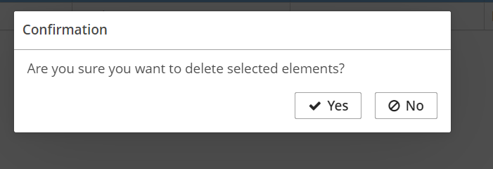

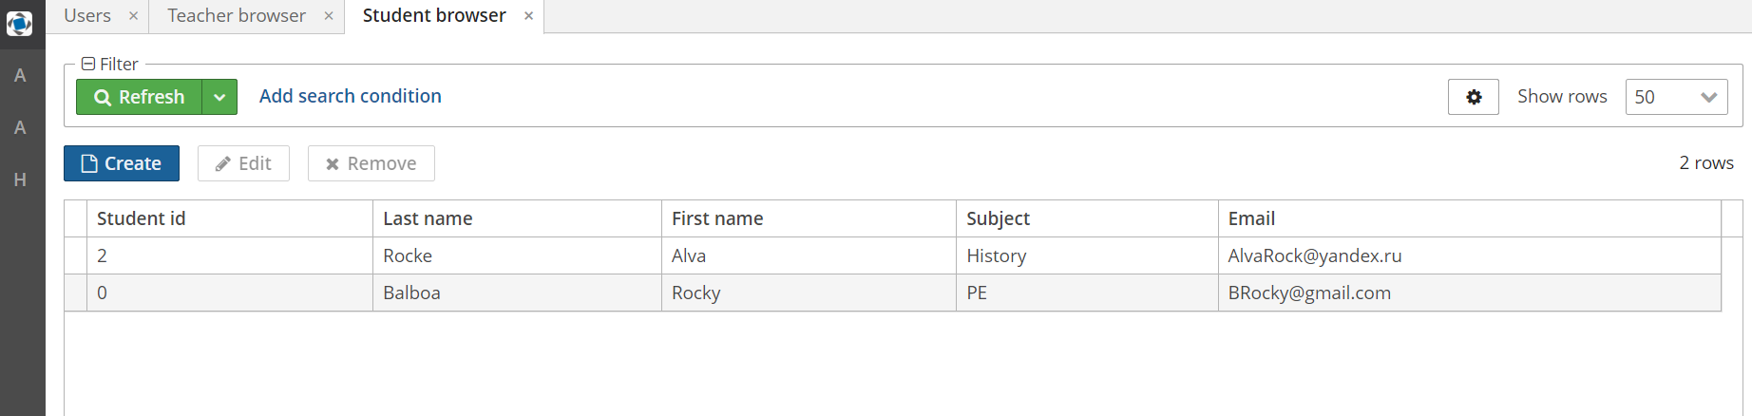

We also can create meeting:

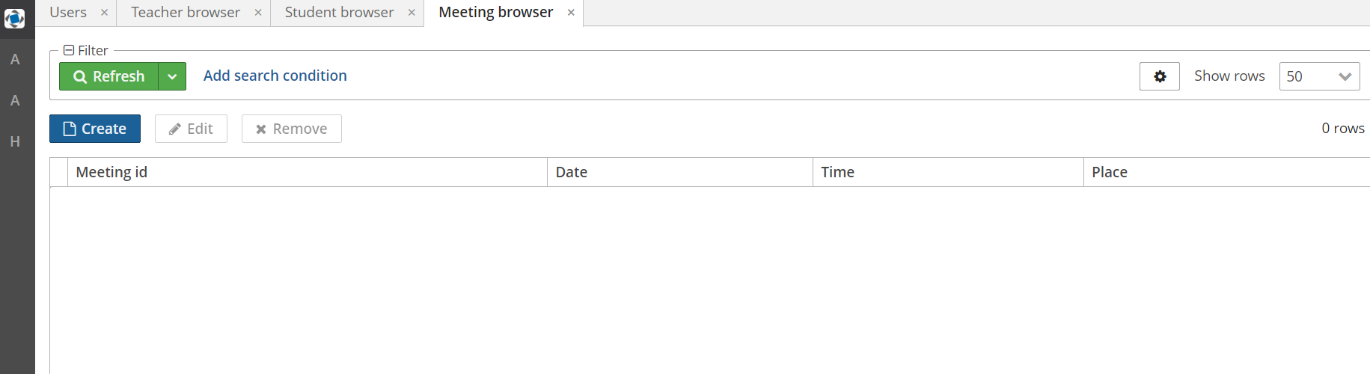

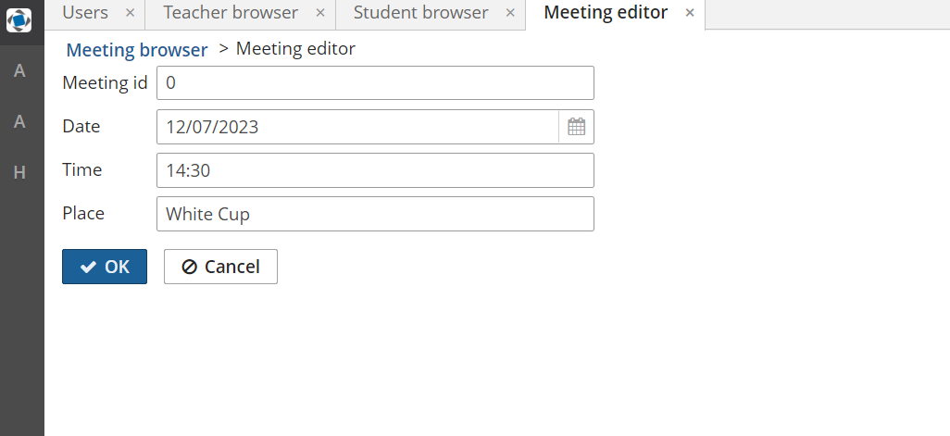

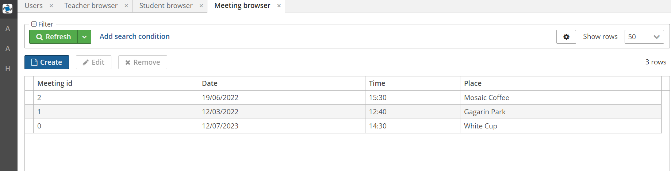

Edit meeting:

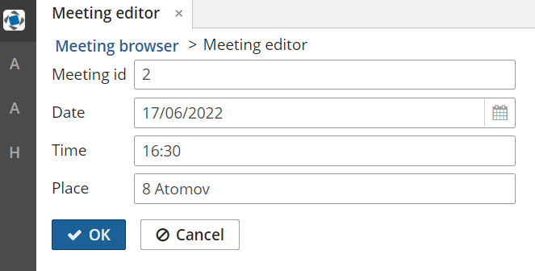

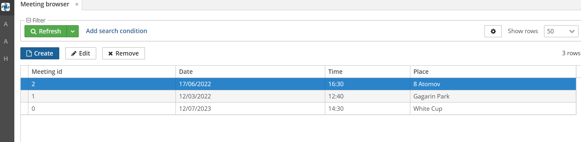

We can also remove some meeting:

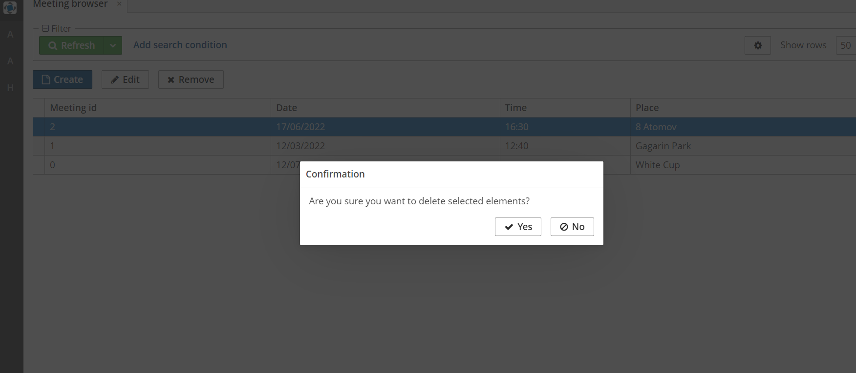

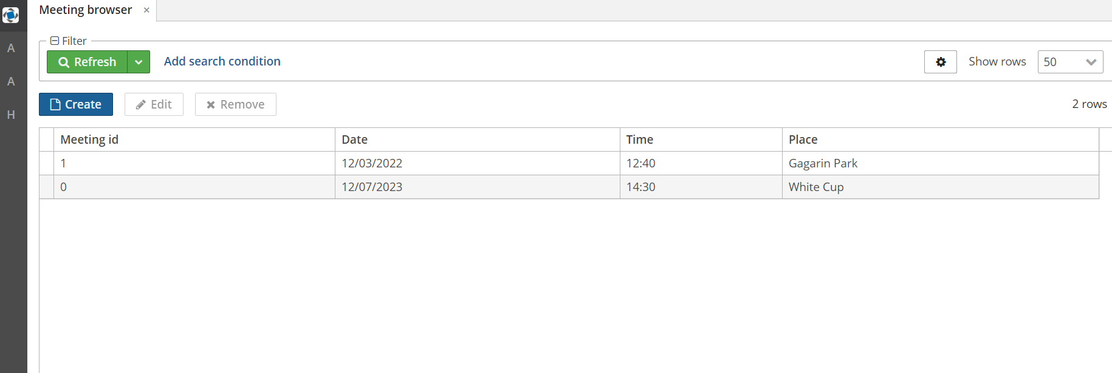

Архив с приложением можно найти GitHub по ссылке: https://github.com/vlad-korsh/ESD_Labs/blob/main/timetomeet.zip