Measuring the risk build up in Armenian financial system: A Growth-at-Risk approach
Vladimir Yeghiazaryanª, Arthur Grigoryan^{b}
ª Central Bank of Armenia, Yerevan, Armenia, vladimir.yeghiazaryan@cba.am
^{b} Central Bank of Armenia, Yerevan, Armenia, arthur.grigoryan@cba.am

Abstract
In recent years macroprudential policy has been evolving, with the aim to more closely manage the build-up of cyclical vulnerabilities in the financial system. The materialization of financial stress can trigger downside risks for growth in the medium term, but the realization of these risks can be mitigated through the effective use of macroprudential tools. This paper aims to quantify these risks and the effects of macroprudential policy on them, through the use of empirical growth-at-risk (GaR) frameworks. It also aims to augment the process of decision-making by proposing methods for designing a policy rule for macroprudential policy. This rule shouldn't be viewed as a binding constraint, but rather as guideline that could serve as a basis for preemptive action.
Keywords
growth-at-risk, systemic risk, quantile regressions, macroprudential policy, policy stance

- Introduction
In this paper, we focus on designing a policy rule for macroprudential policy for the case of the Armenian financial system. To estimate the effects of macroprudential policy, the current literature (Alam, et al., 2019) (Galán, 2020) opts to constructing an index given the history and the macroprudential policy stance of a country. Unfortunately, like many countries, the data related to macroprudential policy in Armenian is quite limited. To account for this, we use a two-step approach. First, we estimate a panel quantile regression very close in its logic and spirit to Galán (2020) and Aikman et al. (2019). Using a quarterly dataset with 43 countries and 21 variables for the period 1993-2023 we derive robust results for the effects of macroprudential policy on the distribution of the output growth. The reason we focus on the gross domestic product (GDP) growth, is because it is closely related to the performance of the financial system and is a good measure for quantifying the vulnerabilities and potential losses. Next, we estimate a similar, but local quantile regression model for Armenia, with 11 variables for the period 2003-2024 including the limited macroprudential data. Finally, we use the results from the panel model to improve the macroprudential policy estimates of the local model.
According to the results, macroprudential policy has nonlinear effects on the short-term output growth distribution. The effects are negative on the median of the distribution. For the case of countercyclical capital buffer (CCyB), a tightening of macroprudential policy would imply stricter capital requirements on the banks and a reduction of credit supply. This would be followed by a decrease in consumption and investment, and thus negatively affect short-term output growth. Additionally, we find that macroprudential policy has positive effects on the tail of the distribution. Following our example with the CCyB, higher capital increases the resilience of the banks and reduces potential losses in case of tail events. Jiménez et al. (2017) also find that an increase in capital buffers extends credit to firms and reduces the risk of insolvency. Our results are in line with the literature (Galán, 2020) and support the theoretical frame where macroprudential policy is facing a trade-off between short-term costs (a decline in output) and the long-term benefits (reduction of risks captured by the shrinking tail of the distribution).
It is important to note that the effect of macroprudential policy also depends other economic conditions. In this paper we distinguish two main indicators, financial vulnerability and financial stress. To measure the financial vulnerability in the system we use the financial cycle index (FCyI), which is an extension to the Basel credit-to-GDP gap approach. On the other hand, to measure financial stress, we estimate a financial conditions index (FCI) following the methodology by Gary Koop and Dimitris Korobilis (2014). A factor augmented vector autoregressive model with time-varying coefficients and stochastic volatility is used with 17 financial variables that are aggregated to form the index. Financial vulnerabilities are risks that are realized during financial stress, as such, these two indices are tightly related. To account for the relationship between them, we also include their product, aka the “crisis index” (CI) as part of the control variables in the model.
For designing the policy rule, this paper uses the work of Javier Suarez (2021) as its main reference. For the policy rule Suarez (2021) proposes a simple welfare function derived from micro foundations. We use our empirical framework alongside this utility function to determine the “optimal policy.” We have performed this analysis with a strong intention to use it in the policymaking procedure while also contributing to the existing research.
- Methodology
  - Panel quantile regression
As we have discussed before, macroprudential policy has different effects on the GDP growth distribution (Boar et al., 2017). To model these nonlinearities we use the quantile regression framework (Koenker & Bassett, 1978) which allows us to focus on different conditional quantiles of the ditribution and not just the conditional mean. Quantile regression has also become quite popular in forecasting growth-at-risk, which is the expected loss in GDP growth given a a tail event. In fact, it has proven to outperform GARCH-type models (Kipriyanov, 2022) in this task. In a panel framework, quantile regression helps to account for heterogeneous covariates, while the fixed effects consider the unobserved heterogeneity which doesn’t change with respect to time (Galán, 2020). It is important to note that in this framework the fixed effects are subject to change depending on the quantile. For a general case, a panel quantile regression takes the following form:
$$\begin{aligned}y_{i,t+h}=α_{i,τ}+X_{i,t}β_{τ}+v_{τ,t+h}\#\left(1\right)\end{aligned}$$
$$\begin{aligned}v_{τ,t+h}=\sum_{i=1}^{n}{\sum_{t=1}^{T-h}{ρ_{τ}\left|{y_{i,t+h}-y}_{i,t+h}^{*}\right|}}\#\left(2\right)\end{aligned}$$
$$\begin{aligned}ρ_{τ}=τ⋅1_{y_{i,t+h}≥y_{i,t+h}^{*}}+\left(1-τ\right)⋅1_{y_{i,t+h}≤y_{i,t+h}^{*}}\#\left(3\right)\end{aligned}$$
where, $y_{it+h}^{*}$ is the quantile regression estimate, $X_{i,t}$ is a vector of exogenous variables, $α_{i,τ}$ is a vector of fixed effects, $ρ_{τ}$ are the quantile-based weights, $τ$ is the quantile, while $T$ and $n$ are the time dimension and the cross-section dimension respectively. In our case $T=124$ and $n=43$. An important note is that the model uses least absolute deviation (LAD) as its optimality criterion.
  - Financial conditions index
To estimate the FCI we will use a factor augmented VAR with structural instabilities and time-varying coefficients (TVP-FAVAR). The p-lag TVP-FAVAR (Koop & Korobilis, 2014) state space model takes the form:
$$\begin{aligned}\left[\begin{matrix}y_{t} \\ x_{t}\end{matrix}\right]=\left[\begin{matrix}1 & 0 \\ λ_{t}^{y} & λ_{t}^{f}\end{matrix}\right]\left[\begin{matrix}y_{t} \\ f_{t}\end{matrix}\right]+\left[\begin{matrix}0 \\ v_{t}\end{matrix}\right]\#\left(4\right)\end{aligned}$$
$$\begin{aligned}\left[\begin{matrix}y_{t} \\ f_{t}\end{matrix}\right]=c_{t}+Β_{t,1}\left[\begin{matrix}y_{t-1} \\ f_{t-1}\end{matrix}\right]+{…+Β}_{t,p}\left[\begin{matrix}y_{t-p} \\ f_{t-p}\end{matrix}\right]+ϵ_{t}\#\left(5\right)\end{aligned}$$
$\begin{aligned}λ_{t}=λ_{t-1}+θ_{t}\#\left(6\right)\end{aligned}$
$\begin{aligned}β_{t}=β_{t-1}+η_{t}\#\left(7\right)\end{aligned}$
where $x_{t}$ is an $n_{f}×1$ vector of financial variables, with $n_{f}=17$. These include interest rate spreads, mortgage rates, government bond rates, the level, slope and curvature of the yield curve, the return on equity (RoE) of banks and so on. The $y_{t}$ is an $s_{m}×1$ vector of macro variables. In our model we included the consumer price index (CPI), real GDP growth and the monetary policy rate. In our design matrix $λ_{t}^{y}$ is a vector of regression coefficients, while $λ_{t}^{f}$ is a vector of factor loadings. In the state equation we have the latent factor $f_{t}$ interpreted as the FCI. The $c_{t}$ is a vector intercepts, while $(Β_{t,1}…Β_{t,p})$ are matrices of VAR coefficients. We use $λ_{t}={\left({\left(λ_{t}^{y}\right)}^{T},{\left(λ_{t}^{f}\right)}^{T}\right)}^{T}$and $β_{t}={\left(c_{t}^{T},vec{\left(Β_{t,1}\right)}^{T}…ec{\left(Β_{t,p}\right)}^{T}\right)}^{T}$ to track the time-varying properties of the parameters. Finally, the error terms $v_{t}$, $ϵ_{t}$, $θ_{t}$ and $η_{t}$ are zero-mean gaussian disturbances. Their covariances $V_{t}$, $Q_{t}$, $W_{t}$ and $R_{t}$ may also change over time. $V_{t}$, $W_{t}$ and $R_{t}$ are diagonal, thus the disturbance terms are uncorrelated with each other.
To estimate the model a 3-step algorithm is used. First, we initialize the parameters, and estimate the principal component analysis (PCA) based $f_{t}^{*}$. Next, we use this $f_{t}^{*}$ to obtain our time-varying parameters. We then use the “Variance Discounting” (VD) method proposed by the authors (Koop & Korobilis, 2014) to estimate $V_{t}$, $Q_{t}$, $W_{t}$ and $R_{t}$. Using these disturbances, we can then estimate the actual $λ_{t}$ and $β_{t}$ using Kalman filtering and smoothing (KFS). Finally, we use the time-varying coefficients to generate $f_{t}$ using KFS.
  - Financial cycle index
The financial cycle index is an aggregate of different variables related to loan loss. These include credit-to-GDP gap, private and corporate loan flows, real estate prices, and so on. Formally, (Holló, Kremer, & Lo Duca, 2012) the aggregation can be expressed as:
$$\begin{aligned}FCyI_{t}={\left(w⊙s_{t}\right)}^{T}C_{t}\left(w⊙s_{t}\right)\#\left(8\right)\end{aligned}$$
where, $s_{t}$ is the vector of exogenous indicators at time t and w is a vector showing the relative importance of the values in $s_{t}$. The expression $\left(w⊙s_{t}\right)$ is the Hadamard-product between the vectors (element-wise multiplication). The matrix $C_{t}$ contains values of the cross-correlation coefficients for the indicators at time t. The matrix $C_{t}$ is estimated recursively using an exponentially weighted moving average (EWMA) process, utilizing the previous variance and covariance values as a base. Finally, the relative weights $w$ are determined by running a constrained optimization to find the $FCyI_{t}$ that provides the best predictions for future loan loss impairments (Plašil, Seidler, Hlaváč, & Konečný, 2014).
  - Quantile regression for Armenia
The baseline quantile regression model for the Armenian economic takes the form:
$$y_{t+h}=α_{τ}+β_{1,τ}y_{t}+β_{2,τ}{FCyI}_{t}+β_{3,τ}{FCI}_{t}+β_{4,τ}{CI}_{t}+β_{5,τ}{MPI}_{t}+β_{6,τ}{CAR}_{t}+β_{7,τ}{LR}_{t}+ \\ \begin{aligned}+β_{8,τ}{CPI}_{t}+β_{9,τ}{TB}_{t}+β_{10,τ}{CP}_{t-1}+β_{11,τ}{REER}_{t}+β_{12,τ}{MF}_{t}+β_{13,τ}{CL}_{t}\#\left(9\right)\end{aligned}$$
In this specification $y_{t+h}$ is the annualized average growth rate of real GDP at $t+h$ quarters ahead. The $α_{τ}$ is an intercept, $y_{t}$ is the autoregressive component, ${FCyI}_{t}$ is the financial cycle index, ${FCI}_{t}$ is the financial conditions index and ${CI}_{t}=St\left({FCyI}_{t}\right)*St({FCI}_{t})$ is the “crisis index,” which is the product between the standardized ($N(0,1)$) ${FCyI}_{t}$ and ${FCI}_{t}$.
Next, we include the macroprudential policy index ${MPI}_{t}$ and the 1-year average change in capital adequacy ratio ${CAR}_{t}$. The MPI is computed (both for the local and panel models) using the methodology and the dataset proposed by Alam et al. (2019). The dataset includes 17 categories of macroprudential measures over time. Each tightening is expressed as +1, while each loosening event is represented as -1. Finally, no or neutral actions are marked as 0. We define the sum of the 17 dummy categories at time t as $MP_{t}$. We express the MPI as the 4-quarter rolling sum of $MP_{t}$ like so:
$$\begin{aligned}MPI_{t}=\sum_{p=0}^{3}{MP_{t-p}}\#\left(10\right)\end{aligned}$$
The rest of the variables in the model are controls. These include the ${LR}_{t}$ liquidity ratio (HQLA/Assets), ${CPI}_{t}$ 1-year average change in consumer price index, ${TB}_{t}$ trade balance, ${CP}_{t-1}$ 1-year lag of the logarithm of copper prices, ${REER}_{t}$ the real effective exchange rate, ${MF}_{t}$ 3-year average growth of mortgage loan flows and ${CL}_{t}$ 2-year average growth of construction loans.
To improve the coefficient for MPI ($β_{5,τ}$) in our local model using the results from the panel estimation, we use a simple weighted averaging method:
$$\begin{aligned}c_{improved}=\left(1-w_{s}\right)c_{local}+w_{s}c_{panel}\#\left(11\right)\end{aligned}$$
where, $c_{local}$ and $c_{panel}$ are the respective quantile estimates from the local and panel models. In our paper we use $w_{s}=0.5$.
  - Suarez welfare function
The one of the main advantages of GaR is that it is measured in the same units as GDP growth. This makes the comparison between the two very straightforward. Yet compared to monetary policy, the macroprudential policy literature still lacks explicit design rules. Javier Suarez (2021) fills this gap by suggesting a welfare function that “rewards expected GDP growth and penalizes the gap between expected GDP growth and GaR.” To derive this welfare function from micro foundations, the following steps are used.
First, let $Y$ denote GDP and $y$ the GDP growth rate:
$$\begin{aligned}Y=\left(1+y\right)Y_{0}\#\left(12\right)\end{aligned}$$
Now let us assume that there is a representative agent with a local coefficient of absolute risk aversion $λ\left(Y_{0}\right)$ at $Y=Y_{0}$. Then we can express the utility function as one exhibiting constant absolute risk aversion (CARA) with $λ\left(Y_{0}\right)$, so that:
$$\begin{aligned}U\left(Y\right)=-\exp\left(λ\left(Y_{0}\right)Y\right)\#\left(13\right)\end{aligned}$$
If we insert equation (eq.) 11 in eq.12, then perform a monotonic transformation, then we get:
$$\begin{aligned}u\left(y\right)=-\exp\left(λ\left(Y_{0}\right)Y_{0}y\right)=-\exp\left(ρ_{0}y\right)\#\left(14\right)\end{aligned}$$
In eq. 13 $ρ_{0}=λ\left(Y_{0}\right)Y_{0}$ describes the agent’s coefficient of relative risk aversion at $Y_{0}$. If we assume GDP growth is normally distributed, so that $y\sim N(y_{m}, σ_{y}^{2})$, then using the known moment functions we can write the agent’s expected utility as:
$$\begin{aligned}E\left[u\left(y\right)\right]=-E\left[\exp\left(ρ_{0}y\right)\right]=-\exp\left({-ρ}_{0}y_{m}+\frac{1}{2}ρ_{0}^{2}σ_{y}^{2}\right)\#\left(15\right)\end{aligned}$$
Indirectly eq. 14 can also be described as:
$$\begin{aligned}v=y_{m}-\frac{ρ_{0}}{2}σ_{y}^{2}\#\left(16\right)\end{aligned}$$
$$\begin{aligned}σ_{y}=\frac{y_{c}-y_{m}}{Φ^{-1}\left(c\right)}\#\left(17\right)\end{aligned}$$
$$\begin{aligned}v=y_{m}-\frac{1}{2}\frac{ρ_{0}}{{\left(Φ^{-1}\left(c\right)\right)}^{2}}{\left(y_{c}-y_{m}\right)}^{2}\#\left(18\right)\end{aligned}$$
Finally, by reordering some terms and assigning $w=\left(\frac{ρ_{0}}{{\left(Φ^{-1}\left(c\right)\right)}^{2}}\right)$, which we can interpret as the aversion for financial instability, we derive the social welfare function proposed by Suarez:
$$\begin{aligned}W=y_{m}-\frac{1}{2}w{\left(y_{m}-y_{c}\right)}^{2}\#\left(19\right)\end{aligned}$$
The limitations of this function are embedded in its assumptions. Since most GDP growth distributions aren’t normally distributed this makes the function sensitive choice of quantile c. Additionally, even if the c is chosen correctly, the value for $ρ_{0}$ and consequently is up to the policy maker. Nevertheless, this function can still serve as a good basis for policy recommendations since it offers a means to perform a cost-benefit analysis for the effects of macroprudential policy.
  - Data
For the panel model we used a quarterly dataset with 43 countries and 21 variables for the period 1993-2023. Most of this data was download from two key International Monetary Fund (IMF) databases. These are the international financial statistics (IFS) and the financial soundness indicators (FSI) (IMF, 2024). Additionally, for data related the equity index we used the global economic monitor (GEM) which is one of the databases (2023) maintained by the World Bank (WB). Some of the variables related to government bond rates were extracted from individual central bank websites. Finally, the data for the MPI was extracted from the iMaPP database (Alam, et al., 2019).
The Armenian model effectively utilized 38 variables (without counting the derived indices) for the period 2003-2024. The FCI required 17 interest rate related variables, FCyI was constructed using 12 credit related variables, while the final model included 11 exogenous indicators (including the two indices). All of the data for the local model were collected from the central bank of Armenia (CBA).
- Results
  - financial vulnerabilities and stress
One of the primary aims of macroprudential policy is to improve the resilience of the financial system, or in other words, to reduce the negative impact of crises on economic growth. No crisis is the same, but during a crisis the financial to system has the potential to amplify these shocks. The extent of this amplification will depend on the existing vulnerabilities in the system. In Figure 1, we plot FCyI, FCI and real GDP growth. The key takeaway from this plot is that FCyI and FCI react differently depending on the type of the shock. During the 2007-2009 financial crisis we observe the severe financial stress first, and then those losses are materialized. A similar pattern can be seen in 2015-2016 when Armenia was affected by the Russian oil crisis. Meanwhile, during the Covid shock, the GDP reacted first, with the vulnerabilities and financial stress emerging much later.
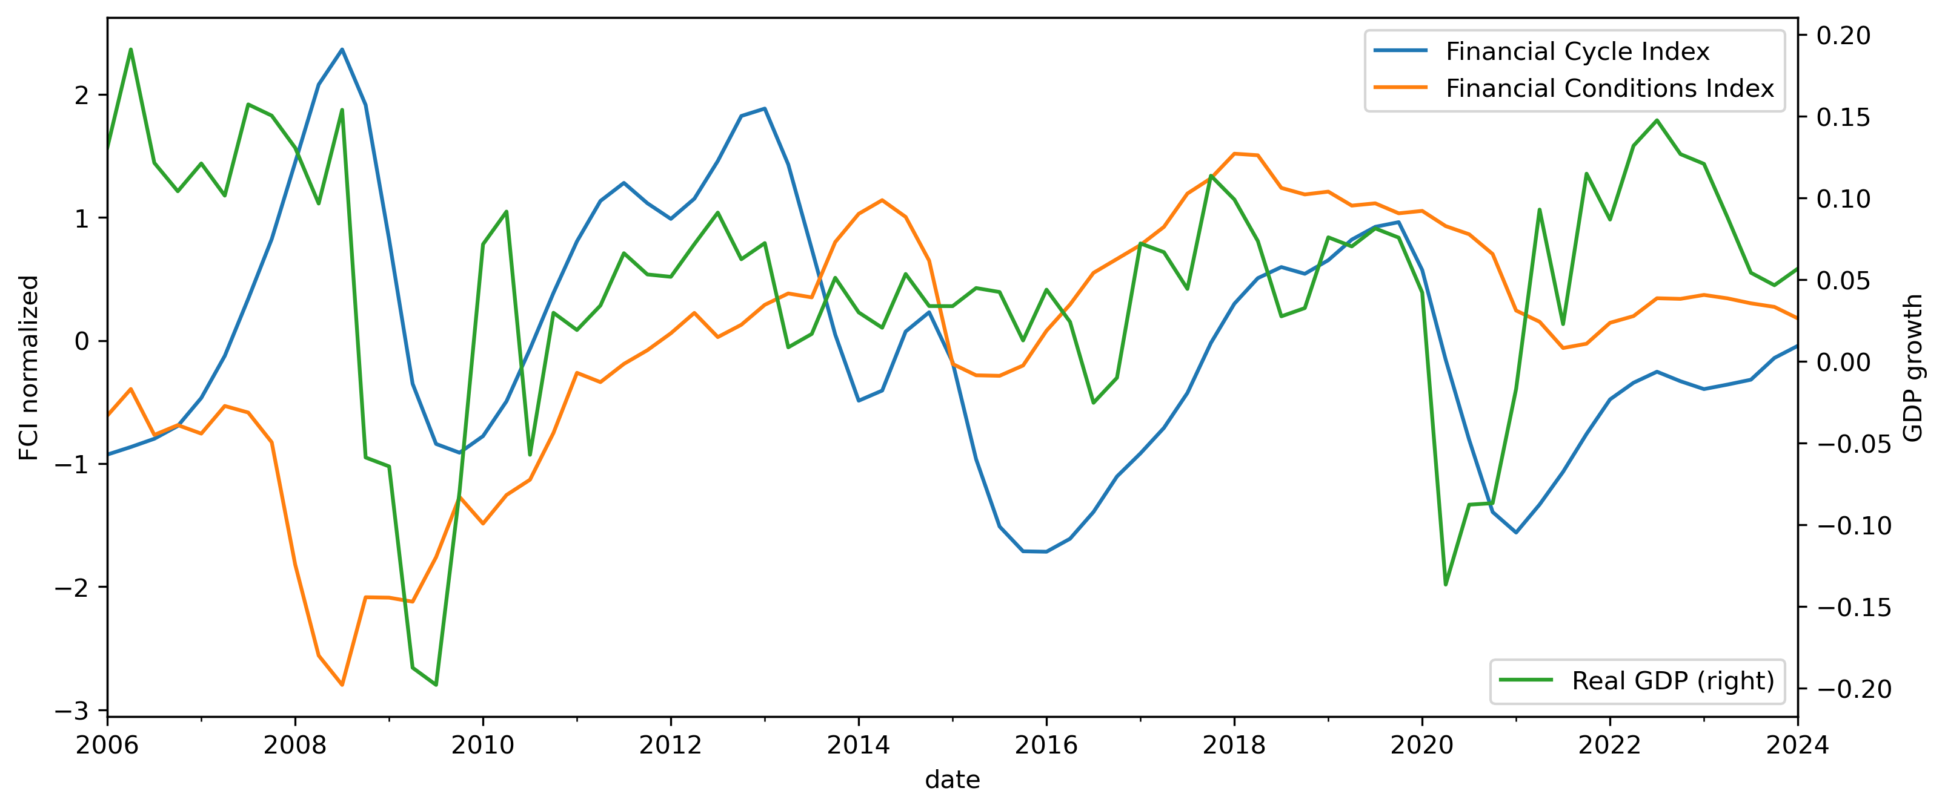
Figure 1. the financial cycle index, financial conditions index and real GDP growth. The FCyI and FCI are normalized to have zero mean and a standard deviation of one.
Macroprudential has also managed to play its role in these events. As we can see from Figure 2, macroprudential policy in Armenia has implemented a lot of tightening measures after the 2009 crisis. After that, it managed to implement loosening policies in all three proceeding crises.
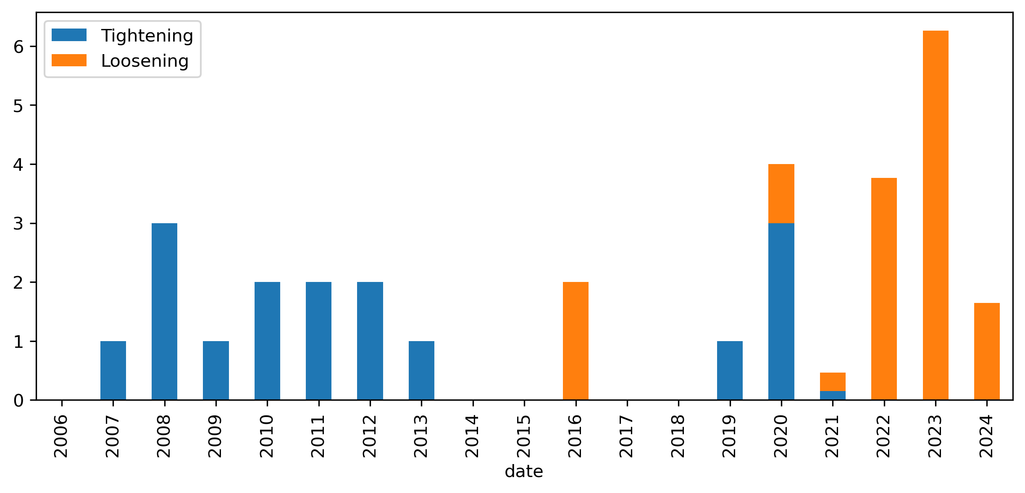
Figure 2. Use of macroprudential policy in Armenia
In Figure 3, we compare the GDP distribution of Armenia during the tightening and loosening windows to identify on how they could have reshaped the distribution. During tightening, we see that the distribution had much more certain, but less severe tails. Meanwhile, during loosening periods we observe historically shorter tails and quicker recovery.
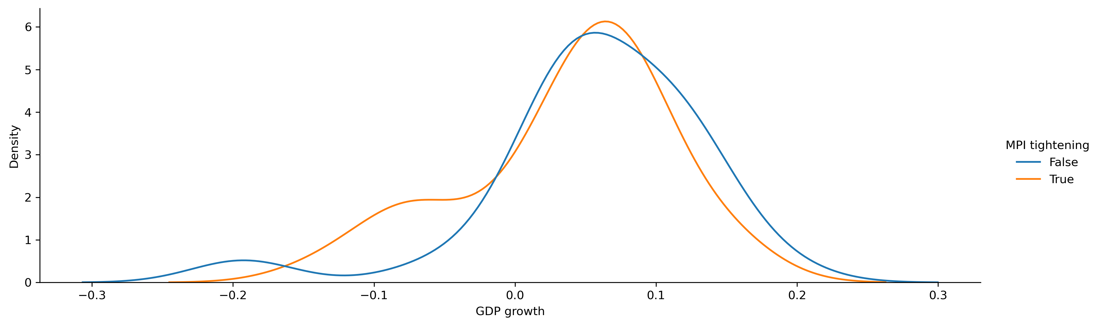
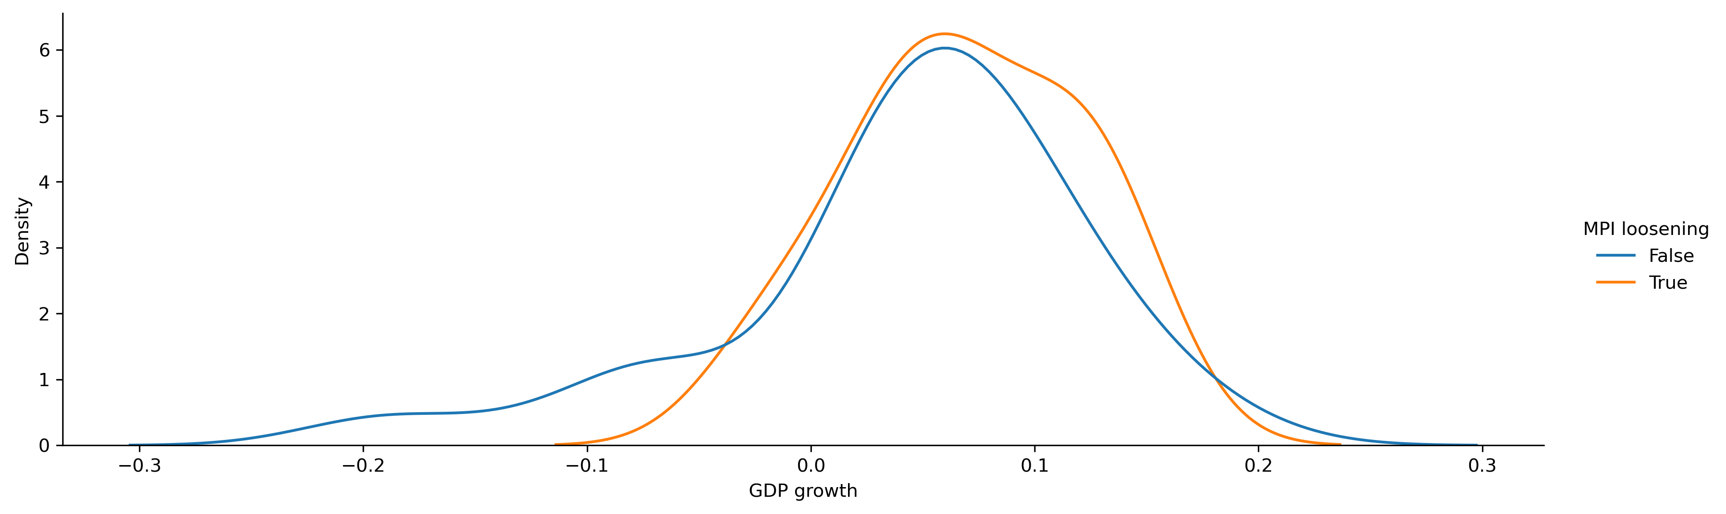
Figure 3. GDP growth distribution of Armenia, during the macroprudential policy tightening and loosening periods

It should be noted that the shorter observed tails in Figure 3, also stem from the fact that macroprudential policy was implemented after 2009 financial crisis.
  - Impact on GDP
To better understand the effects of macroprudential policy, we estimate the model described in eq. 9. In Figure 4 we plot the goodness of fit for our quantile regression models across the quantiles and horizons. Horizons 4, 8 and 12 are equivalent to annualized 1, 2 and 3 years ahead GDP growth estimates. From the charts we can observe that the model achieves best results in the lower quantiles of the GDP growth distribution. This outcome is by design since our aim isn’t to perform accurate GDP forecasts, but rather to be able to estimate the GDP distribution in its entirety, with our focus being GaR.
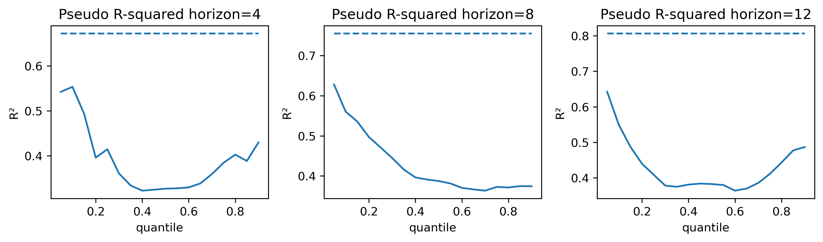
Figure 4. Pseudo r-squared for quantile regression estimates across quantiles and horizons. OLS r-squared displayed as a dashed line. Note: generally, quantile regression and OLS r-squared aren’t comparable. They are here for convenience.
In Figure 5, we plot the quantile regression estimates for the four key variables in the model. From the chats we can observe the heterogeneous effects of MPI. In the short run MPI has positive effect on the tail, and negative effects on the median. The short-run effects of MPI are insignificant at the 95% confidence intervals, but they are significant at 90%. Meanwhile, at longer horizons MPI displays clear positive effects on both the median and the tail.
We also observe the heterogeneous effects in FCyI, that said, most of these effects are insignificant in the short run. The FCyI displays negative effects on the GDP distribution the long run. This is in line with the theory of business and financial cycles where a maturity or a peak phase is followed by a contraction.
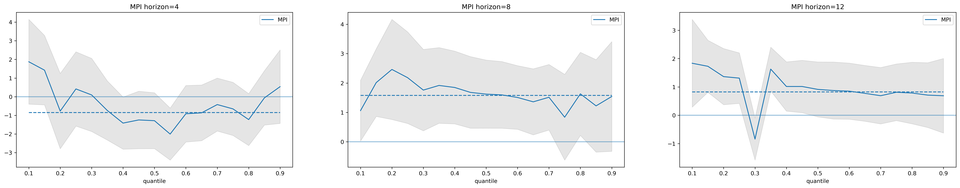
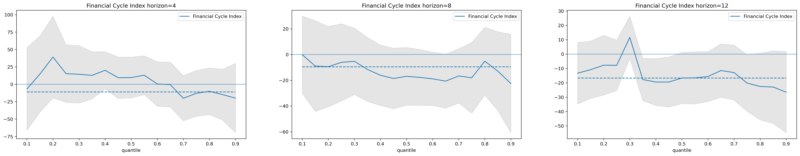
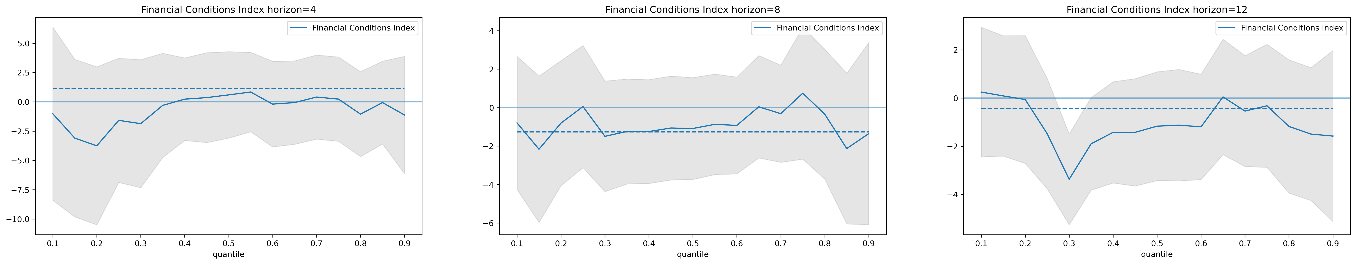
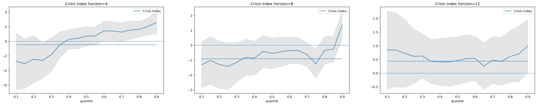
Figure 5. Estimated quantile regression coefficients for horizons 4, 8 and 12. The grey shaded areas represent the 95% confidence intervals. The dashed horizontal line represents the OLS coefficient.
The FCI is also insignificant in the short-run and yet shows heterogeneous effects in the long-run. As one might expect financial stress has cyclical properties and thus low stress today indicates a negative effect on the median of the GDP growth distribution in the future. Interestingly enough, the long run FCI effects on the tail are insignificant. This could suggest that the realization of tailed risks don’t necessarily determine the severity of tail events.
In Figure 6, we present normalized coefficients for the 4-horizon median and tail quantile regression models. The variables with the strongest effects on the median include the FCyI, FCI, CPI and trade balance. Meanwhile, the variables with the strongest effects on the tail are mortgage flows, liquidity ratio, MPI and FCyI.
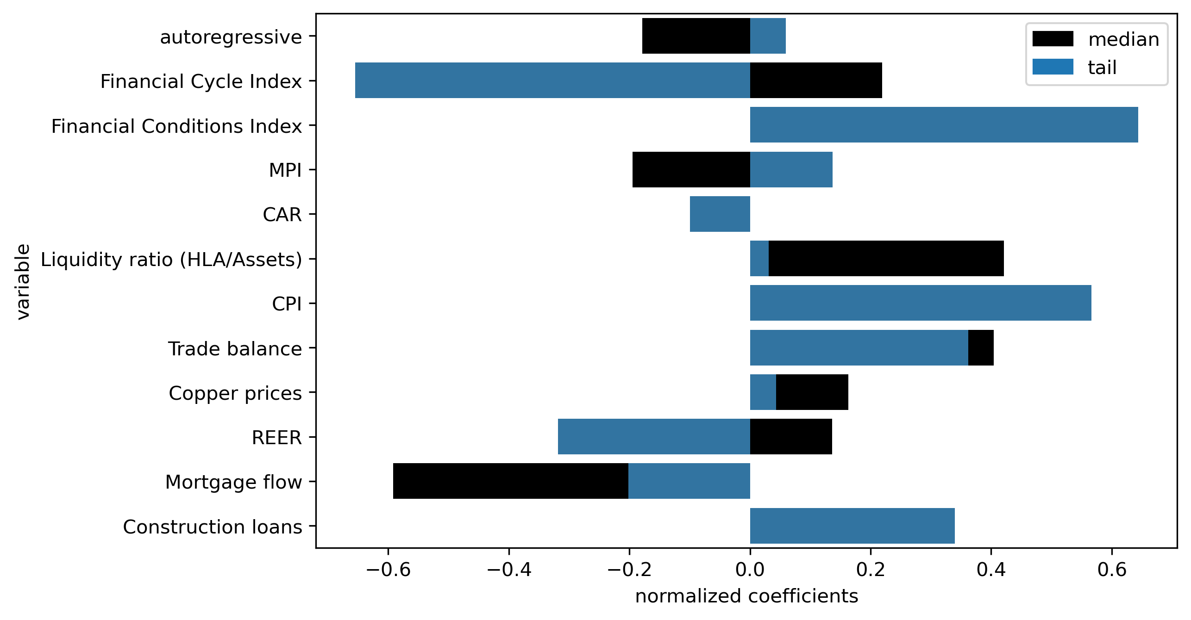
Figure 6. Normalized quantile regression coefficients for horizon 4. In the figure we present the coefficients for quantiles 0.5 (median) and 0.1 (tail).
- The optimal policy rule
To showcase the ability of the model for making macroprudential policy recommendations, we perform a 1 year ahead forecast with and without policy interventions. The results for this simulation are presented in Figure 7. First, we observe that according the forecast, the GDP distribution is going to shift to the right, improving both the median and the tail. The forecast will allow macroprudential policymakers to track the movements of the distribution and act accordingly. For example, if the we observed an increase in the median, but a reduction in the tail due the heterogeneous effects of the other variables, then perhaps a stricter policy action would have been recommended. Finally, the welfare function proposed by Suarez will allow us to finetune the response.

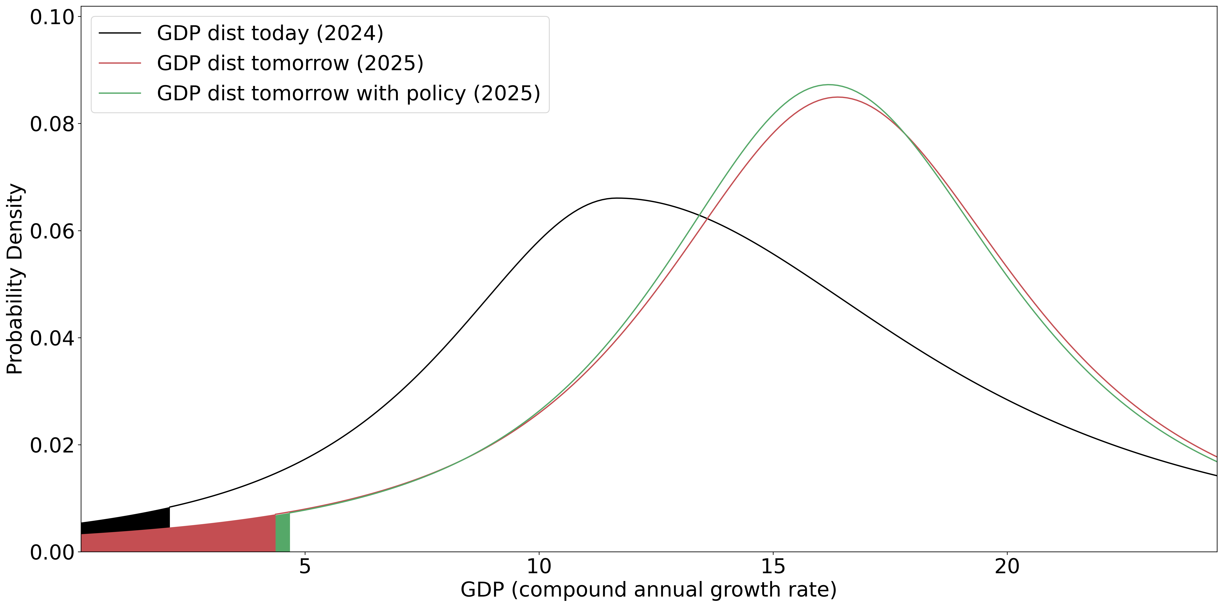
Figure 7. One year ahead GDP distribution forecast and optimal policy calibration. Note: to achieve the distribution for the optimal policy case, MPI should increase by 1 (equivalent 0.5 step in CCyB). Suarez w (aversion for financial instability) is assumed to be 0.1.
- Conclusion
In this paper, we develop a quantile regression framework for estimating the output growth distribution for the Armenian economy. Using this model, we derive effects for macroprudential policy, financial cycle index, financial conditions index and 8 other control variables. Additionally, we use this framework to perform forecasts for the output growth distribution. We are able to quantify the buildup of systemic risk and arrive at an optimal macroprudential policy rule. This framework aims to improve the decision-making process of the policymaker by defining clear guidelines for preemptive action.
References
ESRB. (2018). European Systemic Risk Board A Review of Macroprudential Policy in the EU in 2017.
Mack, S. (2021). Never waste a good crisis European banking regulation in the pandemic Policy Brief. Berlin: Hertie School.
Schmitz, S., Posch, M., & Strobl, P. (2022). The EU macroprudential review should prioritize removing regulatory overlaps and increasing the flexibility of the CCyB. Oesterreichische Nationalbank. SUERF.
Stojkov, K. (2020, September 17). Different Approaches to Implementing a Countercyclical Capital Buffer | Bulletin – September Quarter 2020. Financial Stability Department.
Galán, J. (2020, November). The benefits are at the tail: Uncovering the impact of macroprudential policy on growth-at-risk. Journal of Financial Stability(100831), 10.1016/j.jfs.2020.100831.
Galvez, J., & Mencia, J. (2014). Distributional Linkages between European Sovereign Bond and Bank Asset Returns. SSRN Electronic Journal, 10.2139/ssrn.2523863.
Aikman, D., Bridges, J., Hoke, S. H., O’Neill, C., & Raja, A. (2019, September). Credit, capital and crises: a GDP-at-Risk approach.
Prasad, A., Elekdag, S., Jeasakul, P., Lafarguette, R., Alter, A., Xiaochen Feng, A., & Wang, C. (2019). Growth at Risk: Concept and Application in IMF Country Surveillance. IMF Working Papers, 19(36), 10.5089/9781484397015.001.
Suarez, J. (2022). Growth-at-risk and macroprudential policy design. Journal of Financial Stability, 60(1572-3089), 10.1016/j.jfs.2022.101008.
Koop, G., & Korobilis, D. (2014). A new index of financial conditions. European Economic Review, 71(0014-2921), 101-116, 10.1016/j.euroecorev.2014.07.002.
Cecchetti, S. G., & Suarez, J. (2021, December). On the Stance of Macroprudential Policy. SSRN Electronic Journal(11), 10.2139/ssrn.3975941.
Chavleishvili, S., Engle, R. F., Fahr, S. A., Kremer, M., Manganelli, S., & Schwaab, B. (2021). The Risk Management Approach to Macro-Prudential Policy. SSRN Electronic Journal, 10.2139/ssrn.3859109.
Alam, Z., Alter, A., Eiseman, J., Gelos, R., Kang, H., Narita, M., . . . Wang, N. (2019). Digging Deeper--Evidence on the Effects of Macroprudential Policies from a New Database. IMF Working Papers, 19(66), 10.5089/9781498302708.001.
Jiménez, G., Ongena, S., Peydró, J.-L., & Saurina, J. (2017). Macroprudential Policy, Countercyclical Bank Capital Buffers, and Credit Supply: Evidence from the Spanish Dynamic Provisioning Experiments. Journal of Political Economy, 125(6), 2126-2177, 10.1086/694289.
Boar, C., Gambacorta, L., Lombardo, G., & Silva, L. A. (2017). What are the Effects of Macroprudential Policies on Macroeconomic Performance? BIS Quarterly Review.
Koenker, R., & Bassett, G. (1978). Regression Quantiles. Econometrica, 46(1), 33, 10.2307/1913643.
Kipriyanov, A. (2022). Comparison of Models for Growth-at-Risk Forecasting. Russian journal of money and finance, 81(1), 23-45, 10.31477/rjmf.202201.23.
Holló, D., Kremer, M., & Lo Duca, M. (2012). A Composite Indicator of Systemic Stress in the Financial System. ECB Working Paper 1426.
Plašil, M., Seidler, J., Hlaváč, P., & Konečný, T. (2014). An indicator of the financial cycle in the Czech economy. Czech Financial Stability Report 2013/2014.
IMF. (2024). International Financial Statistics.
IMF. (2024). Financial Soundness Indicators.
World Bank. (2023). Global Economic Monitor (GEM) [Data set]. https://databank.worldbank.org/source/global-economic-monitor-(gem).

