Measuring the risk build up in Armenian financial system: A Growth-at-Risk approach
Vladimir Yeghiazaryanª, Arthur Grigoryan^{b}
ª Central Bank of Armenia, Yerevan, Armenia, vladimir.yeghiazaryan@cba.am
^{b} Central Bank of Armenia, Yerevan, Armenia, arthur.grigoryan@cba.am

Abstract
In recent years macroprudential policy has been evolving, with the aim to more closely manage the build-up of cyclical vulnerabilities in the financial system. The materialization of financial stress can trigger downside risks for growth in the medium-term, but the realization of these risks can be mitigated through the effective use of macroprudential tools. This paper aims to quantify these risks and the effects of macroprudential policy on them, through the use of empirical growth-at-risk (GaR) frameworks. It also aims to augment the process of decision-making by proposing methods for designing a policy rule for macroprudential policy. This rule shouldn't be viewed as a binding constraint, but rather as guideline that could serve as a basis for preemptive action.
Keywords
growth-at-risk, systemic risk, quantile regressions, macroprudential policy, policy stance

- Introduction
In the span of 20 years, the Armenian economy has experienced four major crises and one positive economic upturn, all of which have been triggered by external shocks. Even though all of these are major events, the specific risks and propagation channels behind them are fundamentally different. In this paper, we quantify the systemic risks relevant to the Armenian financial system, differentiating between various types of risks and comparing the buildup and materialization of these risks before and during the major crises. Additionally, we assess the impact of macroprudential policy on these risks and propose a macroprudential policy rule that considers both the risks and resilience of the Armenian financial system.
We distinguish between two types of systemic risks: financial vulnerability and financial stress. To measure financial vulnerability, we use the Financial Cycle Index (FCyI) (Holló, Kremer, & Lo Duca, 2012) (Plašil, Seidler, Hlaváč, & Konečný, 2014). For financial stress, we rely on the financial conditions index (FCI) (Koop & Korobilis, 2014). Finally, to estimate the effects of macroprudential policy, the current literature (Alam, et al., 2019) (Galán, 2020) suggests constructing a macroprudential policy index (MPI) based on the history and the macroprudential stance of a country.
However, as in many countries, the data related to macroprudential policy in Armenian is quite limited. To address this, we estimate a panel quantile regression model, following a methodology similar to that of Galán (2020) and Aikman et al. (2019) as a robustness check. We derive results for the effects of macroprudential policy on the distribution of output growth. We focus on output growth because it is closely related to the performance of the financial system and serves as a useful measure for quantifying vulnerabilities and potential losses.
Next, we estimate a similar, but local quantile regression model for Armenia including the limited macroprudential data. Finally, we compare the results from the panel model with the macroprudential policy estimates from the local model.
According to the results, financial vulnerabilities negatively affect the lower tail of the future GDP growth distribution, while their impact on the median is either negative or insignificant. An increase in the FCyI indicates higher vulnerabilities; this relationship is best characterized by a leveraged bubble (Jordà, Schularick, & Taylor, 2015), that may emerge from positive feedback loops between credit growth and asset prices, and upon collapse create a severe recession with slower recovery. Meanwhile, an increase in FCI reflects higher financial stress. The deterioration of the financial conditions has a negative effect on current GDP growth, while its effect on future growth is either positive or insignificant.
Finally, macroprudential policy exhibits nonlinear effects on the short-term output growth distribution. The effects are negative on the median of the distribution. For instance, when the countercyclical capital buffer (CCyB) is tightened, stricter capital requirements are imposed on banks, leading to a reduction in the credit supply. This, in turn, leads to a decrease in consumption and investment, thereby negatively affecting short-term output growth. However, our findings also show that macroprudential policy has positive effects on the tail of the distribution. Continuing with the example for CCyB, higher capital enhances the resilience of the banks and reduces potential losses in the event of tail risks. Jiménez et al. (2017), also find that an increase in capital buffers extends credit to firms and reduces the risk of insolvency. Our results are consistent with the existing literature (Galán, 2020) and support the theoretical framework where macroprudential policy is facing a trade-off between short-term costs (a decline in output) and long-term benefits (reduction of risks captured by the shrinking tail of the distribution).
Using this framework, it is possible to perform conditional forecasts for the median and the tail of the GDP growth distribution. We also refer to the difference between the median and tail as “distance-to-tail” or “Gap.” The conditional distance-to-tail serves as a measure of the overall systemic risk in the economy stemming from financial exposures. By tightening the MPI, we reduce the median, but the distance-to-tail is also reduced. The benefits of this trade-off for the policymaker will depend on their definition of welfare.
In designing the policy rule, two approaches are considered: the distance-to-tail rule (ESRB, 2024) and the Suarez (2021) welfare function. The distance-to-tail rule focuses on systemic risks, comparing the estimated distance-to-tail values with systemic thresholds derived from the quantiles of the historical series. The thresholds serve as an implicit measure of the resilience of the financial system. When the estimated distance-to-tail exceeds these thresholds, it indicates that systemic risks are underestimated, warranting a tightening of macroprudential policy. Meanwhile, the utility function is based on the welfare approach developed by Suarez (2021). For the policy rule, Suarez (2021) proposes a simple welfare function derived from microfoundations, incorporating both the median and distance-to-tail of the GDP growth distribution. This allows us to capture the trade-offs that macroprudential policy imposes. If the long-term benefits outweigh short-term costs, then the policy should be tightened. We use our empirical framework alongside this utility function to determine the “optimal policy.”
This paper makes several contributions to both academic research and policy development. First, it provides a comprehensive assessment of systemic risks in the Armenian financial system, offering insights into the specific vulnerabilities faced by small, open economies that are particularly sensitive to external shocks. Second, it employs both panel and localized models to measure the impact of macroprudential policy, examining how different approaches can affect the results. Finally, the paper presents a flexible framework and a set of indicators that are instrumental for macroprudential policy decision-making and can be applied to other emerging economies. We have performed this analysis with a strong intention to use it in the policymaking procedure.
The rest of the paper has the following structure. Section 2 provides an overview of systemic risks and the Growth-at-Risk (GaR) framework. Section 3 evaluates the role of macroprudential policy and its effects on both risks and resilience. Section 4 introduces the methodological approach and describes the data used in the study. We discuss and interpret the quantile regression results in Section 5. Section 6 will discuss the two approaches for the macroprudential policy stance and their relevance for making informed policy decisions. Finally, Section 7 offers concluding remarks and discusses the broader policy implications of the framework.
- Systemic risks
  - Growth-at-Risk framework
The Growth-at-Risk (GaR) framework, drawing from the Value-at-Risk (VaR) concept in finance, links the probability and severity of negative economic outcomes to pre-existing financial vulnerabilities (Adrian, et al., 2019). Essentially, GaR captures the time lag between the accumulation of systemic risks and the materialization of losses. Unlike models focusing solely on expected outcomes, GaR accounts for the entire distribution of the future output growth, particularly the tail of the distribution (Szabo, 2020). This approach is crucial as systemic risks often behave non-linearly, especially during economic downturns.
For the policymaker, it is a practical means of differentiating and quantifying potential risks before they manifest. In small open economies, for instance, external shocks propagate through the financial system more aggressively, leading to amplified negative effects (ESRB, 2021). A case in point is Peru, where the impact of external shocks was found to be twice as large as that of internal factors, such as leverage (Adrian, et al., 2019). While macroprudential policies cannot prevent the occurrence or magnitude of these crises, they can mitigate their impact through countercyclical measures (ESRB, 2021).
In practice, the GaR framework has many variations. For instance, Aikman, et al. (2019) employed a panel quantile regression, incorporating variables like credit-to-GDP growth, asset price volatility, house price growth, current account deficit, and bank capital. Adrian, Boyarchenko, and Giannone (2019) took a different approach by using the National Financial Conditions Index (NFCI), a composite indicator of debt, equity, and money markets. They also smooth out the estimated quantiles by interpolating between them using a skewed t-distribution. Meanwhile, Adrian, et al. (2019) construct multiple partitions comprising of three parts: the domestic price of risk (reflects interest rate markets and financial conditions), leverage (measures credit growth and macrofinancial vulnerabilities), and external conditions (like commodity prices). According to the authors (Adrian, et al., 2019), the partitioning technique helps extract common trends and remove idiosyncratic noise, which improves the quality of the quantile regressions.
Similarly, Galán (2020) applied a panel quantile regression model using factors like the FCI (Koop & Korobilis, 2014), credit-to-GDP growth, house prices and the MPI. Galán’s (2020) model diverges from Adrian, Boyarchenko, and Giannone (2019) by employing a kernel-based non-parametric method to interpolate between quantiles, allowing for greater flexibility. Galán (2020) also emphasizes the role of macroprudential policy, considering its effects across different phases of the financial cycle.
Compared to the other authors, Szabo (2020) proposes a Bayesian quantile regression model, which addresses overfitting and enhances out-of-sample forecasting. They also use “system priors” to make the model more consistent with the official GDP projections. Focusing on systemic risks, Szabo (2020) utilized variables such as the financial cycle indicator (equivalent to FCyI), the banking prudence indicator (BPI), the financial stress index (CISS), and the global uncertainty index (GEPU).
Finally, the reports by the European Systemic Risk Board (ESRB) (2021, 2024) cover the GaR framework quite extensively. They decompose systemic risks into financial vulnerabilities and financial stress. The framework also includes structural factors, specifically related to the financial sector, control variables and the MPI. Using a panel quantile regression, they compare the performance of different indices for assessing the systemic risks. Lastly, they compare the systemic risks across the European countries and discuss their relevance in the current macroprudential stance.
Building on the insights from the literature, we employ both panel and localized quantile regressions in our analysis. We focus on key risk indicators such as financial vulnerabilities and financial stress, supplemented by structural variables like the capital adequacy ratio (CAR) and the liquidity ratio (HQLA/Assets). Since Armenia is a small open economy, we also incorporate the macroeconomic indicator (MI) to account for the impact of external shocks. After estimating conditional quantiles, we interpolate between them using both parametric and non-parametric methods. Finally, for deriving the macroprudential stance we use the distance-to-tail metric (ESRB, 2024), but also extend that with the work of Suarez (2021).
  - Key indicators of risk
No crisis is the same, but during a crisis, the financial system has the potential to amplify shocks. The extent of this amplification will depend on the type and magnitude of existing vulnerabilities within the system. In this paper, we assess systemic risk exposures by examining the current financial cycle and conditions.
The FCyI is an extension of the Basel credit-to-GDP gap approach that also incorporates elements from mortgage markets, property prices, and the trade deficit. It serves as a leading indicator for future deteriorations in GDP growth. A rising FCyI suggests that economic agents are accumulating substantial debt. It may also describe credit bubbles where excessive borrowing drives up asset prices. Furthermore, the FCyI can reflect sovereign risk exposures, such as those witnessed during the European debt crisis of 2010.
In contrast, the FCI follows the methodology proposed by Gary Koop and Dimitris Korobilis (2014), using A factor-augmented vector autoregressive model with time-varying coefficients and stochastic volatility to aggregate the financial variables into a single index. This index primarily focuses on the interest rate markets, thus reflecting both current and future expectations of output growth. However, within the context of the GaR framework, the FCI is primarily used as a measure of financial stress. We define financial stress as “periods in which risks have [materialized], reflected in stress episodes with larger asset price volatility, interest rate spreads, and deteriorated risk sentiment” (ESRB, 2021).
In Figure 1, we plot the FCyI, FCI, MI, and real GDP growth. The key insight from this plot is that FCyI, FCI, and MI respond differently depending on the nature of the shock. During the 2007–2009 financial crisis, MI showed the first signs of deterioration, followed by increased financial stress, and finally a shift in the financial cycle as losses materialized. Meanwhile, in 2014-2015 when Armenia was affected by the Russian oil crisis financial stress rose first, followed by changes in MI and the financial cycle. In the cases of the Covid-19 shock and the Nagorno-Karabakh war, the output growth was the first to decline, with vulnerabilities and financial stress increasing almost immediately after. Lastly, the Russo-Ukrainian war initially posed inflationary and trade-related risks for Armenia, but overall, it was a net positive shock for the economy due to the influx of businesses and skilled migrants. Financial conditions improved, and the financial cycle continued to rise.
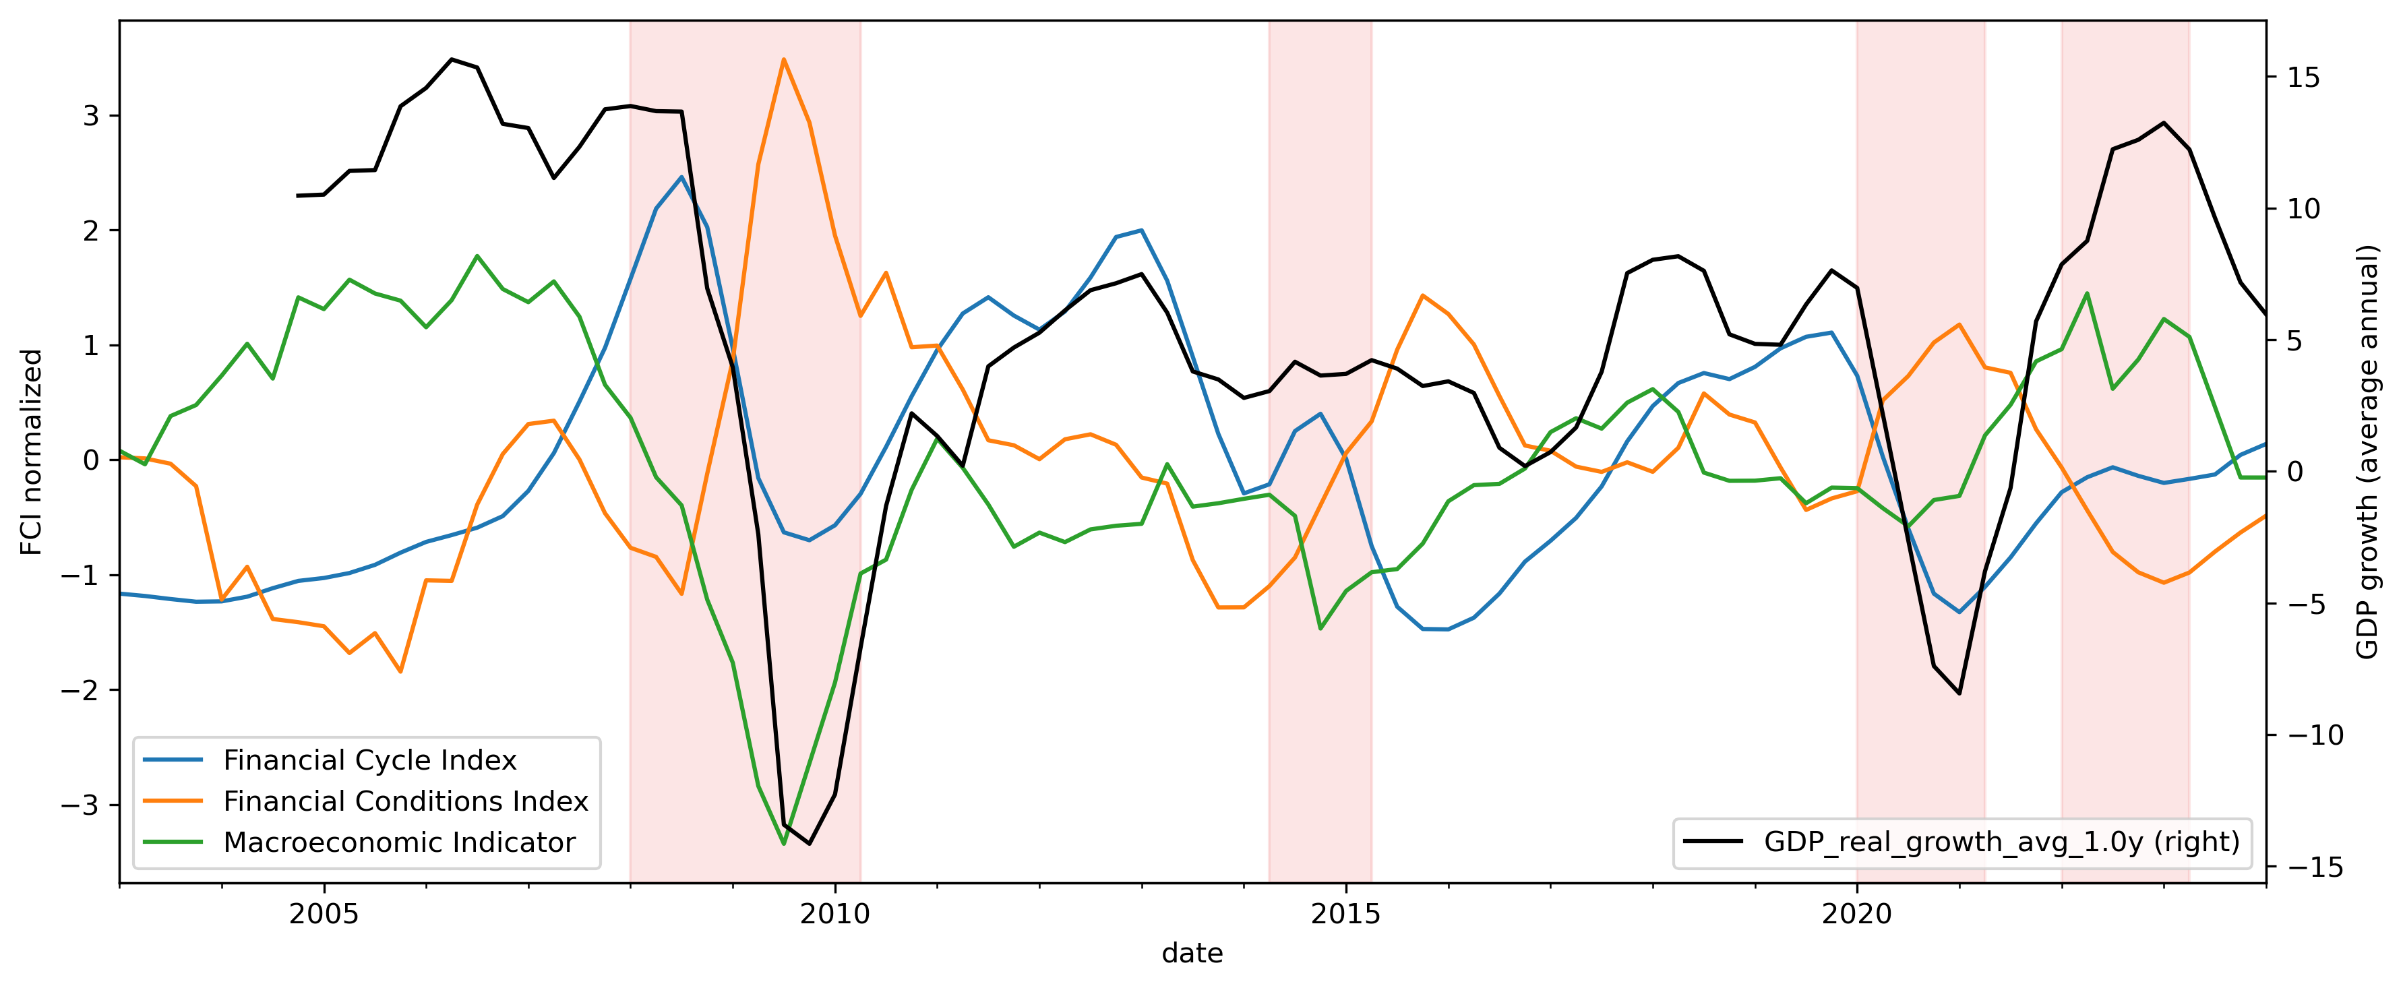
Figure 1. The financial cycle index, financial conditions index, macroeconomic indicator and real GDP growth. The FCyI, FCI and MI are normalized to have zero mean and a standard deviation of one. Vertical areas in red represent economic disturbances.
Throughout these crises, the primary goal of macroprudential policy is to improve the resilience of the financial system, thereby mitigating the negative impact of the crises on economic growth. However, it is important to recognize that the effectiveness of such policy also depends on the economic conditions. The impact of the policy can vary according on the current buildup of vulnerabilities (the position in the financial cycle) and the degree of financial stress (before, during, and after a crisis). Financial vulnerabilities represent risks that manifest during periods of financial stress, as such, these two indices are also closely interconnected. To account for the relationships between these variables, we include three interaction terms in our models: (1) the product of the normalized FCyI and FCI, referred to as the Crisis Index (CI); (2) the product of MPI and the normalized FCyI, termed the Cycle-Based Policy Adjustment (CyBPA); and (3) the product between MPI and normalized FCI, the Conditions-Based Policy Adjustment (CBPA).
- How should macroprudential policy respond to risks?
  - Macroprudential policy uses
Prior to the 2008 Great Recession, macroprudential regulation remained largely underdeveloped. The policy primarily focused on microprudential approaches and operated under the assumption that strong individual institutions would result in a stable financial system (Galati & Moessner, 2013). However, systemic risks related to leverage and bank interconnectedness remained high. The financial crisis revealed these vulnerabilities, prompting a shift in policymakers' focus from micro-level concerns to broader, macroprudential considerations. The Central Bank of Armenia (CBA) was no exception, implementing a series of tightening measures in the aftermath of the crisis.
Figure 2 illustrates the evolution of tightening and loosening macroprudential measures in Armenia. Following the 2008 Great Recession, most regulatory changes focused on capital and asset risk weights. Indirect loosening measures were also used. In 2016, the risk weights for mortgage loans denominated in local currency that met specific criteria were reduced from 50% to 35%. Additionally, in February of that year, the risk weights for correspondent accounts, set at 20% for AMD and 30% for FX, were extended to demand deposits of banks with maturities of up to three months. These regulations effectively lowered banks' risk-weighted assets (RWA) relative to their equity, making it easier to meet capital requirements.
In 2020, the CBA adopted a more accommodative stance in response to the economic impacts of the Covid-19 pandemic. Specifically, funds received from state support programs were exempted from reserve requirements, providing relief to banks during the economic downturn. This marked a temporary shift toward loosening regulatory requirements to support financial stability during the crisis.
In April 2022, the CBA implemented currency-based loan-to-value (LTV) caps, setting a maximum LTV ratio of 90% for real estate loans in AMD and 70% for those in FX. Lastly, although the minimum CAR was reduced from 12% to 11%, other capital-based measures increased. The CCyB was raised from 1% (effective from May 2023) to 1.5% (effective from August 2023), the buffer for systemically important financial institutions (SIFIs) increased from 1% to 1.5%, and the capital conservation buffer (CCoB) was raised from 1.5% to 2%. Collectively, these measures resulted in a net tightening of the macroprudential policy.
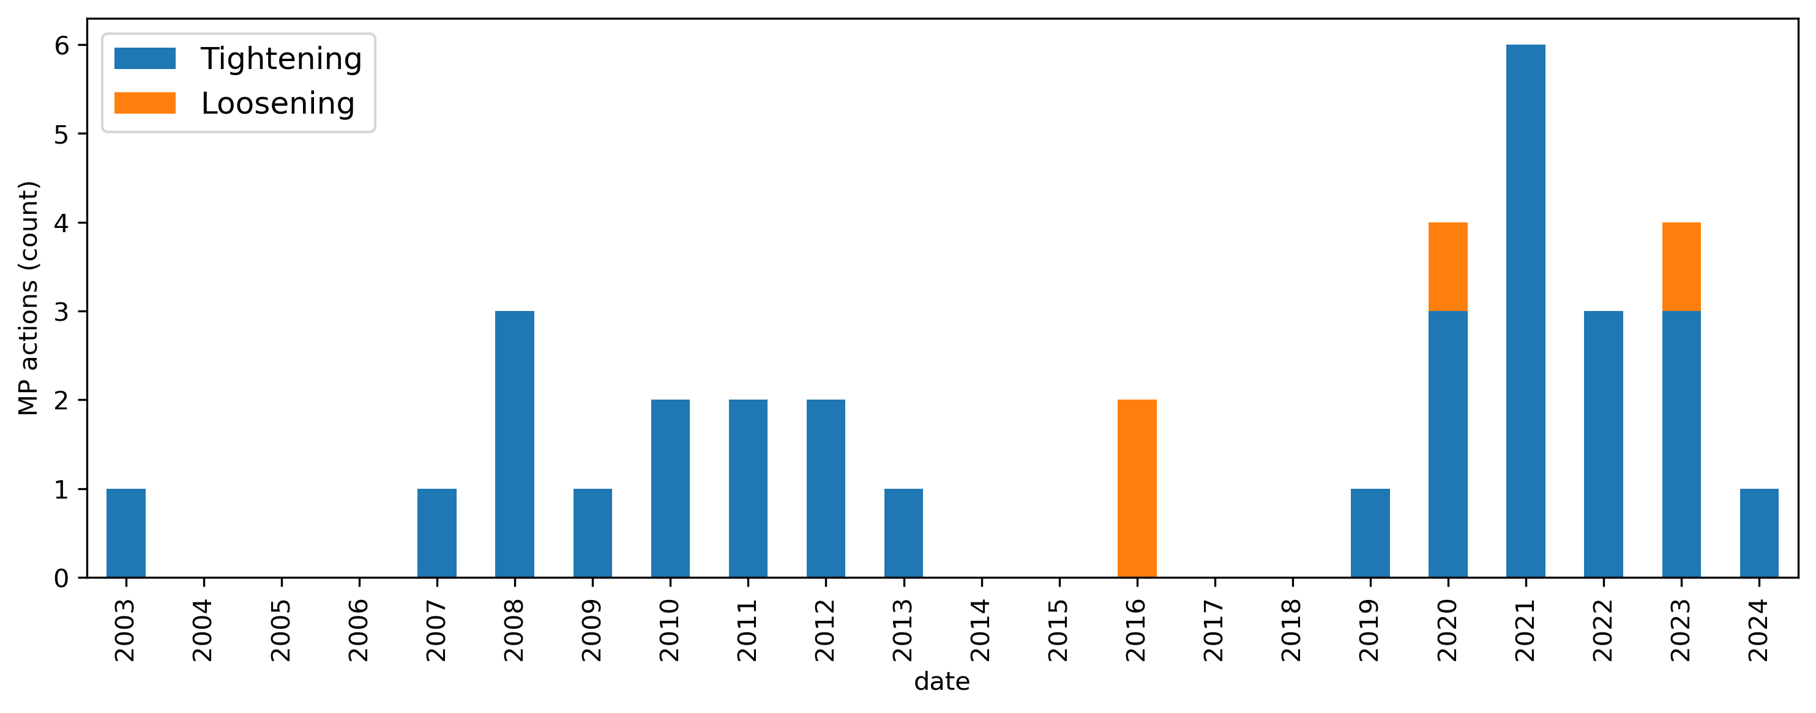
Figure 2. Use of macroprudential policy in Armenia. Y-axis show the number of policy actions taken.
To analyze the impact of these policies we compare the GDP growth distribution of Armenia one year after tightening actions, as shown in Figure 3. The comparison distinguishes between stable and crisis periods. The results indicate that when tightening actions are not followed by a crisis, there is little effect on the left tail of the distribution. However, these actions tend to reduce the right tail, suggesting that they may limit the potential for excessive economic growth. Meanwhile, when a tightening action is followed by a crisis, the distribution shows a less severe left tail. This suggests that tightening policies may mitigate the severity of economic downturns. Finally, the right tail remains relatively unaffected.
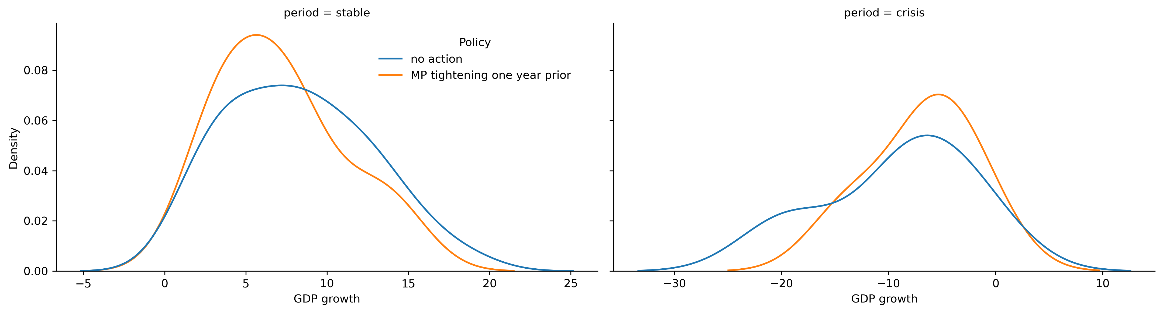
Figure 3. GDP growth distribution of Armenia, one year after macroprudential policy tightening and during different economic phases.
To continue our analysis on the evolution of macroprudential policy, in Figure 4 we investigate the tightening and loosening measures used in the other 40 countries of our study. We observe an active use of loosening measures during the 2008-2009 crisis, in 2012 during the European debt crisis and during the 2020 Covid-19 pandemic. We also observe an increase in the number of tightening measures starting 2015. Figure 5 also delves deeper into the specific measures used over time. In 2009 and 2012 the majority of loosening measures were implemented thought reserve requirements, while in 2020 a much wider array of tools was available for the policymakers, including capital and liquidity-based measures, loan loss provisions (LLPs), LTV measures and many others. Lastly, the increase of tightening measures in 2015 was primarily driven by the introduction of the capital conservation buffers and liquidity measures such as liquidity coverage ratio (LCR), liquid asset ratio (LAR) and net stable funding ratio (NSFR).
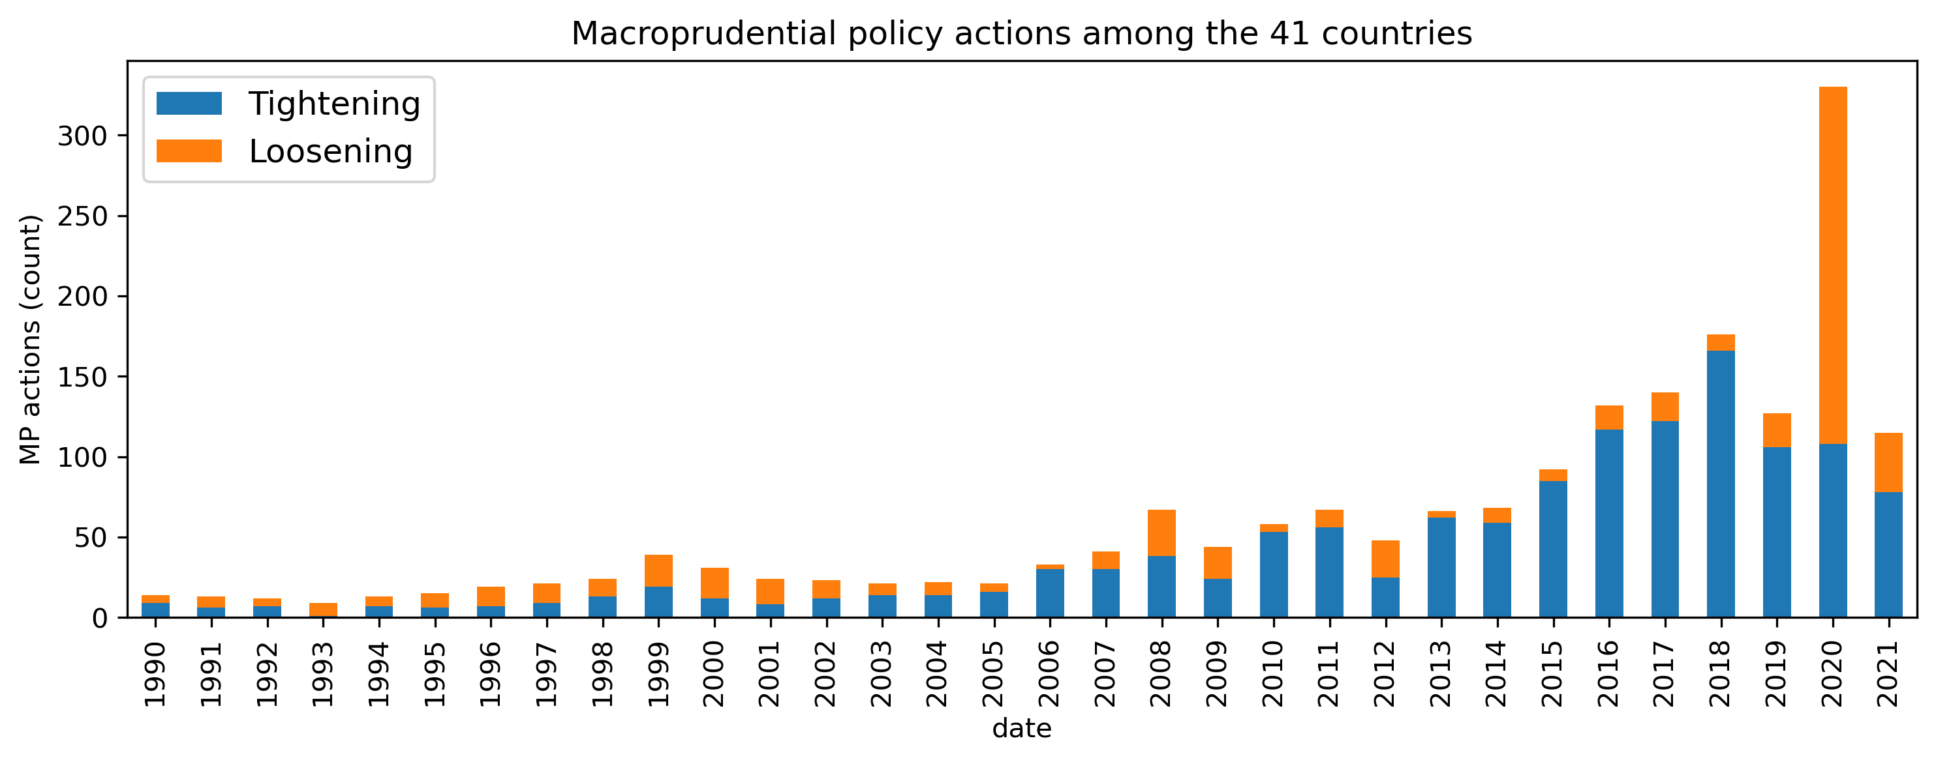
Figure 4. Use of macroprudential policy in 41 countries. Y-axis show the number of policy actions taken.
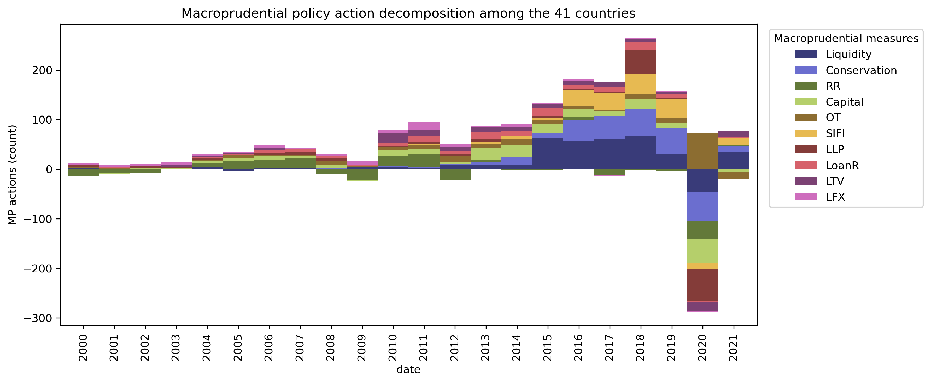
Figure 5. Use of macroprudential policy in 41 countries and decomposition of macroprudential measures. Y-axis show the net number of tightening vs loosening policy actions taken.
We examine the impact of macroprudential policy on the GDP growth distribution of the 41 countries in Figure 6. During the crisis period the major difference is observed on the right tail of the distribution, which may imply faster recovery. The difference becomes more significant when examining the recovery period. Countries that had implemented tightening measures had higher GDP growth in this period.
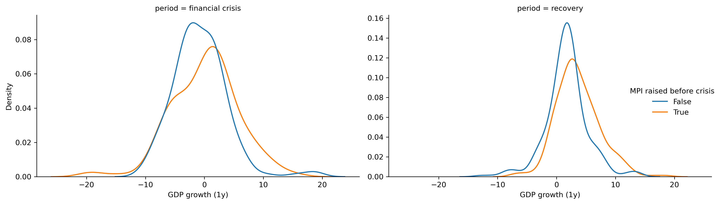
Figure 6. GDP growth distribution of 41 countries that implemented macroprudential policy tightening one year before a major crisis.
  - Materialization of risks
Macroprudential policy affects the GDP growth distribution by regulating the buildup of systemic risks. These vulnerabilities tend to accumulate during periods characterized by rising asset prices and low market volatility. In such environments, the ease of borrowing encourages economic agents to increase leverage. These conditions reduce the incentives of financial intermediaries to manage liquidity and solvency risks while simultaneously expanding their lending capacity and risk appetite. Consequently, this leads to negative externalities, manifesting as “increased leverage, mismatches of maturity and financial positions, growing indebtedness, reduced debt servicing capacity, and other balance sheet weaknesses” (Adrian, et al., 2019). During periods of financial stress, banks reduce lending and engage in deleveraging, which further exacerbates the decline in asset prices. Ultimately, these exposures contribute to deeper, more prolonged, and severe economic downturns (Cardarelli, Elekdag, & Lall, 2011).
In Figure 7, we present the unconditional GDP growth distribution of Armenia. The dotted lines represent the median and the 10th percentile (or tail) of the distribution. The difference between the median and the tail, referred to as the “distance-to-tail,” reflects the unconditional risks faced by the financial system. This metric captures not only the direct impact of potential crises but also the amplifying effects of systemic risks. In the case of Armenia, a crisis, defined as the worst 10% of possible outcomes, could reduce GDP growth by up to 12.4%.
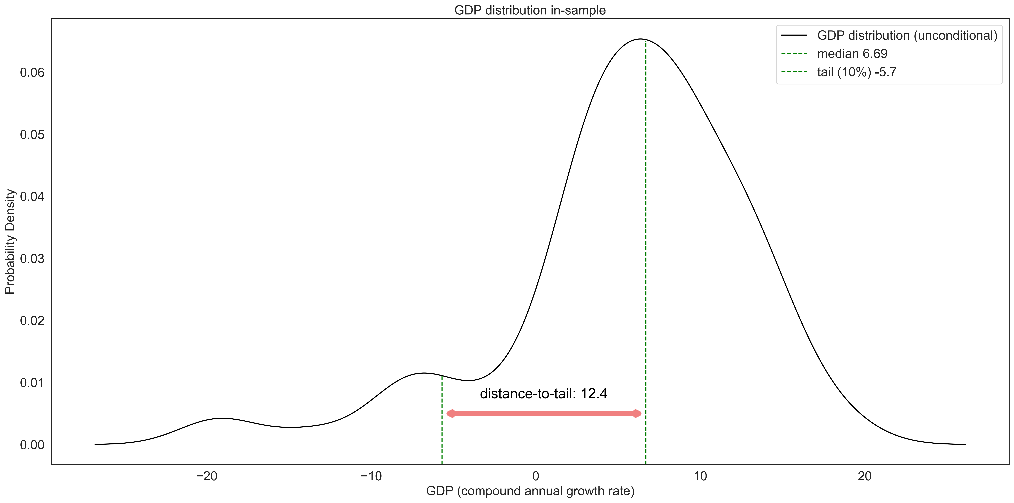
Figure 7. Unconditional GDP growth distribution of Armenia and distance-to-tail.
In Figure 8, we illustrate the GDP growth distribution of Armenia conditional on systemic risks. This conditional distribution displays how the risks shape the uncertainty surrounding GDP growth expectations. The conditional distance-to-tail serves as a means to quantify the negative impact that the buildup of systemic risks can exert on the economy. In the same figure, we simulate how a buildup of financial vulnerabilities, such as excessive credit growth a year prior will affect the shape of the distribution (shown in yellow). This type of environment may increase or decrease the median depending on the nature of externalities, but it will always negatively affect the tail. The distance-to-tail will sharply increase as a result, reflecting the potential severity of these risks. Lastly, we simulate the impact that a tightening of macroprudential policy during excessive credit growth might have on the distribution (shown in green). While tightening policies tend to lower the median due to the short-term costs imposed on banks, they also improve the tail outcomes. As a result, the distance-to-tail decreases, signaling a reduction in negative outcomes related to systemic risks. This is both a result of the reduction in risks, but also the increased resilience of the system.
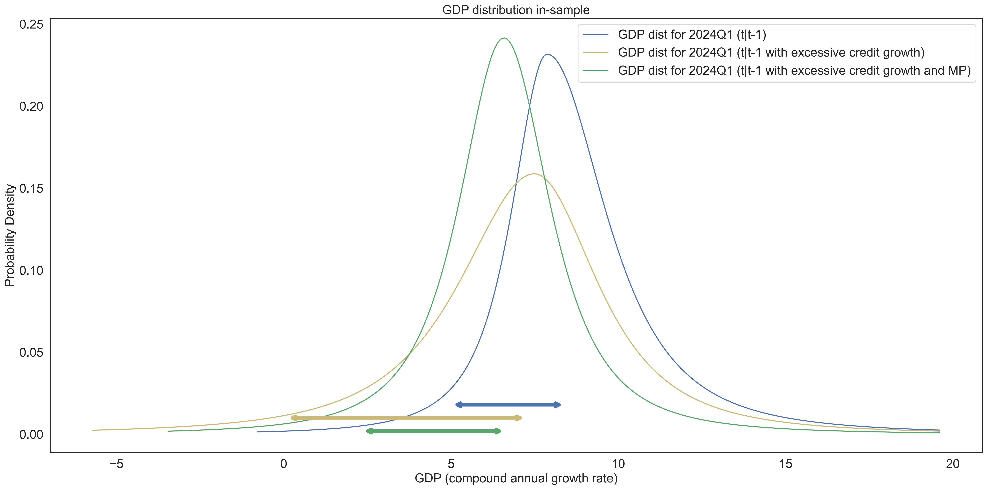
Figure 8. GDP growth distribution of Armenia conditional on systemic risks in 2024Q1. The yellow distribution considers the effect of an increase in financial vulnerabilities, while the green distribution considers the former, but also a tightening of macroprudential policy.
  - Macroprudential stance
Generally, when considering macroprudential policy through the “risk-resilience framework,” a stance metric represents the residual systemic risk in the financial system (ESRB, 2019). We derive the residual risk by “assessing the aggregate risk and subtracting any exogenous and/or policy-induced resilience” (ESRB, 2021). From this perspective, macroprudential policy is a risk management approach, where we balance systemic risk and resilience, while accounting for policymakers' tolerance of the net residual risk. As part of the indicator-based approach for Borrower-Based Measures (BBMs), ESRB (2024) defines the macroprudential stance as:
$$\begin{aligned}Stance=Risk-Resilience-Policy\#\left( SEQ Equation \backslash * ARABIC 1\right)\end{aligned}$$
In the GaR framework, the conditional distance-to-tail tracks the changes in systemic risk over time, thus it can be used as one of the main indicators for the macroprudential stance. The metric primarily focuses on risks and policy, while using systemic thresholds as a reference for resilience. The systemic thresholds are calculated from the quantiles of the historical distance-to-tail series. The loss function for the distance-to-tail approach takes the form:
$$\begin{aligned}\min_{ρ_{t}}{L}=\max\left(\left(y_{m}-y_{c}\right),threshold\right)\#\left( SEQ Equation \backslash * ARABIC 2\right)\end{aligned}$$
Where $y_{m}$ and $y_{c}$ are the median and the tail, while $\left(y_{m}-y_{c}\right)$ is the distance-to-tail. When this value exceeds the threshold, we are incentivized to tighten the macroprudential policy to minimize the loss. The complete ESRB (2024) formulation includes multiple thresholds at the 10th, 30th, 70th, and 90th percentiles of the distance-to-tail distribution. The resulting stances are classified into 5 categories: tight, grey-tight, neutral, grey-loose, and loose. Thus, the long-term goal of the policy is to maintain the stance at the neutral level.
The main limitation of this approach is that it does not consider the costs that macroprudential policy will impose for reducing systemic risks. Additionally, the systemic thresholds are not a dynamic measure of the resilience of the financial system. As an alternative to the distance-to-tail approach, we consider the welfare function proposed by Suarez (2021). The function takes the form:
$$\begin{aligned}W=y_{m}-\frac{1}{2}w{\left(y_{m}-y_{c}\right)}^{2}\#\left( SEQ Equation \backslash * ARABIC 3\right)\end{aligned}$$
$$\begin{aligned}\min_{ρ_{t}}{L}=-E_{t}\left\{\sum_{t=0}^{T}{b^{t}W_{t+1}}\right\}\#\left( SEQ Equation \backslash * ARABIC 4\right)\end{aligned}$$
where $w$ is interpreted as the aversion to financial instability, while $b$ is a discount factor. This formulation considers both the median and the distance-to-tail, capturing the costs of macroprudential policy along with its benefits. It is apparent from Equation 3, that the optimal policy is subject to the choice of $w∈(0,1)$. This term includes the policymakers’ appetite for risk, but also the probability of crisis. A higher value of $w$ indicates that the policymaker is more sensitive to risks, while a value of zero would imply a complete disregard for the systemic risks in the economy. The calibration results indicate that the reasonable value of $w$ in Armenia is around 0.11. The specific trade-off for the policymakers will depend on their tolerance for downside risks, but also the effectiveness of macroprudential policy (ESRB, 2021; Suarez, 2021).
- Methodology
  - Panel quantile regression
As we have discussed before, macroprudential policy has different effects on the GDP growth distribution (Boar et al., 2017). To model these nonlinearities we use the quantile regression framework (Koenker & Bassett, 1978) which allows us to focus on different conditional quantiles of the distribution and not just the conditional mean. Quantile regression has also become quite popular in forecasting growth-at-risk, which is the expected loss in GDP growth given a tail event. In fact, it has proven to outperform GARCH-type models (Kipriyanov, 2022) in this task. In a panel framework, quantile regression helps to account for heterogeneous covariates, while the fixed effects consider the unobserved heterogeneity which doesn’t change with respect to time (Galán, 2020). It is important to note that in this framework the fixed effects are subject to change depending on the quantile. For a general case, a panel quantile regression takes the following form:
$$\begin{aligned}y_{i,t+h}=α_{i,τ}+X_{i,t}β_{τ}+v_{τ,t+h}\#\left( SEQ Equation \backslash * ARABIC 5\right)\end{aligned}$$
$$\begin{aligned}v_{τ,t+h}=\sum_{i=1}^{n}{\sum_{t=1}^{T-h}{ρ_{τ}\left|{y_{i,t+h}-y}_{i,t+h}^{*}\right|}}\#\left( SEQ Equation \backslash * ARABIC 6\right)\end{aligned}$$
$$\begin{aligned}ρ_{τ}=τ⋅1_{y_{i,t+h}≥y_{i,t+h}^{*}}+\left(1-τ\right)⋅1_{y_{i,t+h}≤y_{i,t+h}^{*}}\#\left( SEQ Equation \backslash * ARABIC 7\right)\end{aligned}$$
where, $y_{it+h}^{*}$ is the quantile regression estimate, $X_{i,t}$ is a vector of exogenous variables, $α_{i,τ}$ is a vector of fixed effects, $ρ_{τ}$ are the quantile-based weights, $τ∈Γ$ is the quantile, while $T$ and $n$ are the time dimension and the cross-section dimension respectively. In our case $T=120$ and $n=41$. An important note is that the model uses least absolute deviation (LAD) as its optimality criterion.
  - Quantile regression for Armenia (local model)
The baseline quantile regression model for the Armenian economy takes the form:
$$y_{t+h}=α_{τ}+β_{1,τ}y_{t}+β_{2,τ}{FCyI}_{t}+β_{3,τ}{FCI}_{t}+β_{4,τ}{CI}_{t}+β_{5,τ}{MPI}_{t}+β_{6,τ}{CAR}_{t}+β_{7,τ}{LR}_{t}+ \\ \begin{aligned}+β_{8,τ}{MI}_{t}+β_{9,τ}{CyBPA}_{t}+β_{10,τ}{CBPA}_{t}+ϵ_{t,τ}\#\left( SEQ Equation \backslash * ARABIC 8\right)\end{aligned}$$
In this specification $y_{t+h}$ is the annualized average growth rate of real GDP at $t+h$ quarters ahead. The $α_{τ}$ is an intercept, $y_{t}$ is the autoregressive component, ${FCyI}_{t}$ is the financial cycle index, ${FCI}_{t}$ is the financial conditions index and ${CI}_{t}=St\left({FCyI}_{t}\right)*St({FCI}_{t})$ is the “crisis index,” which is the product between the standardized ($N(0,1)$) ${FCyI}_{t}$ and ${FCI}_{t}$.
Next, we include the macroprudential policy index ${MPI}_{t}$, the 2-year change in the excess capital adequacy ratio (actual minus minimum requirement) ${CAR}_{t}$ and the excess liquidity ratio (HQLA/Assets) ${LR}_{t}$. The MPI is computed (both for the local and panel models) using the methodology and the dataset proposed by Alam et al. (2019). The dataset includes 17 categories of macroprudential measures over time. Each tightening is expressed as +1, while each loosening is represented as -1. Finally, no or neutral actions are marked as 0. We define the sum of the 17 dummy categories at time t as $MP_{t}$. We express the MPI as the 4-quarter rolling sum of $MP_{t}$ like so:
$$\begin{aligned}MPI_{t}=\sum_{p=0}^{3}{MP_{t-p}}\#\left( SEQ Equation \backslash * ARABIC 9\right)\end{aligned}$$
The rest of the model includes a control variable, the macroeconomic indicator ${MI}_{t}$. This variable is constructed using a partial least squares regression between the current GDP growth (autoregressive term in eq. 7) and 10 macro variables. These include the exchange rate, trade balance, copper prices, current account, unemployment rate, government debt, government expenditure, the fiscal impulse from the QPM, CPI and the central bank refinancing rate.
Finally, we include the interaction terms with the MPI, specifically, the Cycle-Based Policy Adjustment ${CyBPA}_{t}$ and the Conditions-Based Policy Adjustment ${CBPA}_{t}$.
  - Financial conditions index
To estimate the FCI we will use a factor augmented VAR with structural instabilities and time-varying coefficients (TVP-FAVAR). The p-lag TVP-FAVAR (Koop & Korobilis, 2014) state space model takes the form:
$$\begin{aligned}\left[\begin{matrix}y_{t} \\ x_{t}\end{matrix}\right]=\left[\begin{matrix}1 & 0 \\ λ_{t}^{y} & λ_{t}^{f}\end{matrix}\right]\left[\begin{matrix}y_{t} \\ f_{t}\end{matrix}\right]+\left[\begin{matrix}0 \\ v_{t}\end{matrix}\right]\#\left( SEQ Equation \backslash * ARABIC 10\right)\end{aligned}$$
$$\begin{aligned}\left[\begin{matrix}y_{t} \\ f_{t}\end{matrix}\right]=c_{t}+Β_{t,1}\left[\begin{matrix}y_{t-1} \\ f_{t-1}\end{matrix}\right]+{…+Β}_{t,p}\left[\begin{matrix}y_{t-p} \\ f_{t-p}\end{matrix}\right]+ϵ_{t}\#\left( SEQ Equation \backslash * ARABIC 11\right)\end{aligned}$$
$\begin{aligned}λ_{t}=λ_{t-1}+θ_{t}\#\left( SEQ Equation \backslash * ARABIC 12\right)\end{aligned}$
$\begin{aligned}β_{t}=β_{t-1}+η_{t}\#\left( SEQ Equation \backslash * ARABIC 13\right)\end{aligned}$
where $x_{t}$ is an $n_{f}×1$ vector of financial variables, with $n_{f}=17$. These include interest rate spreads, mortgage rates, government bond rates, the level, slope and curvature of the yield curve, the return on equity (RoE) of banks and so on. The $y_{t}$ is an $s_{m}×1$ vector of macro variables. In our model we included the consumer price index (CPI), real GDP growth and the monetary policy rate. In our design matrix $λ_{t}^{y}$ is a vector of regression coefficients, while $λ_{t}^{f}$ is a vector of factor loadings. In the state equation we have the latent factor $f_{t}$ interpreted as the FCI. The $c_{t}$ is a vector of intercepts, while $(Β_{t,1}…Β_{t,p})$ are matrices of VAR coefficients. We use $λ_{t}={\left({\left(λ_{t}^{y}\right)}^{T},{\left(λ_{t}^{f}\right)}^{T}\right)}^{T}$and $β_{t}={\left(c_{t}^{T},vec{\left(Β_{t,1}\right)}^{T}…ec{\left(Β_{t,p}\right)}^{T}\right)}^{T}$ to track the time-varying properties of the parameters. Finally, the error terms $v_{t}$, $ϵ_{t}$, $θ_{t}$ and $η_{t}$ are zero-mean gaussian disturbances. Their covariances $V_{t}$, $Q_{t}$, $W_{t}$ and $R_{t}$ may also change over time. $V_{t}$, $W_{t}$ and $R_{t}$ are diagonal, thus the disturbance terms are uncorrelated with each other.
To estimate the model a 3-step algorithm is used. First, we initialize the parameters, and estimate the principal component analysis (PCA) based $f_{t}^{*}$. Next, we use this $f_{t}^{*}$ to obtain our time-varying parameters. We then use the “Variance Discounting” (VD) method proposed by the authors (Koop & Korobilis, 2014) to estimate $V_{t}$, $Q_{t}$, $W_{t}$ and $R_{t}$. Using these disturbances, we can then estimate the actual $λ_{t}$ and $β_{t}$ using Kalman filtering and smoothing (KFS). Finally, we use the time-varying coefficients to generate $f_{t}$ using KFS.
  - Financial cycle index
The financial cycle index is an aggregate of different variables related to loan loss. These include credit-to-GDP gap, private and corporate loan flows, real estate prices, and so on. Formally, (Holló, Kremer, & Lo Duca, 2012) the aggregation can be expressed as:
$$\begin{aligned}FCyI_{t}={\left(w⊙s_{t}\right)}^{T}C_{t}\left(w⊙s_{t}\right)\#\left( SEQ Equation \backslash * ARABIC 14\right)\end{aligned}$$
where, $s_{t}$ is the vector of exogenous indicators at time $t$ and $w$ is a vector showing the relative importance of the values in $s_{t}$. The expression $\left(w⊙s_{t}\right)$ is the Hadamard-product between the vectors (element-wise multiplication). The matrix $C_{t}$ contains values of the cross-correlation coefficients for the indicators at time t. The matrix $C_{t}$ is estimated recursively using an exponentially weighted moving average (EWMA) process, utilizing the previous variance and covariance values as a base. Finally, the relative weights $w$ are determined by running a constrained optimization to find the $FCyI_{t}$ that provides the best predictions for future loan loss impairments (Plašil, Seidler, Hlaváč, & Konečný, 2014).
  - Parametric fit
After evaluating the quantile regression models, we end up with conditional quantile estimates $y_{t+h,τ}^{*}$. With a sufficiently large set of quantiles $Γ$, one can describe the conditional cumulative distribution function (CDF) of the output growth at time $t+h$. To derive the probability distribution function (PDF) a parametric t-skew fit (Adrian, Boyarchenko, & Giannone, 2019) is used. Compared to the normal distribution, the t-distribution is much better suited for capturing the fat tails. Using the closed-form specification of the distribution proposed by Giot and Laurent (2003) we define the CDF as:
$$\begin{aligned}F\left(x, μ,σ, df, ξ\right)=\frac{2}{1+ξ^{2}}T_{cdf}\left(\frac{x-μ}{σ}ξ,df\right) if x≤μ\#\left( SEQ Equation \backslash * ARABIC 15\right) \end{aligned}$$
$$\begin{aligned}F\left(x, μ,σ, df, ξ\right)=1-\frac{2}{1+\frac{1}{ξ^{2}}}T_{cdf}\left(-\frac{x-μ}{σ}\frac{1}{ξ},df\right) if x>μ\#\left( SEQ Equation \backslash * ARABIC 16\right) \end{aligned}$$
where $μ$ and $σ$ are the location and scale parameters, while $ξ$ is the skewness. To simplify the search space to only three parameters we anchor the degrees of freedom at 2 ($df=2$). Finally, we define the optimization function in terms of quantiles:
$$\begin{aligned}μ_{t+h}^{*},σ_{t+h}^{*}, ξ_{t+h}^{*}=argmin\left(\sum_{τ}{{\left(F\left(y_{t+h,τ}^{*},μ,σ,df^{*},ξ\right)-τ\right)}^{2}} \right)\#\left( SEQ Equation \backslash * ARABIC 17\right)\end{aligned}$$
After the location, scale and skewness parameters are estimated they can be used to generate the t-skew PDF and CDF at time at time $t+h$.
  - Data
The panel model for this study utilizes a quarterly dataset covering 41 countries and 16 variables (19, including interaction effects) for the period from 1993 to 2020. The majority of the data was sourced from two key International Monetary Fund (IMF) databases: the International Financial Statistics (IFS) and the Financial Soundness Indicators (FSI) (IMF, 2024). For data related to equity indices, we relied on the Global Economic Monitor (GEM) database (2023), maintained by the World Bank (WB). Some of the variables related to government bond rates were extracted from individual central bank websites. Lastly, data for the MPI was sourced from the iMaPP database (Alam, et al., 2019).
The Armenian model effectively utilized 32 variables (35 with interaction effects) covering the period from 2003 to 2024. The FCI required 8 interest-rate related variables, FCyI was constructed using 9 credit-related variables, the MI incorporated 10 macroeconomic variables, while the final model included 8 exogenous indicators (including the three indices). All of the data for the local model were collected from the Central Bank of Armenia.
- Results
  - Quantile regression estimates for panel and local models
To analyze the relationship between systemic risks, macroprudential policy, and GDP growth, we use the model estimates of Equation 5 and Equation 8 as the foundation for the comparisons. Figure 9 and Figure 10 illustrate the goodness of fit of the panel and local quantile regression models across various quantiles and horizons. Specifically, horizons 4, 8, and 12 represent GDP growth projections for 1, 2, and 3 years ahead. The models demonstrate optimal in-sample performance at the lower and upper quantiles of the GDP growth distribution. This outcome is by design since our focus is on tail risks. In the panel model, the strongest fit occurs when predicting GDP growth 2-3 years ahead, whereas the local model excels in forecasting 1-2 years ahead. This may suggest that the lag between systemic risk buildup and its materialization is shorter in Armenia compared to other countries. Therefore, we adopt the 1-year ahead estimates as the primary benchmark for our comparisons and discussions.
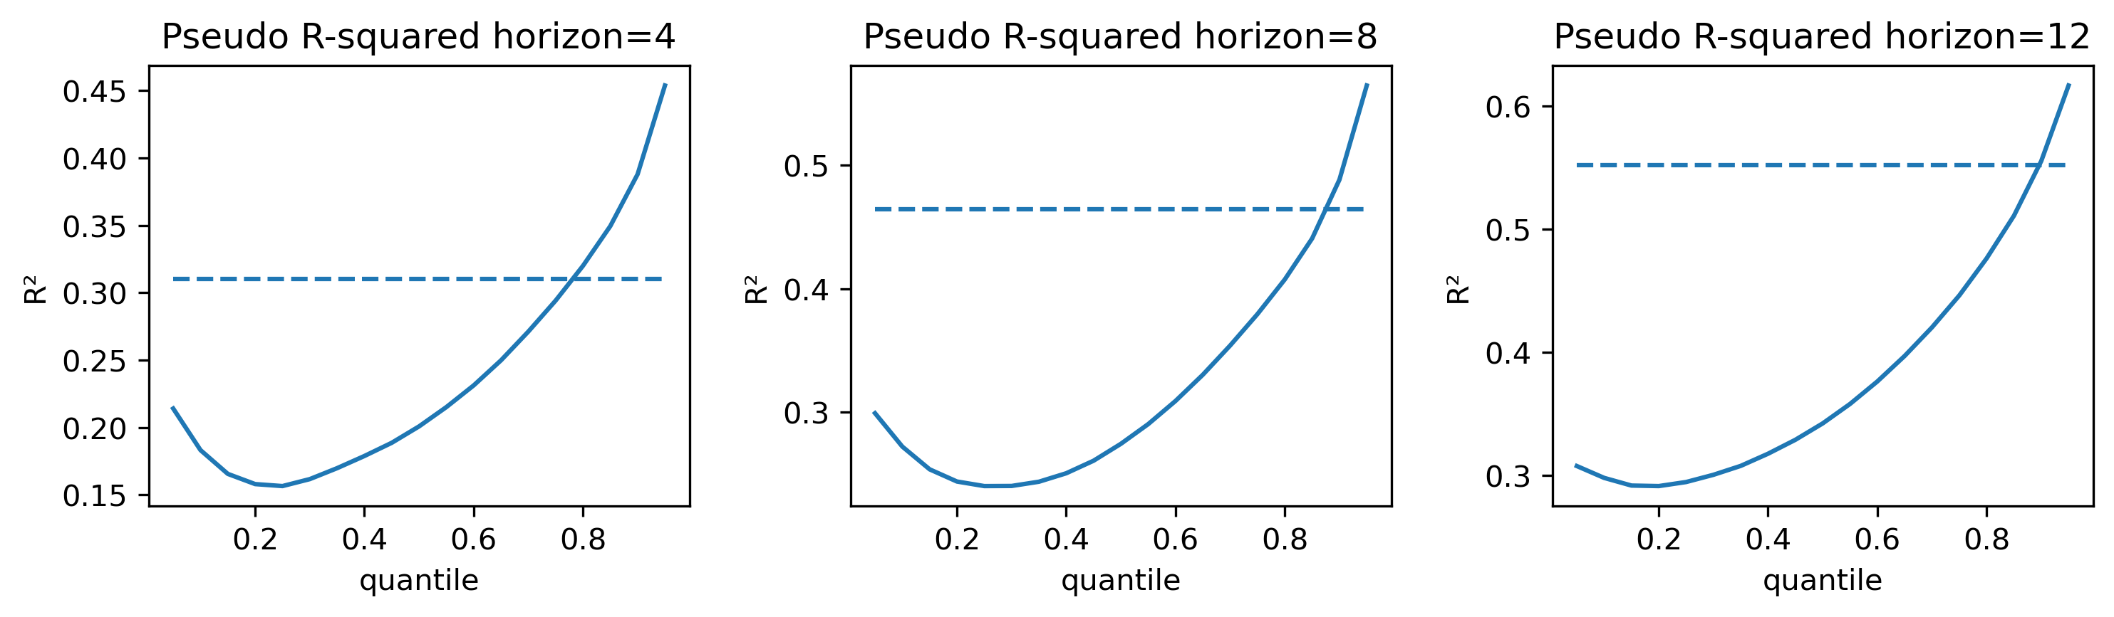
Figure 9. Pseudo r-squared for panel quantile regression estimates across quantiles and horizons. OLS r-squared displayed as a dashed line. Note: generally, quantile regression and OLS (pseudo) r-squared aren’t comparable. They are here for convenience.
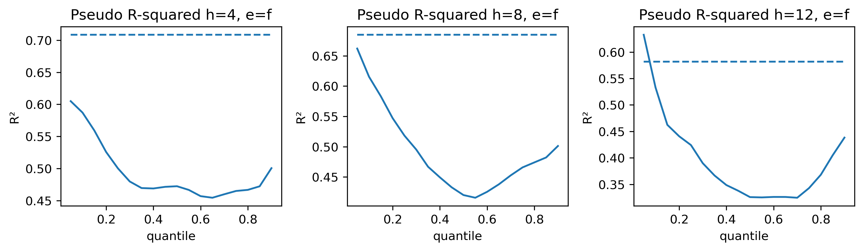
Figure 10. Pseudo r-squared for local quantile regression estimates across quantiles and horizons. OLS r-squared displayed as a dashed line.
Figure 11 and Figure 12 display the quantile regression coefficients for the FCyI in the local and panel models, respectively. In the local model, the FCyI shows a negative but insignificant effect in the short run, while its negative impact becomes significant over the long run. Conversely, the panel model demonstrates a consistently negative and significant FCyI effect in both the short and long run.
Additionally, the results reveal heterogeneous effects of FCyI across the distribution, with more pronounced impacts in the lower quantiles. This indicates that increases in FCyI exacerbate tail risks, suggesting that it would increase distance-to-tail, which is in line with the theory of business and financial cycles where a maturity or a peak phase is followed by a contraction. The results suggest that financial vulnerabilities affect the economy in the medium-term. This relationship was also observed in Portugal where credit aggregates were the most relevant medium-term predictors of future GDP growth (Adrian, et al., 2019).
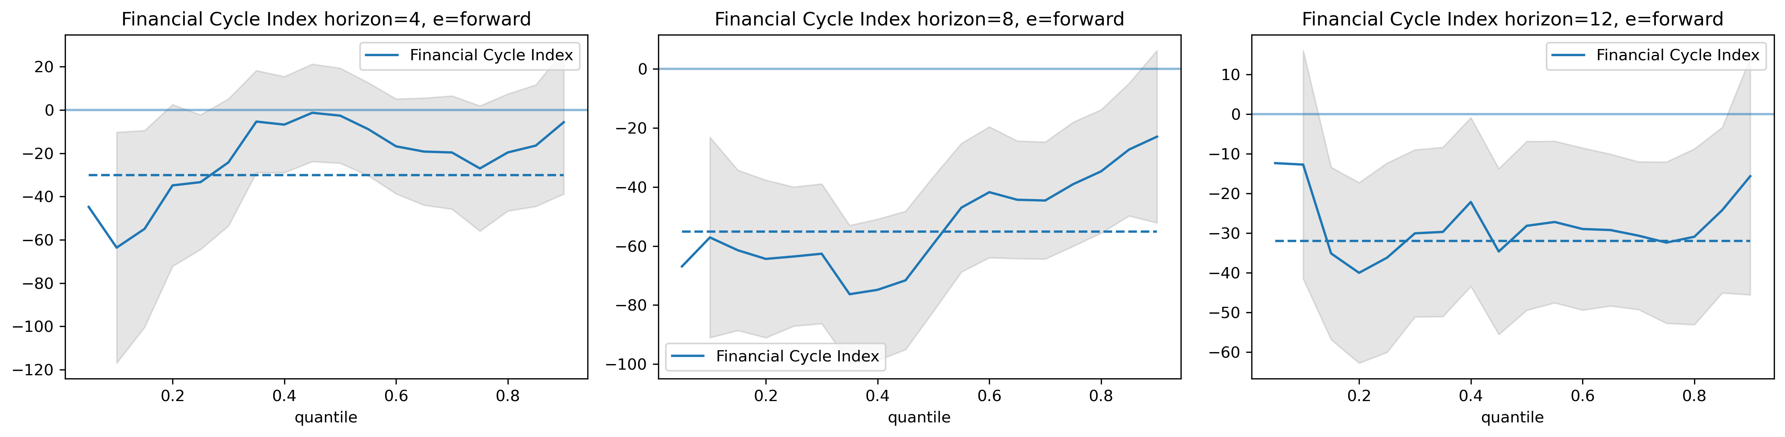
Figure 11. Local model Financial Cycle Index coefficients. Estimated quantile regression coefficients for horizons 4, 8 and 12. The grey shaded areas represent the 95% confidence intervals. The dashed horizontal line presents the OLS coefficient.
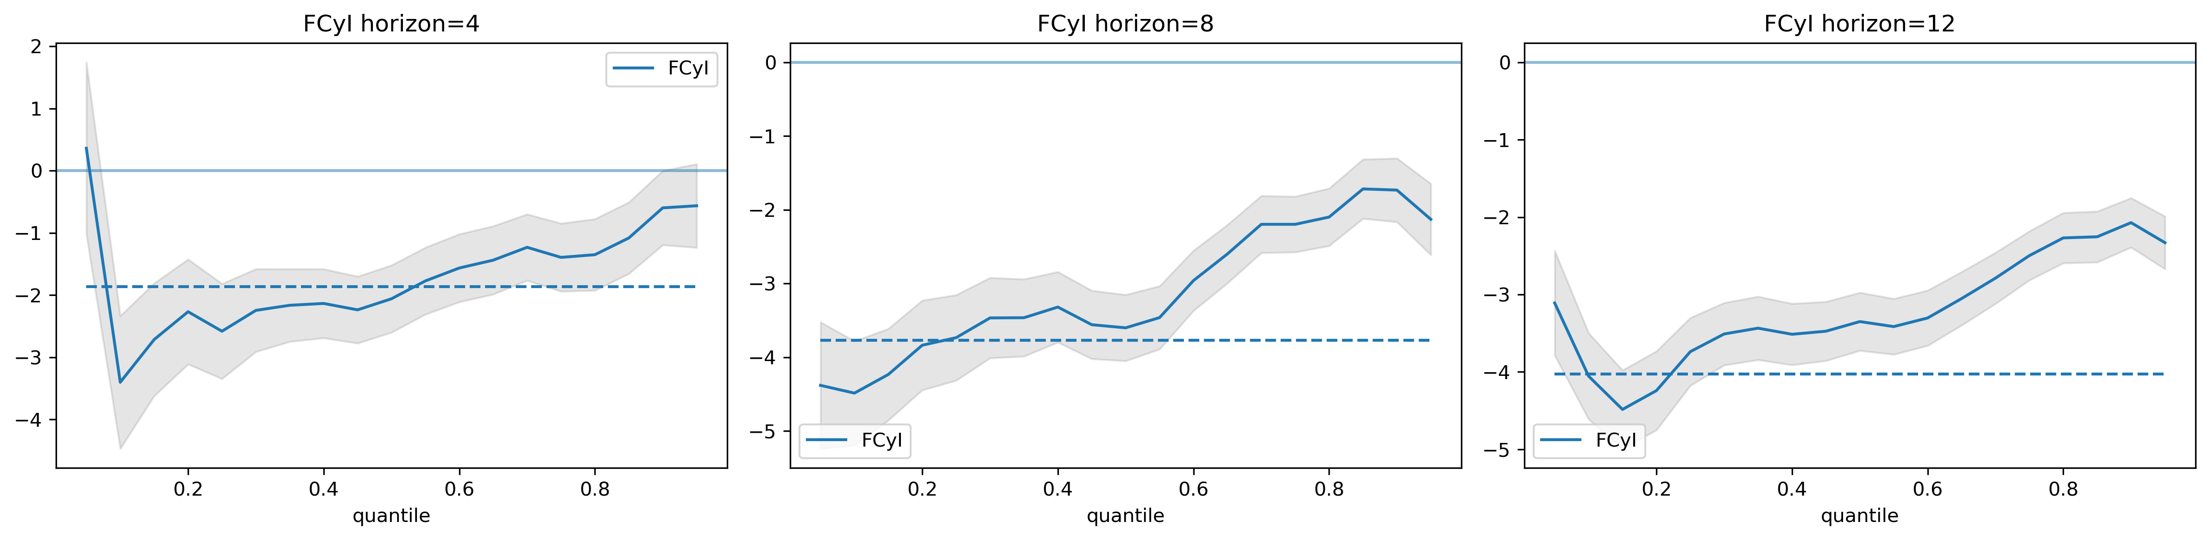
Figure 12. Panel model Financial Cycle Index coefficients.
Figure 13 and Figure 14 present the quantile regression coefficients for the FCI in both the local and panel models. In the local model, the FCI is positive and largely significant in the short run but becomes insignificant over the long-term. In contrast, the panel model shows that FCI remains significant across both time dimensions, though its effect varies considerably. The FCI negatively impacts the left and right tails while positively influencing the middle quantiles.
A high FCI reflects tight financial conditions. In the near term, this effect should be negative, yet due to its cyclical and mean-reverting nature, it will eventually normalize, boosting future growth (Adrian, et al., 2019). The positive short-term coefficient in the local model likely reflects this cycle, where financial stress is followed by economic recovery. Meanwhile, the negative effect on the left tail in the panel model underscores the long-term negative externalities that financial stress can create. Overall, the literature suggests that FCIs should primarily exert short-term effects on the GDP growth distribution (ESRB, 2021).
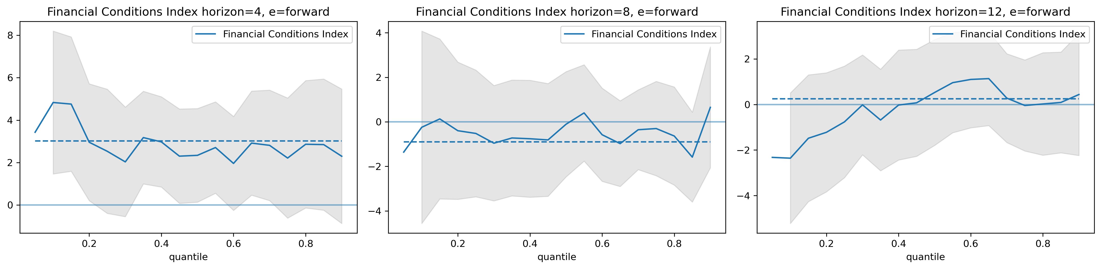
Figure 13. Local model Financial Conditions Index coefficients. Estimated quantile regression coefficients for horizons 4, 8 and 12. The grey shaded areas represent the 95% confidence intervals. The dashed horizontal line presents the OLS coefficient.
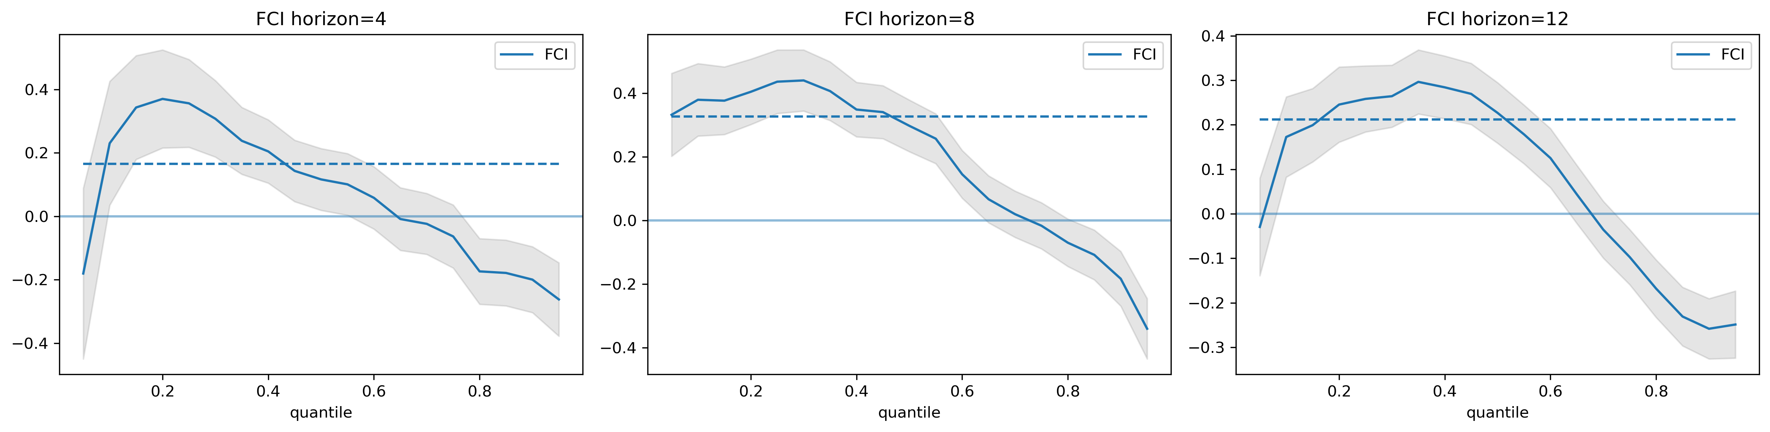
Figure 14. Panel model Financial Conditions Index coefficients.
  - The impact of macroprudential policy on output growth distribution
Macroprudential policy enters the panel and local equations through both direct and indirect (interaction) effects. Direct effects capture the benefits of increased resilience from policy interventions, as well as the associated costs. Interaction effects, on the other hand, capture the role of macroprudential policy in mitigating systemic risks.
Figure 15 and Figure 16 plot the quantile regression coefficients for the direct effects of MPI in the local and panel models, respectively. In the local model, the short-run direct effects are positive at the left tail and negative at the median, though these coefficients are statistically insignificant. The panel model shows similar short-run patterns but with significant effects. Lastly, the long-run direct effects are negative and significant.
The heterogeneity in the direct effects suggests that, in the short run, MPI improves resilience and reduces distance-to-tail. However, if financial conditions remain stable and no crisis is observed, MPI could have negative long-term implications for both the median and distance-to-tail. These outcomes reflect the practical costs of macroprudential policy, but also the prolonged requirement for banks to hold excess capital, which may suppress economic activity over time.
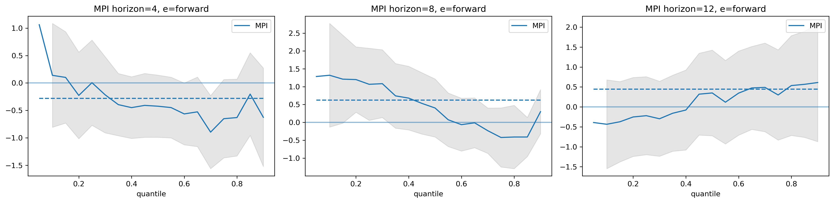
Figure 15. Local model direct Macroprudential Policy Index coefficients. Estimated quantile regression coefficients for horizons 4, 8 and 12. The grey shaded areas represent the 95% confidence intervals. The dashed horizontal line presents the OLS coefficient.
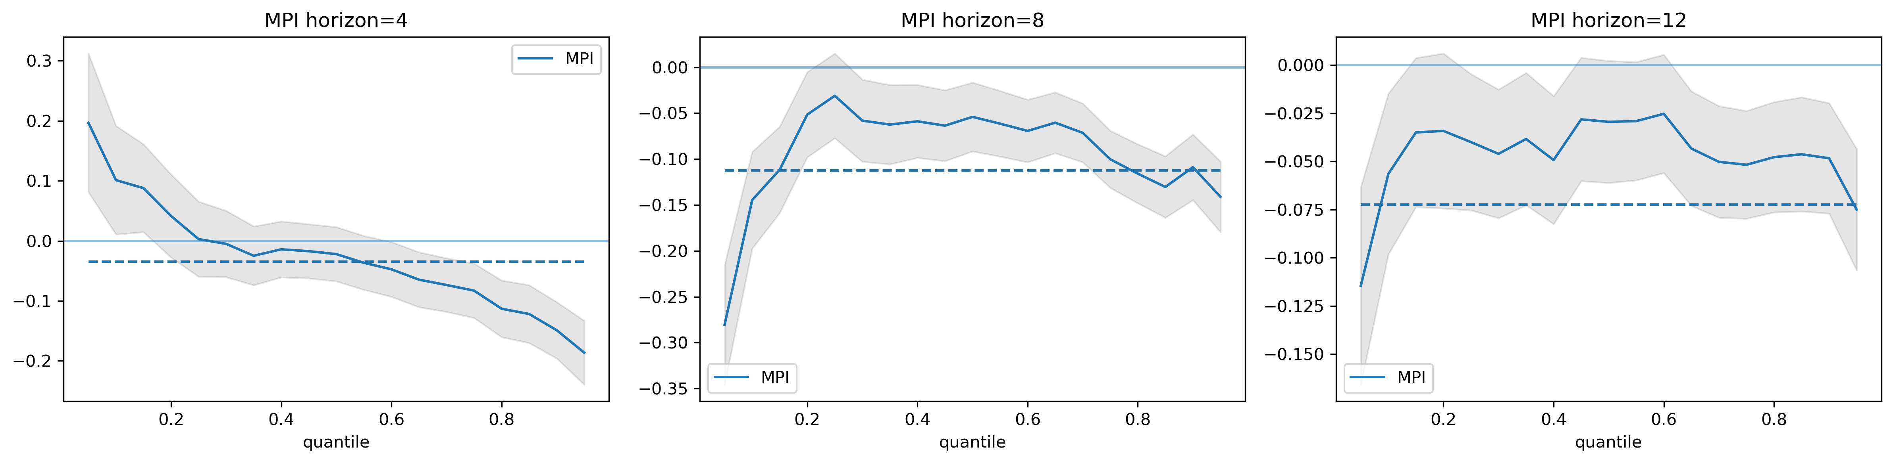
Figure 16. Panel model direct Macroprudential Policy Index coefficients.
To examine the overall impact of macroprudential policy, we present the conditional MPI coefficients in Figure 17. Both short- and long-term effects highlight the positive influence on the lower tail of the GDP growth distribution and the negative impact on the upper quantiles. The findings suggest that macroprudential policy is most effective during periods of low financial stress. However, if such periods coincide with excessive credit growth or asset price surges, the short-term costs to growth will be higher. Nonetheless, these conditions also lead to the most significant reduction of risks in the medium term.
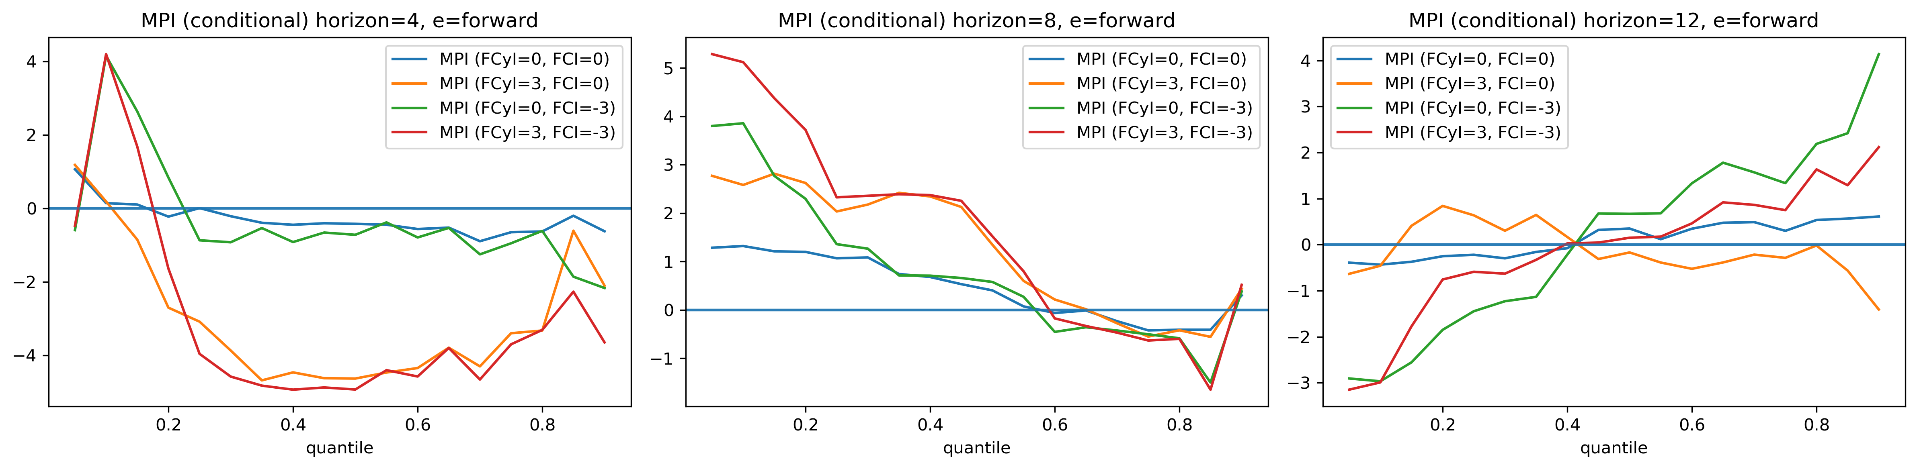
Figure 17. Local model conditional Macroprudential Policy Index coefficients. Estimated quantile regression coefficients for horizons 4, 8 and 12.
- Macroprudential policy stance
  - Distance-to-tail approach
The goal of stance assessment is to assist macroprudential policymakers in making informed decisions to manage financial stability. The distance-to-tail approach achieves this by quantifying and differentiating systemic risks in the economy. Figure 18 depicts Armenia's estimated distance-to-tail over time. An increase in this value signals the buildup of financial exposures. We classify systemic risks into financial vulnerabilities, financial stress, liquidity risks, capital risks, and the interactions between these risks. We also separate them from the effects of macroeconomic events.
The results demonstrate that financial vulnerabilities follow a cyclical pattern, while financial stress tends to appear more abruptly. Liquidity risks are persistent but exhibit slow changes with minimal volatility. Capital risks are more prominent during crisis periods. Additionally, financial intermediaries often hold excess capital after economic downturns, which contributes to a reduction of risks. The interaction between financial vulnerabilities and financial stress has a procyclical behavior, manifesting during financial crises and amplifying existing risks. Macroprudential policy actions mostly contribute to a reduction of risks. Their impact on financial vulnerabilities is much stronger than on financial stress. However, failure to implement loosening measures during crisis periods can heighten risk perception. Finally, the influence of macroeconomic events on systemic risks is minimal, as they tend to shift the entire GDP growth distribution uniformly, showing little heterogeneity in their effects.
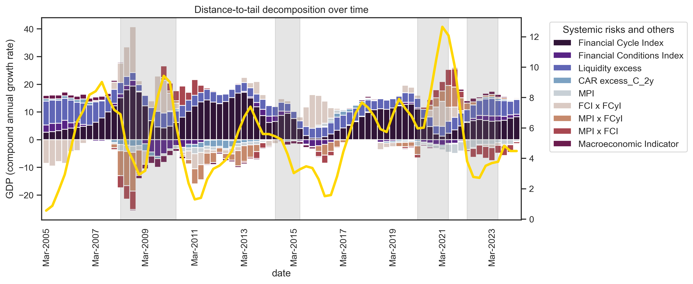
Figure 18. Estimated distance-to-tail over time and decomposition of systemic risks. Vertical areas in grey represent economic disturbances.
To examine the performance of the distance-to-tail metric for crisis periods we compare systemic risks in Armenia before four major economic disturbances in Figure 19. Prior to the 2007–2009 financial crisis, there was a significant buildup of financial vulnerabilities, along with the accumulation of other risks that could intensify economic downturns. These exposures continued to be prominent during the 2014-2015 Russian oil crisis, accompanied by capital-related risks. Before the Covid-19 shock and the Nagorno-Karabakh war, we observe a steady increase in both financial vulnerabilities and financial stress. Lastly, the period leading up to the Russo-Ukrainian war overlaps with the Nagorno-Karabakh conflict, during which Armenia experienced a downturn in the financial cycle. The interaction terms during this time period capture the heightened uncertainty linked to those downturns.
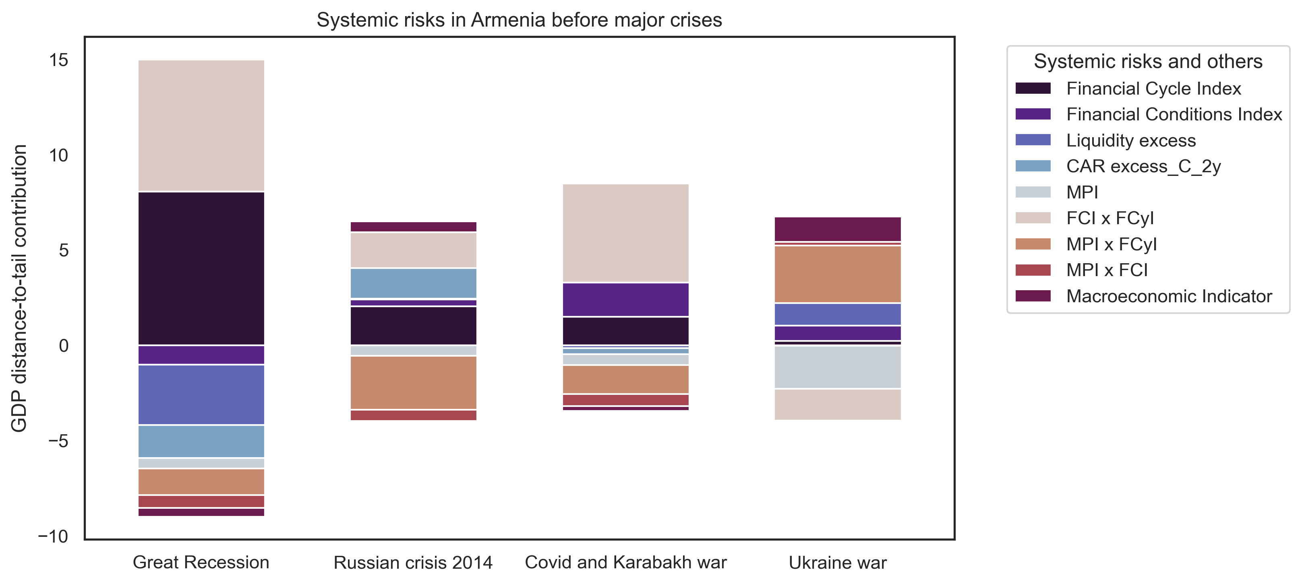
Figure 19. Changes in distance-to-tail and the buildup of systemic risks before major economic disturbances.
The distance-to-tail approach uses systemic thresholds to determine the macroprudential stance. The stance metric alongside these thresholds is presented in Figure 20. When this value exceeds the 7% distance-to-tail threshold (the 70th percentile), it signals a relatively loose stance, prompting consideration of tightening measures to maintain it at the neutral level. As of 2024Q1, the metric is at the neutral level, suggesting no immediate need for tightening actions. However, the value exhibits an upward trend, indicating growing risks in the system.
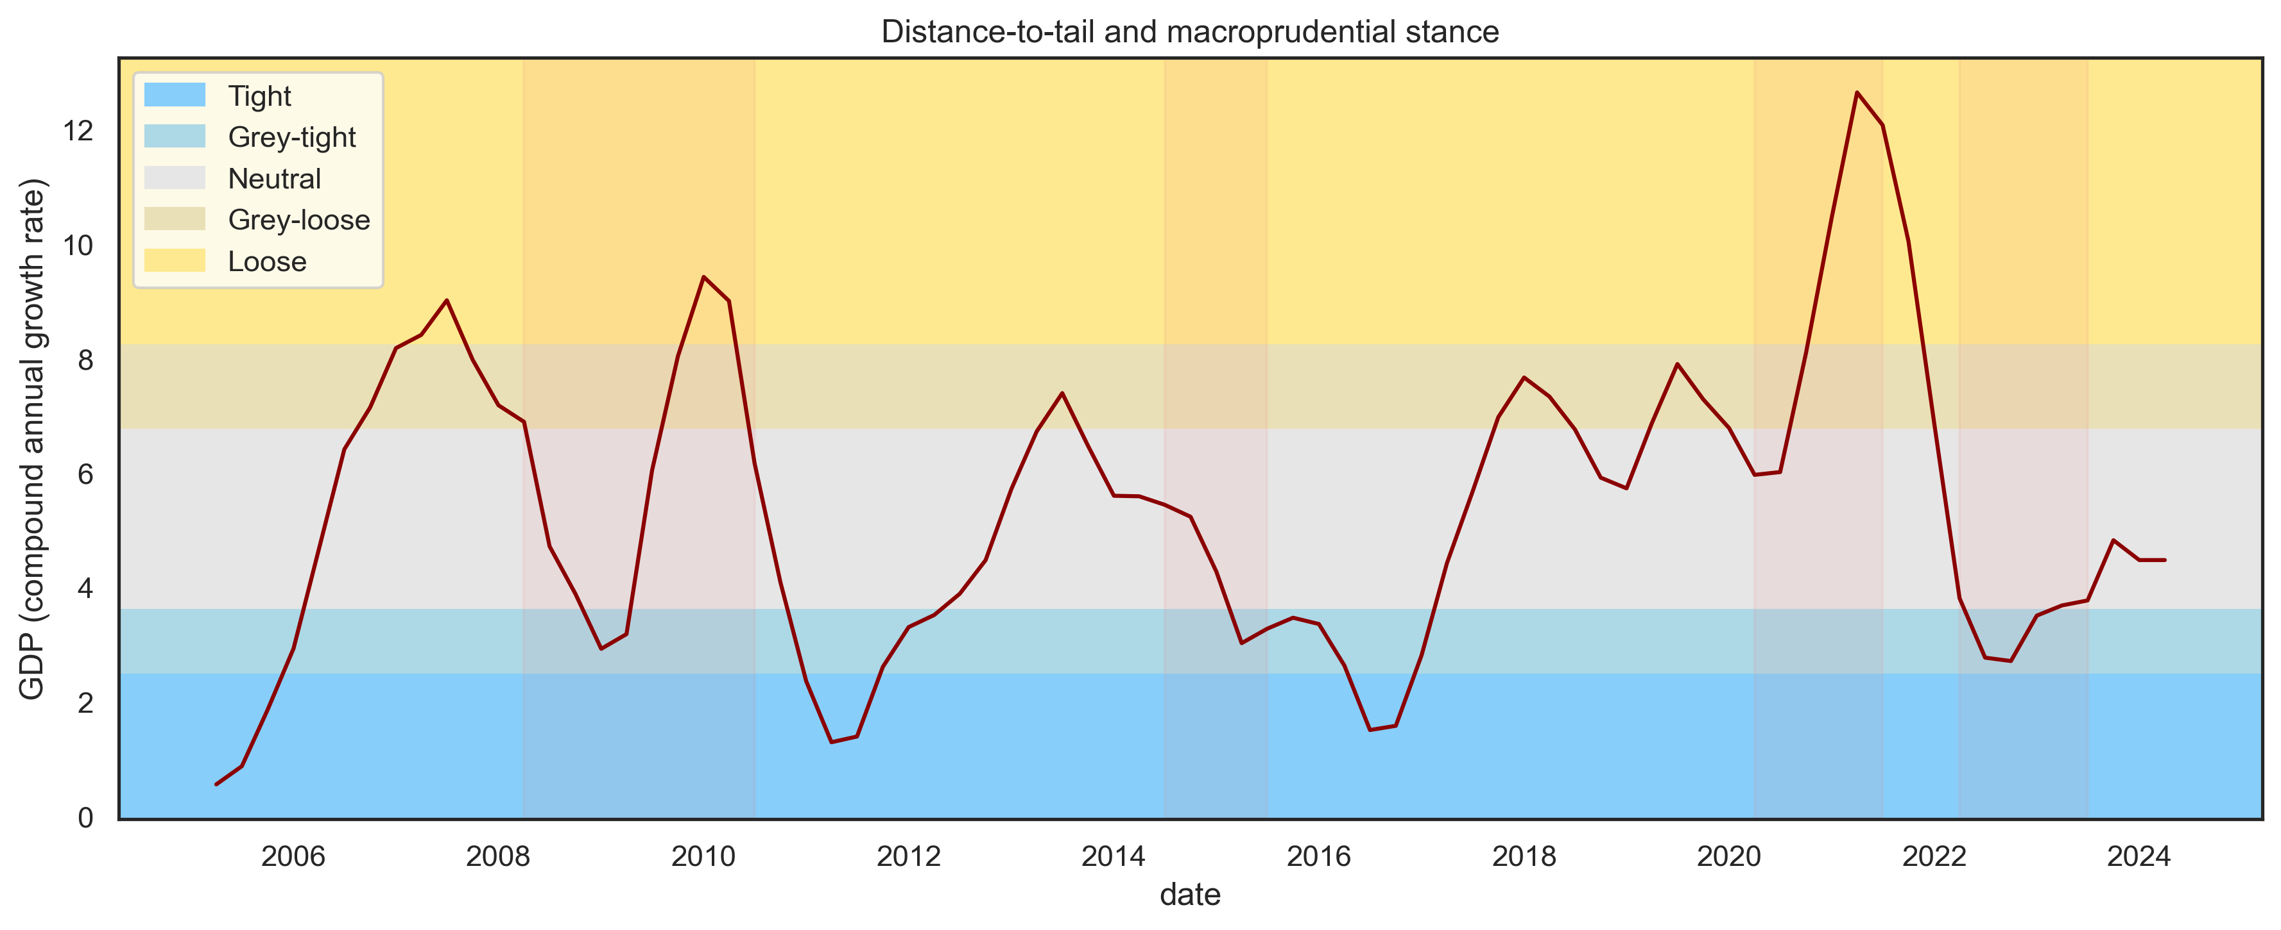
Figure 20. Estimated distance-to-tail and the macroprudential stance assessment over time. The boundaries describe the 10th, 30th, 70th, and 90th percentiles of the distance-to-tail distribution.
A key limitation of the distance-to-tail approach is that the selected threshold is not tied to a measure of the financial system’s resilience, but rather inferred from systemic risks. To test the reliability and robustness of this threshold we use an alternative methodology to derive it, inspired by modern portfolio theory. Using the estimated median and the distance-to-tail (Gap) from the panel quantile regression, we construct an efficient frontier across 41 countries, as shown in Figure 21. In this context, GDP growth represents each country’s "portfolio," with the median as the expected return and the distance-to-tail as the associated risk. The efficient frontier illustrates that beyond a certain threshold, countries that face additional risk do not generate excess returns in proportion to those risks. If we exclude India this threshold is around 5-6%, while including India lowers it to approximately 3%.
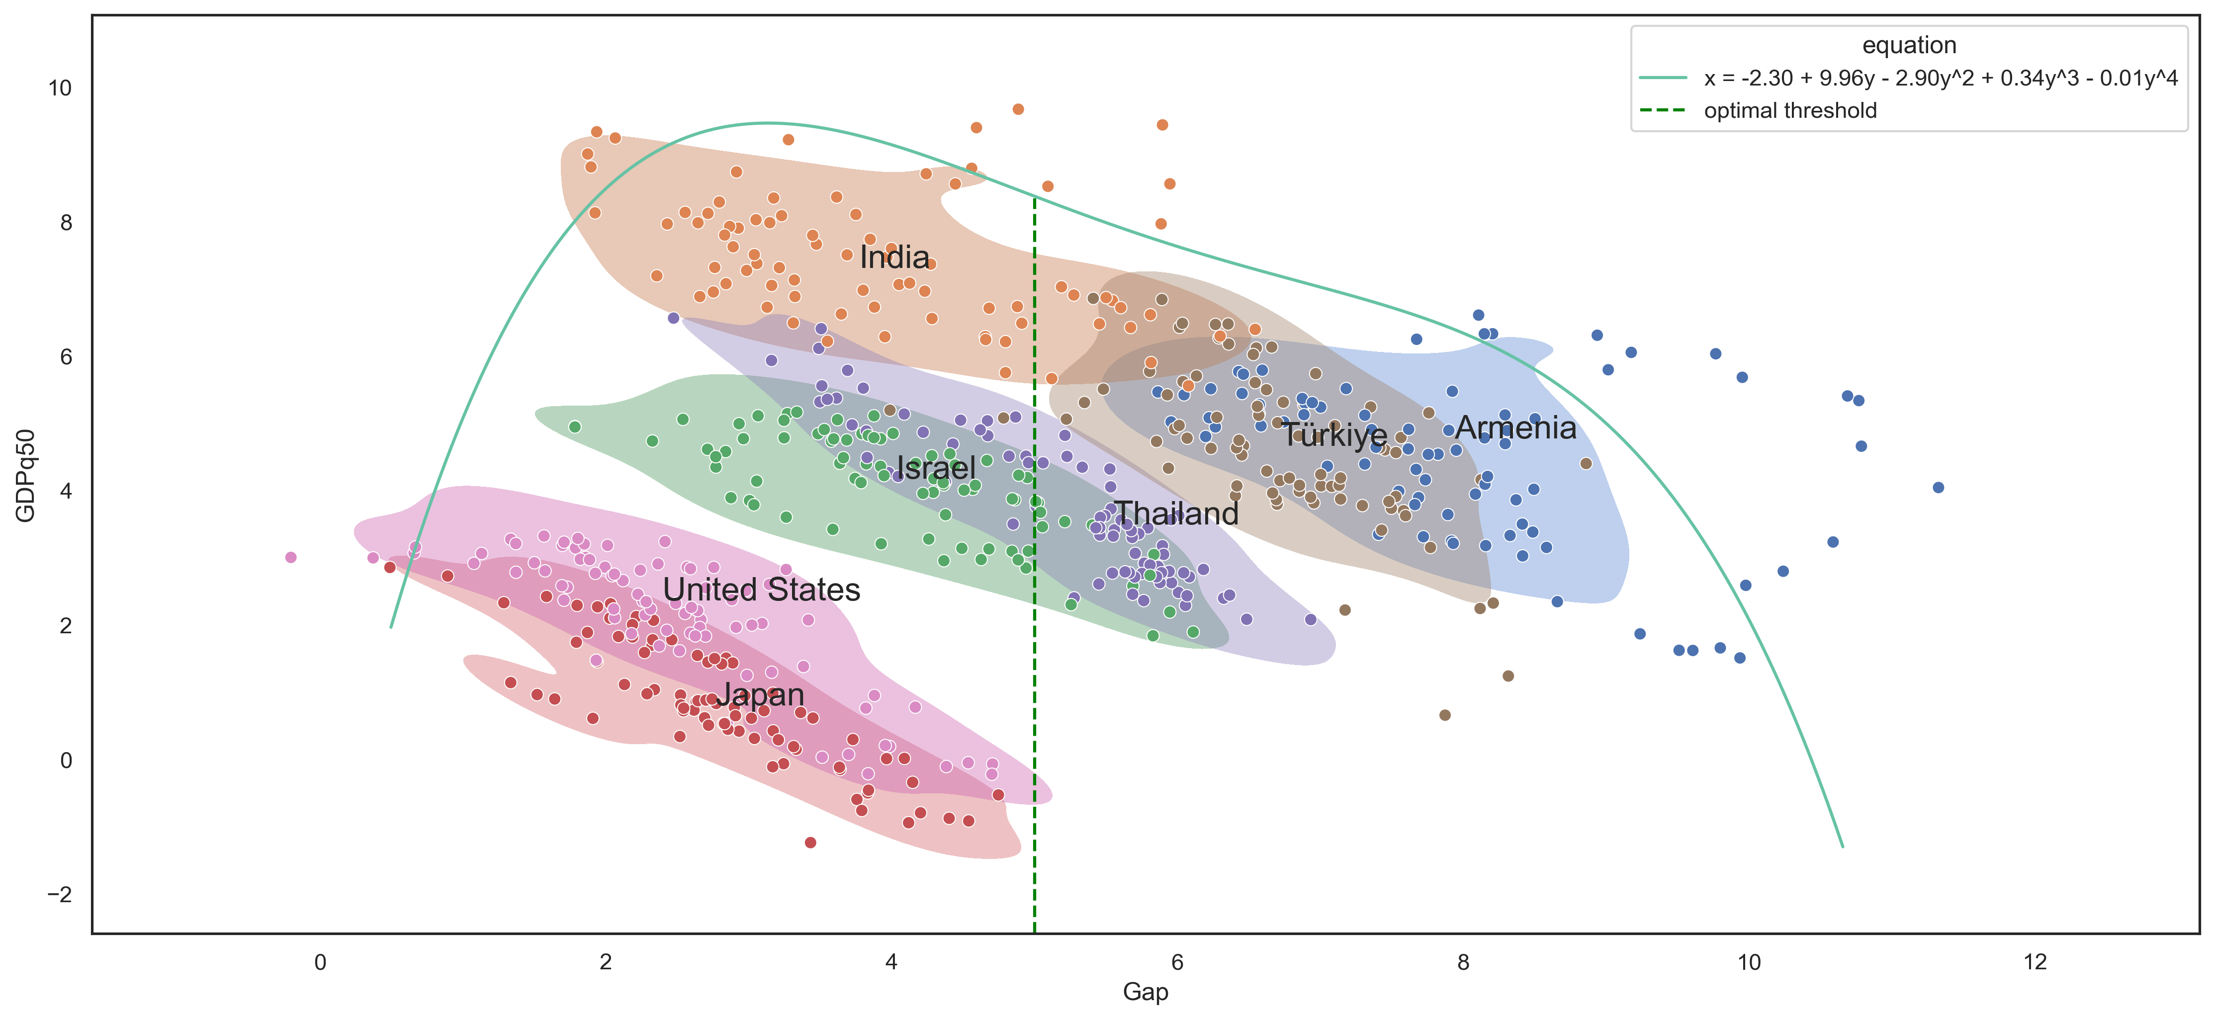
Figure 21. Efficient frontier based on the median and distance-to-tail (Gap) estimates from the 41 countries. The green line represents the frontier and was estimated using a Local Outlier Factor (LOF) algorithm.
  - Suarez welfare approach
Unlike the distance-to-tail approach, the Suarez (2021) welfare function also considers the median of the distribution, enabling us to account for the costs of the policy. For example, a policy that reduces the median without impacting the tail would be considered unfavorable, despite lowering the distance-to-tail. However, with the welfare function, such a policy would decrease overall utility. In other words, the welfare function favors policies that are capable of improving the tail, without a reduction in the median. As of 2024Q1, the conditional 1-year ahead GDP growth distribution has a median of 5.2% and a distance-to-tail of 7.3%. The full distribution is illustrated in Figure 22.
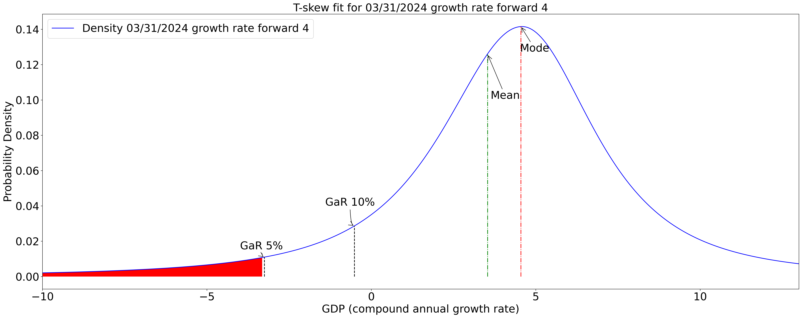
Figure 22. Conditional GDP growth distribution of Armenia using skewed t-distribution fit for interpolation.
To present how systemic risks shape the GDP growth distribution, we compare the conditional distributions for 2023Q1 and 2024Q1 in Figure 23. Compared to the previous year, the median has decreased by 3.5%, while the distance-to-tail increased by 4.2%. Figure 24 further breaks down the factors contributing to this shift. The decline in the median is largely driven by macroeconomic factors, while the widening distance-to-tail reflects heightened uncertainties stemming from rising financial vulnerabilities and the indirect effects of financial stress.
Finally, we demonstrate how a tightening of macroprudential policy can affect future growth. Estimates suggest that a 1.5-point increase in the MPI would reduce the median by 1% and shrink the distance-to-tail by 2.19%, which is also the utility-maximizing policy. This is equivalent to a CCyB tightening of 0.33%.
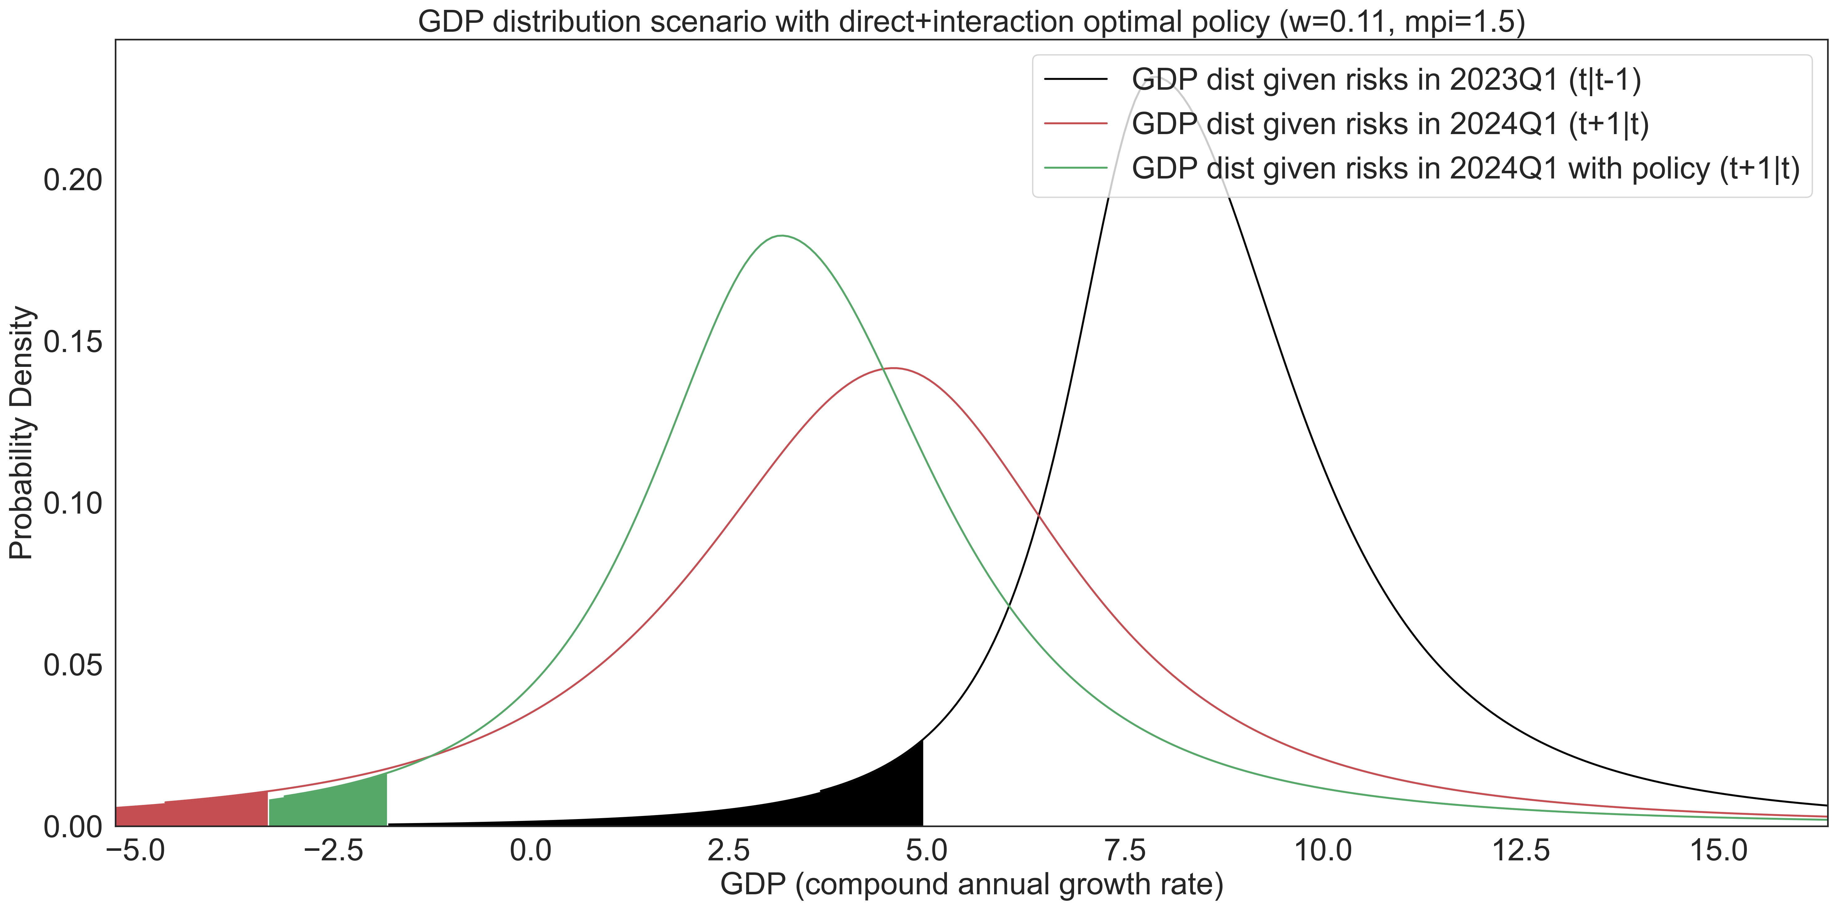
Figure 23. GDP growth distribution conditional on systemic risks in 2023Q1 and 2024Q1. Optimal policy interaction effects are marked in green.
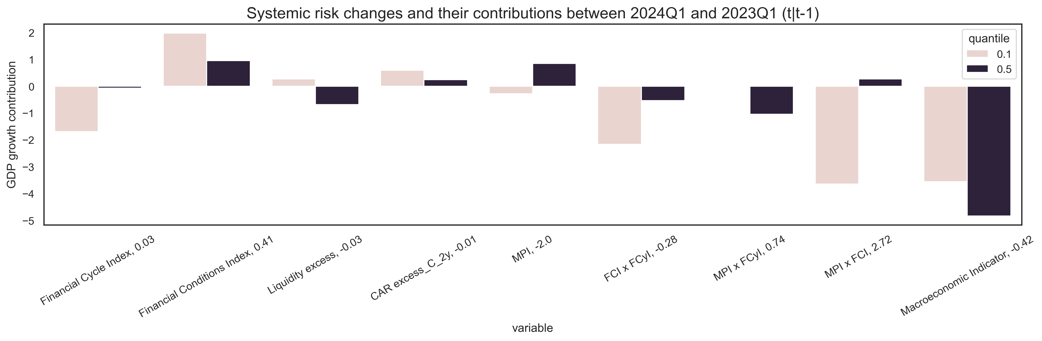
Figure 24. Changes in systemic risks between 2023Q1 and 2024Q1 and their impact on the GDP growth.
When comparing the results from both approaches, it is apparent that they provide different conclusions. We do not view one approach as inherently superior to the other, but instead stress the importance of policymakers considering both perspectives. Each approach highlights distinct dimensions of systemic risks and policy impacts, which together provide a more comprehensive understanding of the financial system and the macroprudential stance.
- Conclusion
In this paper, we develop a quantile regression framework for estimating the output growth distribution for the Armenian economy and deriving a macroprudential policy stance. Using the model, we examine the effects of macroprudential policy, financial cycles, financial conditions, liquidity risks, capital risks, and macroeconomic factors. We use this framework to perform forecasts for the output growth distribution and quantify the buildup of systemic risk. Using two distinct approaches we arrive at an optimal macroprudential policy rule. This framework aims to improve the decision-making process of the policymaker by defining clear guidelines for preemptive action.
References
Mack, S. (2021). Never waste a good crisis European banking regulation in the pandemic Policy Brief. Berlin: Hertie School.
Schmitz, S., Posch, M., & Strobl, P. (2022). The EU macroprudential review should prioritize removing regulatory overlaps and increasing the flexibility of the CCyB. Oesterreichische Nationalbank. SUERF.
Stojkov, K. (2020, September 17). Different Approaches to Implementing a Countercyclical Capital Buffer | Bulletin – September Quarter 2020. Financial Stability Department.
Galán, J. (2020, November). The benefits are at the tail: Uncovering the impact of macroprudential policy on growth-at-risk. Journal of Financial Stability(100831), 10.1016/j.jfs.2020.100831.
Galvez, J., & Mencia, J. (2014). Distributional Linkages between European Sovereign Bond and Bank Asset Returns. SSRN Electronic Journal, 10.2139/ssrn.2523863.
Aikman, D., Bridges, J., Hoke, S. H., O’Neill, C., & Raja, A. (2019, September). Credit, capital and crises: a GDP-at-Risk approach.
Suarez, J. (2022). Growth-at-risk and macroprudential policy design. Journal of Financial Stability, 60(1572-3089), 10.1016/j.jfs.2022.101008.
Koop, G., & Korobilis, D. (2014). A new index of financial conditions. European Economic Review, 71(0014-2921), 101-116, 10.1016/j.euroecorev.2014.07.002.
Cecchetti, S. G., & Suarez, J. (2021, December). On the Stance of Macroprudential Policy. SSRN Electronic Journal(11), 10.2139/ssrn.3975941.
Chavleishvili, S., Engle, R. F., Fahr, S. A., Kremer, M., Manganelli, S., & Schwaab, B. (2021). The Risk Management Approach to Macro-Prudential Policy. SSRN Electronic Journal, 10.2139/ssrn.3859109.
Alam, Z., Alter, A., Eiseman, J., Gelos, R., Kang, H., Narita, M., . . . Wang, N. (2019). Digging Deeper--Evidence on the Effects of Macroprudential Policies from a New Database. IMF Working Papers, 19(66), 10.5089/9781498302708.001.
Jiménez, G., Ongena, S., Peydró, J.-L., & Saurina, J. (2017). Macroprudential Policy, Countercyclical Bank Capital Buffers, and Credit Supply: Evidence from the Spanish Dynamic Provisioning Experiments. Journal of Political Economy, 125(6), 2126-2177, 10.1086/694289.
Boar, C., Gambacorta, L., Lombardo, G., & Silva, L. A. (2017). What are the Effects of Macroprudential Policies on Macroeconomic Performance? BIS Quarterly Review.
Koenker, R., & Bassett, G. (1978). Regression Quantiles. Econometrica, 46(1), 33, 10.2307/1913643.
Kipriyanov, A. (2022). Comparison of Models for Growth-at-Risk Forecasting. Russian journal of money and finance, 81(1), 23-45, 10.31477/rjmf.202201.23.
Holló, D., Kremer, M., & Lo Duca, M. (2012). A Composite Indicator of Systemic Stress in the Financial System. ECB Working Paper 1426.
Plašil, M., Seidler, J., Hlaváč, P., & Konečný, T. (2014). An indicator of the financial cycle in the Czech economy. Czech Financial Stability Report 2013/2014.
IMF. (2024). International Financial Statistics.
IMF. (2024). Financial Soundness Indicators.
World Bank. (2023). Global Economic Monitor (GEM) [Data set]. https://databank.worldbank.org/source/global-economic-monitor-(gem).
Jordà, Ò., Schularick, M., & Taylor, A. M. (2015). Leveraged bubbles. Journal of Monetary Economics, 76, S1-S20, 10.1016/j.jmoneco.2015.08.005.
Giot, P., & Laurent, S. (2003). Value-at-risk for long and short trading positions. Journal of Applied Econometrics, 18, 641-663, 10.1002/jae.710.
Cardarelli, R., Elekdag, S., & Lall, S. (2011). Financial stress and economic contractions. Journal of Financial Stability, 7, 78-97, 10.1016/j.jfs.2010.01.005.
Szabo, M. (2020). Growth-at-Risk: Bayesian Approach. Working Paper Series of the Czech National Bank (CNB).
Adrian, A., Prasad, A., Elekdag, S., Jeasakul, P., Lafarguette, R., Xiaochen Feng, A., & Wang, C. (2019). Growth at Risk: Concept and Application in IMF Country Surveillance. IMF Working Papers, 19(36), 10.5089/9781484397015.001.
Adrian, T., Boyarchenko, N., & Giannone, D. (2019). Vulnerable Growth. American Economic Review, 109, 1263–89, 10.1257/aer.20161923.
Galati, G., & Moessner, R. (2013). MACROPRUDENTIAL POLICY – A LITERATURE REVIEW. Journal of Economic Surveys, 27, 846-878, 10.1111/j.1467-6419.2012.00729.x.
BIS. (2010). Guidance for national authorities operating the countercyclical capital buffer. Basel: Basel Committee on Banking Supervision.
CNB. (2023). The CNB’s approach to setting the countercyclical capital buffer. Prague: Czech National Bank.
ESRB. (2019). Features of a macroprudential stance: initial considerations. Frankfurt: European Systemic Risk Board.
ESRB. (2018). A Review of Macroprudential Policy in the EU in 2017. Frankfurt: European Systemic Risk Board.
ESRB. (2024). Improvements to the ESRB macroprudential stance framework. Frankfurt: European Systemic Risk Board.
ESRB. (2021). Report of the Expert Group on Macroprudential Stance – Phase II (implementation). Frankfurt: European Systemic Risk Board.

Appendix A: Suarez welfare function
The one of the main advantages of GaR is that it is measured in the same units as GDP growth. This makes the comparison between the two very straightforward. Yet compared to monetary policy, the macroprudential policy literature still lacks explicit design rules. Suarez (2021) fills this gap by suggesting a welfare function that “rewards expected GDP growth and penalizes the gap between expected GDP growth and GaR.” To derive this welfare function from micro foundations, the following steps are used.
First, let $Y$ denote GDP and $y$ the GDP growth rate:
$$\begin{aligned}Y=\left(1+y\right)Y_{0}\#\left( SEQ Equation \backslash * ARABIC 18\right)\end{aligned}$$
Now let us assume that there is a representative agent with a local coefficient of absolute risk aversion $λ\left(Y_{0}\right)$ at $Y=Y_{0}$. Then we can express the utility function as one exhibiting constant absolute risk aversion (CARA) with $λ\left(Y_{0}\right)$, so that:
$$\begin{aligned}U\left(Y\right)=-\exp\left(λ\left(Y_{0}\right)Y\right)\#\left( SEQ Equation \backslash * ARABIC 19\right)\end{aligned}$$
If we insert equation (eq.) 11 in eq.12, then perform a monotonic transformation, then we get:
$$\begin{aligned}u\left(y\right)=-\exp\left(λ\left(Y_{0}\right)Y_{0}y\right)=-\exp\left(ρ_{0}y\right)\#\left( SEQ Equation \backslash * ARABIC 20\right)\end{aligned}$$
In eq. 13 $ρ_{0}=λ\left(Y_{0}\right)Y_{0}$ describes the agent’s coefficient of relative risk aversion at $Y_{0}$. If we assume GDP growth is normally distributed, so that $y\sim N(y_{m}, σ_{y}^{2})$, then using the known moment functions we can write the agent’s expected utility as:
$$\begin{aligned}E\left[u\left(y\right)\right]=-E\left[\exp\left(ρ_{0}y\right)\right]=-\exp\left({-ρ}_{0}y_{m}+\frac{1}{2}ρ_{0}^{2}σ_{y}^{2}\right)\#\left( SEQ Equation \backslash * ARABIC 21\right)\end{aligned}$$
Indirectly eq. 14 can also be described as:
$$\begin{aligned}v=y_{m}-\frac{ρ_{0}}{2}σ_{y}^{2}\#\left( SEQ Equation \backslash * ARABIC 22\right)\end{aligned}$$
$$\begin{aligned}σ_{y}=\frac{y_{c}-y_{m}}{Φ^{-1}\left(c\right)}\#\left( SEQ Equation \backslash * ARABIC 23\right)\end{aligned}$$
$$\begin{aligned}v=y_{m}-\frac{1}{2}\frac{ρ_{0}}{{\left(Φ^{-1}\left(c\right)\right)}^{2}}{\left(y_{c}-y_{m}\right)}^{2}\#\left( SEQ Equation \backslash * ARABIC 24\right)\end{aligned}$$
Finally, by reordering some terms and assigning $w=\left(\frac{ρ_{0}}{{\left(Φ^{-1}\left(c\right)\right)}^{2}}\right)$, which we can interpret as the aversion for financial instability, we derive the social welfare function proposed by Suarez:
$$\begin{aligned}W=y_{m}-\frac{1}{2}w{\left(y_{m}-y_{c}\right)}^{2}\#\left( SEQ Equation \backslash * ARABIC 25\right)\end{aligned}$$
The limitations of this function are embedded in its assumptions. Since most GDP growth distributions aren’t normally distributed this makes the function sensitive choice of quantile c. Additionally, even if the c is chosen correctly, the value for $ρ_{0}$ and consequently is up to the policy maker. Nevertheless, this function can still serve as a good basis for policy recommendations since it offers a means to perform a cost-benefit analysis for the effects of macroprudential policy.
Appendix B: Additional Panel and local model estimation results
B1. Panel model estimation results
The full list of countries used in the panel estimation includes Armenia, Australia, Austria, Belgium, Brazil, Chile, Colombia, Croatia, Czech Republic, Denmark, Finland, France, Georgia, Germany, Greece, Hong Kong, China, Hungary, Iceland, India, Ireland, Israel, Italy, Japan, Korea, Republic of, Mexico, Netherlands, New Zealand, Norway, Philippines, Poland, Portugal, Romania, Russian Federation, Singapore, Spain, Sweden, Switzerland, Thailand, Türkiye, United Kingdom and United States.
Table 1. In sample panel quantile regression coefficients
Variables |  | GDP growth, h=4, q=0.1, e=f | GDP growth, h=4, q=0.5, e=f
autoregressive | 0.0302 |  | 0.1038***
 | (0.0276) |  | (0.0107)
FCyI | -3.4029*** |  | -2.0606***
 | (0.6489) |  | (0.3287)
FCI | 0.2306* |  | 0.1166**
 | (0.1188) |  | (0.0593)
MPI | 0.1012* |  | -0.0221
 | (0.0550) |  | (0.0275)
DSR | -0.1543*** |  | -0.1084***
 | (0.0274) |  | (0.0147)
Interest_margin/Income_normalized_C_2y | -0.1249** |  | -0.0268
 | (0.0559) |  | (0.0270)
Bank_liabilities_MC_normalized_C_1y | -0.8270*** |  | -0.5366***
 | (0.1662) |  | (0.0803)
NPL_ratio_PctC_3y | -0.1747*** |  | -0.0424
 | (0.0562) |  | (0.0290)
Provisions/NPL_C_2y | 0.0231*** |  | 0.0057**
 | (0.0044) |  | (0.0024)
RPP_Real_PctC_3y | 3.6966*** |  | 3.9197***
 | (0.4692) |  | (0.2543)
RRE_Loans_MC_PctC_1y | 1.3092*** |  | 0.7058***
 | (0.1921) |  | (0.1395)
CPI_C_1y | -0.1441*** |  | -0.0532***
 | (0.0212) |  | (0.0109)
MPR_log | -0.2010*** |  | -0.0307
 | (0.0539) |  | (0.0273)
Unemployment_normalized | 1.0673*** |  | 0.6037***
 | (0.0969) |  | (0.0451)
FX_log_C_2y | 0.8575*** |  | 0.5483***
 | (0.1767) |  | (0.0886)
Import_Merchandise_Price_normalized | -0.9196*** |  | -0.4745***
 | (0.0833) |  | (0.0405)
FCyI x FCI | 2.0863*** |  | 0.9796**
 | (0.6735) |  | (0.3813)
MPI x FCyI | -0.2048* |  | 0.0615
 | (0.1066) |  | (0.0614)
MPI x FCI | -0.9881*** |  | -0.3099***
 | (0.1947) |  | (0.0913)
N | 4469 |  | 4469
Pseudo-R2 | 0.18 |  | 0.20
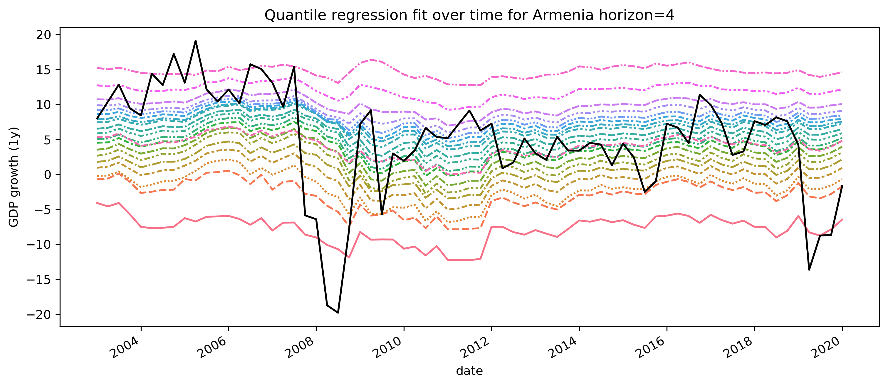
Figure 25. Panel quantile regression one year ahead fitted values of Armenia for different quantiles.
In Figure 26 we plot the estimated median and distance-to-tail (Gap) values. We then use the Local Outlier Factor (LOF) algorithm on the data points to compute local densities for each of the points relative to their neighbors. Points with very low density are considered to be outliers (marked in red). Using this density function we derive a boundary that best describes the efficient frontier for our risk (Gap) and reward (median) pairs. Boundary points are marked in orange. By fitting a polynomial onto these points, it is possible to derive an explicit frontier function.
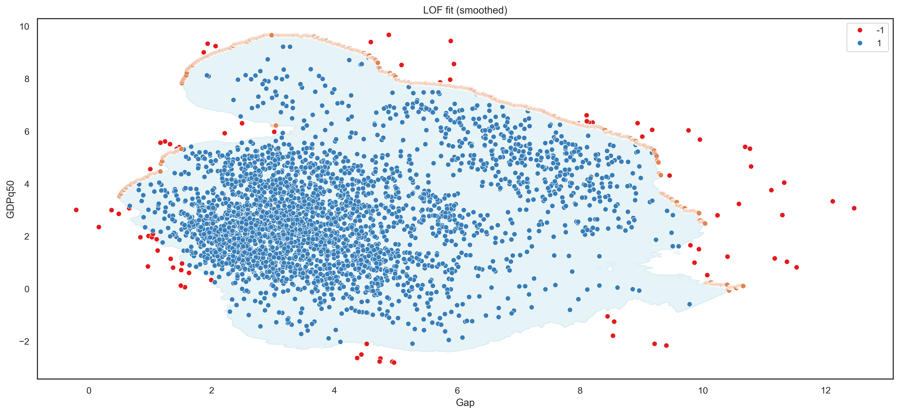
Figure 26. Local Outlier Factor (LOF) boundary based on estimates from 41 countries.
B2. Local model estimation results
Table 2. In sample local quantile regression coefficients
Variables | GDP growth, h=4, q=0.1, e=b | GDP growth, h=4, q=0.1, e=f | GDP growth, h=4, q=0.5, e=b | GDP growth, h=4, q=0.5, e=f
autoregressive | -0.49*** | -0.10 | -0.41*** | -0.19*
 | (0.16) | (0.20) | (0.09) | (0.11)
const | -11.06** | 10.90 | -1.03 | 5.20*
 | (4.57) | (7.75) | (3.13) | (2.95)
Financial Cycle Index | 46.43** | -63.60* | 33.46** | -2.61
 | (17.57) | (31.94) | (13.46) | (13.15)
Financial Conditions Index | -2.47 | 4.83** | -2.16 | 2.34*
 | (1.92) | (2.02) | (1.35) | (1.32)
Liquidity excess | 56.85** | -7.73 | 28.59** | 19.38
 | (22.41) | (31.87) | (13.45) | (12.43)
CAR excess_C_2y | -61.56** | -44.55* | -23.07 | -18.15
 | (30.06) | (25.40) | (23.04) | (21.13)
MPI | -1.11** | 0.14 | -0.49 | -0.42
 | (0.45) | (0.57) | (0.36) | (0.34)
FCI x FCyI | -4.05*** | 7.65*** | -1.50 | 1.89**
 | (1.47) | (1.86) | (0.95) | (0.94)
MPI x FCyI | -0.86* | 0.01 | 0.02 | -1.40***
 | (0.50) | (0.83) | (0.35) | (0.34)
MPI x FCI | -1.34 | -1.34 | -0.52 | 0.10
 | (0.94) | (0.89) | (0.52) | (0.45)
Macroeconomic Indicator | 21.75*** | 8.46* | 19.36*** | 11.51***
 | (3.97) | (4.33) | (2.88) | (3.11)
N | 77 | 73 | 77 | 73
Pseudo-R2 | 0.66 | 0.59 | 0.50 | 0.47
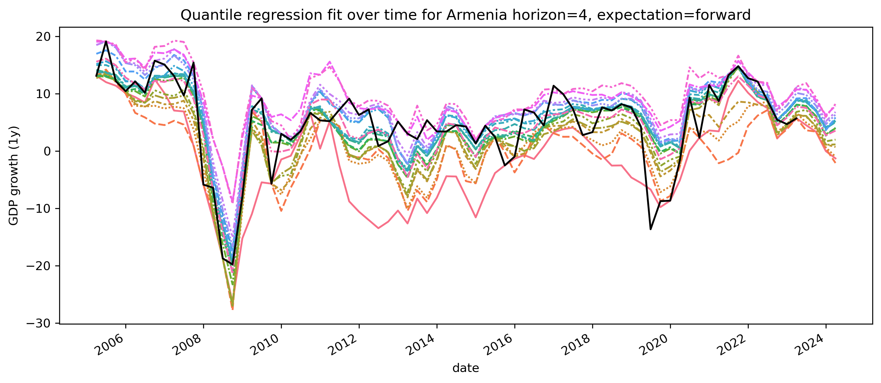
Figure 27. Local quantile regression one year ahead fitted values of Armenia for different quantiles.
Figure 28 shows the GDP growth distribution of Armenia conditional on systemic risks in 2024Q1. Instead of a using skewed t-distribution as in Figure 22, a Kernel density-based estimation is used to interpolate the quantiles. Even though it is more sensitive to the choice of the number of quantiles, it does a better job at describing the left tail of the distribution.
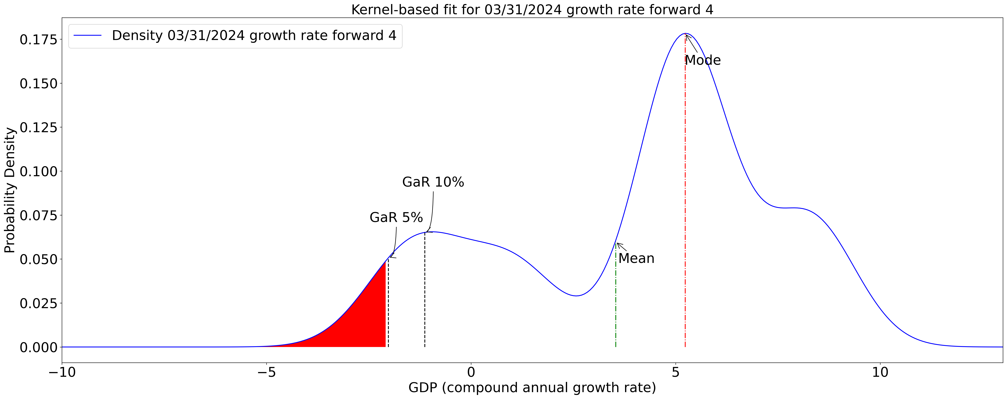
Figure 28. Conditional GDP growth distribution using non-parametric KDE based interpolation.
Appendix C: Input data and transformations
C1. Data for the panel model
Table 3 and Table 4 illustrate summary statistics related to the panel data before and after the transformations. Variables with the prefix “_C” and “_PctC” describe the simple difference and percentage change difference transformations respectively. Variables with the prefix “_lag_$i$” indicate that the series has been shifted backward by $i$ quarters.
Table 3. Panel summary statistics
Variables | count | mean | std | min | 50% | max
GDP_real_growth_1.0y | 5,084.00 | 3.22 | 4.52 | -23.37 | 2.98 | 45.60
REER | 5,248.00 | 96.60 | 14.51 | 19.09 | 97.92 | 163.71
Bond_yield_5Y | 5,248.00 | 6.47 | 5.63 | -0.99 | 5.33 | 61.15
Bond_yield_1Y | 5,248.00 | 5.60 | 5.09 | -0.77 | 4.62 | 35.50
Unemployment | 5,248.00 | 7.64 | 4.21 | 0.48 | 6.90 | 28.20
CPI | 5,248.00 | 87.32 | 31.82 | 0.00 | 90.46 | 350.54
Credit_GDP_ratio | 5,248.00 | 134.63 | 68.67 | 6.03 | 133.60 | 400.60
Credit_GDP_gap | 5,248.00 | 0.89 | 14.49 | -107.20 | 0.87 | 80.00
Liquid_asset_ratio | 5,248.00 | 27.76 | 23.50 | 3.46 | 23.94 | 211.54
RPP_Real | 5,248.00 | 95.07 | 34.67 | 33.32 | 96.13 | 237.65
Provisions/NPL | 5,248.00 | 60.56 | 43.70 | -94.42 | 52.65 | 314.02
Bank_liabilities_MC | 5,248.00 | 336,897,733.54 | 935,041,903.27 | 515.90 | 6,667,702.39 | 3,633,974,000.00
RRE/Loans | 5,248.00 | 21.56 | 17.09 | 0.12 | 18.57 | 84.34
Interest_margin/Income | 5,248.00 | 58.42 | 16.15 | -294.33 | 59.07 | 498.61
CAR_T1 | 5,248.00 | 12.83 | 4.00 | -3.64 | 12.49 | 33.72
MPI | 5,248.00 | 0.54 | 1.82 | -13.00 | 0.00 | 12.00
DSR | 5,248.00 | 16.34 | 5.36 | 3.00 | 16.20 | 40.10
Financial Conditions Index | 4,756.00 | 0.00 | 0.76 | -5.13 | 0.16 | 1.74
Financial Cycle Index | 4,756.00 | 0.15 | 0.14 | -0.01 | 0.11 | 0.82
Table 4. Panel summary statistics for transformed variables
Variables | count | mean | std | min | 50% | max
GDP_real_growth_1.0y | 5,084.00 | 3.22 | 4.52 | -23.37 | 2.98 | 45.60
GDP_real_growth_2.0y | 4,920.00 | 3.11 | 3.43 | -13.03 | 2.84 | 30.49
GDP_real_growth_3.0y | 4,756.00 | 3.16 | 3.03 | -8.39 | 2.82 | 25.84
REER_lag_1_normalized | 4,756.00 | 0.02 | 0.96 | -4.00 | 0.05 | 3.17
Bond_yield_5Y_C_2y | 4,756.00 | -0.68 | 3.70 | -56.70 | -0.55 | 52.49
Bond_yield_1Y_normalized_C_3y | 4,756.00 | -0.28 | 0.77 | -6.37 | -0.23 | 4.92
Unemployment_normalized | 4,756.00 | -0.01 | 0.99 | -3.63 | -0.11 | 5.73
CPI_C_1y | 4,756.00 | 2.89 | 4.10 | -54.50 | 2.16 | 72.00
Credit_GDP_ratio_PctC_2y | 4,756.00 | 0.05 | 0.12 | -0.65 | 0.04 | 1.23
Credit_GDP_gap_PctC_2y | 4,756.00 | -0.43 | 10.40 | -434.15 | -0.18 | 125.00
Liquid_asset_ratio_PctC_2y | 4,756.00 | 0.01 | 0.16 | -0.73 | -0.00 | 1.84
RPP_Real_PctC_3y | 4,756.00 | 0.08 | 0.19 | -0.45 | 0.06 | 1.12
Provisions/NPL_C_2y | 4,756.00 | 0.53 | 16.28 | -169.40 | 0.36 | 99.23
Bank_liabilities_MC_normalized_C_1y | 4,756.00 | 0.06 | 0.45 | -4.73 | 0.01 | 3.77
RRE/Loans_PctC_1y | 4,756.00 | 0.20 | 2.11 | -0.98 | 0.01 | 57.52
Interest_margin/Income_normalized_C_2y | 4,756.00 | 0.02 | 1.29 | -10.64 | 0.02 | 10.96
CAR_T1_lag_3_PctC_1y | 4,756.00 | 0.02 | 0.55 | -31.89 | 0.02 | 12.64
MPI | 4,756.00 | 0.59 | 1.90 | -13.00 | 0.00 | 12.00
DSR | 4,756.00 | 16.44 | 5.33 | 3.00 | 16.42 | 40.10
Financial Conditions Index | 4,756.00 | 0.00 | 0.76 | -5.13 | 0.16 | 1.74
Financial Cycle Index | 4,756.00 | 0.15 | 0.14 | -0.01 | 0.11 | 0.82
C2. Data from the local model
Table 5. Local model summary statistics
Variables | count | mean | std | min | 25% | 50% | 75% | max
GDP_real_growth_1.0y | 81 | 5.5 | 7.4 | -19.8 | 3 | 6.7 | 10.2 | 19.1
Financial Cycle Index | 85 | 0.1 | 0.1 | 0 | 0.1 | 0.1 | 0.2 | 0.3
Financial Conditions Index | 85 | 0 | 0.7 | -1.3 | -0.6 | 0 | 0.3 | 2.4
Liquidity excess | 85 | 0.2 | 0.1 | 0.1 | 0.1 | 0.2 | 0.2 | 0.4
CAR excess | 85 | 0.1 | 0.1 | 0 | 0 | 0.1 | 0.2 | 0.2
Mortgage stock | 72 | 0.3 | 0.4 | 0 | 0.1 | 0.2 | 0.4 | 1.6
Mortgage flow | 72 | 0.4 | 0.6 | -0.8 | 0 | 0.2 | 0.6 | 1.6
Mortgage interest rate | 63 | -2.1 | 0.1 | -2.3 | -2.2 | -2.1 | -2.1 | -1.6
Construction loans | 77 | 0.7 | 0.6 | -0.1 | 0.3 | 0.5 | 0.8 | 3
Real estate prices | 81 | 0.1 | 0.1 | -0.2 | 0 | 0.1 | 0.1 | 0.4
DSTI | 77 | 0 | 0 | 0 | 0 | 0 | 0 | 0.1
Macroeconomic Indicator | 85 | 0 | 0.3 | -1 | -0.1 | 0 | 0.2 | 0.5
MP | 85 | 0.3 | 0.7 | -1 | 0 | 0 | 0 | 3
MPI | 85 | 1.2 | 1.7 | -2 | 0 | 1 | 2 | 6
Appendix D: w calibration results
This section discusses the calibration procedure used to derive a representative value for $w$, the aversion for financial instability from the Suarez (2021) welfare function. For any arbitrary value of $w∈(0,1)$, it is possible to simulate an optimal policy path $\vec{p_{w}}$ (see Figure 30). Using simple rules, we define 3 preferred policy paths: $\vec{p_{h}}$, $\vec{p_{b}}$ and $\vec{p_{c}}$. The $\vec{p_{h}}$ path assumes that the historical policy of Armenia is the optimal path. The $\vec{p_{b}}$ path follows the CCyB rule defined by the Basel Committee (2010), using the credit-to-GDP gap to arrive at optimal values for CCyB. According to estimates performed by ESRB (2021), a “capital-based macroprudential policy corresponds to a CET1 capital of 0.87 of risk-weighted assets.” Using this “conversion rate” we are able to map the CCyB rule to macroprudential policy actions and generate the Basel preferred policy path $\vec{p_{b}}$. The $\vec{p_{c}}$ path follows the same logic as $\vec{p_{b}}$, except for the CCyB values it uses the rule defined by the Czech National Bank (CNB). This rule is defined as a piecewise function that maps different phases of the financial cycle to CCyB decisions (CNB, 2023). After applying the “conversion rate” we end up with the policy path $\vec{p_{c}}$. The historical CCyB policy measures for the Basel and CNB methods are presented in Figure 29.
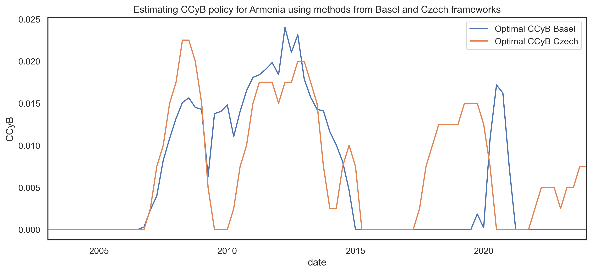
Figure 29. Optimal CCyB tightening measures derived using the Basel gap and Financial Cycle Index (CNB)
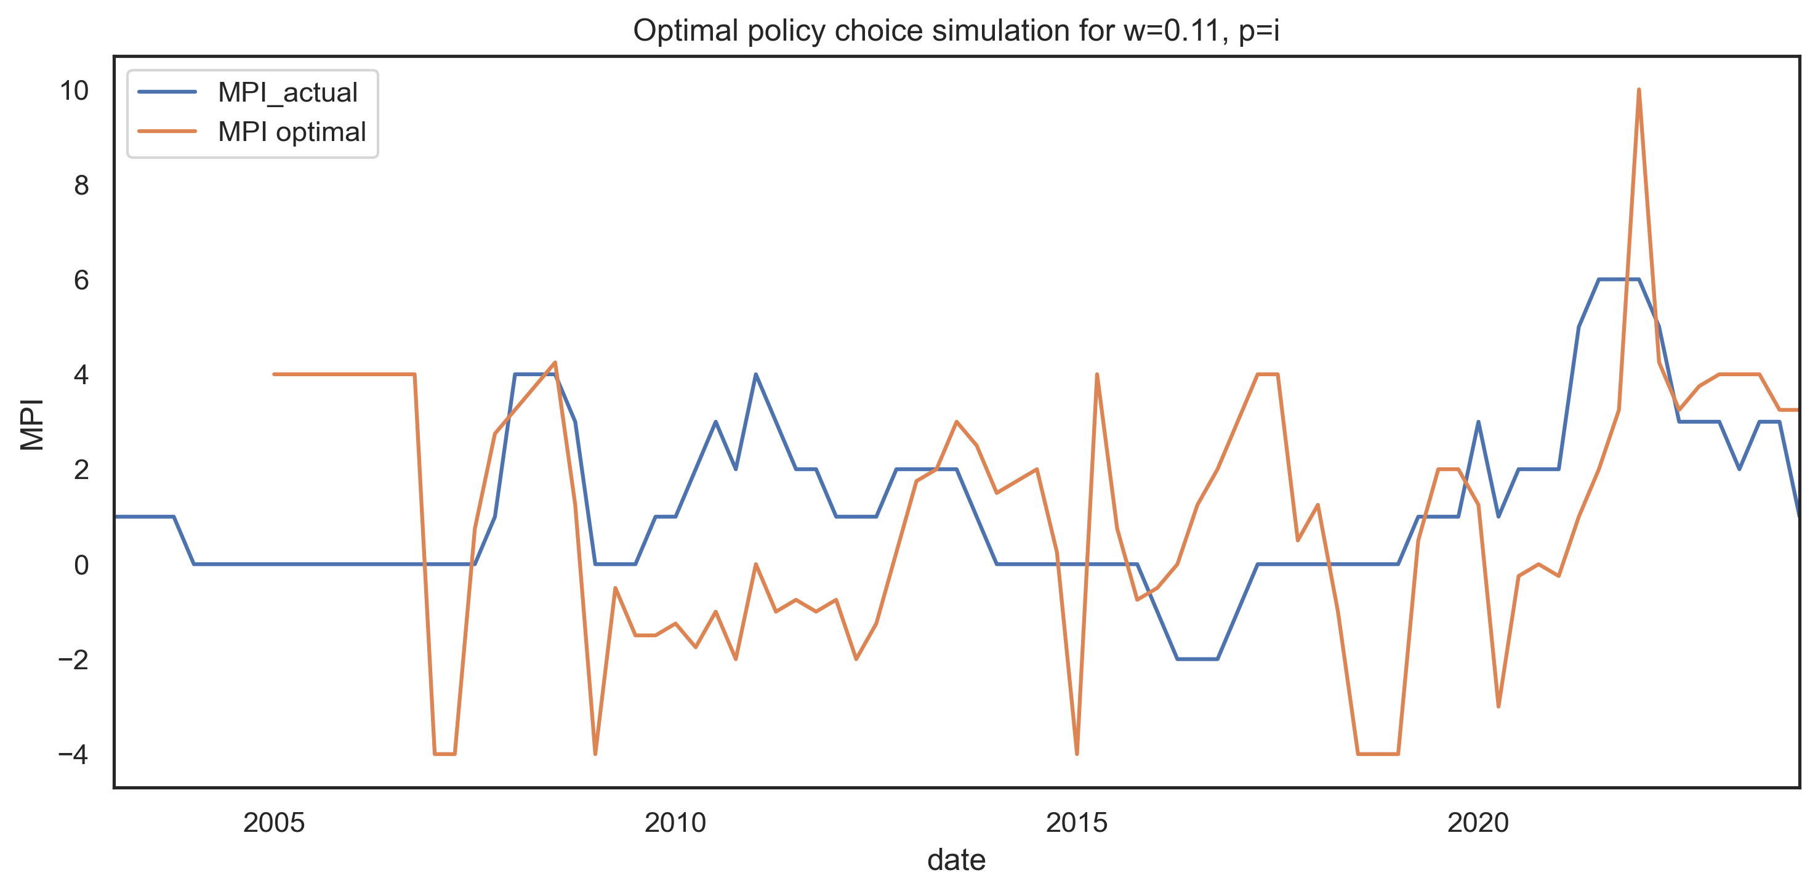
Figure 30. Policy path simulation given an arbitrary value for w.
Next, to see which path is the most viable we compare all of the optimal paths $p_{w}$ with the 3 preferred policy paths by taking the Euclidean distance between them. Figure 31 shows the relationship between the choice of $w$ and the 3 preferred policy paths. Using the elbow method and optimal choices from the Basel and CNB methods, we believe that 0.11 is a representative value.
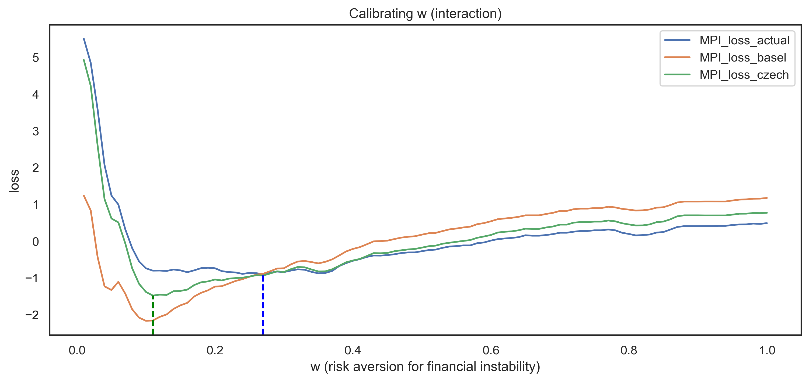
Figure 31. Euclidean distance between $\vec{p_{w}}$ and the 3 preferred policy paths for all values of w. Dotted lines show the points with the smallest distance.
As a robustness check for the calibration results above, we ignore the 2 preferred policy paths and instead allow the value of $w$ to change over time. We then select the set $\vec{w}$ so that $\vec{p_{\vec{w}}}$ matches almost exactly with $\vec{p_{h}}$. Finally, we plot the distribution for $w$ in Figure 32. The selected value of 0.11 is not significantly different from the modes of these distributions.
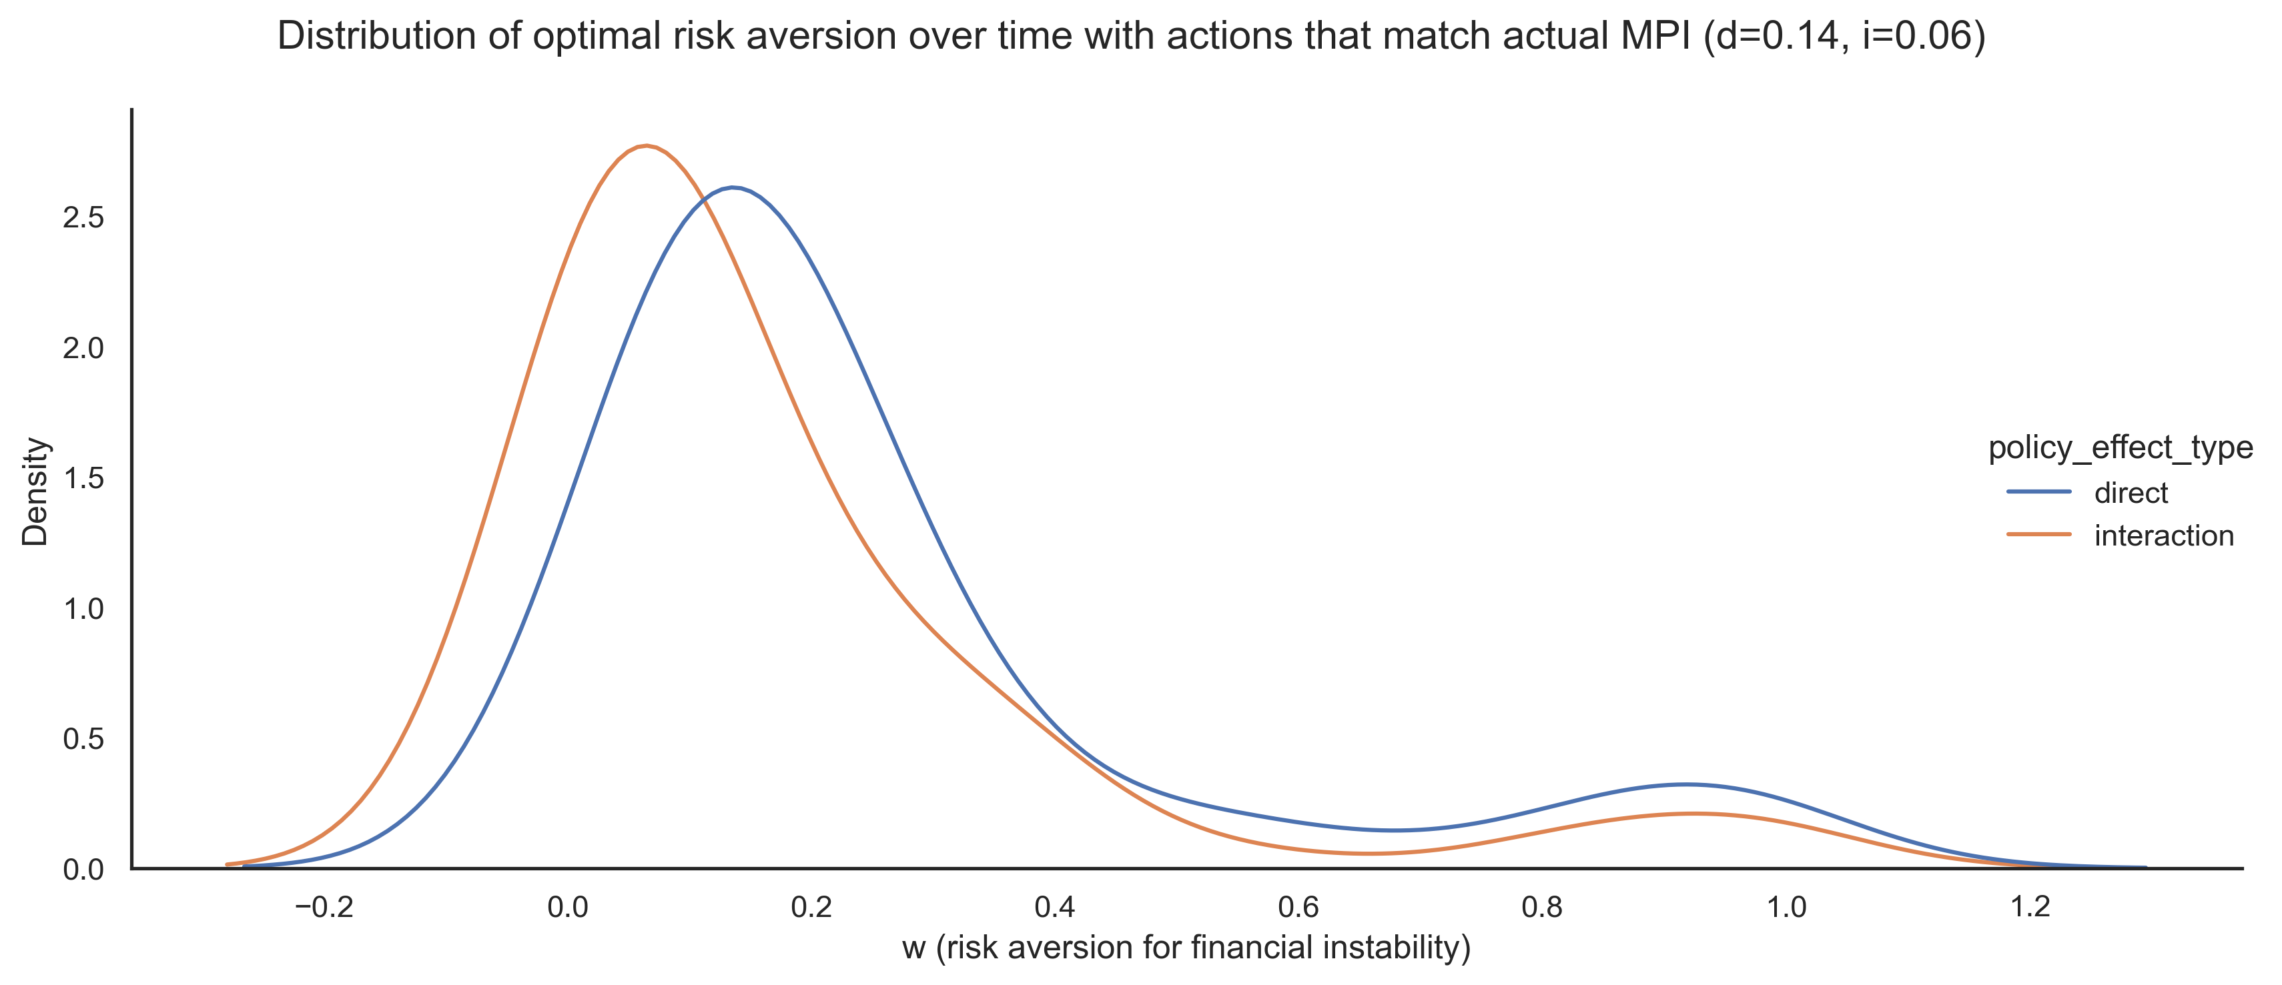
Figure 32. Distribution for the dynamic values of $w$ over time.

For detailed information on the calibration procedure, see Appendix D.
To overview summary statistics and data transformations please refer to appendix C.
For details on the methodology behind the frontier, see Appendix B.
The conversion is performed using a simple formula:$\left(\frac{1.5⋅0.87}{4}\right)$. For details on the “conversion rate” see Appendix D.

